LARUS Vario Display
Installation and Configuration Manual

Table of Contents
1 Preliminary Remarks 4
1.1 Important Notices 4
1.2 Limited Warranty 4
1.3 Conventions and Pictograph Definitions 4
2 Safety 5
2.1 Safety Precautions 5
2.2 Proper Use 5
2.3 Improper Use 5
3 LARUS Vario Display Quick Start Manual 5
4 Product Description 5
4.1 Scope of Delivery 5
4.2 Design and Function 6
4.3 Connectors 7
4.3.1 Overview of the Connectors 7
4.3.2 CAN and RS232 Ports 8
4.3.3 GPIO / D-SUB 9 8
4.3.4 Audio 9
4.3.5 SD-Card 9
4.4 CAN Termination 9
4.4.1 Installation 10
4.5 Installation Location 10
4.6 Installation Orientation 11
4.7 Initial Operation and Function Test 11
4.8 Firmware Updates 11
5 Operation 12
5.1 Display 12
5.1.1 Circling Mode 12
5.1.2 Straight Flight Mode 13
5.1.3 Available Central Displays 13
5.1.4 Switching from Circling (Vario) to Speed to Fly 15
5.1.5 Acoustic Quiet Zone in Speed to Fly Mode. 15
5.2 Control Elements 16
5.2.1 Short Press Menu Structure 16
5.2.2 Long Press Menu Structure 17
6 Configuration 20
6.1 Glider Polar 20
6.2 Calibrating The Larus Senor Box 20
6.2.1 Calibration on the Ground (Roll Angle) 20
6.2.2 Calibration During Flight (Pitch Angle) 21
7 Maintenance 21
8 Troubleshooting 22
9 Technical Data 23

Preliminary Remarks

Important Notices
Before using any part of the system, please read and understand this manual. All information in this document is subject to change without notice. The latest version can be downloaded from www.stefly.aero.
CoTexx GmbH does not accept responsibility for damages which are the result of installation and operation of the device.

Limited Warranty
The LARUS Vario Display as well as its accessories are warranted to be free from defects in materials or workmanship for two years from the date of purchase. Within this period, CoTexx will, at its sole discretion, repair or replace any components that fail in normal use. Such repairs or replacement will be made at no charge to the customer for parts and labour, provided that the customer shall be responsible for any transportation cost. This warranty does not cover failures due to abuse, misuse, accident, or unauthorised alterations or repairs.

Conventions and Pictograph Definitions
The safety instructions in SteFly operating manuals are the result of risk evaluations and hazard analyses. In this document, the following hazard levels and information are considered:
 | Pay special attention to critical notes marked with a yellow caution symbol, because non-observance may result in damage or any other critical situation.
 | A red caution symbol signalises that non-observance may result in injuries.
 | Command to perform an action or task associated with a source of danger, the disregarding of which may result in serious accidents.
 | A blue cloud indicates useful information or tips.

Safety

Safety Precautions
 | Duty to inform  Each person involved in the installation or operation of LARUS must read and observe the safety-related parts of these operating instructions.

Proper Use
LARUS Vario Display visualises data which are measured and calculated by the LARUS sensor box. LARUS was designed to calculate direction and strength of thermals and wind quickly and reliably. Therefore, the sensor unit combines data from high-precision sensors and GNSS receivers in sophisticated algorithms.
LARUS Vario Display shall be installed in the instrument panel.
LARUS Gliding Sensor Unit is an additional feature to supply glider pilots with accurate information about wind, vertical air movement as well as additional attitude of the aircraft. Its use is limited to day VFR conditions. Security decisions must be made regardless of having installed LARUS.

Improper Use
Improper use will cause all claims for liability and guarantees to be forfeited. Improper use is deemed to be all use for purposes deviating from those mentioned above, especially:
- Using LARUS data in non-VFR conditions or during night is forbidden. LARUS is not certified. Although LARUS provides AHRS data to XCSoar you must not rely on the artificial horizon display.
- Using LARUS data during aerobatics or during flight conditions with high angle of attack (stall) or high g-forces. The algorithm was optimised for normal flight conditions.
- Operating LARUS Vario Display outside the operation conditions defined in technical data section, e.g. input voltage, temperature and humidity.

LARUS Vario Display Quick Start Manual
LARUS Vario Display may be operated out of the box. Simply perform the following actions:
- Disassemble both rotary knobs with a 1,5 mm HEX key (scope of delivery)
- Mount LARUS Vario Display in a 57 mm cutout of the instrument panel with 3 screws. It may be mounted in all four directions.
- Assemble both rotary knobs
- Connect the CAN port of LARUS Vario Display and LARUS Sensor Box with a 1:1 patch cable included in scope of delivery.
- Power on LARUS
- Check that the satellite symbol on the screen is yellow or green and the current heading is shown.
- Choose or create a proper polar for your glider.
- Your LARUS Vario Display is ready to fly!

Product Description

Scope of Delivery
The scope of delivery contains the following:
- LARUS Vario Display
- Mounting screws
- 1:1 standard RJ45 cable
- Micro SD card with adapter
- D-Sub-9 solder connector and housing
- 1,5 mm HEX key for mounting the rotary knobs

Design and Function
LARUS Vario Display shows the data measured and calculated by LARUS. LARUS is an advanced variometer with real time wind measurement capabilities. It incorporates state of the art pressure sensors, an advanced IMU and GNSS receivers to gather precise flight information data.
Key features of the display are:
- Round display for 57 mm standard instrument panel cutouts
- Bright and colourful screen
- Lightweight, compact design with black anodised aluminium housing
- Two rotary knobs with push-button function to change settings and enter the menus
LARUS Vario Display is designed and continuously improved by Prof. Dr. Klaus Schaefer, Maximilian Betz, Winfried Simon, Peter Simon and the SteFly team.

The system architecture of LARUS in Single Seater Configuration:

The system architecture of LARUS in Double Seater Configuration:

Connectors and Cabling

Overview of the Connectors
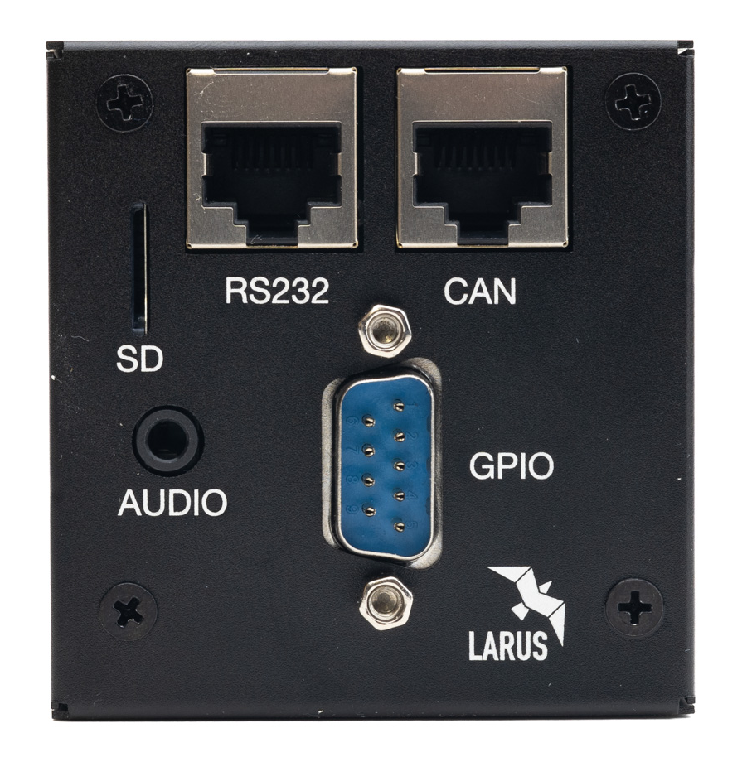

CAN and RS232 Ports
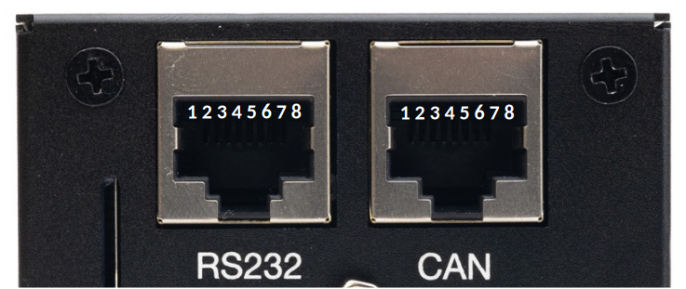
Pin | CAN | RS232
1 | GND (internally connected) | GND (internally connected)
2 | GND (internally connected) | GND (internally connected)
3 | NC | RS232_1_RX
4 | CAN Low | RS232_1_TX
5 | CAN High | NC
6 | NC | NC
7 | VCC [9-28V DC] (internally connected) | VCC [9-28V DC] (internally connected)
8 | VCC [9-28V DC] (internally connected) | VCC [9-28V DC] (internally connected)

GPIO / D-SUB 9
Several other switches, sensors and devices can be connected via the d-sub connector. Please note that not all functions have been implemented at date of release of this manual.
The following sketch shows the view into the male connector of the LARUS Vario Display.
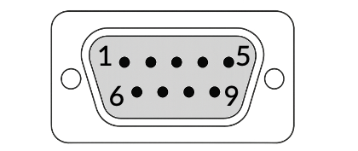
Pin number | Pin name | I/O
1 | GND | (Ground)
2 | DI3 - Gear | Input
3 | DI1 – Water Ballast | Input
4 | DO2 | Output
5 | GND | (Ground)
6 | DI4 – Speed Brakes | Input
7 | DI2 – Speed to Fly | Input
8 | GND | (Ground)
9 | DO1 – Canopy Flasher | Output

For easier pin identification these numbers are also moulded into the female connector (scope of delivery).
After wiring, settings must be made in the LARUS Vario Display.

Audio
An audio socket is available for connecting a loudspeaker with a 3.5 mm jack plug. The internal resistance of the speaker must be between 4-8 Ω (max. output of 3 W @ 8 Ω).
A single loudspeaker must not be connected to more than one device.

SD-Card
The device has an SD card slot for firmware updates.
As SD card extensions can damage the LARUS Vario Display, we do not accept any liability for damage resulting from their use.

Cabling
If a serial connection (RS232) is established between SteFly NAV and LARUS Vario Display, the MC value settings, for example, is synchronised/transferred between the devices. In addition, the LARUS Vario Display processes inputs from a Speed to Fly / Vario switch that is connected directly to the SteFly Remote Control Stick.

The following steps are required:
- Connect devices with cable:
  - The LARUS Sensor Box CAN-port needs to be connected with 1:1 patch cables with the CAN-port of the LARUS VARIO Display (in double seater configurations using the cablebox)
  - The devices running XCSoar can be connected between Vario Display RS232 port and SteFly NAV ttySx port with patch cable RX/TX crossed
- Optionally connect switches for automatic adjustment of water ballast and gear warning to the appropriate DSUB-9 pin and any GND pin. For the gear warning you have the option to use two distinct directly connected switches for the gear and speed brake (recommended) or one cable with the two switches connected in series to the DSUB-9 connector.
- The SteFly Remote Control Stick can be connected in two different ways:
  - if available: with a separate cable to the DSUB-9 pin 7
  - Using the USB-Cable (always available)
- Adjust settings in XCSoar (Version 7.44 or higher) / OpenSoar (7.43 or higher):
  - If the Vario Display is connected directly to the SteFly NAV, select the corresponding ttyS port: Config -> Devices -> select a free line and enter the port, Baud rate 38400, Driver Larus, Sync. to device on
- Adjust settings in LARUS Vario Display settings for the connected optional switches
  - Gear warning
  - water ballast
  - StF Switch configuration (if not automatically switched)
    - Input Pin: To use an external switch (at the control stick, flaps lever etc), set Vario Control to Input Pin and choose the right setting in StF Pin Config (active: when open/closed)
    - NMEA for SteFly Remote Control Stick. In addition to the setting in the vario you need to enable install an event definition file in XCSoar/OpenSoar (Config / System / Look / Language, Input / Events – check Expert, click on Events – Download – GLB-XCI-xcremote-XCNAV.xci). Leave XCSoar config and restart XCSoar.

CAN Termination
LARUS Vario Display and LARUS Sensor Box are connected via CAN. CAN bus networks require termination resistors at each end of the network. Therefore, all units have integrated a switch to activate the resistor:
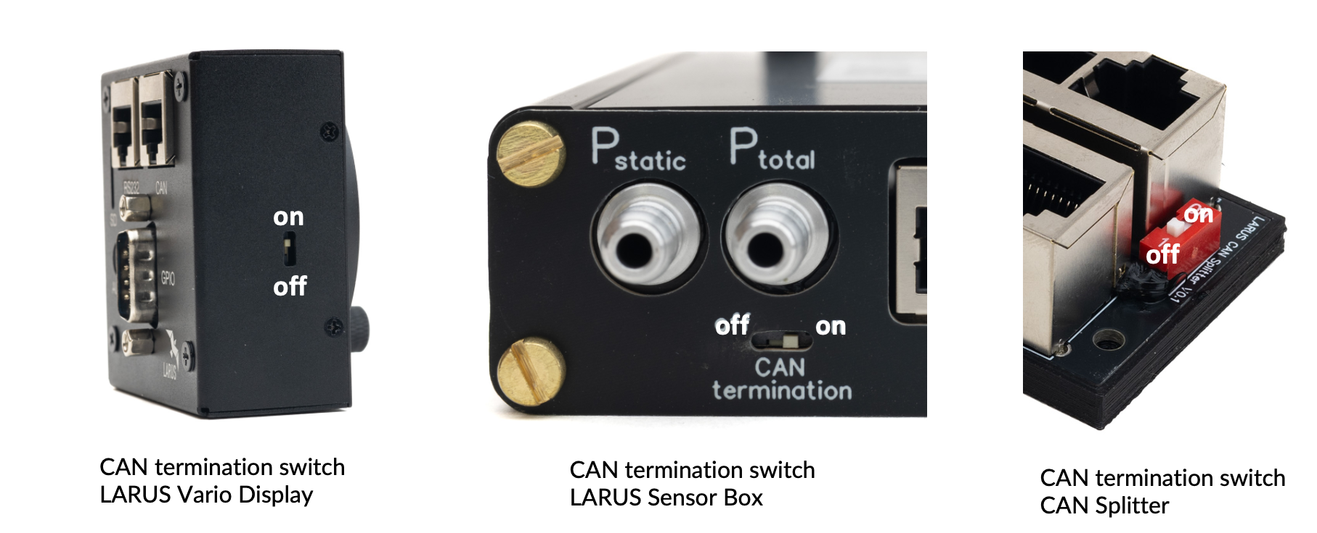
The following table gives examples of how to set the CAN termination switches:
Description | Display front | LARUS box | CAN Splitter | Display rear
Single seater | on | on | - | -
Double seater, LARUS box in front panel | off | on | off | on
Double seater, LARUS box in rear panel | on | on | off | off

Please note: All LARUS Sensor Boxes delivered before March 2025 have no CAN termination switch. CAN termination is always on from default.

Installation
Usually, LARUS Vario Display is powered by LARUS via patch cable between the CAN ports. LARUS needs to be protected by an external fuse (500 mA to max. 3A) like it is common practice for all electric devices in aviation. If LARUS gets its energy from another main instrument (e.g. SteFly NAV via D-Sub connector) please make sure that the main instrument is protected by an external fuse.

Installation Location
The following picture shows a typical installation situation of LARUS Vario Display in the instrument panel of a glider.
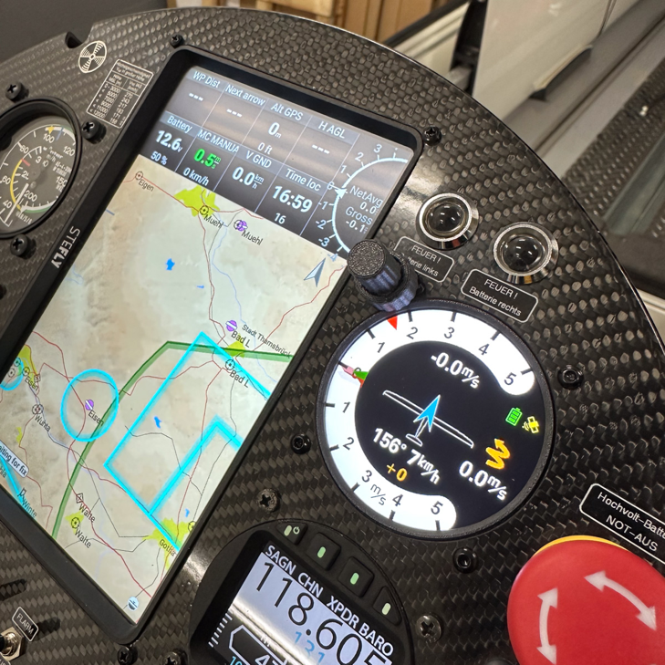

The display fits in a standard 57 mm cutout and is fastened by 3 M3 screws.
For installation it is required to remove the two rotary knobs with a HEX 1,5mm key.
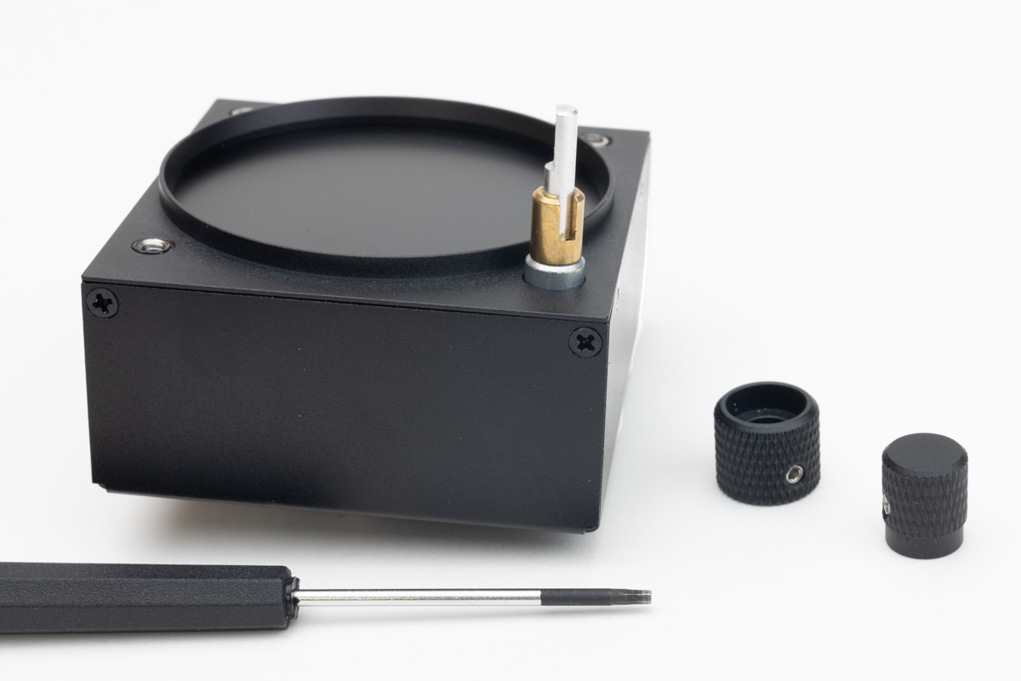

Installation Orientation
If you intend to replace an existing instrument with the Lars Vario Display, check the desired installation position before drilling the 7.3 mm hole for the rotary encoder due to the asymmetrical housing to the display
The display can be mounted in the orientations 0° / 90° / 180° / 270°.
After mounting the display, its orientation needs to be configured in the menu Display Rotation.

Initial Operation and Function Test
For initial operation please follow these steps:
- Check that the LARUS Vario Display is connected to LARUS Sensor Box or CAN Splitter according to the drawings in chapter 4.2
- Power on LARUS
- Check that LARUS Vario Displays boots and a yellow or green satellite pictogram appears. The vario pointers should perform slight movements around zero position.

Firmware Updates
The LARUS team is continuously improving the software and releasing updates e.g. on LARUS Vario Display web page.
To update the firmware, put the new .bin-file on the SD card included in scope of delivery and insert it into the SD-card slot of LARUS Vario Display. The device will only install compatible firmware releases greater than the release installed. After powering on, the device is booting within less than a second. If a compatible firmware is detected on the SD Card, the display keeps black for about 3-5 seconds before displaying the a Firmware Upgrade is in process. Afterwards the name of the new firmware version will appear.
If the update is not initialised after powering on the device with an inserted SD card containing a new firmware release, please use a different SD card.
Requirements for the SD card: min. 4 GB SDHC, FAT32 format (not GPT)

Operation

Display
The Central Display Information distinguishes between Circling Mode and Straight Flight Mode. If a turn rate of at least 1°/sec is observed for more than 10 seconds Circling mode is activated. If the turn rate is less than this value for more than 10 seconds it is switched back to Straight Flight Mode.
This behaviour cannot be adjusted with the current firmware versions.
Switching from Variometer Mode to Speed To Fly Mode is independent from switching the central display information.
For details see chapter Switching from Circling (Vario) to Speed to Fly.

Circling Mode

Info 1: The parameter show is defined in Info 1 Content.
Data Quality: The colour of the symbol indicates:
- Red: no connection to LARUS Sensor Unit
- Yellow: connection to LARUS Sensor Unit established, Unit has no GPS-Fix
- Green: connection to LARUS Sensor Unit established. Unit has GPS-Fix
Battery symbol: The colour of the symbol indicates:
- Green: Voltage of the battery is above Battery Good
- Yellow: Voltage of the battery is below Battery Good
- Red: Voltage of the battery is below Battery Low
Average Climb in Thermal: The average climb rate since starting circling.
Info 2: The parameter shown is defined in Info 2 Content.
Current Climb Rate: Time Constant can be changed in Sensor Unit settings Vario TC.
Average Climb (TC): The average climb rate in the timespan defined in the TC Climb Rate.
Center Circling Info: Select a Wind or Thermaling Assistance view in Center Circling.

Straight Flight Mode

Displays that differ from Circling Mode:
Center Straight Info: Select one of two available graphical representations
StF Command Band: The position of the band shows whether you are flying too fast or too slowly. Positive values mean you are flying too fast and negative values mean you are flying too slow. The length of the tape tells you by how much. 1 m/s corresponds to 10 km/h.
Last Average Climb (TC): The green indicator for the average climb rate is showing the value for the last thermal. The value is not updated until the next switch from speed to fly to vario.

Available Central Displays

Central Displays in Circling Mode
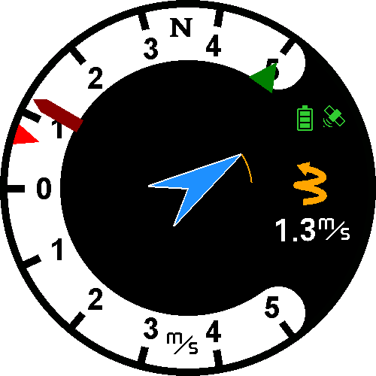
- Single Arrow
The current wind direction is represented by one central arrow. The arrow size is proporional to the wind speed. Changes of the wind direction to a mid term average direction is show by a trailing vane, changes in wind speed to the mid term average speed is represented by the vane’s width.
The arrow direction is related to North.
- Double Arrow
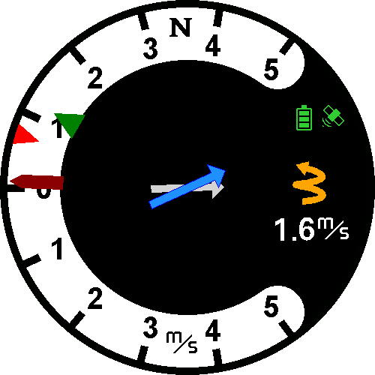
Current wind direction and speed is represented by the blue arrow, information related to mid term wind is shown by the grey arrow in the background. Arrow sizes depend on the wind speed.
The arrow directions are related to North.
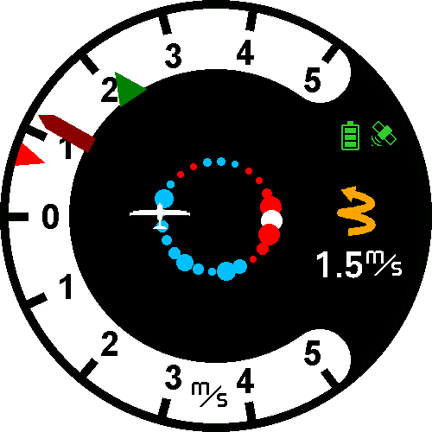
- Dotted Assistant
Meaning of the colours of the circle points:
  - Blue: climb rate is below the average
  - Red: climb rate is about the average
  - White/Yellow: climb rate is above the average
The diameter of the dots is proportional to the climb rate.
- Spider Assistant
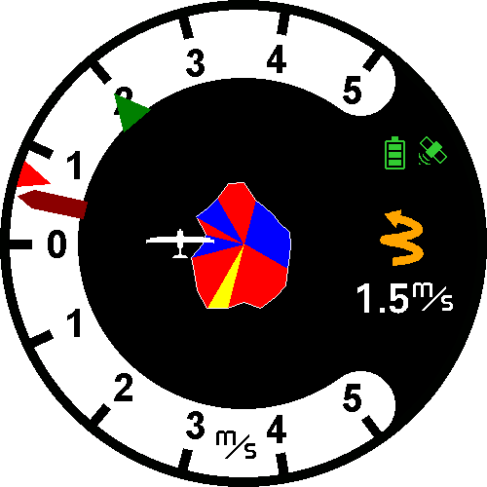
Meaning of the segment colours:
  - Blue: climb rate is below the average
  - Red: climb rate is about the average
  - Yellow: climb rate is above the average
The diameter of the segment is proportional to the climb rate.

Central Displays in Straight Flight Mode
- Single Arrow
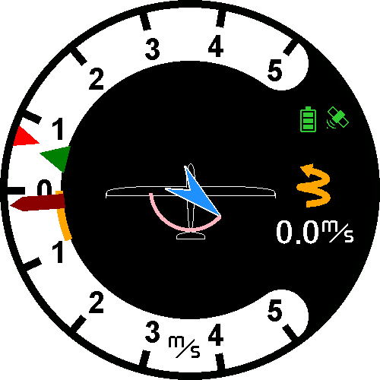
The current wind direction is represented by one central arrow. The arrow size is proporional to the wind speed. Changes of the wind direction to a mid term average direction is show by a trailing vane, changes in wind speed to the mid term average speed is represented by the vane’s width.
The arrow direction is related to the airplanes longitudinal axis. It is advisable to keep the airplane symbol shown (on) in StF Mode in order to support this details.
- Double Arrow
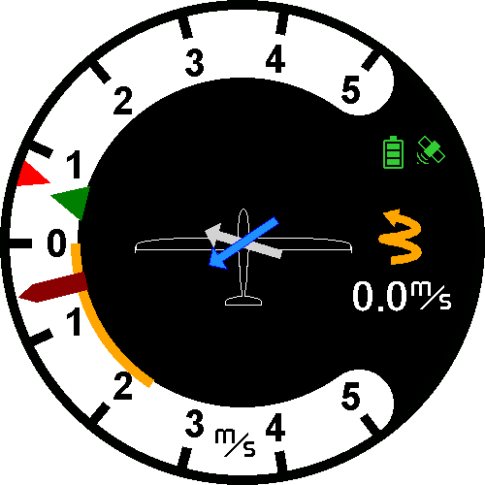
Current wind direction and speed is represented by the blue arrow, information related to mid term wind is shown by the grey arrow in the background. Arrow sizes depend on the wind speed.
The arrow direction is related to the airplanes longitudinal axis. It is advisable to keep the airplane symbol shown in StF Mode in order to support this details.

Switching from Circling (Vario) to Speed to Fly
Switching the tone information from Speed to Fly to Vario is depending on your Vario Control configuration:
  - Auto: below 1.1 times speed of best glide ratio: Vario mode, above: Speed To Fly mode. If in Vario mode and still circling, Vario mode keeps active even this speed limit is exceeded.
  - Input Pin: To use an external switch (at the control stick, flaps lever etc)
  - SteFly Remote Control Stick

Acoustic Quiet Zone in Speed to Fly Mode.
You can define a speed range in which the acoustic Speed To Fly signal is quiet. Set the desired values in StF Upper/Lower Limit in the LARUS Vario Displays advanced settings.

Control Elements
The device has 2 rotary knobs and a push button that can be used to make various settings.
The following functions are assigned to the button and the two rotary knobs:
- Turn the small/upper rotary knob: Volume control
- Turn the large/lower rotary knob: Set the Ma￹cCready￹￹ value
- Short press on the rotary knob: Menu for common settings
- Long press on the rotary knob: Menu for configuration settings of the LARUS Vario Display, configuration and calibration of LARUS Sensor Unit.
The following two chapters show the menu structure of the LARUS Vario. Details on the submenu items are documented in the subsequent chapters..

Short Press Menu Structure
    - Water Ballast
Set the current value for the amount of water ballast. The entered value is propagated to XCSoar/OpenSoar.
    - Bugs
Set the fly correction factor in percent to adjust the polar values to the contamination situation of the wing.
    - Pilot Weight
Enter the pilots weight in kg for the area load calculation.
    - Display
Use this option to change between Vario and AHRS display.

Long Press Menu Structure
Views
‍  ‍  ‍  ‍  ‍  ‍  ‍  ‍  ‍  ‍  ‍  ‍  ‍  ‍  ‍  ‍  ‍  ‍  ‍ | Info 1 Content
‍  ‍  ‍  ‍  ‍  ‍  ‍  ‍  ‍  ‍  ‍  ‍  ‍  ‍  ‍  ‍  ‍  ‍  ‍ |  | None
‍  ‍  ‍  ‍  ‍  ‍  ‍  ‍  ‍  ‍  ‍  ‍  ‍  ‍  ‍  ‍  ‍  ‍  ‍ |  | Avg Climb Rate
‍  ‍  ‍  ‍  ‍  ‍  ‍  ‍  ‍  ‍  ‍  ‍  ‍  ‍  ‍  ‍  ‍  ‍  ‍ |  | Drift Angle
‍  ‍  ‍  ‍  ‍  ‍  ‍  ‍  ‍  ‍  ‍  ‍  ‍  ‍  ‍  ‍  ‍  ‍  ‍ |  | Flight Level
‍  ‍  ‍  ‍  ‍  ‍  ‍  ‍  ‍  ‍  ‍  ‍  ‍  ‍  ‍  ‍  ‍  ‍  ‍ |  | Speed To Fly
‍  ‍  ‍  ‍  ‍  ‍  ‍  ‍  ‍  ‍  ‍  ‍  ‍  ‍  ‍  ‍  ‍  ‍  ‍ |  | True Air Speed
‍  ‍  ‍  ‍  ‍  ‍  ‍  ‍  ‍  ‍  ‍  ‍  ‍  ‍  ‍  ‍  ‍  ‍  ‍ |  | True Course
‍  ‍  ‍  ‍  ‍  ‍  ‍  ‍  ‍  ‍  ‍  ‍  ‍  ‍  ‍  ‍  ‍  ‍  ‍ |  | UTC Time
‍  ‍  ‍  ‍  ‍  ‍  ‍  ‍  ‍  ‍  ‍  ‍  ‍  ‍  ‍  ‍  ‍  ‍  ‍ | Info 2 Content
‍  ‍  ‍  ‍  ‍  ‍  ‍  ‍  ‍  ‍  ‍  ‍  ‍  ‍  ‍  ‍  ‍  ‍  ‍ |  | Same options as Info 1 Content
‍  ‍  ‍  ‍  ‍  ‍  ‍  ‍  ‍  ‍  ‍  ‍  ‍  ‍  ‍  ‍  ‍  ‍  ‍ |  | Wind, avg Wind
‍  ‍  ‍  ‍  ‍  ‍  ‍  ‍  ‍  ‍  ‍  ‍  ‍  ‍  ‍  ‍  ‍  ‍  ‍ |  | Wind and Delta
‍  ‍  ‍  ‍  ‍  ‍  ‍  ‍  ‍  ‍  ‍  ‍  ‍  ‍  ‍  ‍  ‍  ‍  ‍ | Center Circling
‍  ‍  ‍  ‍  ‍  ‍  ‍  ‍  ‍  ‍  ‍  ‍  ‍  ‍  ‍  ‍  ‍  ‍  ‍ |  | Single Arrow
‍  ‍  ‍  ‍  ‍  ‍  ‍  ‍  ‍  ‍  ‍  ‍  ‍  ‍  ‍  ‍  ‍  ‍  ‍ |  | Spider Assistant
‍  ‍  ‍  ‍  ‍  ‍  ‍  ‍  ‍  ‍  ‍  ‍  ‍  ‍  ‍  ‍  ‍  ‍  ‍ |  | Dotted Assistant
‍  ‍  ‍  ‍  ‍  ‍  ‍  ‍  ‍  ‍  ‍  ‍  ‍  ‍  ‍  ‍  ‍  ‍  ‍ |  | Spider Assistant
‍  ‍  ‍  ‍  ‍  ‍  ‍  ‍  ‍  ‍  ‍  ‍  ‍  ‍  ‍  ‍  ‍  ‍  ‍ | Center Straight
‍  ‍  ‍  ‍  ‍  ‍  ‍  ‍  ‍  ‍  ‍  ‍  ‍  ‍  ‍  ‍  ‍  ‍  ‍ |  | Single Arrow
‍  ‍  ‍  ‍  ‍  ‍  ‍  ‍  ‍  ‍  ‍  ‍  ‍  ‍  ‍  ‍  ‍  ‍  ‍ |  | Double Arrow
‍  ‍  ‍  ‍  ‍  ‍  ‍  ‍  ‍  ‍  ‍  ‍  ‍  ‍  ‍  ‍  ‍  ‍  ‍ | Display Rotation
‍  ‍  ‍  ‍  ‍  ‍  ‍  ‍  ‍  ‍  ‍  ‍  ‍  ‍  ‍  ‍  ‍  ‍  ‍ |  | Rotate 0°/90°/180°/270°
‍  ‍  ‍  ‍  ‍  ‍  ‍  ‍  ‍  ‍  ‍  ‍  ‍  ‍  ‍  ‍  ‍  ‍  ‍ | Glider Symbol
‍  ‍  ‍  ‍  ‍  ‍  ‍  ‍  ‍  ‍  ‍  ‍  ‍  ‍  ‍  ‍  ‍  ‍  ‍ |  | On / Off
‍Advanced
‍‍  ‍  ‍  ‍‍  ‍  ‍  ‍  ‍  ‍  ‍ | User Profile  The Vario currently supports four different user-specific settings. The settings are completely independent of each other. All settings must be repeated in each of the user profiles manually, including aircraft polar and pin configurations of the switches.  When selecting a user profile, the device will be restarted with this profile.
‍‍  ‍  ‍  ‍‍  ‍  ‍  ‍  ‍  ‍  ‍ |  | User Profile 1
‍‍  ‍  ‍  ‍‍  ‍  ‍  ‍  ‍  ‍  ‍ |  | User Profile 2
‍‍  ‍  ‍  ‍‍  ‍  ‍  ‍  ‍  ‍  ‍ |  | User Profile 3
‍‍  ‍  ‍  ‍‍  ‍  ‍  ‍  ‍  ‍  ‍ |  | User Profile 4
‍‍  ‍  ‍  ‍‍  ‍  ‍  ‍  ‍  ‍  ‍ | Center Frequency  Select the centre frequency for 0 m/s (500-1000 Hz).
‍‍  ‍  ‍  ‍‍  ‍  ‍  ‍  ‍  ‍  ‍ | Battery Good  Set the voltage value below which the battery symbol is shown in yellow
‍‍  ‍  ‍  ‍‍  ‍  ‍  ‍  ‍  ‍  ‍ | Battery Low  Set the voltage value below which the battery symbol is shown in red
‍‍  ‍  ‍  ‍‍  ‍  ‍  ‍  ‍  ‍  ‍ | Flash Control  Depending on the setting Activ: open/close: connects or opens D-SUB9 DO1 Pin to GND when the sensor measures more than 40 km/h IAS
‍‍  ‍  ‍  ‍‍  ‍  ‍  ‍  ‍  ‍  ‍ |  | Not connected
‍‍  ‍  ‍  ‍‍  ‍  ‍  ‍  ‍  ‍  ‍ |  | Active: close
‍‍  ‍  ‍  ‍‍  ‍  ‍  ‍  ‍  ‍  ‍ |  | Active: open
‍‍  ‍  ‍  ‍‍  ‍  ‍  ‍  ‍  ‍  ‍ | Config Reset
‍‍  ‍  ‍  ‍‍  ‍  ‍  ‍  ‍  ‍  ‍ |  | Default Config  Resets the settings of the current user profile to default values. The airplane polar data is not been touched. The reset includes the configuration of the input and output pins.
‍‍  ‍  ‍  ‍‍  ‍  ‍  ‍  ‍  ‍  ‍ |  | Factory Reset  Resets all user profiles including the airplane polar data to factory settings.
‍‍  ‍  ‍  ‍‍  ‍  ‍  ‍  ‍  ‍  ‍ |  | Do not change
‍‍  ‍  ‍  ‍‍  ‍  ‍  ‍  ‍  ‍  ‍ | Average Climb Rate
‍‍  ‍  ‍  ‍‍  ‍  ‍  ‍  ‍  ‍  ‍ |  | Average Climb Source
‍‍  ‍  ‍  ‍‍  ‍  ‍  ‍  ‍  ‍  ‍ |  |  | Frontend
‍‍  ‍  ‍  ‍‍  ‍  ‍  ‍  ‍  ‍  ‍ |  |  | Sensorbox
‍‍  ‍  ‍  ‍‍  ‍  ‍  ‍  ‍  ‍  ‍ |  | TC Climb Rate
‍‍  ‍  ‍  ‍‍  ‍  ‍  ‍  ‍  ‍  ‍ | Speed to Fly
‍‍  ‍  ‍  ‍‍  ‍  ‍  ‍  ‍  ‍  ‍ |  | TC Speed To Fly
‍‍  ‍  ‍  ‍‍  ‍  ‍  ‍  ‍  ‍  ‍ |  | Vario Control
‍‍  ‍  ‍  ‍‍  ‍  ‍  ‍  ‍  ‍  ‍ |  |  | Auto
‍‍  ‍  ‍  ‍‍  ‍  ‍  ‍  ‍  ‍  ‍ |  |  | Input Pin
‍‍  ‍  ‍  ‍‍  ‍  ‍  ‍  ‍  ‍  ‍ |  |  | NMEA
‍‍  ‍  ‍  ‍‍  ‍  ‍  ‍  ‍  ‍  ‍ |  | StF Pin Config
‍‍  ‍  ‍  ‍‍  ‍  ‍  ‍  ‍  ‍  ‍ |  |  | Not configured
‍‍  ‍  ‍  ‍‍  ‍  ‍  ‍  ‍  ‍  ‍ |  |  | when opened
‍‍  ‍  ‍  ‍‍  ‍  ‍  ‍  ‍  ‍  ‍ |  |  | when closed
‍‍  ‍  ‍  ‍‍  ‍  ‍  ‍  ‍  ‍  ‍ |  |  | when toggled
‍‍  ‍  ‍  ‍‍  ‍  ‍  ‍  ‍  ‍  ‍ |  | StF Upper Limit
‍‍  ‍  ‍  ‍‍  ‍  ‍  ‍  ‍  ‍  ‍ |  | StF Lower Limit
‍‍  ‍  ‍  ‍‍  ‍  ‍  ‍  ‍  ‍  ‍ | Gear Alarm
‍‍  ‍  ‍  ‍‍  ‍  ‍  ‍  ‍  ‍  ‍ |  | Alarm Volume
‍‍  ‍  ‍  ‍‍  ‍  ‍  ‍  ‍  ‍  ‍ |  | Gear Alarm Config
‍‍  ‍  ‍  ‍‍  ‍  ‍  ‍  ‍  ‍  ‍ |  |  |  | One Pin Mode
‍‍  ‍  ‍  ‍‍  ‍  ‍  ‍  ‍  ‍  ‍ |  |  |  | Two Pin Mode
‍‍  ‍  ‍  ‍‍  ‍  ‍  ‍  ‍  ‍  ‍ |  | Gear Pin Config
‍‍  ‍  ‍  ‍‍  ‍  ‍  ‍  ‍  ‍  ‍ |  | ‍ | When opened
‍‍  ‍  ‍  ‍‍  ‍  ‍  ‍  ‍  ‍  ‍ |  | ‍ | When closed
‍‍  ‍  ‍  ‍‍  ‍  ‍  ‍  ‍  ‍  ‍ |  | ‍ | Not connected
‍‍  ‍  ‍  ‍‍  ‍  ‍  ‍  ‍  ‍  ‍ |  | Air Brakes Pin Config
‍‍  ‍  ‍  ‍‍  ‍  ‍  ‍  ‍  ‍  ‍ |  | ‍ | When opened
‍‍  ‍  ‍  ‍‍  ‍  ‍  ‍  ‍  ‍  ‍ |  | ‍ | When closed
‍‍  ‍  ‍  ‍‍  ‍  ‍  ‍  ‍  ‍  ‍ |  | ‍ | Not connected
‍‍  ‍  ‍  ‍‍  ‍  ‍  ‍  ‍  ‍  ‍ | Drain Control
‍‍  ‍  ‍  ‍‍  ‍  ‍  ‍  ‍  ‍  ‍ |  | Drain Pin Config
‍‍  ‍  ‍  ‍‍  ‍  ‍  ‍  ‍  ‍  ‍ |  |  | When opened
‍‍  ‍  ‍  ‍‍  ‍  ‍  ‍  ‍  ‍  ‍ |  |  | When closed
‍‍  ‍  ‍  ‍‍  ‍  ‍  ‍  ‍  ‍  ‍ |  |  | Not connected
‍‍  ‍  ‍  ‍‍  ‍  ‍  ‍  ‍  ‍  ‍ |  | Lowest Flow  Value in Liters/Minute
‍‍  ‍  ‍  ‍‍  ‍  ‍  ‍  ‍  ‍  ‍ |  | Flow Slope  time based correction value
‍ | Return
‍
Polar Settings
‍‍  ‍‍  ‍‍  ‍‍  ‍‍  ‍‍  ‍‍  ‍‍  ‍‍  ‍‍  ‍‍ | Glider
‍‍  ‍‍  ‍‍  ‍‍  ‍‍  ‍‍  ‍‍  ‍‍  ‍‍  ‍‍  ‍‍ | Empty Mass
‍‍  ‍‍  ‍‍  ‍‍  ‍‍  ‍‍  ‍‍  ‍‍  ‍‍  ‍‍  ‍‍ | Max Ballast
‍‍  ‍‍  ‍‍  ‍‍  ‍‍  ‍‍  ‍‍  ‍‍  ‍‍  ‍‍  ‍‍ | Reference Weight
‍‍  ‍‍  ‍‍  ‍‍  ‍‍  ‍‍  ‍‍  ‍‍  ‍‍  ‍‍  ‍‍ | Polar V1
‍‍  ‍‍  ‍‍  ‍‍  ‍‍  ‍‍  ‍‍  ‍‍  ‍‍  ‍‍  ‍‍ | Polar V2
‍‍  ‍‍  ‍‍  ‍‍  ‍‍  ‍‍  ‍‍  ‍‍  ‍‍  ‍‍  ‍‍ | Polar V3
‍‍  ‍‍  ‍‍  ‍‍  ‍‍  ‍‍  ‍‍  ‍‍  ‍‍  ‍‍  ‍‍ | Polar Si1
‍‍  ‍‍  ‍‍  ‍‍  ‍‍  ‍‍  ‍‍  ‍‍  ‍‍  ‍‍  ‍‍ | Polar Si2
‍‍  ‍‍  ‍‍  ‍‍  ‍‍  ‍‍  ‍‍  ‍‍  ‍‍  ‍‍  ‍‍ | Polar Si3
‍‍  ‍‍  ‍‍  ‍‍  ‍‍  ‍‍  ‍‍  ‍‍  ‍‍  ‍‍  ‍‍ | Return
‍Sensorbox
‍‍  ‍  ‍  ‍  ‍  ‍  ‍  ‍  ‍  ‍  ‍  ‍  ‍  ‍  ‍  ‍ | Left Wing Down
‍‍  ‍  ‍  ‍  ‍  ‍  ‍  ‍  ‍  ‍  ‍  ‍  ‍  ‍  ‍  ‍ | Right Wing Down
‍‍  ‍  ‍  ‍  ‍  ‍  ‍  ‍  ‍  ‍  ‍  ‍  ‍  ‍  ‍  ‍ | Wings Straight
‍‍  ‍  ‍  ‍  ‍  ‍  ‍  ‍  ‍  ‍  ‍  ‍  ‍  ‍  ‍  ‍ | Calc Orientation
‍‍  ‍  ‍  ‍  ‍  ‍  ‍  ‍  ‍  ‍  ‍  ‍  ‍  ‍  ‍  ‍ | Straight Flight
‍‍  ‍  ‍  ‍  ‍  ‍  ‍  ‍  ‍  ‍  ‍  ‍  ‍  ‍  ‍  ‍ | Reset Sensorbox
‍‍  ‍  ‍  ‍  ‍  ‍  ‍  ‍  ‍  ‍  ‍  ‍  ‍  ‍  ‍  ‍ | Ini Settings
‍‍  ‍  ‍  ‍  ‍  ‍  ‍  ‍  ‍  ‍  ‍  ‍  ‍  ‍  ‍  ‍ | ‍  ‍  ‍  ‍  ‍  ‍  ‍  ‍ | Sensor Tilt Roll  Rotation from Sensor System to air frame system. Normaly: do not change
‍‍  ‍  ‍  ‍  ‍  ‍  ‍  ‍  ‍  ‍  ‍  ‍  ‍  ‍  ‍  ‍ | ‍  ‍  ‍  ‍  ‍  ‍  ‍  ‍ | ‍Sensor Tilt Pitch  Rotation from Sensor System to air frame system. Normaly: do not change
‍‍  ‍  ‍  ‍  ‍  ‍  ‍  ‍  ‍  ‍  ‍  ‍  ‍  ‍  ‍  ‍ | ‍  ‍  ‍  ‍  ‍  ‍  ‍  ‍ | ‍Sensor Tilt Yaw  Rotation from Sensor System to air frame system. Normaly: do not change
‍‍  ‍  ‍  ‍  ‍  ‍  ‍  ‍  ‍  ‍  ‍  ‍  ‍  ‍  ‍  ‍ | ‍  ‍  ‍  ‍  ‍  ‍  ‍  ‍ | ‍Pitot Offset  Zero pressure reading of the pitot sensor. Normally: no need to change it.
‍‍  ‍  ‍  ‍  ‍  ‍  ‍  ‍  ‍  ‍  ‍  ‍  ‍  ‍  ‍  ‍ | ‍  ‍  ‍  ‍  ‍  ‍  ‍  ‍ | Pitot Span‍  Calibrated airspeed fine adjustment. Normally: no need to change it.
‍‍  ‍  ‍  ‍  ‍  ‍  ‍  ‍  ‍  ‍  ‍  ‍  ‍  ‍  ‍  ‍ | ‍  ‍  ‍  ‍  ‍  ‍  ‍  ‍ | ‍QNH Delta  Abolute pressure sensor fine adjustment. Normally no need to change it.
‍‍  ‍  ‍  ‍  ‍  ‍  ‍  ‍  ‍  ‍  ‍  ‍  ‍  ‍  ‍  ‍ | ‍  ‍  ‍  ‍  ‍  ‍  ‍  ‍ | ‍Mag Auto Calib  Set to „1“. Do not change.
‍‍  ‍  ‍  ‍  ‍  ‍  ‍  ‍  ‍  ‍  ‍  ‍  ‍  ‍  ‍  ‍ | ‍  ‍  ‍  ‍  ‍  ‍  ‍  ‍ | ‍Vario TC  Variometer damping fine adjustment. Useful range: 0.5 … 3 seconds.
‍‍  ‍  ‍  ‍  ‍  ‍  ‍  ‍  ‍  ‍  ‍  ‍  ‍  ‍  ‍  ‍ | ‍  ‍  ‍  ‍  ‍  ‍  ‍  ‍ | ‍Vario Avg TC  Average variometer time constant. Default 30 seconds, maybe adjusted.
‍‍  ‍  ‍  ‍  ‍  ‍  ‍  ‍  ‍  ‍  ‍  ‍  ‍  ‍  ‍  ‍ | ‍  ‍  ‍  ‍  ‍  ‍  ‍  ‍ | Wind TC  Wind speed damping time constant. Usually set to 1 .. 10 seconds.
‍‍  ‍  ‍  ‍  ‍  ‍  ‍  ‍  ‍  ‍  ‍  ‍  ‍  ‍  ‍  ‍ | ‍  ‍  ‍  ‍  ‍  ‍  ‍  ‍ | Wind Avg TC  Average wind speed time constant. Default 30 seconds, maybe adjusted.
‍‍  ‍  ‍  ‍  ‍  ‍  ‍  ‍  ‍  ‍  ‍  ‍  ‍  ‍  ‍  ‍ | ‍  ‍  ‍  ‍  ‍  ‍  ‍  ‍ | GNSS Config  Larus Essential: 1  Larus Dual GNSS: 2
‍‍  ‍  ‍  ‍  ‍  ‍  ‍  ‍  ‍  ‍  ‍  ‍  ‍  ‍  ‍  ‍ | ‍  ‍  ‍  ‍  ‍  ‍  ‍  ‍ | Ant Base Len  DGNSS version only: Distance between Front and Rear GNSS Antenna in meter.
‍‍  ‍  ‍  ‍  ‍  ‍  ‍  ‍  ‍  ‍  ‍  ‍  ‍  ‍  ‍  ‍ | ‍  ‍  ‍  ‍  ‍  ‍  ‍  ‍ | Ant Slave Down (currrently named Ant Slave Lend)  Vertical Distance between front antenna to rear antenna in normal flight attitude, Unit of measurement: Meter. Positiv if front antenna is lower than rear antenna.
‍‍  ‍  ‍  ‍  ‍  ‍  ‍  ‍  ‍  ‍  ‍  ‍  ‍  ‍  ‍  ‍ | ‍  ‍  ‍  ‍  ‍  ‍  ‍  ‍ | Ant Slave Right  Horizontall distance between front antenna and rear antenna. Unit of measurement: Meter, positiv if front antenna is more right than the rear antenna.
‍‍  ‍  ‍  ‍  ‍  ‍  ‍  ‍  ‍  ‍  ‍  ‍  ‍  ‍  ‍  ‍ | ‍  ‍  ‍  ‍  ‍  ‍  ‍  ‍ | Return
‍‍  ‍  ‍  ‍  ‍  ‍  ‍  ‍  ‍  ‍  ‍  ‍  ‍  ‍  ‍  ‍ | Return

Configuration

Glider Polar
In order to get the right Speed to Fly information you have to select or edit the right polar values for your glider. All glider polars available in XCSoar/OpenSoar have been imported into the LARUS Vario. Select the right one in Settings / Polar Settings / Glider.
After selecting the glider you should update the empty mass of your glider.
If you do not find your glider in the list, you can select any glider polar and change the single settings to the values of your gliders polar. You can currently not change the gliders name.
Every time you enter the glider list in polar settings all values you may have changed before are replaced by the selected gliders hard coded values.

Calibrating The Larus Senor Box
Before you start your first flight, you should calibrate the position sensor of the Larus sensor.
The individual calibration steps can be carried out using functions in the front end (minimum firmware versions required: sensor box: 0.5.1, vario: 0.3.7). Calibration is performed in two sections.

Calibration on the Ground (Roll Angle)
Assemble your glider, place it on a flat surface. After taking the individual positions, wait until vibrations in the aircraft can no longer be felt before initiating the measurement.
Do not use a tail dolly in order to fix the vertical axis of your glider during the following operations.

Left Wing
Place the left-hand tip of the wing on the surface. Invoke the function Settings / Sensorbox / Left Wing down.

Right Wing
Place the left-hand tip of the wing on the surface. Invoke the function Settings / Sensorbox / Right Wing down.

Level Wings
Keep the wing horizontal. Invoke the function Setting / Sensorbox / Wings straight

Calculate Roll Angle Sensor Values
For this step it is important to carry out all three steps mentioned before. The order of the steps does not matter, but they must have been completed in full.
Invoke the function Settings / Sensorbox / Calculate Orientation

Calibration During Flight (Pitch Angle)
The pitch angle calibration is performed during flight. It is advisable to perform this step in a flight not disturbed by thermal gusts.
Level your glider out at the speed of the best glide ratio (if you have flaps, with flaps setted for this speed). Invoke Settings / Sensorbox / Straight Flight.
Now you are done. You can check the calibration by swithing to the AHRS Display.

Maintenance
The whole system has no serviceable parts.
To obtain warranty service, please SteFly directly.
Opening the housing of LARUS Vario Display will void the warranty!

Troubleshooting
Problem | Possible Causes | Solution
LARUS Vario Display boots, but satellite pictogram is red and vario pointers are fixed | Connection to LARUS CAN port with Rx / Tx crossed patch cable instead of standard 1:1 patch cable | Change the patch cable and use the one supplied in scope of delivery
 | Connection to LARUS via RS232 port | Connect the CAN ports instead

Technical Data

Size | Unit | Value
mass | g | 80
Housing dimensions (without knob) | mm (length x width x height) | 60,5 mm x 63,4 mm x 31,2 mm
input voltage | V DC | via patch cable with RJ45 connector from LARUS Sensor Box or CAN Splitter, 9 – 28 V DC
amperage | mA (@ 13,0 V DC) | 80
interfaces |  | RS232 (x1) - RJ45  CAN (x1) - RJ45  microSD  3,5 mm audio jack
operating temperature | °C | -30 to +60
operating rel. humidity | % | 0 - 95
material housing |  | black anodised aluminium

