
Department of Mechanical & Industrial Engineering
MIE1624H – Introduction to Data Science and Analytics

Course Project
Made by Group 11:

Name | Student ID
Edwardo Bassil | 1010830969
Daniel Roberts | 1005809760
Tiffany Costas | 1005854844
Amreen Imrit | 1005902971
Fatima Shabbeer | 1008713215
MohammadAmir Ahmadian Shahreza | 1011679337

Delivered to:
Dr. Oleksandr Romanko

On date:
2025-03-31

Table of Contents
I. Introduction 2
II. Innovation Approach Across the World 2
1. World leaders’ approach to innovation 2
2. Key lessons for Canada 3
III. Proposal for Canada’s Innovation Strategy 3
1. Policy 1 : Addressing the Commercialization Gap 3
2. Policy 2 : Innovation Tax Advantage 5
3. Policy 3 : Talent Canada Initiative 7
4. Policy 4 : Strategic Energy Infrastructure for Innovation Advancement 8
IV. Conclusion 10
V. References 12
VI. Appendix 13
1. Appendix A-Policy 1 13
2. Appendix B- Policy 2 14
3. Appendix C - Policy 3 17
4. Appendix D- Policy 4 20
5. Appendix E- Chatbot 31

Executive Summary
This report examines Canada’s innovation challenges and outlines a comprehensive strategy to elevate its global competitiveness. Despite a highly educated workforce, Canada ranks 14th on the Global Innovation Index due to low R&D investments, a pronounced commercialization gap, and significant talent drain to more innovation-friendly countries. In contrast, global leaders such as the United States, Singapore, Switzerland, and key East Asian economies have built robust innovation ecosystems through aggressive R&D funding, strategic public–private partnerships, and supportive regulatory environments.
To address these challenges, the report proposes four interrelated policy initiatives:
- Addressing the Commercialization Gap:
While Canada excels in early-stage innovation, a disproportionate focus on initial funding limits progress to later-stage commercialization. The report recommends reallocating innovation funding toward later-stage ventures, incentivizing private-sector R&D with targeted tax credits and matching investment schemes, and leveraging public procurement as a market validation tool to help startups scale and compete internationally.
- Innovation Tax Advantage:
High corporate tax rates and regulatory burdens hinder Canada’s startup ecosystem. The proposed Innovation Tax Advantage policy seeks to reduce these barriers by streamlining regulatory processes, offering tax incentives for R&D and commercialization, and enhancing support for venture capital investments. This approach aims to create a more dynamic, startup-friendly environment that encourages reinvestment in domestic innovation.
- Talent Canada Initiative:
A critical driver of Canada’s innovation deficit is the ongoing brain drain of high-skilled professionals. The Talent Canada Initiative addresses this by proposing competitive wage incentive programs, affordable housing initiatives near key innovation hubs, and streamlined re-entry and global talent attraction programs. These measures are designed to retain domestic talent and attract international experts in sectors such as AI, biotech, and engineering.
- Strategic Energy Infrastructure for Innovation Advancement:
Reliable, cost-effective energy is essential for sustaining high-value, energy-intensive industries. By developing regional energy hubs optimized for sectors like AI computation, biotechnology, and advanced manufacturing, Canada can reduce operational risks and lower production costs. This policy calls for targeted investments in grid modernization and strategic partnerships between federal and provincial governments, ensuring that energy infrastructure supports the nation’s broader innovation goals.
Together, these initiatives aim to transform Canada’s innovation landscape by fostering stronger public–private collaborations, streamlining funding and regulatory mechanisms, and creating a more attractive environment for both domestic and foreign investments. Ultimately, the proposed strategies are designed to reverse current trends, reduce brain drain, and position Canada as a global leader in innovation.

Introduction
Innovation is one of the key drivers of a country’s economic development and global competitiveness. Countries with especially high levels of innovation, such as the United States, Singapore, and Switzerland, often foster vibrant ecosystems that support the growth of world-class companies—like the U.S.’s “Magnificent 7” tech firms, Singapore’s digitally-driven DBS Bank, or Switzerland’s pharmaceutical giant Hoffman-LaRoche. These innovation-driven environments contribute significantly to economic growth, job creation, and the attraction of global talent. However, Canada is struggling to secure a position among the world’s innovation leaders, as reflected in the World Intellectual Property Organization’s Global Innovation Index 2024 (GII), where it ranks 14th out of 20 countries [1]. Despite having a highly educated workforce, Canada struggles in R&D investments and commercialization, as well as slow adoption of new technologies [2]. To make up for the lost ground, this report will aim to summarize the reason behind Canada’s low innovation index and develop a proposal for Canada’s innovation and development strategy with practical steps of implementation. Finally, we built a large language model chatbot allowing users to have a meaningful conversation about Canada’s innovation strategy.

Innovation Approach Across the World
Countries like the United States, China, Japan, Singapore, Switzerland and many others have adopted policies and frameworks allowing them to be at the forefront of R&D investment, commercialization and adoption of cutting-edge technologies. Analyzing those countries’ approach to innovation helped us develop the best practices Canada should adopt and formulate them into policies. Before we analyze what other countries have been exceeding at lets first a visualize the gap that has been forming with Canada through the use of a composite innovation index, details behind methodology found in Appendix D6.

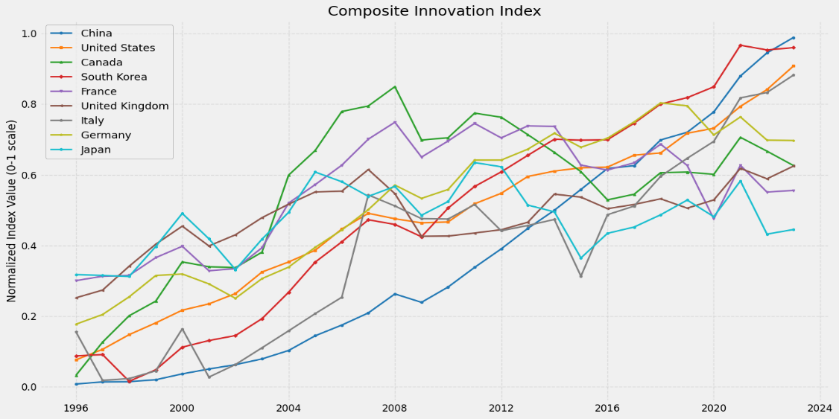
Figure 1: Composite Innovation Index

World leaders’ approach to innovation
The USA dominates global innovation due to its massive private-sector R&D investment, strong venture capital ecosystems, and government-backed initiatives in AI, quantum computing, and defense technologies. Policies such as the CHIPS and Science Act prioritize semiconductor manufacturing, while the National AI Initiative drives AI commercialization [3]. Although the USA ranks 3rd on WIPO’s GII (behind Switzerland and Sweden), it is home to the biggest and most innovative companies in the world like Apple, Microsoft, Nvidia, Alphabet, META and Amazon.

On the European side, the EU’s Horizon Europe (€90B R&D fund) fuels deep-tech innovation—referring to breakthrough technologies rooted in scientific research— while the AI Act and Digital Markets Act regulate emerging technologies. The EU emphasizes green energy, digital transformation, and semiconductor independence [4]. The UK, which ranks 5th on WIPO’s GII, fosters innovation through R&D tax credits, university-industry partnerships, and the Future Fund: Breakthrough to support tech startups with a £375M scale-up fund. The UK prioritizes biotech, fintech, and AI governance leadership [5]. Lastly, Switzerland consistently ranks first in the Global Innovation Index due to an investment of 3.2% of its GDP in R&D, strong university-industry partnerships, and world-class intellectual property protection laws [6].

On the East Asian front, South Korea, which ranks 6th on WIPO’s GII, leads in semiconductors, AI, and digital infrastructure, with $450B invested in chip manufacturing and fast-track regulatory approvals for biotech and AI innovations [7]. Japan ranks one spot ahead of Canada, at 13th on WIPO’s GII, and invests heavily in their Society 5.0 concept—an initiative that envisions a human-centered, technology-integrated society—along with quantum computing, and AI-powered smart cities, with $900B in R&D over five years [8]. Singapore’s Smart Nation strategy integrates AI into public services, high-tech manufacturing, and financial technology, while also advancing university-industry partnerships and initiatives to attract and retain engineering talent [9]. These efforts have contributed to Singapore’s rising position in WIPO’s GII, where it currently sits at 4th in 2024 by taking the lead in terms of number of GII innovation indicators for which it ranks top globally, ranking 1st in the world on 14 out of 78 indicators [1].

Key lessons for Canada
Canada’s overall R&D spending is around 1.7% of GDP, highlighting its lack of investment in that area [1][Appendix D 21]. Canada also struggles at commercialization and adoption of new technologies. For instance, promising academic innovations in biotechnology and clean tech often fail to reach the market due to limited early-stage venture capital and weak university–industry partnerships [10]. Moreover, Canada experiences significant brain-drain of talented innovators to the United States thanks to a more start-up friendly, less regulated environment, as well as a higher earnings potential. This exodus is especially apparent amongst recent software engineering graduates from Canada’s top universities of which two-thirds migrated to the United States [11]. A key point to Canada’s lack of success in innovation is the lack of well-constructed intellectual property laws. Canada must formulate an innovation strategy inspired by Switzerland’s approach of setting an aggressive target of GDP allocation to R&D – who invests 3.2 % of GDP in R&D – and foster industry partnerships to help convert that investment to market-ready products. Canada should also focus on attracting and retaining top experts in trend fields such as AI, quantum computing, energy, and biotech experts by implementing enticing incentives to limit brain-drain to the USA. Finally, Canada must additionally implement targeted strategic energy infrastructure, such as regional high-capacity innovation hubs, to support the energy-intensive sectors driving modern R&D and commercialization.

Proposal for Canada’s Innovation Strategy
Now that Canada’s weak points are identified, we are better equipped to define policies to improve Canada’s innovation strategy. The following subsections develop four recommended policies based on insights from the Global Innovation Index (GII) 2022 & 2024 to help Canada strengthen its innovation ecosystem.

Policy 1 : Addressing the Commercialization Gap
Canada performs well on early-stage innovation metrics and it ranks second in the Organisation for Economic Co-operation and Development (OECD) data for total venture capital (VC) investments [12], and Canadian startups attract competitive levels of early funding leading every nation except the U.S. (Appendix A1(a)). However, these strengths are not translating into global success. Canada has the lowest rate of startups reaching Series B funding or beyond (8.4%) among leading nations as shown Figure 1(a). This stage is critical as it marks the point where a company moves beyond initial validation and begins to scale its business, often requiring substantial capital to expand operations, grow market share, and compete internationally [13]. Patent output also remains modest with Canada ranking only 10th globally as depicted in Figure 1(b).
Figure 2(a) is the percentage allocation of VC investments in early and late stage, showing that the government’s focus on R&D, intellectual property, and patents is misguided. Countries leading in innovation invest a balanced share or focus more in later-stage ventures. Canada, by contrast, disproportionately emphasizes early-stage support by 15%, limiting the growth potential of its most promising firms [12]. Canada should close the gap between early and late-stage or follow the path that other leading countries are taking and emphasize more on late-stage funding. In summary, Canada’s problems are about taking products to market and not that of invention capacity and creating those products in the first place.
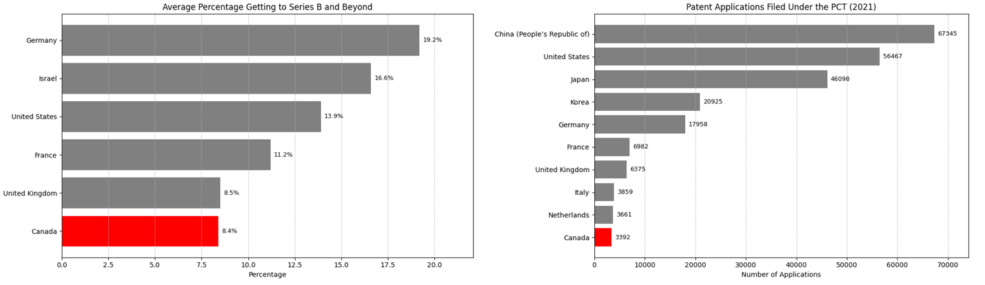
Figure 1: (a) Average percentage of start-up companies getting to Series B and beyond funding per country. [13] (b) Top 10 countries with the highest patent applications filled under the Patent Cooperation Treaty (PCT). [12]
Strategic Reallocation of Innovation Funding
Canada’s innovation spending remains fragmented. The Jenkins Report [14] and the report by Canada’s Advisory Council on Economic Growth [15] both noted the inefficiency of over 60 federal innovation programs operating independently. Although some progress has been made, consolidation is still needed. Reducing administrative overlap and concentrating funds into fewer, larger programs with commercialization mandates would free up significant resources. These could be redirected to late-stage support for companies, which is critical for scaling and international growth.
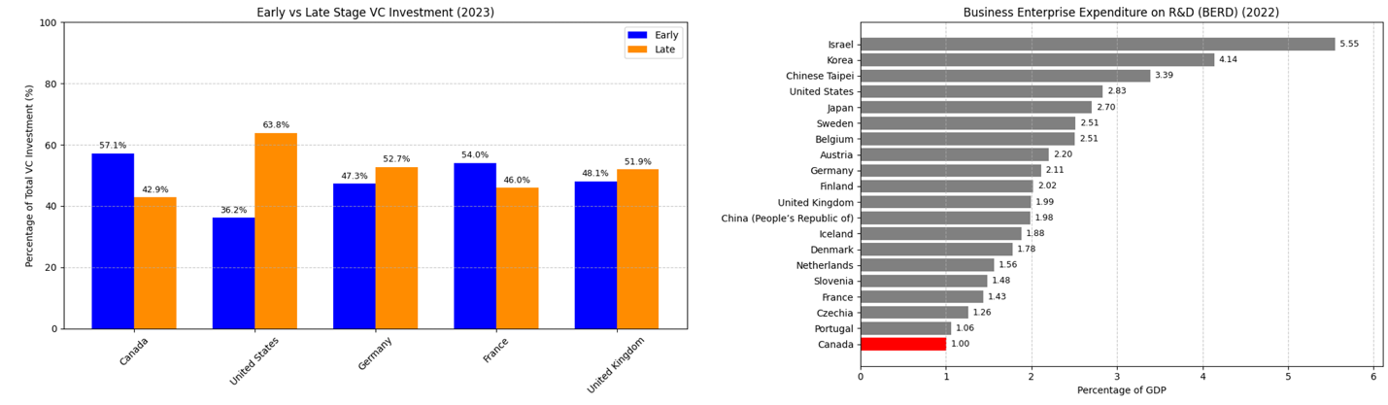
Figure 2: (a) Early-stage and late-stage VC investments’ percentage in 2023 [12]. (b) Top 20 countries with the highest business enterprise expenditure on R&D (BERD)per percentage of GDP in 2022 [12].

Incentivizing Private-Sector R&D
Canada’s Business Expenditure on R&D (BERD) ranks 20th at OECD, with businesses contributing only 1% of GDP [12]. In contrast, countries like Israel and South Korea exceed 3%. Figure 2(b) shows a clear correlation between higher private-sector R&D and stronger commercialization outcomes. To address this, the federal government should introduce targeted tax incentives and matching investment mechanisms to boost private R&D activity. These include R&D tax credits tied to commercialization outcomes, which reward firms not just for conducting research, but for turning it into market-ready solutions. The government can also implement matching investment programs, where a business invests in its own R&D or scale-up efforts and the government matches that investment—either fully or partial—based on the size, sector, or strategic potential of the project. This approach reduces financial risk for firms while ensuring that public funds support ventures with private sector commitment. In addition, revenue-based incentives for firms that increase R&D spending as they grow would promote sustained innovation. Together, these tools would reduce the ecosystem’s reliance on grants and create a more market-responsive innovation environment.

Leveraging Public Procurement for Commercialization
Capital is not the only barrier and scaling also requires customers and credibility. Government procurement can act as a powerful commercialization tool. Programs like Innovative Solutions Canada (ISC), modeled on the U.S. Small Business Innovation Research (SBIR), have demonstrated high returns—generating over $3 in GDP and $1.40 in tax revenue for every $1 invested. Yet ISC funding has declined in recent budgets [16]. Expanding such programs, especially with mandates for late-stage firms, would offer promising Canadian companies meaningful market validation and early revenue.
Mandating federal departments to allocate a portion of procurement budgets to innovative Canadian firms—particularly those at the scale-up stage—would provide early market access and credibility. Departments should also be encouraged to prioritize procurement from qualified domestic innovators where feasible, especially in strategic sectors such as clean technology, digital services, and health innovation.

Policy 2 : Innovation Tax Advantage
Canada’s high regulatory burden and corporate tax rates discourages startups and high-growth companies from establishing operations domestically, resulting in a brain-drain of ideas and startups to the USA. To create a more competitive business environment, the group advises the government to introduce the Innovation Tax Advantage (ITA) policy, aimed at reducing barriers for startups, scaling companies, and high-tech industries.
Despite having comparable success and failure rates to the U.S., Canada’s startup ecosystem remains much smaller, with only about 5,000 startups compared to over 80,000 in the U.S based on current 2025 data from Startup Ranking [17](Appendix Figure B1). Moreover, the number of most current unicorns for Canada is less than 30 while the US has around 780 (Appendix Figure B2) suggesting that external pressure, such as bureaucratic delays, inability to bring product to market and an unfavorable tax climate, hamper growth in Canada [18] [19]. Data from Startup Ranking indicate that these challenges are compounded by a risk-averse culture, with surveys by the Global Entrepreneurship Monitor revealing a high fear of failure among Canadians aged 18–64, which discourages entrepreneurial ventures (Appendix Figure B3) [17] [20] [21].
The analysis using data from the World Bank and OECD highlights that several factors such as venture capital investment (VCI), GDP Growth and Corporate tax rate play a large role in determining startup success. Both VCI and GDP growth showed a statistically significant effect when it came to corporate taxes (with p values of close to 0 for both) (Appendix Figure B4 and B5). When mapping different countries, their corporate tax rates revealed a negative correlation when mapped against their GDP growth, as shown in Figure 3. Canada can be seen on the figure to have a higher tax rate and lower GDP growth when compared to most countries on the graph. This indicates that although robust tax revenue is necessary for public investments, an overly burdensome tax environment limits economic performance and stifles the benefits of R&D spending.
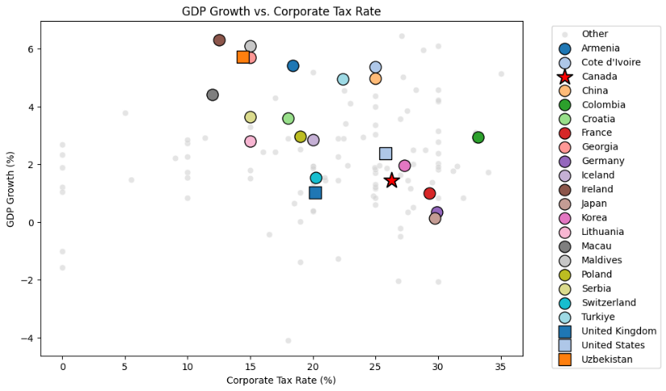
Figure 3: GDP Growth vs Corporate Tax Rate
The ITA policy is designed to directly address these challenges by implementing measures to stimulate innovation. This policy proposes to implement tax breaks for innovative sectors, deregulation by streamlining regulatory process, and encouraging venture capital investment via tax exemptions. These measures will help encourage reinvestment in innovation and reduce financial risks associated with entrepreneurial failure.

To encourage innovation, this policy will offer tax breaks to key sectors, such as artificial intelligence, biotech, clean tech and quantum computing. It will offer tax incentives for R&D spending and commercialization, similar to the UK’s R&D tax credit model [3] [22]. It will also continue to enhance current federal policies such as Scientific Research and Experimental Development (SR&ED) tax credit and Strategic Innovation fund (ISED) [23] [24]. Furthermore, it will push adoption of provincial policies such as Ontario Innovation Tax Credit (OITC) and Quebec R&D Tax Credit by expanding them across Canada [25] [26] .

To reduce bureaucratic delays, the ITA policy will streamline regulatory processes without compromising necessary safeguards. It will build on the one-window clearance initiative used in provinces such as British Columbia for businesses to have a single place to navigate regulatory requirements efficiently, helping reduce administrative burden, increase regulatory harmonization across Canada and speed up project initiation specifically for artificial intelligence, biotech, clean tech and quantum, computing [27]. ITA will also introduce accelerated pathways for these sectors to streamline approval processes and enable innovative products and services to reach the market faster without sacrificing safety and efficacy assessments, like Health Canadas’ Accelerated Review Pathways [28].

This policy will also bring special attention to making Canada more startup-friendly by providing tax exemptions for venture capital investments in Canadian deep-tech startups and eliminating capital gains tax on existing startup to encourage entrepreneurs to reinvest in Canada. These measures aim to encourage reinvestment and reduce the financial risks associated with entrepreneurial failure.

Expected outcomes of this policy include higher number of startups and higher startup success rates. By reducing financial and regulatory barriers, Canada will become a preferred destination for high-growth ventures. More companies will also relocate to Canada, driving economic growth and direct investment. Finally, incentives help startups scale instead of relocating to the U.S. or Europe. If Canada can foster and preserve local startups that eventually scale up, it will fare better in the global innovation scene.

Policy 3 : Talent Canada Initiative
Canada is experiencing a growing brain drain, with skilled professionals in AI, biotechnology, and engineering relocating to the U.S. and other countries in search of higher salaries, stronger venture capital ecosystems, and better commercialization opportunities. A 2016 study titled “Reversing the Brain Drain: Where is Canadian STEM Talent Going?”, revealed that Canada lost two-thirds of its recent software engineering graduates from top universities to the U.S. [11]. More recent emigration data from the OECD indicates that 86% of Canadians living abroad reside in the U.S., and a significant portion remain there long-term [29]. Nearly 300,000 highly educated Canadians have stayed in the U.S. for over 20 years (Appendix Figure C6), highlighting the persistence of this trend among the country’s most skilled population.

Our analysis identified several key factors contributing to Canadian emigration, including average wages, unemployment rates, and housing prices. By incorporating OECD data, our modeling revealed that elevated housing costs, higher unemployment rates, and lower wages have a statistically significant effect on current emigration trends as seen in Appendix C Figures C3, C4, C5 (with p-values of 0.01, 0.00, and 0.02 respectively). Over the years, the gap in housing, unemployment and wages continues to grow between Canada and the U.S. leading to increasing numbers of emigration (Figure 5). These findings emphasize that Canada’s innovation potential is being compromised by economic conditions that incentivize skilled workers to leave.
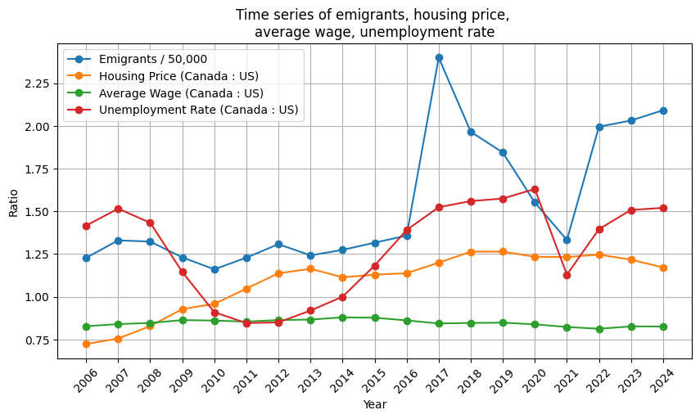
Figure 4: Comparing Canada vs US trends in emigration, housing prices, average wages, and unemployment from 2006-2024
The group proposes the Talent Canada Initiative (TCI) to retain high-skilled workers and attract global talent by addressing key economic drivers behind emigration. This policy will implement a competitive compensation strategy, promote affordable housing near innovation hubs, and streamline re-entry and global talent attraction programs.
Competitive Compensation Strategy
To ensure Canadian wages remain globally competitive, the policy will take a multi-faceted approach. First, wage incentive grants will be established for key sectors like AI, building on successful initiatives like the 2017 Student Work-Integrated Learning Program in biotechnology [30]. Expanding these grants to other sectors could improve job opportunities and retain Canadian talent.

Building on the government’s $2.4 billion AI investment [31]. Building on the government’s $2.4 billion AI investment [31], the policy will introduce a targeted allocation within the Strategic Innovation Fund (SIF) to support wage growth in AI and tech companies. Currently, the SIF supports large-scale projects with a minimum budget of $20 million but lacks explicit wage targets for funding recipients [32]. The policy will require 20% of SIF funding to be dedicated to salary enhancements and workforce development. Additionally, companies offering 10% above provincial median wages for tech roles will receive a 5% non-repayable contribution from the $700 million allocated to Canadian AI Champions [31]. This ensures funding supports both technological growth and fair salaries, strengthening Canada’s position in the global AI sector.

At the provincial level, a standardized salary reporting system will be implemented, requiring companies above a certain size to disclose salary ranges and report compensation data to a centralized database. Public access to this information will encourage wage alignment with market standards, reduce pay disparities, and strengthen employee bargaining power. Companies demonstrating fair pay structures may qualify for tax incentives or recognition programs, further promoting competitive wages in high-tech industries. This approach builds on existing pay transparency mandates in British Columbia and Ontario.

Affordable Housing Initiatives Near Innovation Hubs
Recognizing that high living costs can drive talent away, the policy will promote affordable housing projects in proximity to major innovation centers in Toronto, Vancouver, Montreal and Waterloo. This will be achieved by incentivizing public-private partnerships to develop mixed-use housing complexes tailored for STEM professionals. Drawing on successful initiatives such as Vancouver's 1050 Smithe Street Housing Project and the Little Mountain Housing Project [33], which use inclusionary zoning and innovative funding models to combine market-rate and affordable units, the policy aims to maintain long-term affordability. By incorporating housing subsidies and streamlining zoning and permitting processes, these initiatives will ease financial pressures on workers, countering the adverse impacts of high urban living costs [34]. This comprehensive approach will help retain talent by making high-demand urban areas more accessible and attractive for high-tech professionals.

Re-Entry and Global Talent Attraction Programs
While Canada's Express Entry and Global Talent Stream have helped attract skilled professionals, further improvements are needed to address shortages in AI and advanced technology [35] . The policy will establish fast-track visa pathways for STEM roles, expanding the Global Talent Occupations List and leveraging the Global Talent Stream’s two-week Labour Market Impact Assessment (LMIA) processing [36]. Support for returning Canadians will be enhanced through mentorship programs and networking opportunities with innovation hubs like MaRS Discovery District. By refining these initiatives, Canada can improve talent retention and attraction, securing its competitive edge in high-tech industries.

Expected outcomes of TCI include a stronger retention of highly skilled professionals and an enhanced innovation ecosystem. By addressing wage disparities, reducing housing burdens, and streamlining re-entry processes, Canada will become a preferred destination for both established companies and emerging high-growth ventures. This comprehensive approach is expected to attract greater global talent, drive economic growth, and increase direct foreign investment, ultimately ensuring that Canada remains competitive on the global innovation stage.

Policy 4 : Strategic Energy Infrastructure for Innovation Advancement
The reliability and competitive cost of energy are foundational for attracting and sustaining advanced industrial and technological activities that drive modern innovation. Sectors crucial to future growth are AI computation (data centers), biotechnology research and manufacturing, and advanced materials production. These are sectors characterized by significant and demanding energy requirements and thrive in countries which have forward thinking policies [37]. From the Composite Innovation Index detailed in Appendix D6, South Korea and China showed huge growth. This aligned with sharp rises in electricity consumption, visualized in Figure 4, indicating the increasing energy consumption country’s fostering innovation demand.

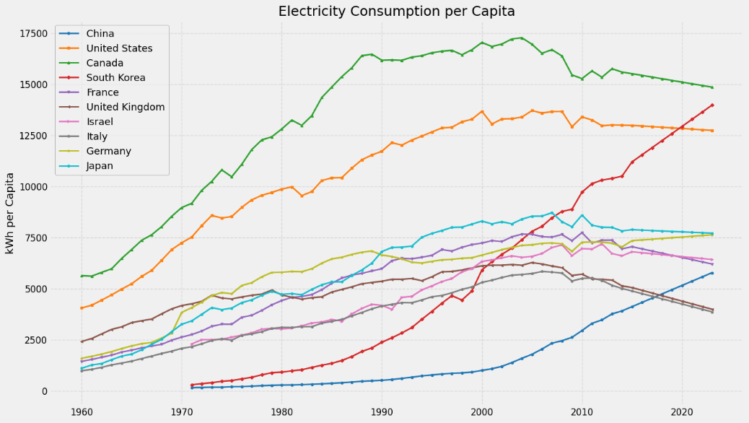
Figure 4: Electricity C [38]onsumption per Capita
The comprehensive analysis of Canadian data found in (Appendix D) revealed a nuanced relationship between energy consumption and innovation outcomes. While simple historical correlations surprisingly linked higher per capita electricity use to lower per capita R&D expenditure and scientific article output (Appendix D9, D10), this picture changed dramatically when implementing a multivariate analysis. Controlling for GDP and Capital Formation per capita, our models indicate a significant positive conditional association between electricity consumption and key innovation drivers like patenting activity, and R&D Expenditure per Capita (Appendix D16, D18). A sample of the results is shown in Table 1 below. This finding suggests that simply increasing broad-based energy consumption will not be a direct path to increasing innovation successfully, but the availability of reliable and cheap energy will act as a crucial enabler when paired with economic scale and investment. This underpins the crucial activities such as research, development and advanced computation that when scaled translate into positive innovation outputs.

Table 1: Multivariate Analysis Sample Results (Elec. Cons. Per Capita.)
Dependent | Observations | X Coefficient | X Std Err | X p-value | Significance
Patents | 44 | 0.3390 | 0.0796 | 0.000 | ***
R&D Expenditure per capita | 28 | 0.0559 | 0.0094 | 0.000 | ***
Researchers per capita | 28 | 0.0000 | 0.0000 | 0.000 | ***
Patents Non-Residents per capita | 44 | 0.0000 | 0.0000 | 0.001 | **

Canada possesses inherent advantages in its energy sector, notably a grid already characterized by a high proportion of reliable, low-carbon sources such as hydropower and nuclear generation (Appendix D1). This existing profile offers a strong starting point for competitive differentiation and grounding from which we can build upon. However, our analysis also highlighted Canada's significant lag the US in patenting efficiency (Patents per kWh) (Appendix D15) and widening gaps in R&D investment and overall patenting (Appendix D12, D13). Therefore, instead of pursuing generalized energy cost reductions or focusing primarily on expanding already-strong renewable sources, Canada should implement a Strategic Energy Infrastructure for Innovation Advancement (SEIIA) program. This initiative focuses on leveraging and developing Canada's energy strengths with the aim to specifically attract and retain the energy-intensive, high-value industries, which are crucial for closing the gaps found in Canada’s innovation.

The core proposal involves proactively developing and marketing regional energy hubs optimized for innovation-intensive sectors. This means ensuring beyond just competitive pricing, but also guaranteeing superior power quality, grid stability, and sufficient capacity in these designated zones. The proposal will require upgrades to the existing infrastructure such as upgrading and expanding transmission reinforcement and substations. Funding will be secured through joint federal and provincial government contracts which will leverage the additional energy sector revenues to offset costs. Rather than broad subsidies, consider long-term, predictable energy contracts or dedicated industrial tariffs for strategic anchor investments in AI, biotech, quantum, and semiconductor-related fields. This provides the certainty required for multi-billion-dollar facility investments.

Crucially, this policy will also directly support the objectives of the policies discussed previously. By ensuring world-class energy infrastructure in targeted innovation zones, Canada reduces a major operational cost and risk factor for the companies undertaking R&D and commercialization which Policies 1 & 2 aim to attract. This will lead to Canada becoming a more compelling location for establishing R&D centers, advanced manufacturing sites, not just regional branch offices. These activities will directly address the commercialization and patenting gaps identified relative to the US (Appendix D15). Through the more crucial role Canada will therefore play in major companies international and regional operations, the creation of high-value employment opportunities will arise compounding the positive effects we expect.

Strategic reinvestment of existing energy sector revenues should prioritize grid modernization focused on reliability, and capacity enhancement for these targeted industrial innovation loads, complementing necessary investments in long-term energy solutions. This plan requires robust federal-provincial coordination to align key areas including, energy infrastructure development and utility regulation targeting specific innovation ecosystems.

The SEIIA program is expected to significantly enhance Canada's value proposition for global investment in strategic, energy-intensive technology sectors. By focusing on reliability and targeted competitiveness rather than just broad cost reduction or redundant green expansion, it directly supports the attraction and retention of industries engaged in advanced R&D and commercialization. This can help improve Canada's lagging patent efficiency (Appendix D7), create high-value jobs, mitigate brain drain, and provide the essential energy foundation upon which the broader innovation ecosystem, nurtured by Policies 1-3, can thrive. It positions energy not as a direct driver of R&D figures, but as a critical strategic enabler of the industrial base needed for a leading economy where innovation excels.

Conclusion
Today Canada stands at an inflection point for its viability and ability to harbour and foster innovation. Although Canada has a highly educated workforce, significant hurdles in R&D, startup development, commercialization, and talent retention persist, as evidenced by its low ranking in the Global Innovation Index 2024 [1]. The analysis presented highlights that a multifaceted policy framework that consists of the Public-Private Commercialization Partnerships, Innovation Tax Advantage Policy, the Talent Canada initiative and the Strategic Energy Infrastructure for Innovation Advancement Policy can help Canada tackle the challenges it faces in innovation. By using global leaders such as the United States, Singapore, United Kingdom and Switzerland as benchmarks, these policies offer a practical roadmap to reinvigorate Canada’s ecosystem. Enhanced public-private collaboration, deregulation and tax breaks, competitive fiscal incentives and a robust energy infrastructure are critical to creating an environment where startups can flourish, and enterprises continue to see growth with a reduced risk of failure. This approach is expected to stimulate economic growth and reverse the impacts of brain drain while positioning Canada as a destination for both domestic and foreign investment.

References

[1] | World Intellectual Property Organization (WIPO), "Global Innovation Index 2024: Unlocking the Promise of Social Entrepreneurship," 2024. [Online]. Available: https://www.wipo.int/web-publications/global-innovation-index-2024/assets/67729/2000%20Global%20Innovation%20Index%202024_WEB3lite.pdf.
[2] | The Conference Board of Canada, "2024 Innovation Report Card: Benchmarking Canada’s Innovation Performance," 11 April 2024. [Online]. Available: https://www.conferenceboard.ca/product/innovation-report-card_2024/.
[3] | United States Government, "United States Government National Standards Strategy for Critical and Emerging Technology," 2023. [Online]. Available: https://bidenwhitehouse.archives.gov/wp-content/uploads/2023/05/US-Gov-National-Standards-Strategy-2023.pdf.
[4] | European Central Bank, "The Future of European Competitiveness," 9 September 2024. [Online]. Available: https://commission.europa.eu/topics/eu-competitiveness/draghi-report_en#paragraph_47059.
[5] | United Kingdom Government, "Build Back Better : Our Plan for Growth," March 2021. [Online]. Available: https://assets.publishing.service.gov.uk/media/6048fd05d3bf7f1d16e263fd/PfG_Final_Web_Accessible_Version.pdf.
[6] | Switzerland Global Enterprise , "Swiss Innovation," 2020. [Online]. Available: https://www.s-ge.com/sites/default/files/publication/free/factsheet-innovation-switzerland-s-ge-en-2020_1.pdf.
[7] | World Economic Forum, "Korea’s new innovation strategy: Digital Platform Government," 13 January 2023. [Online]. Available: https://www.weforum.org/stories/2023/01/davos23-korea-digital-platform-government/.
[8] | Japan Government, "Integrated Innovation Strategy 2022: Making Great Strides Toward Society 5.0," 30 June 2022. [Online]. Available: https://www.japan.go.jp/kizuna/2022/06/integrated_innovation_strategy.html.
[9] | Singapore Management University, "The National Innovation System of Singapore," 2010. [Online]. Available: https://ink.library.smu.edu.sg/cgi/viewcontent.cgi?params=/context/soe_research/article/2218/&path_info=NationalInnovationSysSingapore_av.pdf.
[10] | Council of Canadian Academies, "Competing in a Global Innovation Economy : The Current State of R&D in Canada," 2018. [Online]. Available: https://cca-reports.ca/wp-content/uploads/2018/09/Competing_in_a_Global_Innovation_Economy_FullReport_EN.pdf.
[11] | C. R. Singer, "Canada’s Brain Drain: Figures Show Technology Graduate Exodus," 26 September 2023. [Online]. Available: https://immigration.ca/canadas-brain-drain-figures-show-technology-graduate-exodus/?utm_source=chatgpt.com.
[12] | OECD, [Online]. Available: https://www.oecd.org/en/data/dashboards.html?orderBy=mostRelevant&page=0.
[13] | C. Plant, "The Class of 2014," Narwhal Project, 2024.
[14] | Independent Panel on Federal Support to Research and Development, "Innovation Canada: A Call to Action," Government of Canda, 2011.
[15] | Advisory Council on Economic Growth, "The Path to Prosperity: Resetting Canada’s Growth Trajectory," Government of Canada, 2017.
[16] | SSTI, "SSTI.org," 2023. [Online]. Available: https://ssti.org/blog/canadian-program-similar-sbir-faces-big-budget-cuts#:~:text=Programs%20for%20Business%20Innovation%20www,40%20increase%20in%20tax%20revenue. [Accessed 2025].
[17] | S. Ranking. [Online]. Available: https://www.startupranking.com/countries.
[18] | Crunchbase, "The Crunchbase Unicorn Board," [Online]. Available: https://news.crunchbase.com/unicorn-company-list.
[19] | C. McIntyre, "Here’s the data that shows why Canadian startups struggle to grow," The Logic, 16 December 2024. [Online]. Available: https://thelogic.co/news/canadian-startups-fundraising-growth/.
[20] | "Startup Statistics 2025 (Numbers & Success Rate)," Demand Sage, [Online]. Available: https://www.demandsage.com/startup-statistics/.
[21] | Global Entrepreneurship Monitor , [Online]. Available: https://www.gemconsortium.org/data.
[22] | UK Government, "Research & Development (R&D) tax relief," 1 January 2007. [Online]. Available: https://www.gov.uk/guidance/corporation-tax-research-and-development-rd-relief#:~:text=Research%20and%20Development%20(%20R%26D%20)%20tax,can%20qualify%20for%20this%20relief.. [Accessed March 15 2025].
[23] | Goverment of Canada, [Online]. Available: https://www.canada.ca/en/revenue-agency/services/scientific-research-experimental-development-tax-incentive-program.html.
[24] | Government of Canada, [Online]. Available: https://ised-isde.canada.ca/site/strategic-innovation-fund/en.
[25] | "Ontario Innovation Tax credit," 21 March 2024. [Online]. Available: https://www.canada.ca/en/revenue-agency/services/tax/businesses/topics/corporations/provincial-territorial-corporation-tax/ontario-provincial-corporation-tax/ontario-innovation-tax-credit.html. [Accessed 18 March 2025].
[26] | R. QUEBEC, "Tax Credit," [Online]. Available: https://www.revenuquebec.ca/en/citizens/tax-credits/tax-credits-for-scientific-research-and-experimental-development-rd/]. .
[27] | Canada Energy Regulator, [Online]. Available: https://www.cer-rec.gc.ca/en/index.html.
[28] | Government of Canada, [Online]. Available: https://www.canada.ca/en/health-canada/corporate/transparency/regulatory-transparency-and-openness/improving-review-drugs-devices.html.
[29] | OECD, "Database on Immigrants in OECD and Non-OECD Countries," [Online]. Available: https://www.oecd.org/en/data/datasets/database-on-immigrants-in-oecd-and-non-oecd-countries.html.
[30] | "New Academic Wage-Subsidy Program to Create 1,000 Student Job Opportunities in Canadian Biotech Companies," BioTalent Canada, 28 August 2017. [Online]. Available: https://www.biotalent.ca/news/new-academic-wage-subsidy-program-to-create-1000-student-job-opportunities-in-canadian-biotech-companies/. [Accessed 25 March 2025].
[31] | Government of Canada, "Investing to Raise Wages," [Online]. Available: https://budget.canada.ca/update-miseajour/2024/report-rapport/chap2-en.html.
[32] | Government of Canada, "Strategic Innovation Fund," [Online]. Available: https://ised-isde.canada.ca/site/strategic-innovation-fund/en/project-requirements/funding-amounts. [Accessed 30 March 2025].
[33] | NRGTEK, "Case Studies of Successful Affordable Housing Models in BC’s Urban Centers," [Online]. Available: https://nrgtek.ca/affordable-housing-how/case-studies-of-successful-affordable-housing-models-in-bcs-urban-centers/.
[34] | MERCER, "According to Mercer’s 2024 cost-of-living data, Hong Kong, Singapore and Zurich are currently the costliest cities for international workers," [Online]. Available: https://www.mercer.com/insights/total-rewards/talent-mobility-insights/cost-of-living/.
[35] | Government of Canada, "Express Entry," [Online]. Available: https://www.canada.ca/en/immigration-refugees-citizenship/services/immigrate-canada/express-entry/who-can-apply.html.
[36] | Government of Canada, "Program requirements for the Global Talent Stream," 31 January 2025. [Online]. Available: https://www.canada.ca/en/employment-social-development/services/foreign-workers/global-talent/requirements.html.
[37] | McKinsey&Company, "How data centers and the energy sector can sate AI’s hunger for power," 17 September 2024. [Online]. Available: https://www.mckinsey.com/industries/private-capital/our-insights/how-data-centers-and-the-energy-sector-can-sate-ais-hunger-for-power.
[38] | R. James, "Pearl Meyer," December 2024. [Online]. Available: https://pearlmeyer.com/insights-and-research/article/designing-an-effective-bonus-plan-for-early-stage-biotech-companies. [Accessed 25 March 2025].
[39] | World Bank Group, [Online]. Available: https://data.worldbank.org/.
[40] | Dubai Future Foundation, "The Global 50," 2023. [Online]. Available: https://www.dubaifuture.ae/wp-content/uploads/2023/04/THE-GLOBAL-50-EN.pdf.
[41] | OECD, "OECD Migration," [Online]. Available: https://webfs.oecd.org/Els-com/Migration/Databases/Database%20on%20Immigrants%20in%20OECD%20and%20non-OECD%20Countries%20DIOC/DIOC%20database%20-%20click%20here/.
[42] | C. R. Singer, "Immigration.ca," 26 September 2023. [Online]. Available: https://immigration.ca/canadas-brain-drain-figures-show-technology-graduate-exodus/. [Accessed 25 March 2025].
[43] | "New Academic Wage-Subsidy Program to Create 1,000 Student Job Opportunities in Canadian Biotech Companies," BioTalent Canada, 28 August 2017. [Online]. Available: https://www.biotalent.ca/news/new-academic-wage-subsidy-program-to-create-1000-student-job-opportunities-in-canadian-biotech-companies/. [Accessed 25 March 2025].
[44] | Statistics Canada, [Online]. Available: https://www.statcan.gc.ca/eng/start.
[45] | Government of Canada, "Attracting tech talent to Canada," [Online]. Available: https://www.canada.ca/en/immigration-refugees-citizenship/campaigns/tech-talent.html.
[46] | Monster, "Pay Transparency & Equity Mandates for Employers in Canada," 20 June 2024. [Online]. Available: https://hiring.monster.ca/resources/job-market-trends-insights/pay-transparency-equity-mandates-canada-employers/.
[47] | palette skills, "Salary growth in Canada’s tech sector continues to outpace Canadian average," [Online]. Available: https://paletteskills.org/resources/salary-growth-in-canadas-tech-sector-continues-to-outpace-canadian-average.
[48] | Government of Canada, "Evaluation of the Student Work Placement Program," [Online]. Available: Evaluation of the Student Work Placement Program - Canada.ca.
[49] | [Online].

Appendix

Appendix A-Policy 1
Figure A1 highlights the Canada’s strong position in investing in R&D and innovation and VC investments across other countries.
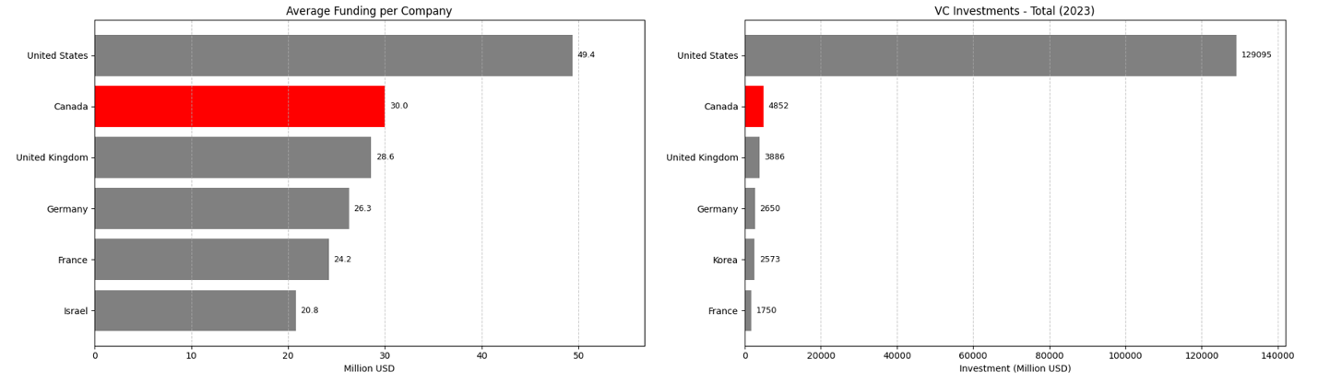
Figure A 1: (a) Average funding per company for leading nations [13]. (b) Top 6 countries withthe highest total venture capital investments [12].

Appendix B- Policy 2
According to Demandsage and Startup ranking, current number of startups in US is around 80,000 while Canada is only around 5000 [20] [17] , as shown in Figure B1.

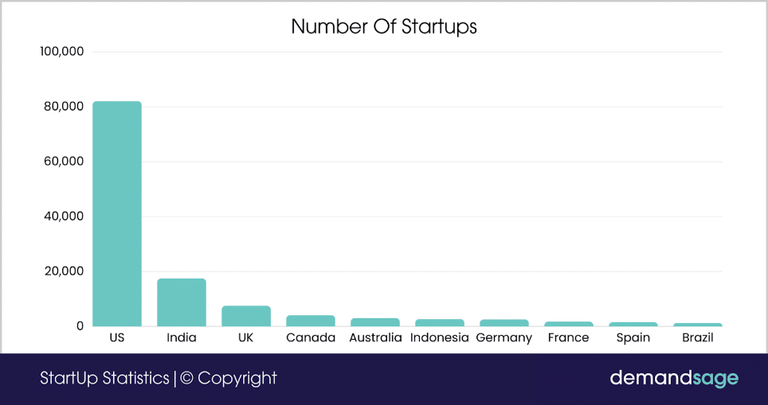
Figure B 1: Number of Startups by country according to Startup Statistics 2025 report on Demand Sage [20] [17]
Similarly to startup data, current number of startups in US is above 750 unicorns, in China is above 250 unicorns, in India is above 50 unicorns, while Canada is only around 25 [18], as shown in Figure B2.
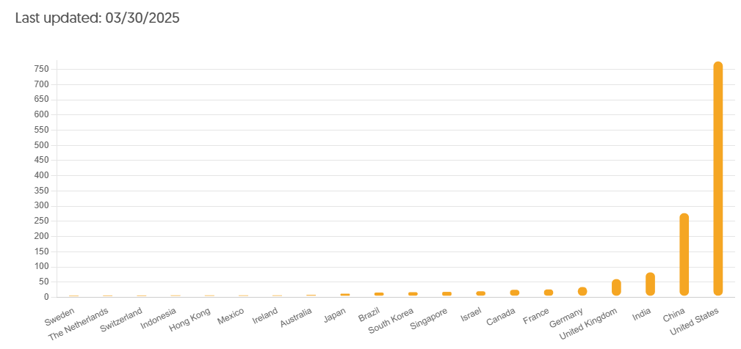
Figure B 2: Countries with current unicorns (update 03/30/2025) [18]

The heat map in Figure B3, shows the fear of failure rate among 18-64 year old population who agree that they see good opportunities but would not start a business for fear it might fail [21]. Canada on the map can be seen to have very high Fear of Failure.

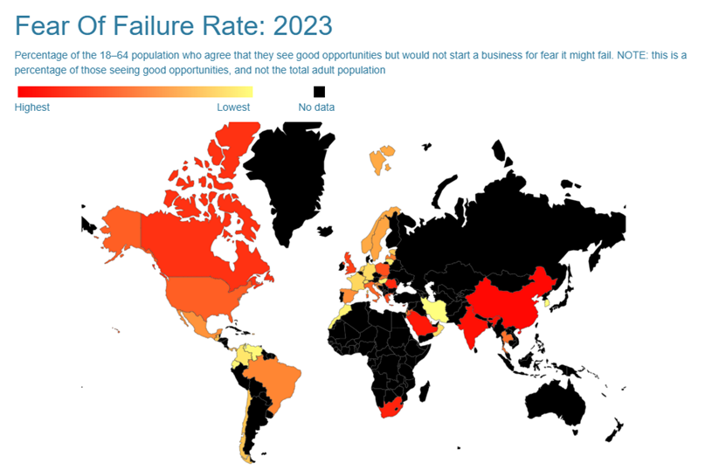
Figure B 3: Fear of Failure Rate 2023 by country [21]
To understand how corporate tax rates impact innovation and economic growth, tax rates, VC investments, GDP Growth and startup Success Score were examined for countries globally. The Data was obtained by World Bank Group and OECD. The correlation matrix in Figure B4 illustrates that Corporate tax rate has a negative correlation with both Venture Capital Investments and GDP Growth. This means that when corporate tax rates are high, venture investments in those countries may be discouraged due to the high cost of tax, acting as a barrier to innovation and growth. Since entrepreneurship and business creation are key engines of growth, this relationship helps explain why GDP growth is also negatively associated with higher tax rates while GDP growth and VCI are positively correlated.

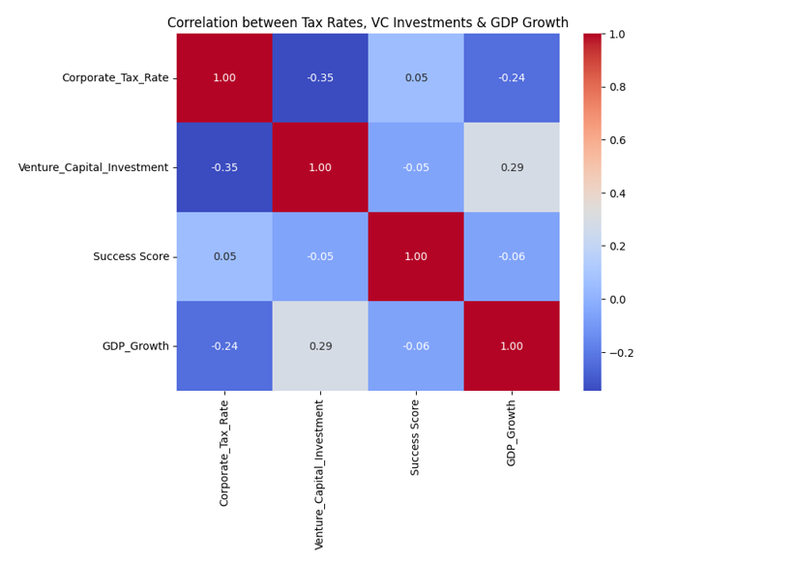
Figure B 4: Correlation between Tax Rates, VC Investment and GDP Growth [12] [39]
Figure B5, shows that as Corporate Tax Rate increases in a country, Venture Capital Investment decreases. This is because it reduces the potential returns for investors, making them less likely to allocate capital to high-risk(startups), high-reward ventures. Startups in countries of higher corporate tax will retain less profit after paying taxes, making investing in them not as desirable. A reduction in venture capital investment can cause slowdown in economic growth and innovation, since venture capital is seen as a crucial source of funding for startups.

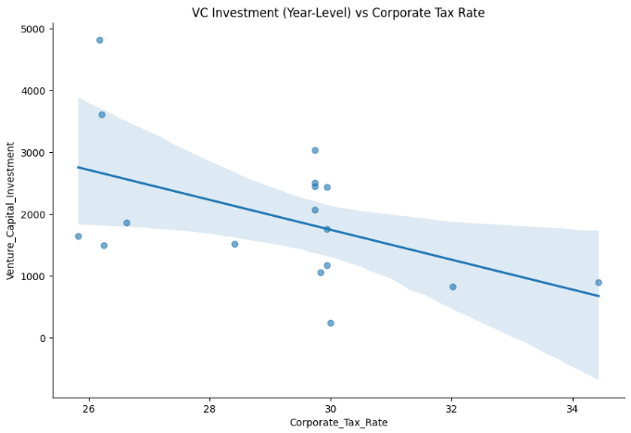
Figure B 5: VC Investment (Year-Level) vs Corporate Rate [12] [39]

Current Policy Environment:
In 2025, tax and innovation are covered in a mix of provincial and federal policies. These are mainly focused on supporting R&D in Canada in an effort to foster a competitive business landscape. The primary federal policy is the Scientific Research and Experimental Development (SR&ED) tax credit which provides companies substantial R&D incentives who invest in R&D (Innovation, Science and Economic Development Canada. [23] Another federal policy is the Strategic Innovation fund which aims to support high tech, specifically AI, biotech and clean initiatives. [24] On a provincial level, Quebec and Ontario have programs to attract both high growth companies and startups at a local level by enhancing the local innovation ecosystems. [25] [26]

Appendix C - Policy 3
OECD emigration data has shown that 30% of Canadian’s stay in the USA for over 20 years [29]. A major pull factor is access to higher-paying and more abundant jobs in sectors like professional and scientific services, healthcare, finance, and education, as shown in Figure C1. These industries not only offer better compensation but also clearer career paths.
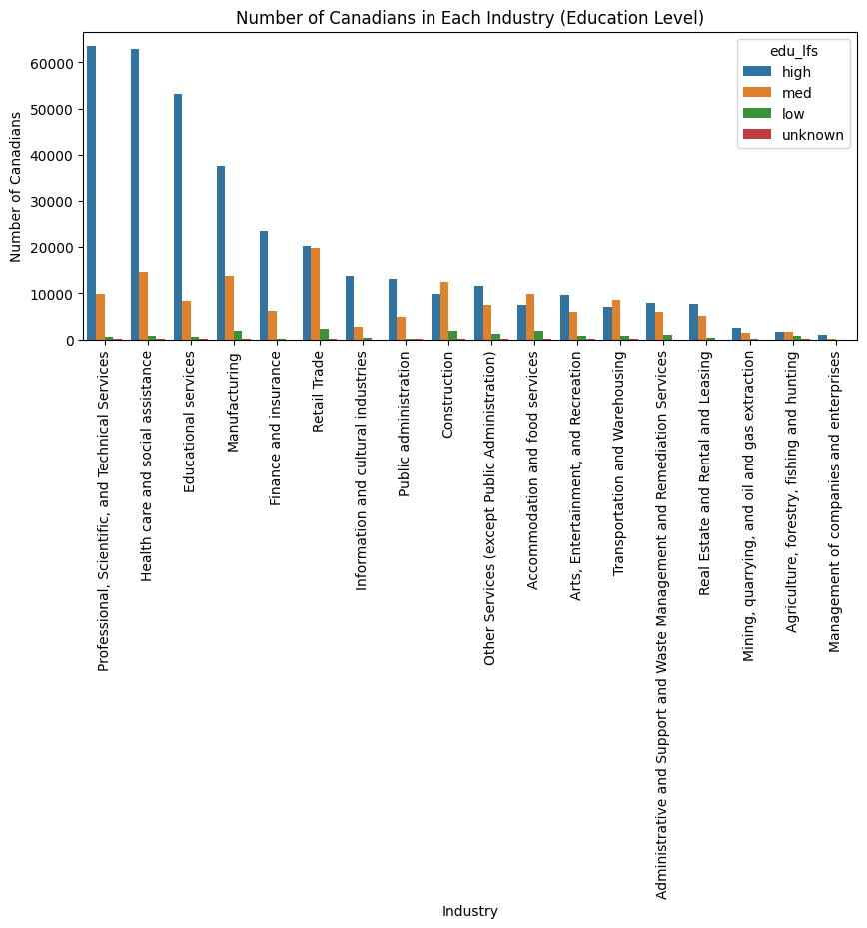
Figure C 1: Number of Canadians in U.S. Industries by Education Level
In analyzing root causes, we examined Canadian emigration (2020–2021) against economic indicators from 2019—applying a 2-year lag to account for typical migration delays. The correlation matrix in Figure C2 reveals that emigration is positively correlated with average wage levels abroad and negatively correlated with unemployment and housing prices. This implies that when job prospects are better and housing more affordable elsewhere, Canadians are more likely to leave.
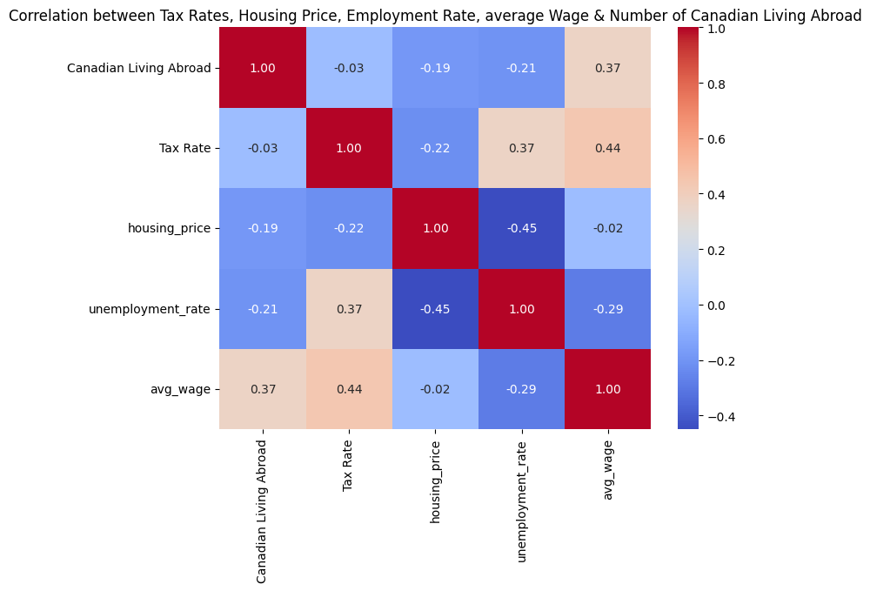
Figure C 2: Correlation Between Economic Indicators and Canadian Emigration
To see the correlation between emigration trends in Canada and the Canadian to USA housing price, unemployment rate and average wage, we performed a linear regression using data from 2005-2024. P-values from this analysis are all below 0.05, suggesting that we can reject the hypothesis that these factors have no effect on emigration. Considering the P values are relatively low, it signifies that these factors have a significant effect on emigration.
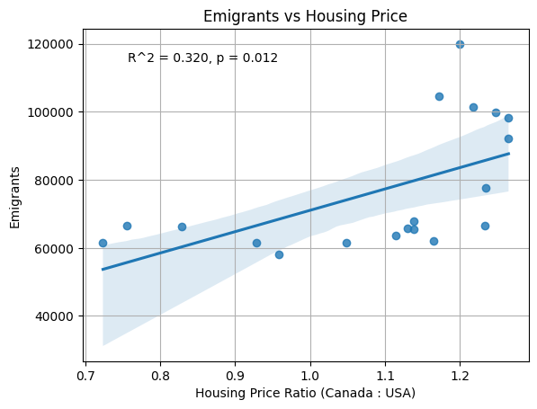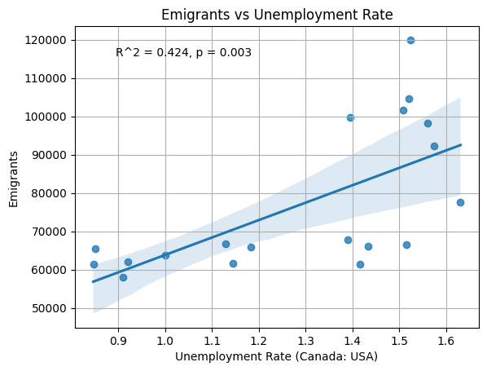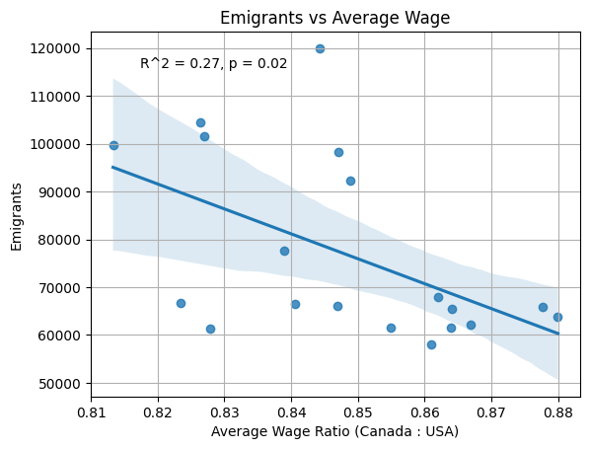
Figure C 3: (top left), C4 (top right) & C5 (bottom): Emigration trends across Housing Prices, Unemployment Rates and Average Wage
Looking at the time series of housing price, unemployment rate and average wage we notice a trend in Canada’s emigration (see Figure C6). On average, Canadian housing prices and unemployment rates are higher compared to the U.S., both depicting upward trends. The mean wages in Canada continue to be lower than the U.S., showing no indications of increase. Emigration shows an increasing trend, especially around the years 2015-2024 (with COVID years having the expected drop). This effectively shows that Canada continues to have a brain drain issue, reinforcing the need for a new strategy to retain talent.

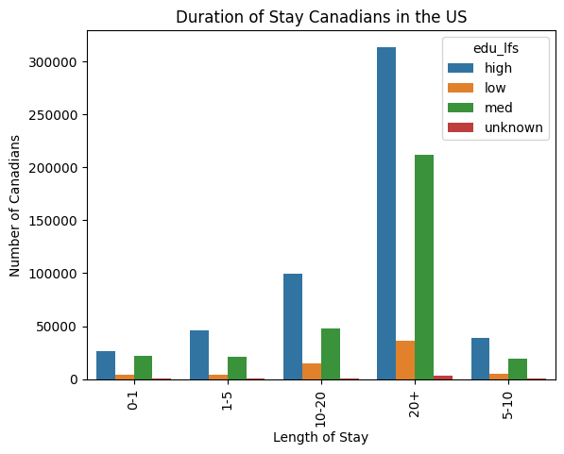
Figure C6: Duration of Stay in the U.S of Canadian who emigrated to the US

Appendix D- Policy 4

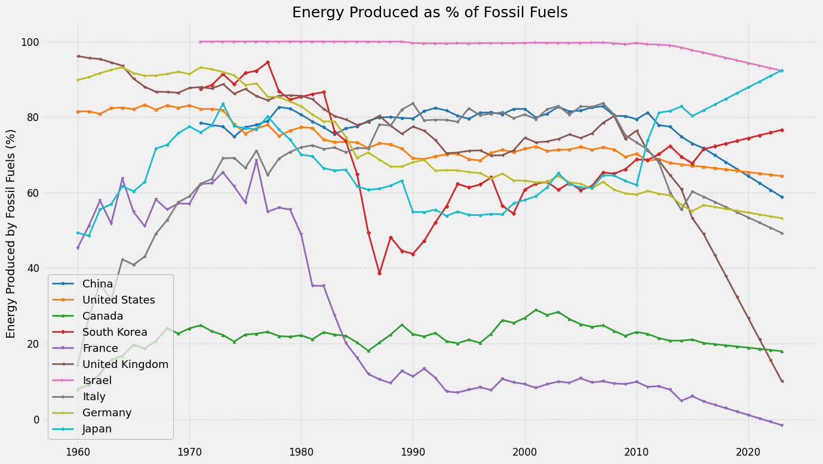
Figure D 1: % Energy Produced by Fossil Fuels
Figure D1 shows a trend of decreasing reliance on fossil fuels for electricity generation among most nations. This trend is most significant in the UK and Germany. Canada and France stand out for consistently maintaining very low percentages, contrasting sharply with Israel's sustained high dependency near 100%.

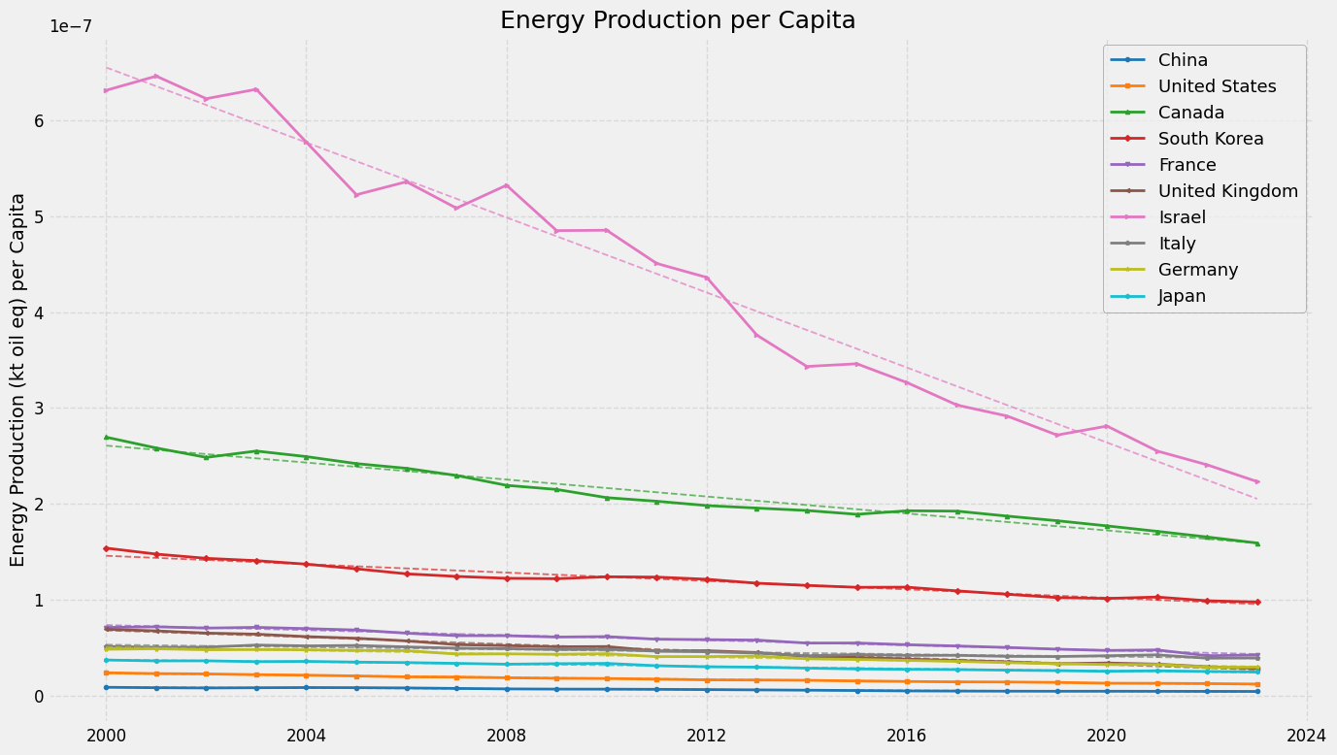
Figure D 2: Energy Production per Capita
Figure D2 depicts that Israel and Canada exhibit the highest per capita energy production (kt oil eq) among nations. In addition to this both show distinct downward trends over the past twenty years. South Korea follows with a more stable, moderate production level, while the remaining G7 countries, China, and Japan are at substantially lower per capita production rates, showing slight declines or relative stability.
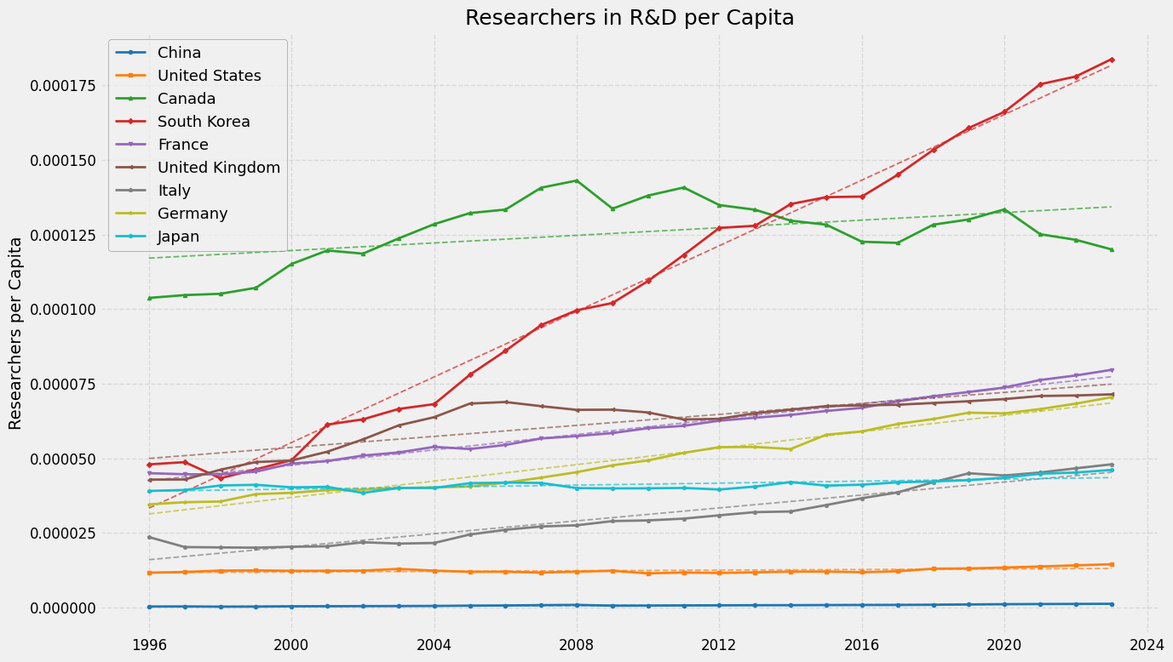
Figure D 3: Researchers in R&D per Capita
Figure D3 reveals South Korea's dramatic rise to lead in researchers per capita, surpassing Canada which has seen its initially high ratio stagnate and recently decline. Meanwhile, nations like France and Germany show steady increases, while the US and China notably lag far behind most peers on this measure of R&D input.
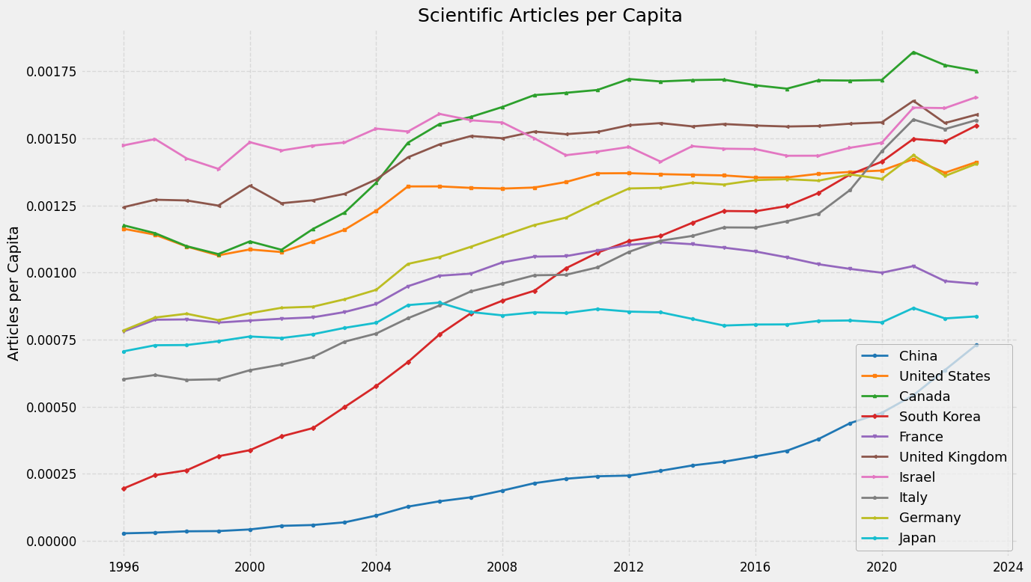
Figure D 4: Scientific Articles per capita
Figure D4 indicates Canada consistently ranks among the world leaders in scientific articles per capita, alongside nations like the UK and Israel, maintaining a strong research output relative to its population. While countries like South Korea and China show faster growth rates from different starting points, Canada remains a top performer in this specific innovation metric.

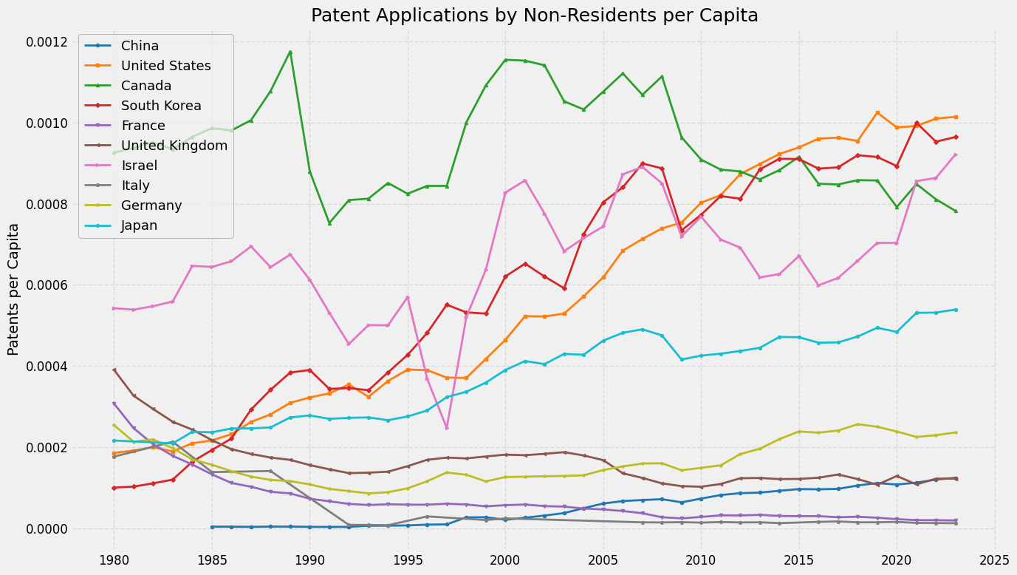
Figure D 5: Patent Applications by Non-Residents per Capita
Figure D5 shows Canada historically led in attracting non-resident patent applications per capita but has since declined, whereas the United States, South Korea, and Israel now demonstrate higher and generally increasing rates. China and several European nations show substantially lower levels of attracting foreign patents on a per capita basis.

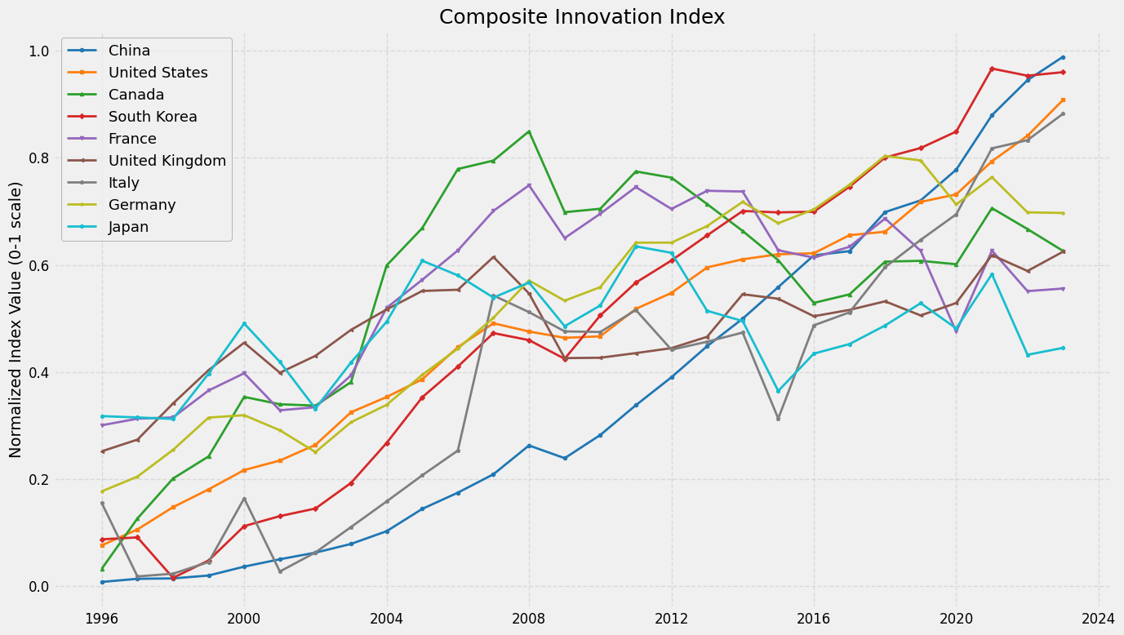
Figure D 6: Composite Innovation Index
The composite innovation index shown in Figure D6 combines multiple factors such as Patents, R&D Expenditure and Scientific Articles per capita to name a few. Weighting was assigned to each based on a subjective importance level that metric plays in a country’s innovation.
The per capita metrics and weights representing the composite index are the following: Patents– 0.25, Non-resident Patents – 0.07, R&D Expenditure – 0.25, Researchers – 0.15, FDI Inflows – 0.06, Scientific Articles – 0.15, Gross Capital Formation - 0.07. The logic behind the selection of these weights were that Patents by residents (0.25) and R&D Expenditure (0.25) are direct outputs and inputs of the innovation process. Researchers in R&D and Scientific Articles both with 0.15, represent human capital and knowledge dissemination and are crucial but less direct measures of innovation. The remaining indicators are weighted less between 0.07 and 0.06 as these were seen as factors that support or attract innovation thus less essential to the core innovation effort. Additionally, normalization was applied separately for each indicator and within each specific country using Min-Max scaling. The normalization was needed due to the diverse scale and units of the metrics considered in the analysis. Due to scaling from 0-1, the final values now become directly comparable and will lead to a more realistic and accurate presentation of findings. If this was not done, factors such as R&D Expenditure would dominate the index even if a small weight was assigned compared to metrics with smaller values.

The plot reveals a general upward trend across most nations, with South Korea, China, and the United States demonstrating the best recent performance. This adds validity to the metrics and weights used as we know today these three nations are among the best when it relates to producing and designing innovative solutions and products. Canada, while highly competitive in the past is now showing a more stagnant trend and is falling behind the leaders. It is this fall the group wants to address.

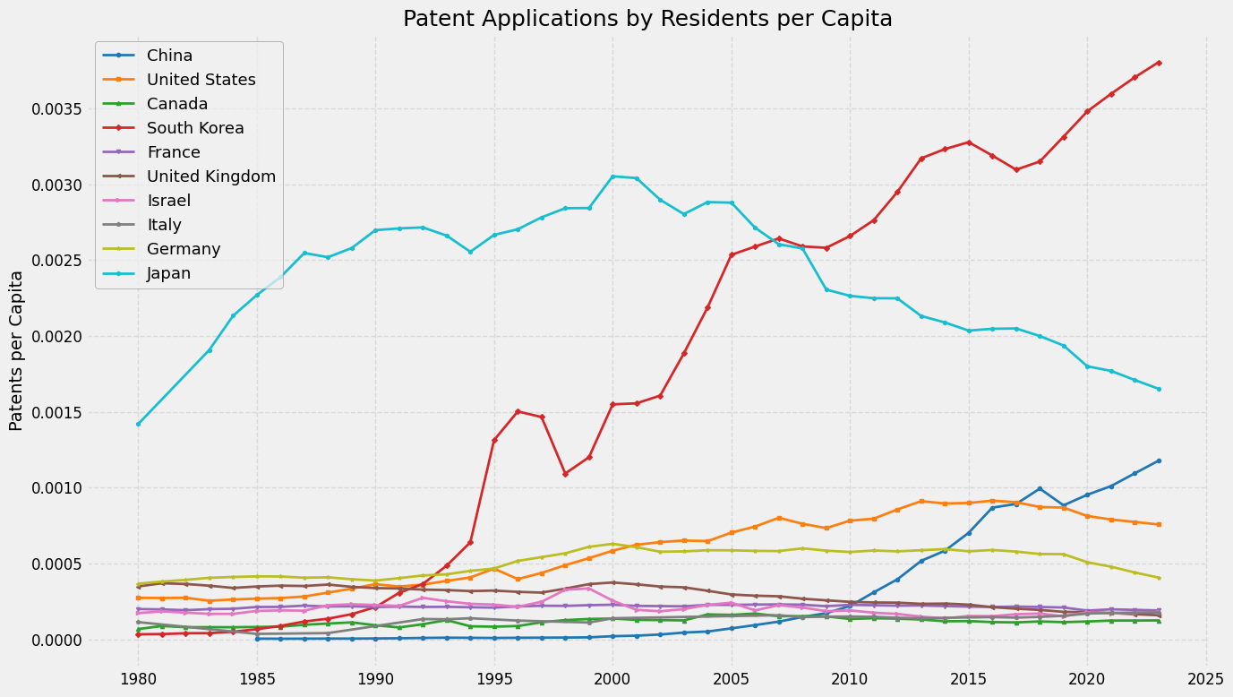
Figure D7: Patent Applications by Residents per capita
Figure D7 shows South Korea is the leader in resident patent applications per capita with a strong upward trend, contrasting starkly with Japan's significant decline from its earlier peak. China exhibits dramatic recent growth from a low base, while Canada consistently ranks near the bottom among these nations on this innovation output metric.

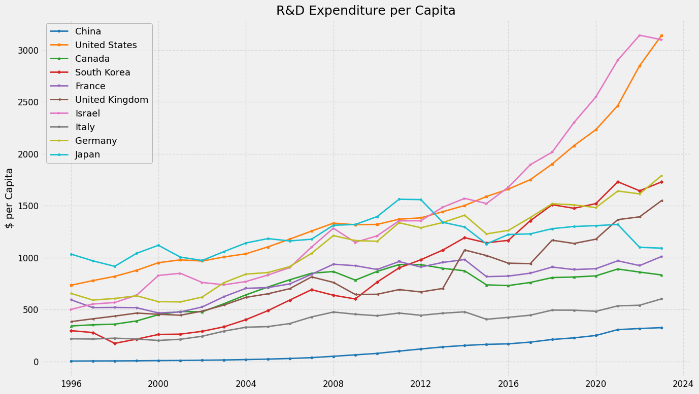
Figure D8: R&D Expenditure per capita
Figure D8 shows that the United States and Israel are by far the leaders in per capita R&D expenditure with strong upward trends. This contrasts Canada which is being outpaced and remains in the middle tier with less dynamic growth recently. Meanwhile, nations like South Korea and China exhibit rapid increases in their per capita R&D investment over this period.

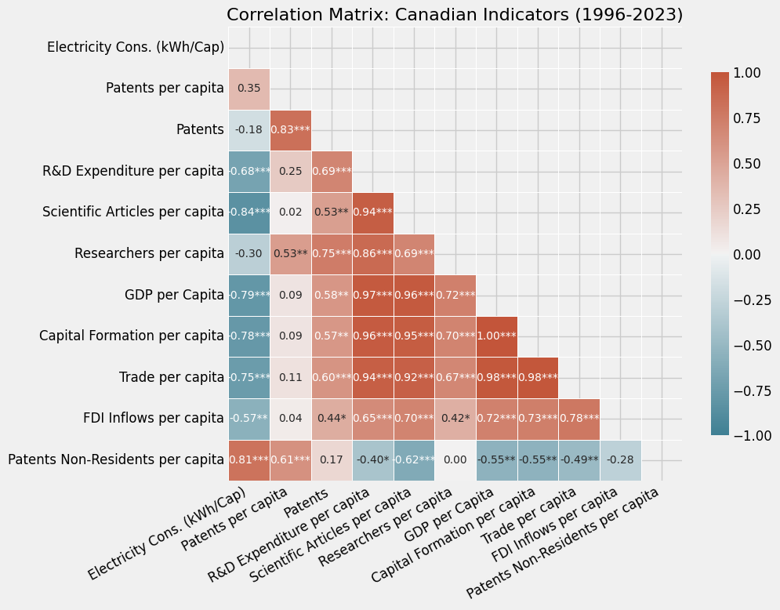
Figure D9: Correlation Matrix: Canadian Indicators
The results from Figure D9 are mixed and partially counter-intuitive compared to expectation that higher energy use accompanies higher innovation output. The strong negative correlations with R&D Expenditure and Scientific Articles are noteworthy and unexpected. To understand this further, look at the time series plots comparing nations to observe the trends of some of the indicators investigated. The declining energy consumption in Canada while other metrics remaining stable or even increasing is what would have led to the negative statistical relationships. This could suggest some decoupling or shifts in the structure of the economy. Additionally, as time goes on production and experiments become more efficient and use less electricity, so this is an additional factor to help explain the observed negative relations.
The positive significant correlation with patents per capita aligns closely with intuition. As energy is needed for productive activities that lead to patents. For Canada between 1996-2023, higher per capita electricity use is significantly associated with lower R&D spending and scientific articles per capita but moderately associated with higher patents per capita. These relationships are strong for R&D and articles but only moderate for patents per capita.
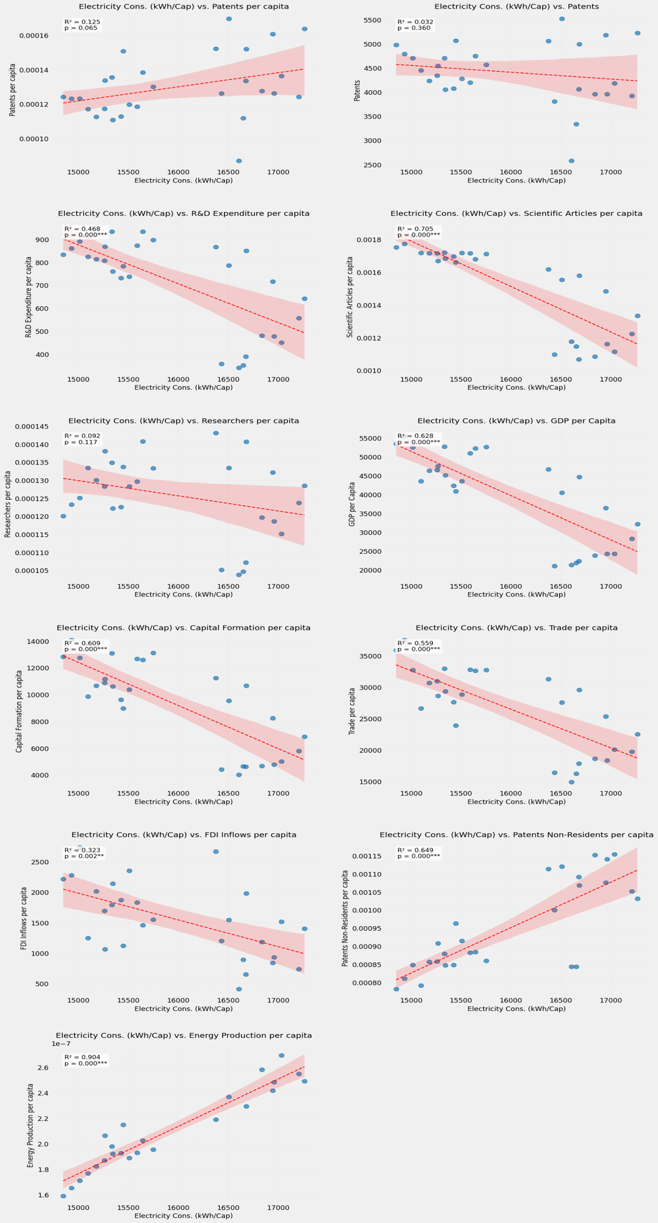
Figure D 10: Correlation Plot (simple): Canadian Indicators
For the simple regression correlation analysis considering no controls in Figure D10, the negative sloped indicators were Scientific Articles per capita, Researchers per capita, GDP per Capita and FDI Inflows per capita. Positively sloped indicators include Patents per capita, Patents Non-Residents per capita and Energy Production per capita. For R&D Expenditure and FDI Inflows, the linear trend captures the general direction but is unreliable due to the significant scatter seen. This indicates either that other factors are contributing more significantly, or the relationship may not be linear. Surprising points including that for R&D expenditure there are points with high electricity consumption but low R&D. The strong negative relationships between electricity and Scientific Articles, GDP, Capital, Trade and R&D are apparent. The strong positive relations with energy production and Patents of non-residents are also depicted clearly. However, due to lower significance observed and the degree of scatter of the points, several indicators need further analysis which is where a multivariate analysis is a powerful tool.

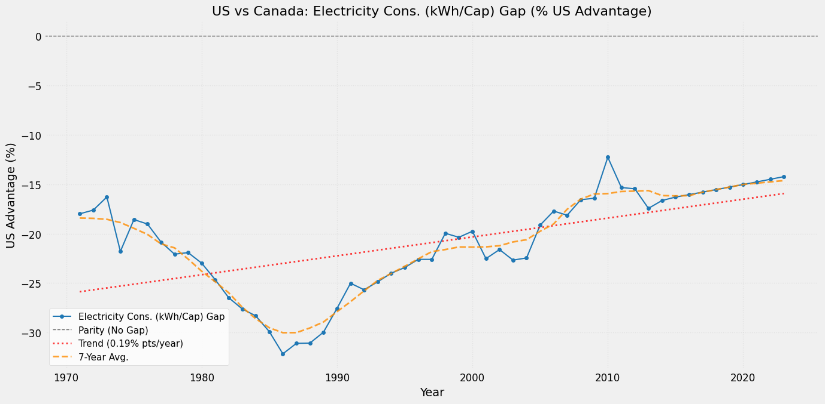
Figure D 11: US vs Canada: Electricity Consumption Gap
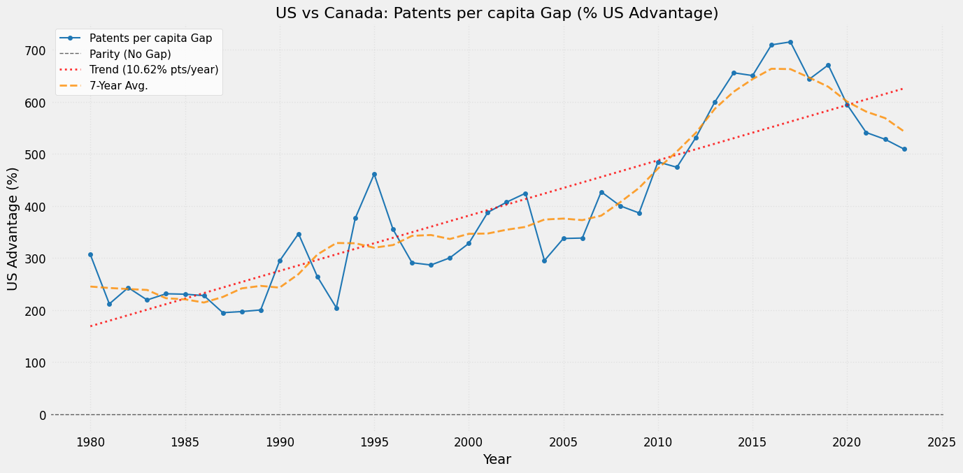
Figure D 12: US vs Canada: Patents per Capita Gap

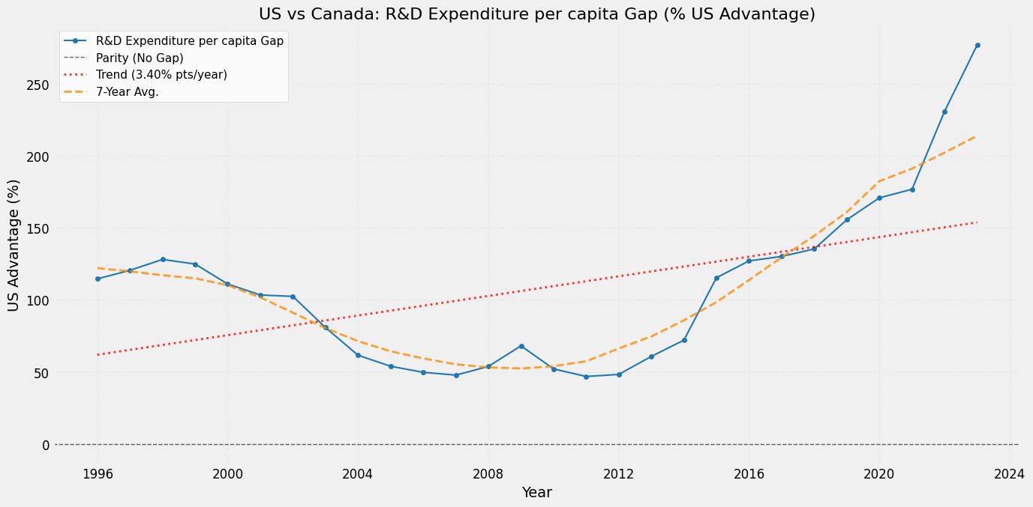
Figure D 13: US vs Canada: R&D Expenditure per Capita Gap
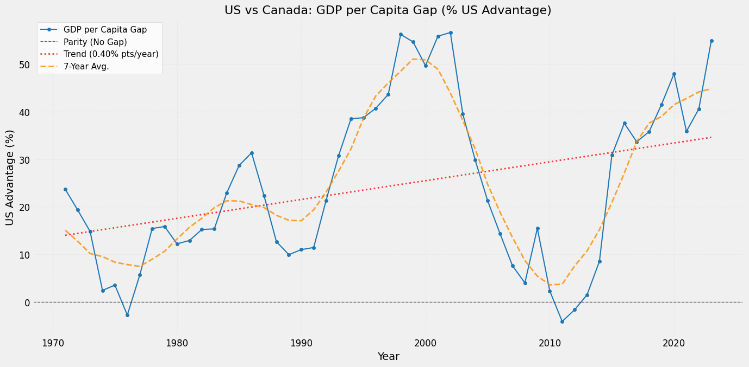
Figure D 14: US vs Canada: GDP per Capita Gap
In Figures D: 11, 12, 13 & 14 the US shows a large advantage in Patents per capita and R&D Expenditure per capita. While Canada leads (negative US advantage) in Researchers per capita, Scientific Articles per capita, and Electricity Consumption per capita although the gap has been narrowing for the last two. GDP per capita, Capital Formation per capita, and FDI Net Inflows per capita show greater volatility with distinctive conclusions harder to be drawn. Although the longer-term trends do indicate slightly widening US advantage for GDP and narrowing advantages for Capital Formation and FDI.

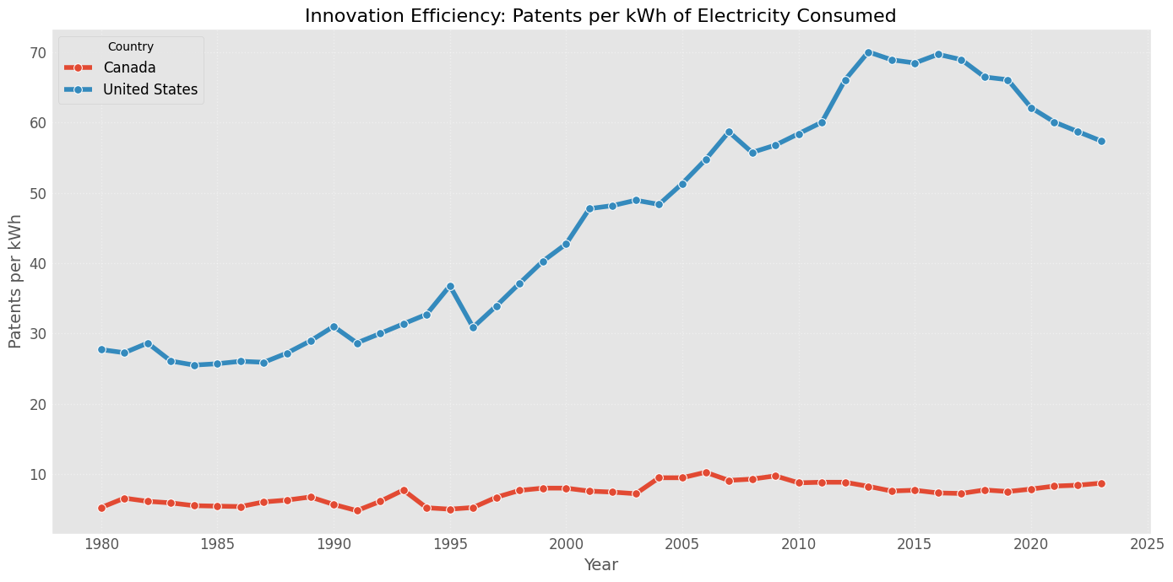
Figure D 15: Innovation Efficiency: Patents per kWh of Electricity Consumed
Figure D15 shows there is a very significant difference between the two countries; the US consistently generates more patents per kWh of electricity consumed compared to Canada throughout the entire period. US efficiency saw an increase from 1980, peaking around 2012-2014 before starting a slight downward trend, while CA efficiency has remained low and stable over the same period. Over the 21st century, the US advantage was on average ~600%.

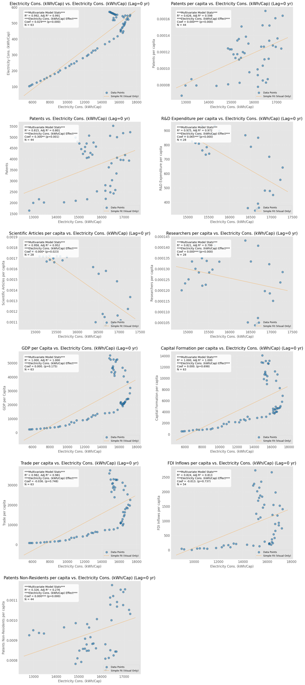
Figure D 16: Multi-variate (lag=0) Correlation Graphs for Canadian Indicators
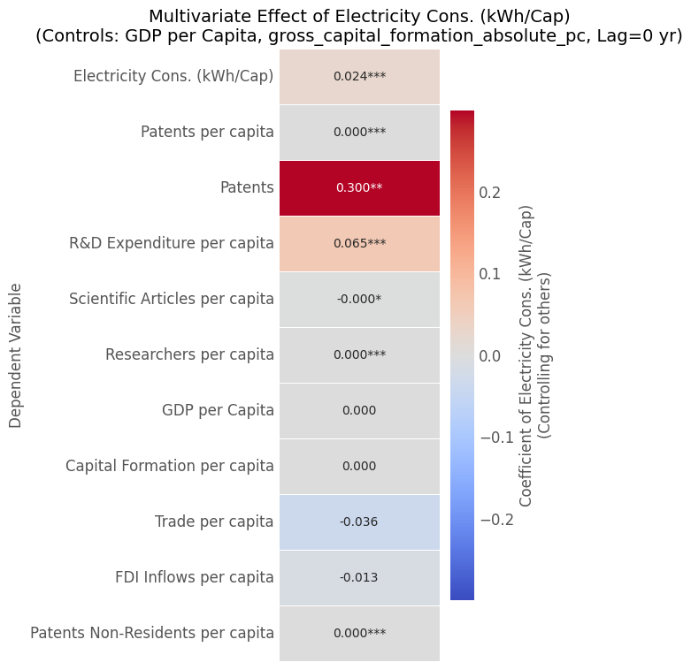
Figure D 17: Multi-variate (lag=0) Correlation matrix for Canadian Indicators
The multivariate analysis results from Figures D16 & D17 involves examining the impact of electricity consumption (kWh/cap) with no lags (0) while controlling for GDP and capital formation per capita. It reveals positive and significant associations with current levels of Patents, R&D Expenditure, and Researchers per capita in Canada. In this example no lags were used meaning that we assumed or examined an immediate reaction between the change of electricity consumption and the dependent variables. This is unlikely to be the case but was good to set a baseline for analysis. The relationship with scientific articles is negative and not highly significant, while Trade and FDI show no significant link to past energy consumption in this controlled model. This then indicates diverse drivers for different aspects of the economy and innovation system.
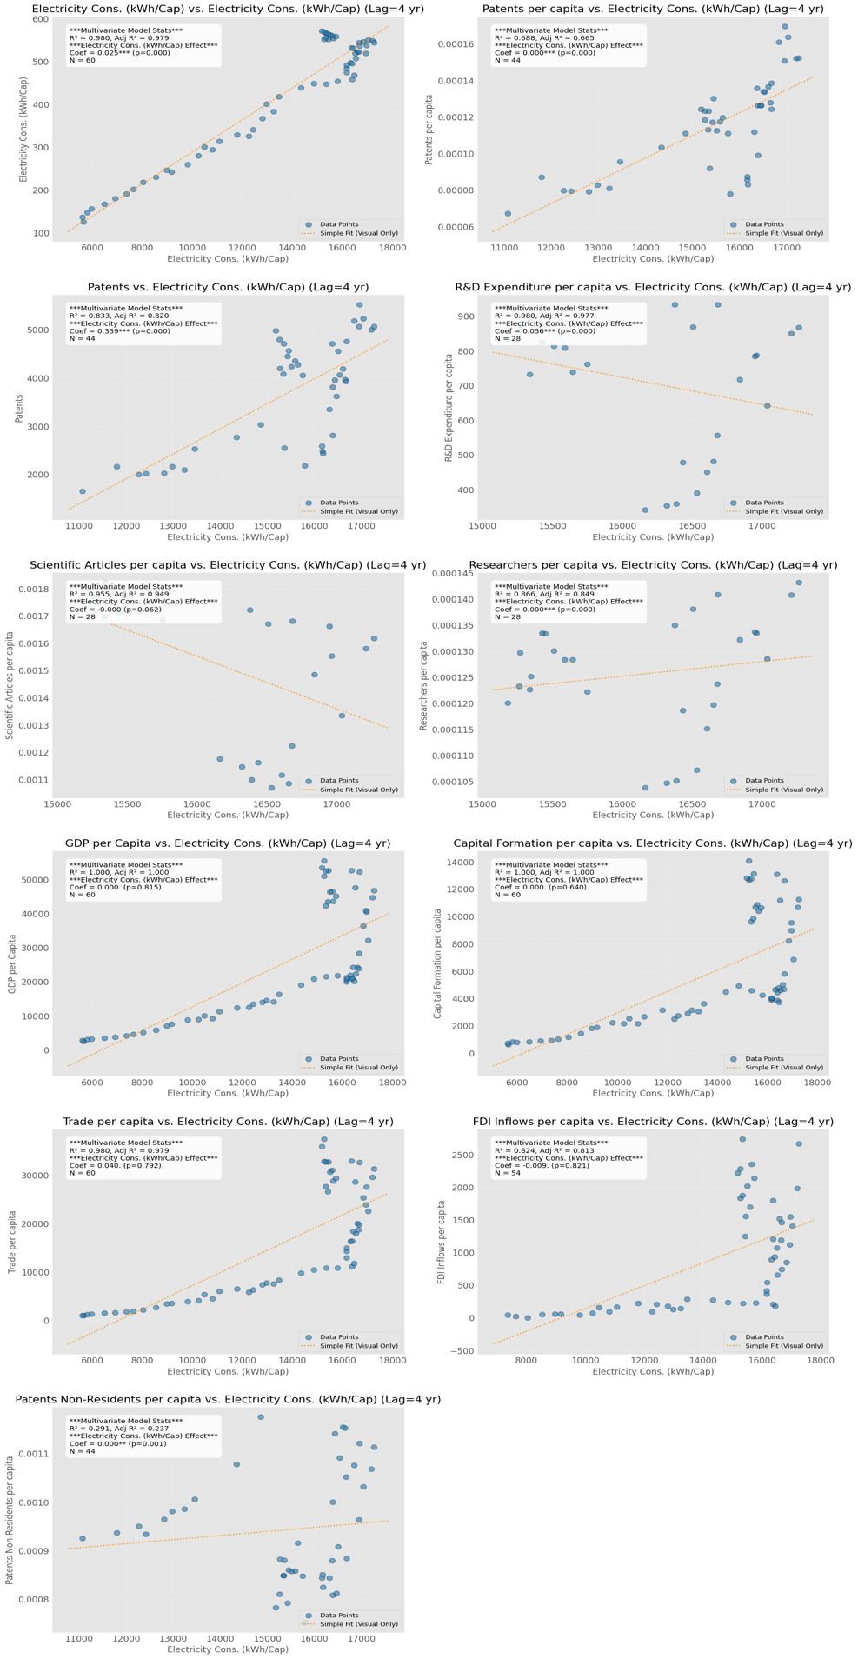
Figure D 18: Multi-variate (lag=4) Correlation Graphs for Canadian Indicators
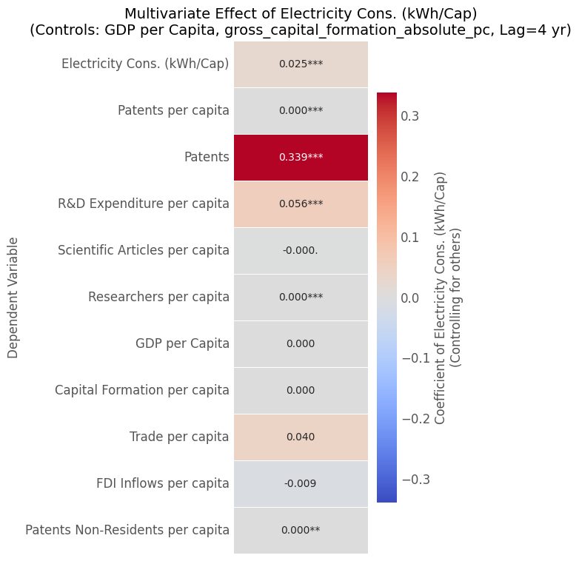
Figure D 19: Multi-variate (lag=4) Correlation matrix for Canadian Indicators
In Figures D18 & D19 we examined the impact of electricity consumption (kWh/cap) from 4 years prior while maintaining the same control variables. It revealed that lagging the relationships led to stronger coefficient for patents and making it more significant. Additionally, trade per capita shifted from a slightly negative relation to a slightly positive although the significance remained low. This lagged relationship was explored to see if higher coefficients among variables would arise, as we know that the outcomes of increased energy usage might not be immediately apparent.

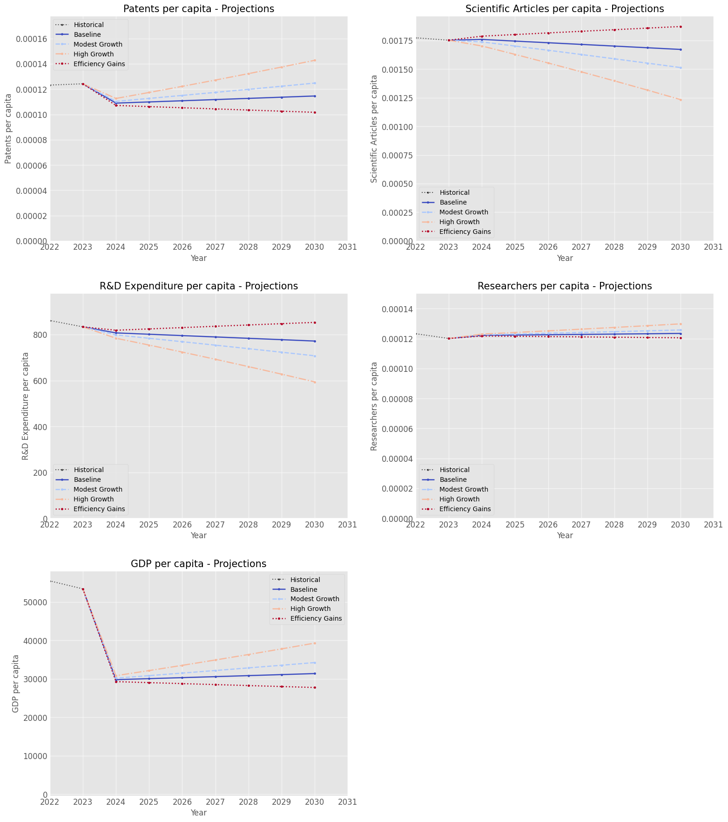
Figure D 20: Projections (1) Patents per Capita (2) Scientific Articles per Capita (3) R&D Expenditure per Capita (4) Researchers per Capita (5) GDP per Capita
Scenario | Patents per Capita (2030) | % GDP Difference vs Baseline (2030)
Modest Growth | 0.000125 | 13.2%
High Growth | 0.000143 | 36.6%
Efficiency Gains | 0.000102 | -16.7%
Table D 21: Results of Projections w/ various scenarios
Figure D20 presents the visualization of the simulation analysis. The simulator created estimates future innovation and economic metrics by projecting four energy consumption scenarios (including baseline) using a simple historical statistical model (OLS: Innovation ~ Energy). This method was chosen as it is a simplified way to illustrate and compare how different energy trajectories might influence innovation outcomes. The major assumption for the modeling is that past statistical relationships continue to hold. The baseline energy growth rate was 0.5% per year with the modest, high and efficiency models representing 0.75%, 2% and -1% growth applied to the baseline respectively. Higher energy growth correlates with higher projected Patenting activity and GDP per capita which is shown in the significant estimated GDP difference in the scenario impact table. Table D21 highlighted that the estimated GDP in the year 2030 would be 13%, 36% and -17% above the baseline estimate. Counter-intuitively increasing energy consumption per capita correlates with lower Scientific Articles and R&D expenditure. These contradictory results, indicate that the underlying simple models utilized are probably omitting crucial factors like overall GDP growth and others. This highlights the limitations of this approach and the necessity of incorporating the multivariate results to be more confident in the projections and simulations.

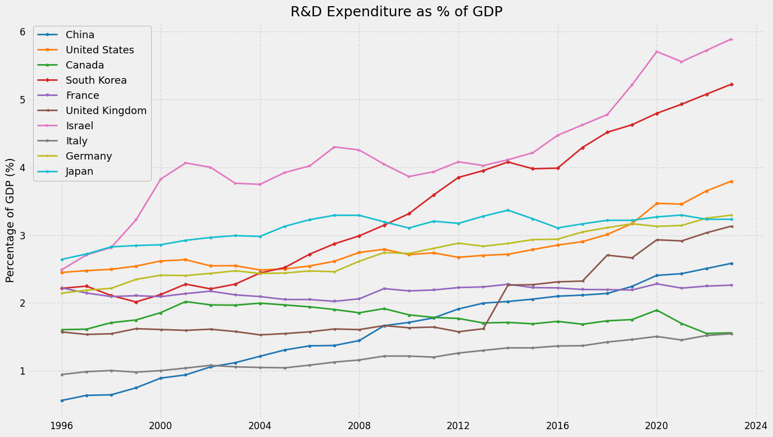
Figure D 22: R&D Expenditure as % of GDP
Figure D22 reveals that Israel and South Korea dedicate a significantly higher percentage of their GDP to R&D compared to other nations, showing strong upward trends. While most countries, including the rapidly growing China, have increased their R&D investment ratio, Canada's proportion has remained relatively flat or even slightly declined in recent years, lagging peers like the US and Germany.

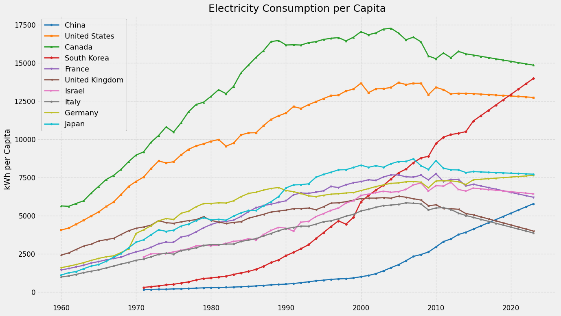
Figure D 23: Electricity Consumption per Capita
Figure D 23 depicts that Canada, and the United States maintain high historical levels of electricity consumption per capita, though recent trends suggest stabilization or decline, contrasting with the rapid growth observed in China and South Korea. European nations and Japan generally show more moderate consumption levels with varied recent trajectories.

Appendix E- Chatbot

This Chatbot is a great tool for understanding Canada’s innovation strategy and the policies proposed in this report. It can be used as a key source to handle commonly asked questions, providing both troubleshooting guidance and 24/7 assistance. It can also have a meaningful conversation with the user by providing data, and key insights on Canada’s innovation Strategy.
Chatbot for Canada’s innovation strategy can be found here:

https://dandrob-chatbot-chatbotfrontendfrontend-streamlit-tdtfty.streamlit.app/

Click on the link to reach the chatbot’s frontend, Figure E1, available to ask about Canada’s innovation strategy.


Figure E 1: Canada's Innovation Strategy Chatbot

Some examples of questions that can be asked can be seen in figure E2, E3, and E4.

