Department of Mechanical & Industrial Engineering

**MIE1624H – Introduction to Data Science and Analytics**

**Course Project**

Made by Group 11 :

| **Name** | **Student ID** |
| --- | --- |
| Edwardo Bassil | 1010830969 |
| Daniel Roberts | 1005809760 |
| Tiffany Costas | 1005854844 |
| Amreen Imrit | 1005902971 |
| Fatima Shabbeer | 1008713215 |
| MohammadAmir Ahmadian Shahreza | 1011679337 |

Delivered to :

**Dr. Oleksandr Romanko**

On date :

**2025-03-10**

Table of contents

I. Introduction 1

II. Innovation data collection 1

1. World leaders’ approach to innovation 1

2. Key lessons for Canada 2

III. Proposal for Canada’s innovation strategy 2

1. Policy 1: Public-Private Commercialization Partnership 2

2. Policy 2: Innovation Tax Advantage 3

1. Current Policy Environment: 4

2. Analysis of Key Challenges 4

Innovation Gaps and Startup Struggles 4

Economic Impact of Corporate Tax and Regulatory Environment 6

Proposal: Innovation Tax Advantage (ITA) Policy 7

Policy Objectives and Fiscal Targets 7

Implementation 7

Expected outcomes 8

References 8

3. Policy 3: Talent Canada Initiative 9

4. Policy 4: Energy Advantage Program 9

Policy Summary 9

**References 11**

**Appendix A-Policy 1 13**

**Appendix B- Policy 2 14**

**Appendix C- Policy 3 15**

# Introduction

Innovation is one of the key drivers of a country’s economic development and global competitiveness. Countries with especially high levels of innovation, such as the United States, Singapore, and Switzerland, often foster vibrant ecosystems that support the growth of world-class companies—like the U.S.’s “Magnificent 7” tech firms, Singapore’s digitally-driven DBS Bank, or Switzerland’s pharmaceutical giant Hoffman-LaRoche. These innovation-driven environments contribute significantly to economic growth, job creation, and the attraction of global talent. However, Canada is struggling to secure a position among the world’s innovation leaders, as reflected in the World Intellectual Property Organization’s Global Innovation Index 2024 (GII), where it ranks 14th [WIPO] (World Intellectual Property Organization (WIPO), 2024). Despite having a highly educated workforce, Canada especially struggles in R&D investments and commercialization, as well as slow adoption of new technologies (The Conference Board of Canada, 2024). To make up for the lost ground, our group created this report aiming to summarize the reason behind Canada’s low innovation index and develop a proposal for Canada’s innovation and development strategy with practical steps of implementation. Finally, we built a large language model chatbot allowing users to have a meaningful conversation about Canada’s innovation strategy.

# Innovation data collection

Countries like the United States, China, Japan, Singapore, Switzerland and many others have adopted policies and frameworks allowing them to be at the forefront of R&D investment, commercialization and adoption of cutting-edge technologies. Analyzing those countries’ approach to innovation helped us develop the best practices Canada should adopt and later formulate them in the format of policies.

## World leaders’ approach to innovation

The USA dominates global innovation due to massive private-sector R&D investment, strong venture capital ecosystems, and government-backed initiatives in AI, quantum computing, and defense technologies. Policies such as the CHIPS and Science Act prioritize semiconductor manufacturing, while the National AI Initiative drives AI commercialization (United States Government, 2023). Although the USA ranks 3rd on WIPO’s GII (behind Switzerland and Sweden), it is home to the biggest and most innovative companies in the world like Apple, Microsoft, NVidia, Alphabet, META and Amazon.

The EU’s Horizon Europe (€90B R&D fund) fuels deep-tech innovation—referring to breakthrough technologies rooted in scientific research— while the AI Act and Digital Markets Act regulate emerging technologies. The EU emphasizes green energy, digital transformation, and semiconductor independence (European Central Bank, 2024).

The UK, which ranks 5th on WIPO’s GII, fosters innovation through R&D tax credits, university-industry partnerships, and the Future Fund: Breakthrough to support tech startups with a £375M scale-up fund. The UK prioritizes biotech, fintech, and AI governance leadership (United Kingdom Government, 2021).

South Korea, which ranks 6th on WIPO’s GII, leads in semiconductors, AI, and digital infrastructure, with $450B invested in chip manufacturing and fast-track regulatory approvals for biotech and AI innovations (World Economic Forum, 2023).

Japan ranks one spot ahead of Canada, at 13th on WIPO’s GII, and invests heavily in their Society 5.0 concept—an initiative that envisions a human-centered, technology-integrated society—along with quantum computing, and AI-powered smart cities, with $900B in R&D over five years (Japan Government, 2022).

Switzerland consistently ranks first in the Global Innovation Index due to an investment of 3.2% of its GDP in R&D, strong university-industry partnerships, and world-class intellectual property protection laws (Switzerland Global Enterprise , 2020).

Singapore’s Smart Nation strategy integrates AI into public services, high-tech manufacturing, and financial technology, while also advancing university-industry partnerships and initiatives to attract and retain engineering talent (Singapore Management University, 2010). These efforts have contributed to Singapore’s rising position in WIPO’s GII, where it currently sits at 4th in 2024 by taking the lead in terms of number of GII innovation indicators for which it ranks top globally, ranking 1st in the world on 14 out of 78 indicators (World Intellectual Property Organization (WIPO), 2024).

Dubai has positioned itself as a future-tech hub by embracing AI, blockchain, and space exploration through government-led innovation accelerators (Dubai Future Foundation, 2023). Dubai is—almost single handedly—driving the UAE to 32nd on WIPO’s GII ranking.

## Key lessons for Canada

Canada’s overall R&D spending is around 1.7% of GDP, highlighting its lack of investment in that area. Canada also struggles at commercialization and adoption of new technologies. For instance, promising academic innovations in biotechnology and clean tech often fail to reach the market due to limited early-stage venture capital and weak university–industry partnerships (Council of Canadian Academies, 2018). Moreover, Canada experiences significant brain-drain of talented innovators to the United States thanks to a more start-up friendly, less regulated environment, as well as a higher earnings potential. This exodus is especially apparent amongst recent software engineering graduates from Canada’s top universities of which two-thirds migrated to the United States (Singer, 2023). A key point to Canada’s lack of success in innovation is the lack of well-constructed intellectual property laws.

Canada must formulate an innovation strategy inspired by Switzerland’s approach of setting an aggressive target of GDP allocation to R&D – who invests 3.2 % of GDP in R&D – and foster university-industry partnerships to help convert that investment to market-ready products. Canada should also focus on attracting and retaining top experts in AI, quantum computing and biotech experts by implementing enticing incentives to limit brain-drain to the USA. Finally, Canada should refine its intellectual property laws to prevent Canadian innovations from being commercialized abroad.

# Proposal for Canada’s innovation strategy

Now that Canada’s weak points are identified, we are better equipped to define policies to improve Canada’s innovation strategy. The following subsections develop four recommended policies based on insights from the *Global Innovation Index (GII) 2022 & 2024* to help Canada strengthen its innovation ecosystem.

## Policy 1: Public-Private Commercialization Partnership

Canada has a strong research foundation but struggles to commercialize innovation at the same pace of global leaders. To address this, the government can implement a Public-Private Innovation Partnership (PPIP) that strengthens collaboration between universities, research institutions, and industry partners, similarly to Singapore’s approach to foster innovation (Singapore Management University, 2010).

The group proposes the creation of the Public-Private Commercialization Partnership policy that integrates the co-investment of private sectors in federally funded research projects. This shifts financial risk away from the government while ensuring that research aligns with market needs. Moreover, the government should create incentives for startups to collaborate with universities which will help R&D transitioning directly into industry applications. Finally, the government should take inspiration from the USA (who directly supported Qualcomm) and implement a government-backed venture fund to help AI, quantum computing and biotech companies to scale globally.

Expected outcomes of the adoption of this policy include increased commercialization rates leading to more Canadian patents developed into market-ready technologies, greater private-sector R&D investment which will reduce the reliance on government grants. Those aspects will enable Canada to achieve a stronger global competitiveness which will enable Canada to retain high-growth startups instead of losing them to the U.S.

## Policy 2: Innovation Tax Advantage

Canada’s high regulatory burden and corporate tax rates discourage startups and high-growth companies from establishing operations domestically, resulting in a brain-drain of ideas and startups to the USA. To create a more competitive business environment, the group advises the government to introduce the Innovation Tax Advantage (ITA) policy, aimed at reducing barriers for startups, scaling companies, and high-tech industries.

This policy’s goals will be to implement tax breaks for innovative sectors such as AI, bio tech, clean tech, and quantum computing startups. The policy will also offer tax incentives for R&D spending and commercialization, similar to the UK’s R&D tax credit model. However, tax breaks alone are not enough to make Canada more competitive in the global innovation race. This policy must also aim towards the deregulation of those high-growth and high-pace industries by heavily reducing bureaucratic delays. Finally, the policy should bring special attention to making Canada more startup-friendly by providing tax exemptions for venture capital investments in Canadian deep-tech startups and eliminating capital gains tax on startup exits to encourage entrepreneurs to reinvest in Canada.

Expected outcomes of this policy include higher startup success rates. By reducing financial and regulatory barriers, Canada will become a preferred destination for high-growth ventures. More companies will also relocate to Canada, driving economic growth and direct investment (FDI). Finally, incentives help startups scale instead of relocating to the U.S. or Europe. If Canada can foster and preserve local startups that eventually scale up, it will fare better in the global innovation scene.

## 

### 1. Current Policy Environment:

In 2025, tax and innovation are covered in a mix of provincial and federal policies. These are mainly focused on supporting R&D in Canada in an effort to foster a competitive business landscape. The primary federal policy is the Scientific Research and Experimental Development (SR&ED) tax credit which provides companies substantial R&D incentives who invest in R&D (Innovation, Science and Economic Development Canada [ISED], n.d.). Another federal policy is the Strategic Innovation fund which aims to support high tech, specifically AI, biotech and clean initiatives(Government of Canada, Budget 2025). On a provincial level, Quebec and Ontario have programs to attract both high growth companies and startups at a local level by enhancing the local innovation ecosystems. (Ontario Ministry of Economic Development, n.d.; Quebec Ministry of Economy, Innovation and Energy, n.d.).

According to Statistics Canada, tax incentives related to innovation account for about 0.2-0.3% of the GDP which results in about 5 billion CAD in annual fiscal expenditure (Statistics Canada, 2025). However, the majority of this spending is directed toward R&D subsidies rather than policies that ease regulatory constraints or provide direct corporate tax breaks. In fact, less than 10% of this expenditure is allocated to initiatives explicitly focused on deregulation and reducing overall corporate tax burdens (Government of Canada, Budget 2025).

### 2. Analysis of Key Challenges

#### Innovation Gaps and Startup Struggles

According to DemandSage/Startup Ranking as of November 2024 (2023), suggests that there is a large difference in success and failure rates between countries(see fig x). What is interesting to note is although Canada has a similar success and failure rate to the US, the amount of startups in US compare to Canada are significantly different with US having over 80K startups and Canada having about 5 k in contrast(see fig x). Furthermore only a small portion of startups actually become unicorns(see fig x). The trends seen in these figure suggest that Canadian startups are impacted by external pressures such as bureaucratic delays and unfavorable tax environments with high failure rates and low number of unicorn startups (<100). This further highlights the need for policy intervention to incentivize risk taking amount the entrepreneurs and lower barriers to growth.

Fig: Startup Failure & Success Rates by Country

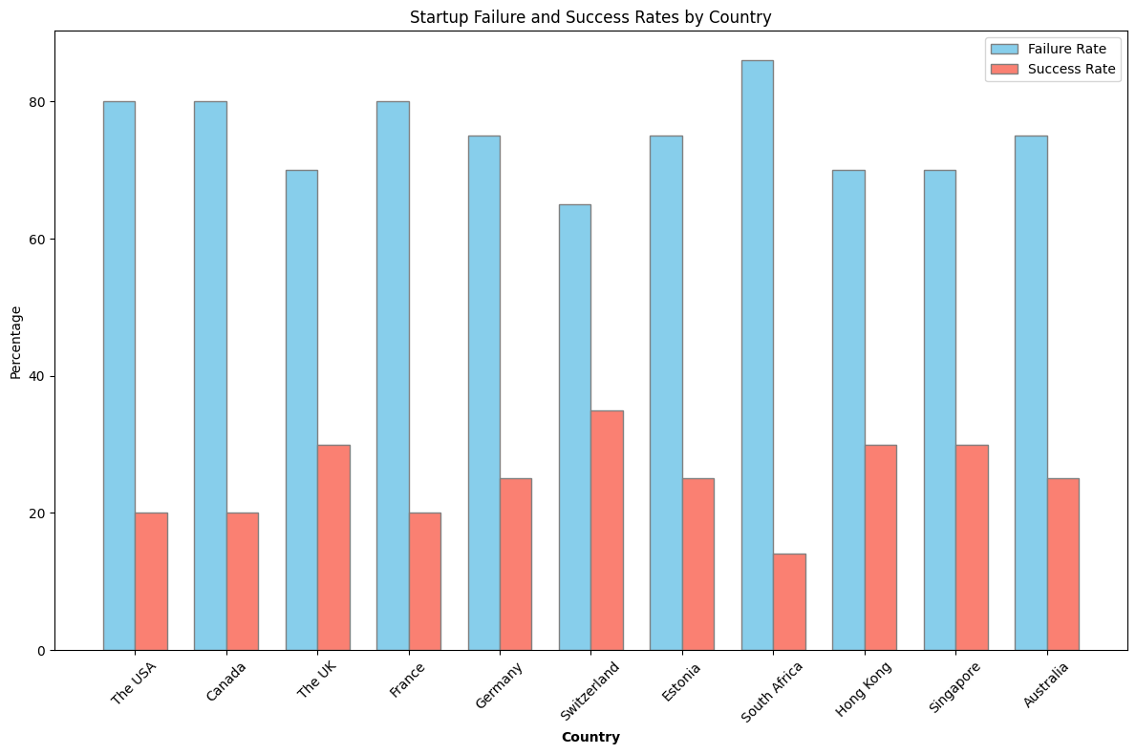

Fig: Number of Startups by country

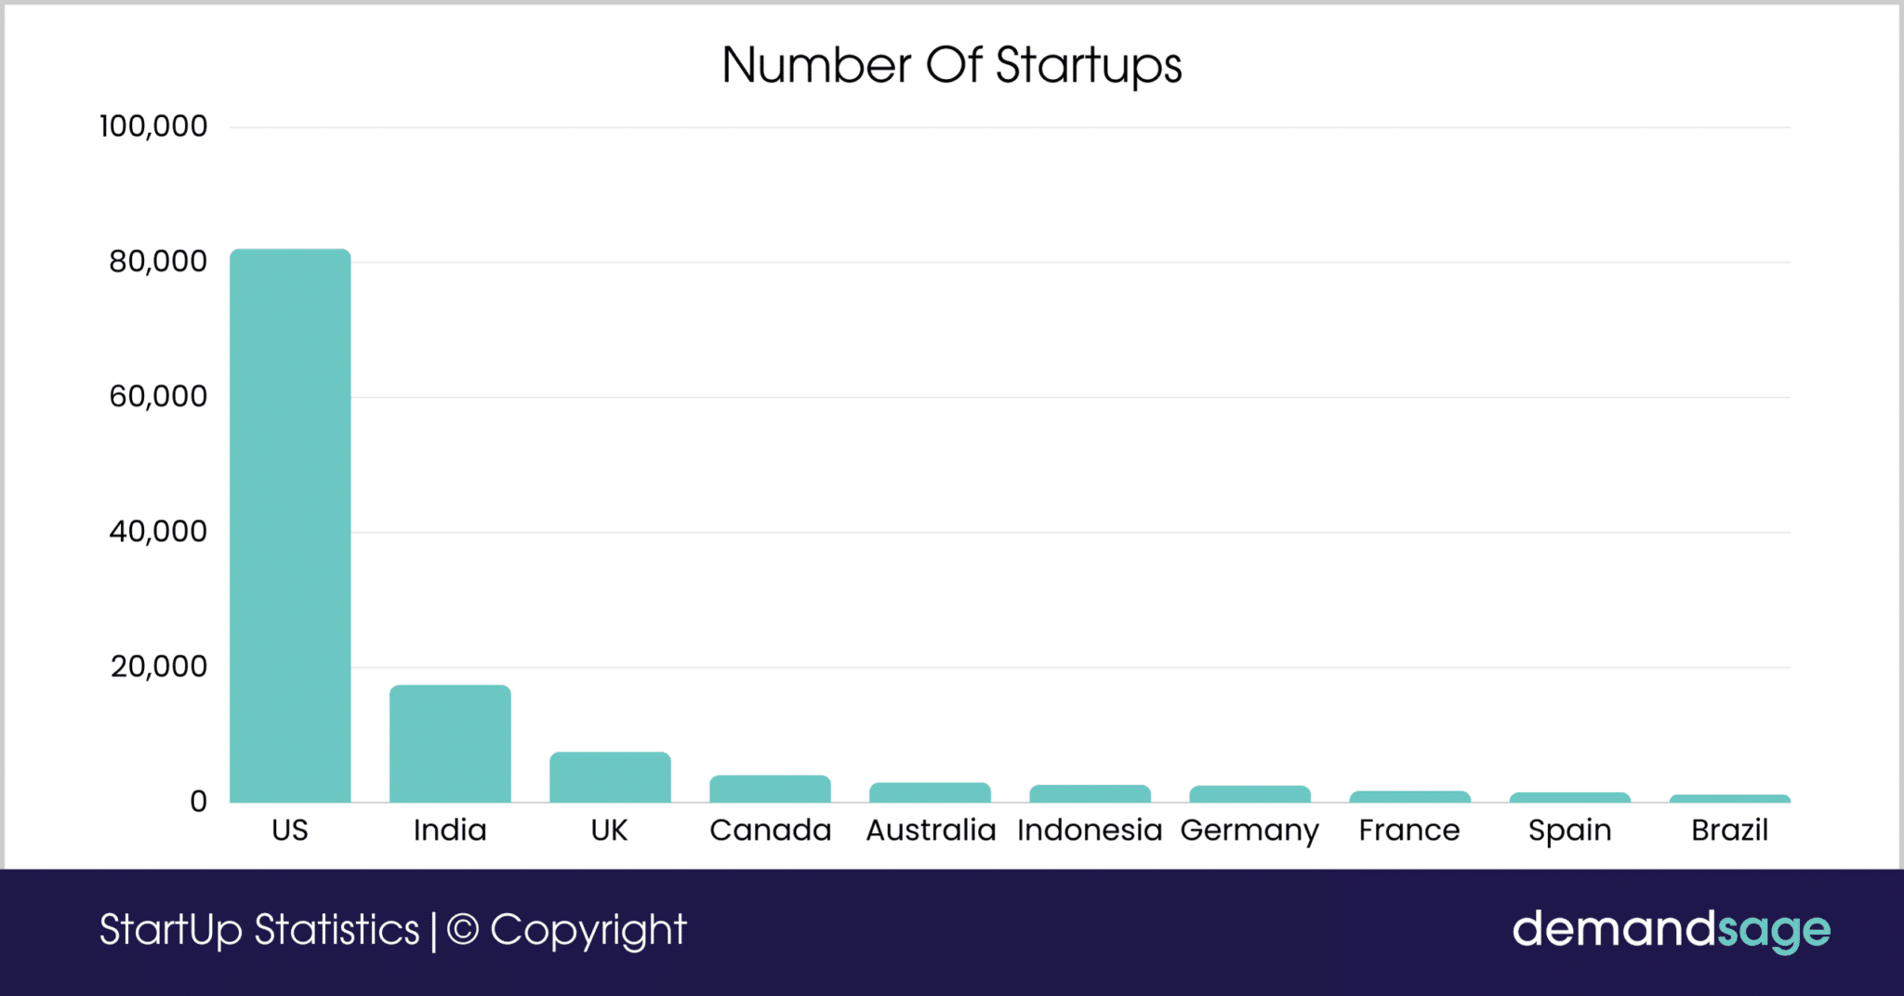

Fig: Number of Unicorn Startups in 2022 and 2023 by country

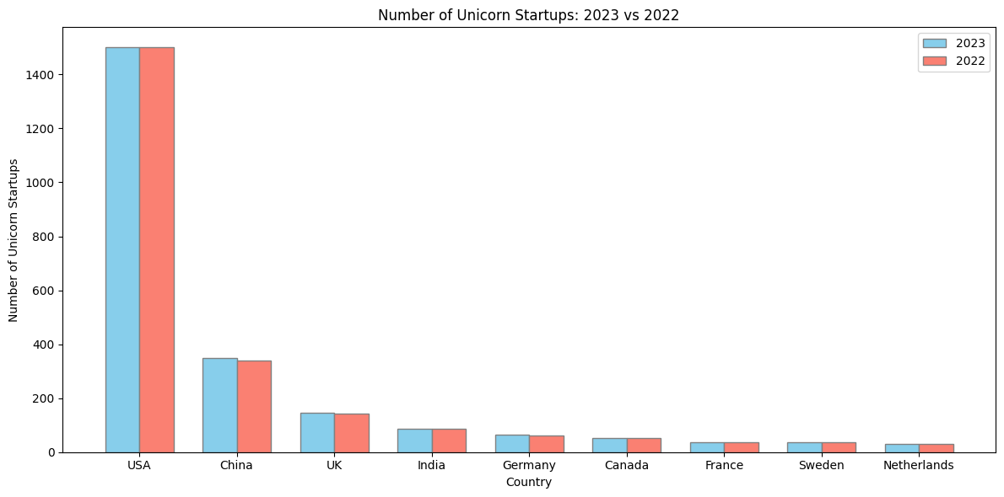

Furthermore when exploring the sentiment for entrepreneurship, the global Entrepreneurship monitor (GEM) highlights a concerning trend in Canada for entrepreneurs, where there is high fear or failure leading to a moderate intention for entrepreneurship among a population of 18-64 years (see fig x & x). This is a stark difference from the US <add more comparisons here>. This shows that Canada risk adverse culture hinders formation and growth of startups, where entrepreneurs feel that the psychological and financial costs of failure are significant. The ITA policy would aim to lower the concerns and stakes for startups through corporate tax breaks, venture capital incentives and deregulation in an effort to enhance Canada's position globally in terms of innovation.

Fig: Fear of Failure Rate 2023 by country

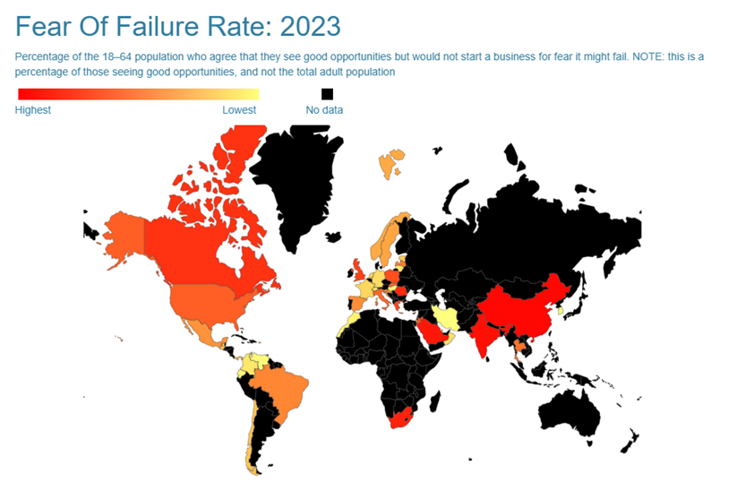

Fig: Entrepreneurial Intentions 2023 by country

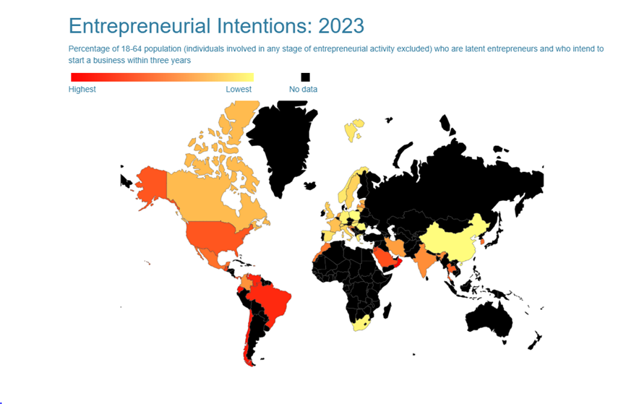

#### Economic Impact of Corporate Tax and Regulatory Environment

Analyses from the World Bank and OECD further support the need for the ITA policy. A correlation matrix (see fig x) indicates a negative relationship between corporate tax rates and GDP growth. This means that as corporate taxes rise, the overall economic expansion tends to slow down. Additionally, a separate analysis (see fig x)) shows a negative correlation between corporate tax rates and venture capital (VC) investment levels at the year level. Lower corporate taxes are associated with higher VC activity, which is essential for fueling innovation and providing the capital that startups need to scale.

Moreover, data examining Tax Revenue as a percentage of GDP versus overall GDP (see fig x)) and corporate tax levels versus GDP per capita (see fig x) suggest that while tax revenue is necessary for public investments, an excessively high tax burden can suppress economic performance. These insights are reinforced by further analysis of R&D Expenditure (as a percentage of GDP) against GDP per capita in purchasing power parity (PPP) terms (see fig x)). Although Canada invests in R&D, the relative benefits are limited by the overall fiscal environment, which does not optimally reward high-growth, innovative ventures.

While R&D subsidies have supported research efforts, the current framework does not adequately address the broader economic and regulatory barriers—resulting in a brain-drain of innovative startups to markets like the USA and Europe.

### Proposal: Innovation Tax Advantage (ITA) Policy

#### Policy Objectives and Fiscal Targets

The primary goals of the ITA policy are to:

* Incentivize Innovation in Key Sectors: Offer targeted tax breaks for innovative sectors such as artificial intelligence, biotech, clean tech, and quantum computing.
* Enhance R&D and Commercialization Incentives: Extend tax credits for research and development (R&D) spending and commercialization activities, modeled after successful frameworks like the UK’s R&D tax credit program (UK Government, n.d.).
* Streamline Regulatory Processes: Implement robust deregulation measures that significantly reduce bureaucratic delays without compromising necessary safeguards.
* Encourage Venture Capital Investment: Provide tax exemptions for venture capital investments in Canadian deep-tech startups and eliminate capital gains tax on startup exits to encourage reinvestment.

For the short term, this fiscal target commitment for this policy should allocate about 0.2% (CAD 4 Billion) of Canada’s GDP on tax advantages and regulatory reform. In the long term, this should be increased to 0.3% (CAD 6 billion) of GDP by 2030 to ensure that fiscal expenditure for innovation continues to scale with economic growth.

#### Implementation

1. **Balanced Fiscal Impact:** Ensure tax breaks and deregulation measures stimulate innovation without causing significant revenue losses or undermining public services (World Bank, OECD, n.d.).
2. **Robust Regulatory Oversight:** Establish clear guidelines and performance metrics to remove only unnecessary red tape while preserving essential safeguards.
3. **Adaptive Policy Framework:** Incorporate periodic reviews and adjustments through an independent oversight body to keep pace with evolving technologies and global economic trends. Assess the policy’s performance against key innovation and economic indicators—such as venture capital flows, startup success rates, and GDP growth.
4. **Provincial Alignment:** Implement ITA as a joint federal-provincial initiative to tailor complementary measures to regional needs, ensuring nationwide impact.

#### Expected outcomes

* **Enhanced Global Ranking:** Improved fiscal and regulatory conditions could boost Canada’s position on the global innovation tax index.
* **Higher Startup Success:** Lower financial and regulatory barriers will help more startups scale successfully within Canada, reversing the current brain-drain.
* **Increased Foreign Direct Investment:** A competitive innovation tax environment will attract both domestic and international investors.
* **Stimulated VC Activity:** Empirical data show that lower corporate taxes correlate with higher venture capital investments, fueling further growth.

### **References**

* Global Innovation Index. (2024). Global Innovation Index Ranking. Retrieved from<https://www.globalinnovationindex.org/>
* UK Government. (n.d.). R&D Tax Credits. Retrieved from<https://www.gov.uk/guidance/corporation-tax-research-and-development-tax-relief>
* Innovation, Science and Economic Development Canada (ISED). (n.d.). Retrieved from<https://www.ic.gc.ca>
* Government of Canada. (2025). Budget 2025. Retrieved from the official Government of Canada website. <https://www.budget.gc.ca/2025/home-accueil-en.html>
* Statistics Canada. (2025). [Economic and fiscal data]. Retrieved from the Statistics Canada website. <https://www.statcan.gc.ca/eng/start>
* Ontario Ministry of Economic Development. (n.d.). [Initiatives and programs].<https://www.ontario.ca/page/minister-economic-development-job-creation-and-trade>
* Quebec Ministry of Economy, Innovation and Energy. (n.d.). [Policy initiatives]. <https://www.economie.gouv.qc.ca/en/>
* ISED. (2017). National Innovation and Science Agenda. <https://www.ic.gc.ca/eic/site/093.nsf/eng/00004.html>
* DemandSage. (2023). Startup Statistics: Failure and Success Rates by Country. Retrieved from [DemandSage Startup Statistics → https://www.startupranking.com/countries](https://www.demandsage.com/startup-statistics/)
* World Bank & OECD Data. (2021–2022). Various economic indicators.
* Global Entrepreneurship Monitor (GEM). (2024). Entrepreneurial Intentions in Canada. Retrieved from<https://www.gemconsortium.org/data>

### 

## Policy 3: Talent Canada Initiative

Canada is experiencing a growing brain drain, with skilled professionals—particularly in AI, biotech, and engineering—relocating to the U.S. and other countries for higher salaries, stronger venture capital ecosystems, and better commercialization opportunities. To maintain its global competitiveness, Canada must implement the Talent Canada Initiative (TCI) to retain high-skilled workers and attract global talent.

The group proposes a policy that offers tax breaks for STEM professionals and startup founders to make Canada more financially competitive with the USA. The group also proposes the implementation of a stock option tax benefit for employees in high-growth startups, similar to the U.S. Silicon Valley models. Moreover, by increasing the government’s budget allocated to R&D, researchers’ compensation levels could be pushed higher to incentivize those skilled workers staying in Canada. Finally, Canada being reliant on immigration, the policy includes a visa program that provides expedited residency for highly skilled professionals who commit to working in Canada.

By adopting this policy, Canada is expected to reduce brain-drain to the USA and retain highly skilled AI, quantum computing and biotech workers which will drive salaries up and foster an entrepreneurial mindset that will lead to more domestically grown startups.

## Policy 4: Energy Advantage Program

Energy costs are a critical factor in business investment, manufacturing, and high-tech infrastructure, particularly in industries like AI-driven data centers, advanced manufacturing, and clean technology. To attract global investment and ensure economic competitiveness, Canada can implement the Energy Advantage Program (EAP) to provide cheaper, reliable, and sustainable energy for businesses and innovation hubs.

The group proposes a policy consisting of Canada exploiting its high reserves of natural resources to achieve cheaper energy costs while reinvesting a portion of the profits in green tech startups and green energy programs. Canada has the third largest oil reserves and the fourth largest uranium reserves in the world which can both be leveraged to lower energy prices and undercut the USA’s electricity rates. Moreover, nuclear energy is both powerful and clean and can be used to power tech-driven industries like datacenters who are notorious for being power hungry. Combining that aspect with discounted electricity rates for data centers, AI research labs, and semiconductor manufacturing plants is expected to heavily encourage global firms to relocate to Canada. Finally, this policy suggests that Canada will use revenue from expanded energy exports to fund next-generation renewables (fusion, advanced wind/solar, smart grids) and position Canada as a leader in both affordable energy and green innovation.

## 

## Policy Summary

## 

|  | Short term | Long term |
| --- | --- | --- |
| Current | 1.6-1.7 % of GDP | |
| Policy 1 | .2 | .3 |
| Policy 2 |  |  |
| Policy 3 |  |  |
| Policy 4 |  |  |
| Goal |  | 3% of GDP |

## 

# References

| [WIPO] | World Intellectual Property Organization (WIPO). (2024). Global Innovation Index 2024: Unlocking the Promise of Social Entrepreneurship. Retrieved from https://www.wipo.int/web-publications/global-innovation-index-2024/assets/67729/2000%20Global%20Innovation%20Index%202024_WEB3lite.pdf |
| --- | --- |
|  |  |
|  |  |
|  |  |
|  |  |
|  |  |

* Council of Canadian Academies. (2018). *Competing in a Global Innovation Economy : The Current State of R&D in Canada.* Retrieved from https://cca-reports.ca/wp-content/uploads/2018/09/Competing_in_a_Global_Innovation_Economy_FullReport_EN.pdf
* Dubai Future Foundation. (2023). *The Global 50.* Retrieved from https://www.dubaifuture.ae/wp-content/uploads/2023/04/THE-GLOBAL-50-EN.pdf
* European Central Bank. (2024, September 9). *The Future of European Competitiveness.* Retrieved from https://commission.europa.eu/topics/eu-competitiveness/draghi-report_en#paragraph_47059
* Japan Government. (2022, June 30). *Integrated Innovation Strategy 2022: Making Great Strides Toward Society 5.0.* Retrieved from https://www.japan.go.jp/kizuna/2022/06/integrated_innovation_strategy.html
* Singapore Management University. (2010). *The National Innovation System of Singapore.* Retrieved from https://ink.library.smu.edu.sg/cgi/viewcontent.cgi?params=/context/soe_research/article/2218/&path_info=NationalInnovationSysSingapore_av.pdf
* Singer, C. R. (2023, September 26). *Canada’s Brain Drain: Figures Show Technology Graduate Exodus.* Retrieved from Immigration.ca: https://immigration.ca/canadas-brain-drain-figures-show-technology-graduate-exodus/?utm_source=chatgpt.com
* Switzerland Global Enterprise . (2020). *Swiss Innovation.* Retrieved from https://www.s-ge.com/sites/default/files/publication/free/factsheet-innovation-switzerland-s-ge-en-2020_1.pdf
* The Conference Board of Canada. (2024, April 11). *2024 Innovation Report Card: Benchmarking Canada’s Innovation Performance.* Retrieved from https://www.conferenceboard.ca/product/innovation-report-card_2024/
* United Kingdom Government. (2021, March). *Build Back Better : Our Plan for Growth.* Retrieved from https://assets.publishing.service.gov.uk/media/6048fd05d3bf7f1d16e263fd/PfG_Final_Web_Accessible_Version.pdf
* United States Government. (2023). *United States Government National Standards Strategy for Critical and Emerging Technology.* Retrieved from https://bidenwhitehouse.archives.gov/wp-content/uploads/2023/05/US-Gov-National-Standards-Strategy-2023.pdf
* World Economic Forum. (2023, January 13). *Korea’s new innovation strategy: Digital Platform Government.* Retrieved from https://www.weforum.org/stories/2023/01/davos23-korea-digital-platform-government/
* World Intellectual Property Organization (WIPO). (2024). *Global Innovation Index 2024: Unlocking the Promise of Social Entrepreneurship.* Retrieved from https://www.wipo.int/web-publications/global-innovation-index-2024/assets/67729/2000%20Global%20Innovation%20Index%202024_WEB3lite.pdf

# Appendix A-Policy 1

# Appendix B- Policy 2

# Appendix C- Policy 3