**Nazarbayev Intellectual School of Physics and Mathematics in Astana**

**AI-driven medical skills training platform**

**Section:**

Computer Programming

**Completed by:**

Danial Iskakov 12F

Bexultan Karimtayev 12F

Arsen Argandykov 12B

**Supervisor:**

Deputy Director for scientific and methodological work of NIS Ph&M Astana

Kayirkenova Raigul Altynbekovna

**Astana 2025**

**Table of Contents**

Abstract 3

Introduction 4

Chapter 1. MATERIALS AND METHODS OF RESEARCH 5

1.1 Research materials 5

1.2 Social problems of Kazakhstan 5

1.3 The problem of non-sale of goods 5

2. THE METHOD OF SOLVING THE PROBLEM 7

2.1 Tools 7

2.2 Website layout 7

2.3 Creating the front-end part 8

2.4 Creating the back-end part 11

2.5 Algorithm implementation 13

CONCLUSION 19

Reference List 20

# Abstract

**The purpose of the study:** The development of charity in the country, the elimination of corruption in this area and the centralization of volunteerism in general.

**Hypothesis:** The direct aid distribution platform “Úles” will be able to ensure transparency in the delivery of aid from the sender to the recipient, reducing the human factor to a minimum.

Experimental methodology

We launched a beta test of the application and registered the products, after which we checked the work of the distribution algorithm using a separate button. The products were distributed among all users whose profile type is consumer.

The novelty of the research and the degree of independence

In our country, there is still no implementation of volunteering using technologies and algorithms to optimize the distribution of humanitarian aid among socially vulnerable segments of the population. Also, our project allows stores to get an alternative to the export of irrelevant goods.

Results and conclusions:

1. A platform has been created and the initial areas of activity have been identified.
2. The prospects of the platform have been identified
3. A distribution algorithm was created and filed for a patent.

Areas of practical use of the results:

Using this platform in the field of business will help to use resources. Also, for volunteer organizations and in working with the state, our platform will be a good alternative to bureaucracy.

# Introduction

Every year, inflation in our country is growing and more and more people are below the poverty line, which leads to the fact that people lack basic food and clothing. At the same time, there are organizations that want to help, but cannot fully cover the entire poor segment of the population.

To solve this problem, we decided to create a platform for issuing direct assistance that will be able to:

* Centralize volunteer and community organizations.
* Minimizes bureaucracy.
* Will connect donors, volunteers, and those in need.

To implement the project, it is required:

1. Create the layout and design of the site.
2. Create an algorithm for distributing aid.
3. Create a website mechanism and its interface.
4. Attract and create a volunteer community.

# MATERIALS AND METHODS OF RESEARCH

## Research materials

In this study, we use data from the UNFPA report on the state of the population in Kazakhstan. 61% of large families have four children, 19.4% have five, 13.6% have six, 5.1% have seven, and the proportion of families with eight or more children does not exceed 1%. 83% of large families have preschool children, 97.6% of large families have school children [1].

## Social problems of Kazakhstan

According to UNFPA, 61% of large families in Kazakhstan have four or more children, while such families have a higher level of poverty. According to the article on the website Informburo.kz There are about 90 thousand poor families in Kazakhstan, which is about 1.2% of the total population [2]. These families have difficulty accessing food and other vital goods. In addition, inflation in Kazakhstan in 2022 amounted to 20.3% [3], which may lead to an increase in prices for food and other goods, which, in turn, will reduce the availability of these goods for the poor and vulnerable segments of the population.

## The problem of non-sale of goods

Studies show that throwing out irrelevant goods is a significant problem in Kazakhstan, leading to significant losses for stores and environmental problems.

According to a study conducted by the National Office for Standardization and

Metrology of Kazakhstan in 2020, about 30% of food is thrown away in the country [4]. This means that every third product in the store can be thrown away, which is a huge cost for stores.

The main reasons for discarding food in Kazakhstan, as in other countries, include expired shelf life, damaged packaging, poor quality of products, errors in ordering, low speed of sale and insufficient understanding of consumer needs. At the same time, according to the data provided by the Statistics Committee of the Ministry of National Economy of the Republic of Kazakhstan, the average turnover rate of goods in stores in Kazakhstan is 2.3 turnover per week, which is quite low [5].

# THE METHOD OF SOLVING THE PROBLEM

## Tools

To achieve our goals, we decided to create a special web platform. This web application will be implemented using Nextjs for the interface part and Django for the server part. Also, we imlemented the AI with the OpenAI API to simulate a dialog with patients. And to process requests and transfer data between Django and NextJS, we used Django rest of the framework, which includes the JWT token function that we used for registration.

## Development of the Frontend

The landing page is quite simple, contains a Header, in which you can register or log in, as well as a button to start simulation, clicking on which the user will go to the page with simulations

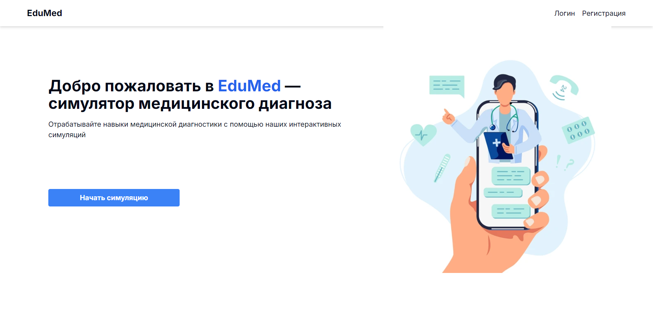

Figure 1. Landing page

The user registration page is demonstrated below

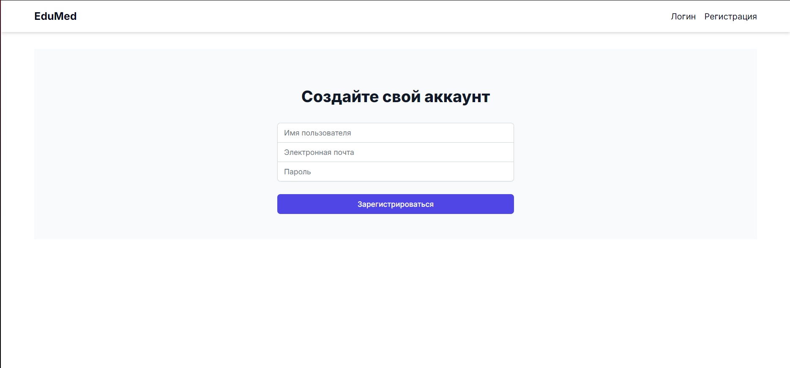

Figure 2. Registration page

You can then go to your profile where you can see your points, top users and personal information.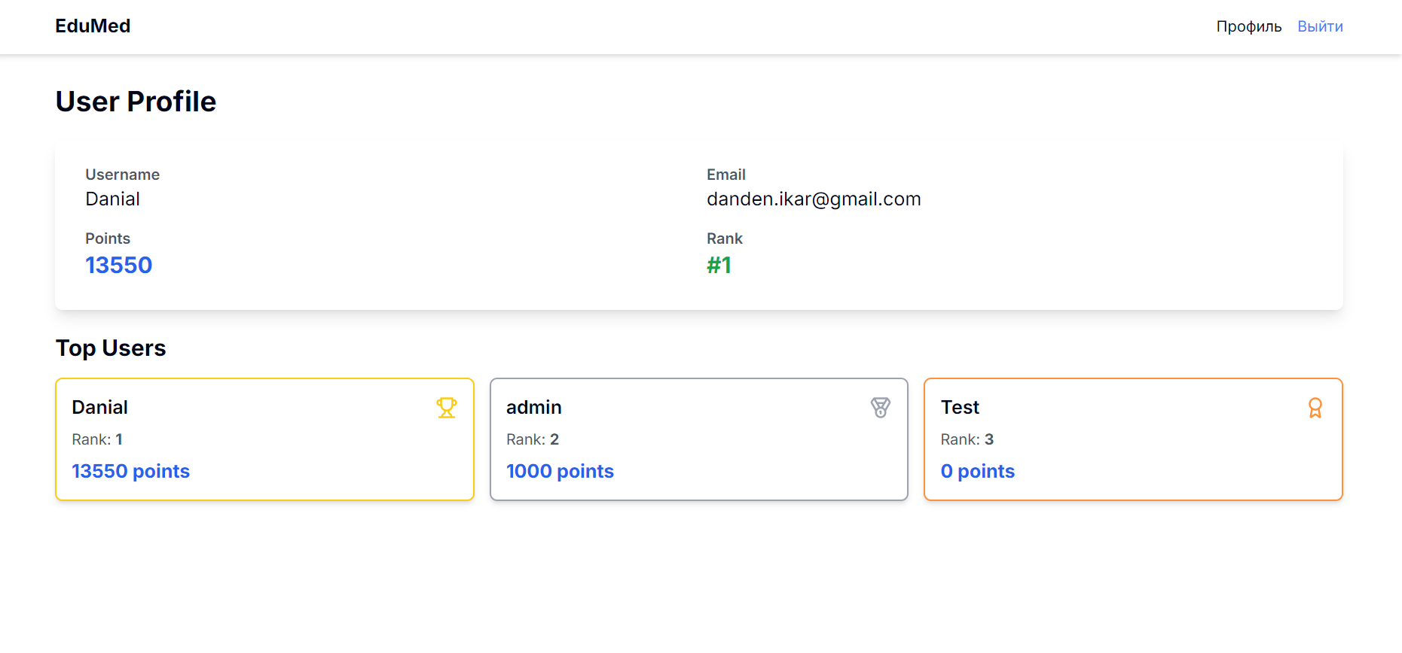

Figure 3. User profile

Technologies used to create the functional:

**Next.Js:** This is a framework for developing web applications in JavaScript. It allows us to create fast and scalable applications using modern technologies such as React.

**TailwindCSS:** This is a tool for fast and convenient development of user interfaces. It provides ready-made components and classes that can be used to quickly create styles and markup.

**Axios:** This is a library for executing HTTP requests from JavaScript. It allows us to exchange data easily and conveniently between the client and the server.

## Development of the Backend

When creating the site, we decided to use the Python – Django framework, which is convenient for working with Next.js and this library has many methods and functions that we used when creating the project. Also, in addition to Django, we chose RestFramework, which is very convenient for working and testing the backend part without the front-end.

The first thing we decided to implement was registration. We decided to use the technology of JWT tokens, with which we stored user information on the front-end part, encrypting personal data.

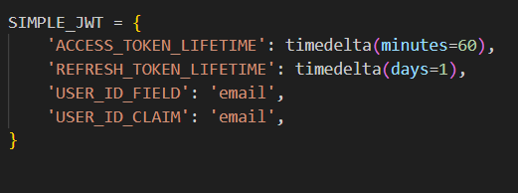

Figure 4. Token Setup

The simple-jwt library gives us ready to use views to create, update and check tokens, so we just need to connect it through the routes. Also we connect admin page and other apps within the application.

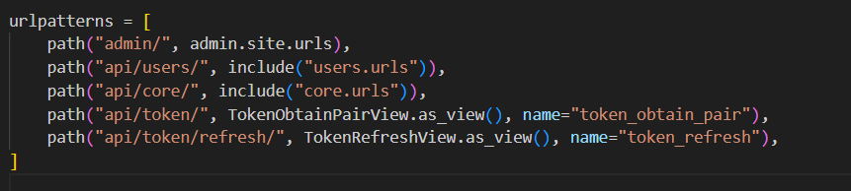

Figure 5. Adding main routes

These tokens contain information about the user, specifically basic information (email, username) and role of the user (admin or not).

Those fields are stored in the sqlite3 database, where we create new records with the help of the Django models that we created.

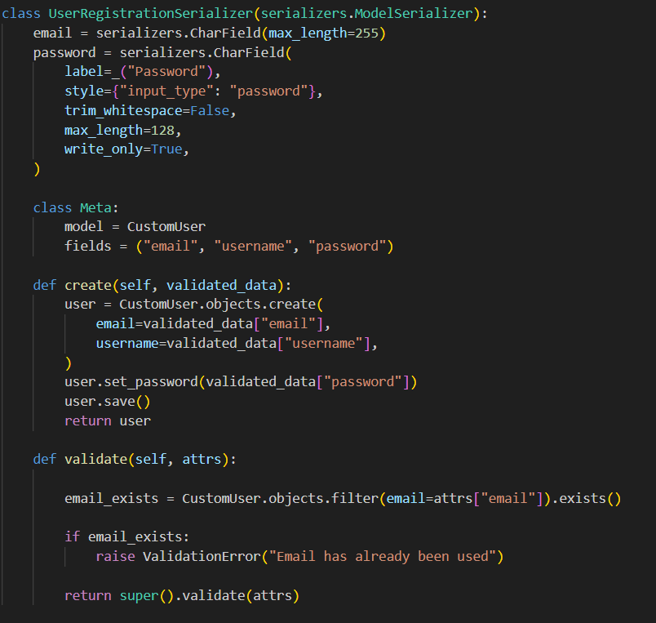

Figure 6. User Serializer

After receiving user data, it is created using special functions and saved as a unique object.

## Creating a simulation

To create the simulations themselves, we first created a prompt for the AI to simulate diagnosis with a doctor. In this prompt we prescribed its behavior depending on the complexity, and prepared a separate list of diseases, from which it chooses a random one and creates a character. It also generates answers to common questions in advance to optimize the process of dialog with the user.

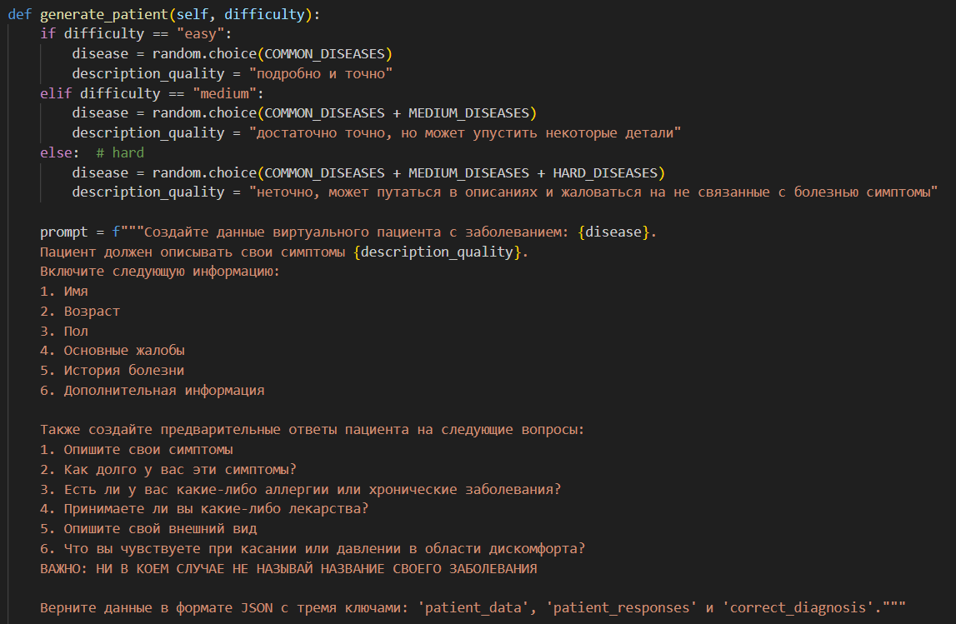

Figure 7. AI prompt

Every game is a chat with AI, so we created special models to store important chat data, message order, disease, patient data and feedback ii sent to the frontend for display.

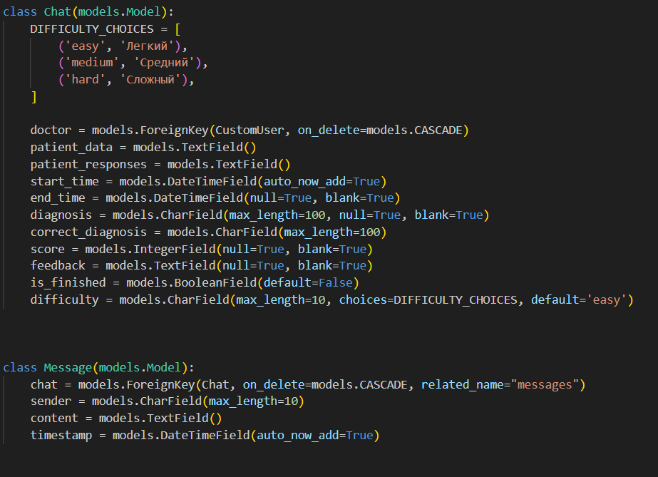

Figure 8. Chat and Message models

During dialog the user asks questions, which are passed to a special function on the backend, and then the AI answers the question with the help of another prompt, so the game is played as a dialog.

Изображение выглядит как текст, снимок экрана, программное обеспечение

Контент, сгенерированный ИИ, может содержать ошибки.

Figure 9. Answer to user question

Once the user is confident over his answer, he can close the game by sending his answer to the backend to a special function that generates feedback from AI using artificial intelligence and evaluates the user's performance according to criteria.

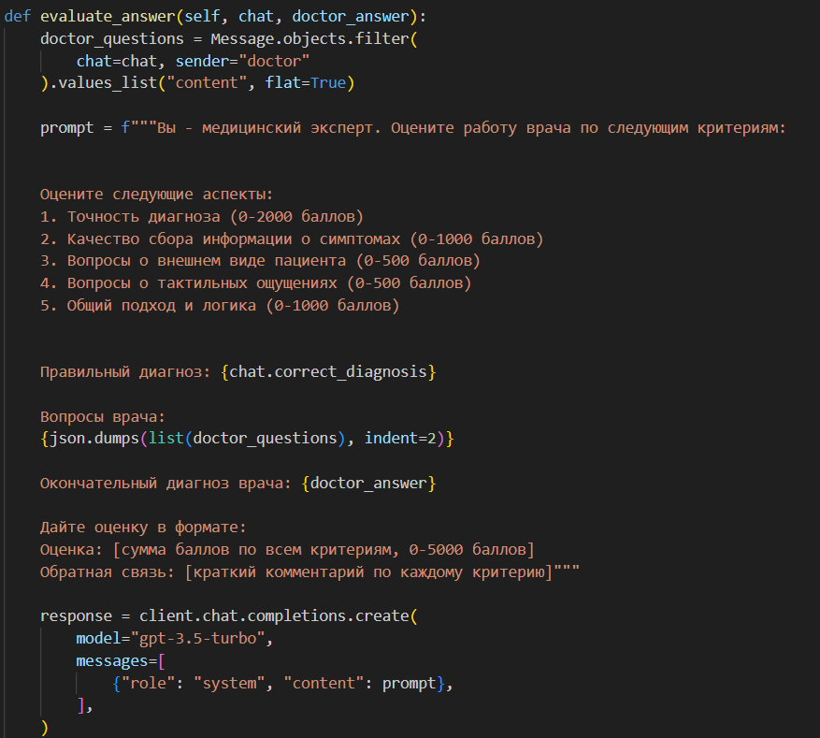

Figure 10. Answer evaluation

At the bottom there is a figure showing the interface of the game itself, where you can create a simulation, view previous simulations, dialog with the AI and finish the game.

Изображение выглядит как текст, снимок экрана, программное обеспечение, веб-страница

Контент, сгенерированный ИИ, может содержать ошибки.

Figure 11. Simulation interface

# CONCLUSION

The results of the research conducted:

1. There are a huge number of vulnerable social strata in our country who lack the means to live.
2. Most of the products that are suitable for use are discarded without recycling due to non-relevance.
3. Most people are not informed about the places where assistance is provided to socially vulnerable segments of society and those in need.

Summary of the results:

The direct assistance platform “Úles” can solve many social problems and provide vulnerable social strata with essential products. Also, this platform allows you to unite a huge number of people into a single society, where people will be able to directly help those who need it, while receiving their benefits in the form of points that PR organizations.

# Reference List

1. UNFPA Kazakhstan (n.d.). Population Situation Analysis Kazakhstan. Retrieved from https://kazakhstan.unfpa.org/en/publications/population-situation-analysiskazakhstan

1. Informburo.kz (n.d.). 90% бедных семей Казахстана – многодетные. Retrieved from https://informburo.kz/stati/90-bednyx-semei-kazaxstanamnogodetnye

1. Kazinform (2022). Inflation hit 20.3% in Kazakhstan in 2022. Retrieved from https://en.inform.kz/article/inflation-hit-203-in-kazakhstan-in-2022

1. Rödl & Partner (n.d.). Effectiveness of Waste Management in Kazakhstan: New

Environmental Code “Quo vadis”. Retrieved from

https://www.roedl.com/insights/kazakhstan-waste-management-effectivenessenvironmental-code

1. Bureau of National Statistics of the Agency for Strategic planning and reforms of the Republic of Kazakhstan (n.d.). Statistics of domestic trade. Retrieved from https://stat.gov.kz/en/industries/economy/local-market/