

Software Requirements Specification

for

Dungeons and Dragons Creative Management System

Version <1.0>

Prepared by

Group Name: Team DMRT

|  |  |  |
| --- | --- | --- |
| Daniel Garrett | 11578525 | [daniel.garrett@wsu.edu](mailto:daniel.garrett@wsu.edu) |
| Matthew Fritz | 11588097 | [matthew.fritz@wsu.edu](mailto:matthew.fritz@wsu.edu) |
| Trevor McLam | 11253274 | [trevor.mclam@wsu.edu](mailto:trevor.mclam@wsu.edu) |
| Ruth Woodcock | 11595951 | [ruth.woodcock@wsu.edu](mailto:ruth.woodcock@wsu.edu) |

|  |  |  |
| --- | --- | --- |
|  |  | |
| Date: 10/25/2019 | |  | |
|  |  | |
|  |  | |
|  |  | |

Contents

Contents ii

Revisions iii

1 Introduction 1

1.1 Document Purpose 1

1.2 Product Scope 1

1.3 Intended Audience and Document Overview 1

1.4 Definitions, Acronyms, and Abbreviations 1

1.5 Document Conventions 2

1.6 References and Acknowledgments 2

2 Overall Description 3

2.1 Product Perspective 3

2.2 Product Functionality 3

2.3 Users and Characteristics 4

2.4 Operating Environment 4

2.5 Design and Implementation Constraints 4

2.6 User Documentation 4

2.7 Assumptions and Dependencies 4

3 Specific Requirements 5

3.1 External Interface Requirements 5

3.2 Functional Requirements 5

Behavior Requirements 6

4 Other Non-functional Requirements 7

4.1 Performance Requirements 7

4.2 Safety and Security Requirements 7

4.3 Software Quality Attributes 7

Appendix A – Data Dictionary 8

Appendix B - Group Log 9

Revisions

| Version | Primary Author(s) | Description of Version | Date Completed |
| --- | --- | --- | --- |
| Initial Edition  1.0 | Daniel Garrett, Matthew Fritz, Trevor McLam, Ruth Woodcock | Initial writing of the entire SRS to our minimum goals for the project. | 10/25/19 |

# 

# Introduction

The Dungeons and Dragons Character Management System is designed to help streamline the character creation experience by collecting all the player creation rules into a single easy to use system. In the following sections, the Purpose, Scope, Users, Abbreviations, Conventions, and References of this project are described.

## Document Purpose

The DnD Character Management System version 1.0 is a system designed to assist players of 5th edition Dungeons and Dragons (DnD) in creating and viewing their Dungeons and Dragons Character Sheets. All Players will be able to create Dungeons and Dragons Characters through a step by step process. Players with a login can save, access and revise previously made Character Sheets associated with their accounts. Players may also print a copy of their Character Sheet.

## Product Scope

The DnD Character Management System (DnDCMS) is designed to allow players to create, save, access and revise Characters pertaining to the Core Ruleset of 5th edition of Dungeons and Dragons. Creating Characters for previous editions, other roleplaying games or using 3rd party resources is outside the scope of this program. The DnDCMS should allow Players to have an easier and more streamlined paperless Player Creation experience by distilling all the player creation rules and choices out of the core 5th edition DnD rule books into one easy to follow system. Players may print a copy of their Character Sheet for future reference.

## Intended Audience and Document Overview

There are two types of user that may make use of the DnD Character Management System:

1. Players and persons who have a working knowledge of DnD, 5th edition

Players may create characters, save characters under their user name, and print character sheets for reference. Players may update their status as they play the game.

2. Professor of CS 320 Software Engineering class, Dr. Xinghui Zhao

This system is not intended for unassisted new players of DnD, 5th edition.

## Definitions, Acronyms, and Abbreviations

5e ­― Fifth edition

#d# ­― The first "#" refers to the quantity of dice rolled, the second "#" refers to the size of the dice. E.g. 4d6 is 4 6 sided die.

AC ­― Armor class

CHA ­― Charisma

CON ­― Constitution

DEX ­― Dexterity

DnD ― Dungeons and Dragons

DnDCMS ― Dungeons and Dragons Character Management System

HD ­― Hit Dice

HP ­― Hit Points

INT ­― Intelligence

PC ­― Player character

STR ­― Strength

WIS ­― Wisdom

XP ― Experience Points

## Document Conventions

Formatting Conventions:

In general, this document follows the IEEE formatting requirements. The font is Arial size 11, or 12 throughout the document for text. Italics are used for comments. Document text is single-spaced unless extra spacing is needed for clarity as in Section 1.4 Acronyms and Abbreviations. Margins are 1”.

## References and Acknowledgments

Jeremy Crawford, Mike Mearls. Dungeons and Dragons Player’s Handbook. Renton, WA: Wizards of the Coast LLC, 2014.

Jeremy Crawford, Mike Mearls. Dungeons and Dragons Xanathar’s Guide to Everything. Renton, WA: Wizards of the Coast LLC, 2017.

Steve Kenson. Dungeons and Dragons Sword Coast Adventurer's Guide. Renton, WA: Wizards of the Coast LLC, 2016.

Mike Mearls. Dungeons and Dragons Volo’s Guide to Monsters. Renton, WA: Wizards of the Coast LLC, 2016.

# Overall Description

## Product Perspective

This product will give the user the ability to easily create a Dungeons and Dragon 5e Character. By streamlining the character creation process, the user will be able to fill out specifics about their character. Some of the character specifications require the user to roll dice; an automated dice roller will also be provided to the user to further streamline the character creation process.

## Product Functionality

* Character Manager
  + Create character
  + Save character
  + Print character
  + Revise character
* Dice Roller

## Users and Characteristics

This product assumes the only users will be players of DnD 5e. The product is designed with players in mind. The pertinent characteristics of this audience include imagination, curiosity, and cooperation. Because the intended audience is Dungeon and Dragons players looking for a streamlined character creation process, these pertinent characteristics will be the foundation of their decision making behind designing characters.

## Operating Environment

The system will run in the Windows operating environment. The main internet browser the product will use is Google Chrome because Chrome can be used by all operating systems. Users will be able to run the application in Mozilla Firefox. The minimum requirements for Windows are as follows:

* Windows 7, Winndows 8.1, Windows 10 or later
* An Intel Pentium 4 processor or later that is SSE2 capable

## Design and Implementation Constraints

The hardware constraints the user will encounter are any of the requirements found in section 2.4; if the user’s set up does not meet the specified requirements, the user may not be able to access the product. The user must have access to the internet either through a WiFi chip or an ethernet cable. The product will be in the English language. All security will be handled by the Django web framework. The product is not designed to be handled by a large organization, only individual users.

## User Documentation

The product will contain an “About” page that will provide an in-depth explanation of each element in the character creation page. Because each element in the character creation page may interact with other elements (for example, constitution affects maximum hit points), the about page will provide the user with how each of these elements interact with other elements.

## Assumptions and Dependencies

The product is not designed to support more than 2 or 3 concurrent open tabs per user. If users attempt to handle more than this threshold, the user may experience lag, unresponsiveness, or even webpage crashing due to the server being overloaded. The product is not designed to be used by third-party or commercial entities as this may result in server crashes. The product is not designed to store or save data during the creation process. Data will be saved only after the character creation process has been completed. If the user attempts to complete half of the character creation process, copy the URL, and open the URL in another tab, the process will not be saved.

# Specific Requirements

## External Interface Requirements

### User Interfaces

There will be a series of pages consisting primarily of dropdown multi-selection interfaces which allow the Player to make Character Creation selections. A dice roller page will be a separate GUI that allows a Player to ‘roll’ a variable number of dice and return the sum and individual result of each die, with optional modifications. A login screen will be available to login to an account this will receive text input for user name and password and will have a login button. The login screen page will also have the option to continue as a Guest. A Character Management screen will follow upon login which will allow a Player to access previously made Character Sheets or produce new Character sheets. The Character Management screen will be accessible without logging in, which will provide the ability to create characters but not save or view previously created characters.

### Hardware Interfaces

Required hardware includes keyboard, mouse, computer screen and equipment to make and maintain an internet connection.

### Software Interfaces

Software interfaces include Windows 7, 8.1, and 10, Google Chrome and Mozilla Firefox.

### Communications Interfaces

The system will use web browsers: Google Chrome and Mozilla Firefox. The Django web framework to handle security and encryption issues.

## Functional Requirements

* Character Management System
  1. Login: will allow the user to either register and login as a returning user or continue as a guest user (which will limit some functionality).
  2. Create Character: will allow the user to step through the various sections of player creation, making selections based on choices they have previously made in making said character.
  3. Print Character: provides users with a print-friendly format to print off the amalgamation of Character Creation data.
  4. Access Character: allows a user who as logged in to access their previously created Characters in either an editable or printable format.
  5. Save Character: allows a logged-in user to save created Characters to be accessed in the future.
* Dice Roller will allow a user to ‘roll’ dice in a pop up window based on the DnD #d# format. This roller should also support the Character Management System where dice rolls are needed in Character Creation.

## Behavior Requirements

### Use Case View

Actors:

1. Player: creates a character.
2. Account management: verifies saved user names and passwords.
3. Database: maintains saved characters.

There are several use case scenarios:

1. A player uses the system to create a character but does not want to save the character.
2. A player creates and saves a character to update and edit later (requires user account).
3. A player may print character details for future reference or to share with other players, including the Dungeon Master for their campaign.

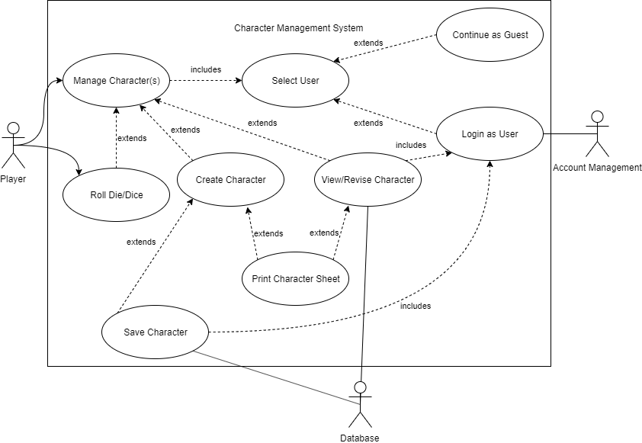

Figure 1: Use Case Diagram for Character Management System

# Other Non-functional Requirements

## Performance Requirements

Actual performance will vary depending on the user’s internet connection, device, and operating software.

## Safety and Security Requirements

* Under dry conditions, the system will operate on the user’s desktop computer or laptop without electrocuting the user. The system is not intended for use in manmade or natural wet environments, such as bathtubs, swimming pools, rivers, or lakes. The user is advised to use common sense when operating this system during thunderstorms or other forms of inclement weather.
* This system is not intended for use while operating a motor vehicle or heavy equipment.
* When the user observes safe internet practices, the system will provide the user the ability to create DnD characters, 5e, without adding malware, viruses or spyware of any kind.
* The system will use the Django web framework to handle user authentication.
* The system will not share user information with any outside parties without the express permission from the user.
* The system will allow the user access to his/her own records.
* Users may terminate their account at any time.
* The system will not retain information from terminated accounts.
* Disclaimer: The developers of this system are not responsible for the loss of Player character data due to Players forgetting their login password.
* The developers of this system respect and observe the disclaimer as written in the Player’s Handbook, page 3: ‘Wizards of the Coast is not responsible for the consequences of splitting up the party, sticking appendages in the mouth of a leering green devil face, accepting a dinner invitation from bugbears, storming the feast hall of a hill giant steading, angering a dragon of any variety, or saying yes when the DM asks, “Are you really sure?”’

## Software Quality Attributes

* The system will be available and maintained during the Fall 2019 semester at Washington State University, Vancouver.
* Support is not guaranteed after December 2019.

Appendix A - Group Log

Group met 10/11/19 from 9 am to 10 am

Initial meeting to formalize group members and decide on a project. Group decided to create a Dungeons and Dragons character creator. Trevor, as the most experienced DnD player, put together a flow chart for generating a character.

Group met 10/18/19 from 9 am to 11 am

Discussed SRS sections 1 and 2 and compared them with the example of Requirements for the Mentcare System. Took written notes to add to our own SRS rough draft.

Group met 10/24/19 from 1:30 pm to 3 pm

Discussed the use of GitHub, Google docs, and OneDrive for the management of team input to the SRS document. Agreed that the most efficient system was OneDrive.

Group met 10/25/19 9 am to 1:30 pm

Finished writing SRS document. Each member took a different section of the document. Group input was solicited for each section. Group proofread the entire document before uploading it to Blackboard as a finished assignment.