# LOGIN

TELA

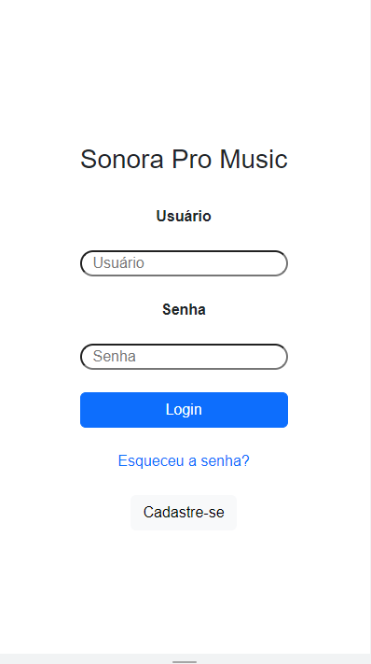

CODIGO

<!DOCTYPE *html*>

<html *lang*="pt-br">

<head>

<meta *charset*="UTF-8">

<meta *http-equiv*="X-UA-Compatible" *content*="IE=edge">

<meta *name*="viewport" *content*="width=device-width, initial-scale=1.0">

<link *href*="https://cdn.jsdelivr.net/npm/bootstrap@5.3.0-alpha1/dist/css/bootstrap.min.css" *rel*="stylesheet"

*integrity*="sha384-GLhlTQ8iRABdZLl6O3oVMWSktQOp6b7In1Zl3/Jr59b6EGGoI1aFkw7cmDA6j6gD" *crossorigin*="anonymous">

<link *rel*="stylesheet" *href*="../css/index.css">

<title>Sonora</title>

<script *src*="https://code.jquery.com/jquery-3.3.1.slim.min.js"

*integrity*="sha384-q8i/X+965DzO0rT7abK41JStQIAqVgRVzpbzo5smXKp4YfRvH+8abtTE1Pi6jizo"

*crossorigin*="anonymous"></script>

<script *denfer* *type*="module" *src*="../js/index.js"></script>

</head>

<body>

<div *class*="container vh-100 d-flex flex-column justify-content-center align-items-center overflow-none gap-4">

<header *class*="text-center">

<img *src*="img/person.svg" *alt*="">

<h1>Sonora Pro Music</h1>

</header>

<div *class*="d-flex flex-column row gy-4 text-center">

<label *class*="fw-bold" *for*="user">Usuário</label>

<input *class*="rounded-pill" *type*="text" *name*="user" *placeholder*="Usuário" *required*>

<label *class*="fw-bold" *for*="password">Senha</label>

<input *class*="rounded-pill" *type*="text" *name*="password" *placeholder*="Senha" *required*>

<button *id*="login" *type*="button" *class*="btn btn-primary">Login</button>

<a *href*="#">Esqueceu a senha?</a>

</div>

<footer>

<button *type*="button" *class*="btn btn-light">Cadastre-se</button>

</footer>

</div>

</body>

</html>

# PRINCIPAL

TELA

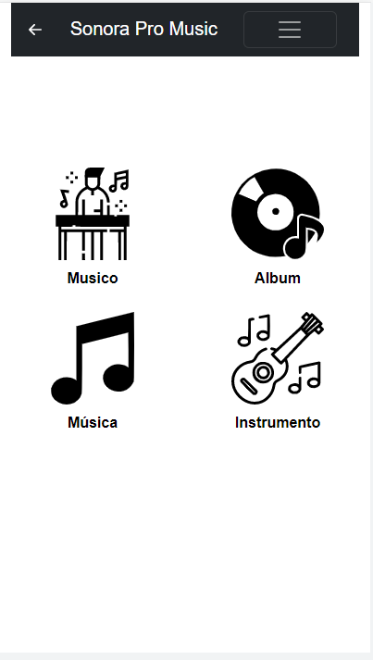

CODIGO

<!DOCTYPE *html*>

<html *lang*="en">

<head>

<meta *charset*="UTF-8">

<meta *http-equiv*="X-UA-Compatible" *content*="IE=edge">

<meta *name*="viewport" *content*="width=device-width, initial-scale=1.0">

<title>Home</title>

<link *href*="https://cdn.jsdelivr.net/npm/bootstrap@5.3.0-alpha1/dist/css/bootstrap.min.css" *rel*="stylesheet" *integrity*="sha384-GLhlTQ8iRABdZLl6O3oVMWSktQOp6b7In1Zl3/Jr59b6EGGoI1aFkw7cmDA6j6gD" *crossorigin*="anonymous">

<script *src*="https://cdn.jsdelivr.net/npm/bootstrap@5.0.2/dist/js/bootstrap.bundle.min.js" *integrity*="sha384-MrcW6ZMFYlzcLA8Nl+NtUVF0sA7MsXsP1UyJoMp4YLEuNSfAP+JcXn/tWtIaxVXM" *crossorigin*="anonymous"></script>

<link *rel*="stylesheet" *href*="../css/home.css">

</head>

<body >

<div *class*="container-fluid vh-100 overflow-none">

<nav *class*=" navbar navbar-expand-lg navbar-dark bg-dark ">

<div *class*="container-fluid row">

<a *class*="navbar-brand d-flex gap-4 col-8 " *href*="index.html"><svg *xmlns*="http://www.w3.org/2000/svg" *width*="32" *height*="32" *fill*="currentColor" *class*="bi bi-arrow-left-short" *viewBox*="0 0 16 16">

<path *fill-rule*="evenodd" *d*="M12 8a.5.5 0 0 1-.5.5H5.707l2.147 2.146a.5.5 0 0 1-.708.708l-3-3a.5.5 0 0 1 0-.708l3-3a.5.5 0 1 1 .708.708L5.707 7.5H11.5a.5.5 0 0 1 .5.5z"/>

</svg>Sonora Pro Music</a>

<button *class*="navbar-toggler col" *type*="button" *data-bs-toggle*="collapse" *data-bs-target*="#navbarNavAltMarkup" *aria-controls*="navbarNavAltMarkup" *aria-expanded*="false" *aria-label*="Toggle navigation">

<span *class*="navbar-toggler-icon"></span>

</button>

<div *class*="collapse navbar-collapse col-4" *id*="navbarNavAltMarkup">

<div *class*="navbar-nav">

<a *class*="nav-link active" *aria-current*="page" *href*="#">Home</a>

<a *class*="nav-link" *href*="#">Musicas</a>

<a *class*="nav-link" *href*="#">Preço</a>

<a *class*="nav-link " *href*="#">Fale conosco</a>

</div>

</div>

</div>

</nav>

<main *class*="row row-cols-2 g-4 mt-5 pt-5">

<a *class*="col d-flex flex-column justify-content-center align-items-center gap-2" *href*="musico.html"><img *src*="../imgs/ouvindo-musica.svg" *alt*="">Musico</a>

<a *class*="col d-flex flex-column justify-content-center align-items-center gap-2" *href*="#"><img *src*="../imgs/album-de-musica.svg" *alt*="">Album</a>

<a *class*="col d-flex flex-column justify-content-center align-items-center gap-2" *href*="#"><img *src*="/imgs/reprodutor-de-musica.svg" *alt*="">Música</a>

<a *class*="col d-flex flex-column justify-content-center align-items-center gap-2" *href*="#"><img *src*="/imgs/musica-de-guitarra.svg" *alt*="">Instrumento</a>

</main></div></body></html>

# MUSICO

TELA

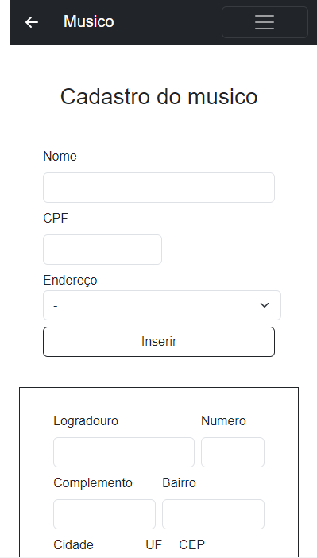

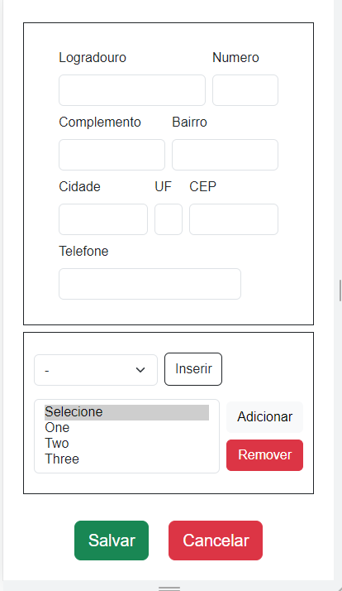

CODIGO

<!DOCTYPE *html*>

<html *lang*="pt-br">

  <head>

    <meta *charset*="UTF-8" />

    <meta *http-equiv*="X-UA-Compatible" *content*="IE=edge" />

    <meta *name*="viewport" *content*="width=device-width, initial-scale=1.0" />

    <title>Musico</title>

    <link

*href*="https://cdn.jsdelivr.net/npm/bootstrap@5.3.0-alpha1/dist/css/bootstrap.min.css"

*rel*="stylesheet"

*integrity*="sha384-GLhlTQ8iRABdZLl6O3oVMWSktQOp6b7In1Zl3/Jr59b6EGGoI1aFkw7cmDA6j6gD"

*crossorigin*="anonymous"

    />

    <script

*src*="https://cdn.jsdelivr.net/npm/bootstrap@5.0.2/dist/js/bootstrap.bundle.min.js"

*integrity*="sha384-MrcW6ZMFYlzcLA8Nl+NtUVF0sA7MsXsP1UyJoMp4YLEuNSfAP+JcXn/tWtIaxVXM"

*crossorigin*="anonymous"

    ></script>

    <link *rel*="stylesheet" *href*="../css/home.css" />

  </head>

  <body>

    <div *class*="container-fluid vh-100 overflow-none ">

      <nav *class*="navbar navbar-expand-lg navbar-dark bg-dark vw-100">

        <div *class*="container-fluid row">

          <a *class*="navbar-brand d-flex gap-4 col-8" *href*="index.html"

            ><svg

*xmlns*="http://www.w3.org/2000/svg"

*width*="32"

*height*="32"

*fill*="currentColor"

*class*="bi bi-arrow-left-short"

*viewBox*="0 0 16 16"

          >

              <path

*fill-rule*="evenodd"

*d*="M12 8a.5.5 0 0 1-.5.5H5.707l2.147 2.146a.5.5 0 0 1-.708.708l-3-3a.5.5 0 0 1 0-.708l3-3a.5.5 0 1 1 .708.708L5.707 7.5H11.5a.5.5 0 0 1 .5.5z"

              /></svg>Musico</a>

          <button

*class*="navbar-toggler col"

*type*="button"

*data-bs-toggle*="collapse"

*data-bs-target*="#navbarNavAltMarkup"

*aria-controls*="navbarNavAltMarkup"

*aria-expanded*="false"

*aria-label*="Toggle navigation"

          >

            <span *class*="navbar-toggler-icon"></span>

          </button>

          <div *class*="collapse navbar-collapse col-4" *id*="navbarNavAltMarkup">

            <div *class*="navbar-nav">

              <a *class*="nav-link active" *aria-current*="page" *href*="#">Home</a>

              <a *class*="nav-link" *href*="#">Musicas</a>

              <a *class*="nav-link" *href*="#">Preço</a>

              <a *class*="nav-link" *href*="#">Fale conosco</a>

            </div>

          </div>

        </div>

      </nav>

<main *class*="container-fluid d-flex flex-column gap-2 mt-5 ">

    <h1 *class*="container d-flex align-itens-center justify-content-center">Cadastro do musico</h1>

  <div *class*="container d-flex flex-column  justify-content-center gap-2" *style*="padding: 30px;">

          <div>

            <label *for*="nome" *class*="form-label">Nome</label>

            <input *class*="form-control" *id*="nome" *type*="text" *aria-label*="default input example">

          </div>

          <div *style*="width: 150px;">

            <label *for*="cpf" *class*="form-label">CPF</label>

            <input *class*="form-control" *id*="cpf" *type*="number" *aria-label*="default input example">

          </div>

          <div *class*="d-flex gap-2 flex-column">

            <div>

              <label *for*="endereco">Endereço</label>

              <select *class*="form-select" *id*="endereco" *aria-label*="Default select example" *style*="width:300px;">

                <option *selected*>-</option>

                <option *value*="1">One</option>

                <option *value*="2">Two</option>

                <option *value*="3">Three</option>

              </select>

            </div>

            <button *type*="button" *class*="btn btn-outline-dark">Inserir</button>

          </div>

  </div>

    <!-- DADOS DO ENDEREÇO-->

    <div *class*="container d-flex flex-column  justify-content-center gap-2 border border-dark " *style*="padding: 30px;">

             <div *class*="container d-flex flex-row  justify-content-center gap-2">

                      <div>

                        <label *for*="logradouro" *class*="form-label">Logradouro</label>

                        <input *class*="form-control" *id*="logradouro" *type*="text" *aria-label*="default input example">

                      </div>

                      <div *style*="width: 100px;">

                        <label *for*="num" *class*="form-label">Numero</label>

                        <input *class*="form-control" *id*="num" *type*="number" *aria-label*="default input example">

                      </div>

            </div>

             <div *class*="container d-flex flex-row  justify-content-center gap-2">

                      <div>

                        <label *for*="complemento" *class*="form-label">Complemento</label>

                        <input *class*="form-control" *id*="complemento" *type*="text" *aria-label*="default input example">

                      </div>

                      <div>

                        <label *for*="bairro" *class*="form-label">Bairro</label>

                        <input *class*="form-control" *id*="bairro" *type*="text" *aria-label*="default input example">

                      </div>

            </div>

             <div *class*="container d-flex flex-row  justify-content-center gap-2">

                      <div>

                        <label *for*="cidade" *class*="form-label">Cidade</label>

                        <input *class*="form-control" *id*="cidade" *type*="text" *aria-label*="default input example">

                      </div>

                      <div *style*="width: 70px;">

                        <label *for*="uf" *class*="form-label">UF</label>

                        <input *class*="form-control" *id*="uf" *type*="text" *aria-label*="default input example">

                      </div>

                      <div>

                        <label *for*="cep" *class*="form-label">CEP</label>

                        <input *class*="form-control" *id*="cep" *type*="number" *aria-label*="default input example">

                      </div>

            </div>

             <div *class*="container d-flex flex-row  justify-content-start gap-2">

                      <div>

                        <label *for*="telefone" *class*="form-label">Telefone</label>

                        <input *class*="form-control" *id*="telefone" *type*="tel" *aria-label*="default input example">

                      </div>

            </div>

  </div>

<!--SELECIONAR-->

<div *class*="container d-flex flex-column  justify-content-start gap-3 py-4 border border-dark">

    <div *class*="d-flex gap-2 flex-row align-items-end">

              <div>

                <select *class*="form-select" *id*="endereco" *aria-label*="Default select example" *style*="width:150px;">

                  <option *selected*>-</option>

                  <option *value*="1">One</option>

                  <option *value*="2">Two</option>

                  <option *value*="3">Three</option>

                </select>

              </div>

                        <button *type*="button" *class*="btn btn-outline-dark" *style*="height:40px;">Inserir</button>

    </div>

    <div *class*="d-flex justify-content-between align-items-center gap-2">

                <div *style*="width: 300px;">

                  <select *class*="form-select" *multiple* *aria-label*="multiple select example">

                    <option *selected*>Selecione</option>

                    <option *value*="1">One</option>

                    <option *value*="2">Two</option>

                    <option *value*="3">Three</option>

                  </select>

                </div>

                <div *class*="d-flex flex-column gap-2">

                  <button *type*="button" *class*="btn btn-light">Adicionar</button>

                  <button *type*="button" *class*="btn btn-danger">Remover</button>

                </div>

    </div>

</div>

<div *class*="d-flex  align-items-center justify-content-center gap-4 py-4">

  <button *type*="button" *class*="btn btn-success btn-lg">Salvar</button>

  <button *type*="button" *class*="btn btn-danger btn-lg">Cancelar</button>

</div>

</main>

    </div>

  </body>

</html>

# INSTRUMENTO

TELA

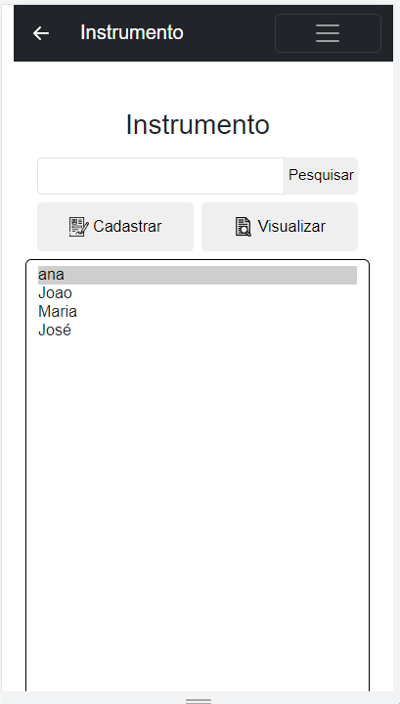

CODIGO

<!DOCTYPE *html*>

<html *lang*="pt-br">

  <head>

    <meta *charset*="UTF-8" />

    <meta *http-equiv*="X-UA-Compatible" *content*="IE=edge" />

    <meta *name*="viewport" *content*="width=device-width, initial-scale=1.0" />

    <title>Instrumento</title>

    <link

*href*="https://cdn.jsdelivr.net/npm/bootstrap@5.3.0-alpha1/dist/css/bootstrap.min.css"

*rel*="stylesheet"

*integrity*="sha384-GLhlTQ8iRABdZLl6O3oVMWSktQOp6b7In1Zl3/Jr59b6EGGoI1aFkw7cmDA6j6gD"

*crossorigin*="anonymous"

    />

    <script

*src*="https://cdn.jsdelivr.net/npm/bootstrap@5.0.2/dist/js/bootstrap.bundle.min.js"

*integrity*="sha384-MrcW6ZMFYlzcLA8Nl+NtUVF0sA7MsXsP1UyJoMp4YLEuNSfAP+JcXn/tWtIaxVXM"

*crossorigin*="anonymous"

    ></script>

    <link *rel*="stylesheet" *href*="../css/home.css" />

  </head>

  <body>

    <div *class*="container-fluid vh-100 overflow-none ">

      <nav *class*="navbar navbar-expand-lg navbar-dark bg-dark vw-100">

        <div *class*="container-fluid row">

          <a *class*="navbar-brand d-flex gap-4 col-8" *href*="index.html"

            ><svg

*xmlns*="http://www.w3.org/2000/svg"

*width*="32"

*height*="32"

*fill*="currentColor"

*class*="bi bi-arrow-left-short"

*viewBox*="0 0 16 16"

          >

              <path

*fill-rule*="evenodd"

*d*="M12 8a.5.5 0 0 1-.5.5H5.707l2.147 2.146a.5.5 0 0 1-.708.708l-3-3a.5.5 0 0 1 0-.708l3-3a.5.5 0 1 1 .708.708L5.707 7.5H11.5a.5.5 0 0 1 .5.5z"

              /></svg>Instrumento</a>

          <button

*class*="navbar-toggler col"

*type*="button"

*data-bs-toggle*="collapse"

*data-bs-target*="#navbarNavAltMarkup"

*aria-controls*="navbarNavAltMarkup"

*aria-expanded*="false"

*aria-label*="Toggle navigation"

          >

            <span *class*="navbar-toggler-icon"></span>

          </button>

          <div *class*="collapse navbar-collapse col-4" *id*="navbarNavAltMarkup">

            <div *class*="navbar-nav">

              <a *class*="nav-link active" *aria-current*="page" *href*="#">Home</a>

              <a *class*="nav-link" *href*="#">Musicas</a>

              <a *class*="nav-link" *href*="#">Preço</a>

              <a *class*="nav-link" *href*="#">Fale conosco</a>

            </div>

          </div>

        </div>

      </nav>

<main *class*="container-fluid d-flex flex-column gap-2 mt-5 ">

    <h1 *class*="container d-flex align-itens-center justify-content-center">Instrumento</h1>

    <!-- BARRA PESQUISAR -->

    <div *class*="container d-flex flex-row  justify-content-center  " >

      <input *class*="form-control " *id*="bairro" *type*="text" *aria-label*="default input example" *style*="border-radius:5px 0 0 5px;">

      <button *style*="width: 100px;border-radius:0 5px 5px 0; border: none;font-size:15px;">Pesquisar</button>

  </div>

  <!--BOTÃO SELECIONAR-->

  <div *class*="container d-flex flex-row  justify-content-center gap-2 ">

   <button *style*="width:300px; height: 50px;border: none; border-radius:5px;"><img *style*="width:5vw;" *src*="../imgs/cadastro.png" *alt*=""> Cadastrar</button>

   <button *style*="width:300px; height: 50px;border: none; border-radius:5px;"><img *style*="width:5vw;" *src*="../imgs/documento.png" *alt*=""> Visualizar</button>

</div>

<!--SELECIONAR-->

                  <select *class*="form-select" *multiple* *aria-label*="multiple select example" *style*="border: solid black 1px; height:500px">

                    <option *selected*>ana</option>

                    <option *value*="1">Joao</option>

                    <option *value*="2">Maria</option>

                    <option *value*="3">José</option>

                  </select>

</main>

    </div>

  </body>

</html>

# TIPO DE INTRUMENTO

TELA

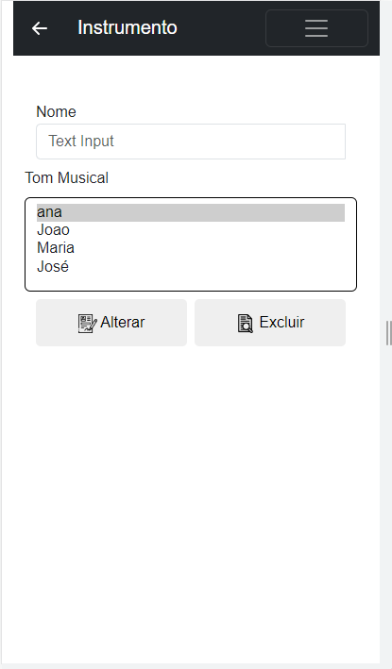

CODIGO

<!DOCTYPE *html*>

<html *lang*="pt-br">

  <head>

    <meta *charset*="UTF-8" />

    <meta *http-equiv*="X-UA-Compatible" *content*="IE=edge" />

    <meta *name*="viewport" *content*="width=device-width, initial-scale=1.0" />

    <title>Instrumento</title>

    <link

*href*="https://cdn.jsdelivr.net/npm/bootstrap@5.3.0-alpha1/dist/css/bootstrap.min.css"

*rel*="stylesheet"

*integrity*="sha384-GLhlTQ8iRABdZLl6O3oVMWSktQOp6b7In1Zl3/Jr59b6EGGoI1aFkw7cmDA6j6gD"

*crossorigin*="anonymous"

    />

    <script

*src*="https://cdn.jsdelivr.net/npm/bootstrap@5.0.2/dist/js/bootstrap.bundle.min.js"

*integrity*="sha384-MrcW6ZMFYlzcLA8Nl+NtUVF0sA7MsXsP1UyJoMp4YLEuNSfAP+JcXn/tWtIaxVXM"

*crossorigin*="anonymous"

    ></script>

    <link *rel*="stylesheet" *href*="../css/home.css" />

  </head>

  <body>

    <div *class*="container-fluid vh-100 overflow-none ">

      <nav *class*="navbar navbar-expand-lg navbar-dark bg-dark vw-100">

        <div *class*="container-fluid row">

          <a *class*="navbar-brand d-flex gap-4 col-8" *href*="index.html"

            ><svg

*xmlns*="http://www.w3.org/2000/svg"

*width*="32"

*height*="32"

*fill*="currentColor"

*class*="bi bi-arrow-left-short"

*viewBox*="0 0 16 16"

          >

              <path

*fill-rule*="evenodd"

*d*="M12 8a.5.5 0 0 1-.5.5H5.707l2.147 2.146a.5.5 0 0 1-.708.708l-3-3a.5.5 0 0 1 0-.708l3-3a.5.5 0 1 1 .708.708L5.707 7.5H11.5a.5.5 0 0 1 .5.5z"

              /></svg>Instrumento</a>

          <button

*class*="navbar-toggler col"

*type*="button"

*data-bs-toggle*="collapse"

*data-bs-target*="#navbarNavAltMarkup"

*aria-controls*="navbarNavAltMarkup"

*aria-expanded*="false"

*aria-label*="Toggle navigation"

          >

            <span *class*="navbar-toggler-icon"></span>

          </button>

          <div *class*="collapse navbar-collapse col-4" *id*="navbarNavAltMarkup">

            <div *class*="navbar-nav">

              <a *class*="nav-link active" *aria-current*="page" *href*="#">Home</a>

              <a *class*="nav-link" *href*="#">Musicas</a>

              <a *class*="nav-link" *href*="#">Preço</a>

              <a *class*="nav-link" *href*="#">Fale conosco</a>

            </div>

          </div>

        </div>

      </nav>

<main *class*="container-fluid d-flex flex-column gap-2 mt-5 ">

    <!-- BARRA PESQUISAR -->

    <div *class*="container d-flex flex-column  justify-content-center  " >

      <label *for*="nome">Nome</label>

      <input *class*="form-control " *placeholder*="Text Input" *id*="nome" *type*="text" *aria-label*="default input example" *style*="border-radius:5px 0 0 5px;">

  </div>

<!--SELECIONAR-->

                  <label *for*="">Tom Musical</label>

                  <select *class*="form-select" *multiple* *aria-label*="multiple select example" *style*="border: solid black 1px; height:100px">

                    <option *selected*>ana</option>

                    <option *value*="1">Joao</option>

                    <option *value*="2">Maria</option>

                    <option *value*="3">José</option>

                  </select>

                    <!--BOTÃO SELECIONAR-->

  <div *class*="container d-flex flex-row  justify-content-center gap-2 ">

    <button *style*="width:300px; height: 50px;border: none; border-radius:5px;"><img *style*="width:5vw;" *src*="../imgs/cadastro.png" *alt*=""> Alterar</button>

    <button *style*="width:300px; height: 50px;border: none; border-radius:5px;"><img *style*="width:5vw;" *src*="../imgs/documento.png" *alt*=""> Excluir</button>

 </div>

</main>

    </div>

  </body>

</html>

# TOM MUSICAL

TELA

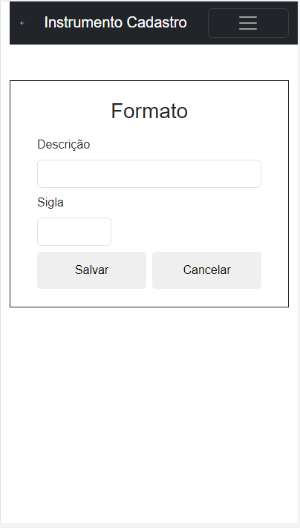

CODIGO

<!DOCTYPE *html*>

<html *lang*="pt-br">

  <head>

    <meta *charset*="UTF-8" />

    <meta *http-equiv*="X-UA-Compatible" *content*="IE=edge" />

    <meta *name*="viewport" *content*="width=device-width, initial-scale=1.0" />

    <title>Instrumento Cadastro</title>

    <link

*href*="https://cdn.jsdelivr.net/npm/bootstrap@5.3.0-alpha1/dist/css/bootstrap.min.css"

*rel*="stylesheet"

*integrity*="sha384-GLhlTQ8iRABdZLl6O3oVMWSktQOp6b7In1Zl3/Jr59b6EGGoI1aFkw7cmDA6j6gD"

*crossorigin*="anonymous"

    />

    <script

*src*="https://cdn.jsdelivr.net/npm/bootstrap@5.0.2/dist/js/bootstrap.bundle.min.js"

*integrity*="sha384-MrcW6ZMFYlzcLA8Nl+NtUVF0sA7MsXsP1UyJoMp4YLEuNSfAP+JcXn/tWtIaxVXM"

*crossorigin*="anonymous"

    ></script>

    <link *rel*="stylesheet" *href*="../css/home.css" />

  </head>

  <body>

    <div *class*="container-fluid vh-100 overflow-none ">

      <nav *class*="navbar navbar-expand-lg navbar-dark bg-dark vw-100">

        <div *class*="container-fluid row">

          <a *class*="navbar-brand d-flex gap-4 col-8" *href*="index.html"

            ><svg

*xmlns*="http://www.w3.org/2000/svg"

*width*="32"

*height*="32"

*fill*="currentColor"

*class*="bi bi-arrow-left-short"

*viewBox*="0 0 16 16"

          >

              <path

*fill-rule*="evenodd"

*d*="M12 8a.5.5 0 0 1-.5.5H5.707l2.147 2.146a.5.5 0 0 1-.708.708l-3-3a.5.5 0 0 1 0-.708l3-3a.5.5 0 1 1 .708.708L5.707 7.5H11.5a.5.5 0 0 1 .5.5z"

              /></svg>Instrumento Cadastro</a>

          <button

*class*="navbar-toggler col"

*type*="button"

*data-bs-toggle*="collapse"

*data-bs-target*="#navbarNavAltMarkup"

*aria-controls*="navbarNavAltMarkup"

*aria-expanded*="false"

*aria-label*="Toggle navigation"

          >

            <span *class*="navbar-toggler-icon"></span>

          </button>

          <div *class*="collapse navbar-collapse col-4" *id*="navbarNavAltMarkup">

            <div *class*="navbar-nav">

              <a *class*="nav-link active" *aria-current*="page" *href*="#">Home</a>

              <a *class*="nav-link" *href*="#">Musicas</a>

              <a *class*="nav-link" *href*="#">Preço</a>

              <a *class*="nav-link" *href*="#">Fale conosco</a>

            </div>

          </div>

        </div>

      </nav>

<main *class*="container-fluid d-flex flex-column wh-100  justify-content-center gap-2 mt-5   border border-dark p-4">

    <h1  *class*="container d-flex align-itens-center justify-content-center">Formato</h1>

    <!-- BARRA PESQUISAR -->

    <div *class*="container d-flex flex-column gap-2  justify-content-center  " >

        <label *for*="descricao">Descrição</label>

        <input *class*="form-control " *id*="descricao" *type*="text" *aria-label*="default input example" >

    <label *for*="sigla">Sigla</label>

      <input *class*="form-control " *id*="sigla" *type*="text" *aria-label*="default input example" *style*=" width: 100px;">

  </div>

  <!--BOTÃO SELECIONAR-->

  <div *class*="container d-flex flex-row  justify-content-center gap-2 ">

   <button *style*="width:300px; height: 50px;border: none; border-radius:5px;"> Salvar</button>

   <button *style*="width:300px; height: 50px;border: none; border-radius:5px;"> Cancelar</button>

</div>

</main>

    </div>

  </body>

</html>

# MUSICA

TELA

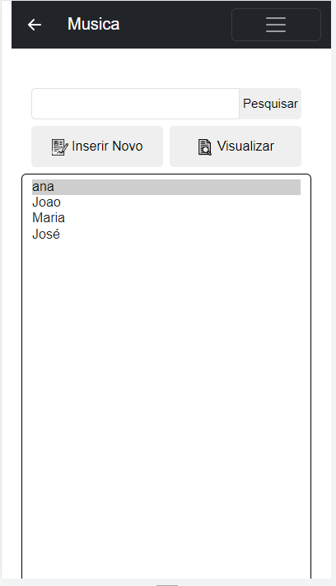

CODIGO

<!DOCTYPE *html*>

<html *lang*="pt-br">

  <head>

    <meta *charset*="UTF-8" />

    <meta *http-equiv*="X-UA-Compatible" *content*="IE=edge" />

    <meta *name*="viewport" *content*="width=device-width, initial-scale=1.0" />

    <title>Instrumento</title>

    <link

*href*="https://cdn.jsdelivr.net/npm/bootstrap@5.3.0-alpha1/dist/css/bootstrap.min.css"

*rel*="stylesheet"

*integrity*="sha384-GLhlTQ8iRABdZLl6O3oVMWSktQOp6b7In1Zl3/Jr59b6EGGoI1aFkw7cmDA6j6gD"

*crossorigin*="anonymous"

    />

    <script

*src*="https://cdn.jsdelivr.net/npm/bootstrap@5.0.2/dist/js/bootstrap.bundle.min.js"

*integrity*="sha384-MrcW6ZMFYlzcLA8Nl+NtUVF0sA7MsXsP1UyJoMp4YLEuNSfAP+JcXn/tWtIaxVXM"

*crossorigin*="anonymous"

    ></script>

    <link *rel*="stylesheet" *href*="../css/home.css" />

  </head>

  <body>

    <div *class*="container-fluid vh-100 overflow-none ">

      <nav *class*="navbar navbar-expand-lg navbar-dark bg-dark vw-100">

        <div *class*="container-fluid row">

          <a *class*="navbar-brand d-flex gap-4 col-8" *href*="index.html"

            ><svg

*xmlns*="http://www.w3.org/2000/svg"

*width*="32"

*height*="32"

*fill*="currentColor"

*class*="bi bi-arrow-left-short"

*viewBox*="0 0 16 16"

          >

              <path

*fill-rule*="evenodd"

*d*="M12 8a.5.5 0 0 1-.5.5H5.707l2.147 2.146a.5.5 0 0 1-.708.708l-3-3a.5.5 0 0 1 0-.708l3-3a.5.5 0 1 1 .708.708L5.707 7.5H11.5a.5.5 0 0 1 .5.5z"

              /></svg>Musica</a>

          <button

*class*="navbar-toggler col"

*type*="button"

*data-bs-toggle*="collapse"

*data-bs-target*="#navbarNavAltMarkup"

*aria-controls*="navbarNavAltMarkup"

*aria-expanded*="false"

*aria-label*="Toggle navigation"

          >

            <span *class*="navbar-toggler-icon"></span>

          </button>

          <div *class*="collapse navbar-collapse col-4" *id*="navbarNavAltMarkup">

            <div *class*="navbar-nav">

              <a *class*="nav-link active" *aria-current*="page" *href*="#">Home</a>

              <a *class*="nav-link" *href*="#">Musicas</a>

              <a *class*="nav-link" *href*="#">Preço</a>

              <a *class*="nav-link" *href*="#">Fale conosco</a>

            </div>

          </div>

        </div>

      </nav>

<main *class*="container-fluid d-flex flex-column gap-2 mt-5 ">

    <!-- BARRA PESQUISAR -->

    <div *class*="container d-flex flex-row  justify-content-center  " >

      <input *class*="form-control " *id*="bairro" *type*="text" *aria-label*="default input example" *style*="border-radius:5px 0 0 5px;">

      <button *style*="width: 100px;border-radius:0 5px 5px 0; border: none;font-size:15px;">Pesquisar</button>

  </div>

  <!--BOTÃO SELECIONAR-->

  <div *class*="container d-flex flex-row  justify-content-center gap-2 ">

   <button *style*="width:300px; height: 50px;border: none; border-radius:5px;"><img *style*="width:5vw;" *src*="../imgs/cadastro.png" *alt*=""> Inserir Novo</button>

   <button *style*="width:300px; height: 50px;border: none; border-radius:5px;"><img *style*="width:5vw;" *src*="../imgs/documento.png" *alt*=""> Visualizar</button>

</div>

<!--SELECIONAR-->

                  <select *class*="form-select" *multiple* *aria-label*="multiple select example" *style*="border: solid black 1px; height:500px">

                    <option *selected*>ana</option>

                    <option *value*="1">Joao</option>

                    <option *value*="2">Maria</option>

                    <option *value*="3">José</option>

                  </select>

</main>

    </div>

  </body>

</html>

# ALBUM

TELA

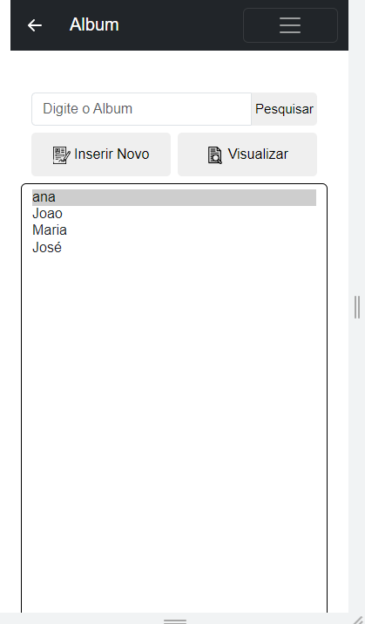

CODIGO

<!DOCTYPE *html*>

<html *lang*="pt-br">

  <head>

    <meta *charset*="UTF-8" />

    <meta *http-equiv*="X-UA-Compatible" *content*="IE=edge" />

    <meta *name*="viewport" *content*="width=device-width, initial-scale=1.0" />

    <title>Instrumento</title>

    <link

*href*="https://cdn.jsdelivr.net/npm/bootstrap@5.3.0-alpha1/dist/css/bootstrap.min.css"

*rel*="stylesheet"

*integrity*="sha384-GLhlTQ8iRABdZLl6O3oVMWSktQOp6b7In1Zl3/Jr59b6EGGoI1aFkw7cmDA6j6gD"

*crossorigin*="anonymous"

    />

    <script

*src*="https://cdn.jsdelivr.net/npm/bootstrap@5.0.2/dist/js/bootstrap.bundle.min.js"

*integrity*="sha384-MrcW6ZMFYlzcLA8Nl+NtUVF0sA7MsXsP1UyJoMp4YLEuNSfAP+JcXn/tWtIaxVXM"

*crossorigin*="anonymous"

    ></script>

    <link *rel*="stylesheet" *href*="../css/home.css" />

  </head>

  <body>

    <div *class*="container-fluid vh-100 overflow-none ">

      <nav *class*="navbar navbar-expand-lg navbar-dark bg-dark vw-100">

        <div *class*="container-fluid row">

          <a *class*="navbar-brand d-flex gap-4 col-8" *href*="index.html"

            ><svg

*xmlns*="http://www.w3.org/2000/svg"

*width*="32"

*height*="32"

*fill*="currentColor"

*class*="bi bi-arrow-left-short"

*viewBox*="0 0 16 16"

          >

              <path

*fill-rule*="evenodd"

*d*="M12 8a.5.5 0 0 1-.5.5H5.707l2.147 2.146a.5.5 0 0 1-.708.708l-3-3a.5.5 0 0 1 0-.708l3-3a.5.5 0 1 1 .708.708L5.707 7.5H11.5a.5.5 0 0 1 .5.5z"

              /></svg>Album</a>

          <button

*class*="navbar-toggler col"

*type*="button"

*data-bs-toggle*="collapse"

*data-bs-target*="#navbarNavAltMarkup"

*aria-controls*="navbarNavAltMarkup"

*aria-expanded*="false"

*aria-label*="Toggle navigation"

          >

            <span *class*="navbar-toggler-icon"></span>

          </button>

          <div *class*="collapse navbar-collapse col-4" *id*="navbarNavAltMarkup">

            <div *class*="navbar-nav">

              <a *class*="nav-link active" *aria-current*="page" *href*="#">Home</a>

              <a *class*="nav-link" *href*="#">Musicas</a>

              <a *class*="nav-link" *href*="#">Preço</a>

              <a *class*="nav-link" *href*="#">Fale conosco</a>

            </div>

          </div>

        </div>

      </nav>

<main *class*="container-fluid d-flex flex-column gap-2 mt-5 ">

    <!-- BARRA PESQUISAR -->

    <div *class*="container d-flex flex-row  justify-content-center  " >

      <input *class*="form-control " *placeholder*="Digite o Album" *id*="bairro" *type*="text" *aria-label*="default input example" *style*="border-radius:5px 0 0 5px;">

      <button *style*="width: 100px;border-radius:0 5px 5px 0; border: none;font-size:15px;">Pesquisar</button>

  </div>

  <!--BOTÃO SELECIONAR-->

  <div *class*="container d-flex flex-row  justify-content-center gap-2 ">

   <button *style*="width:300px; height: 50px;border: none; border-radius:5px;"><img *style*="width:5vw;" *src*="../imgs/cadastro.png" *alt*=""> Inserir Novo</button>

   <button *style*="width:300px; height: 50px;border: none; border-radius:5px;"><img *style*="width:5vw;" *src*="../imgs/documento.png" *alt*=""> Visualizar</button>

</div>

<!--SELECIONAR-->

                  <select *class*="form-select" *multiple* *aria-label*="multiple select example" *style*="border: solid black 1px; height:500px">

                    <option *selected*>ana</option>

                    <option *value*="1">Joao</option>

                    <option *value*="2">Maria</option>

                    <option *value*="3">José</option>

                  </select>

</main>

    </div>

  </body>

</html>