**Department of Electrical and Computer Engineering**

**University of Massachusetts Dartmouth**

**ECE565 System Resource Management / Prof. Hong Liu**

**HW04 Key: Storage Management [Ch04]**

1. [Tanenbaum 4.1] Give five different path names for the file /etc/passwd.

(Hint: Think about the directory entries “.” and “..”.)

**Answer:**

You can go up and down the tree as often as you want using ‘‘..’’. Some of the many paths are

/etc/passwd

/././etc/passwd

/etc/../etc/passwd

/etc/../etc/../etc/../etc/passwd

/etc/../etc/../etc/../etc/../etc/passwd

1. [Tanenbaum 4.12] Describe the effects of a corrupted data block for a given file for allocation with:
2. Contiguous
3. Linked
4. Indexed (or table based).

**Answer:**

1. Contiguous: If a data block gets corrupted, then only this block is affected; the remainder of the file’s blocks can be read.
2. Linked: The corrupted block cannot be read; also, location data about all blocks starting from this corrupted block is lost.
3. Indexed: Only the corrupted data block is affected.
4. [Tanenbaum 4.16] Consider the i-node shown in Fig. 4-13. If it contains 8 direct addresses (as shown in the diagram below: Address of disk block 0, 1, …, 7) and these were 8 bytes each and all disk blocks were 1024 Bytes (1KB), what would the largest possible file be?

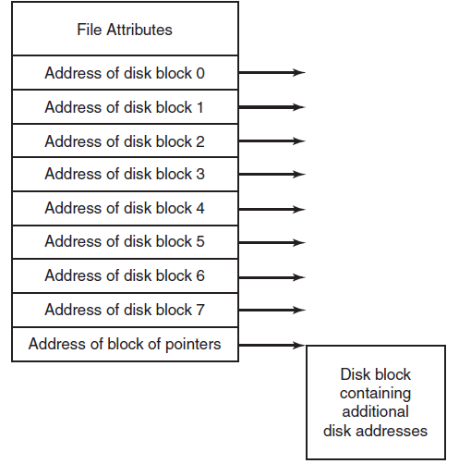

[Tanenbaum] Figure 4-13.An example i-node.

**Answer:**

The question is actually asking the maximum number of data disk blocks.

* # of Direct Addresses = 8 (each pointing to one data disk block)
* Block Size = 1KB (1024 Bytes) & Address Size = 8 Bytes

# of Indirect Addresses = 1024/8 = 210 / 23 = 27 = 128 (“Disk block containing additional disk addresses”, i.e., indirect addresses)

The maximum file has 136 (= 8+128) blocks.

Since each block is 1KB, the largest file is 136 KB.

1. [Tanenbaum 4.41] How many disk operations are needed to fetch the i-node for a file with the path name */usr/ast/courses/os/handout.t*? Assume that the i-node for the root directory is in memory, but nothing else along the path is in memory. Also assume that all directories fit in one disk block.

**Answer:**

The following disk reads are needed:

directory for /

i-node for */usr*

directory for */usr*

i-node for */usr/ast*

directory for */usr/ast*

i-node for */usr/ast/courses*

directory for */usr/ast/courses*

i-node for */usr/ast/courses/os*

directory for */usr/ast/courses/os*

i-node for */usr/ast/courses/os/handout.t*

In total, 10 disk reads are required.

The disk reads are illustrated in the table below: total of 10.

|  |  |  |  |  |  |  |  |  |  |
| --- | --- | --- | --- | --- | --- | --- | --- | --- | --- |
| Directory | i-node | Directory | i-node | Directory | i-node | Directory | i-node | Directory | i-node |
| / | usr | / | ast | / | courses | / | os | / | Handout.t |
| 1 | 2 | 3 | 4 | 5 | 6 | 7 | 8 | 9 | 10 |

1. [Tanenbaum 4.21] Name one advantage of hard links over symbolic links and one advantage of symbolic links over hard links.

**Answer:**

* Hard links do not require any extra disk space, just a counter in the i-node to keep track of how many there are. This makes them a lot faster to access
* Symbolic links are just that, symbols. The link can then point to any location such as an internet address, or a file location that is abnormally long and would be difficult for the program to handle.

1. [Liu] Write a program that downloads a webpage with hyperlinks. Consider your downloaded webpage as a local replica, i.e., a self contained webpage with all directories and files in the same domain downloaded. Your code can stop going circular links if exist, leave broken links, and not download files outside the original webpage domain.

Test your system on this course webpage:

Code:

function main{

param (

[Parameter(Mandatory=$false)][string]$address = "http://www.faculty.umassd.edu/hong.liu/ece565.html"

)

mirrorWebPage $address

}

function mirrorWebPage{

param (

[Parameter(Mandatory=$true)][string]$address,

[Parameter(Mandatory=$false)][string]$baseURL = ""

)

Write-Host "Getting $address"

if($baseURL -eq ""){

$folderIndex = $address.LastIndexOf("/")

if($address.EndsWith("/")){

$address = $address.Remove($folderIndex)

$folderIndex = $address.LastIndexOf("/")

$address += "/"

}

$baseURL = $address.Substring(0,$folderIndex)

}

$path = $address -replace $baseURL,""

$path = ".$path"

if($path.EndsWith("/")){

New-Item $path -ItemType Directory -Force

}

else{

New-Item $path -Force

}

$page = Invoke-WebRequest $address

$page.RawContent | Out-File $path

if($page.Links.Count -gt 0){

foreach($link in $page.Links){

if($link.href -ne $address){

if($link.href -notmatch "http" -and $link.href -notmatch "#" -and $link.href -notmatch '\?' -and $link.href -notmatch 'mailto'){

mirrorWebPage "$baseURL/$($link.href)" $baseURL

}

}

}

}

}

main

Output:

PS C:\Users\jgarc\ECE565> c:\Users\jgarc\ECE565\Homework4-WebCrawler.ps1

Getting http://www.faculty.umassd.edu/hong.liu/ece565.html

Directory: C:\Users\jgarc\ECE565

Mode LastWriteTime Length Name

---- ------------- ------ ----

-a---- 10/8/2017 3:09 PM 0 ece565.html

Getting http://www.faculty.umassd.edu/hong.liu/ece565/ece565-W01ch01.pptx

Directory: C:\Users\jgarc\ECE565\ece565

Mode LastWriteTime Length Name

---- ------------- ------ ----

-a---- 10/8/2017 3:09 PM 0 ece565-W01ch01.pptx

Getting http://www.faculty.umassd.edu/hong.liu/ece565/ece565-W01ch12.pptx

-a---- 10/8/2017 3:09 PM 0 ece565-W01ch12.pptx

Getting http://www.faculty.umassd.edu/hong.liu/ece565/ece565-W02ch02.pptx

-a---- 10/8/2017 3:09 PM 0 ece565-W02ch02.pptx

Getting http://www.faculty.umassd.edu/hong.liu/ece565/ece565-hw01.docx

-a---- 10/8/2017 3:09 PM 0 ece565-hw01.docx

Getting http://www.faculty.umassd.edu/hong.liu/ece565/ece565-hw01key.docx

-a---- 10/8/2017 3:09 PM 0 ece565-hw01key.docx

Getting http://www.faculty.umassd.edu/hong.liu/ece565/ece565-projAssign.docx

-a---- 10/8/2017 3:09 PM 0 ece565-projAssign.docx

Getting http://www.faculty.umassd.edu/hong.liu/ece565/ece565-hw02.docx

-a---- 10/8/2017 3:09 PM 0 ece565-hw02.docx

Getting http://www.faculty.umassd.edu/hong.liu/ece565/ece565-hw02key.docx

-a---- 10/8/2017 3:09 PM 0 ece565-hw02key.docx

Getting http://www.faculty.umassd.edu/hong.liu/ece565/ece565-W03ch03.pptx

-a---- 10/8/2017 3:09 PM 0 ece565-W03ch03.pptx

Getting http://www.faculty.umassd.edu/hong.liu/ece565/ece565-hw03.docx

-a---- 10/8/2017 3:09 PM 0 ece565-hw03.docx

Getting http://www.faculty.umassd.edu/hong.liu/ece565/ece565-hw03key.docx

-a---- 10/8/2017 3:09 PM 0 ece565-hw03key.docx

Getting http://www.faculty.umassd.edu/hong.liu/ece565/ece565-W04ch04.pptx

-a---- 10/8/2017 3:09 PM 0 ece565-W04ch04.pptx

Getting http://www.faculty.umassd.edu/hong.liu/ece565/ece565-hw04.docx

-a---- 10/8/2017 3:09 PM 0 ece565-hw04.docx

Getting http://www.faculty.umassd.edu/hong.liu/ece565/ece565-hw04key.docx

-a---- 10/8/2017 3:09 PM 0 ece565-hw04key.docx

Getting http://www.faculty.umassd.edu/hong.liu/ece565/ece565-W05ch05.pptx

-a---- 10/8/2017 3:09 PM 0 ece565-W05ch05.pptx

Getting http://www.faculty.umassd.edu/hong.liu/ece565/ece565-hw05.docx

-a---- 10/8/2017 3:09 PM 0 ece565-hw05.docx

Getting http://www.faculty.umassd.edu/hong.liu/ece565/ece565-hw05key.docx

-a---- 10/8/2017 3:09 PM 0 ece565-hw05key.docx

Getting http://www.faculty.umassd.edu/hong.liu/ece565/ece565-projProgress.docx

-a---- 10/8/2017 3:09 PM 0 ece565-projProgress.docx

Getting http://www.faculty.umassd.edu/hong.liu/ece565/ece565-W07ch08a.pptx

-a---- 10/8/2017 3:09 PM 0 ece565-W07ch08a.pptx

Getting http://www.faculty.umassd.edu/hong.liu/ece565/ece565-hw06.docx

-a---- 10/8/2017 3:09 PM 0 ece565-hw06.docx

Getting http://www.faculty.umassd.edu/hong.liu/ece565/ece565-hw06key.docx

-a---- 10/8/2017 3:09 PM 0 ece565-hw06key.docx

Getting http://www.faculty.umassd.edu/hong.liu/ECE565/ECE565-reviewMidterm.pptx

-a---- 10/8/2017 3:09 PM 0 ECE565-reviewMidterm.pptx

Getting http://www.faculty.umassd.edu/hong.liu/ece565/ece565-practiceMidterm.docx

-a---- 10/8/2017 3:09 PM 0 ece565-practiceMidterm.docx

Getting http://www.faculty.umassd.edu/hong.liu/ECE565/ECE565-W08ch08b.pptx

-a---- 10/8/2017 3:09 PM 0 ECE565-W08ch08b.pptx

Getting http://www.faculty.umassd.edu/hong.liu/ece565/ece565-hw07.docx

-a---- 10/8/2017 3:09 PM 0 ece565-hw07.docx

Getting http://www.faculty.umassd.edu/hong.liu/ece565/ece565-hw07key.docx

-a---- 10/8/2017 3:09 PM 0 ece565-hw07key.docx

Getting http://www.faculty.umassd.edu/hong.liu/ece565/ece565-W09ch07a.pptx

-a---- 10/8/2017 3:09 PM 0 ece565-W09ch07a.pptx

Getting http://www.faculty.umassd.edu/hong.liu/ece565/ece565-hw08.docx

-a---- 10/8/2017 3:09 PM 0 ece565-hw08.docx

Getting http://www.faculty.umassd.edu/hong.liu/ece565/ece565-hw08key.docx

-a---- 10/8/2017 3:09 PM 0 ece565-hw08key.docx

Getting http://www.faculty.umassd.edu/hong.liu/ece565/ece565-projPresent.docx

-a---- 10/8/2017 3:09 PM 0 ece565-projPresent.docx

Getting http://www.faculty.umassd.edu/hong.liu/ece565/ece565-W10ch07b.pptx

-a---- 10/8/2017 3:09 PM 0 ece565-W10ch07b.pptx

Getting http://www.faculty.umassd.edu/hong.liu/ece565/ece565-hw09.docx

-a---- 10/8/2017 3:09 PM 0 ece565-hw09.docx

Getting http://www.faculty.umassd.edu/hong.liu/ece565/ece565-hw09key.docx

-a---- 10/8/2017 3:09 PM 0 ece565-hw09key.docx

Getting http://www.faculty.umassd.edu/hong.liu/ece565/ece565-W11ch07c.pptx

-a---- 10/8/2017 3:09 PM 0 ece565-W11ch07c.pptx

Getting http://www.faculty.umassd.edu/hong.liu/ece565/ece565-W13ch09.pptx

-a---- 10/8/2017 3:09 PM 0 ece565-W13ch09.pptx

Getting http://www.faculty.umassd.edu/hong.liu/ece565/ece565-hw10.docx

-a---- 10/8/2017 3:09 PM 0 ece565-hw10.docx

Getting http://www.faculty.umassd.edu/hong.liu/ece565/ece565-hw10key.docx

-a---- 10/8/2017 3:09 PM 0 ece565-hw10key.docx

Getting http://www.faculty.umassd.edu/hong.liu/ece565/ece565-projSchedule.docx

-a---- 10/8/2017 3:09 PM 0 ece565-projSchedule.docx

Getting http://www.faculty.umassd.edu/hong.liu/ece565/ece565-projReport.docx

-a---- 10/8/2017 3:09 PM 0 ece565-projReport.docx

Getting http://www.faculty.umassd.edu/hong.liu/ECE565/ECE565-reviewFinal.pptx

-a---- 10/8/2017 3:09 PM 0 ECE565-reviewFinal.pptx

Getting http://www.faculty.umassd.edu/hong.liu/ece565/ece565-practiceFinal.docx

-a---- 10/8/2017 3:09 PM 0 ece565-practiceFinal.docx

Directory of script execution:

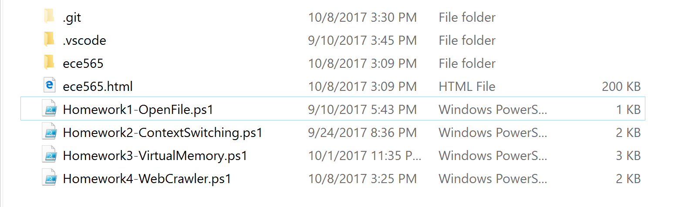

Ece565 folder:

