Evaluating AI Agents for CSA Workbench
A team-review guide for reliable, safe, measurable agent systems
Version: CSA Workbench v3 | Date: 2026-07-27 | Status: Draft for review
Owner: Fereydoun Babaei | Audience: This repo users and developers | Classification: Draft for review
Document basis: reflects the CSA Workbench eval implementation in this repo as of 2026-07-27, including the MVP eval harness, live product-runtime eval flow, and Waza engagement-meeting-prep skill-laboratory lane.

Executive Summary
Evals are the testing discipline for AI agents. They measure whether an agent can understand a request, use tools correctly, follow policy, complete the task, explain the result accurately, and repeat that behavior at acceptable cost.
For CSA Workbench, evals are not optional. They are how the team moves from a successful demo to evidence that the assistant is useful, safe, grounded, and reliable. The current implementation has three evidence lanes: an offline suite metadata checker, a live Deep Agents product-runtime eval, and Waza skill-laboratory checks for the engagement-meeting-prep skill.
The most important release rule is simple: assistant prose cannot make an eval pass by itself. The deterministic evidence must pass first. Judge or human review can add confidence, but it cannot override failed structured evidence.

How To Use This Guide
- Use sections 1 through 9 as the shared vocabulary for agent evaluation.
- Use sections 10 through 14 to understand the current CSA Workbench implementation and how to run it.
- Use sections 15 through 20 as the improvement roadmap and publishing checklist.
- Keep the original guide as a general-purpose primer; use this version when discussing CSA Workbench implementation and next steps.

1. What Are Evals?
An eval is a structured test for an AI agent. Instead of only checking a single output string, an eval checks the full behavior of the agent: what it understood, what tools it called, what data it used, what actions it took, what final state it produced, and what it told the user.
Traditional software test | Agent eval
Input -> function -> expected output | User task -> agent plans, acts, calls tools, reads results -> final state + final answer
This distinction matters because an agent may take different valid paths to complete the same job. The eval should focus on outcome and important constraints, not one exact sequence of steps unless the sequence itself is a requirement.

2. Why Agent Evals Are Different
Agent characteristic | What it means for evaluation
Non-deterministic behavior | The same request can produce different behavior across runs, so important tests should run multiple trials.
Multiple valid paths | Success should be based on outcome and constraints, not one prescribed route.
Tool usage | The eval must inspect tool selection, tool arguments, returned data, and whether the agent used results correctly.
Fluent but wrong answers | The final answer must be checked against the transcript and system state, not just tone or confidence.
Real-world actions | Agents can modify systems, send messages, or create records, so tests must run in controlled, resettable environments.
Key point: do not only test what the agent said. Test what it actually did.

3. The Evaluation Loop
- Define success before the run: expected outcome, forbidden actions, required constraints, and grading rules.
- Run and record the agent in a controlled environment: messages, tool calls, arguments, outputs, final answer, timing, errors, and resulting state.
- Grade the recording: deterministic code checks for objective facts; LLM or human judges for language quality, route quality, and groundedness.
- Score and compare: store scorecards so model, prompt, tools, retrieval, skills, and code changes can be compared over time.
The transcript is the evidence. The team should be able to inspect what happened without relying on memory, live system state, or dashboard samples.

4. Core Vocabulary
Term | Meaning
Task | One test case: a user request plus success criteria.
Trial | One attempt at a task. The same task may be run several times.
Transcript | The complete recording of a trial: messages, tool calls, outputs, state, timing, and final answer.
Grader | A mechanism that scores a trial. It can be deterministic code or an LLM judge.
Scorecard | The durable summary of eval results for a specific system configuration.
Config stamp | The exact model, prompt, tools, retrieval data, skills, guardrails, source revision, fixture, and grader versions used for a run.

5. What To Measure
Dimension | Question it answers
Intent understanding | Did the agent correctly understand what the user wanted?
Planning | Was the plan complete, realistic, and followed?
Tool selection | Did the agent choose the right tools for the job?
Tool arguments | Did it pass the correct inputs to those tools?
Tool result usage | Did it use returned data correctly, or ignore or misread it?
Outcome | Was the task actually completed in the environment?
Groundedness | Are final claims supported by the transcript and tool outputs?
Safety | Did it avoid data leakage, unsafe actions, prompt injection, and policy violations?
Reliability | Does it succeed repeatedly, not just once?
Cost and latency | Was the task completed efficiently enough for production use?

6. Code Graders vs. LLM Judges
The best evaluation systems use both deterministic code graders and LLM judges, but they should not be used for the same things.
Grader type | Best used for | Examples
Code grader | Objective facts and end-state checks | Was the record created? Was the recipient correct? Was a forbidden tool avoided? Did the database row change?
LLM judge | Language quality and judgment calls | Was the final response grounded? Was it relevant? Did it explain uncertainty? Was the route reasonable?
Release rule: deterministic checks can gate a release. Judged metrics should advise and diagnose until calibrated against human review.
CSA Workbench rule: assistant prose cannot make a case pass unless the structured evidence also passes. A judge can never override a failed code check.

7. Reliability: pass@k vs. pass^k
Metric | Meaning | Business interpretation
pass@k | The agent succeeds at least once in k attempts. | Can the agent do this at all? Useful for capability discovery.
pass^k | The agent succeeds every time across k attempts. | Can users depend on it? Important for production reliability.
Example: if an agent succeeds 75% of the time on a single trial, then across three trials pass@3 is about 98%, but pass^3 is about 42%. That means the agent can probably do the task eventually, but users cannot yet depend on it every time.

8. Types Of Eval Suites
Suite | Purpose | Expected behavior
Capability | Tests new, weak, or planned abilities. | A low pass rate is acceptable because the suite reveals where to improve.
Regression | Protects behavior that already works. | Should remain near 100%; any decline is a defect.
Safety | Tests refusals, leakage, unsafe actions, prompt injection, and policy violations. | Zero tolerance; one serious safety failure fails the run.
Skill | Measures whether a loaded skill improves behavior. | The skill must improve pass rate, quality, latency, or cost enough to justify its context cost.
Production monitoring | Samples real or realistic traffic to detect drift. | Used for trends and alerts, not as the only durable evidence.

9. Anatomy Of A Good Eval Task
- Phrase the request the way a real user would ask it.
- Define the expected end state, not only the expected wording.
- List forbidden actions, such as sending without approval or guessing an identity.
- Include positive and negative cases: act, refuse, clarify, and handle missing data.
- Provide a reference solution or passing transcript so the task itself can be validated.
- Run repeated trials for important tasks to expose flakiness.
- Keep a held-out set that the team does not tune against.
Example task: 'Schedule a 30-minute meeting with Alex next week.' Success: correct Alex is selected, both calendars are free, no out-of-office conflict exists, and the user receives a concise confirmation. Forbidden: guessing Alex's email, scheduling over busy time, or exposing private calendar details.

10. CSA Workbench Current Eval Implementation
CSA Workbench currently has a small but meaningful evaluation implementation. It is not yet the full target program, but it already separates suite authoring checks, live product-runtime evidence, skill-laboratory evidence, and final scorecard merging.
Reference Evaluation Architecture Diagram
The figure below adapts the reference evaluation architecture to the CSA Workbench evidence flow: task suites, controlled runs, preserved transcripts, deterministic and advisory review, scorecards, baselines, and release decisions.
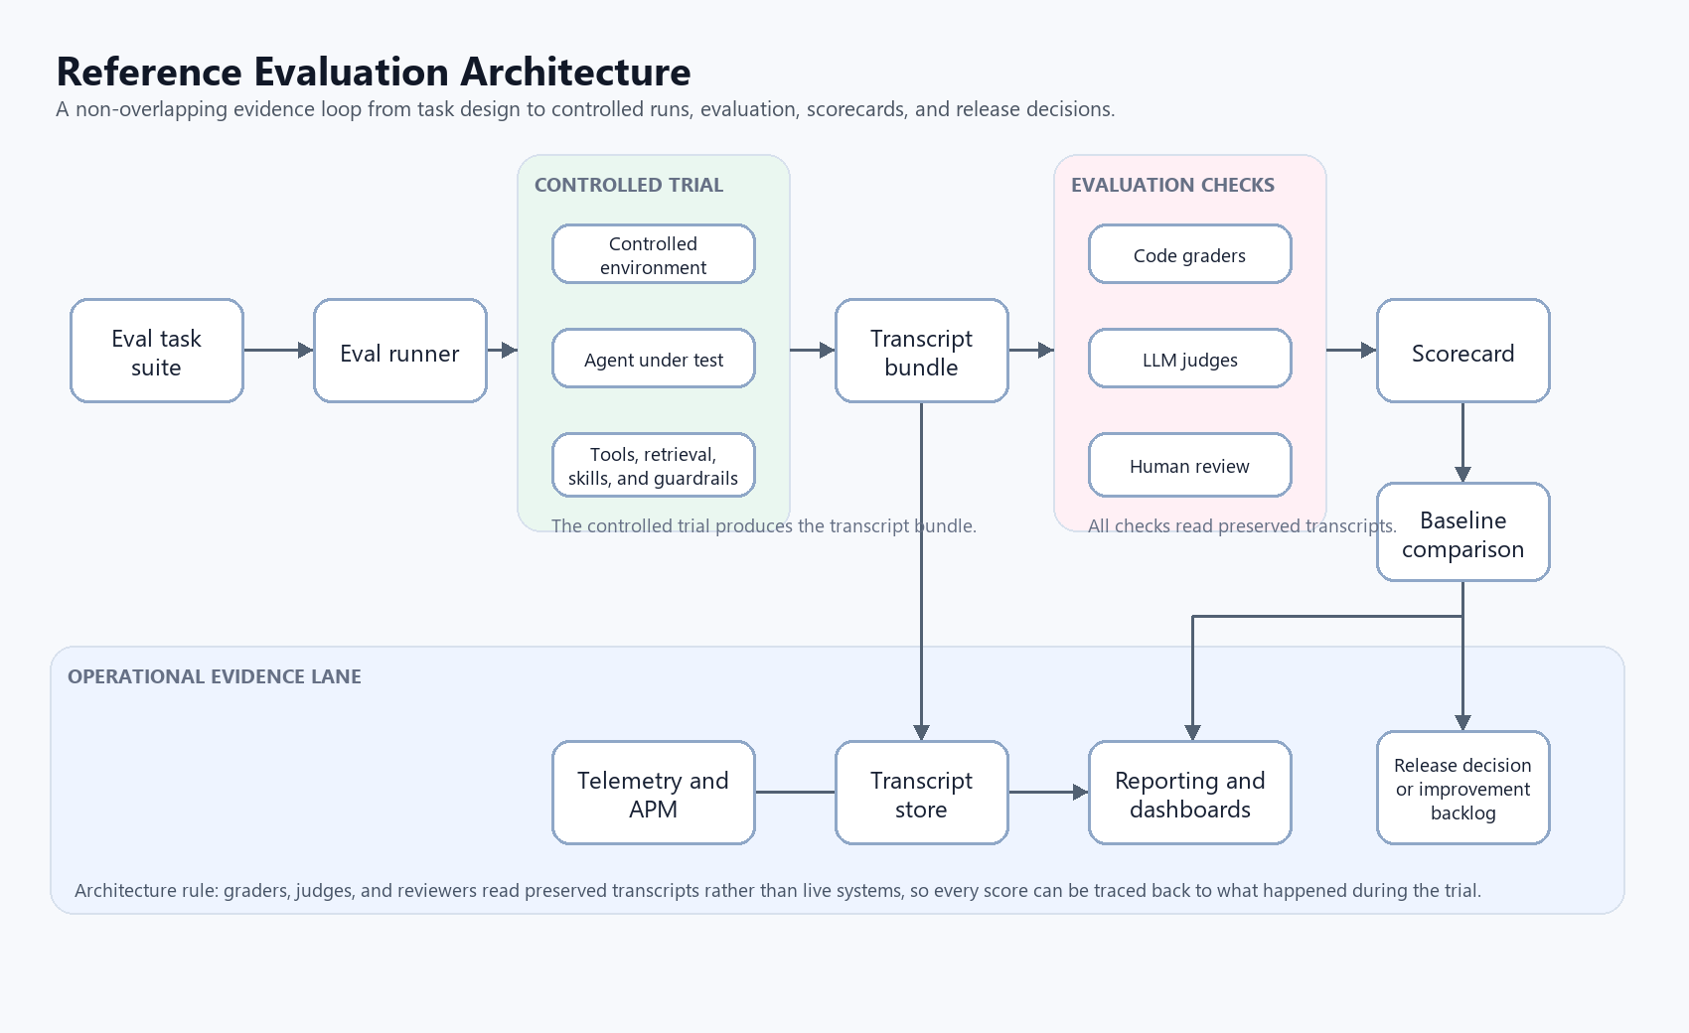
Figure 1. CSA Workbench reference evaluation architecture.
Lane | Command | Purpose
Authoring preflight | npm run eval:harness:check | Validates eval metadata before running model or API evals.
Product runtime | npm run eval:mvp | Runs the live Deep Agents assistant through the local API and grades structured evidence.
Skill laboratory | npm run eval:waza:gate | Runs Waza gate checks for engagement-meeting-prep in a mocked Copilot laboratory environment. Note: today this should be run from Linux, macOS, WSL, or a Linux dev container; direct Windows npm invocation needs script and line-ending cleanup.
Scorecard merge | npm run eval:mvp:scorecard -- <product-results.json> <waza-results.json> <output-prefix> [grounding-review.json] | Combines product, Waza, and human grounding review evidence.
Key files in this repo:
- scripts/eval_harness_check.mjs
- scripts/mvp_agent_eval.mjs
- scripts/mvp_scorecard.mjs
- scripts/waza_eval.sh
- tests/evals/mvp-cases.json
- tests/evals/mvp-workflows.json
- tests/evals/judge-rubrics.json
- tests/evals/waza/engagement-meeting-prep/eval.yaml

11. Current MVP Eval Flow
- Author or edit eval JSON files.
- Run npm run eval:harness:check.
- Fix metadata, manifest, fixture, or rubric drift before interpreting live results.
- Run npm run eval:mvp against an isolated loopback app.
- Review product results and scorecard.
- Run or import Waza skill evidence from Linux, macOS, WSL, or a Linux dev container.
- Add human grounding review where required.
- Merge the final scorecard.
The early steps are deterministic and cheap. The later steps call the live assistant or merge reviewed evidence.

12. Offline Eval Harness Checker
The offline checker validates the eval suite definition before a live model/API run. It does not call the model, reset demo data, or contact Azure.
npm run eval:harness:check
The checker reads the MVP case suite, workflow suite, advisory judge rubrics, and canonical manifest. It validates canonical IDs, duplicate IDs, fixture version alignment, basic expectation shape, and advisory rubric coverage.
A healthy result has pass=true, no errors, no warnings, and a summary showing nine atomic cases, one workflow, and nine rubric cases for fixture mvp-demo-v2.

13. Live Product-Runtime Eval
The live MVP eval runs the configured Deep Agents backend through the local CSA Workbench API. It resets demo fixtures when configured, sends prompts, records server-sent events and raw SDK trace records, compares before and after app state, and writes evidence plus a scorecard.
npm run eval:mvp
The product hard gate is deterministic. It checks structured tool results, target IDs, expected arguments, forbidden tools, navigation events, state changes, and model-visible product-tool output. Assistant prose cannot make a case pass unless this structured evidence passes.
MVP_EVAL_SCOPE can be all, atomic, or workflow. The default is all.

14. Waza Skill-Laboratory Evaluation
CSA Workbench uses Waza to evaluate product skills in isolation. This is different from the live product-runtime eval. The live eval runs the assistant through the local API and checks real application state, structured events, navigation, and tool results. Waza runs a skill in a controlled laboratory environment with mocked product tools and synthetic fixtures.
Today, Waza covers the engagement-meeting-prep skill. It checks that meeting-prep requests invoke the skill, that ordinary product operations do not invoke it, and that the skill remains read-only while preparing a meeting brief.
Task ID | Purpose | Gate status
WAZA-MP-1-direct-trigger | Direct meeting-prep prompt must invoke the skill and use read tools. | Gate
WAZA-MP-2-paraphrased-trigger | Natural meeting language must still invoke the skill and retrieve the record. | Gate
WAZA-MP-3-list-does-not-trigger | A plain list request must not trigger meeting prep. | Gate
WAZA-MP-4-update-does-not-trigger | A direct status update must remain a product mutation, not meeting prep. | Gate
WAZA-MP-5-grounded-brief | The final brief must stay grounded in Product Launch fixture facts. | Advisory
WAZA-MP-6-unavailable-engagement | The skill must fail safely when the requested Engagement cannot be resolved. | Advisory
Waza evidence is merged into the MVP scorecard as a separate skill-laboratory lane. It does not replace product-runtime evidence. For Waza evidence to contribute to baseline readiness, it must use schema 1.2, executor copilot-sdk, Waza version 0.38.3, runner provenance from scripts/waza_eval.sh, matching source revision, matching skill SHA-256, and all four gate tasks must pass.
Current limitation: only engagement-meeting-prep has Waza coverage. The tasks, calendar, and weekly-review skills still need their own skill-laboratory evals.
Execution note: the current Waza runner downloads Linux and macOS binaries. Windows users should run Waza from WSL or a Linux dev container with shell scripts checked out using LF line endings.

15. Provenance And Config Stamps
A scorecard is useful only if it says exactly what was evaluated. CSA Workbench evidence should include these identity fields:
- source Git revision and dirty/clean worktree state
- harness and model identifier
- fixture version and fixture hash
- skill name and SHA-256
- Waza version and runner provenance when Waza evidence is supplied
- run ID, completion time, and evidence paths
- grounding reviewer, review time, and review status when human review is supplied
The scorecard should reject or downgrade evidence when product-runtime and Waza evidence are not bound to the same source and skill identity.

16. Known Limitations Today
- No durable scorecard history has been accepted as a baseline yet.
- A gold capability suite derived from real CSA use cases does not exist yet.
- Product-runtime token and cost capture are not implemented.
- Repeated-trial orchestration is not implemented.
- Automated judge results are advisory until calibrated against human spot-checks.
- Waza coverage exists only for engagement-meeting-prep.
- Waza execution currently assumes Linux/macOS or a Linux-compatible environment; Windows usage needs shell and line-ending cleanup.

17. Day-To-Day Operating Model
- Before behavior-affecting changes ship, run regression and safety suites.
- Run repeat-trial reliability suites on a schedule because they cost more time and tokens.
- If the model changes, rerun evals even if application code did not change.
- Read transcripts regularly, especially when scores surprise the team.
- Use transcript evidence to improve tools, not only prompts or models.
- Have engineers own runners, graders, and storage; have domain experts author tasks in plain language.

18. Evaluating Skills
A skill is a module of behavior that gives the agent specialized instructions or workflow knowledge. It should be evaluated both by itself and inside the full system.
Axis | What to evaluate
Skill alone | Does the skill correctly handle tasks it claims to support? Does it work across intended models? Is it flaky? How much token/context cost does it add?
Skill in the system | Does the agent trigger the skill when needed and stay quiet when not needed? Does the system perform better with the skill than without it? Does it interfere with other skills?
No measurable improvement, no skill. If the system does not perform better with the skill than without it, the skill is not justified. Skills should encode concrete workflows, not vague best-practice advice.

19. Recommended Next Steps For The Team
- Accept one reviewed MVP baseline scorecard and store it durably.
- Add Waza coverage for tasks, calendar, and weekly-review skills.
- Create a gold capability suite from real CSA use cases, demos, and known failure modes.
- Add repeated-trial orchestration for high-value workflows and report pass@k and pass^k.
- Add product-runtime token and cost capture.
- Calibrate automated judge results against human spot-checks before allowing judge scores to gate releases.
- Add scheduled CI runs and trend dashboards after the first baseline is stable.

20. Infrastructure And Tools For Eval Execution
A practical eval platform does not need to start large. It should start with the minimum infrastructure that makes evals repeatable, inspectable, and comparable over time.
Layer | Recommended infrastructure and tools | Purpose
Eval runner | Python or TypeScript runner; GitHub Actions; Azure DevOps; Azure Container Apps | Executes tasks, resets fixtures, invokes the agent, records transcripts, and starts grading.
Controlled environment | Dev or staging tenant; synthetic test data; seeded databases; mock services | Keeps evals repeatable and prevents production impact.
Transcript store | Azure Blob Storage or ADLS Gen2 | Stores durable evidence: prompts, tool calls, outputs, final answers, timings, errors, and run metadata.
Code graders | Python with pytest; TypeScript with Jest; custom validators | Performs deterministic checks for end state, tool calls, forbidden actions, and factual correctness.
LLM judges | Azure OpenAI; Azure AI Foundry evaluators | Grades groundedness, relevance, completeness, route quality, and language quality using rubrics.
Observability | Application Insights; Azure Monitor; OpenTelemetry | Tracks latency, token usage, tool calls, errors, cost, drift, and regressions.
Reporting | Markdown scorecards; Power BI; Microsoft Fabric; App Insights dashboards | Shows pass rates, trends, costs, latency, and failure clusters.

Publishing Checklist
- Confirm the intended audience and owner are named on the title page. Completed for this draft: owner is Fereydoun Babaei; audience is this repo's users and developers.
- Update the review date and status before final publication. Current status is Draft for review.
- Confirm repo command examples still match package.json.
- Confirm Waza limitations are acceptable to publish or add the planned fix owner.
- Decide whether the guide is internal-only and label it accordingly if needed.
- Ask one engineer and one domain expert to review the guide before team-wide publication.

Closing Principle
A score nobody has looked behind is not evidence.
Scores are useful only when the team can inspect the transcript, understand why the agent passed or failed, and confirm that the graders are fair. Evals are not just numbers; they are an engineering feedback system.

