Evaluating AI Agents
A practical guide for building reliable, safe, and measurable agent systems
Author: Fereydoun Babaei
Date: 2026-07-27 | Status: Draft for broader review
Audience: AI agent builders, product owners, engineering leads, evaluators, and stakeholders outside a single repository or product team
Purpose: Provide a practical, standalone guide for evaluating AI agents across products, teams, and agent frameworks, including product-runtime evals, skill-laboratory evals, Waza-style checks, provenance, governance, and publication readiness.

Executive Summary
Evals are the testing discipline for AI agents. They measure whether an agent can understand a request, use tools correctly, follow policy, complete the task, explain the result accurately, and repeat that behavior at acceptable cost.
For agent development, evals are not optional. They are how teams move from a successful demo to evidence that a system is useful, safe, reliable, and ready for broader use.
The central rule is simple: test what the agent did, not only what it said. A fluent final answer is not enough if the transcript, tool calls, and resulting state do not support it.

How To Use This Guide
- Use sections 1 through 9 to build shared vocabulary and design good eval tasks.
- Use sections 10 through 15 to design an eval architecture, skill-lab lane, and operating model.
- Use sections 16 through 20 to choose infrastructure, govern releases, and prepare a publishable eval program.
- Adapt examples to your product, risk level, regulatory context, and agent architecture.

1. What Are Evals?
An eval is a structured test for an AI agent. Instead of only checking a single output string, an eval checks the full behavior of the agent: what it understood, what tools it called, what data it used, what actions it took, what final state it produced, and what it told the user.
Traditional software test | Agent eval
Input -> function -> expected output | User task -> agent plans, acts, calls tools, reads results -> final state + final answer
This distinction matters because an agent may take different valid paths to complete the same job. The eval should focus on outcome and important constraints, not one exact sequence of steps unless the sequence itself is a requirement.

2. Why Agent Evals Are Different
Agent characteristic | What it means for evaluation
Non-deterministic behavior | The same request can produce different behavior across runs, so important tests should run multiple trials.
Multiple valid paths | Success should be based on outcome and constraints, not one prescribed route.
Tool usage | The eval must inspect tool selection, tool arguments, returned data, and whether the agent used results correctly.
Fluent but wrong answers | The final answer must be checked against the actual transcript and system state, not just tone or confidence.
Real-world actions | Agents can modify systems, send messages, or create records, so tests must run in controlled, resettable environments.
Key point: do not only test what the agent said. Test what it actually did.

3. The Evaluation Loop
- Define success before the run: expected outcome, forbidden actions, required constraints, and grading rules.
- Run and record the agent in a controlled environment: messages, tool calls, arguments, outputs, final answer, timing, errors, and resulting state.
- Grade the recording: deterministic code checks for objective facts; LLM or human judges for language quality, route quality, and groundedness.
- Score and compare: store scorecards so changes in model, prompt, tools, retrieval, skills, or code can be compared over time.
The transcript is the evidence. A team should be able to inspect what happened without relying on memory, live system state, or a dashboard sample.

4. Core Vocabulary
Term | Meaning
Task | One test case: a user request plus success criteria.
Trial | One attempt at a task. The same task may be run several times.
Transcript | The complete recording of a trial: messages, tool calls, outputs, state, timing, and final answer.
Grader | A mechanism that scores a trial. It can be deterministic code, an LLM judge, or a human review protocol.
Scorecard | The durable summary of eval results for a specific system configuration.
Config stamp | The exact model, prompt, tools, retrieval data, skills, guardrails, data fixtures, source version, and grader versions used for a run.

5. What To Measure
Dimension | Question it answers
Intent understanding | Did the agent correctly understand what the user wanted?
Planning | Was the plan complete, realistic, and followed?
Tool selection | Did the agent choose the right tools for the job?
Tool arguments | Did it pass the correct inputs to those tools?
Tool result usage | Did it use returned data correctly, or ignore or misread it?
Outcome | Was the task actually completed in the environment?
Groundedness | Are final claims supported by the transcript and tool outputs?
Safety | Did it avoid data leakage, unsafe actions, prompt injection, and policy violations?
Reliability | Does it succeed repeatedly, not just once?
Cost and latency | Was the task completed efficiently enough for production use?

6. Code Graders, LLM Judges, And Human Review
The best evaluation systems use multiple grading methods, but each method should grade the thing it is good at.
Grader type | Best used for | Examples
Code grader | Objective facts and end-state checks | Was the record created? Was the recipient correct? Was a forbidden tool avoided? Did the database row change?
LLM judge | Language quality and judgment calls | Was the final response grounded? Was it relevant? Did it explain uncertainty? Was the route reasonable?
Human review | Calibration, high-risk decisions, and unclear failures | Does the rubric match domain expectations? Did the automated judge miss a subtle safety or quality issue?
Release rule: deterministic checks can gate a release. Judged metrics should advise and diagnose until calibrated against human review. A judge should never override a failed code check for objective behavior.

7. Reliability: pass@k vs. pass^k
Metric | Meaning | Business interpretation
pass@k | The agent succeeds at least once in k attempts. | Can the agent do this at all? Useful for capability discovery.
pass^k | The agent succeeds every time across k attempts. | Can users depend on it? Important for production reliability.
Example: if an agent succeeds 75% of the time on a single trial, then across three trials pass@3 is about 98%, but pass^3 is about 42%. That means the agent can probably do the task eventually, but users cannot yet depend on it every time.

8. Types Of Eval Suites
Suite | Purpose | Expected behavior
Capability | Tests new, weak, or planned abilities. | A low pass rate is acceptable because the suite reveals where to improve.
Regression | Protects behavior that already works. | Should remain near 100%; any decline is a defect.
Safety | Tests refusals, leakage, unsafe actions, prompt injection, and policy violations. | Zero tolerance; one serious safety failure fails the run.
Skill | Measures whether a loaded skill improves behavior. | The skill must improve pass rate, quality, latency, or cost enough to justify its context cost.
Production monitoring | Samples real or realistic traffic to detect drift. | Used for trends and alerts, not as the only durable evidence.
Adversarial | Tests malicious or confusing inputs. | Used to harden safety boundaries and tool permissions.

9. Anatomy Of A Good Eval Task
- Phrase the request the way a real user would ask it.
- Define the expected end state, not only the expected wording.
- List forbidden actions, such as sending without approval or guessing an identity.
- Include positive and negative cases: act, refuse, clarify, and handle missing data.
- Provide a reference solution or passing transcript so the task itself can be validated.
- Run repeated trials for important tasks to expose flakiness.
- Keep a held-out set that the team does not tune against.
Example task: 'Schedule a 30-minute meeting with Alex next week.' Success: correct Alex is selected, both calendars are free, no out-of-office conflict exists, and the user receives a concise confirmation. Forbidden: guessing Alex's email, scheduling over busy time, or exposing private calendar details.

10. Reference Evaluation Architecture
Component | Role
Runner | Starts tasks, resets fixtures, records everything, and applies deterministic checks.
Agent under test | The actual agent stack: harness, model, prompts, tools, retrieval, skills, and guardrails.
Controlled environment | Synthetic or staging-like data that can be reset before every trial.
Transcript store | Immutable, complete recordings of each run. This is the evidence source.
Code graders | Objective validators for facts, tool calls, end state, and forbidden actions.
LLM judges | Rubric-based evaluators for groundedness, language quality, route sanity, and policy interpretation.
Scorecards | Version-controlled summaries of results and config stamps.
Telemetry/APM | Operational trends and debugging signals. Useful for observing, not sufficient as durable grading evidence.
Architecture principle: graders should read transcripts, not live systems. Live systems change; transcripts preserve what actually happened during the trial.

Reference Architecture Diagram
The figure below summarizes the reference evaluation architecture described above. It shows how task suites, controlled runs, transcripts, graders, judges, reviewers, and release decisions connect into one evaluation loop.
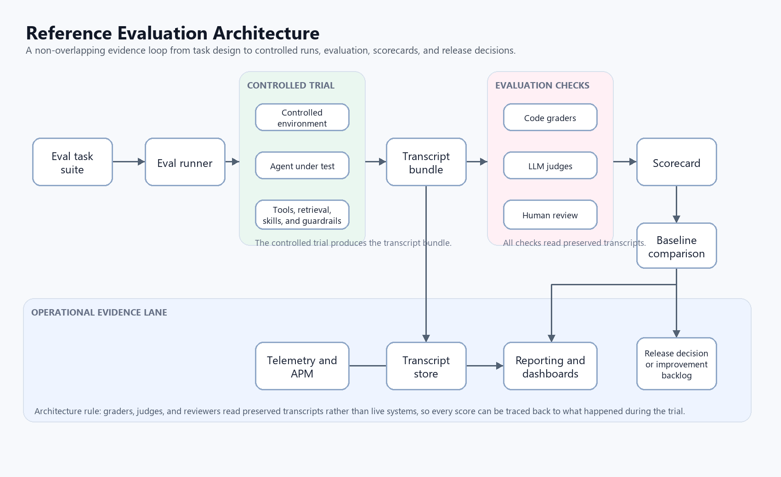
Figure 1. Reference evaluation architecture.

11. Waza-Style Skill-Laboratory Evaluation
Many teams evaluate agent skills in two lanes: a full product-runtime lane and a skill-laboratory lane. Waza is an example of a skill-laboratory approach: it runs a skill in a controlled environment with mocked or synthetic tools, then checks whether the skill routes correctly, stays within boundaries, and produces grounded behavior.
Question | Product-runtime eval | Skill-laboratory eval
What is tested? | The full application and agent stack in a realistic environment. | A specific skill, tool contract, or routing behavior in isolation.
What is strong? | End-to-end state, integration, permissions, and user-visible behavior. | Fast feedback on skill triggers, non-triggers, read/write boundaries, and prompt/tool contract drift.
What is weak? | More expensive, slower, and harder to debug. | Does not prove the full product works end to end.
How should results be used? | Can gate releases when deterministic evidence passes. | Can gate skill readiness, but should not replace product-runtime evals.
If a team uses Waza or a similar skill-lab framework, the evidence should be stamped with the skill name, skill version or hash, runner version, schema version, executor, model, fixtures, source revision, and pass/fail criteria. Separate gate tasks from advisory tasks so routing and safety failures are not hidden inside subjective quality scores.
Recommended skill-lab task pattern: direct trigger, paraphrased trigger, similar-but-not-trigger prompt, forbidden mutation prompt, grounded final answer, and unavailable-data behavior.

12. Evaluating Skills
A skill is a module of behavior that gives the agent specialized instructions or workflow knowledge. It should be evaluated both by itself and inside the full system.
Axis | What to evaluate
Skill alone | Does the skill correctly handle tasks it claims to support? Does it work across intended models? Is it flaky? How much token or context cost does it add?
Skill in the system | Does the agent trigger the skill when needed and stay quiet when not needed? Does the system perform better with the skill than without it? Does it interfere with other skills?
No measurable improvement, no skill. If the system does not perform better with the skill than without it, the skill is not justified. Skills should encode concrete workflows, not vague best-practice advice.

13. Provenance And Config Stamps
A scorecard is useful only if it says exactly what was evaluated. Every serious eval run should include enough identity metadata to reproduce or explain the result later.
- source revision and dirty/clean state
- model name, deployment, parameters, and provider
- prompt, system instructions, tools, retrieval indexes, skills, and guardrails
- fixture version and fixture hash
- runner, grader, judge, and safety-eval versions
- run ID, time, environment, evidence path, and reviewer status
Do not compare scorecards unless the differences in their config stamps are understood. A model change, prompt change, tool contract change, or fixture change can all explain a score movement.

14. Day-To-Day Operating Model
- Before behavior-affecting changes ship, run regression and safety suites.
- Run repeat-trial reliability suites on a schedule because they cost more time and tokens.
- If the model changes, rerun evals even if application code did not change.
- Read transcripts regularly, especially when scores surprise the team.
- Use transcript evidence to improve tools, data, retrieval, and workflow design, not only prompts or models.
- Have engineers own runners, graders, and storage; have domain experts author tasks in plain language.

15. Common Failure Modes And Anti-Patterns
- Only grading the final answer while ignoring tool calls and system state.
- Letting an LLM judge override deterministic failures.
- Tuning prompts directly against the entire eval suite until the suite becomes training data.
- Using production data without a privacy and reset strategy.
- Changing model, prompt, tools, and fixtures at the same time, then treating the result as one clean comparison.
- Publishing pass rates without sample size, trial count, config stamp, or known limitations.

16. Recommended First Steps For A Team
- Select one important agent workflow and write 20 to 50 realistic eval tasks from known failures, demos, support tickets, and pre-release checks.
- Define success criteria, forbidden actions, and grading rules for each task.
- Create a controlled test environment with resettable fixtures.
- Record complete transcripts for every run and store them durably.
- Add code graders for objective outcomes and LLM judges for language and route quality.
- Create a baseline scorecard and compare every behavior-affecting change against it.
- Run safety checks every time and reliability checks on a scheduled cadence.

17. Infrastructure And Tools For Eval Execution
A practical eval platform does not need to start large. It should start with the minimum infrastructure that makes evals repeatable, inspectable, and comparable over time.
Layer | Recommended infrastructure and tools | Purpose
Eval runner | Python or TypeScript runner; GitHub Actions; Azure DevOps Pipelines; container jobs | Executes tasks, resets fixtures, invokes the agent, records transcripts, and starts grading.
Controlled environment | Dev or staging tenant; synthetic test data; seeded databases; mock services; test mailboxes and calendars | Keeps evals repeatable and prevents production impact.
Agent runtime | Azure AI Foundry Agent Service; custom agent harness; Semantic Kernel; LangGraph; AutoGen | Runs the agent under test with a fixed, stamped configuration.
Transcript store | Azure Blob Storage; ADLS Gen2; object storage; versioned file store | Stores durable evidence: prompts, tool calls, outputs, final answers, timings, errors, and run metadata.
Code graders | Python with pytest; TypeScript with Jest; custom validators | Performs deterministic checks for end state, tool calls, forbidden actions, and factual correctness.
LLM judges | Azure OpenAI; Azure AI Foundry evaluators; calibrated judge services | Grades groundedness, relevance, completeness, route quality, and language quality using rubrics.
Safety evals | Azure AI Foundry evaluators; PyRIT; OWASP LLM test cases; prompt-injection suites | Tests leakage, unsafe actions, jailbreak resistance, prompt injection, and policy violations.
Observability | Application Insights; Azure Monitor; OpenTelemetry | Tracks latency, token usage, tool calls, errors, cost, drift, and regressions.
Reporting | Markdown scorecards; Power BI; Microsoft Fabric; App Insights dashboards | Shows pass rates, trends, costs, latency, and failure clusters.

18. Minimal Practical Stack
- A repository for eval task files, grader code, config stamps, and scorecards.
- A Python or TypeScript eval runner that calls the agent, records transcript JSON, and invokes graders.
- Durable object storage for transcript bundles keyed by run ID.
- pytest or Jest for deterministic code graders.
- An LLM judge or evaluator service for advisory rubric-based grading.
- CI/CD for pull request, release, and scheduled execution.
- Observability for traces, latency, token usage, tool calls, and operational telemetry.

19. Publishing And Governance Checklist
- Name the owner, audience, status, and date before sharing broadly.
- State whether the guide is internal-only, public, confidential, or draft for review.
- Separate proven facts from recommendations and future-state aspirations.
- Document known limitations and areas where examples need adaptation.
- Have at least one engineer and one domain expert review the guide.
- Update command examples, tool names, and framework names before publication.
- Keep a changelog when the guide becomes a living document.

20. Closing Principle
A score nobody has looked behind is not evidence.
Scores are useful only when the team can inspect the transcript, understand why the agent passed or failed, and confirm that the graders are fair. Evals are not just numbers; they are an engineering feedback system.

