# AINT 253 Door Design

### Chosen Idea

The type of door I have chosen is a simple sliding door, designed to go into a living room or kitchen which splits an open room into 2 separate rooms. I have chosen this idea because there are many aspects that I can focus on such as the style of door and the type of animation to open the door.

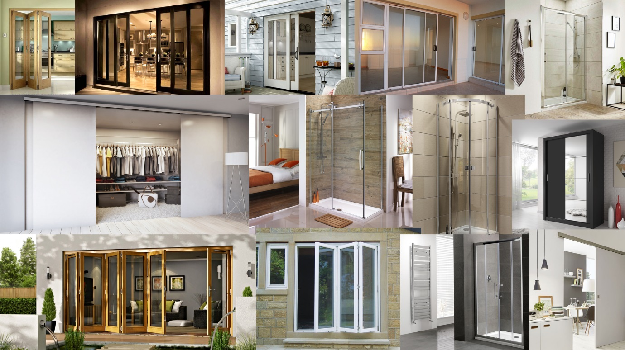

From the mood board above there is a clear theme across all the images and that is simplicity with little detail but still providing a high-quality outcome. Within the board there are a few types of sliding doors such as the simple single sliding door to a 2-curved sliding shower door. For these doors, there are very few hinges to create any sort of creaking sound effect meaning that the for the sound design, I will need to find a rolling sound with a latch click to provide audio feedback for the user. With these doors the is little texturing to do but trying to get a realistic glass effect will be challenging.

With sliding doors that is very little sounds which accompany these such as the sound of wheels on which the door slides open and the clicking sound when the door has reached its open state. This means that I need to focus on sounds surrounding the door as well to provide a realistic experience.