*Test #1 (Verbose)*

Puzzle configuration:

3,0,2

4,1,5

6,7,8

Manhatten distance: 3

Expected output: 3 moves: 1->4->3->COMPLETE

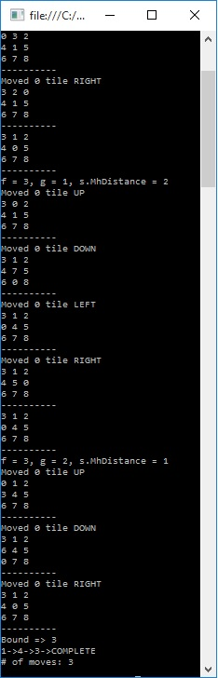

*Test #2*

Puzzle configuration:

0,1,2

4,3,5

6,7,8

Manhatten distance: 2

Expected output: Puzzle configuration has no solution.

