МІНІСТЕРСТВО ОСВІТИ І НАУКИ УКРАЇНИ
Національний університет “Львівська політехніка”
Інститут комп’ютерних наук та інформаційних технологій
Кафедра автоматизованих систем управління



Звіт
про виконання лабораторної роботи №4
з дисципліни “ Паралельні обчислення і розподілені системи”
на тему:
“Мікросервіси”

Виконав:
студент групи ОІ-21СП
Горбатюк Д. О.

Прийняла:
доцентка кафедри АСУ,
Федевич О. Ю.

Лабораторна робота №4
Тема: Мікросервіси.
Мета роботи: Оволодіти практичними прийомами розробки мікросервісів.

Завдання лабораторної роботи
Варіант по списку групи - 1
Завдання:
Розбийте систему, розроблену вами у лабораторній роботі №3 на окремі мікросервіси.

ХІД РОБОТИ
- Спроєктував розбиття роботи із ЛР3 (моноліт) на мікросервіси. Діаграма рішення наведена на Рис. 1.1.
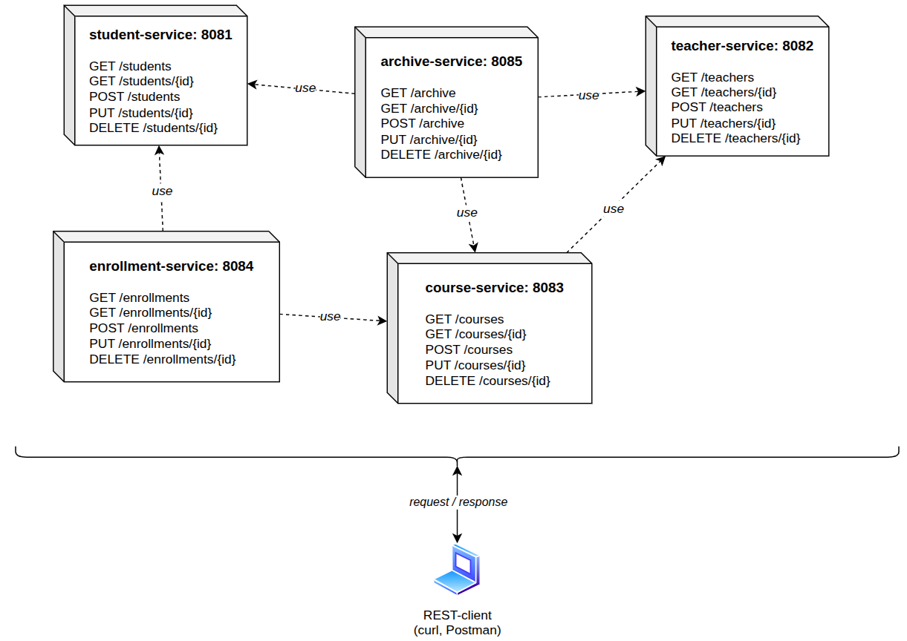
Рис. 1.1. Діаграма рішення у ЛР4
- Запуск буде відбуватись на різних портах. Рішення зумовлене простотою його виконання, компактністю.
- Створюємо відповідні проєкти Spring Boot у середовищі Intellij Idea, відповідно до діаграми на Рис. 1.1, проводимо налаштування портів, на яких буде працювати кожен сервіс.
- Створю перші два сервіси: student-service, teacher-service, адже вони не використовують інших сервісів – запити йдуть тільки до них. Код наведений у додатках XX-XX.
Блок 1 - набір запитів до сервісу student-service;
Блок 2 - відповідь на запит через консоль
echo "=============================="
echo "STUDENT SERVICE TEST START"
echo "=============================="

echo
echo "[1] CREATE STUDENT"
curl -X POST http://localhost:8081/students \
-H "Content-Type: application/json" \
-d '{
"fullName": "Danylo Horbatiuk",
"groupName": "OI-21SP",
"email": "danylo@student.edu"
}'

echo
echo
echo "[2] GET ALL STUDENTS"
curl http://localhost:8081/students

echo
echo
echo "[3] GET STUDENT BY ID = 1"
curl http://localhost:8081/students/1

echo
echo
echo "[4] UPDATE STUDENT ID = 1"
curl -X PUT http://localhost:8081/students/1 \
-H "Content-Type: application/json" \
-d '{
"fullName": "Danylo Horbatiuk Updated",
"groupName": "OI-22SP",
"email": "danylo.updated@student.edu"
}'

echo
echo
echo "[5] GET UPDATED STUDENT BY ID = 1"
curl http://localhost:8081/students/1

echo
echo
echo "[6] DELETE STUDENT ID = 1"
curl -X DELETE http://localhost:8081/students/1

echo
echo
echo "[7] GET ALL STUDENTS AFTER DELETE"
curl http://localhost:8081/students

==============================
STUDENT SERVICE TEST START
==============================

[1] CREATE STUDENT
{"id":1,"fullName":"Danylo Horbatiuk","groupName":"OI-21SP","email":"danylo@student.edu"}

[2] GET ALL STUDENTS
[{"id":1,"fullName":"Danylo Horbatiuk","groupName":"OI-21SP","email":"danylo@student.edu"}]

[3] GET STUDENT BY ID = 1
{"id":1,"fullName":"Danylo Horbatiuk","groupName":"OI-21SP","email":"danylo@student.edu"}

[4] UPDATE STUDENT ID = 1
{"id":1,"fullName":"Danylo Horbatiuk Updated","groupName":"OI-22SP","email":"danylo.updated@student.edu"}

[5] GET UPDATED STUDENT BY ID = 1
{"id":1,"fullName":"Danylo Horbatiuk Updated","groupName":"OI-22SP","email":"danylo.updated@student.edu"}

[6] DELETE STUDENT ID = 1

[7] GET ALL STUDENTS AFTER DELETE
[]

Блок 1 - набір запитів до сервісу teacher-service;
Блок 2 - відповідь на запит через консоль
echo "=============================="
echo "TEACHER SERVICE TEST START"
echo "=============================="

echo
echo "[1] CREATE TEACHER"
curl -X POST http://localhost:8082/teachers \
-H "Content-Type: application/json" \
-d '{
"fullName": "Ivan Petrenko",
"department": "Computer Science",
"email": "ivan.petrenko@university.edu"
}'

echo
echo
echo "[2] GET ALL TEACHERS"
curl http://localhost:8082/teachers

echo
echo
echo "[3] GET TEACHER BY ID = 1"
curl http://localhost:8082/teachers/1

echo
echo
echo "[4] UPDATE TEACHER ID = 1"
curl -X PUT http://localhost:8082/teachers/1 \
-H "Content-Type: application/json" \
-d '{
"fullName": "Ivan Petrenko Updated",
"department": "Distributed Systems",
"email": "ivan.updated@university.edu"
}'

echo
echo
echo "[5] GET UPDATED TEACHER BY ID = 1"
curl http://localhost:8082/teachers/1

echo
echo
echo "[6] DELETE TEACHER ID = 1"
curl -X DELETE http://localhost:8082/teachers/1

echo
echo
echo "[7] GET ALL TEACHERS AFTER DELETE"
curl http://localhost:8082/teachers
echo
==============================
TEACHER SERVICE TEST START
==============================

[1] CREATE TEACHER
{"id":1,"fullName":"Ivan Petrenko","department":"Computer Science","email":"ivan.petrenko@university.edu"}

[2] GET ALL TEACHERS
[{"id":1,"fullName":"Ivan Petrenko","department":"Computer Science","email":"ivan.petrenko@university.edu"}]

[3] GET TEACHER BY ID = 1
{"id":1,"fullName":"Ivan Petrenko","department":"Computer Science","email":"ivan.petrenko@university.edu"}

[4] UPDATE TEACHER ID = 1
{"id":1,"fullName":"Ivan Petrenko Updated","department":"Distributed Systems","email":"ivan.updated@university.edu"}

[5] GET UPDATED TEACHER BY ID = 1
{"id":1,"fullName":"Ivan Petrenko Updated","department":"Distributed Systems","email":"ivan.updated@university.edu"}

[6] DELETE TEACHER ID = 1

[7] GET ALL TEACHERS AFTER DELETE
[]

- Далі enrollment-service.
Блок 1 - набір запитів до сервісу enrollment-service;
Блок 2 - відповідь на запит через консоль
echo "=============================="
echo "ENROLLMENT SERVICE TEST START"
echo "=============================="

echo
echo "[0] CREATE STUDENT"
curl -X POST http://localhost:8081/students \
-H "Content-Type: application/json" \
-d '{
"fullName": "Danylo Horbatiuk",
"groupName": "OI-21SP",
"email": "danylo@student.edu"
}'

echo
echo
echo "[1] CREATE TEACHER"
curl -X POST http://localhost:8082/teachers \
-H "Content-Type: application/json" \
-d '{
"fullName": "Ivan Petrenko",
"department": "Computer Science",
"email": "ivan.petrenko@university.edu"
}'

echo
echo
echo "[2] CREATE COURSE"
curl -X POST http://localhost:8083/courses \
-H "Content-Type: application/json" \
-d '{
"title": "Parallel Computing",
"credits": 5,
"teacherId": 1
}'

echo
echo
echo "[3] CREATE ENROLLMENT"
curl -X POST http://localhost:8084/enrollments \
-H "Content-Type: application/json" \
-d '{
"studentId": 1,
"courseId": 1
}'

echo
echo
echo "[4] GET ALL ENROLLMENTS"
curl http://localhost:8084/enrollments

echo
echo
echo "[5] GET ENROLLMENT BY ID = 1"
curl http://localhost:8084/enrollments/1

echo
echo
echo "[6] NEGATIVE TEST: DUPLICATE ENROLLMENT"
curl -X POST http://localhost:8084/enrollments \
-H "Content-Type: application/json" \
-d '{
"studentId": 1,
"courseId": 1
}'

echo
echo
echo "[7] NEGATIVE TEST: INVALID STUDENT"
curl -X POST http://localhost:8084/enrollments \
-H "Content-Type: application/json" \
-d '{
"studentId": 99,
"courseId": 1
}'

echo
echo
echo "[8] NEGATIVE TEST: INVALID COURSE"
curl -X POST http://localhost:8084/enrollments \
-H "Content-Type: application/json" \
-d '{
"studentId": 1,
"courseId": 99
}'

echo
echo
echo "[9] UPDATE ENROLLMENT ID = 1"
curl -X PUT http://localhost:8084/enrollments/1 \
-H "Content-Type: application/json" \
-d '{
"studentId": 1,
"courseId": 1
}'

echo
echo
echo "[10] DELETE ENROLLMENT ID = 1"
curl -X DELETE http://localhost:8084/enrollments/1

echo
echo
echo "[11] GET ALL ENROLLMENTS AFTER DELETE"
curl http://localhost:8084/enrollments

echo

==============================
ENROLLMENT SERVICE TEST START
==============================

[0] CREATE STUDENT
{"id":1,"fullName":"Danylo Horbatiuk","groupName":"OI-21SP","email":"danylo@student.edu"}

[1] CREATE TEACHER
{"id":1,"fullName":"Ivan Petrenko","department":"Computer Science","email":"ivan.petrenko@university.edu"}

[2] CREATE COURSE
{"id":1,"title":"Parallel Computing","credits":5,"teacherId":1}

[3] CREATE ENROLLMENT
{"id":1,"studentId":1,"courseId":1}

[4] GET ALL ENROLLMENTS
[{"id":1,"studentId":1,"courseId":1}]

[5] GET ENROLLMENT BY ID = 1
{"id":1,"studentId":1,"courseId":1}

[6] NEGATIVE TEST: DUPLICATE ENROLLMENT
This student is already enrolled in this course

[7] NEGATIVE TEST: INVALID STUDENT
Student with id 99 does not exist

[8] NEGATIVE TEST: INVALID COURSE
Course with id 99 does not exist

[9] UPDATE ENROLLMENT ID = 1
{"id":1,"studentId":1,"courseId":1}

[10] DELETE ENROLLMENT ID = 1

[11] GET ALL ENROLLMENTS AFTER DELETE
[]

- Далі archive-service.
Блок 1 - набір запитів до сервісу archive-service;
Блок 2 - відповідь на запит через консоль
echo "=============================="
echo "ARCHIVE SERVICE TEST START"
echo "=============================="

echo
echo "[0] CREATE STUDENT"
curl -X POST http://localhost:8081/students \
-H "Content-Type: application/json" \
-d '{
"fullName": "Danylo Horbatiuk",
"groupName": "OI-21SP",
"email": "danylo@student.edu"
}'

echo
echo
echo "[1] CREATE TEACHER"
curl -X POST http://localhost:8082/teachers \
-H "Content-Type: application/json" \
-d '{
"fullName": "Ivan Petrenko",
"department": "Computer Science",
"email": "ivan.petrenko@university.edu"
}'

echo
echo
echo "[2] CREATE COURSE"
curl -X POST http://localhost:8083/courses \
-H "Content-Type: application/json" \
-d '{
"title": "Parallel Computing",
"credits": 5,
"teacherId": 1
}'

echo
echo
echo "[3] CREATE ARCHIVE RECORD"
curl -X POST http://localhost:8085/archive \
-H "Content-Type: application/json" \
-d '{
"studentId": 1,
"courseId": 1,
"teacherId": 1,
"grade": 95
}'

echo
echo
echo "[4] GET ALL ARCHIVE RECORDS"
curl http://localhost:8085/archive

echo
echo
echo "[5] GET ARCHIVE RECORD BY ID = 1"
curl http://localhost:8085/archive/1

echo
echo
echo "[6] UPDATE ARCHIVE RECORD ID = 1"
curl -X PUT http://localhost:8085/archive/1 \
-H "Content-Type: application/json" \
-d '{
"studentId": 1,
"courseId": 1,
"teacherId": 1,
"grade": 100
}'

echo
echo
echo "[7] NEGATIVE TEST: INVALID GRADE"
curl -X POST http://localhost:8085/archive \
-H "Content-Type: application/json" \
-d '{
"studentId": 1,
"courseId": 1,
"teacherId": 1,
"grade": 150
}'

echo
echo
echo "[8] NEGATIVE TEST: INVALID STUDENT"
curl -X POST http://localhost:8085/archive \
-H "Content-Type: application/json" \
-d '{
"studentId": 99,
"courseId": 1,
"teacherId": 1,
"grade": 90
}'

echo
echo
echo "[9] NEGATIVE TEST: INVALID TEACHER"
curl -X POST http://localhost:8085/archive \
-H "Content-Type: application/json" \
-d '{
"studentId": 1,
"courseId": 1,
"teacherId": 99,
"grade": 90
}'

echo
echo
echo "[10] NEGATIVE TEST: INVALID COURSE"
curl -X POST http://localhost:8085/archive \
-H "Content-Type: application/json" \
-d '{
"studentId": 1,
"courseId": 99,
"teacherId": 1,
"grade": 90
}'

echo
echo
echo "[11] DELETE ARCHIVE RECORD ID = 1"
curl -X DELETE http://localhost:8085/archive/1

echo
echo
echo "[12] GET ALL ARCHIVE AFTER DELETE"
curl http://localhost:8085/archive

echo

==============================
ARCHIVE SERVICE TEST START
==============================

[0] CREATE STUDENT
{"id":2,"fullName":"Danylo Horbatiuk","groupName":"OI-21SP","email":"danylo@student.edu"}

[1] CREATE TEACHER
{"id":2,"fullName":"Ivan Petrenko","department":"Computer Science","email":"ivan.petrenko@university.edu"}

[2] CREATE COURSE
{"id":2,"title":"Parallel Computing","credits":5,"teacherId":1}

[3] CREATE ARCHIVE RECORD
{"id":1,"studentId":1,"courseId":1,"teacherId":1,"grade":95}

[4] GET ALL ARCHIVE RECORDS
[{"id":1,"studentId":1,"courseId":1,"teacherId":1,"grade":95}]

[5] GET ARCHIVE RECORD BY ID = 1
{"id":1,"studentId":1,"courseId":1,"teacherId":1,"grade":95}

[6] UPDATE ARCHIVE RECORD ID = 1
{"id":1,"studentId":1,"courseId":1,"teacherId":1,"grade":100}

[7] NEGATIVE TEST: INVALID GRADE
Grade must be between 0 and 100

[8] NEGATIVE TEST: INVALID STUDENT
Student with id 99 does not exist

[9] NEGATIVE TEST: INVALID TEACHER
Teacher with id 99 does not exist

[10] NEGATIVE TEST: INVALID COURSE
Course with id 99 does not exist

[11] DELETE ARCHIVE RECORD ID = 1

[12] GET ALL ARCHIVE AFTER DELETE
[]

Отже, відповідну структуру реалізовано. Проте є великі недоліки використання саме такої схеми мікросервісів, адже кожен із них модерується і обслуговується як окремий проєкт, що створює труднощі у підтримці їх життєздатності.
ВИСНОВКИ
У ході роботи монолітну систему з лабораторної роботи №3 було розбито на окремі мікросервіси, які запускаються на різних портах і взаємодіють між собою через HTTP-запити. Було реалізовано student-service, teacher-service, course-service, enrollment-service та archive-service.
Загалом робота допомогла краще зрозуміти принцип побудови мікросервісної архітектури. Разом із тим, стало видно, що така схема ускладнює підтримку системи, бо кожен сервіс потрібно окремо запускати, налаштовувати і контролювати.

