1. The title, authors

Title: **Dynamic Constraint Ordering Heuristics for Dynamic CSPs**

Author: Saida Hammoujan∗, Yosra Acodad∗ Imade Benelallam∗ ‡ and El Houssine Bouyakhf∗

1. The source of the paper (e.g. Journal name, and date of publication, links on the web)

Source: Applied Mathematical Sciences Vol. 7

Date of pubication: November 2013

Links:https://www.researchgate.net/publication/262013256_Dynamic_Constraint_Ordering_Heuristics_for_Dynamic_CSPs

1. Concepts that are different in contrast to the traditional CSP:

A CSP consists of a set of variables, each associated with a domain of values, and a set of constraints. A solution to a CSP is an assignment of a value to every variable, and every constraint must be satisfied. Nevertheless, many problems in happen in dynamic environments, which the information is not defined once and for all, but is incrementally evolve.   
 A Dynamic Constraint Satisfaction Problem (DCSP) is an extension to a static CSP that considers the addition and the retraction of constraints. So, it is more powerful for dealing real-world problems. However, even if DCSP sounds powerful, there are some attributes that can affect the result of DCSP. The author says that for many problems, the best choice of variable and value ordering can have a huge impact on finding the solution. Nevertheless, only some few works have been done on **constraint ordering heuristics**.  
 In this paper, the author presents a new constraint ordering approach for repairing solutions in dynamic CSPs, called Dynamic Constraint Ordering DCO heuristic. This kind of heuristic selects the constraints which is likely to lead to a conflict as soon as possible. Furthermore, this heuristic method guides the repair algorithm, Partial-Order Dynamic Backtracking (PDB), to a hard constraint network sub-network in order to correct solution’s assignments.   
 The key idea of this paper is to **exploit the flexibility of PDB algorithm by proposing a new dynamic constraint ordering heuristic** that can be used in the context of Dynamic CSP.

**4.** Methods and heuristics used in the solving such a new CSP in order to find a solution fast:

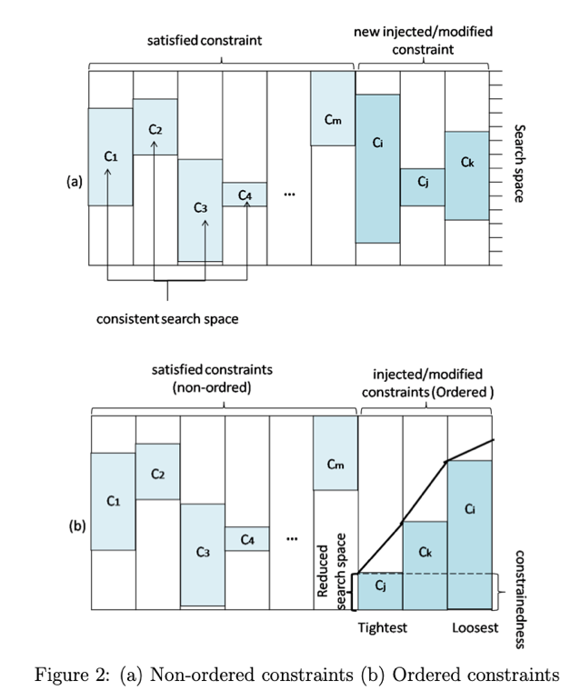

Fig2. (a) Non-ordered constraints (b) Ordered constraints

The author proposes dynamic constraint-based heuristics for repairing solution in dynamic CSPs, called Dynamic Constraint Ordering (DCO). These heuristics help PDB to make decision and **select the most relevant constraint** to be satisfied with priority.   
 The order of the constraints in a dynamic search is used to choose what constraint to check at each step of the search. The Author states that these heuristics should be designed based on the topology of the constraint graph and weight constraints to minimize the length or the depth of each branch. For the more detail author’s definition, please to the Fig1. Furthermore, Fig2 shows an example of (a) modified constraints in a natural order and (b) classified using constraint tightnesses Ctight（Cij）. As a result, this heuristic method can help DCSP work more efficiently.

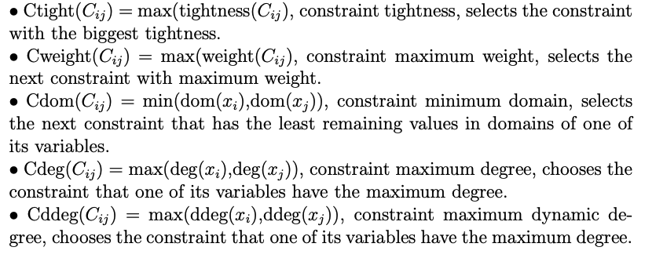

Fig1. The proposed constraint ordering heuristics