COSC 4372 – Assignment 2
Name: Dan Kalhori
PSID: 2153552
9/29/2024
github link: https://github.com/DanKalh/4372-hw2-fall2024-DanKalh
I Problem

Q.1 Physical Properties Maps: Generate and present the A-map, T1-map, and T2-map of your phantom.


Q.2.1 Compute the SI for all four compartments using the various acquisition parameters and complete the table below.

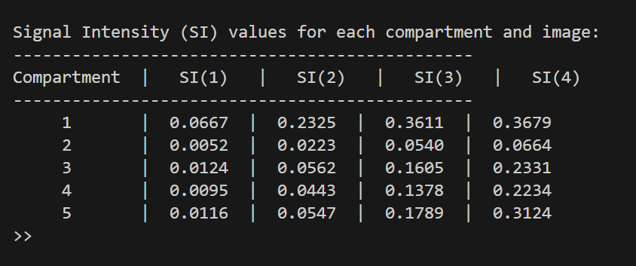

Q.2.2 Report the four generated MRIs (one for each set of the acquisition parameters). Add a legend to each image reporting the used acquisition parameter and the calculated SI for each compartment. (10 pts)

Q.2.3 Plot SI versus TR (10 pts). What is your observation regarding the impact of varying TR? (15 pts)


As TR increases, the Signal Intensity also increases, but can sometimes make them seem uniform if increasing too much.

Q.2.4 Fix TR at 250, and adjust TE to 10, 40, and 80, 150. Calculate the SI only for compartment 2 using these TE values (5 pts). Plot the SI versus TE (2 pts). What is your observation regarding the impact of varying TE? (8 pts)

As TE increases (for Compartment 2) the Signal Intensity decreases fairly quickly. It could help to increase contrast even further alongside TR.
Q.3.1 Compute the SSIM (Structural Similarity Index) between the following pairs of images generated in Q.2.1 (10 pts): • Image 1 and Image 2 • Image 1 and Image 3 • Image 1 and Image 4 What do you observe and why (10 pts)?

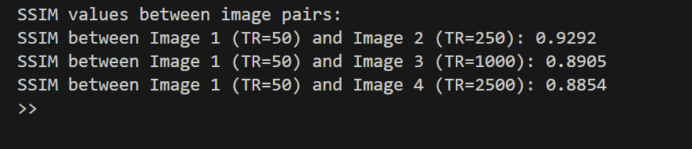
As we increase TR, the SSIM value decreases which means the images are becoming more different. The changes are in the hundredths so they seem to be a bit small, but it does demonstrate at a basic level how MRI works. Short T1 means faster images taken so tissues that take longer to “reset” look darker (water) and ones that reset quicker look brighter (fat). Increasing the time allows for more of the tissues to reset so with enough data on the reset speed of types of cells, we can adjust scanning times to “look” for certain cells.

II Method

I used the phantom from the previous assignment which had ellipses to represent different parts of the head/brain. By varying the TR and TE values, I calculated the signal intensities using the given formulas. I also used SSIM to quantify those changes in appearance.

III Implementation

I used MATLAB to implement a modified_phantom same as before. I then added functions for each section to generate images and graphs for the given sections.
- Phantom Generation: The phantom from assignment 1 was reused. Each compartment was assigned a water content (A), T1, and T2 relaxation times.
- Signal Intensity Calculation: For different acquisition parameters (varying TR and TE values), signal intensity (SI) was computed using the given formula.
- Image Generation: Images were generated for different TR and TE values to observe changes in tissue contrast. The SSIM function was used to compare the similarity between images.
- SSIM Calculation: We calculated SSIM between Image 1 (TR = 50 ms) and the other images to measure changes in image similarity as TR increased.

IV Results

The results show how varying MRI parameters affect image contrast. As TR increased, the signal intensity rose, resulting in more uniform images and reduced contrast between tissues, while shorter TR values provided enhanced contrast. When TE was increased, the signal intensity decreased, especially for tissues with shorter T2 times. The SSIM analysis indicated that images with higher TR values became less similar to the original (TR = 50 ms), demonstrating how TR adjustments impact the overall image contrast and appearance.

Modified Phantom:
function phantom_image = dynamic_phantom(N, M, center_positions, rotation_angles, sizes, signal_intensities)
% modified_phantom: Generate a custom phantom with dynamic number of ellipses.
% Inputs:
% N - Phantom matrix size (NxN).
% M - Number of ellipses.
% center_positions - Mx2 matrix, where each row is [X, Y] for ellipse center.
% rotation_angles - Mx1 vector, each element is the rotation angle (in degrees).
% sizes - Mx2 matrix, where each row is [width, height] of the ellipse.
% signal_intensities - Mx1 vector, signal intensity of each ellipse.
%
% Outputs:
% phantom_image - The generated phantom image.

% Initialize the phantom matrix to zeros
phantom_image = zeros(N);

% Generate x and y axis grids that span [-1, 1]
x_axis = ((0:N-1) - (N-1)/2) / ((N-1)/2);
x_grid = repmat(x_axis, N, 1); % X coordinates
y_grid = rot90(x_grid); % Y coordinates

% Loop through each ellipse and add it to the phantom
for k = 1:M
% Extract ellipse properties for the current ellipse
center_x = center_positions(k, 1);
center_y = center_positions(k, 2);
rotation_angle = rotation_angles(k);
semi_axis_a = sizes(k, 1) / 2; % Horizontal semi-axis (width / 2)
semi_axis_b = sizes(k, 2) / 2; % Vertical semi-axis (height / 2)
signal_intensity = signal_intensities(k);

% Convert rotation angle to radians
rotation_angle_rad = rotation_angle * pi / 180;

% Shift the x and y grids by the ellipse center position
x_shifted = x_grid - center_x;
y_shifted = y_grid - center_y;

% Rotate the coordinates based on the rotation angle
x_rotated = x_shifted * cos(rotation_angle_rad) + y_shifted * sin(rotation_angle_rad);
y_rotated = -x_shifted * sin(rotation_angle_rad) + y_shifted * cos(rotation_angle_rad);

% Equation of the ellipse (normalized form)
ellipse_equation = (x_rotated.^2) / (semi_axis_a^2) + (y_rotated.^2) / (semi_axis_b^2);

% Find pixels inside the ellipse (where equation is <= 1)
ellipse_mask = ellipse_equation <= 1;

% Add the ellipse to the phantom with the specified signal intensity
phantom_image(ellipse_mask) = phantom_image(ellipse_mask) + signal_intensity;
end
end

