

**Bank of Ireland, IT Centre, Cabinteely**

16

**Industry Project**

**A project report submitted in partial fulfilment of the requirements for ITT Dublin’s Bachelor of Science Degree (Ord.) in IT Management**

**Institute of Technology, Tallaght**

**Kennedy, Daniel**



Table of Content

Abstract 3

Chapter 1 - Host Company Background and Strategic Objectives 4

Background: 4

*Technology Services* 5

*Service Control Team* 6

*Service Governance & Reporting* 7

Strategic Objectives: 8

Conclusion: 10

Chapter 2 - Critical Evaluation of Work Undertaken at Host Company 11

Access Control Team 11

Service Reporting 12

Conclusion 13

Chapter 3 – Mini Project 14

Introduction 14

*What is a Service Management Tool?* 14

Research Undertaken 14

*Interviews* 15

*Workshops and Testing Sessions* 15

SIAM Programme Overview 16

ISM 17

*Overview* 17

*Disadvantages* 17

Service Now 20

*Overview* 20

*Internal Research & Funding* 20

*Migration process* 22

*Benefits of ServiceNow toolset* 23

*Potential Issues* 25

Conclusion & Recommendations 26

# Abstract

The Industry Project is a mandatory project for all students completing work placement in either a 3rd year IT Management or Computing course. This project encourages the student to not only interact with their day to day work but also to try to gain a real understanding of the area and role they are working in and also the business they are working for.

Within this project I attempted to display my understanding as to how the Technology Services department of the Bank works and also show how my role is affecting different areas within the organization.

Upon coming into the work placement I did not have a great understanding of what the division I was going into was and what my role would be. The Industry Project and the work placement as a whole have given me a great insight into the Service Control side of the IT Industry. I am now completing my work placement with the knowledge that this would be an ideal career path for me to pursue and I thoroughly hope I will get the chance to work in this area in the future.

# Chapter 1 - Host Company Background and Strategic Objectives

I am very happy to be undertaking work placement in an area which such relevance to both my course and the career I wish to pursue. I began work placement in the Technology Services (TS) area of Bank of Ireland based in the IT Centre in Cabinteely. I am a part of the Service Governance & Reporting Team. I have been placed in the Access Control team, a sub team within the Service Governance & Reporting Team. Thus far it has been a really challenging but enjoyable experience. I have been able to use a wide range of IT, social, and business skills that I have learned throughout my time in college while on placement and I have found it interesting seeing how knowledge developed throughout college can be put into practice in the working world. In this report I will discuss the background of IT services within Bank of Ireland and describe the role of the different teams within the Group Technology and Change area, paying special attention to the areas that I am either involved in or interact with. I will also describe some of the many challenges within the Access Control Team, Service Control, and the Technology Services within Bank of Ireland as a whole and what actions are being taken to meet these challenges.

## Background:

Bank of Ireland, like any bank or financial institution, depends heavily on technology to deliver its products and services to its customers. The department responsible for delivering the technology that supports the Bank’s business is Group Technology and Change (GTAC). The department has two main operational areas:

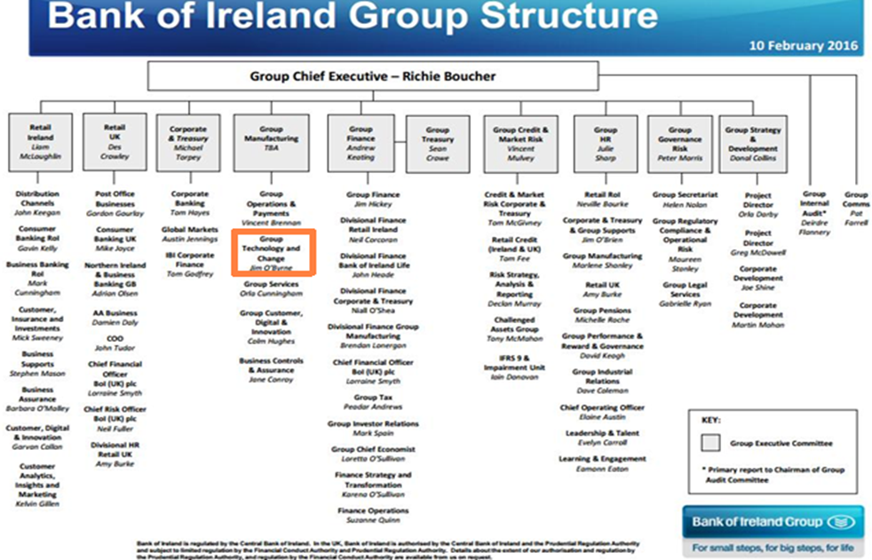

* Technology Services (TS) – supports the provision of service to the customer
* ChangeZone – supports the delivery of change to existing technology or the introduction of new technology.

Bank of Ireland outsources aspects of their IT functions to different external companies such as Accenture, IBM, BT, Dell, HCL and Oracle. Outsourcing gives the company access to the skills and experience to support digital transformations. Bank of Ireland outsources its Group Technology and Change (GTAC) division to global technology consultancy group Accenture. Accenture’s Bank of Ireland offices are based in Bank of Ireland’s IT Centre. The Bank of Ireland Service Desk is outsourced to IBM, and is hosted in Bangalore, India. On an annual basis the Service Desk handles c.150000 phone and c.217000 email contacts, made up primarily of incidents and service requests. Given the scale of both operations, it is vital to have large amounts of trained staff which Accenture and IBM can provide.

### Technology Services

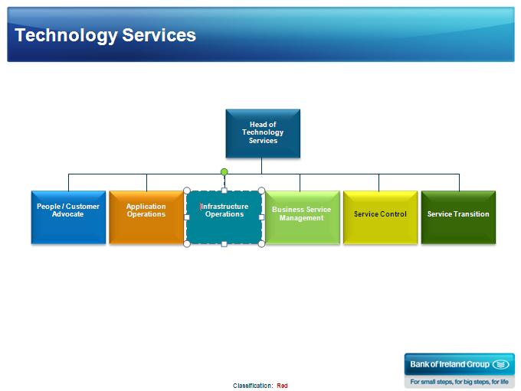

One of the primary functions of the Technology Services area is to oversee and manage the delivery of IT services to Bank of Ireland by these outsourced Service Providers. The area is divided into several different teams:

* Business Service Management – This team looks work closely with the GTAC Business Partners. It is their duty to ensure the delivery of service to the business is sufficient.
* Service Control – This is the team in which I am working in. Service Control consists of several functional areas, Service Operations (incident & problem management), Service Governance & Reporting, Service Design and Vendor Management.
* Application Operations – Application Operations provide suport for the management of day to day application operations.
* Service Transition – It is the job of the Service Transition team, along with the Change delivery Teams, to ensure that all operational changes within the company run smoothly and are delivered efficiently.
* Infrastructure Operations – This is the team that is responsible for the provision of a stable and performant IT infrastructure environment to enable the business to run. They work closely with severeal of the banks service providers to achive this.

### Service Control Team

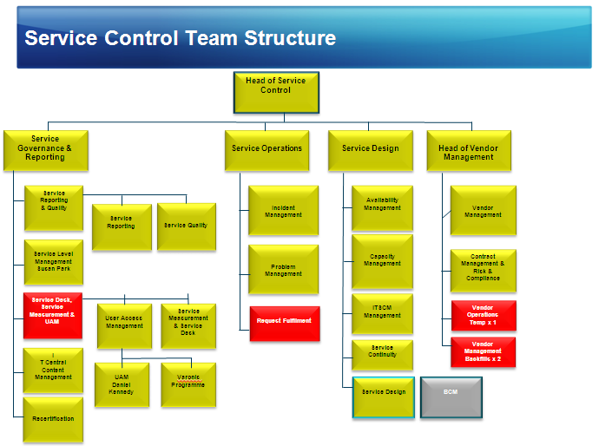

I was excited to discover I would be undertaking my work placement in the busy Service Control area of the bank. I feel this area has a close relation to my college course , and as I intend on pursuing a career in the area in the future, working in a business environment as large as Bank of Ireland will be extremely beneficial for me going forward. The different teams within the area work closely together to try ensure that the best possible service can be delivered to the banks customers from its service providers. After many discussions with different members of each team I have gained an understandng of the different responsibilities each team within Service Control have. The roles of the different teams are:

* Service Operations – It is their job to ensure that operation and provision of IT Services is occuring efficiently. They do this through a rigurous problem and incident mangment procedures. Incident Management’s goal is to restore normal service operation as quickly as possible and minimise the impact on business operations. They receive a large volume of incidents every day and have be quick to resolve the tickets in a timely manner. Problem Management’s main objective is to prevent these incidents from reoccuring. They do this through establishing root cause anaylsis (RCA) on all problem tickets in the payments space and reporting on how the problems arose, steps took to solve them and how to prevent them occuring again. This helps to reduce the number of impacting incidents going forward.
* Service Governance and Reporting – Service Governance and Reporting allows for the continual improvement of services and supporting processes. It is their job to ensure that service providers are providing sufficient service through interacting with these providers, reporting on any issues with services deliverance and the monitoring of SLA’s.
* Service Design – It is the repsponsibility of this team to ensure service availability through Capacity, Availability and IT Service Continuity Management.
* Vendor Management – The main objective of this team is to deliver the highest level of performance possible and maximise business value through proactive management of the bank’s strategic partners. They do this through an optimised Service Integration and Management Function (SIAM), reguarly communicating with vendors regarding their current roles and how they are doing in terms of perofrmance and also providing them with details of any changes being made in TS.

### Service Governance & Reporting

I am working within the Service Governance & Reporting Team. There are currently 16 members within this team including myself and it is broken into several different areas:

* Service Governance – this is the decision making area of Service Control. Decisions are made in this area on service investments, continual improvement, risk reduction and business/ IT interactions basing these decisions on investment rather than spend.
* Service Level Management – this is where the vital procedure of monitoring Service Level Agreements (SLAs) takes place. These SLAs set out the expected services to be provided by the bank’s service providers and the conditions that must be met to successfully provide this service. The team are required to maintain a Service Level Management (SLM) Framework to Satisfy Business Objectives and align them with Business Needs. Their main objective is to provide value to the business through measurement, monitoring and reporting.
* Service Reporting – The role of the Service Reporting team is to support the development and implementation of a reporting framework to allow IT services to be effectively managed. Reports are to be produced based on the bank’s technology services and the performance of the bank’s service providers. These reports must be maintained in a service report library.
* Service Quality – it is the responsibility of the team to ensure a robust Service Quality Framework is in place and that this is used to provide reports on current performance to help drive continuous improvement across all service providers in order to meet GTAC’s requirements. They also act as an escalation point for service quality within GTAC.
* Service Measurement & Service Desk – The team is responsible for setting up a framework of agreed metrics and measures with service providers. These metrics are to be maintained in a repository in order to allow the Service Reporting team to present IT Service performance to relevant stakeholders. They are also responsible for assisting with IBM Service Desk activities.
* User Access Management – This is the area where I have been originally placed on my work placement. There are 4 members in our team and we look after access to the group’s network through Forefront Identity Manager (FIM), sensitive file share through Varonis and high value group GM applications.
* 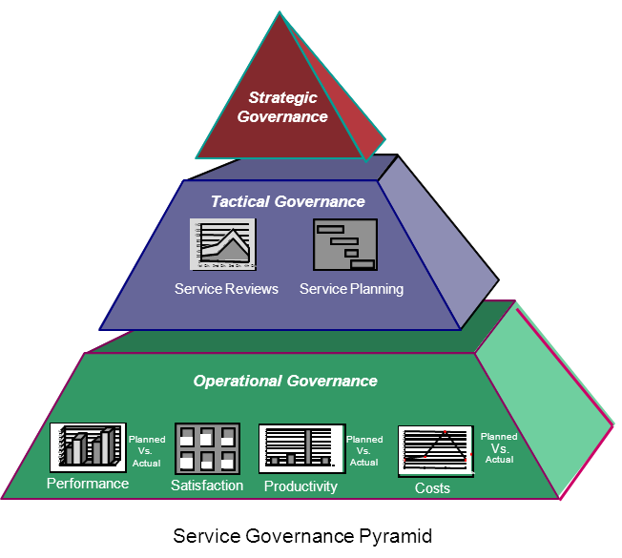IT Central Content Management – This team looks after the management of the IT Central website, where staff can raise service desk tickets online in their own time and convenience. They also maintain an up to date shop of current IT to equipment to meet expectations and requirements.

Each of these areas plays a significant role in enabling the continual improvement of Services and supporting of processes. My manager, Damien Purcell, has told me that he hopes to me the opportunity to work with several of the different teams within Service Governance & Reporting. This will give me an invaluable chance to assess which roles would possibly suit me going forward.

## Strategic Objectives:

I have many hopes and aspirations for my time on work placement but my main objective is to gain an insight and a deeper understanding of the area I will be working in and also get the chance to put the skills and knowledge I have gained throughout my time in IT Tallaght into place in the working world. Up until now, even though I have not struggled with college work and have always done my best to achieve any academic objectives, there is always the thought in the back of my mind as to how I will cope under the pressure of having to bring these skills into an organisation that depends on my capability. I hope that participating in work placement in the busy TS department of Bank of Ireland will give me first-hand experience dealing with these pressures and allow me to be able to apply what I have learned in college in real life experiences.

Within the area of Access Control there are many challenges and objectives for the Bank. The main one of these being the pressure being put on the team to reduce the amount of users who are present within the Forefront Identity Manager (FIM) database and active within the Global Markets (GM) UAM applications but are not with the bank anymore. These users are taking up space in the applications and are therefore affecting performance to some applications. While it may seem that deleting only a few users from a system might not seem like a large amount of space, over time they add up and each week deleting several users off each application over the course of a year can provide a surprising amount of storage. Another reason for the strain on the team of constantly monitoring users on the system is the fact that if they leave, their access has to be removed for security reasons. If a user has left their position with the company but still has access to applications with sensitive information or the capability to largely impact the business, the results can be devastating to the Bank and its shareholders. For this reason a watchful eye has to be kept over leavers of the company.

The implementation of the weekly IAM Leavers process helps to prevent users being inappropriately active on FIM. This process involves HR sending a list of the daily leavers to Access Control. At the end of the week, I, or one of my team members create a spread sheet containing these leavers. We then compare this spread sheet to the daily SAPHR file which shows all users who are active on SAP and should be active on FIM. Any users that are not on this list are recorded and sent to HR to receive a comment on the user’s status. Access Control revises this list, takes appropriate action and records this action. At the end of the month, a monthly IAM Leavers process in undertaken to ensure that any users who were supposed to be terminated at a future date are dealt with appropriately. Within the GM UAM Applications, there has been a major recertification process which is using the IAM Leavers recorded to remove access from any users who have left from the GM Applications. Requests to delete these users are sent to the team through ISM and appropriate action is taken.

While these are the challenges currently being faced within my team, Service Control and TS as a whole face entirely different more widespread challenges. One of the challenges within TS currently is to improve capability and service availability by reducing amount of incidents per year. Over the past year TS has worked with appropriate vendors in order to put capability plans in place. Through these plans the firm has completed sufficient recruitment in areas of need and delivered successful results in terms of reducing incidents, reduction of costs and improved performance across all areas of TS.

The main challenge for Service Control and for all of TS is the migration from IBM ISM to ServiceNow service desk software. The programme of work to transition from one toolset to the other is a large scale operation and will take 18 months to 2 years to complete. This change to the leading service provider will allow the bank to take more control of the monitoring of services being provided. Due to the fact that ServiceNow is not an IBM developed product like ISM, it allows the bank to manage and communicate with different vendors including IBM in a more transparent fashion.

The bank has taken many measures in order to ensure a safe and productive transfer from ISM. The software was thoroughly examined and the possible benefits and risks in areas such as cost, performance and transition. As it is such a large-scale change involving a wide range of individuals and different departments throughout the bank, it will be brought into the company in phases. This will allow both employees within the bank and third parties involved to adjust to how the system works and also due to the fact everything isn’t rolled out at once, the organization doesn’t have to manage all potential implementation issues and problems at the same time. They can then also use their experience of how they managed the implementation of earlier stages to guide the rest of the change. There have been many workshops in order for ServiceNow representatives to meet with people from each team across TS in order to decide on a design for the system that meets all the needs of the bank. As I am completing my project on ServiceNow, I have been invited to attend these meetings and have found them quite productive. Along with these sessions, there has also been software testing sessions where employees from the bank are able to test the software that could potentially be used within the new system. From this they can obtain knowledge of how the system works while also evaluating what, if any, changes need to be made to suit them.

## Conclusion:

Through completing this report I was able to gain a better understanding of my role within the Bank. I found that breaking the GTAC department down from the top to the bottom and explaining each layer as I went along of great benefit and it showed me the amount of people involved in this vital area in banking and the scale of the operation that they are running. Through my research and through the interviewing of several people in different teams, I was able to discoverer the role each of these teams played within TS and the role TS plays in Bank of Ireland as a whole. The many strategic objectives discussed showed me how the sector of the business is always busy and employees in the department, like all IT professionals, have to be constantly ready for new changes and challenges in their area.

# Chapter 2 - Critical Evaluation of Work Undertaken at Host Company

While on work placement in the IT Centre in Bank of Ireland, in Cabinteely, I will be able to take up a variety of roles and gain experience in many different areas. Being placed in the Service Governance and Reporting Team allows me to undertake many different positions as the team has such a wide scope. There was a real emphasis placed on not getting too settled in a role within the team. I found the prospect of this both challenging and rewarding.

## Access Control Team

Upon arrival, I was placed in the Access Control Team where I would be working with three other members. This team looks after the granting of access to many of the companies different Group Manufacturing (GM) applications to each member of staff throughout the bank. They also look after the Forefront Identity Manager (FIM) database. This shows all users throughout the group and allows the team to control their access to the system as a whole. The team looks after any problems with these.

Examples of problems with FIM might be:

* A user being set in a terminated state when they are still working with the company and active on SAPHR. The user would be set to active and it would take an hour for the account to link with AD (Active Directory) and set them up on this.
* A user failed to set up on FIM due to information with their account not being correct such as an invalid OU or Domain. The team would have to edit this to the correct information and wait for an automatic email from FIM to confirm the account has been set up.
* Users being set up with no manager. This affects the setup as a new user inherits their information from their manager. The team would have to report these to HR who would take action in order to find out the users manager.
* Amend rules for users who are not synchronising to AD.

Examples of GMUAM issues:

* The Access Control team completes user set ups in the GM applications such as IBIS ROI, VAX (Dublin, London, US, BoIUK), Summit FT, GPP High Care and Mass Pay, Murex, Oracle applications including Static Data Maintenance, Message Repository, FX (Dublin, London, US). A lot of the time this done through the cloning of an existing user who has the access required by the requester.
* We are also responsible for password resets in all of these applications as well the GOOD email application.
* I have provided four eyes approval for my colleagues on actions they have undertaken within GM applications.
* The team often receive requests to amend user access to an application either by cloning another user’s access or individually adding or deleting user roles.

Requests for any of these applications come through ISM in a ticketing system. Using the different applications and also experiencing the usage of a ticket queuing system will be of great benefit to me in the future when leaving college and starting life in the working world. In terms of applying skills learned in college towards the usage of these applications, I used my knowledge of oracle databases in order to help me while using Message Repository, Static Data Maintenance and FX Dublin, London, and US.

During my time with the Access Control Team, I have seen first-hand how convenient the use of excel is the recording of information and I have gained a lot of experience in using it on a day to day basis. This is a skill which in college, due to the fact that you may be learning higher level technical skills, can be overlooked. I was delegated a weekly task of preparing an excel spread sheet of weekly IAM leavers from the firm, sending it to Human Resources for their approval and when received, deleting user accounts on FIM. During only my third week on placement, I was tasked with the documenting of an entire year’s worth of IAM Leavers. The process took me a substantial amount of time and our work was noted at the weekly huddle by the head of Service Operations. I also had to prepare a spread sheet displaying users with 7 digit usernames as users should only have 6 digits. This was then sent to HR in order to decide what to do with these accounts as a number of these users had duplicate accounts.

I have helped with the large scale clean-up of FIM users and the GM applications. This is to prevent unauthorised users or users who have left the company having access to applications or information that they shouldn’t have.

I created and edited user guides for both GMUAM applications and FIM. This was beneficial for all parties as it gave me a chance to fully understand the usage of all the applications used by the team and also the opportunity to enhance my reporting skills, which I will need while working with the Service Reporting team. It also was a help to Ambrose and the rest of the team as they will be able to use these guides for future students who undertake work placement in their team or any new staff that may start in Access Control.

## Service Reporting

This week I have made the move to the Service Reporting Team. I was sad to leave the Access Control Team as I felt I had settled in with the team well, but am excited at the prospect gaining experience of a wider scope in terms of Service Governance and Reporting. I have observed how Damien (team leader) goes about his work and have been listening in on conference calls he would have with several of the banks vendors. He would then report on how they are doing in terms of maintaining their SLA’s in terms of agreed performance. Damien has to attend many meetings with different teams and vendors each day as he is the team leader for both Service Reporting and the Service Management Teams. Due to this he told me he hopes that I can relieve him of a lot of his reporting duties in the coming weeks.

## Conclusion

I feel that I have really settled in and been delegated my fair share of work while on placement in Bank of Ireland’s IT Centre. It has fascinated to see how the wide ranges of skills I have developed in college are put into place in the working world. As I have not spent a lot of time with the Service Reporting Team and the rest of the teams I will be working with, I have not been able to document and evaluate work undertaken in these areas. However, as I am here until the end of August I will have the chance to gain experience in each of these teams and will be sure to talk about any roles I may have in my final work placement presentation.

# Chapter 3 – Mini Project

*Critical Evaluation of the benefits and drawbacks of Bank of Ireland’s transition from IBM ISM service management tool to a ServiceNow toolset*

## Introduction

This report examines the main benefits and risk factors that come with Bank of Ireland’s planned migration from IBM’s Integrated Service Management (ISM) service desk software to the industry leading toolset in this area, ServiceNow. The Bank of Ireland Service Desk is the central point of contact for c.14000 staff who experience IT issues in their daily work, or need to request a technology related service, such as access or installation, from IT. Bank of Ireland outsources the running of their Service Desk to IBM who hosts the call centre in Bangalore, India. IT Service Desk handles c.150000 phone and c.217000 email contacts daily, made up primarily of incidents and service requests. Given the scale of operation, it is critical that the IT Service Management toolset used is capable of supporting the volume of user contact, and is fully aligned to the Bank of Ireland Service Management structure – the IT Infrastructure Library (ITIL). I felt that this was a strong project and an interesting area to complete research as much of the preparation for the migration is happening during my work placement. The change is coming as part of the SIAM programme which the bank is putting into implementation. During the course of the project I will closely examine every aspect of the transition and the effect it will have on each team within my area and also the organization as a whole.

### What is a Service Management Tool?

IT Service Management (ITSM) tools allow organisations to facilitate successful management of their processes (Incident Management, Problem Management, Request Fulfilment etc.) and aligning IT services with business needs with the main goal of providing the highest level of service to the end user or customer. The tool that a company uses for its service management is the connection between users, resolver groups and the service desk who are often the middle men. Pink Elephant’s Peter Hubbard tells us, in a webinar on picking a service management tool, that organisations should select and use a service management tool based on “process, people, management, and technology”. “If you change any one of these four areas, it ripples through all of them.”

## Research Undertaken

As this project covers such a broad area, there are many different functionalities and capabilities to be researched. I wanted to make sure that the project gives a real insight into the potential risks and benefits that the changing of toolset will bring to the bank and also each of the individual teams within Service Control. I interacted with many different people at different levels within many different teams within the bank. Everyone was very co-operative and eager to help. This made obtaining a large pool of content for the project very easy.

### Interviews

In order to gain an insight into how migration to Service Now will impact some of the teams within my area, Technology Services (TS), I prepared interview questions and set up hour long sessions with five of the ITIL process owners. These were leaders in Incident Management, Request Fulfilment & Change Management, Problem Management and Service Level Management. These interviews went very well and I took a lot from them in terms of content for the body of the project. I also asked them to complete a questionnaire on their opinion of the current tool, ISM, in terms of performance in each of their own areas.

### Workshops and Testing Sessions

I attended several ServiceNow requirement workshops. These were hosted by representatives from ServiceNow and allowed them to meet with members of each of teams within Service Control in order to establish what they need from the tool. During my time on placement, the main requirement workshops were for both Incident and Change Management. These are two of the main processes and both of these teams depend heavily on the Service Desk toolset.

After each session of requirement workshops, a testing session was held. In these testing sessions, the ServiceNow Test Manager guided everyone through the expectations of testing and the approach, as users, to the testing that needed to be performed. This gave me a first-hand view of what using the tool is like.

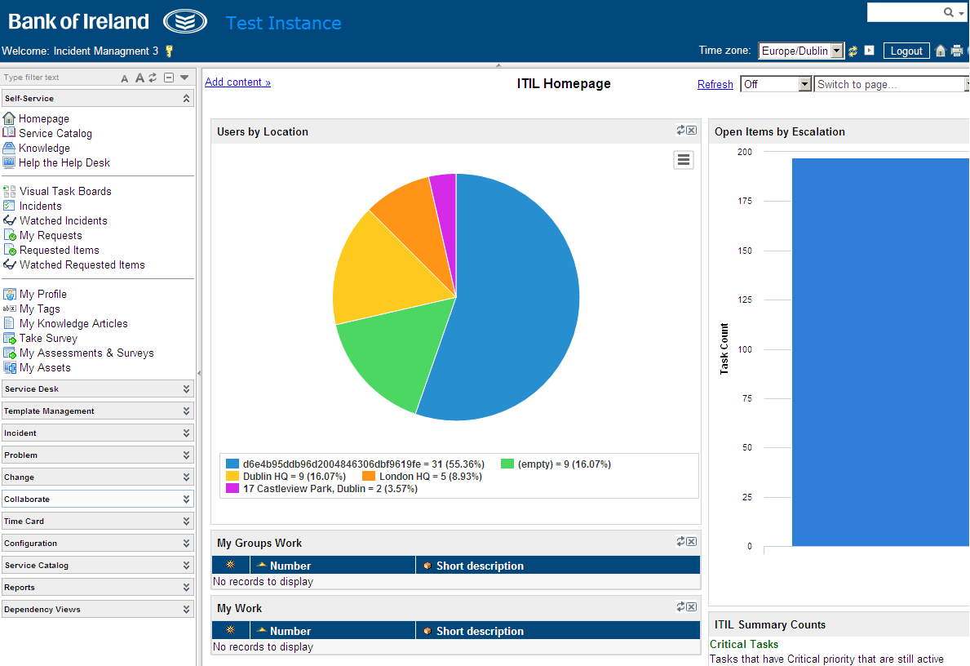

## SIAM Programme Overview

The delivery of the SIAM Programme within Bank of Ireland will provide for the introduction of a fully integrated operating model and enhanced toolset (Service Now) for the effective management of internal and external IT service providers and suppliers. This is a significant programme of work that will take 18 months to 2 years to complete. SIAM is a set of practices based on ITIL principles and the supporting functions that go into delivering end to end services. The SIAM model will allow the Bank to take control and accountability for management of providers and end to end services and adapting the processes accordingly that contribute to achieving this. The Bank’s main aim is to provide a single point of visibility and control for the service management and delivery of all services provided by suppliers.

The SIAM programme requires the delivery of two elements (i.e. Tool Set and SIAM Model) both of which are intrinsically linked together. It is vital to understand that the successful migration from one toolset to another could not be made possible without introducing a sufficient operation model. The programme will be introduced using a phased migration 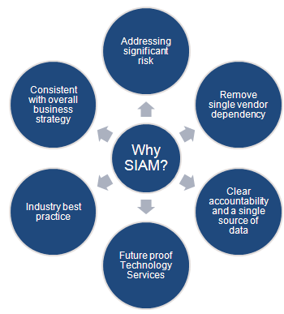strategy with phase one set to be rolled out at the end of September. Phase one will deliver the first stage of the toolset (ServiceNow), out of the box reporting, and also the training of staff to ensure business readiness to support these changes. In order to keep all teams up to date with the progress of the programme and inform staff of the events effecting their areas, the Bank has assigned SIAM Champions across all areas. Damien Purcell, my manager is the SIAM Champion for Service Governance & Reporting and he gave a very informative presentation on the SIAM programme to the team at one of the team meetings. It was upon hearing this presentation that I first gained an understanding of the SIAM programme and the importance of the toolset migration to its success.

They also emphasised major problems with the way in which people are using and interacting with the current tool, making the point that although ISM has its shortcomings, there also has to be major changes in the attitude of people towards ServiceNow when the change takes place.

## ISM



### Overview

Integrated Service Management (ISM) is IBM’s service management tool. Like ServiceNow, it also bases its functionality around the ITIL Service model. ISM consists of Service Level Management, Change Management, Operations Management, Incident Management, Configuration Management, and Quality Management.

The tool has been in use in the bank since 2011. As the Bank’s TS function continues to grow and demand for better communication and a smoother workflow between processes increases, the toolset is struggling to live up to the high standards available from other providers. The bank uses the tool for managing requests and communication with the service desk and there are a number of issues that have arisen with the tool which has led to the bank deciding that they needed to change to another provider.

If the Bank was to remain on IBM’s internal toolset path, the next steps taken would be to move to IBM’s SmartCloud Control Desk (SCCD). Upon performing analysis on this cloud based service management solution, and seeing demos of it in use, little benefit in this ‘upgrade’ was evident. Although the cost outlook of implementing SCCD is smaller than changing provider as it is an upgrade from the current toolset, the change does not reduce internal operational costs and also increases toolset operational costs. IBM have claimed that a lot of the current performance issues within ISM have been resolved, there is no real functionality gain apparent at this stage, meaning that similar challenges and disadvantages the bank is having at the moment will likely arise.

### Disadvantages

The main issue being that they are not having immediate ownership of the toolset or the data that is generated through the tool. As IBM own the toolset the data each of the teams receive comes through IBM before it gets to the teams that will be reporting on any issues. This makes it harder to produce accurate reports. The reporting tool that is provided in ISM is also not as up to date as other service management toolsets in the way in which the templates provided lack real detail.

#### Performance Issues

Upon completing interviews with five of the process owners, I quickly gained an insight into just how many issues the toolset actually had. I had previous experience using the tool during my time with the Access Control Team when I was monitoring queues for Service Requests relating to Forefront Identity Manager (FIM) and Global Markets User Access Management (GMUAM). However I was not interacting with the tool at a critical level and would only have been reading SR’s and Incidents and either updating the log and sending it to another team’s queue or marking it as resolved (closing the ticket). Even in doing such minor tasks, the performance issues become undeniably evident. The tool is slow in every way possible. Tasks that should prove simple for a modern toolset provided by such a big name player like IBM, such as logging in, movement between pages and use of drop down boxes take too long and it is becoming harder and harder to reach maximum performance levels using it.

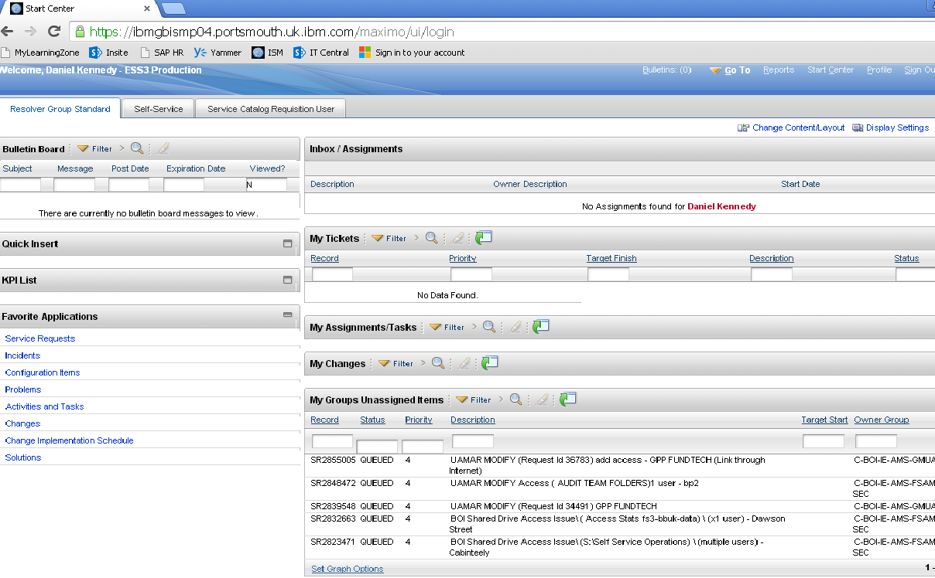

#### Process Performance & Integration

A significant issue with the toolset is the lack of a link between processes and poor visibility among teams. Incident, Change and Problem Management are probably facing the most issues with the current system. An example of this is the fact that problems are currently only being raised as a result of incidents. The problem team need the ability to create their own incidents where they see fit and not just have a dropdown field that turns an existing incident into a problem. A requirement was identified by both incident and problem management that known problems, where the cause has been determined but there is no permanent fix, be categorised as a known error. This is needed as there is little communication within the current tool between teams resulting in incidents dealing with these known problems taking up large amount of time on numerous occasions.

Problem Management are currently experiencing issues with vendors closing tickets that should not be closed. During weekly interlocks with vendors each problem manager in the team will chase on going actions that need to be resolved. However within the current toolset vendors and resolver groups working on these tickets have the ability to close these tickets even if they have not actually been resolved. This should not happen and means that problems need to be re-opened constantly resulting in back logs of un-resolved tickets. The toolset should only allow problem managers to close problem tickets, while still allowing vendors to raise issues. This would allow better monitoring of tickets to take place as calls would only be closed when they are 100% resolved.

In terms of Change Management there are a number of issues with the ISM toolset. The team require the ability to generate monthly change report ourselves. There is currently too much discretion between IBM's monthly change report and the report that is manually generated by Change Management. There are certain fields in ISM change tickets which the team require as being mandatory so as they can get as much information about potential changes as possible.

Upon talking with the process owner for Service Level Management, it was easy to see just how much extra work was being placed on her shoulders from the current toolset. Although she does not have direct daily interaction with ISM, she does monitor the 400+ Service Level Agreements (SLAs) that are contained within the tool. These specify to the Bank’s vendors and resolver groups the different actions that must be taken depending on the type and contents or service requests or incidents. There are currently a lot of issues revolving around the monitoring of these SLA’s within ISM. Currently there is no way to analyse who is spending what amount of time holding a ticket or who is breaking their SLA. It is simply deemed that whoever had the ticket in their queue at the time it breached its SLA was the party who had broken it, even if the ticket had just been placed in their queue. This makes it extremely hard to discover whose fault it may be for the SLA being broken and the service not being provided.

#### Shared Platform

As ISM is a shared toolset meaning all process procedures are shared across all companies that use the tool, if a change is being implemented, it changes the toolset in every company regardless of whether all companies want the change or not. An example of this was in 2012 when IBM where making a change to the incident process that Bank of Ireland did not want. It took months of dispute before the issue was resolved and the change was not put through.

These are some of the main disadvantages and drawbacks I have discovered through my research. There are a lot more issues and it is clear that ISM is some way off the pace in terms of a service management tool especially when comparing it to some of the industry leaders.

## Service Now



### Overview

ServiceNow is the industry leading IT Service Management toolset and is the product that the Bank has chosen to replace ISM. Since its establishment in 2003, ServiceNow, as a company, has expanded enormously and it now provides wide range of cloud-based Service Management solutions.

“The ServiceNow Service Desk cloud service is powerfully simple, highly social and available through any browser. Built on the IT Infrastructure Library (ITIL), it provides the freedom to completely configure the application and the changes made are preserved through all automated upgrades.” The toolset is built on top of the ITIL Framework, meaning it is built to provide solutions using a framework that the Bank is currently practising with and using.

“ServiceNow ITSM solutions give you end to end visibility into your ITIL processes and infrastructure through a single system of record — making it possible to consolidate fragmented tools and legacy systems while automating service management processes.”

### Internal Research & Funding

A lot of research has been undertaken in order to decide upon the best service management tool to migrate to. The first step was preparing in-depth analysis of the shortcomings of ISM and the disadvantages of the continued use of the toolset. A lot of these were clear to see while others were discovered by going from team to team and taking note of any complaints they had with the current system. The next step was to decide on a service management provider. In order to assess different toolsets available, a spread sheet displaying all high level requirements was put together. Each team compiled a list of service management requirements. These requirements were put into a large spread sheet with the final draft containing a large list of requirements from all the different ITIL processes and areas within the Bank including:

1. 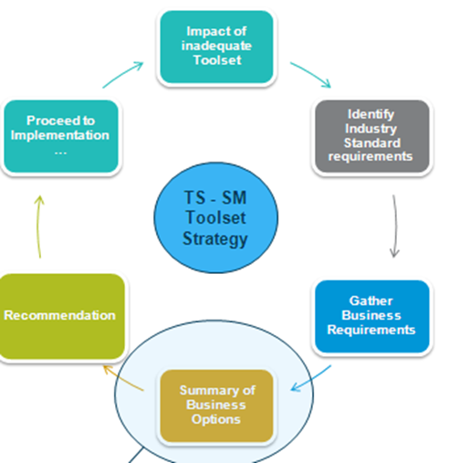Incident
2. Problem
3. Event
4. Request Fulfilment
5. Service Reporting
6. Quality Management
7. Service Asset & Configuration Management
8. Change, Release & Deployment Management
9. Knowledge Management
10. Service Catalogue
11. Service Level Management
12. Capacity Management
13. IT Service Continuity
14. Service Introduction
15. Application Management
16. Infrastructure Management
17. Integration & Access Management
18. Ticket Management - General Tooling Requirements
19. Self Service

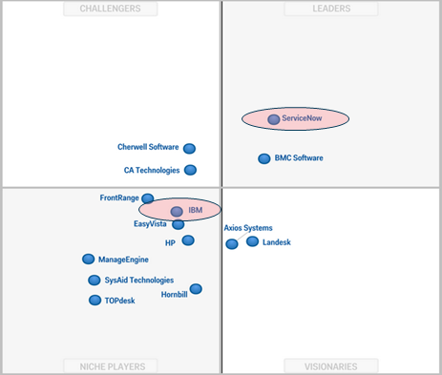For further research on requirements for the ideal service management tool, TS turned to Pink Elephant’s PinkVERIFY Self-Assessment service. These are documents that assess both the toolset and the different processes within the toolset. These documents go very in-depth in their questioning and ensure that no stone is left un-turned. After analysing the different options available and the different tools on the market, it was decided that the best option was ServiceNow. The list of requirements for a new ITSM toolset was then sent to ServiceNow to gain an insight into whether their toolset would be able to meet all of the Bank’s needs. ServiceNow then returned the list to TS stating whether they would be able to fulfil each requirement, whether configuration would be required and a comment on how the tool fulfils manages this process.

Once the toolset had been decided upon, TS needed to propose this idea to the Bank in order to receive funding. A presentation was given in which three options where outlined. These were:

1. Completely migrate to ServiceNow
2. Move to ServiceNow maintaining partnership with IBM
3. Remain using IBM ISM toolset

Possible benefits and disadvantages for each option were displayed. The Gartner Magic Quadrant was also provided in this presentation which provided more information on Service Management toolsets and ranked each of the different provider’s tools against each other. This placed ServiceNow at the top of the list, while IBM’s toolset was placed in the Niche players section, which is the lowest section of the quadrant.

Upon listening to this presentation and taking all the research and resources provided into consideration, the Bank gave full backing to TS to begin planning for a complete migration to ServiceNow.

### Migration process

As it is such a large-scale change involving a wide range of individuals and different departments throughout the bank, much like the implementation of SIAM, ServiceNow will be brought into the company in phases. This means that certain aspects of the toolset will be brought in over the course of three phases in an attempt to minimise disruption to normal services. This will allow staff within the Bank, vendors and all potential resolver groups to adjust to how the system works and also due to the fact everything isn’t rolled out at once, the organization doesn’t have to manage all potential implementation issues and problems at the same time. Phase one of the toolset change will see the Incident Management, Change Management, Problem Management and Service Level Management processes operate off ServiceNow. However old tickets for incidents, problems, and old changes will not be transferred over from ISM to ServiceNow and will have to be completed on the tool.

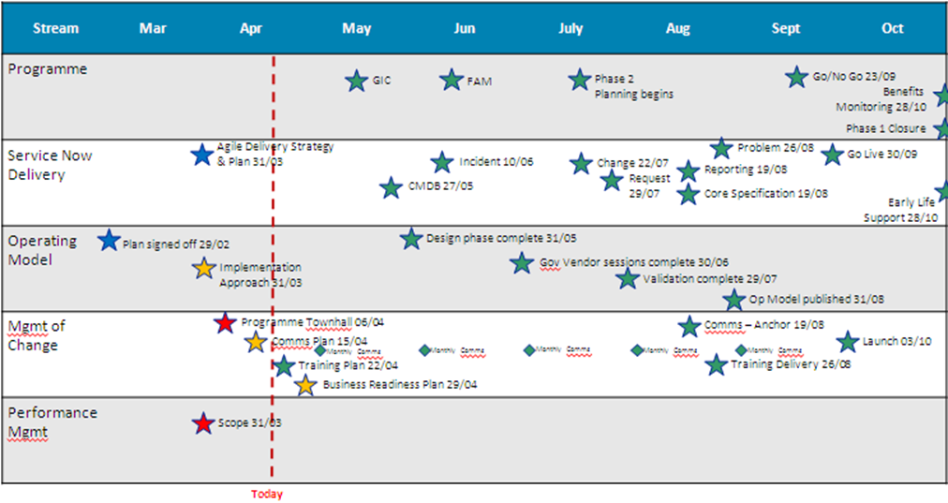

Phase one will then give TS a platform to roll out phase two. A definite plan for phase two has not currently been decided, but after the roll out of phase one at the end of September it will be easier to assess how much of the toolset should be rolled out based on how easy the migration process was, how staff training on the tool went and also how easy it is to migrate data from different processes into the new tool.

### Benefits of ServiceNow toolset

The main benefit of migration from ISM to ServiceNow is the fact that Bank of Ireland will be taking control of its own toolset instead of having IBM, one of the vendors providing IT Services to the bank, having ownership of the toolset. This means that reporting amongst teams will become easier and more accurate. It also allows the Bank to control any changes that need to be made to the toolset without outside interference from IBM.

#### Performance

The toolset is designed to adapt to the needs of the customer, meaning that if something within the toolset is not suited to the needs of the company, it can be easily be configured to fit the customers’ requirements. However after talking with many of the process owners who are co-operating with ServiceNow representatives in order to decide on what features of the tool will be used within the Bank, I got the general feeling that the ‘out of the box’ toolset will be replicated with only minor changes being made. This will make any updates or system maintenance that may need to be done much easier in the future. Despite the fact that the Bank will stick to the ‘out of the box’ toolset, there are still flexible options for continued growth in toolset capability and utilization. This is a major benefit in comparison to ISM which is dated and there is little evidence of any functionality gain in the available upgrade, SCCD.

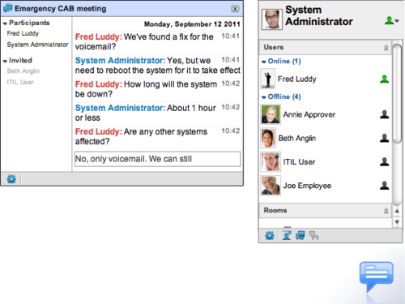ServiceNow is a much more user-friendly toolset than ISM. Aside from the fact that tool performance issues will be drastically reduced, ServiceNow enables for more efficient staff self-service. There is a built in employee self-service tool that provides end users a simple front end to the IBM Service Desk. The Bank is hoping that ServiceNow will reduce calls to the service desk. Most calls to the service desk are for issue requests, access requests, inquiries of ticket status and general inquiries. Features within the toolset will now allow users to set up their own requests and then monitor status updates through a ‘Twitter’ like feed, which will be updated by potential resolver groups. They will also be able to enter entries into this log and communicate with resolver groups through a chat feature, meaning they will not have to ring the Service Desk to enquire about the status or reply to questions from resolver groups. It will also reduce the streams of emails flowing from resolver group to user, as communication can be done through the tool.

#### Reporting

The reporting tool within ServiceNow is also a drastic improvement from the reporting methods currently in use within ISM. The system offers a range of predefined reports and templates for reporting throughout each of the processes. If none of these predefined reports are suitable ServiceNow also includes a User Defined Reporting Functionality allowing users create their own reports from scratch using “lists, charts, or calendar-based views of data in a particular table”.

#### Process Improvement

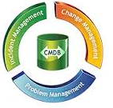Upon talking to some of the process owners within TS it is clear to see that the integration between each of their processes could be a lot better. ServiceNow provides TS with the ability to link Incident, Problem and Change tickets as appropriate. ServiceNow's platform means that any entity can be related to another e.g. users can link incidents to problems, problems to changes etc. All relevant data about the processes in the bank will then be stored in the configuration management database (CMDB) which provides an “organized view of data and a means of examining that data from any desired perspective”.

Within service management tools Incidents are rated on severity, normally between 1 and 4.

* Severity 1 – Critical or System Down
* Severity 2 – Significant Impact
* Severity 3 – Normal/ Minor impact
* Severity 4 – Low Impact

The severity of an incident or service request is currently chosen by the service desk based on the impact it is having on business, and its urgency, or how quick it needs to be addressed. A priority matrix is drawn up to help the service desk operators to choose a severity level. It was decided in the Incident requirement workshops held in March that in the new priority matrix there would be a column with 4 levels of urgency (Immediate, High, Medium, Low) and a row with 4 levels of Impact (Immediate, High, Medium, Low). Within the current ISM matrix there are only three levels of both impact and urgency. The new matrix will hopefully make severity decisions more accurate. In an attempt to reduce severity one ticket, a feature within ServiceNow has been installed allowing only incident managers to declare a severity one ticket. Within ISM severity one ticket could be logged by service desk operators who may have been put under pressure by users facing issues to try and get there ticket resolved faster.

ServiceNow also allows for a much smoother change management process compared to the highly restricted capabilities offered in ISM. There is now a visual roadmap that displays the progress of each category of changes.

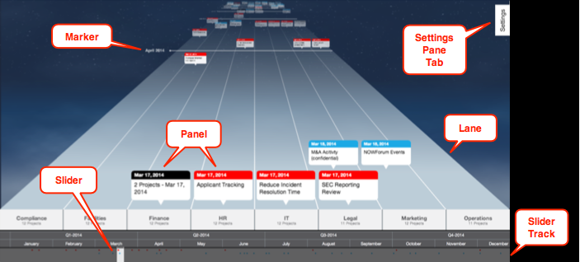

ServiceNow contains a Vendor Performance Management feature which will allow the bank to manage and compare internal and external vendors. Technology Services’ vendor management team will use this feature to evaluate, score, and rank vendors in terms of related categories such as performance, resolution time and user satisfaction. This information will then be stored on scorecards incorporating vendor related information. Another benefit is the fact that the bank will be able to manage different vendors including IBM in a more transparent fashion. This is due to the fact that unlike ISM, ServiceNow is not an IBM developed product, meaning that any issues that IBM may have been able to hide with their performance against SLA’s will come to the attention of TS. The toolset should be of benefit to the Bank and all of its vendors

### Potential Issues

Through my research and use of ServiceNow testing material I have identified a number of potential risks with functions within the tool that have currently been developed.

The main issue with the use of the new tool is the physical migration from ISM to ServiceNow. The phasing method should help this as the fact that only a small amount will be moved at a time it reduces the risk of anything serious going wrong. However the fact that the two tools will be in operation at the one time may cause confusion for vendor groups who will have to monitor tickets coming in from two tools.

IT Central is a SharePoint site where staff within the bank can issue service requests, user access management (UAM) requests and order equipment required for workplace activity. Currently there is a direct bridge between IT Central and ISM. This bridges information such as the service catalogue, UAM information from on-going tickets and also the IT Central template which contains all relevant information for issue requests. No such bridge has been designed between ServiceNow and IT Central. This will need to be configured before the system goes live in September.

It is evident from this and also the fact that staff outside those effected by phase one have little knowledge of the tool and its impact on the bank, that there is a major lack of communication from the team managing the change and the rest of the business. I attended a recent town hall where many of the staff in attendance, including the event management team leader, whose team would be majorly impacted by the migration to ServiceNow, made it known that they had very little knowledge of how the change will affect them.

Even though the Bank is changing to ServiceNow, the Service Desk is still going to be run by IBM. This means that like the staff within BOI, the IBM Service Desk staff in India will also have to be trained in on the features of ServiceNow. There is currently no plan put in place to ensure they receive this training and staff from IBM that work in the same office block as me have said that the training will have to be completed by BOI. This would mean that in order to have all staff trained by the roll out date; training would have to begin in the near future which no plans have been put in place for.

The Bank currently experiences major issues with ‘dirty data’ concerning information around users, such as users having multiple log in accounts, or reporting to themselves within the system. One problem that rises from this is when a user issues a service request, it requires line mangers approval and if they are reporting to themselves, the request cannot be submitted. These issues will not be eradicated within the new system and they will continue to cause problems for users trying to issue requests.

I have made sure to raise these at each of the requirement workshops. Each of these issues must be addressed but most can be solved relatively easily for a business as large as Bank of Ireland. As ServiceNow is such a large tool causing such a big change, it is impressive that these are the only possible issues with the migration.

# Conclusion & Recommendations

I have spent the entire of my work placement so far analysing and researching ServiceNow and it has got to the stage where a lot of staff within TS are coming to me for information on the tool. My knowledge of ITSM toolsets upon starting this project was very limited and I had never even heard of ISM or ServiceNow but due largely to the co-operation of my colleagues I have gained a substantial amount of exposure to both toolsets.

It is clear that BOI are in desperate need of a new ITSM toolset and it is also obvious that they have put a lot of work into their own research of this new tool. The drawbacks of ISM were affecting not only the staff members in Technology Services, but also the bank as a whole and due to the proactive research from teams such as service governance, co-operation from team leaders in incident & change management and funding from the Bank, action was promptly taken to address the matter.

As outlined in this project there are a more benefits than drawbacks to migrating to ServiceNow. ServiceNow is the industry leading ITSM tool and it is easy to see why. Although it is not without its flaws it is by far the best product on the market. I had planned on including an alternative toolset to ServiceNow but upon researching other industry leading toolsets developed by BMC and Cherwell, it was clear to see that while they are both better toolsets than ISM, they do not match ServiceNow in terms of performance, functionality or value for money.

In terms of the Bank and its attitude towards ITSM, I feel there may be an opinion amongst staff that the new toolset will solve all underlining issues that they are having surrounding service management. Upon interviewing 5 of the process owners about ServiceNow, each stressed the importance of full co-operation from everyone within the Bank and also each of the Bank’s vendors in complying with the SIAM programme.

**Appendices**

1. Interview Questions used when interviewing process owners.

