**Dan Koskiranta**

**G00397054**

**Group B**

**Lab 3**

**16 February 2023**

|  |  |  |
| --- | --- | --- |
| **Device Name** | **IP Address** | **Mask** |
| Laptop0 | 192.168.0.105 | 255.255.255.0 |
| Laptop1 | 192.168.0.106 | 255.255.255.0 |
| Laptop2 | 192.168.0.102 | 255.255.255.0 |
| Laptop3 | 192.168.0.103 | 255.255.255.0 |
| PC0 | 192.168.0.104 | 255.255.255.0 |
| PC1 | 192.168.0.107 | 255.255.255.0 |
| Router | 192.168.0.100 | 255.255.255.0 |

**Image of the network created. PC1 is connected by a cable to the router. All the other devices are connected wirelessly.**

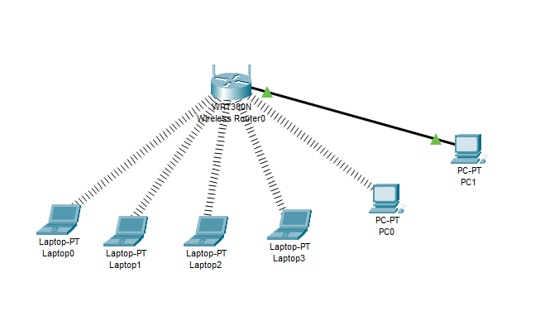

**IPv4 packets going through the network. Packet will firstly arrive to the PC with the physical cable and then to the wireless devices.**

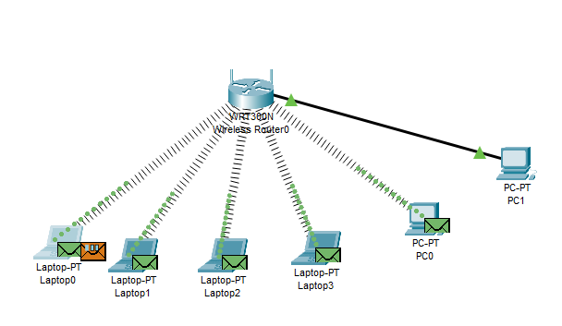

**Different layers of the packet sent. Broadcast message.**

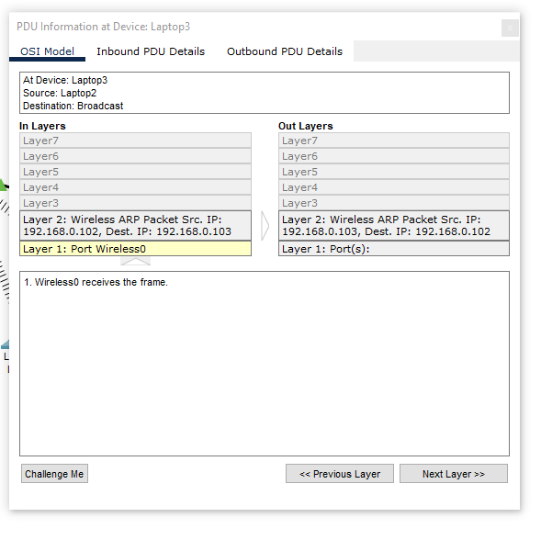

**HTTP message**

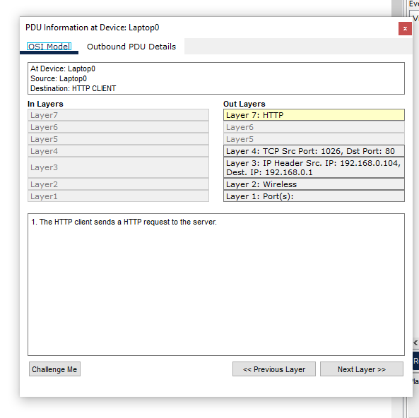

A network packet is small segment of a larger message. Each packet forms part of a complete message and carries address information that helps to identify the sending computer and the recipient. A network packet has three parts: the packet header, payload, and trailer.

**The 7 layers of OSI model:**

**Application – Layer 7**

The application layer is used by end-user software such as web browsers and email clients. It provides protocols that allow software to send and receive information and present data to users. Examples of application layer protocols are the Hypertext TransferProtocol (HTTP), Simple Mail Transfer Protocol (SMTP) and Domain Name System (DNS).

**Presentation – Layer 6**

This layer prepares data for the application layer. Presentation layer defines how two devices should encode, encrypt, and compress data so it received correctly on the other side. The presentation layer takes in any data transmitted by the application layer and prepares it for transmission over the session layer.

**Session – Layer 5**

The session layer creates communication channels, called sessions, between devices. It’s responsible for opening sessions, to ensure they remain open and functional while data is transmitted, and to close them when communication stops.

**Transport – Layer 4**

The transport layer takes data transferred in the session layer and breaks it into “segments” on the transmitting end. It reassembles the segments on the receiving end and turns it back into data that can be used by the session layer. The transport layer carries out flow control, sending data at a rate that matches the connection speed of the receiving machine. It also has error control, so it checks if data was received incorrectly.

**Network – Layer 3**

There are two functions in the network layer. The layer breaks up the segments into network packets, and it reassembles the packets at the receiving end. The second function is routing the packets by discovering the best path across the physical network. The network layer uses network addresses (Internet Protocol addresses) to route packets to a destination node.

**Data Link – Layer 2**

The data link establishes and terminates a connection between two physically connected nodes on a network. It breaks up packets into frames and sends them from source to destination. This layer is composed of two parts – Logical Link Control (LLC), which identifies network protocols, performs error checking, and synchronizes frames. Second part is the Media Access Control (MAC) which uses MAC addresses to connect devices and defines permissions to transmit and receive data.

**Physical – Layer 1**

This layer is responsible for the physical cable or wireless connection between network nodes. The layer transmits the raw data, which is a series of 0’s and 1’s.

**Ping Command:**

The ping command is used to test connection between hosts, so it confirms if you have network connectivity between source and a destination node. It can also help to find the cause of network problems and to check status of remote servers. This command uses the services of the Internet Control Message Protocol (ICMP) and it operates on network layer on the OSI model.