**Dan Koskiranta**

**G00397054**

**Group B**

**Internet Technology 2**

**Lab 4**

**Addressing table for the network.**

|  |  |  |  |
| --- | --- | --- | --- |
| **Dept.** | **Host Name** | **IP address** | **Mask** |
| Engineering | Laptop0 | 192.168.0.2 | 255.255.255.0 |
| Engineering | Laptop1 | 192.168.0.3 | 255.255.255.0 |
| Engineering | PC0 | 192.168.0.4 | 255.255.255.0 |
| Engineering | PC1 | 192.168.0.5 | 255.255.255.0 |
|  |  |  |  |
| Sales | Laptop2 | 192.168.0.6 | 255.255.255.0 |
| Sales | Laptop3 | 192.168.0.7 | 255.255.255.0 |
| Sales | PC2 | 192.168.0.8 | 255.255.255.0 |
| Sales | PC3 | 192.168.0.9 | 255.255.255.0 |

**Image of the network created.**

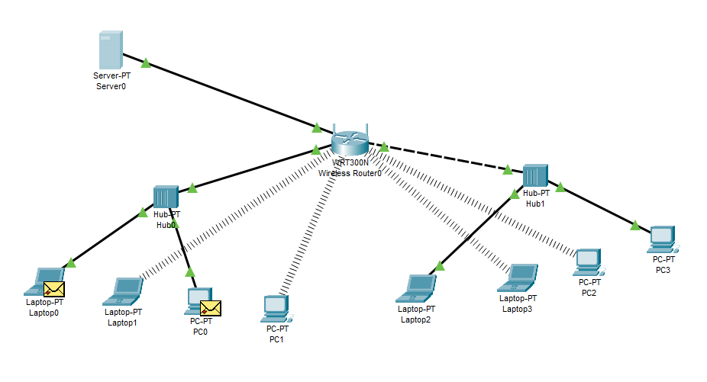

When the packets travel through the network, they consist of two parts: the IP header which contains information of the source and destination IP addresses. The second part of a packet is the IP payload which contains the data to be transferred. With the help of the IP header, the packet can find its destination. Each device on the network has its own IP address. It’s the location ID for each device. The router is the gateway of the network. It connects the PCs to the internet and handles the incoming traffic. The router is the one that allocates the IP addresses to each device in the LAN network.

When you’re using a ping message, you are checking the connectivity between two devices. When a message is sent to the unique IP address of the server. If the IP address exists, the ping message will reach the server and the server will reply to the sending device confirming the connection.

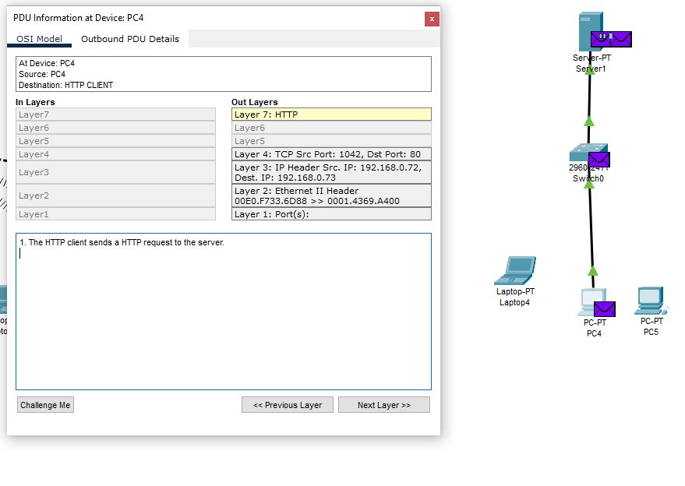

When you want to exchange data between server and a client, we use HTTP messages. The client sends requests to the server, and this will trigger an action on the server and the server will respond to the client.

Number of packets transferred for the HTML page with just text is not going to be very large because you’re just transferring text. When you send a JPEG image, the number of packets is going to be much larger because pictures contain much more information.

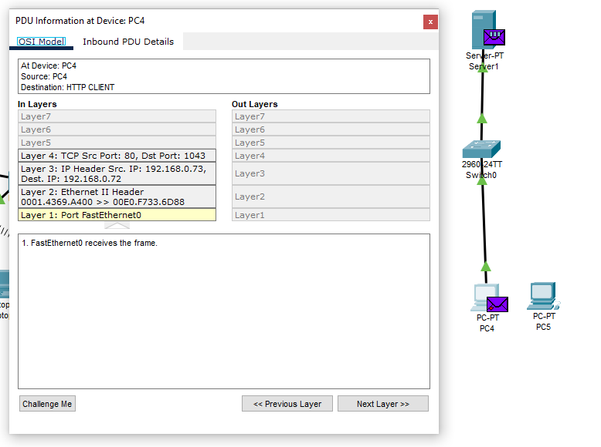

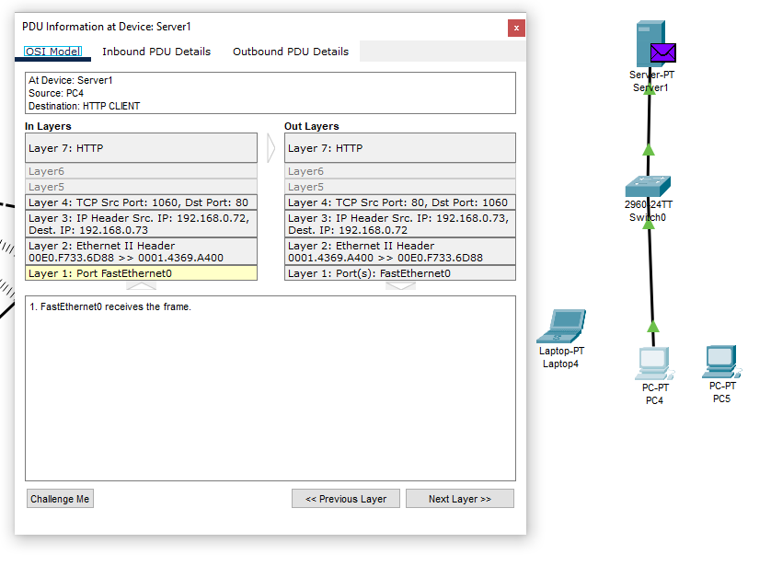

**HTML page with just text.**

