**Dan Koskiranta**

**G00397054**

**Group B**

**Internet Technology 2**

**Lab 5**

**2 March 2023**

**Addressing Table for the Network**

|  |  |  |
| --- | --- | --- |
| **Host Name** | **IP Addressing (Unique)** | **Mask** |
| PC0 | 192.168.0.2 | 255.255.255.0 |
| Laptop0 | 192.168.0.3 | 255.255.255.0 |
| Server | 192.168.0.4 | 255.255.255.0 |
| WRT300N Wireless Router0 | 192.168.0.1 (**Default Gateway**) | 255.255.255.0 |

The network has one PC and a laptop which are connected to a wireless router and the router is connected to a server. As connection type, a copper straight-through cable was used between the PC0, wireless router0 and the server. The laptop0 connected wirelessly to the network.

PC0 and the server used the port FastEthernet0, router used port Ethernet1. To identify each device, a unique IP address had to be assigned to each device. A static method was used to set all the addresses for the network.

Instead of letting the router to assign whatever IP address is available, the static method allows you to assign specific IP addresses to every device you access frequently. So, I’ve set the PC0 to 192.168.0.2 and laptop0 to 192.168.0.3 etc.

The alternative for static is the DHCP (Dynamic Host Configuration Protocol) method. When using this method, the DHCP server on the router will assign an IP address to each device.

**Image of the network created**

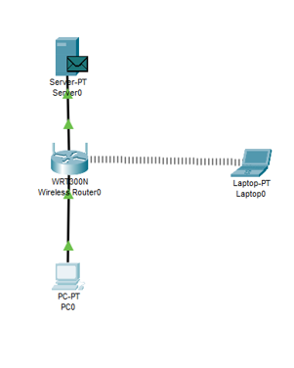

**Image of pinging the server from the PC0**

**Image Above**

Message sent from PC0 to the server. When the message is generated, it is sent through the router to both the server and the laptop. The laptop will recognize that the message was not meant for it so it will ignore the message.

When you want to send a message, firstly the information is broken up into packets, which are smaller blocks of data. A packet must contain information on the source and destination IP addresses. This helps to identify the sending and the receiving device. The other part of the packet is the payload data.

The images below help to explain how messages are transported through the network.

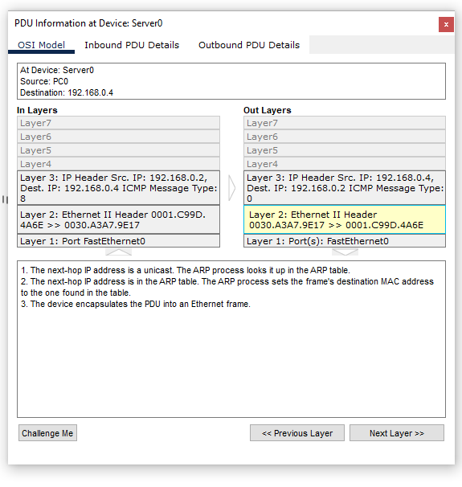

**HTTP message and the layers. The following images contain information on the packets sent.**

The HTTP message is generated in the layer 7 – application layer. Then it’s sent to layer 4 – transport layer where data is segmented. After that the packets are sent to the network layer- layer 3. The network layer breaks the segments into packets. Then, the packets are sent to the data link layer- layer 2. Data link layer breaks down the packets into frames. Finally, the physical layer-layer 1 receives the frame.

**Image Below**

1 packet is transferred with a HTML page with just text.

**Image Below**

The number of packets in a transmission = $\frac{Sequence Number}{Data Length}$.

The number of packets for a JPEG = $\frac{10009}{556}$ = 18 packets. 556 is the original data length.

