**Dan Koskiranta**

**G00397054**

**Group B**

**Internet Technology 2**

**Lab 2**

**9 February 2023**

Address table for the network.

|  |  |  |  |
| --- | --- | --- | --- |
| **Dept.** | **Host Name** | **IP Address** | **Mask** |
| Sales | PC0 | 192.168.30.100 | 255.255.255.0 |
| Sales | PC1 | 192.168.30.101 | 255.255.255.0 |
| Sales | PC2 | 192.168.30.102 | 255.255.255.0 |
| Sales | PC3 | 192.168.30.103 | 255.255.255.0 |
| Marketing | PC4 | 192.168.30.200 | 255.255.255.0 |
| Marketing | PC5 | 192.168.30.201 | 255.255.255.0 |
| Marketing | PC6 | 192.168.30.202 | 255.255.255.0 |
| Marketing | PC7 | 192.168.30.203 | 255.255.255.0 |
| Manufacturing | PC8 | 192.168.30.1 | 255.255.255.0 |
| Manufacturing | PC9 | 192.168.30.2 | 255.255.255.0 |
| Manufacturing | PC10 | 192.168.30.3 | 255.255.255.0 |
| Manufacturing | PC11 | 192.168.30.4 | 255.255.255.0 |

Picture of all three departments connected. The full network.

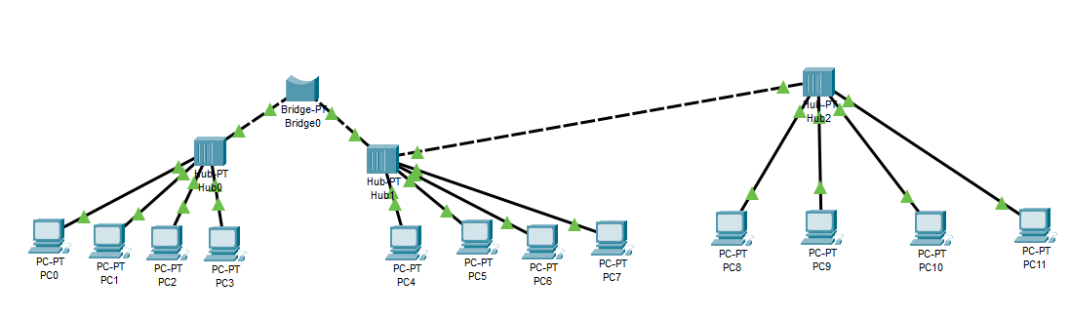

Simulate a ping message between 2 PCs. A message has been sent from PC3 to PC4.

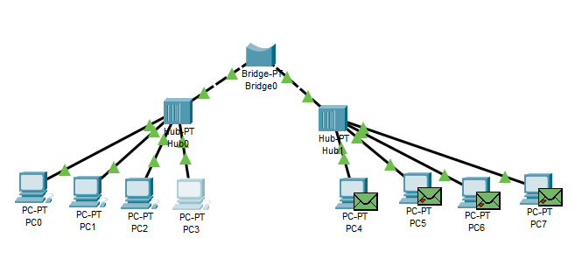

When you change the IP address of one PC to 192.168.1.100 and you try to ping this address from another computer, you won’t be able to send the message. The host network doesn’t identify the IP address.

Pinging the manufacturing department from the sales department. A message from PC0 to PC8.

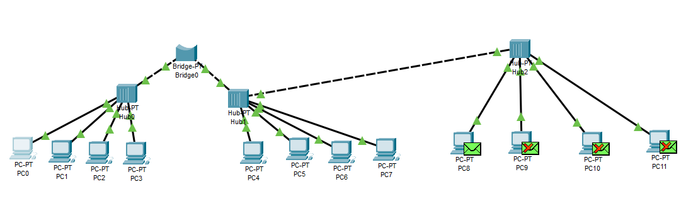

**Details on how the network is operating:**

There are three local networks: sales, marketing, and manufacturing. They all consist of 4 computers and are connected using a hub. We’re using a bridge to connect the networks together. This way the PCs can work as a single network. Bridges extend local area networks to cover larger physical area than the LAN can reach.

Each device has a unique IP address that is used for communication. The IP address identifies the device’s host network and the location of the device on the host network. It’s like a mailing address. When data is sent from one PC to another, the data includes a ‘header’ that includes the IP address of the sending device and the IP address of the destination device.

The bridge inspects the incoming network traffic and determines whether to forward or discard the traffic according to its intended destination. So, the bridge listens to the incoming signal, understands where it comes from and where it needs to go, and directs it accordingly.