Table of Contents

A….. Page 2

A1… Page 2

A2… Page 3

A3… Page 3

A4… Page 4

A5… Page 5

A6… Page 8

B….. Page 10

B1… Page 10

1. The Fourier Transform and its Properties

A1.

A2.

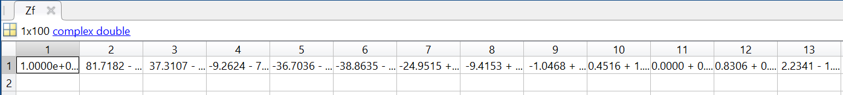

Full values from table can be seen by running the code and expanding each table.

A3.

A4.

Z(w) graph generated by the code above.

Z(t) graph generated by the code above.

The graphs generated would be identical to the graph computed in part A1. We have thus proved the convolution property, as both z(t) = x(t) \* x(t) and Z(w) = X(w)X(w) are both true and identical.

A5.

Graph with a pulse width of 25 generated by code above.

Graph with a pulse width of 5 generated by code above.

As the pulse width is increased or decreased, the amplitude of the resulting graph will be scaled by that factor. This showcases the time-scaling property the transform.

A6.

Generated graph of Wc from code above.

Generated graph of Wnegative from code above.

Generated graph of Wpositive of code above.

From these graphs, we can determine that multiplication of a complex exp. With our function will shift our resulting signal. This showcases the frequency shifting property of the transform. In the case of the Wc graph, cosine is split into two complex exp. Functions, and they are halved (Euler’s identity), so we end up with two “spikes” that are half of the original amplitude.

1. Application of the Fourier Transform

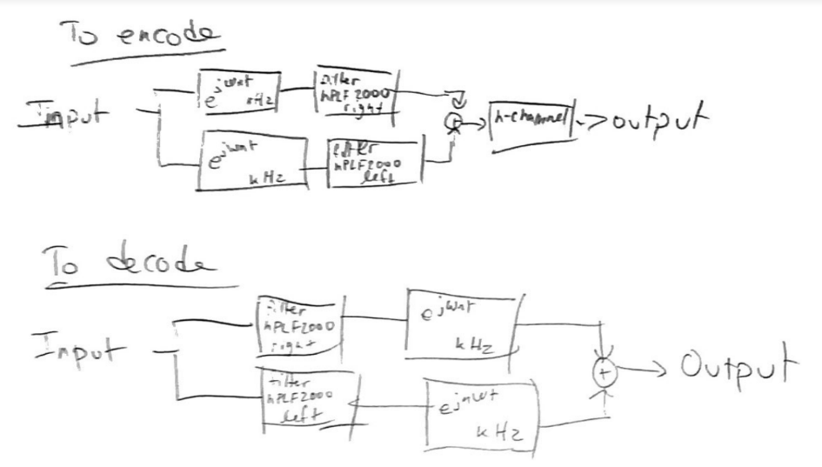

Block diagram of encoding/decoding.

B1.

MagSpectrum code. Given in the lab manual.

Osc code. Given in the lab manual.

Code to generate audio signals.

