CMPE 365 | Algorithms I

Lab 4 and 5 Submission

October 12th, 2019

Daniyal Maniar | 20064993

# Part 1

The code for part 1 may be found in “solution.py”.

# Part 2

The code for part 2 may be found in “modifiedSolution.py”.

***Note:*** In order to run the complete script that generates a plot the Matplotlib library would need to be installed. It will not make an error if the library is not installed

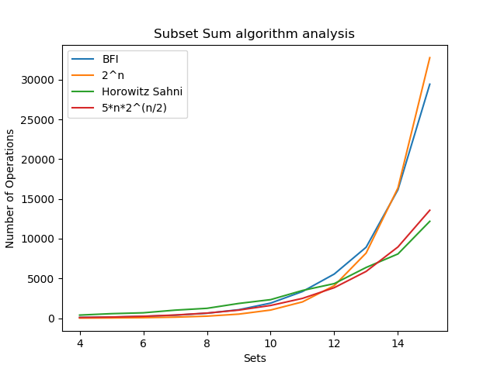

Figure 1 - Comparing the results of each of the algorithms

# Part 3

Based upon the graphed results the BFI subset algorithm follows the trend of $2^{n}$. Additionally, the Horowitz and Sahni subset sum algorithm follows a trend of $n*2^{\frac{n}{2}}$. Based upon rules of algorithm complexity the constants will drop, and the algorithm runs at the predicted complexity.