CMPE 365 | Algorithms I

Lab 7 and 8 Submission

November 2nd, 2019

Daniyal Maniar | 20064993

# Part 1

The code-string dictionary generated is the following:

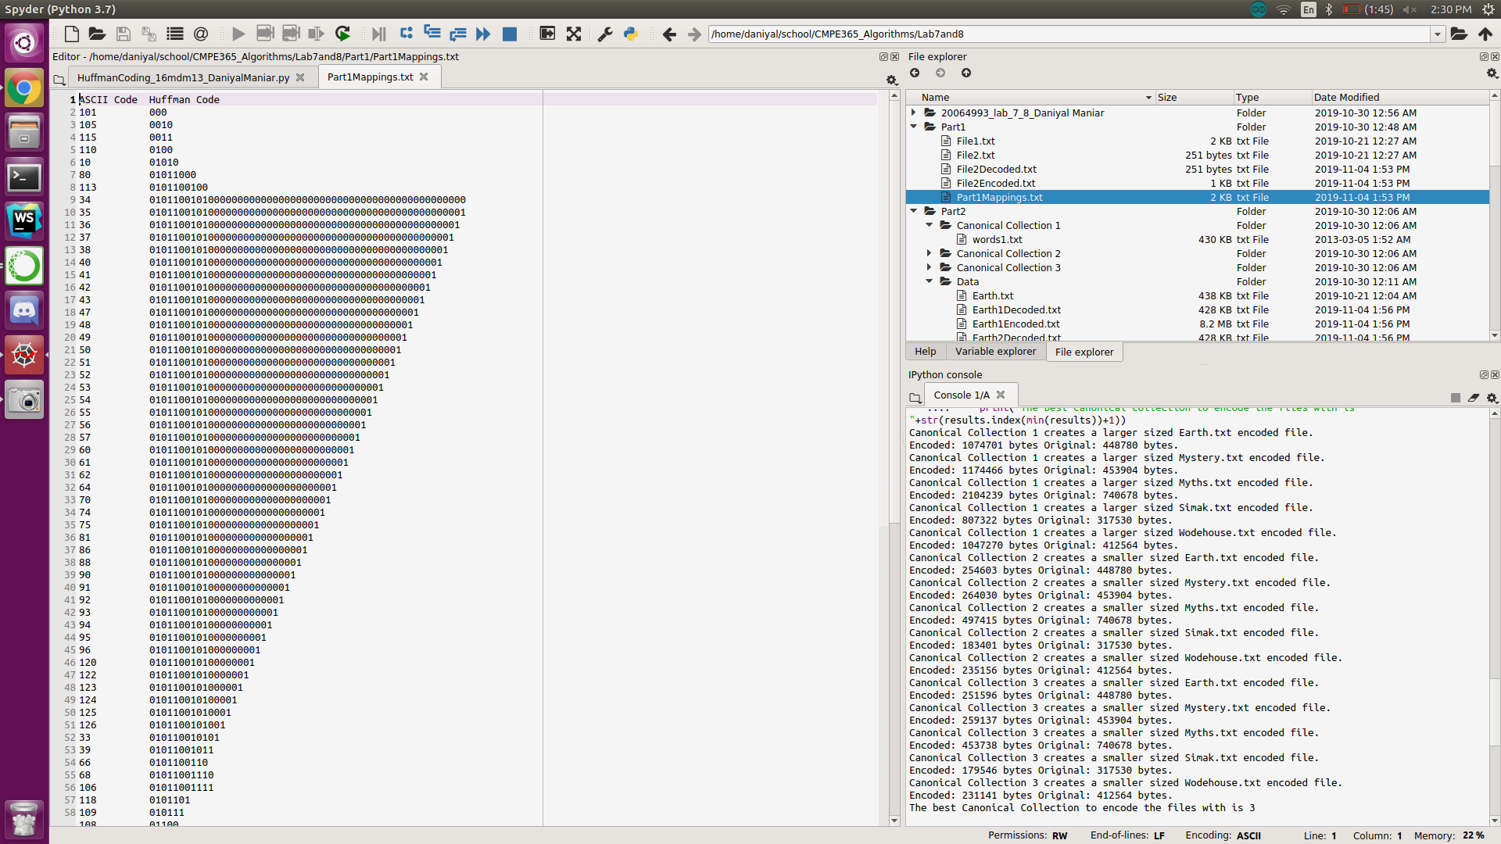

The above results and the decoded files can be seen in the “Part1” directory

# Part 2

Based upon testing the best Canonical Collection to use to generate the codes is “Canonical Collection 3”. We can see that Collection 3 contains the most characters, thus getting the most accurate results for character frequency. This result makes sense since Huffman coding relies upon generating the smallest codes for the most used characters. If we do our best to see which characters are the most used, then we can get the best outcome by generating the shortest encoding. The results for the size comparisons can be seen below.

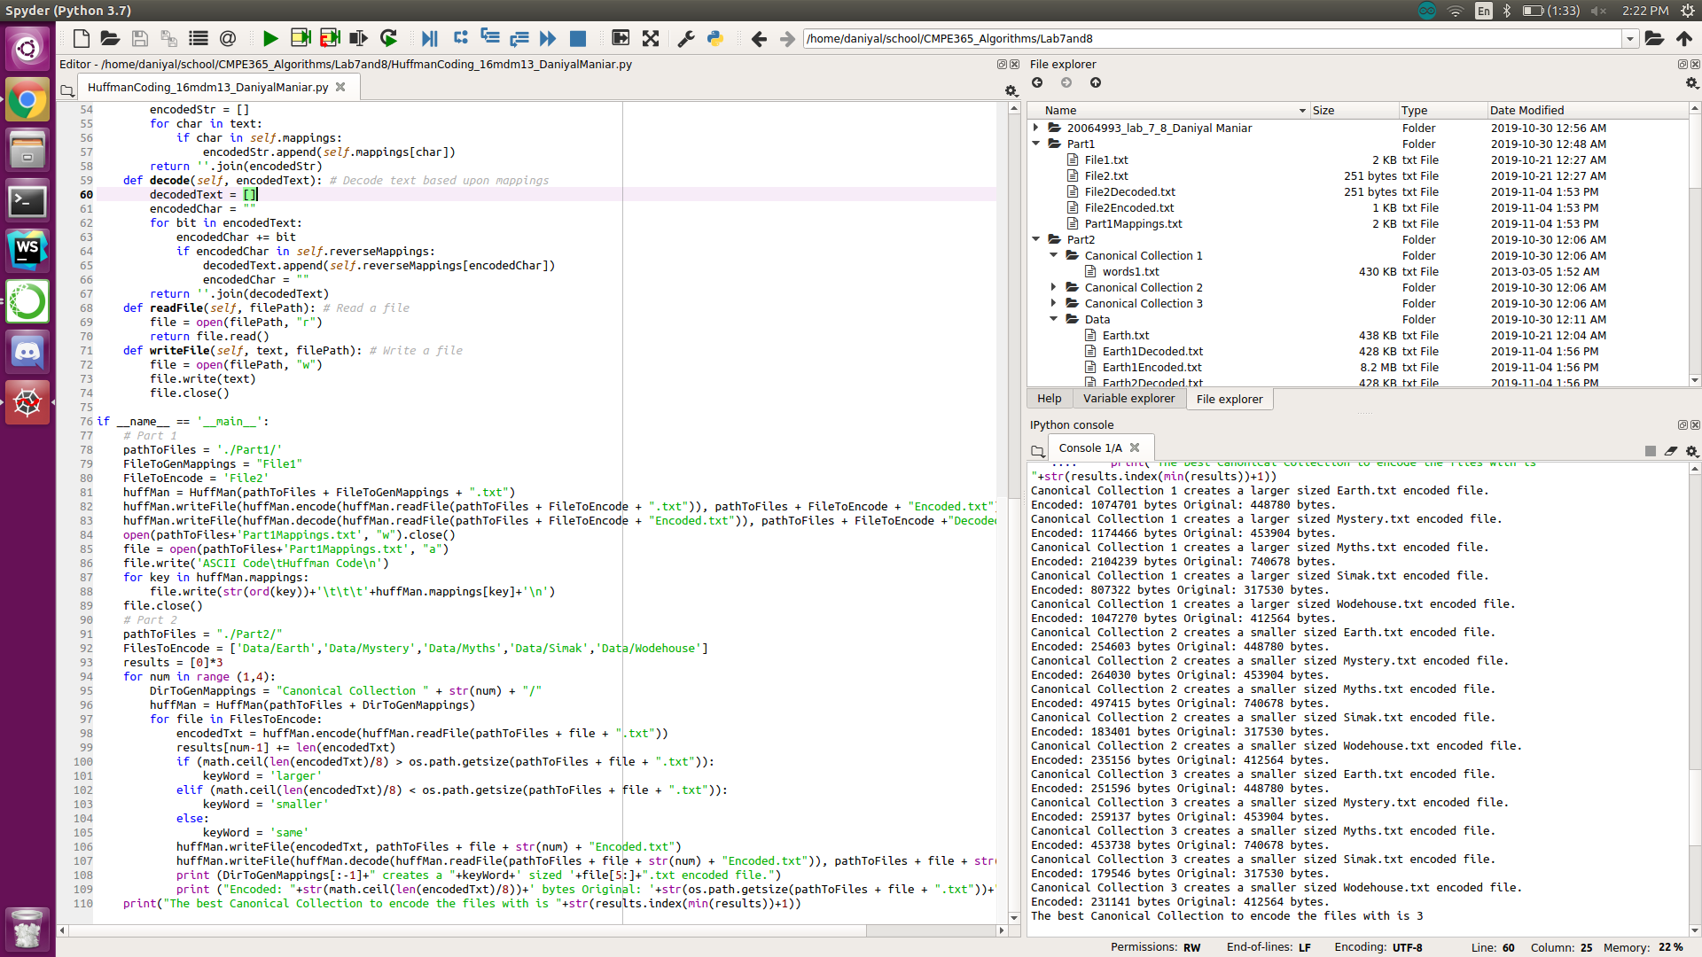

The results of each of the Canonical Collection encoding/decoding can be seen in “Part2/Data/”. Additionally, the “HuffmanCoding_16mdm13_DaniyalManiar.py” script outputs the above results with the minimum encoded bits.