ELEC 374 | Digital Systems Engineering

Machine Problem# 1

April 3rd , 2020

Daniyal Maniar | 20064993

Professor: Ahmad Afsahi, P.Eng

Teaching Assistant: Amir Hossein Sojoodi

# Results

The device query script resulted in providing information about two GPUs connected to the virtual machine. The two GPUs that were connected to the machine were a Tesla C2075, and a Quadro 600. The specifications of each of the processor is provided below.

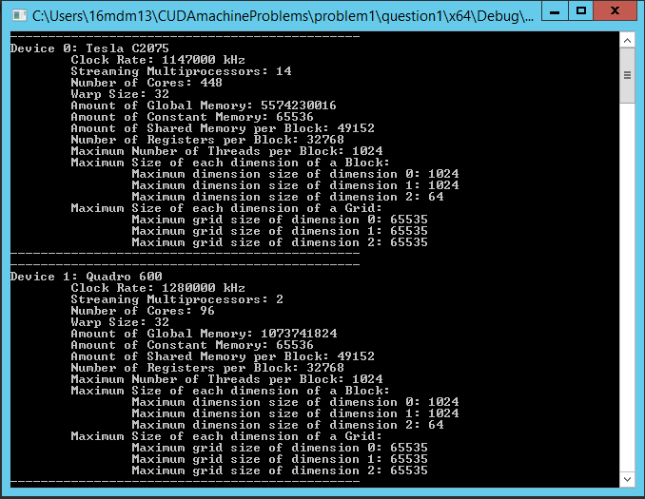

Figure 1 - GPU Device Specifications

# Code

The code for the query is located in “.\question1\question1\kernel.cu”. The code is also provided below.

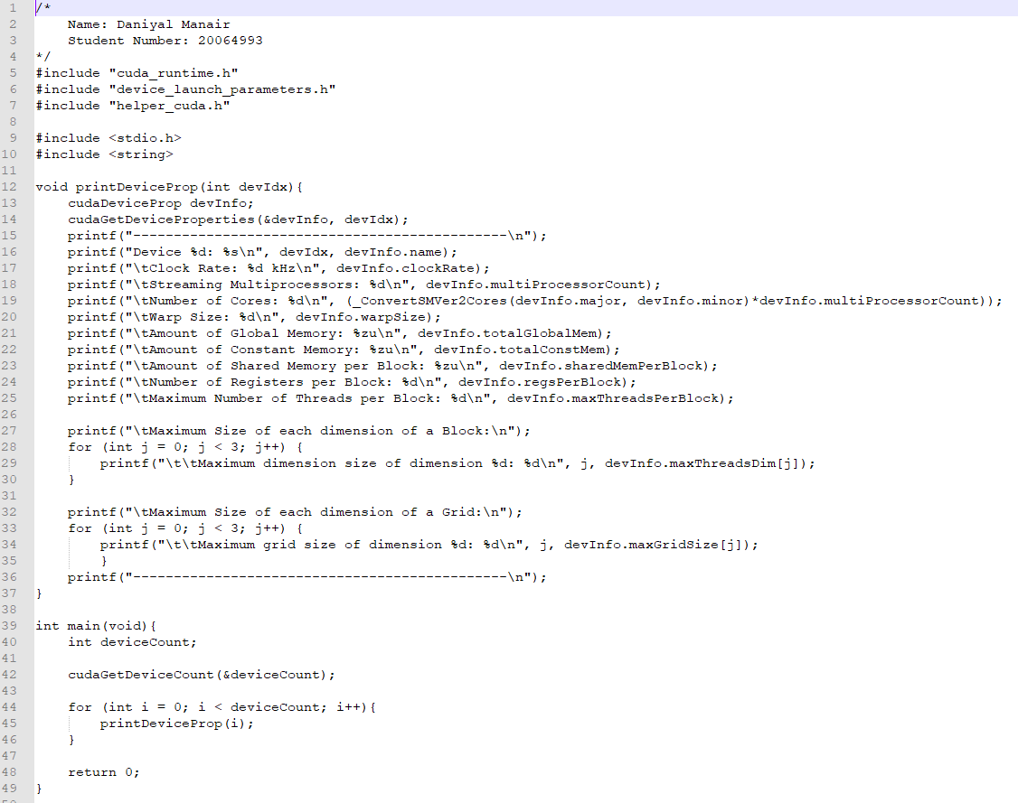

Figure 2 - Code for Device Query