ELEC 374 | Digital Systems Engineering

Machine Problem# 2

April 3rd , 2020

Daniyal Maniar | 20064993

Professor: Ahmad Afsahi, P.Eng

Teaching Assistant: Amir Hossein Sojoodi

# Results

The three GPU kernels were considered for this matrix addition experiment. The kernels were a single element per kernel, an entire row per kernel, and an entire column per kernel. The results of the experiment are tabulated in the chart below:

Figure 1 - Matrix Size vs Time comparison chart

The best results were yielded from the single element per kernel experiment, the compute times were significantly lower than other kernel experiments. The second-best kernel was the column-based computation. The improved performance for column-based processing compared to row-based computation can be attributed to the positioning of the elements being accessed. When a thread is reading from a column of data, the memory read instruction loads adjacent data from memory as well. This allows the kernel to make efficient use of the memory sub system.

The script output for each of the matrix sizes are provided below.

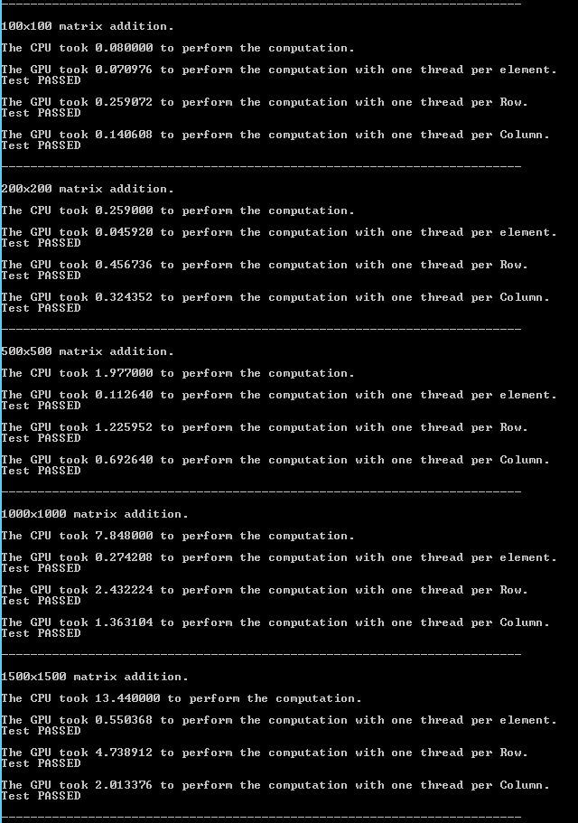

Figure 2 - Matrix Addition Results #1

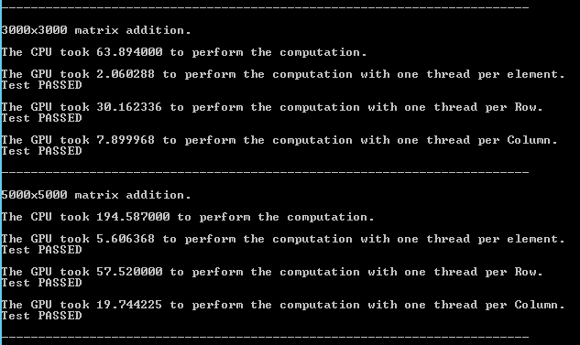

Figure 3 - Matrix Addition Results #2

The code for the problem is located in “.\question2\question2\kernel.cu”.