ELEC 374 | Digital Systems Engineering

Machine Problem# 3

April 3rd , 2020

Daniyal Maniar | 20064993

Professor: Ahmad Afsahi, P.Eng

Teaching Assistant: Amir Hossein Sojoodi

# Results

Results for …

Figure 1 – CPU Core vs GPU Core

Figure 2 - Block width comparison

The script output for each of the matrix sizes are provided below.

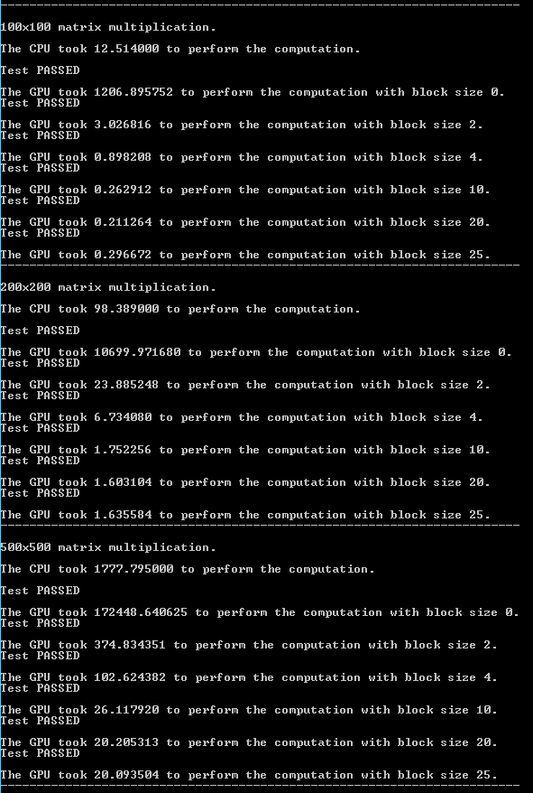

Figure 3 - Matrix Multiplication Results #1

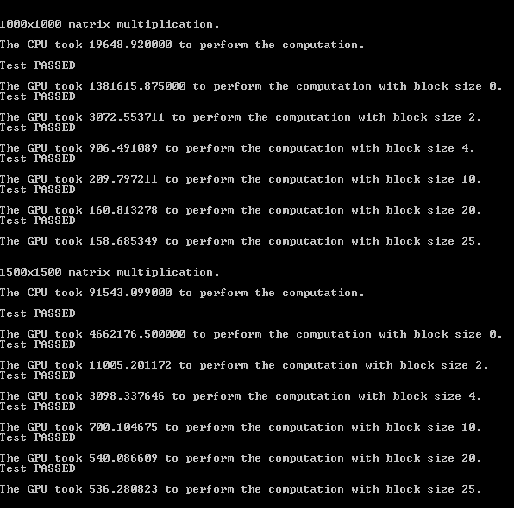

Figure 4 - Matrix Multiplication Results #2

The code for the problem is located in “.\question3\question3\kernel.cu”.