ELEC 374 | Digital Systems Engineering

Machine Problem# 4

April 3rd , 2020

Daniyal Maniar | 20064993

Professor: Ahmad Afsahi, P.Eng

Teaching Assistant: Amir Hossein Sojoodi

# Results

The device query script resulted in providing information about two GPUs connected to the virtual machine. The two GPUs that were connected to the machine were a Tesla C2075, and a Quadro 600.

Figure 1 – CPU Core vs GPU Core

Figure 2 - Block width comparison

The script output for each of the matrix sizes are provided below.

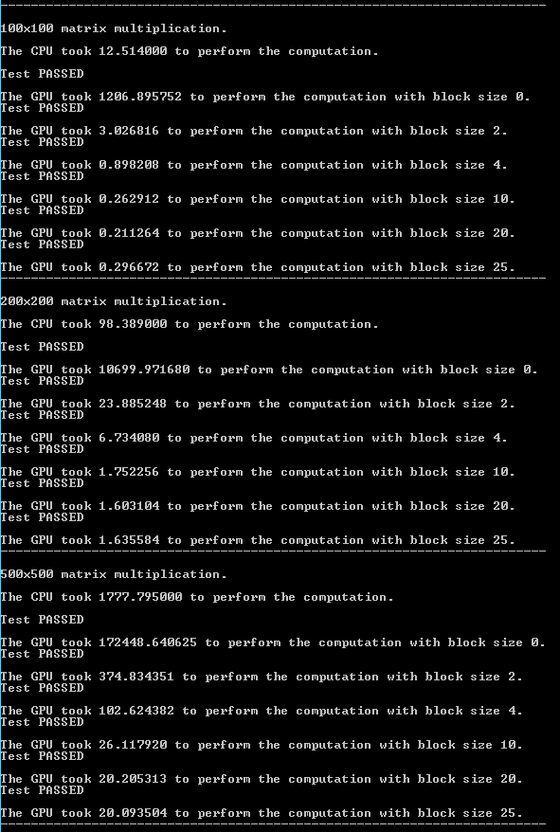

Figure 3 - Matrix Addition Results #1

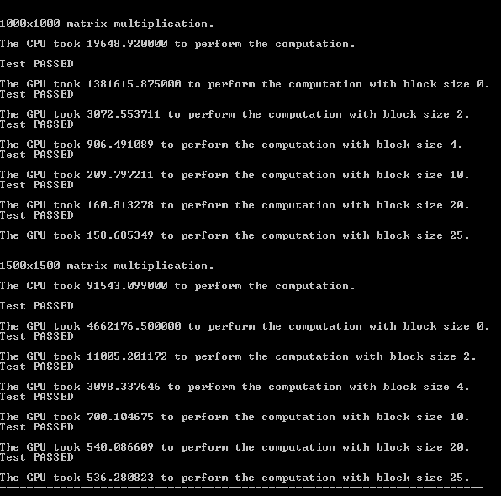

Figure 4 - Matrix Addition Results #2

The code for the problem is located in “.\question4\question4\kernel.cu”.