Daniel Nakhimovich

# Problem 1

Just Temperament:

First, I wrote out the complete table of intervals for just temperament from the notes. Then, I used the circle of fifths to write out the all notes of all the major scales lined up with the corresponding interval for each note. I then found what interval A corresponds to in each scale (either directly or looking an interval above/below Ab/A#) and calculated the frequency of the tonic by 440/(interval ratio). Once I had the tonic frequency the rest of the notes in the scale I calculated by multiplying the notes interval ration in the scale by the tonic frequency.

Equal Temperament:

I know that I could calculate these in the same way as I did the Just Temperament scales but I had already made a table to convert MIDI notation to frequency for use in the matlab based on the link you provided (<https://en.wikipedia.org/wiki/Piano_key_frequencies>) so I just used those values to populate the Equal Temperament table. Only “tricky” part was keeping track of octaves.

# Problem 4

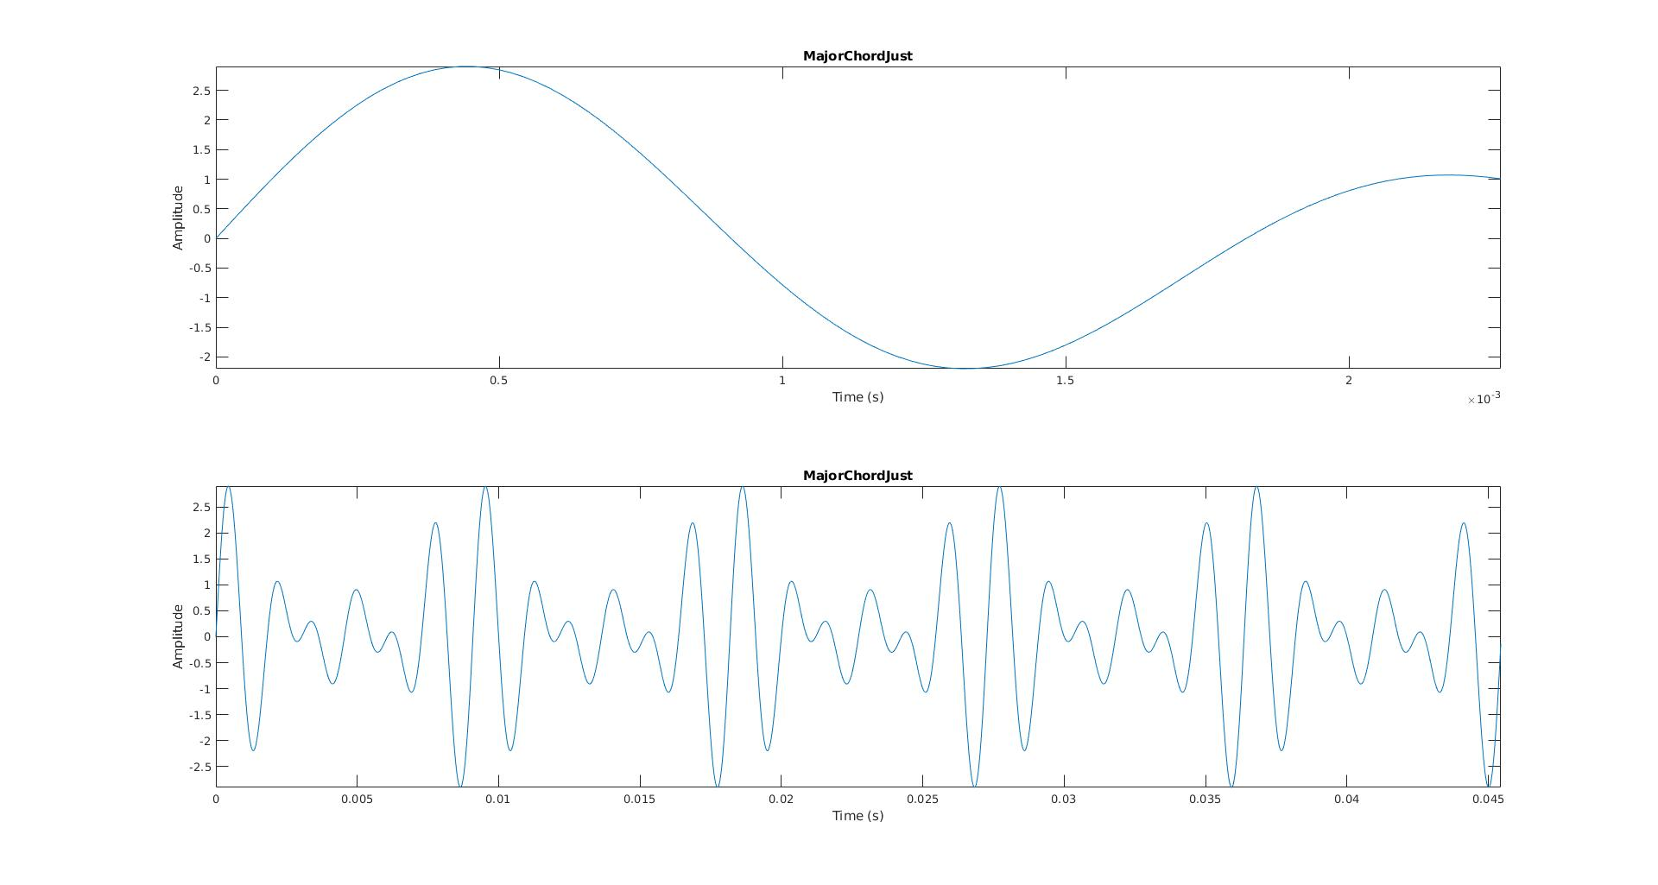

# 

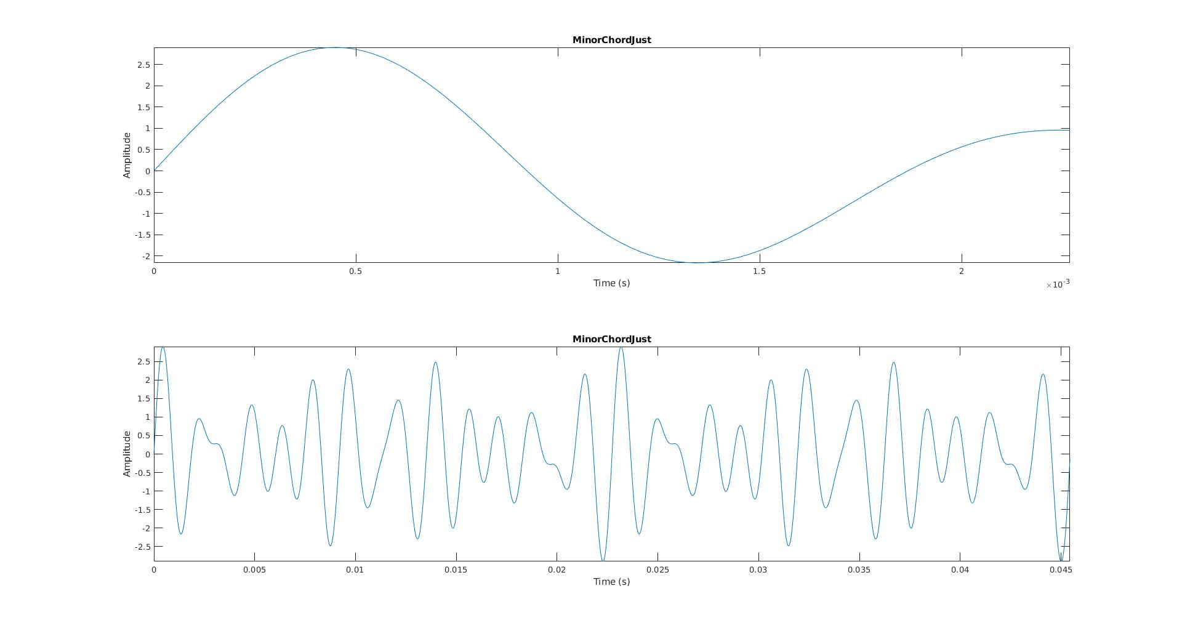

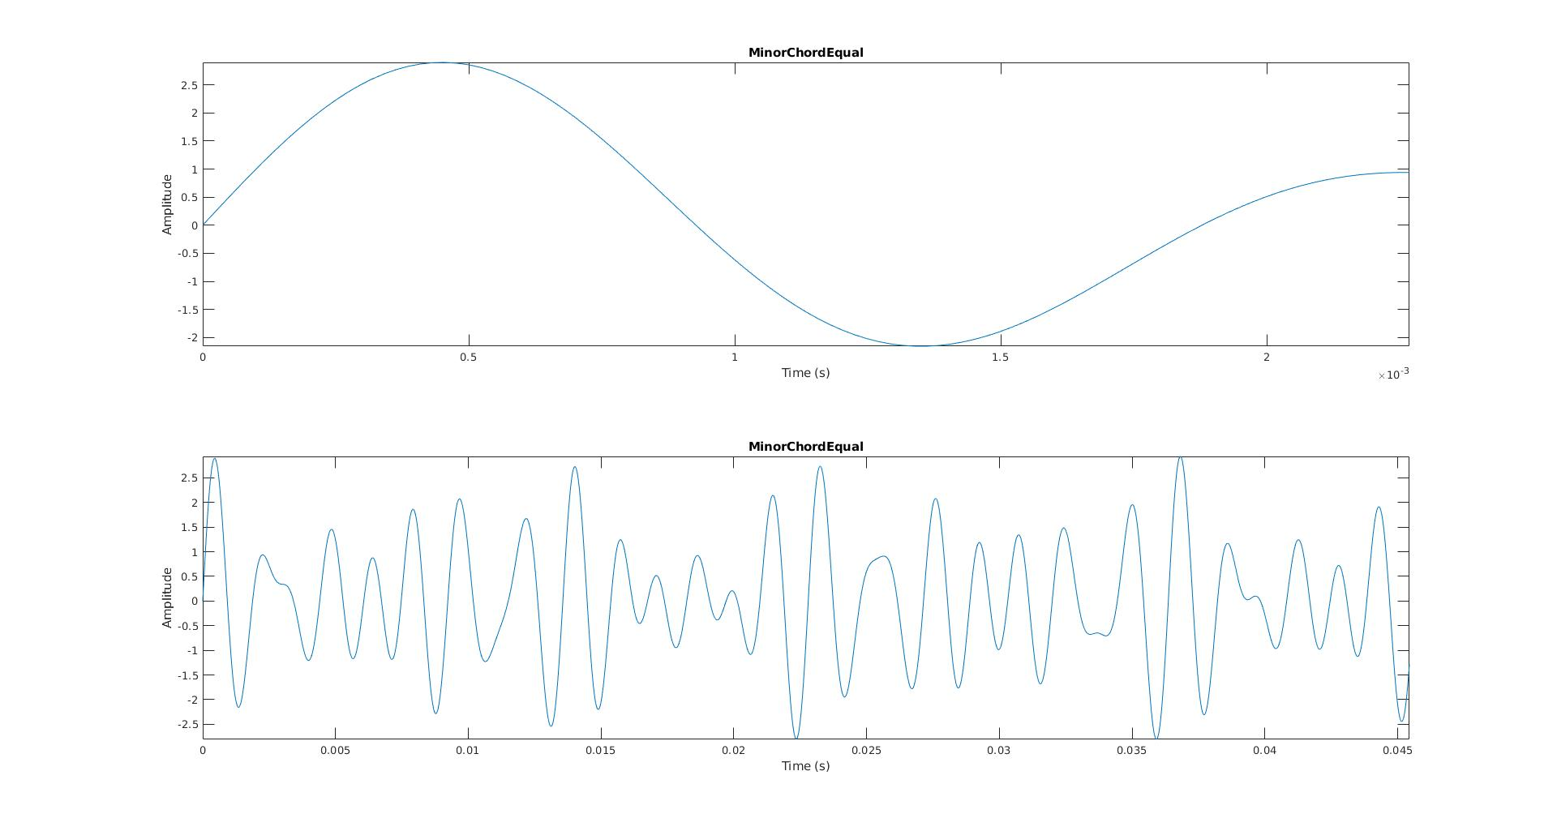

On the order of one wavelength I don’t notice any significant difference between the Just and Equal tempered chords. On the order of 20 wavelengths I did notice that the equal temperament chords were not as perfectly periodic as the Just temperament chords.

# Problem 5

Can you hear the difference between the just tempered Major/Minor scale and the equal tempered Major/Minor scale? Which one sounds better?

No, I could not hear any difference. They sounded equally good. I felt the same about the harmonic minor and melodic minor scales as well.

Can you hear the difference between the just tempered Major/Minor chord and the equal tempered Major/Minor chord? Which one sounds better?

Yes, the equal tempered major chord sounds a little buzzy, and the minor chord a little wavy compared to the just tempered chords. The just tempered chords sound better, but only sightly. The difference was even more apparent between the power chords and even further in the Sus chords. The difference wasn’t as clear between the Dom7 chords and was about as clear as the triads for the Min7 chords.