**Century College**

**CSCI2005 – Fall18**

**Lab4**

**Due on 09/25 @ 9PM**

Create the HTML web page shown below. The necessary images are included in the assignment folder. The page does not have to be an exact match; *it should however be as close as possible* and look the same on the major browsers.

For the dummy links, make the destination URL “#” and use your favorite destinations for the navigation menu.

***Requirements:***

* You must submit valid and semantically appropriate HTML5.
* Your Successful validation as an HTML5 page by using the W3C validation site (<https://validator.w3.org/#validate_by_upload>). Capture the web page that reports successful validation and past it to a word document

***Submitting***

Put your assignment in a folder named lab4. Put all resources used by your assignment into this folder. Upload this folder to the submit drive (make sure zip it first). You will lose marks if you do not follow these submission instructions.

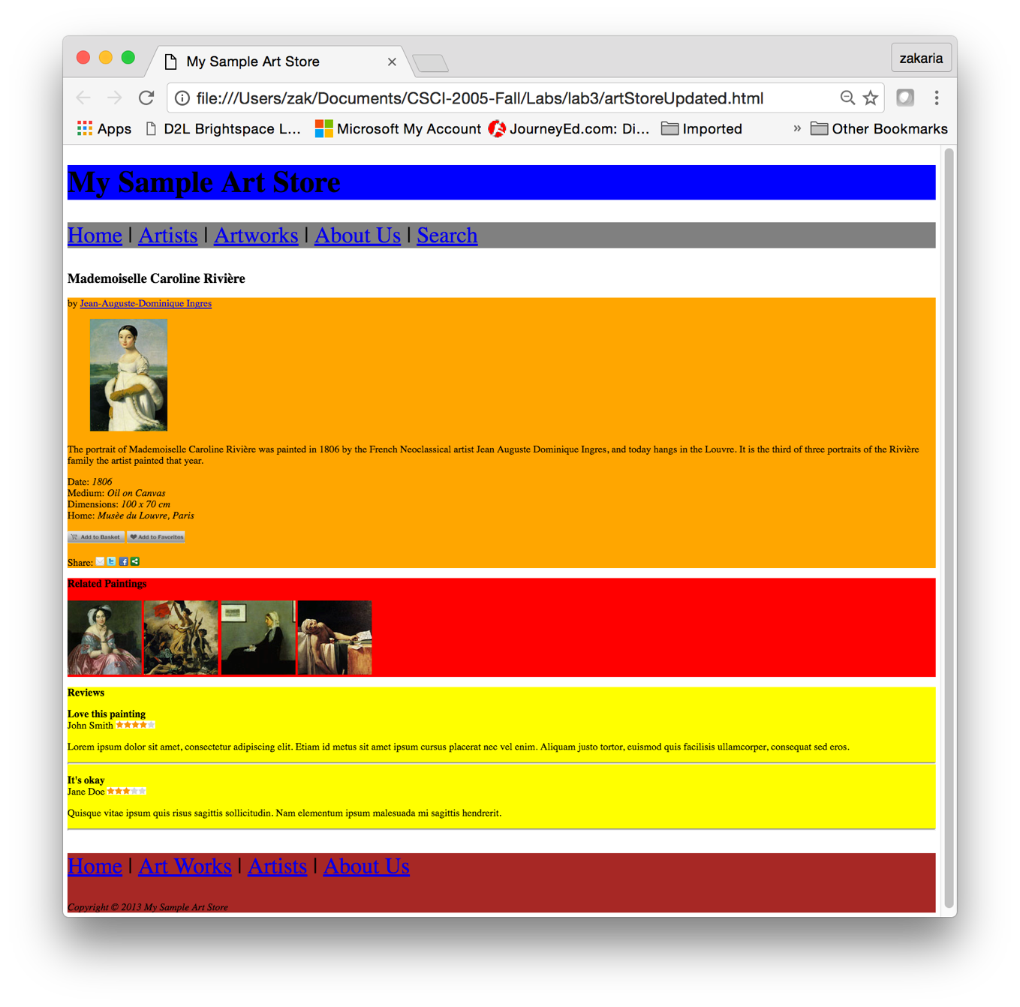

h2 element

Header element

nav element

section element

Section element

Section element

Footer element