**Century College**

**CSCI2005 – Fall18**

**Lab5**

Due on 10/02 @ 9PM

(Lab 5) For this lab you are asked to do to the following project:

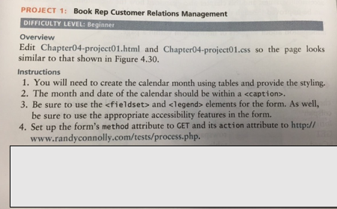

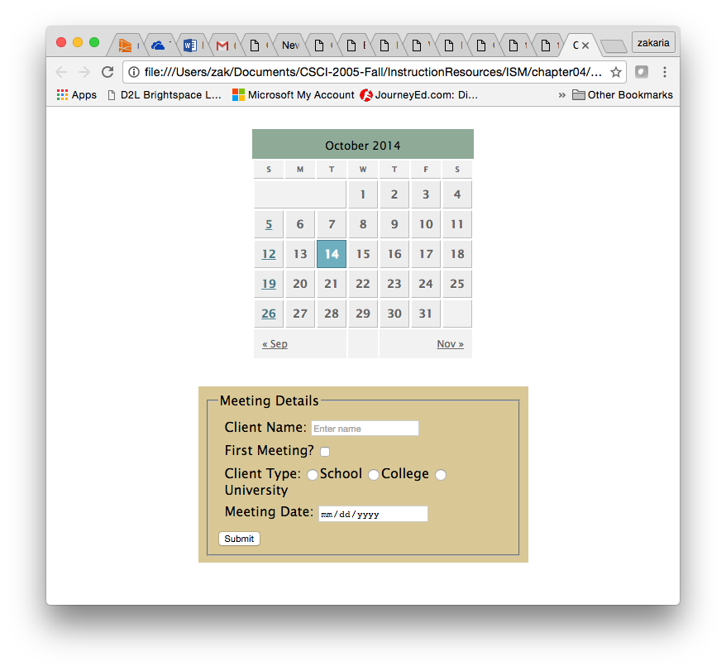

**Figure 4.30**

***Requirements:***

* You must submit valid and semantically appropriate HTML5.
* Your Successful validation as an HTML5 page by using the W3C validation site (<https://validator.w3.org/#validate_by_upload>). Capture the web page that reports successful validation and past it to a word document

***Submitting***

Put your assignment in a folder named lab5. Put all resources used by your assignment into this folder. Upload this folder to the submit drive (make sure zip it first). You will lose marks if you do not follow these submission instructions.