EUA:



**Vehicle Storage**

As vehicles are identified, the computer automatically generates routing or storage missions. These are based on pre-programmed storage and throughput optimizing algorithms and employ rules established early on in the design phase. For example, the [automated parking system](https://www.westfaliaparking.com/parking-systems/) will ensure that SUVs are always stored in levels high enough to allow them to be stored there.

The system will also assign areas to store the car based on frequency of operation. Those cars deemed to be high frequency cars can be stored in zones that are closest to the entry cabins to minimize travel distance of the transfer car.



**Vehicle Retrieval**

Vehicles are retrieved on demand and sent to one of the vertical reciprocating conveyors (VRCs)/lifts. Retrieval processes vary but are usually based on first come, first served rules.

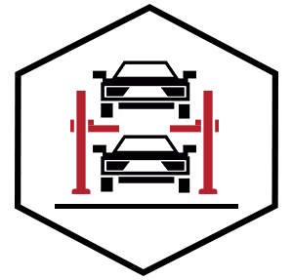

**Parking Space Optimization**

Parking space optimization activities often result in re-storing missions generated for certain vehicles that are stored more than one deep.  For example, if vehicle one is located behind vehicle two and vehicle one is to be retrieved, the system will automatically re-store vehicle two to access vehicle one for car parking management.



**Data Integrity**

Westfalia uses Microsoft SQL Server and Oracle for database management, providing for the ultimate in security and availability of important data. The system will be installed with hardware and software to maintain the integrity of the server and the database.

Savanna.NET PCS is written for electronic interchange with virtually any computer hardware/software platforms and designed to take advantage of multiple processors under the Windows operating systems with no software changes.

<https://www.westfaliaparking.com/parking-systems/software/>

<https://equinsaparking.com/en/management-solutions/car-park-control-and-management-system/>

1. Parkeer

<https://www.parkeer.com.br/>

1. OPERAÇÃO COM CARTÃO DE CÓDIGO DE BARRAS/QR CODE + PLACA

<http://www.estacionamentodigital.com.br/meu-estacionamento.html>

1. GEstacionamento (Software para gerenciamento de estacionamento).

<http://perfilsistemas.com.br/gestacionamento/>

1. Restrições a inadimplência

<https://www.madis.com.br/software/software-md-estacionamento/>