Performance of Growth Parameters

| **Characteristic** | **T0**, N = 4 | **T25**, N = 4 | **T50**, N = 4 | **T75**, N = 4 | **T100**, N = 4 | **p-value** |
| --- | --- | --- | --- | --- | --- | --- |
| Initial Length | 12.91 ± 0.04 | 12.85 ± 0.07 | 12.88 ± 0.09 | 12.84 ± 0.03 | 12.82 ± 0.07 | 0.4 |
| Initial Weight | 1,076 ± 10 | 1,069 ± 22 | 1,068 ± 18 | 1,086 ± 11 | 1,068 ± 44 | 0.8 |
| Final Length | 16.51 ± 0.21 | 16.72 ± 0.27 | 17.05 ± 0.16 | 17.75 ± 0.17 | 16.79 ± 0.34 | <0.001 |
| Final Weight | 2,217 ± 90 | 2,427 ± 45 | 2,445 ± 129 | 2,742 ± 284 | 2,484 ± 160 | 0.007 |
| FCR | 7.52 ± 0.54 | 6.23 ± 0.10 | 6.07 ± 0.45 | 5.24 ± 0.66 | 5.95 ± 0.32 | <0.001 |
| FCR per fish | 0.25 ± 0.02 | 0.21 ± 0.00 | 0.20 ± 0.02 | 0.17 ± 0.02 | 0.20 ± 0.01 | <0.001 |
| Weight gain | 1,141 ± 98 | 1,358 ± 29 | 1,377 ± 139 | 1,656 ± 289 | 1,416 ± 159 | 0.010 |
| Length gain | 3.61 ± 0.22 | 3.88 ± 0.29 | 4.17 ± 0.16 | 4.91 ± 0.18 | 3.96 ± 0.32 | <0.001 |
| PWG | 106 ± 10 | 127 ± 3 | 129 ± 14 | 153 ± 27 | 133 ± 17 | 0.019 |
| DWG | 0.23 ± 0.02 | 0.27 ± 0.01 | 0.27 ± 0.03 | 0.33 ± 0.06 | 0.28 ± 0.03 | 0.010 |
| SGR | 0.187 ± 0.012 | 0.212 ± 0.003 | 0.214 ± 0.016 | 0.238 ± 0.030 | 0.218 ± 0.018 | 0.018 |

## Post Hoc Analysis

Call:  
 aov(formula = Initial Length ~ TREATMENT, data = Feed)  
  
Terms:  
 TREATMENT Residuals  
Sum of Squares 0.01780222 0.05974167  
Deg. of Freedom 4 15  
  
Residual standard error: 0.06310925  
Estimated effects may be unbalanced

Df Sum Sq Mean Sq F value Pr(>F)  
TREATMENT 4 0.01780 0.004451 1.117 0.385  
Residuals 15 0.05974 0.003983

Call:  
 aov(formula = Final Length ~ TREATMENT, data = Feed)  
  
Terms:  
 TREATMENT Residuals  
Sum of Squares 3.668829 0.859259  
Deg. of Freedom 4 15  
  
Residual standard error: 0.2393406  
Estimated effects may be unbalanced

Df Sum Sq Mean Sq F value Pr(>F)   
TREATMENT 4 3.669 0.9172 16.01 2.73e-05 ***  
Residuals 15 0.859 0.0573   
---  
Signif. codes: 0 '***' 0.001 '**' 0.01 '*' 0.05 '.' 0.1 ' ' 1

Call:  
 aov(formula = Length gain ~ TREATMENT, data = Feed)  
  
Terms:  
 TREATMENT Residuals  
Sum of Squares 3.888150 0.885601  
Deg. of Freedom 4 15  
  
Residual standard error: 0.2429816  
Estimated effects may be unbalanced

Df Sum Sq Mean Sq F value Pr(>F)   
TREATMENT 4 3.888 0.972 16.46 2.32e-05 ***  
Residuals 15 0.886 0.059   
---  
Signif. codes: 0 '***' 0.001 '**' 0.01 '*' 0.05 '.' 0.1 ' ' 1

Tukey multiple comparisons of means  
 95% family-wise confidence level  
  
Fit: aov(formula = Length gain ~ TREATMENT, data = Feed)  
  
$TREATMENT  
 diff lwr upr p adj  
T100-T0 0.35360244 -0.1769461 0.8841510 0.2871555  
T25-T0 0.26818783 -0.2623607 0.7987364 0.5420173  
T50-T0 0.55777574 0.0272272 1.0883243 0.0371371  
T75-T0 1.30224469 0.7716961 1.8327932 0.0000143  
T25-T100 -0.08541461 -0.6159632 0.4451339 0.9864088  
T50-T100 0.20417330 -0.3263752 0.7347218 0.7577715  
T75-T100 0.94864224 0.4180937 1.4791908 0.0004821  
T50-T25 0.28958791 -0.2409606 0.8201365 0.4708056  
T75-T25 1.03405686 0.5035083 1.5646054 0.0001965  
T75-T50 0.74446894 0.2139204 1.2750175 0.0045635

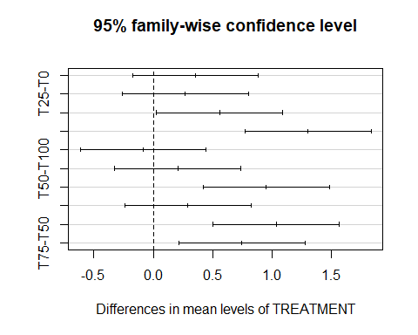

Call:  
 aov(formula = Weight gain ~ TREATMENT, data = Feed)  
  
Terms:  
 TREATMENT Residuals  
Sum of Squares 537514.5 416212.5  
Deg. of Freedom 4 15  
  
Residual standard error: 166.5758  
Estimated effects may be unbalanced

Df Sum Sq Mean Sq F value Pr(>F)   
TREATMENT 4 537515 134379 4.843 0.0104 *  
Residuals 15 416212 27747   
---  
Signif. codes: 0 '***' 0.001 '**' 0.01 '*' 0.05 '.' 0.1 ' ' 1

Tukey multiple comparisons of means  
 95% family-wise confidence level  
  
Fit: aov(formula = Weight gain ~ TREATMENT, data = Feed)  
  
$TREATMENT  
 diff lwr upr p adj  
T100-T0 275.25 -88.467 638.967 0.1869920  
T25-T0 217.00 -146.717 580.717 0.3871512  
T50-T0 235.75 -127.967 599.467 0.3115062  
T75-T0 514.50 150.783 878.217 0.0042644  
T25-T100 -58.25 -421.967 305.467 0.9866712  
T50-T100 -39.50 -403.217 324.217 0.9969595  
T75-T100 239.25 -124.467 602.967 0.2985428  
T50-T25 18.75 -344.967 382.467 0.9998376  
T75-T25 297.50 -66.217 661.217 0.1367426  
T75-T50 278.75 -84.967 642.467 0.1782010

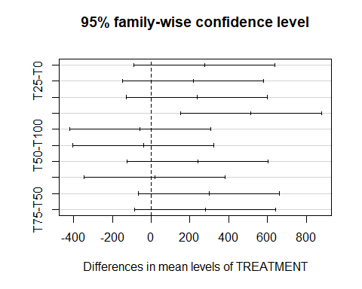

Call:  
 aov(formula = PWG ~ TREATMENT, data = Feed)  
  
Terms:  
 TREATMENT Residuals  
Sum of Squares 4391.450 4019.589  
Deg. of Freedom 4 15  
  
Residual standard error: 16.36987  
Estimated effects may be unbalanced

Df Sum Sq Mean Sq F value Pr(>F)   
TREATMENT 4 4391 1098 4.097 0.0193 *  
Residuals 15 4020 268   
---  
Signif. codes: 0 '***' 0.001 '**' 0.01 '*' 0.05 '.' 0.1 ' ' 1

Tukey multiple comparisons of means  
 95% family-wise confidence level  
  
Fit: aov(formula = PWG ~ TREATMENT, data = Feed)  
  
$TREATMENT  
 diff lwr upr p adj  
T100-T0 26.812372 -8.931111 62.55585 0.1932577  
T25-T0 20.944242 -14.799241 56.68773 0.4040203  
T50-T0 22.930561 -12.812922 58.67404 0.3206654  
T75-T0 46.474061 10.730578 82.21754 0.0084553  
T25-T100 -5.868129 -41.611612 29.87535 0.9853846  
T50-T100 -3.881811 -39.625294 31.86167 0.9969594  
T75-T100 19.661690 -16.081793 55.40517 0.4635121  
T50-T25 1.986319 -33.757164 37.72980 0.9997812  
T75-T25 25.529819 -10.213664 61.27330 0.2300924  
T75-T50 23.543500 -12.199983 59.28698 0.2973656

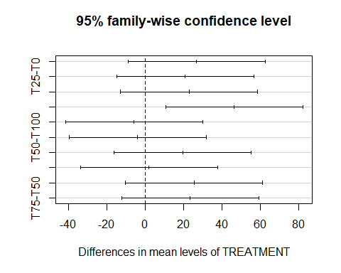

Call:  
 aov(formula = DWG ~ TREATMENT, data = Feed)  
  
Terms:  
 TREATMENT Residuals  
Sum of Squares 0.02116066 0.01638529  
Deg. of Freedom 4 15  
  
Residual standard error: 0.03305076  
Estimated effects may be unbalanced

Df Sum Sq Mean Sq F value Pr(>F)   
TREATMENT 4 0.02116 0.005290 4.843 0.0104 *  
Residuals 15 0.01639 0.001092   
---  
Signif. codes: 0 '***' 0.001 '**' 0.01 '*' 0.05 '.' 0.1 ' ' 1

Tukey multiple comparisons of means  
 95% family-wise confidence level  
  
Fit: aov(formula = DWG ~ TREATMENT, data = Feed)  
  
$TREATMENT  
 diff lwr upr p adj  
T100-T0 0.054613095 -0.01755298 0.12677917 0.1869920  
T25-T0 0.043055556 -0.02911052 0.11522163 0.3871512  
T50-T0 0.046775794 -0.02539028 0.11894187 0.3115062  
T75-T0 0.102083333 0.02991726 0.17424941 0.0042644  
T25-T100 -0.011557540 -0.08372361 0.06060853 0.9866712  
T50-T100 -0.007837302 -0.08000337 0.06432877 0.9969595  
T75-T100 0.047470238 -0.02469583 0.11963631 0.2985428  
T50-T25 0.003720238 -0.06844583 0.07588631 0.9998376  
T75-T25 0.059027778 -0.01313829 0.13119385 0.1367426  
T75-T50 0.055307540 -0.01685853 0.12747361 0.1782010

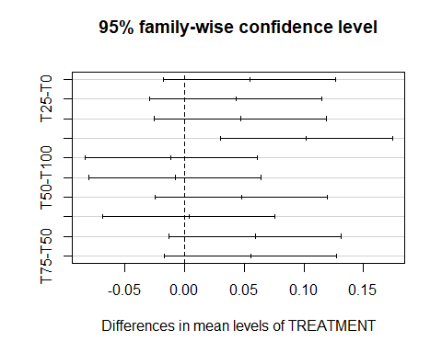

Call:  
 aov(formula = SGR ~ TREATMENT, data = Feed)  
  
Terms:  
 TREATMENT Residuals  
Sum of Squares 0.005420332 0.004867451  
Deg. of Freedom 4 15  
  
Residual standard error: 0.01801379  
Estimated effects may be unbalanced

Df Sum Sq Mean Sq F value Pr(>F)   
TREATMENT 4 0.005420 0.0013551 4.176 0.0181 *  
Residuals 15 0.004867 0.0003245   
---  
Signif. codes: 0 '***' 0.001 '**' 0.01 '*' 0.05 '.' 0.1 ' ' 1

Tukey multiple comparisons of means  
 95% family-wise confidence level  
  
Fit: aov(formula = SGR ~ TREATMENT, data = Feed)  
  
$TREATMENT  
 diff lwr upr p adj  
T100-T0 0.031369769 -0.007963209 0.07070275 0.1520506  
T25-T0 0.025235267 -0.014097711 0.06456825 0.3205969  
T50-T0 0.027112132 -0.012220846 0.06644511 0.2587408  
T75-T0 0.051573932 0.012240954 0.09090691 0.0079156  
T25-T100 -0.006134502 -0.045467480 0.03319848 0.9879254  
T50-T100 -0.004257637 -0.043590615 0.03507534 0.9969978  
T75-T100 0.020204163 -0.019128816 0.05953714 0.5273336  
T50-T25 0.001876865 -0.037456113 0.04120984 0.9998805  
T75-T25 0.026338665 -0.012994314 0.06567164 0.2831073  
T75-T50 0.024461800 -0.014871179 0.06379478 0.3487539

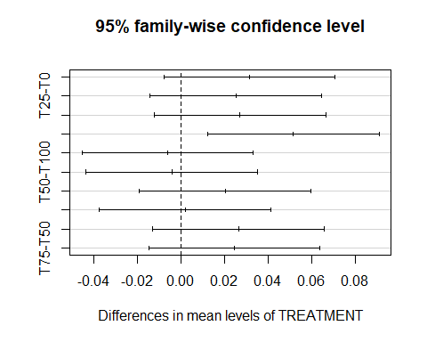

Call:  
 aov(formula = FCR ~ TREATMENT, data = Feed)  
  
Terms:  
 TREATMENT Residuals  
Sum of Squares 10.931555 3.146663  
Deg. of Freedom 4 15  
  
Residual standard error: 0.4580148  
Estimated effects may be unbalanced

Df Sum Sq Mean Sq F value Pr(>F)   
TREATMENT 4 10.932 2.7329 13.03 8.99e-05 ***  
Residuals 15 3.147 0.2098   
---  
Signif. codes: 0 '***' 0.001 '**' 0.01 '*' 0.05 '.' 0.1 ' ' 1

Tukey multiple comparisons of means  
 95% family-wise confidence level  
  
Fit: aov(formula = FCR ~ TREATMENT, data = Feed)  
  
$TREATMENT  
 diff lwr upr p adj  
T100-T0 -1.5690692 -2.5691410 -0.568997407 0.0017080  
T25-T0 -1.2839809 -2.2840527 -0.283909091 0.0093245  
T50-T0 -1.4499993 -2.4500711 -0.449927496 0.0034544  
T75-T0 -2.2741281 -3.2741999 -1.274056258 0.0000353  
T25-T100 0.2850883 -0.7149835 1.285160127 0.8997808  
T50-T100 0.1190699 -0.8810019 1.119141722 0.9956651  
T75-T100 -0.7050589 -1.7051307 0.295012960 0.2404093  
T50-T25 -0.1660184 -1.1660902 0.834053406 0.9847708  
T75-T25 -0.9901472 -1.9902190 0.009924644 0.0529316  
T75-T50 -0.8241288 -1.8242006 0.175943048 0.1324119

