Indices

## Wrangle

## Cpue graph

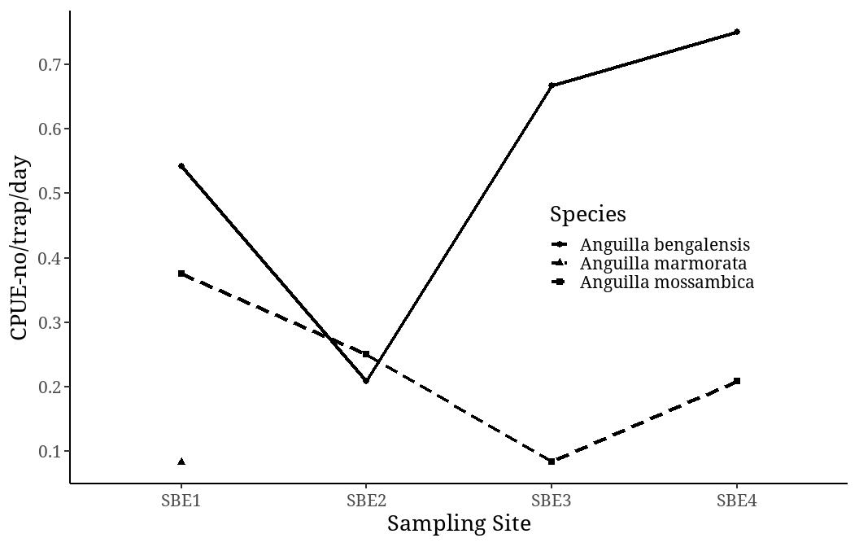

## Distance from the ocean

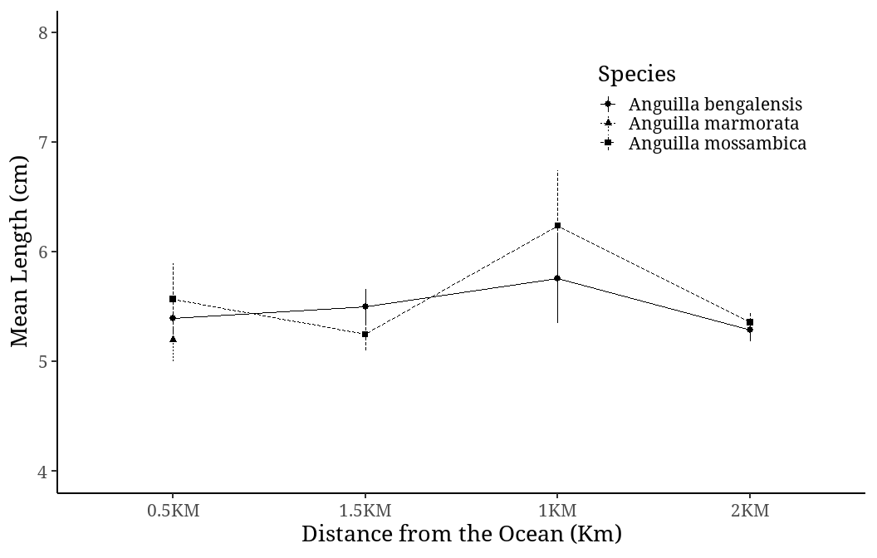

## Yearly Recruitment

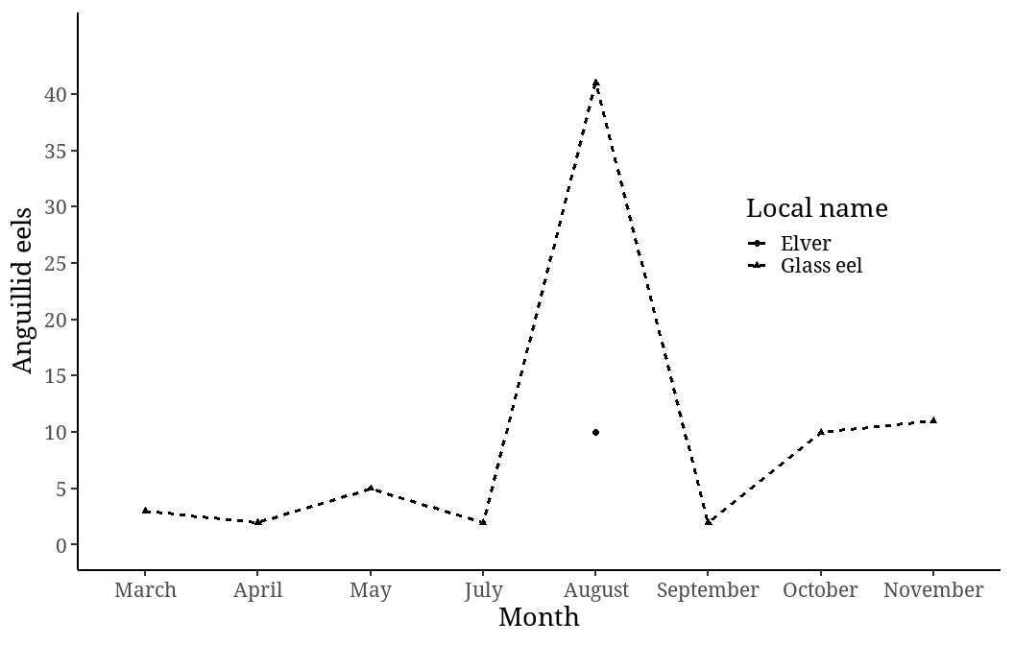

## Indices per site per species

| site | ocular_index_Anguilla mossambica | ocular_index_Anguilla bengalensis | ocular_index_Anguilla marmorata | elongation_index_Anguilla mossambica | elongation_index_Anguilla bengalensis | elongation_index_Anguilla marmorata |
| --- | --- | --- | --- | --- | --- | --- |
| SBE3 | 4.743039 | 5.543290 | NA | 346.9017 | 494.2652 | NA |
| SBE1 | 34.159617 | 5.613006 | 6.307404 | 379.4748 | 423.4866 | 417.1363 |
| SBE2 | 5.422252 | 5.035722 | NA | 558.4992 | 688.9614 | NA |
| SBE4 | 4.187635 | 5.244700 | NA | 322.6729 | 498.7670 | NA |

## Indices per moon phase per species

| Moon Phase | ocular_index_Anguilla mossambica | ocular_index_Anguilla bengalensis | ocular_index_Anguilla marmorata | elongation_index_Anguilla mossambica | elongation_index_Anguilla bengalensis | elongation_index_Anguilla marmorata |
| --- | --- | --- | --- | --- | --- | --- |
| Last Quarter | 3.456868 | 4.450454 | NA | 248.9691 | 428.3952 | NA |
| Waxing Creascent | 6.339108 | 6.121568 | 7.764733 | 575.8137 | 422.9009 | 381.9885 |
| First Quarter | 5.940410 | 5.989961 | NA | 580.8109 | 454.0854 | NA |
| Wanning Gibbous | 33.456629 | 5.032258 | 4.850076 | 319.4720 | 567.9189 | 452.2840 |
| Full moon | NA | 5.843164 | NA | NA | 510.8219 | NA |

## Indices per NEM, SEM per species

| seasonality | ocular_index_Anguilla mossambica | ocular_index_Anguilla bengalensis | ocular_index_Anguilla marmorata | elongation_index_Anguilla mossambica | elongation_index_Anguilla bengalensis | elongation_index_Anguilla marmorata |
| --- | --- | --- | --- | --- | --- | --- |
| SEM | 18.084346 | 5.637519 | 6.307404 | 403.5929 | 471.1580 | 417.1363 |
| NEM | 4.353698 | 4.314626 | NA | 500.7885 | 619.5985 | NA |