EFFECTS OF PARTICIPATORY MONITORING AND EVALUATION ON THE SUSTAINABILITY OF ECONOMIC STIMULUS PROGRAM IN THE KENYAN EDUCATION SECTOR: A CASE OF NAIROBI COUNTY, KENYA

Lucy

## Social Demographics

| **Characteristic** | **N = 110***1* |
| --- | --- |
| Gender |  |
| Female | 54 (49%) |
| Male | 56 (51%) |
| Age |  |
| below 20 | 16 (15%) |
| 20-29 | 74 (67%) |
| 30-39 | 9 (8.2%) |
| 40-49 | 7 (6.4%) |
| 50 years and above | 4 (3.6%) |
| Education |  |
| Diploma | 40 (36%) |
| Bachelor's Degree | 58 (53%) |
| Masters Degree | 7 (6.4%) |
| PHD | 3 (2.7%) |
| Others | 2 (1.8%) |
| Working |  |
| -1 year | 46 (42%) |
| 2-5 years | 42 (38%) |
| 5-10 years | 8 (7.3%) |
| 10-15 years | 4 (3.6%) |
| 15-20 years | 4 (3.6%) |
| 20+ | 6 (5.5%) |
| *1*n (%) | |

## Gender

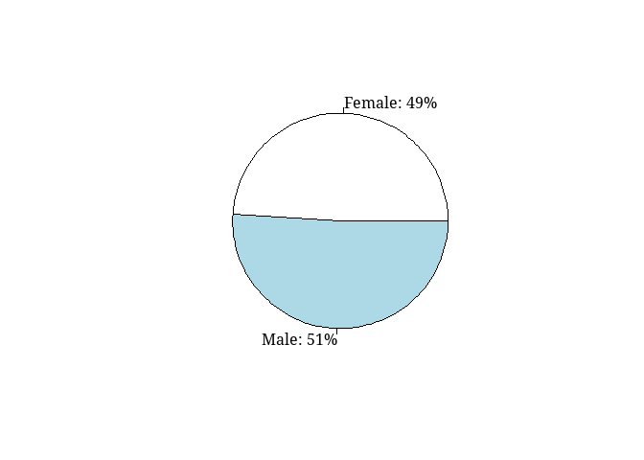

## Age

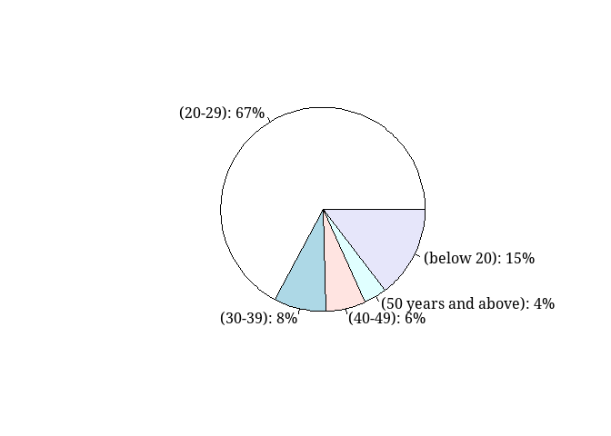

## Education Level

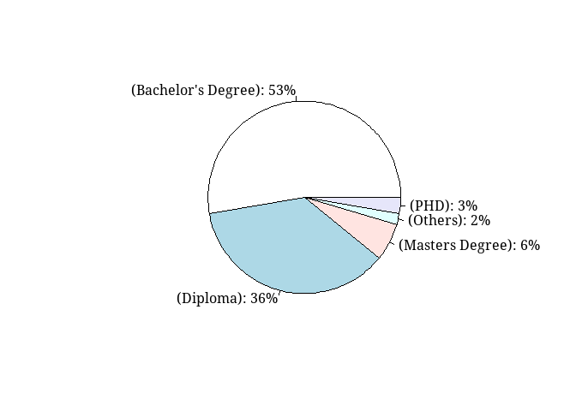

## Working Experience

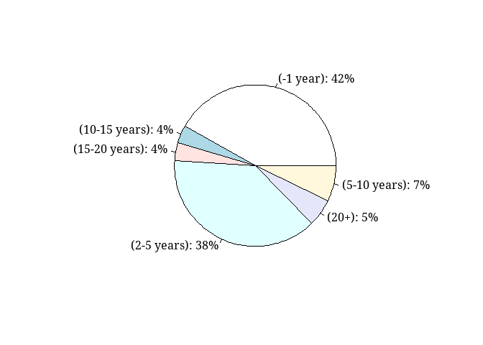

# Stakeholder Involvement

| **Characteristic** | **N = 110**1 |
| --- | --- |
| PME_awareness | 53 (48%) |
| PME use |  |
| as per project requirement | 24 (22%) |
| Monthly | 29 (26%) |
| Quarterly | 47 (43%) |
| Yearly | 10 (9.1%) |
| PME_interactions |  |
| boring but varied | 7 (6.4%) |
| not sure | 32 (29%) |
| Routine and boring | 13 (12%) |
| Routine but very challenging | 19 (17%) |
| Varied and challenging | 39 (35%) |
| 1n (%) | |

## PME Awareness pie

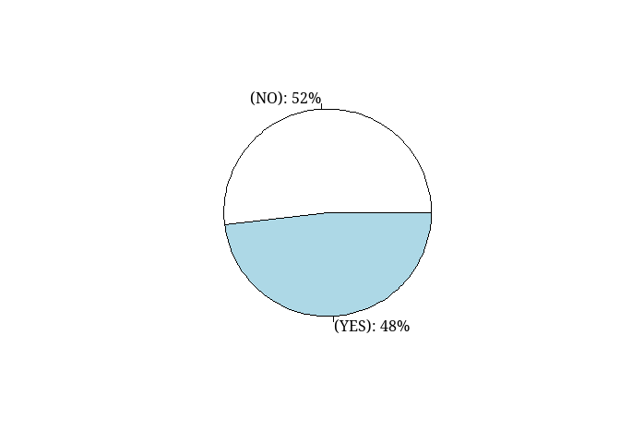

## PME Awareness barplot

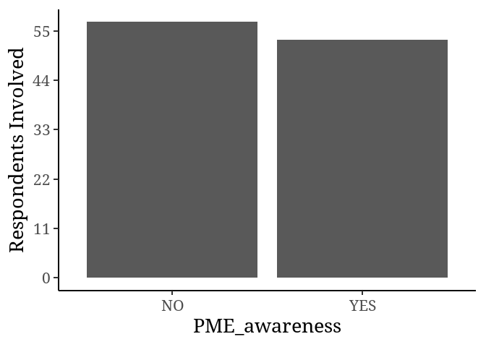

## PME use pie

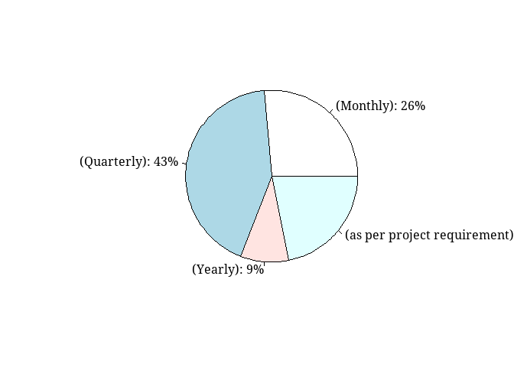

## PME use barplot

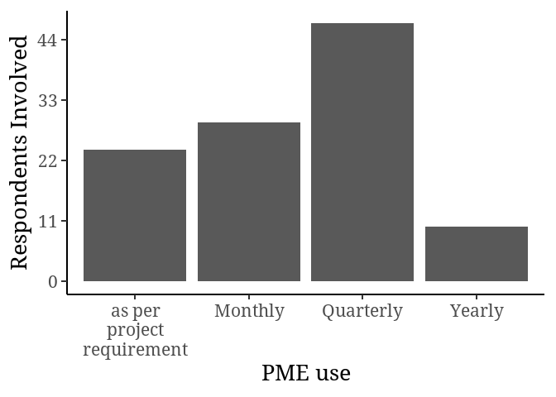

## PME interaction pie

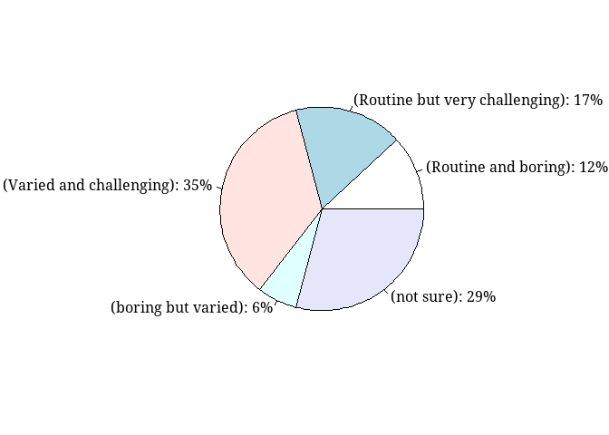

## PME use barplot

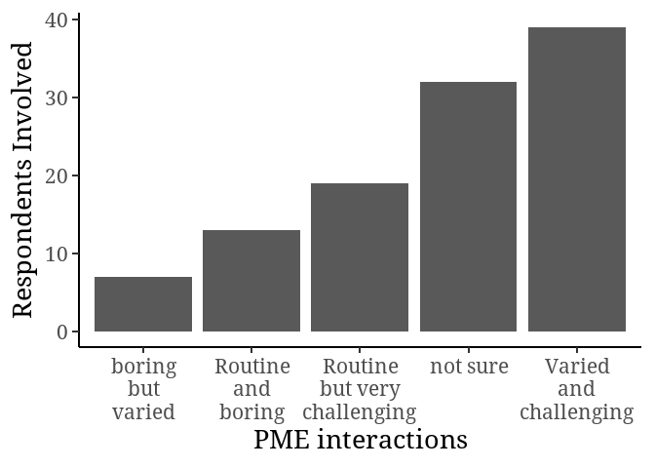

# Key indicators of Stakeholder Involvement

## Categorical wise

| **Characteristic** | **Strongly agree**, N = 2501 | **Agree**, N = 3241 | **Neutrol**, N = 2311 | **Disagree**, N = 541 | **Strongly disagree**, N = 211 |
| --- | --- | --- | --- | --- | --- |
| name |  |  |  |  |  |
| Citizen control | 37 (34%) | 36 (33%) | 31 (28%) | 5 (4.5%) | 1 (0.9%) |
| Delegation of duties | 27 (25%) | 42 (38%) | 33 (30%) | 7 (6.4%) | 1 (0.9%) |
| Partnership | 27 (25%) | 41 (37%) | 32 (29%) | 5 (4.5%) | 5 (4.5%) |
| Project Identification | 25 (23%) | 54 (49%) | 23 (21%) | 7 (6.4%) | 1 (0.9%) |
| Project implementation | 32 (29%) | 40 (36%) | 29 (26%) | 7 (6.4%) | 2 (1.8%) |
| Project ownership | 37 (34%) | 39 (35%) | 21 (19%) | 10 (9.1%) | 3 (2.7%) |
| Project sustainability | 31 (28%) | 40 (36%) | 30 (27%) | 5 (4.5%) | 4 (3.6%) |
| Regular Debriefing | 34 (31%) | 32 (29%) | 32 (29%) | 8 (7.3%) | 4 (3.6%) |
| 1n (%) | | | | | |

## Interval wise

| Citizen control | Project Identification | Delegation of duties | Project implementation | Project sustainability | Project ownership | Partnership | Regular Debriefing | indicators |
| --- | --- | --- | --- | --- | --- | --- | --- | --- |
| 4 | 3 | 3 | 4 | 3 | 5 | 3 | 5 | 3.750 |
| 3 | 2 | 5 | 4 | 3 | 4 | 5 | 2 | 3.500 |
| 4 | 4 | 3 | 4 | 4 | 3 | 4 | 4 | 3.750 |
| 4 | 4 | 4 | 5 | 5 | 5 | 4 | 3 | 4.250 |
| 4 | 3 | 2 | 2 | 5 | 4 | 2 | 5 | 3.375 |
| 2 | 4 | 3 | 3 | 3 | 5 | 1 | 5 | 3.250 |
| 4 | 4 | 4 | 3 | 3 | 2 | 1 | 2 | 2.875 |
| 3 | 4 | 3 | 2 | 2 | 3 | 4 | 3 | 3.000 |
| 3 | 4 | 4 | 4 | 5 | 5 | 5 | 3 | 4.125 |
| 5 | 4 | 5 | 3 | 5 | 5 | 4 | 4 | 4.375 |
| 5 | 4 | 5 | 3 | 4 | 1 | 2 | 2 | 3.250 |
| 5 | 4 | 3 | 4 | 3 | 4 | 4 | 3 | 3.750 |
| 3 | 3 | 3 | 3 | 3 | 4 | 4 | 5 | 3.500 |
| 2 | 4 | 4 | 3 | 4 | 5 | 5 | 5 | 4.000 |
| 3 | 3 | 3 | 3 | 3 | 3 | 3 | 3 | 3.000 |
| 5 | 1 | 4 | 4 | 3 | 2 | 4 | 5 | 3.500 |
| 2 | 4 | 4 | 3 | 5 | 5 | 3 | 3 | 3.625 |
| 3 | 3 | 3 | 4 | 3 | 2 | 4 | 3 | 3.125 |
| 4 | 4 | 4 | 5 | 5 | 5 | 3 | 3 | 4.125 |
| 4 | 1 | 5 | 5 | 5 | 5 | 5 | 5 | 4.375 |
| 5 | 4 | 4 | 4 | 5 | 5 | 5 | 5 | 4.625 |
| 4 | 4 | 4 | 4 | 4 | 4 | 4 | 4 | 4.000 |
| 5 | 1 | 5 | 5 | 5 | 5 | 5 | 5 | 4.500 |
| 4 | 4 | 3 | 4 | 4 | 4 | 4 | 3 | 3.750 |
| 3 | 4 | 3 | 2 | 4 | 3 | 2 | 2 | 2.875 |
| 3 | 1 | 4 | 4 | 4 | 3 | 3 | 3 | 3.125 |
| 5 | 1 | 4 | 4 | 3 | 5 | 5 | 3 | 3.750 |
| 4 | 1 | 5 | 3 | 5 | 4 | 4 | 4 | 3.750 |
| 3 | 4 | 3 | 5 | 4 | 3 | 3 | 4 | 3.625 |
| 5 | 4 | 3 | 4 | 3 | 4 | 3 | 3 | 3.625 |
| 3 | 4 | 4 | 4 | 4 | 4 | 4 | 4 | 3.875 |
| 3 | 4 | 4 | 4 | 4 | 4 | 4 | 3 | 3.750 |
| 2 | 4 | 2 | 3 | 4 | 4 | 3 | 2 | 3.000 |
| 5 | 4 | 5 | 5 | 5 | 5 | 5 | 5 | 4.875 |
| 4 | 4 | 4 | 4 | 4 | 4 | 4 | 4 | 4.000 |
| 4 | 4 | 4 | 5 | 5 | 4 | 3 | 5 | 4.250 |
| 4 | 1 | 5 | 5 | 5 | 4 | 4 | 4 | 4.000 |
| 5 | 4 | 3 | 4 | 4 | 3 | 3 | 3 | 3.625 |
| 4 | 4 | 4 | 4 | 4 | 4 | 4 | 4 | 4.000 |
| 4 | 2 | 4 | 5 | 2 | 1 | 3 | 4 | 3.125 |
| 5 | 4 | 3 | 4 | 3 | 5 | 3 | 4 | 3.875 |
| 5 | 4 | 3 | 5 | 3 | 2 | 4 | 3 | 3.625 |
| 4 | 4 | 4 | 4 | 4 | 4 | 4 | 4 | 4.000 |
| 4 | 2 | 4 | 2 | 4 | 4 | 3 | 4 | 3.375 |
| 5 | 1 | 5 | 4 | 5 | 5 | 5 | 5 | 4.375 |
| 5 | 1 | 5 | 5 | 5 | 5 | 5 | 5 | 4.500 |
| 3 | 3 | 4 | 4 | 4 | 3 | 4 | 3 | 3.500 |
| 4 | 3 | 3 | 3 | 5 | 4 | 3 | 5 | 3.750 |
| 3 | 3 | 3 | 3 | 4 | 4 | 3 | 5 | 3.500 |
| 3 | 4 | 4 | 4 | 4 | 4 | 3 | 3 | 3.625 |
| 4 | 1 | 4 | 3 | 4 | 5 | 3 | 3 | 3.375 |
| 4 | 4 | 4 | 5 | 4 | 5 | 4 | 5 | 4.375 |
| 4 | 3 | 4 | 4 | 4 | 4 | 4 | 4 | 3.875 |
| 4 | 3 | 5 | 4 | 5 | 5 | 5 | 5 | 4.500 |
| 3 | 2 | 2 | 1 | 3 | 3 | 1 | 1 | 2.000 |
| 4 | 4 | 3 | 3 | 4 | 2 | 3 | 3 | 3.250 |
| 3 | 2 | 4 | 3 | 3 | 4 | 5 | 5 | 3.625 |
| 4 | 4 | 4 | 4 | 4 | 5 | 5 | 4 | 4.250 |
| 5 | 1 | 4 | 4 | 3 | 3 | 4 | 4 | 3.500 |
| 1 | 3 | 5 | 5 | 5 | 5 | 5 | 5 | 4.250 |
| 3 | 3 | 3 | 3 | 3 | 3 | 3 | 3 | 3.000 |
| 5 | 4 | 3 | 4 | 4 | 4 | 4 | 5 | 4.125 |
| 4 | 4 | 4 | 4 | 3 | 5 | 4 | 3 | 3.875 |
| 5 | 3 | 4 | 3 | 1 | 5 | 4 | 4 | 3.625 |
| 3 | 4 | 2 | 3 | 3 | 3 | 3 | 3 | 3.000 |
| 3 | 4 | 3 | 5 | 3 | 4 | 3 | 2 | 3.375 |
| 4 | 3 | 2 | 5 | 3 | 2 | 2 | 2 | 2.875 |
| 3 | 4 | 2 | 5 | 2 | 5 | 3 | 5 | 3.625 |
| 4 | 3 | 4 | 3 | 4 | 4 | 4 | 3 | 3.625 |
| 5 | 1 | 5 | 5 | 5 | 5 | 5 | 4 | 4.375 |
| 5 | 4 | 3 | 4 | 3 | 4 | 3 | 3 | 3.625 |
| 3 | 3 | 3 | 3 | 3 | 3 | 3 | 3 | 3.000 |
| 3 | 4 | 3 | 5 | 4 | 3 | 2 | 1 | 3.125 |
| 3 | 1 | 3 | 5 | 3 | 5 | 4 | 4 | 3.500 |
| 5 | 3 | 1 | 3 | 4 | 1 | 4 | 1 | 2.750 |
| 5 | 4 | 3 | 1 | 2 | 4 | 3 | 4 | 3.250 |
| 5 | 1 | 5 | 5 | 5 | 5 | 5 | 5 | 4.500 |
| 4 | 3 | 2 | 5 | 1 | 4 | 3 | 2 | 3.000 |
| 3 | 4 | 5 | 3 | 3 | 5 | 4 | 4 | 3.875 |
| 3 | 1 | 3 | 3 | 3 | 4 | 4 | 4 | 3.125 |
| 5 | 1 | 5 | 5 | 4 | 3 | 4 | 3 | 3.750 |
| 4 | 4 | 4 | 4 | 4 | 4 | 4 | 4 | 4.000 |
| 3 | 1 | 3 | 3 | 3 | 3 | 4 | 3 | 2.875 |
| 3 | 4 | 4 | 4 | 4 | 3 | 3 | 4 | 3.625 |
| 3 | 3 | 3 | 3 | 3 | 3 | 3 | 3 | 3.000 |
| 5 | 4 | 4 | 5 | 4 | 5 | 4 | 4 | 4.375 |
| 5 | 1 | 5 | 5 | 5 | 5 | 5 | 5 | 4.500 |
| 5 | 1 | 4 | 4 | 5 | 4 | 5 | 4 | 4.000 |
| 5 | 1 | 5 | 5 | 5 | 5 | 5 | 5 | 4.500 |
| 5 | 1 | 5 | 5 | 5 | 4 | 5 | 5 | 4.375 |
| 3 | 2 | 4 | 3 | 4 | 3 | 3 | 3 | 3.125 |
| 4 | 1 | 4 | 4 | 4 | 4 | 5 | 4 | 3.750 |
| 4 | 3 | 5 | 4 | 4 | 3 | 3 | 4 | 3.750 |
| 5 | 3 | 4 | 2 | 4 | 2 | 4 | 5 | 3.625 |
| 5 | 1 | 5 | 5 | 5 | 5 | 5 | 5 | 4.500 |
| 4 | 4 | 3 | 5 | 4 | 4 | 5 | 3 | 4.000 |
| 5 | 1 | 5 | 5 | 5 | 5 | 5 | 5 | 4.500 |
| 5 | 3 | 4 | 4 | 2 | 4 | 5 | 5 | 4.000 |
| 2 | 4 | 4 | 3 | 3 | 3 | 4 | 3 | 3.250 |
| 4 | 3 | 5 | 4 | 3 | 2 | 1 | 5 | 3.375 |
| 5 | 4 | 3 | 2 | 1 | 2 | 1 | 1 | 2.375 |
| 3 | 4 | 5 | 4 | 4 | 4 | 4 | 4 | 4.000 |
| 3 | 2 | 4 | 3 | 4 | 5 | 3 | 3 | 3.375 |
| 4 | 4 | 4 | 4 | 4 | 4 | 4 | 4 | 4.000 |
| 5 | 4 | 5 | 5 | 5 | 5 | 4 | 5 | 4.750 |
| 5 | 1 | 5 | 5 | 5 | 5 | 5 | 5 | 4.500 |
| 4 | 4 | 4 | 5 | 5 | 4 | 4 | 5 | 4.375 |
| 4 | 1 | 5 | 3 | 5 | 4 | 4 | 4 | 3.750 |
| 5 | 4 | 3 | 2 | 1 | 2 | 3 | 4 | 3.000 |
| 5 | 4 | 3 | 4 | 5 | 5 | 5 | 5 | 4.500 |

# indicators 2

| name | Mean | Sd |
| --- | --- | --- |
| Citizen control | 3.936364 | 0.9411809 |
| Project Identification | 2.954545 | 1.2295025 |
| Delegation of duties | 3.790909 | 0.9196674 |
| Project implementation | 3.845455 | 0.9785438 |
| Project sustainability | 3.809091 | 1.0181424 |
| Project ownership | 3.881818 | 1.0642809 |
| Partnership | 3.727273 | 1.0308017 |
| Regular Debriefing | 3.763636 | 1.0830408 |

## Capacity building 1

### categorical wise

| **Characteristic** | **Strongly agree**, N = 1261 | **Agree**, N = 1001 | **Neutrol**, N = 851 | **Disagree**, N = 121 | **Strongly disagree**, N = 71 |
| --- | --- | --- | --- | --- | --- |
| name |  |  |  |  |  |
| capacity_building_1 | 52 (47%) | 36 (33%) | 19 (17%) | 1 (0.9%) | 2 (1.8%) |
| capacity_building_2 | 35 (32%) | 35 (32%) | 34 (31%) | 4 (3.6%) | 2 (1.8%) |
| capacity_building_3 | 39 (35%) | 29 (26%) | 32 (29%) | 7 (6.4%) | 3 (2.7%) |
| 1n (%) | | | | | |

## Cpacity building interval wise

| capacity_building_1 | capacity_building_2 | capacity_building_3 | capacity |
| --- | --- | --- | --- |
| 4 | 3 | 2 | 3.000000 |
| 4 | 5 | 2 | 3.666667 |
| 4 | 4 | 4 | 4.000000 |
| 3 | 3 | 3 | 3.000000 |
| 1 | 3 | 3 | 2.333333 |
| 1 | 3 | 1 | 1.666667 |
| 3 | 3 | 3 | 3.000000 |
| 4 | 4 | 3 | 3.666667 |
| 1 | 4 | 5 | 3.333333 |
| 1 | 3 | 5 | 3.000000 |
| 1 | 3 | 2 | 2.000000 |
| 1 | 4 | 4 | 3.000000 |
| 3 | 3 | 3 | 3.000000 |
| 2 | 2 | 2 | 2.000000 |
| 3 | 3 | 3 | 3.000000 |
| 1 | 4 | 5 | 3.333333 |
| 3 | 3 | 3 | 3.000000 |
| 4 | 4 | 3 | 3.666667 |
| 1 | 4 | 5 | 3.333333 |
| 1 | 5 | 5 | 3.666667 |
| 4 | 5 | 3 | 4.000000 |
| 1 | 4 | 5 | 3.333333 |
| 1 | 5 | 5 | 3.666667 |
| 1 | 5 | 5 | 3.666667 |
| 4 | 3 | 4 | 3.666667 |
| 4 | 4 | 5 | 4.333333 |
| 1 | 5 | 5 | 3.666667 |
| 1 | 4 | 3 | 2.666667 |
| 1 | 4 | 3 | 2.666667 |
| 1 | 5 | 5 | 3.666667 |
| 1 | 5 | 5 | 3.666667 |
| 3 | 4 | 3 | 3.333333 |
| 4 | 3 | 4 | 3.666667 |
| 1 | 5 | 2 | 2.666667 |
| 4 | 5 | 4 | 4.333333 |
| 4 | 4 | 4 | 4.000000 |
| 4 | 4 | 4 | 4.000000 |
| 1 | 4 | 4 | 3.000000 |
| 3 | 3 | 3 | 3.000000 |
| 4 | 2 | 5 | 3.666667 |
| 4 | 5 | 4 | 4.333333 |
| 1 | 5 | 1 | 2.333333 |
| 3 | 3 | 3 | 3.000000 |
| 1 | 5 | 5 | 3.666667 |
| 3 | 5 | 4 | 4.000000 |
| 1 | 5 | 3 | 3.000000 |
| 3 | 4 | 2 | 3.000000 |
| 1 | 5 | 5 | 3.666667 |
| 4 | 4 | 4 | 4.000000 |
| 4 | 4 | 3 | 3.666667 |
| 1 | 5 | 5 | 3.666667 |
| 4 | 5 | 4 | 4.333333 |
| 1 | 4 | 3 | 2.666667 |
| 1 | 4 | 5 | 3.333333 |
| 3 | 3 | 3 | 3.000000 |
| 4 | 3 | 3 | 3.333333 |
| 4 | 3 | 4 | 3.666667 |
| 1 | 5 | 4 | 3.333333 |
| 1 | 5 | 5 | 3.666667 |
| 1 | 1 | 1 | 1.000000 |
| 3 | 3 | 3 | 3.000000 |
| 4 | 3 | 3 | 3.333333 |
| 4 | 5 | 5 | 4.666667 |
| 3 | 4 | 2 | 3.000000 |
| 3 | 4 | 5 | 4.000000 |
| 4 | 2 | 4 | 3.333333 |
| 1 | 4 | 3 | 2.666667 |
| 1 | 3 | 4 | 2.666667 |
| 4 | 3 | 4 | 3.666667 |
| 1 | 5 | 4 | 3.333333 |
| 1 | 3 | 4 | 2.666667 |
| 3 | 3 | 3 | 3.000000 |
| 4 | 3 | 5 | 4.000000 |
| 1 | 5 | 5 | 3.666667 |
| 1 | 4 | 3 | 2.666667 |
| 3 | 5 | 3 | 3.666667 |
| 1 | 5 | 5 | 3.666667 |
| 4 | 3 | 3 | 3.333333 |
| 4 | 3 | 5 | 4.000000 |
| 1 | 5 | 5 | 3.666667 |
| 1 | 3 | 5 | 3.000000 |
| 4 | 4 | 4 | 4.000000 |
| 4 | 4 | 5 | 4.333333 |
| 4 | 4 | 4 | 4.000000 |
| 3 | 3 | 3 | 3.000000 |
| 1 | 4 | 4 | 3.000000 |
| 1 | 5 | 4 | 3.333333 |
| 1 | 5 | 5 | 3.666667 |
| 1 | 5 | 5 | 3.666667 |
| 4 | 4 | 5 | 4.333333 |
| 1 | 5 | 5 | 3.666667 |
| 4 | 3 | 4 | 3.666667 |
| 1 | 4 | 4 | 3.000000 |
| 1 | 3 | 4 | 2.666667 |
| 1 | 5 | 5 | 3.666667 |
| 4 | 3 | 5 | 4.000000 |
| 1 | 4 | 5 | 3.333333 |
| 3 | 5 | 3 | 3.666667 |
| 1 | 5 | 5 | 3.666667 |
| 4 | 3 | 5 | 4.000000 |
| 1 | 1 | 3 | 1.666667 |
| 3 | 3 | 3 | 3.000000 |
| 1 | 5 | 5 | 3.666667 |
| 4 | 4 | 4 | 4.000000 |
| 1 | 5 | 5 | 3.666667 |
| 1 | 4 | 5 | 3.333333 |
| 4 | 3 | 3 | 3.333333 |
| 1 | 4 | 4 | 3.000000 |
| 1 | 2 | 3 | 2.000000 |
| 4 | 4 | 4 | 4.000000 |

## Capcity 2

| name | Mean | Sd |
| --- | --- | --- |
| capacity_building_1 | 2.336364 | 1.3699077 |
| capacity_building_2 | 3.881818 | 0.9648104 |
| capacity_building_3 | 3.854545 | 1.0651818 |

## Stakeholder ownership

### Categorical wise

| **Characteristic** | **Strongly agree**, N = 1321 | **Agree**, N = 1651 | **Neutral**, N = 1161 | **Disagree**, N = 171 | **Strongly disagree**, N = 101 |
| --- | --- | --- | --- | --- | --- |
| name |  |  |  |  |  |
| Stakeholder_ownership_1 | 45 (41%) | 37 (34%) | 27 (25%) | 0 (0%) | 1 (0.9%) |
| Stakeholder_ownership_2 | 23 (21%) | 54 (49%) | 29 (26%) | 2 (1.8%) | 2 (1.8%) |
| Stakeholder_ownership_3 | 33 (30%) | 38 (35%) | 25 (23%) | 12 (11%) | 2 (1.8%) |
| Stakeholder_ownership_4 | 31 (28%) | 36 (33%) | 35 (32%) | 3 (2.7%) | 5 (4.5%) |
| 1n (%) | | | | | |

### Stakeholder ownership interval wise

| Stakeholder_ownership_1 | Stakeholder_ownership_2 | Stakeholder_ownership_3 | Stakeholder_ownership_4 | capacity |
| --- | --- | --- | --- | --- |
| 4 | 3 | 5 | 3 | 3.75 |
| 5 | 3 | 2 | 4 | 3.50 |
| 1 | 3 | 3 | 3 | 2.50 |
| 4 | 4 | 5 | 5 | 4.50 |
| 1 | 3 | 3 | 3 | 2.50 |
| 5 | 4 | 3 | 5 | 4.25 |
| 5 | 5 | 5 | 5 | 5.00 |
| 4 | 4 | 4 | 3 | 3.75 |
| 4 | 4 | 5 | 5 | 4.50 |
| 5 | 4 | 3 | 5 | 4.25 |
| 4 | 5 | 3 | 1 | 3.25 |
| 5 | 4 | 5 | 4 | 4.50 |
| 4 | 4 | 3 | 3 | 3.50 |
| 1 | 3 | 3 | 3 | 2.50 |
| 5 | 4 | 5 | 5 | 4.75 |
| 1 | 5 | 3 | 3 | 3.00 |
| 4 | 4 | 3 | 3 | 3.50 |
| 4 | 3 | 2 | 4 | 3.25 |
| 4 | 4 | 5 | 5 | 4.50 |
| 5 | 5 | 5 | 5 | 5.00 |
| 5 | 4 | 4 | 5 | 4.50 |
| 5 | 4 | 5 | 3 | 4.25 |
| 5 | 5 | 5 | 5 | 5.00 |
| 4 | 3 | 3 | 4 | 3.50 |
| 4 | 4 | 2 | 3 | 3.25 |
| 1 | 4 | 4 | 3 | 3.00 |
| 4 | 4 | 4 | 4 | 4.00 |
| 5 | 4 | 3 | 4 | 4.00 |
| 5 | 4 | 4 | 3 | 4.00 |
| 4 | 5 | 4 | 5 | 4.50 |
| 5 | 5 | 5 | 5 | 5.00 |
| 4 | 4 | 4 | 4 | 4.00 |
| 5 | 4 | 4 | 1 | 3.50 |
| 1 | 4 | 5 | 4 | 3.50 |
| 4 | 3 | 5 | 4 | 4.00 |
| 1 | 3 | 4 | 3 | 2.75 |
| 4 | 3 | 4 | 4 | 3.75 |
| 4 | 5 | 4 | 3 | 4.00 |
| 4 | 4 | 4 | 4 | 4.00 |
| 5 | 3 | 4 | 2 | 3.50 |
| 5 | 4 | 5 | 4 | 4.50 |
| 5 | 4 | 4 | 3 | 4.00 |
| 1 | 3 | 2 | 3 | 2.25 |
| 4 | 4 | 4 | 4 | 4.00 |
| 4 | 5 | 5 | 4 | 4.50 |
| 5 | 5 | 4 | 5 | 4.75 |
| 4 | 3 | 4 | 4 | 3.75 |
| 5 | 3 | 3 | 3 | 3.50 |
| 1 | 3 | 3 | 3 | 2.50 |
| 4 | 4 | 4 | 3 | 3.75 |
| 4 | 5 | 5 | 4 | 4.50 |
| 5 | 5 | 4 | 5 | 4.75 |
| 4 | 5 | 4 | 4 | 4.25 |
| 5 | 4 | 5 | 4 | 4.50 |
| 1 | 2 | 2 | 3 | 2.00 |
| 1 | 3 | 3 | 3 | 2.50 |
| 4 | 4 | 4 | 5 | 4.25 |
| 4 | 4 | 4 | 4 | 4.00 |
| 5 | 4 | 5 | 4 | 4.50 |
| 1 | 1 | 1 | 1 | 1.00 |
| 1 | 3 | 3 | 3 | 2.50 |
| 4 | 3 | 3 | 4 | 3.50 |
| 4 | 4 | 4 | 5 | 4.25 |
| 4 | 3 | 3 | 3 | 3.25 |
| 1 | 4 | 4 | 4 | 3.25 |
| 5 | 4 | 4 | 2 | 3.75 |
| 1 | 3 | 3 | 3 | 2.50 |
| 1 | 4 | 2 | 5 | 3.00 |
| 4 | 4 | 4 | 3 | 3.75 |
| 4 | 4 | 5 | 5 | 4.50 |
| 4 | 4 | 5 | 4 | 4.25 |
| 1 | 3 | 3 | 3 | 2.50 |
| 1 | 2 | 4 | 3 | 2.50 |
| 5 | 5 | 5 | 5 | 5.00 |
| 1 | 3 | 1 | 2 | 1.75 |
| 5 | 1 | 5 | 3 | 3.50 |
| 4 | 3 | 3 | 4 | 3.50 |
| 1 | 4 | 2 | 3 | 2.50 |
| 5 | 5 | 4 | 3 | 4.25 |
| 5 | 5 | 5 | 5 | 5.00 |
| 5 | 4 | 5 | 3 | 4.25 |
| 1 | 4 | 4 | 4 | 3.25 |
| 5 | 4 | 4 | 5 | 4.50 |
| 5 | 5 | 5 | 5 | 5.00 |
| 1 | 3 | 3 | 3 | 2.50 |
| 5 | 4 | 4 | 5 | 4.50 |
| 1 | 3 | 4 | 4 | 3.00 |
| 5 | 4 | 4 | 4 | 4.25 |
| 5 | 5 | 5 | 5 | 5.00 |
| 5 | 4 | 4 | 4 | 4.25 |
| 5 | 5 | 5 | 5 | 5.00 |
| 4 | 3 | 3 | 3 | 3.25 |
| 5 | 4 | 5 | 4 | 4.50 |
| 5 | 5 | 2 | 5 | 4.25 |
| 5 | 5 | 5 | 5 | 5.00 |
| 1 | 3 | 3 | 3 | 2.50 |
| 5 | 4 | 4 | 5 | 4.50 |
| 1 | 5 | 3 | 4 | 3.25 |
| 4 | 4 | 5 | 5 | 4.50 |
| 5 | 4 | 2 | 1 | 3.00 |
| 5 | 4 | 2 | 1 | 3.00 |
| 1 | 3 | 2 | 4 | 2.50 |
| 5 | 5 | 5 | 5 | 5.00 |
| 4 | 4 | 4 | 4 | 4.00 |
| 5 | 4 | 5 | 4 | 4.50 |
| 5 | 4 | 5 | 5 | 4.75 |
| 1 | 3 | 3 | 3 | 2.50 |
| 5 | 4 | 4 | 4 | 4.25 |
| 1 | 4 | 2 | 4 | 2.75 |
| 4 | 4 | 4 | 4 | 4.00 |

### stakeholder 2

| name | Mean | Sd |
| --- | --- | --- |
| Stakeholder_ownership_1 | 3.645455 | 1.6118049 |
| Stakeholder_ownership_2 | 3.854545 | 0.8332138 |
| Stakeholder_ownership_3 | 3.800000 | 1.0474959 |
| Stakeholder_ownership_4 | 3.772727 | 1.0374553 |

## Policy recommendation

## Categorical wise

| **Characteristic** | **Strongly agree**, N = 1151 | **Agree**, N = 951 | **Neutral**, N = 981 | **Disagree**, N = 81 | **Strongly disagree**, N = 141 |
| --- | --- | --- | --- | --- | --- |
| name |  |  |  |  |  |
| Policy recommendation_1 | 39 (35%) | 33 (30%) | 31 (28%) | 3 (2.7%) | 4 (3.6%) |
| Policy recommendation_2 | 40 (36%) | 29 (26%) | 35 (32%) | 1 (0.9%) | 5 (4.5%) |
| Policy recommendation_3 | 36 (33%) | 33 (30%) | 32 (29%) | 4 (3.6%) | 5 (4.5%) |
| 1n (%) | | | | | |

## Interval wise

# A tibble: 110 × 4  
# Rowwise:   
 Policy recommendatio…¹ Policy recommendatio…² Policy recommendatio…³ capacity  
 <dbl> <dbl> <dbl> <dbl>  
 1 4 3 2 3   
 2 5 3 1 3   
 3 3 3 3 3   
 4 4 4 4 4   
 5 3 3 3 3   
 6 5 3 5 4.33  
 7 3 5 5 4.33  
 8 3 4 4 3.67  
 9 3 5 5 4.33  
10 5 5 3 4.33  
# ℹ 100 more rows  
# ℹ abbreviated names: ¹​`Policy recommendation_1`, ²​`Policy recommendation_2`,  
# ³​`Policy recommendation_3`

### recommendation 2

| name | Mean | Sd |
| --- | --- | --- |
| Policy recommendation_1 | 3.909091 | 1.036450 |
| Policy recommendation_2 | 3.890909 | 1.060945 |
| Policy recommendation_3 | 3.827273 | 1.073954 |