ASSESSMENT OF GENERALIZED ANXIETY DISORDER AND COMMUNITY-BASED INTERVENTIONS

Manishiwe

# Social Demographics

## Age

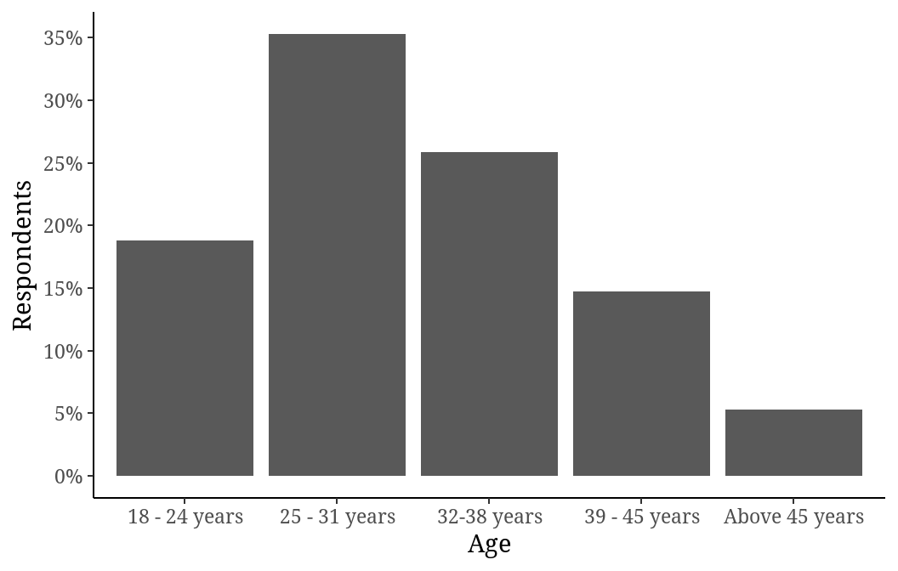

## Gender

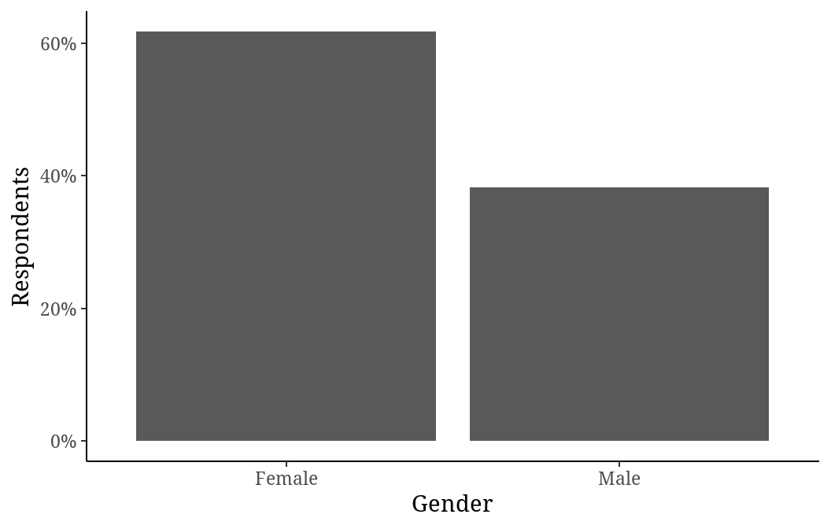

## Marital Status

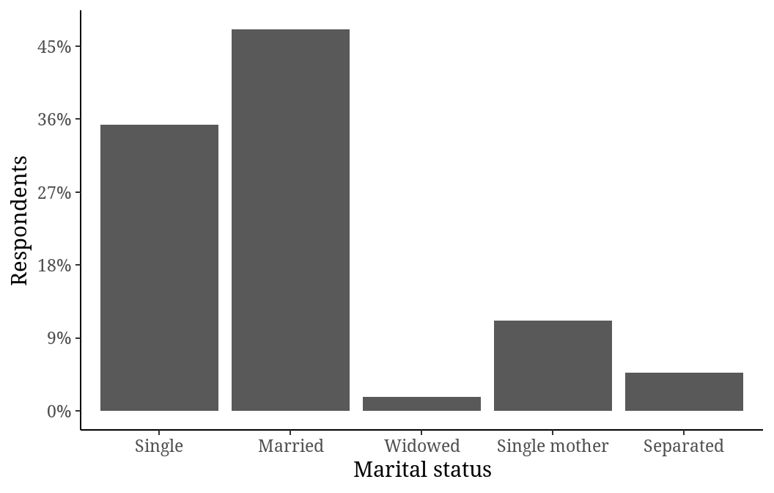

## Level of education

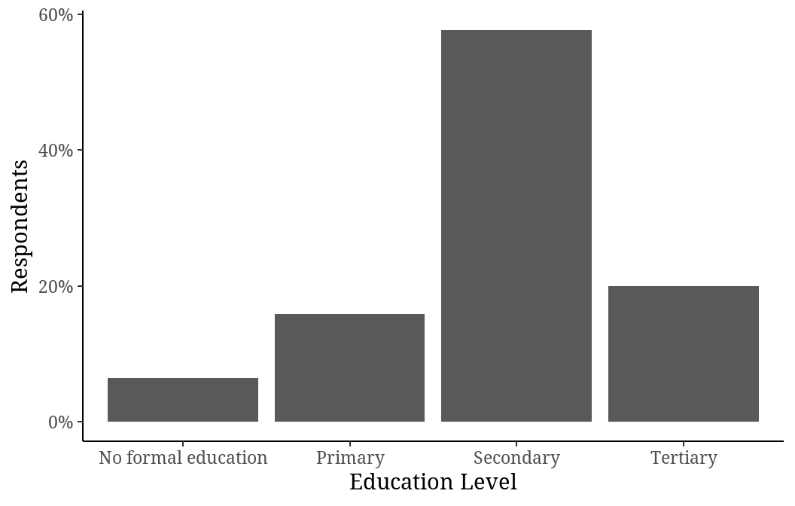

## Occupation

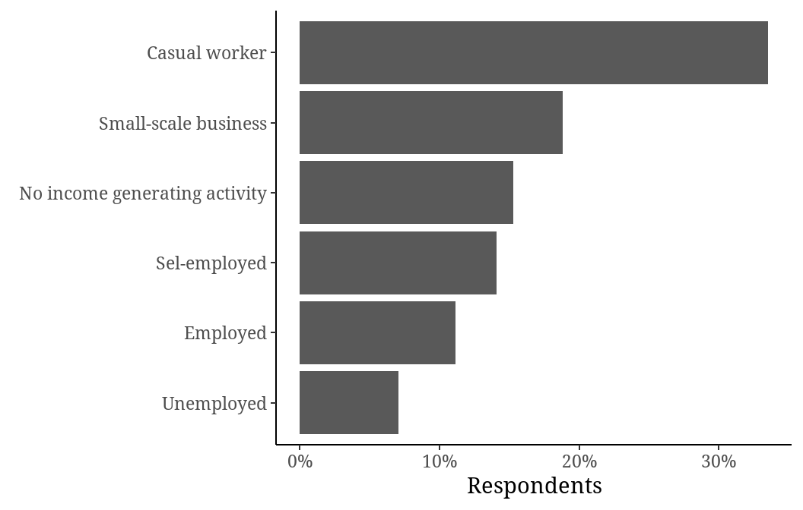

## Residence

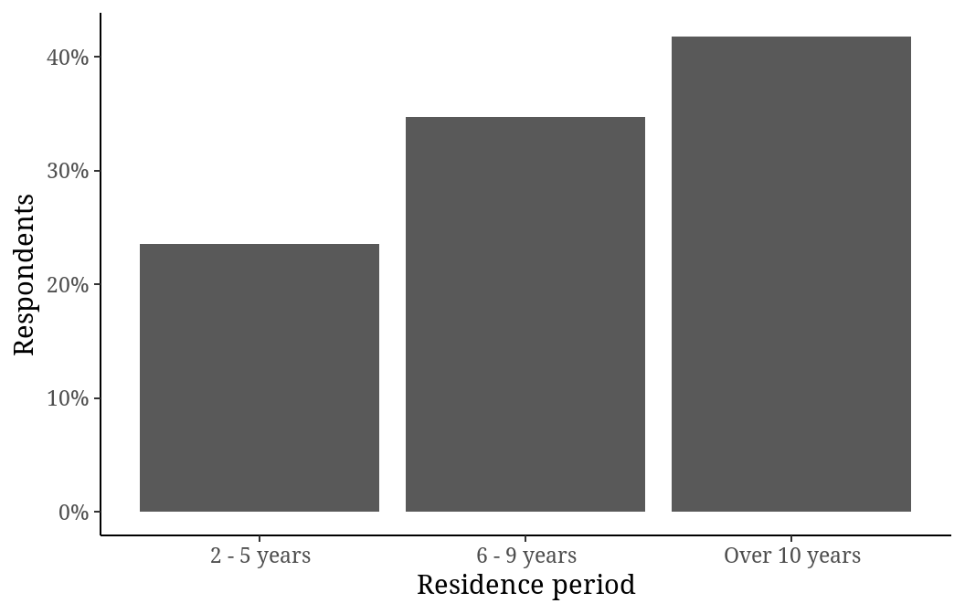

## Nationality

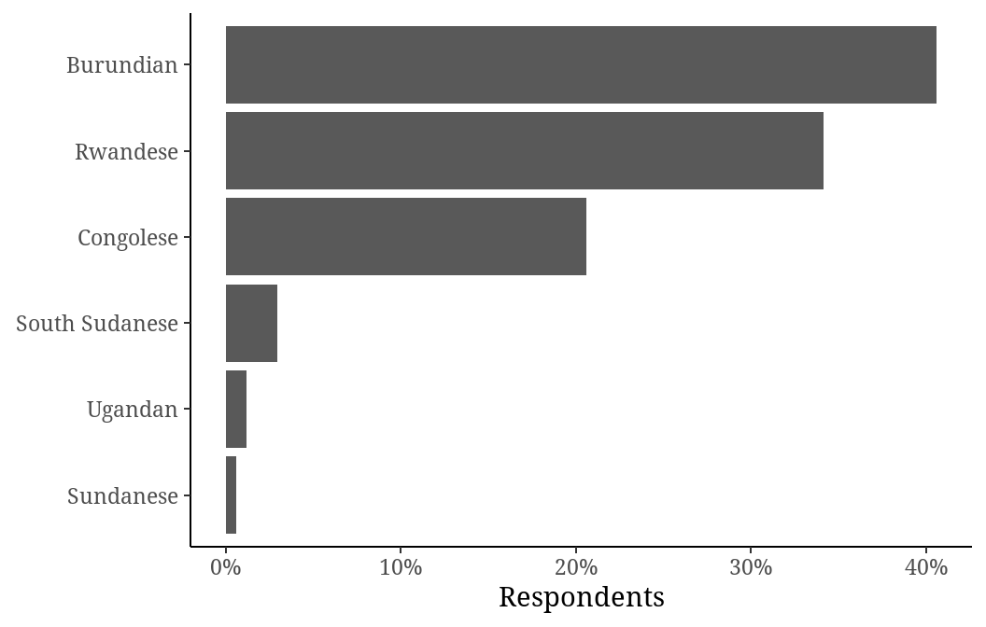

## Social Demographics summary

| **Social Demographic Characteristics** | **Frequency (%)**1 |
| --- | --- |
| Age |  |
| 18 - 24 years | 32 (19%) |
| 25 - 31 years | 60 (35%) |
| 32-38 years | 44 (26%) |
| 39 - 45 years | 25 (15%) |
| Above 45 years | 9 (5.3%) |
| Gender |  |
| Female | 105 (62%) |
| Male | 65 (38%) |
| Marital status |  |
| Single | 60 (35%) |
| Married | 80 (47%) |
| Widowed | 3 (1.8%) |
| Single mother | 19 (11%) |
| Separated | 8 (4.7%) |
| Education Level |  |
| No formal education | 11 (6.5%) |
| Primary | 27 (16%) |
| Secondary | 98 (58%) |
| Tertiary | 34 (20%) |
| Occupation |  |
| Casual worker | 57 (34%) |
| Employed | 19 (11%) |
| No income generating activity | 26 (15%) |
| Sel-employed | 24 (14%) |
| Small-scale business | 32 (19%) |
| Unemployed | 12 (7.1%) |
| Residence period |  |
| 2 - 5 years | 40 (24%) |
| 6 - 9 years | 59 (35%) |
| Over 10 years | 71 (42%) |
| Nationality |  |
| Burundian | 69 (41%) |
| Congolese | 35 (21%) |
| Rwandese | 58 (34%) |
| South Sudanese | 5 (2.9%) |
| Sundanese | 1 (0.6%) |
| Ugandan | 2 (1.2%) |
| 1n (%) | |

# Anxiety

## Prevalence of General Anxiety Disorder

| **Level General Anxiety Disorder** | **Prevalance of General Anxiety Disorder**1 |
| --- | --- |
| GAD_LEVEL |  |
| Minimal Anxiety | 12 (7.1%) |
| Mild Anxiety | 108 (64%) |
| Moderate Anxiety | 48 (28%) |
| Severe Anxiety | 2 (1.2%) |
| 1n (%) | |

## Prevalence viz

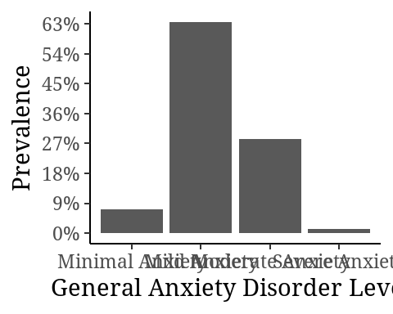

## Association between General disorder and social demographics

| **Characteristic** | **Minimal Anxiety**, N = 121 | **Mild Anxiety**, N = 1081 | **Moderate Anxiety**, N = 481 | **Severe Anxiety**, N = 21 | **p-value**2 |
| --- | --- | --- | --- | --- | --- |
| Age |  |  |  |  |  |
| 18 - 24 years | 4 (33%) | 20 (19%) | 8 (17%) | 0 (0%) |  |
| 25 - 31 years | 2 (17%) | 41 (38%) | 16 (33%) | 1 (50%) |  |
| 32-38 years | 4 (33%) | 30 (28%) | 10 (21%) | 0 (0%) |  |
| 39 - 45 years | 1 (8.3%) | 13 (12%) | 10 (21%) | 1 (50%) |  |
| Above 45 years | 1 (8.3%) | 4 (3.7%) | 4 (8.3%) | 0 (0%) |  |
| Gender |  |  |  |  | 0.3 |
| Female | 9 (75%) | 61 (56%) | 33 (69%) | 2 (100%) |  |
| Male | 3 (25%) | 47 (44%) | 15 (31%) | 0 (0%) |  |
| Marital status |  |  |  |  | 0.4 |
| Single | 5 (42%) | 44 (41%) | 11 (23%) | 0 (0%) |  |
| Married | 6 (50%) | 45 (42%) | 28 (58%) | 1 (50%) |  |
| Widowed | 0 (0%) | 3 (2.8%) | 0 (0%) | 0 (0%) |  |
| Single mother | 1 (8.3%) | 11 (10%) | 6 (13%) | 1 (50%) |  |
| Separated | 0 (0%) | 5 (4.6%) | 3 (6.3%) | 0 (0%) |  |
| Education Level |  |  |  |  | 0.071 |
| No formal education | 0 (0%) | 8 (7.4%) | 3 (6.3%) | 0 (0%) |  |
| Primary | 1 (8.3%) | 16 (15%) | 9 (19%) | 1 (50%) |  |
| Secondary | 4 (33%) | 66 (61%) | 28 (58%) | 0 (0%) |  |
| Tertiary | 7 (58%) | 18 (17%) | 8 (17%) | 1 (50%) |  |
| Occupation |  |  |  |  |  |
| Casual worker | 0 (0%) | 40 (37%) | 16 (33%) | 1 (50%) |  |
| Employed | 3 (25%) | 13 (12%) | 2 (4.2%) | 1 (50%) |  |
| No income generating activity | 0 (0%) | 16 (15%) | 10 (21%) | 0 (0%) |  |
| Sel-employed | 5 (42%) | 13 (12%) | 6 (13%) | 0 (0%) |  |
| Small-scale business | 1 (8.3%) | 21 (19%) | 10 (21%) | 0 (0%) |  |
| Unemployed | 3 (25%) | 5 (4.6%) | 4 (8.3%) | 0 (0%) |  |
| Residence period |  |  |  |  | 0.2 |
| 2 - 5 years | 1 (8.3%) | 28 (26%) | 11 (23%) | 0 (0%) |  |
| 6 - 9 years | 2 (17%) | 38 (35%) | 19 (40%) | 0 (0%) |  |
| Over 10 years | 9 (75%) | 42 (39%) | 18 (38%) | 2 (100%) |  |
| Nationality |  |  |  |  |  |
| Burundian | 5 (42%) | 40 (37%) | 24 (50%) | 0 (0%) |  |
| Congolese | 0 (0%) | 25 (23%) | 10 (21%) | 0 (0%) |  |
| Rwandese | 7 (58%) | 37 (34%) | 12 (25%) | 2 (100%) |  |
| South Sudanese | 0 (0%) | 4 (3.7%) | 1 (2.1%) | 0 (0%) |  |
| Sundanese | 0 (0%) | 1 (0.9%) | 0 (0%) | 0 (0%) |  |
| Ugandan | 0 (0%) | 1 (0.9%) | 1 (2.1%) | 0 (0%) |  |
| 1n (%) | | | | | |
| 2Fisher's exact test | | | | | |

## Comparisons between social demographics and anxiety scores

### Age

| **Characteristic** | **18 - 24 years**, N = 321 | **25 - 31 years**, N = 601 | **32-38 years**, N = 441 | **39 - 45 years**, N = 251 | **Above 45 years**, N = 91 | **p-value**2 |
| --- | --- | --- | --- | --- | --- | --- |
| GAD_SCORE | 7.34 (2.70) | 8.27 (2.47) | 7.84 (3.06) | 9.04 (3.59) | 8.67 (3.94) | 0.5 |
| 1Mean (SD) | | | | | | |
| 2Kruskal-Wallis rank sum test | | | | | | |

### Gender

| **Characteristic** | **Female**, N = 1051 | **Male**, N = 651 | **p-value**2 |
| --- | --- | --- | --- |
| GAD_SCORE | 8.33 (3.22) | 7.77 (2.43) | 0.2 |
| 1Mean (SD) | | | |
| 2Wilcoxon rank sum test | | | |

### Marital status

| **Characteristic** | **Single**, N = 601 | **Married**, N = 801 | **Widowed**, N = 31 | **Single mother**, N = 191 | **Separated**, N = 81 | **p-value**2 |
| --- | --- | --- | --- | --- | --- | --- |
| GAD_SCORE | 7.33 (2.34) | 8.29 (3.08) | 7.67 (0.58) | 9.47 (3.88) | 9.25 (2.38) | 0.085 |
| 1Mean (SD) | | | | | | |
| 2Kruskal-Wallis rank sum test | | | | | | |

### Education Lecwl

| **Characteristic** | **No formal education**, N = 111 | **Primary**, N = 271 | **Secondary**, N = 981 | **Tertiary**, N = 341 | **p-value**2 |
| --- | --- | --- | --- | --- | --- |
| GAD_SCORE | 9.00 (1.90) | 9.07 (3.44) | 8.11 (2.52) | 7.09 (3.65) | 0.2 |
| 1Mean (SD) | | | | | |
| 2Kruskal-Wallis rank sum test | | | | | |

### Occupation

| **Characteristic** | **Casual worker**, N = 571 | **Employed**, N = 191 | **No income generating activity**, N = 261 | **Sel-employed**, N = 241 | **Small-scale business**, N = 321 | **Unemployed**, N = 121 | **p-value**2 |
| --- | --- | --- | --- | --- | --- | --- | --- |
| GAD_SCORE | 8.42 (2.67) | 6.84 (3.66) | 9.23 (2.35) | 7.33 (3.29) | 8.25 (2.20) | 7.50 (4.27) | 0.089 |
| 1Mean (SD) | | | | | | | |
| 2Kruskal-Wallis rank sum test | | | | | | | |

### Residence Period

| **Characteristic** | **2 - 5 years**, N = 401 | **6 - 9 years**, N = 591 | **Over 10 years**, N = 711 | **p-value**2 |
| --- | --- | --- | --- | --- |
| GAD_SCORE | 7.98 (2.65) | 8.19 (2.15) | 8.14 (3.63) | 0.7 |
| 1Mean (SD) | | | | |
| 2Kruskal-Wallis rank sum test | | | | |

### Nationality

| **Characteristic** | **Burundian**, N = 691 | **Congolese**, N = 351 | **Rwandese**, N = 581 | **South Sudanese**, N = 51 | **Sundanese**, N = 11 | **Ugandan**, N = 21 | **p-value**2 |
| --- | --- | --- | --- | --- | --- | --- | --- |
| GAD_SCORE | 8.19 (2.94) | 8.31 (2.26) | 7.91 (3.46) | 7.40 (1.52) | 9.00 (NA) | 9.50 (2.12) | 0.7 |
| 1Mean (SD) | | | | | | | |
| 2Kruskal-Wallis rank sum test | | | | | | | |

# Precipitating Factors

| **Characteristic** | **N = 170**1 |
| --- | --- |
| Uncertainty |  |
| Causing Anxiety | 163 (96%) |
| Not Causing Anxiety | 7 (4.1%) |
| Homesickness |  |
| Causing Anxiety | 156 (92%) |
| Not Causing Anxiety | 14 (8.2%) |
| Lacking basic needs |  |
| Causing Anxiety | 165 (97%) |
| Not Causing Anxiety | 5 (2.9%) |
| Relationships lack |  |
| Causing Anxiety | 112 (66%) |
| Not Causing Anxiety | 58 (34%) |
| immigration issues |  |
| Causing Anxiety | 164 (96%) |
| Not Causing Anxiety | 6 (3.5%) |
| improper documentation |  |
| Causing Anxiety | 153 (91%) |
| Not Causing Anxiety | 16 (9.5%) |
| insecurity |  |
| Causing Anxiety | 119 (70%) |
| Not Causing Anxiety | 51 (30%) |
| residence lack |  |
| Causing Anxiety | 165 (97%) |
| Not Causing Anxiety | 5 (2.9%) |
| discrimination |  |
| Causing Anxiety | 53 (31%) |
| Not Causing Anxiety | 117 (69%) |
| Language barrier |  |
| Causing Anxiety | 130 (76%) |
| Not Causing Anxiety | 40 (24%) |
| Lack refugee solutions |  |
| Causing Anxiety | 168 (99%) |
| Not Causing Anxiety | 2 (1.2%) |
| no income |  |
| Causing Anxiety | 167 (98%) |
| Not Causing Anxiety | 3 (1.8%) |
| 1n (%) | |

# Community based interventions

| **Characteristic** | **N = 170**1 |
| --- | --- |
| Individual counselling |  |
| Not Satisfied | 62 (36%) |
| Satisfied | 108 (64%) |
| Group counselling |  |
| Not Satisfied | 147 (86%) |
| Satisfied | 23 (14%) |
| Psychological trainings |  |
| Not Satisfied | 80 (47%) |
| Satisfied | 90 (53%) |
| Leader's Guidance |  |
| Not Satisfied | 97 (57%) |
| Satisfied | 73 (43%) |
| Handicraft tailoring training |  |
| Not Satisfied | 93 (55%) |
| Satisfied | 77 (45%) |
| Skills talent development |  |
| Not Satisfied | 104 (61%) |
| Satisfied | 66 (39%) |
| Food basic needs |  |
| Not Satisfied | 26 (15%) |
| Satisfied | 144 (85%) |
| fees uniforms |  |
| Not Satisfied | 148 (87%) |
| Satisfied | 22 (13%) |
| Visitor's Social support |  |
| Not Satisfied | 36 (21%) |
| Satisfied | 134 (79%) |
| job opportunities |  |
| Not Satisfied | 114 (67%) |
| Satisfied | 56 (33%) |
| 1n (%) | |

## Association between social demogrpahics and anxiety

## Age

|  | GAD_LEVEL | | | |  |
| --- | --- | --- | --- | --- | --- |
|  | Minimal Anxiety | Mild Anxiety | Moderate Anxiety | Severe Anxiety | Total |
| Age |  |  |  |  |  |
| 18 - 24 years | 4 (33%) | 20 (19%) | 8 (17%) | 0 (0%) | 32 (19%) |
| 25 - 31 years | 2 (17%) | 41 (38%) | 16 (33%) | 1 (50%) | 60 (35%) |
| 32-38 years | 4 (33%) | 30 (28%) | 10 (21%) | 0 (0%) | 44 (26%) |
| 39 - 45 years | 1 (8.3%) | 13 (12%) | 10 (21%) | 1 (50%) | 25 (15%) |
| Above 45 years | 1 (8.3%) | 4 (3.7%) | 4 (8.3%) | 0 (0%) | 9 (5.3%) |
| Total | 12 (100%) | 108 (100%) | 48 (100%) | 2 (100%) | 170 (100%) |

## Gender

|  | GAD_LEVEL | | | |  |
| --- | --- | --- | --- | --- | --- |
|  | Minimal Anxiety | Mild Anxiety | Moderate Anxiety | Severe Anxiety | Total |
| Gender |  |  |  |  |  |
| Female | 9 (75%) | 61 (56%) | 33 (69%) | 2 (100%) | 105 (62%) |
| Male | 3 (25%) | 47 (44%) | 15 (31%) | 0 (0%) | 65 (38%) |
| Total | 12 (100%) | 108 (100%) | 48 (100%) | 2 (100%) | 170 (100%) |

## Marital status

|  | GAD_LEVEL | | | |  |
| --- | --- | --- | --- | --- | --- |
|  | Minimal Anxiety | Mild Anxiety | Moderate Anxiety | Severe Anxiety | Total |
| Marital status |  |  |  |  |  |
| Single | 5 (42%) | 44 (41%) | 11 (23%) | 0 (0%) | 60 (35%) |
| Married | 6 (50%) | 45 (42%) | 28 (58%) | 1 (50%) | 80 (47%) |
| Widowed | 0 (0%) | 3 (2.8%) | 0 (0%) | 0 (0%) | 3 (1.8%) |
| Single mother | 1 (8.3%) | 11 (10%) | 6 (13%) | 1 (50%) | 19 (11%) |
| Separated | 0 (0%) | 5 (4.6%) | 3 (6.3%) | 0 (0%) | 8 (4.7%) |
| Total | 12 (100%) | 108 (100%) | 48 (100%) | 2 (100%) | 170 (100%) |

## Education level

|  | GAD_LEVEL | | | |  |
| --- | --- | --- | --- | --- | --- |
|  | Minimal Anxiety | Mild Anxiety | Moderate Anxiety | Severe Anxiety | Total |
| Education Level |  |  |  |  |  |
| No formal education | 0 (0%) | 8 (7.4%) | 3 (6.3%) | 0 (0%) | 11 (6.5%) |
| Primary | 1 (8.3%) | 16 (15%) | 9 (19%) | 1 (50%) | 27 (16%) |
| Secondary | 4 (33%) | 66 (61%) | 28 (58%) | 0 (0%) | 98 (58%) |
| Tertiary | 7 (58%) | 18 (17%) | 8 (17%) | 1 (50%) | 34 (20%) |
| Total | 12 (100%) | 108 (100%) | 48 (100%) | 2 (100%) | 170 (100%) |

## Occupation

|  | GAD_LEVEL | | | |  |
| --- | --- | --- | --- | --- | --- |
|  | Minimal Anxiety | Mild Anxiety | Moderate Anxiety | Severe Anxiety | Total |
| Occupation |  |  |  |  |  |
| Casual worker | 0 (0%) | 40 (37%) | 16 (33%) | 1 (50%) | 57 (34%) |
| Employed | 3 (25%) | 13 (12%) | 2 (4.2%) | 1 (50%) | 19 (11%) |
| No income generating activity | 0 (0%) | 16 (15%) | 10 (21%) | 0 (0%) | 26 (15%) |
| Sel-employed | 5 (42%) | 13 (12%) | 6 (13%) | 0 (0%) | 24 (14%) |
| Small-scale business | 1 (8.3%) | 21 (19%) | 10 (21%) | 0 (0%) | 32 (19%) |
| Unemployed | 3 (25%) | 5 (4.6%) | 4 (8.3%) | 0 (0%) | 12 (7.1%) |
| Total | 12 (100%) | 108 (100%) | 48 (100%) | 2 (100%) | 170 (100%) |

## Residence period

|  | GAD_LEVEL | | | |  |
| --- | --- | --- | --- | --- | --- |
|  | Minimal Anxiety | Mild Anxiety | Moderate Anxiety | Severe Anxiety | Total |
| Residence period |  |  |  |  |  |
| 2 - 5 years | 1 (8.3%) | 28 (26%) | 11 (23%) | 0 (0%) | 40 (24%) |
| 6 - 9 years | 2 (17%) | 38 (35%) | 19 (40%) | 0 (0%) | 59 (35%) |
| Over 10 years | 9 (75%) | 42 (39%) | 18 (38%) | 2 (100%) | 71 (42%) |
| Total | 12 (100%) | 108 (100%) | 48 (100%) | 2 (100%) | 170 (100%) |

## Nationality

|  | GAD_LEVEL | | | |  |
| --- | --- | --- | --- | --- | --- |
|  | Minimal Anxiety | Mild Anxiety | Moderate Anxiety | Severe Anxiety | Total |
| Nationality |  |  |  |  |  |
| Burundian | 5 (42%) | 40 (37%) | 24 (50%) | 0 (0%) | 69 (41%) |
| Congolese | 0 (0%) | 25 (23%) | 10 (21%) | 0 (0%) | 35 (21%) |
| Rwandese | 7 (58%) | 37 (34%) | 12 (25%) | 2 (100%) | 58 (34%) |
| South Sudanese | 0 (0%) | 4 (3.7%) | 1 (2.1%) | 0 (0%) | 5 (2.9%) |
| Sundanese | 0 (0%) | 1 (0.9%) | 0 (0%) | 0 (0%) | 1 (0.6%) |
| Ugandan | 0 (0%) | 1 (0.9%) | 1 (2.1%) | 0 (0%) | 2 (1.2%) |
| Total | 12 (100%) | 108 (100%) | 48 (100%) | 2 (100%) | 170 (100%) |

## Pie charts

### Age

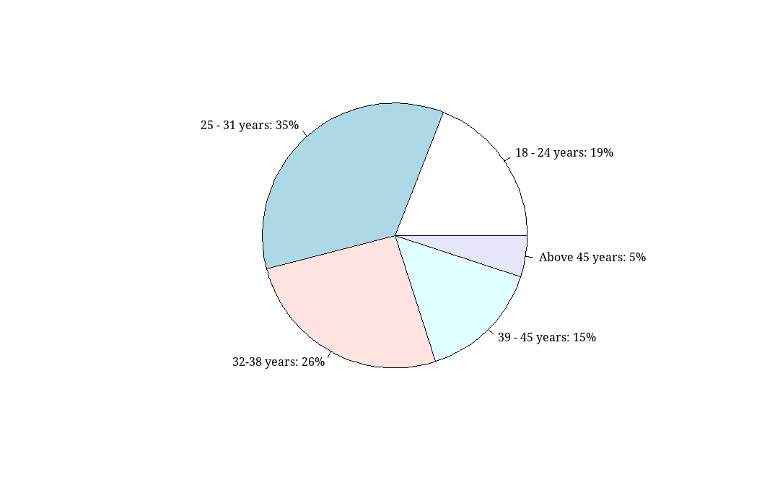

### Gender

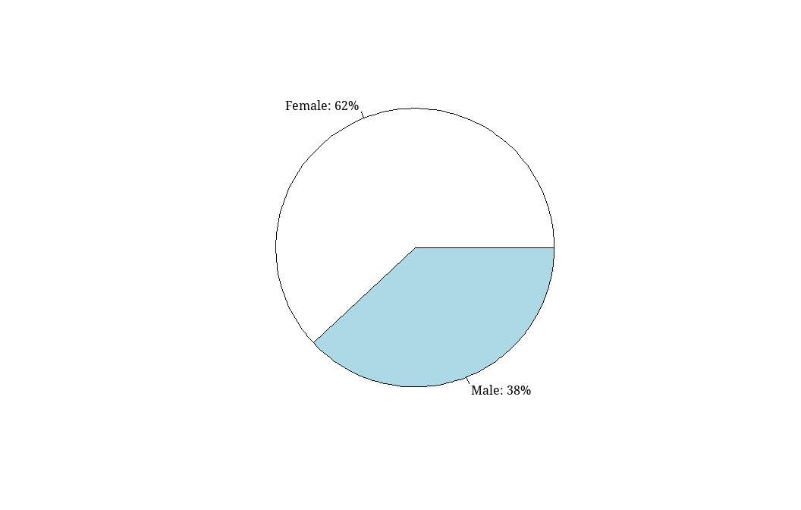

### Marital Status

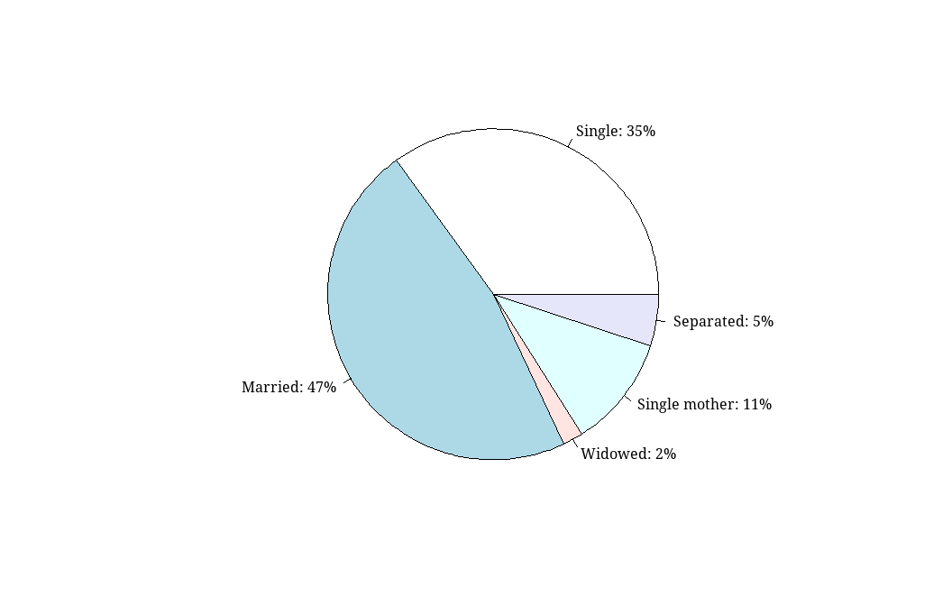

### Education Level

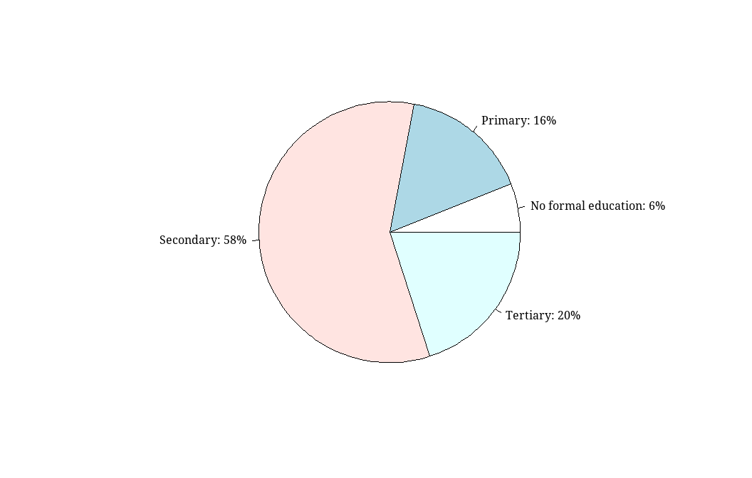

### Occupation

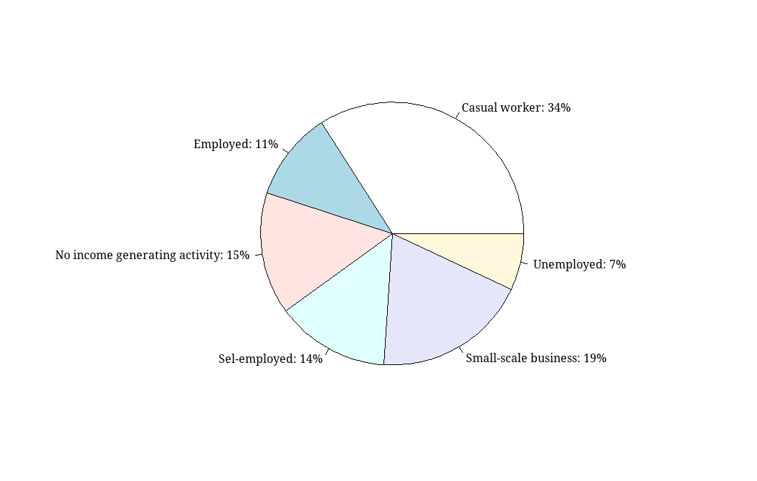

### Residence period

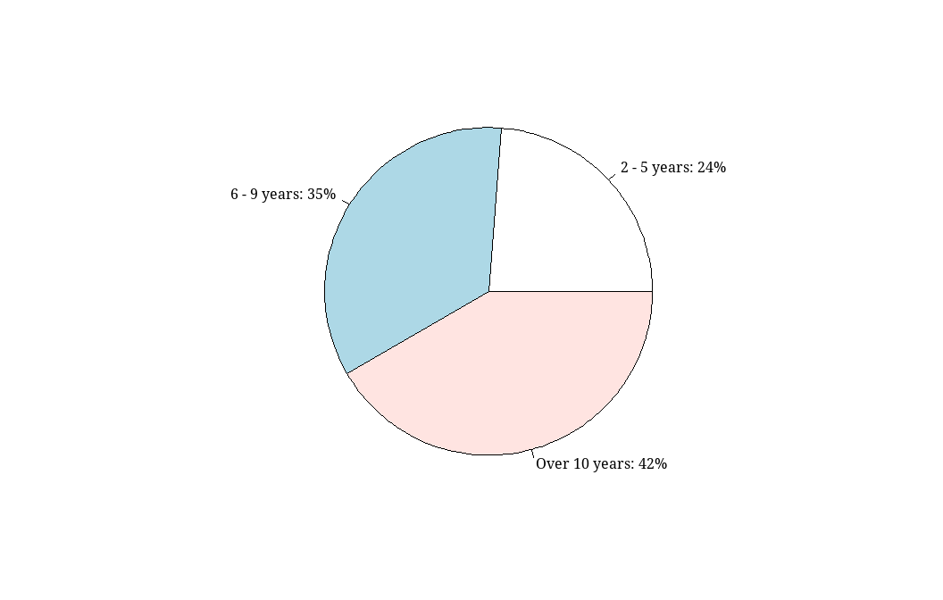

### Nationality

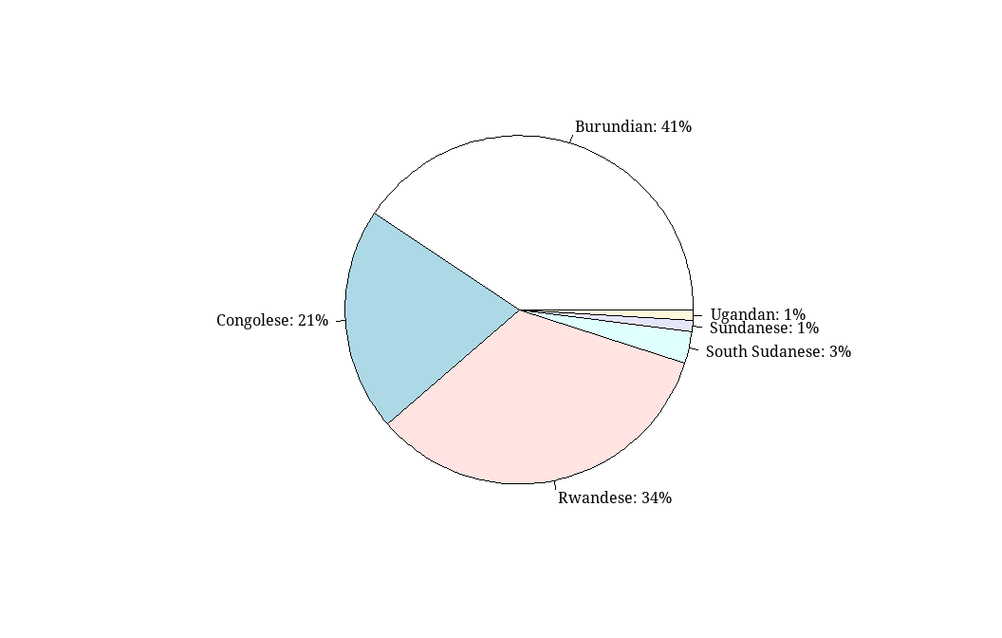

### Anxiety

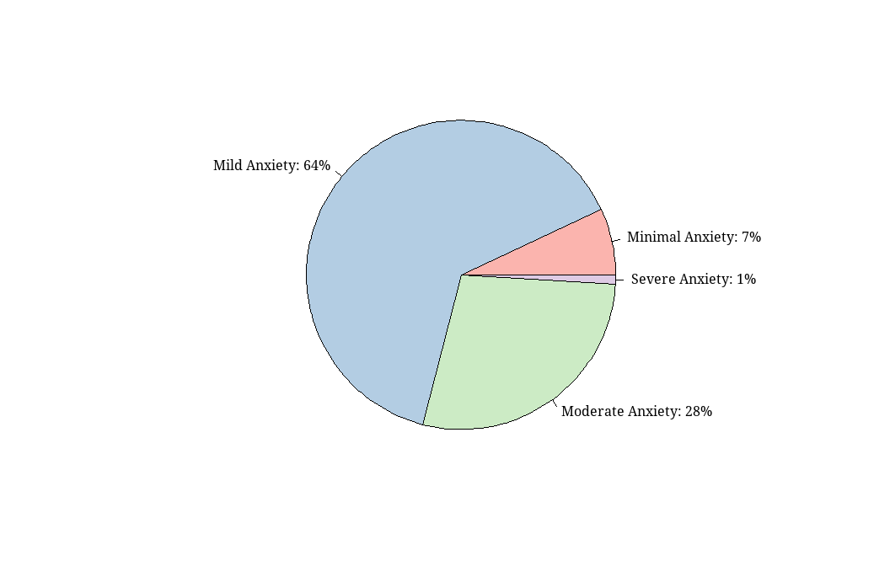

## piedonut

## Anxiety Vs Gender

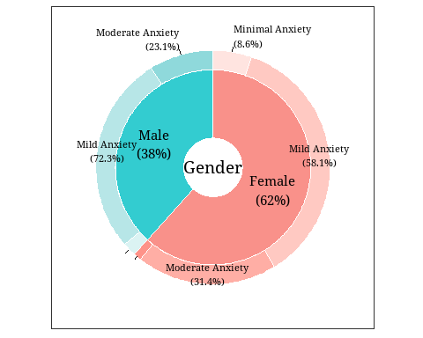

## Anxiety Vs Age

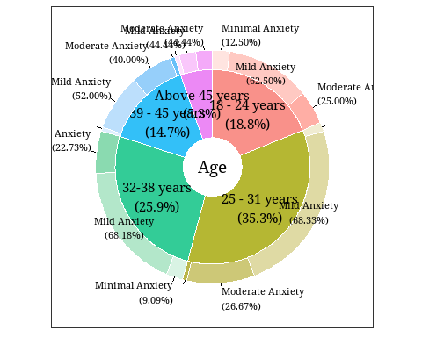

## Anxiety Vs Marital status

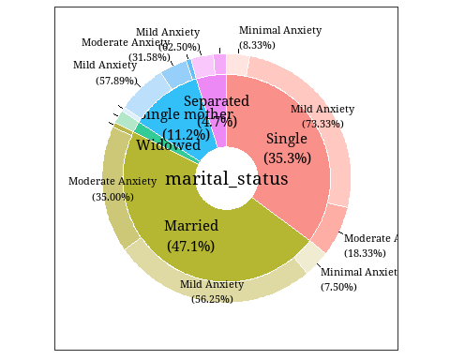

## Anxiety Vs Education Level

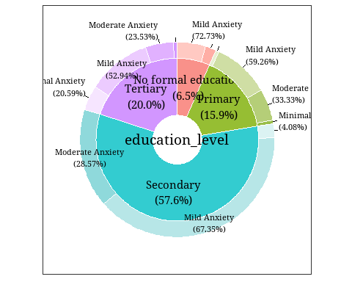

## Anxiety Vs occupation

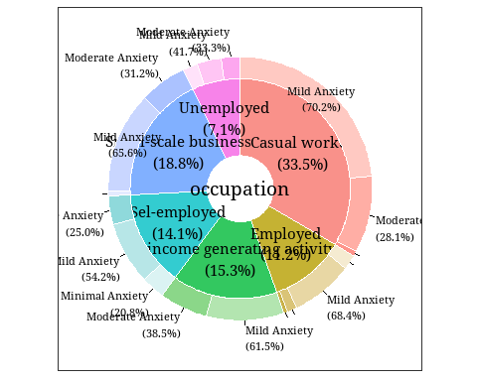

## Anxiety Vs residence period

