General Statistics

TCC

2022-05-11

# Header 1

## Header 2

### Header 3

## Exploration of data

## country continent year lifeExp   
## Afghanistan: 12 Africa :624 Min. :1952 Min. :23.60   
## Albania : 12 Americas:300 1st Qu.:1966 1st Qu.:48.20   
## Algeria : 12 Asia :396 Median :1980 Median :60.71   
## Angola : 12 Europe :360 Mean :1980 Mean :59.47   
## Argentina : 12 Oceania : 24 3rd Qu.:1993 3rd Qu.:70.85   
## Australia : 12 Max. :2007 Max. :82.60   
## (Other) :1632   
## pop gdpPercap   
## Min. :6.001e+04 Min. : 241.2   
## 1st Qu.:2.794e+06 1st Qu.: 1202.1   
## Median :7.024e+06 Median : 3531.8   
## Mean :2.960e+07 Mean : 7215.3   
## 3rd Qu.:1.959e+07 3rd Qu.: 9325.5   
## Max. :1.319e+09 Max. :113523.1   
##

Data summary

|  |  |
| --- | --- |
| Name | gapminder |
| Number of rows | 1704 |
| Number of columns | 6 |
| _______________________ |  |
| Column type frequency: |  |
| factor | 2 |
| numeric | 4 |
| ________________________ |  |
| Group variables | None |

**Variable type: factor**

| skim_variable | n_missing | complete_rate | ordered | n_unique | top_counts |
| --- | --- | --- | --- | --- | --- |
| country | 0 | 1 | FALSE | 142 | Afg: 12, Alb: 12, Alg: 12, Ang: 12 |
| continent | 0 | 1 | FALSE | 5 | Afr: 624, Asi: 396, Eur: 360, Ame: 300 |

**Variable type: numeric**

| skim_variable | n_missing | complete_rate | mean | sd | p0 | p25 | p50 | p75 | p100 | hist |
| --- | --- | --- | --- | --- | --- | --- | --- | --- | --- | --- |
| year | 0 | 1 | 1979.50 | 17.27 | 1952.00 | 1965.75 | 1979.50 | 1993.25 | 2007.0 | ▇▅▅▅▇ |
| lifeExp | 0 | 1 | 59.47 | 12.92 | 23.60 | 48.20 | 60.71 | 70.85 | 82.6 | ▁▆▇▇▇ |
| pop | 0 | 1 | 29601212.32 | 106157896.74 | 60011.00 | 2793664.00 | 7023595.50 | 19585221.75 | 1318683096.0 | ▇▁▁▁▁ |
| gdpPercap | 0 | 1 | 7215.33 | 9857.45 | 241.17 | 1202.06 | 3531.85 | 9325.46 | 113523.1 | ▇▁▁▁▁ |

## [1] 1704 6

## Statistical Tests

### ANOVA

## Call:  
## aov(formula = lifeExp ~ continent, data = gapminder)  
##   
## Terms:  
## continent Residuals  
## Sum of Squares 139343.2 144805.2  
## Deg. of Freedom 4 1699  
##   
## Residual standard error: 9.231992  
## Estimated effects may be unbalanced

## Df Sum Sq Mean Sq F value Pr(>F)   
## continent 4 139343 34836 408.7 <2e-16 ***  
## Residuals 1699 144805 85   
## ---  
## Signif. codes: 0 '***' 0.001 '**' 0.01 '*' 0.05 '.' 0.1 ' ' 1

## Tukey multiple comparisons of means  
## 95% family-wise confidence level  
##   
## Fit: aov(formula = lifeExp ~ continent, data = gapminder)  
##   
## $continent  
## diff lwr upr p adj  
## Americas-Africa 15.793407 14.022263 17.564550 0.0000000  
## Asia-Africa 11.199573 9.579887 12.819259 0.0000000  
## Europe-Africa 23.038356 21.369862 24.706850 0.0000000  
## Oceania-Africa 25.460878 20.216908 30.704848 0.0000000  
## Asia-Americas -4.593833 -6.523432 -2.664235 0.0000000  
## Europe-Americas 7.244949 5.274203 9.215696 0.0000000  
## Oceania-Americas 9.667472 4.319650 15.015293 0.0000086  
## Europe-Asia 11.838783 10.002952 13.674614 0.0000000  
## Oceania-Asia 14.261305 8.961718 19.560892 0.0000000  
## Oceania-Europe 2.422522 -2.892185 7.737230 0.7250559

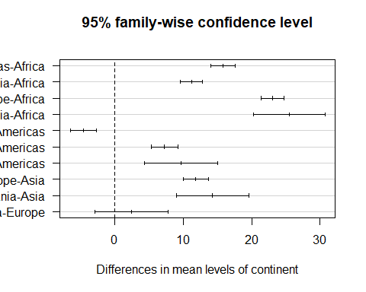

## T TEST

##   
## Welch Two Sample t-test  
##   
## data: New_cases by Country  
## t = 3.6006, df = 1587.5, p-value = 0.0003272  
## alternative hypothesis: true difference in means between group Kenya and group Nigeria is not equal to 0  
## 95 percent confidence interval:  
## 36.78517 124.82006  
## sample estimates:  
## mean in group Kenya mean in group Nigeria   
## 384.8205 304.0178

## Chisquare test

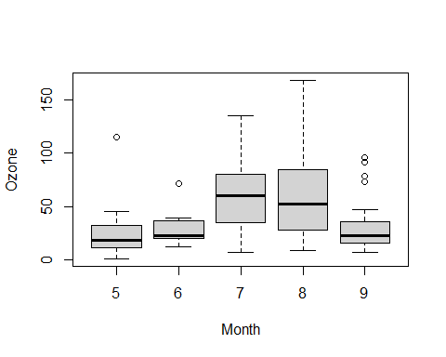

##   
## Kruskal-Wallis rank sum test  
##   
## data: Ozone by Month  
## Kruskal-Wallis chi-squared = 29.267, df = 4, p-value = 6.901e-06

## [1] "MAKUENI" "TAITA/TAVETA" "KAJIADO"

## [1] "36 - 50 years" "26 - 35 years" "Below 25 years" "Above 50 years"

## [1] "Less than Quarter" "Quarter to Half" "More than Half"   
## [4] NA

## grammar of tables

## Summary Tables

| Characteristic | KAJIADO, N = 3541 | MAKUENI, N = 3661 | TAITA/TAVETA, N = 3101 |
| --- | --- | --- | --- |
| gender |  |  |  |
| female | 61 (17%) | 73 (20%) | 67 (22%) |
| male | 293 (83%) | 293 (80%) | 243 (78%) |
| age_bracket |  |  |  |
| 26 - 35 years | 95 (27%) | 171 (47%) | 180 (58%) |
| 36 - 50 years | 135 (38%) | 141 (39%) | 92 (30%) |
| Above 50 years | 74 (21%) | 48 (13%) | 25 (8.1%) |
| Below 25 years | 50 (14%) | 6 (1.6%) | 13 (4.2%) |
| 1n (%) | | | |

# GT TABLES

| Characteristic | Arkard Farms Benue, N = 401 | Imo State Farms, N = 201 | South East, N = 1481 | South West soils, N = 441 | Wells and Ore Farm, N = 1,2921 |
| --- | --- | --- | --- | --- | --- |
| pH | 5.60 ± 0.66 | 4.96 ± 0.17 | 4.93 ± 0.43 | 6.18 ± 0.53 | 5.72 ± 1.14 |
| N | 0.10 ± 0.03 | 0.05 ± 0.01 | 0.09 ± 0.04 | 0.13 ± 0.09 | 0.15 ± 0.09 |
| OC | 1.07 ± 0.30 | 0.53 ± 0.09 | 1.23 ± 0.88 | 1.26 ± 0.88 | 1.40 ± 0.63 |
| P | 2 ± 1 | 29 ± 27 | 18 ± 28 | 9 ± 33 | 7 ± 12 |
| Ca | 561 ± 581 | 85 ± 63 | 368 ± 543 | 1,649 ± 2,266 | 844 ± 704 |
| Mg | 119 ± 129 | 23 ± 11 | 125 ± 146 | 173 ± 119 | 119 ± 77 |
| K | 70 ± 28 | 50 ± 29 | 64 ± 75 | 99 ± 54 | 110 ± 86 |
| Na | 19 ± 2 | 19 ± 1 | 27 ± 29 | 56 ± 10 | 21 ± 7 |
| Zn | 16 ± 8 | 49 ± 34 | 6 ± 7 | 3 ± 3 | 36 ± 36 |
| Cu | 4.12 ± 1.36 | 5.59 ± 2.19 | 3.94 ± 6.04 | 1.89 ± 1.98 | 2.25 ± 2.00 |
| Mn | 37 ± 26 | 4 ± 1 | 13 ± 13 | 252 ± 128 | 48 ± 50 |
| Fe | 128 ± 44 | 64 ± 18 | 19 ± 14 | 153 ± 61 | 193 ± 103 |
| 1Mean ± SD | | | | | |