UrabeVocalSynth
Dan Nixon

- Based on Yamaha's Vocaloid keyboard demo
- Configurable polyphonic waveform synthesiser
  - Provides similar functionality to basic conventional MIDI instrument synthesisers
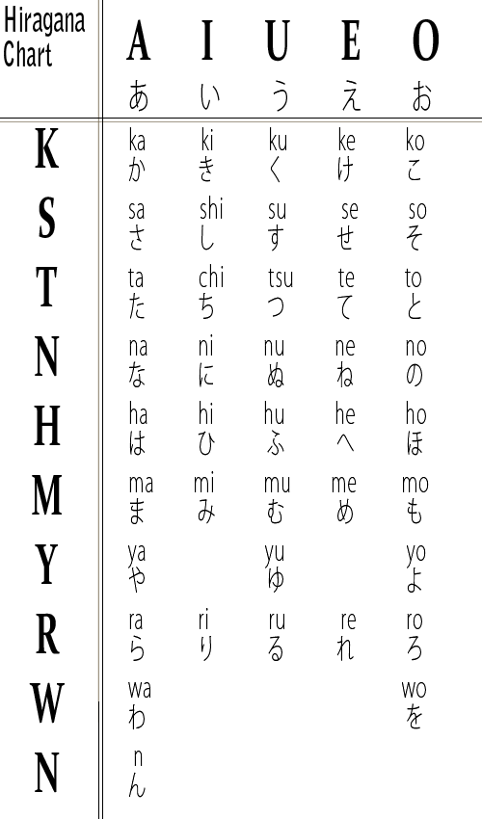
- Japanese vocal synthesis
  - Allows synthesis of Japanese vocals by entering and synthesising individual kana (syllables)
  - Kana are entered using the synth keypad and played using the attached MIDI instrument
  - Software converts each kana to a set of phonemes (most basic unit of a language's sound) for the BabbleBot IC
  - Waveform synthesis is handled within the BabbleBot IC
- Powered by:
  - Arduino Mega
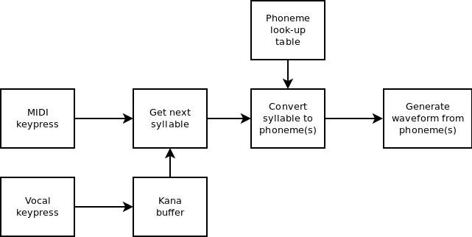

  - BabbleBot waveform synthesis IC
More info:
 https://github.com/DanNixon/UrabeVocalSynth
 @TechnoDucky
dan-nixon.com

