Using R for regional economic analysis, taster session (17th June 2025)

Before we start…
- You’ve got two modes for this session:
- Just watch my screencast and let it wash over you
- Have a go at the R coding we’ll be doing. If you’re trying #2 - you’ll need a copy of these slides open. The link will be going in the chat, or just type bit.ly/rtasterslides into your browser address bar.

- If you want to do some coding but didn’t have a chance to run through the little R setup guide, you’ve got some time now while I do all the pre-amble! The next slide takes you through how to get RStudio working in the browser using posit.cloud.
- Open the slide deck in your own browser using the chat link, so you can keep the instructions on-screen while I carry on (the link to posit.cloud is in those online slides).

Get up and running with RStudio in the cloud
- Create an account at posit.cloud using the ‘sign up’ box. It’ll ask you to check your email for a verification link so do that before proceeding.
- Once verified, go back to the posit.cloud tab and log in. You should see a message: “You are logged into Posit. Please select your destination”. Choose ‘Posit Cloud’ (not Posit Connect Cloud). That’ll take you to your online workspace.
- Click the new project button, top right
- Select ‘new project from template’ (as in the pic below) and then “Data Analysis in R with the tidyverse” (if not already selected). This template comes pre-installed with the tidyverse package, which we’ll be using. Select then click OK down at the bottom. This will open your RStudio project where we’ll do the coding.
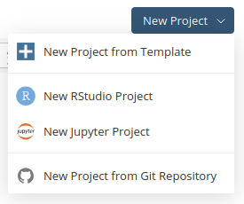

Introduction
We’ll be doing a whistlestop tour of using R for digging into UK regional economics.

Goals for the session
- To actually get you started using R and RStudio if you haven’t before.

- First, apologies - because this is just a taster, we won’t be able to check in on everyone’s progress to make sure it’s working or making sense! I’ve designed the guide so it can be followed step by step - but if we lose you along the way, we’ve also got a poll and ways to stay in touch, if I can help to support outside of this session.

- If this happens, we’ll still run through some of things R can do, and we can set up support later…
- That could include smaller groups where making sure it’s working will be possible!
- The aim: this should work for anyone completely new to RStudio. May veer from insultingly simplistic to horribly complex

- This is a whistlestop tour - if you’re new to any of this, don’t worry about it making sense on first go! I’ll just try to highlight what R can do, and provide pointers to learning more.
- Sometimes things won’t work… [explain]
- Bugs and errors, explain.
- I will pick out one or two basic R things to highlight, but missing a load… [e.g. piping / functions]
- Other things…

The plan
- We’ll work through these slides together, sometimes typing or copying code from the slides into RStudio.
- So I’ll be flitting between the slides and RStudio myself to do the same steps you’ll be trying.
- That could be vexing if you’re trying to look at slides! So make sure you have your own version of the slides open the a browser. I’ll post a link to it in the chat.
- Each slide is numbered - I’ll say where we’re at as we go on

- If you don’t fancy constantly flitting between slides and RStudio I’ve also made a single copy of the whole script we’ll work through, which you can get here (click on the little clipboard symbol top-right to copy, and then when we make a script below, paste the whole thing in).
- I’ll provide that link again below after we’ve made a script.
- Numbers in the comments on the script will (should!) match the slides so you can just follow along in RStudio.

The slides
- Once you have your own copy of the slides open, note the three-bar button, bottom left.
- That lets you see the full contents

CODING TIME!

Making a new R script in RStudio
RStudio is where you’ll be doing all the R loveliness (though see also the spangly new positron, I haven’t tried yet).
Before looking at RStudio, let’s make a new R script, where we’ll do the coding.
Task: Open a new R script in RStudio
- In the file menu in RStudio
- Use new file and R script (note: it tells you the keyboard shortcut for this)
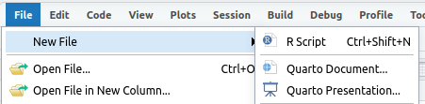

After that new file’s been made, RStudio should look something like the pic below.
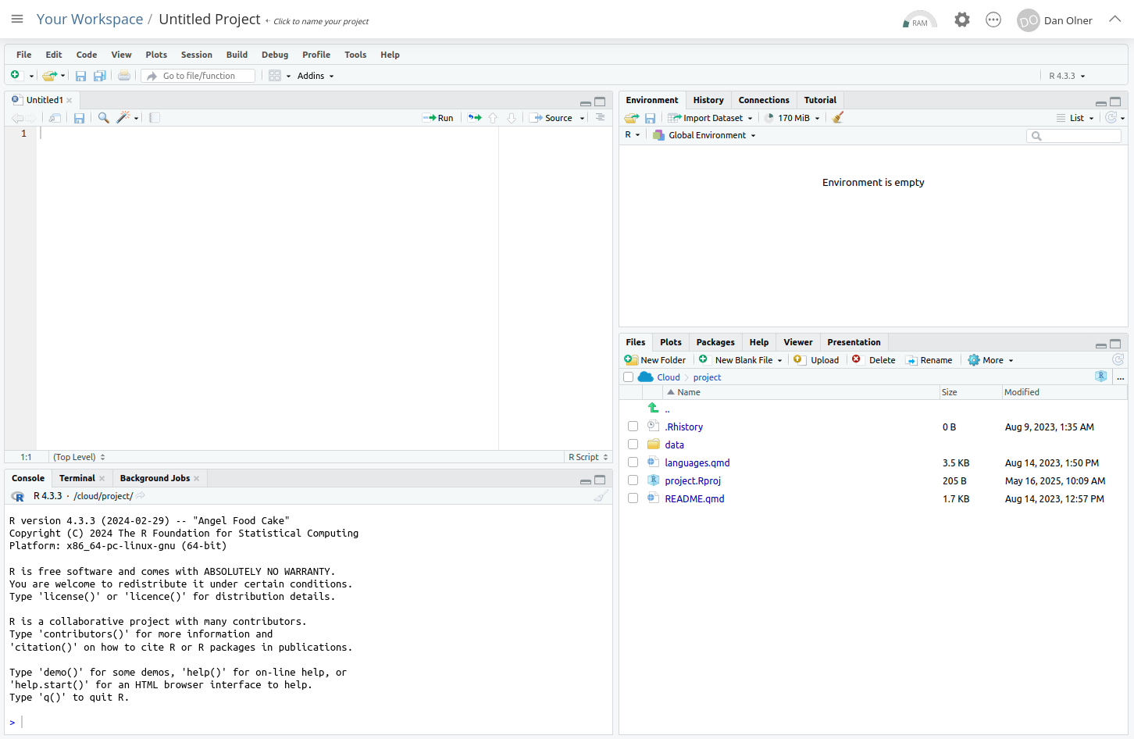

Tour of RStudio / getting set up

1. The console
The console is bottom left: all R commands end up being run here. You either run code directly in the console or send code from your R script.
Task: enter some commands directly into the console
Click in the console area so the cursor is on the command line. Type some random sums (or copy, see next slide) - press enter and you’ll see the results directly in the console.
Note that second one: sqrt is a function and arguments go into the brackets. More on that in a mo.
2+2
[1] 4
sqrt(64)
[1] 8

 Copying code from these slides into RStudio
All code blocks here have a little clipboard symbol if you hover over them to quickly copy so you can paste it all into RStudio. This will come in especially handy with larger code blocks later…
2+2
[1] 4
sqrt(64)
[1] 8

2. Giving things names
We can assign all manner of things a name to then use them elsewhere: values, strings, lists - and, crucially, data objects like all the UK’s regional GVA. But these all use the same method.
Task: Still in the console, assign a value to a name
x = 64
You’ll see that assignment appear top right in RStudio. It can be retrieved just with:
x
[1] 64

3. Using an R script
We’ll now stick some code into that newly created R script we made earlier in the top left of RStudio.
All code will run in the console - what we do with scripts is just send our written/saved code to the console.
Let’s test this by adding code to load the tidyverse library.
 What’s the tidyverse?
It’s a basket of tools that have become part of the R language - they all fit together to make consistent workflows much easier.
The online book R for Data Science is a great source to learn it, by the person who started it.

Task: add a line of code to the R script
Type or paste the following text at the top of the newly opened R script in the top left panel.
library(tidyverse)
When you’ve put that in, the script title will go red, showing it can now be saved (it should look something like the image below).
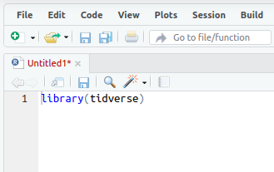
- Save the script either with the CTRL + S shortcut, or file > save. Give it whatever name you like, but note that it saves into your self-contained project folder.

Task: Run the library(tidyverse) line
Now we need to actually run that line of code… we can do this in a couple of ways:
- In your R script, if no code text is highlighted/selected RStudio will Run the code line by line (or chunk by chunk - we’ll cover that in the taster session).
- If a block of text is highlighted, the whole block will run. So e.g. if you select-all in a script and then run it, the entire script will run.
Let’s do #1: Run the code line by line.
- To test this, we’ll load the tidyverse library with the code we just pasted in (which is just one line of code at the moment!) Put the cursor at the end of the libary(tidyverse) line in the script (if it’s not there already), either with the mouse or keyboard. (Keyboard navigation is mostly the same as any other text editor like Word, but here’s a full shortcut list if useful.)
- Once there, either use the ‘run’ button, top right of the script window, or (much easier if you’re doing this repeatedly) press CTRL+ENTER to run it.

If all is well, you should see the text below in the console - the tidyverse library is now loaded. Huzzah!
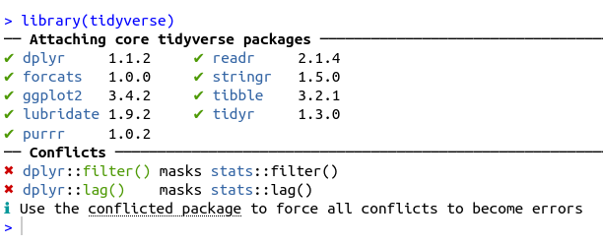

Finally - some economic data! Phew.

Well nearly…
Just one more thing first before actual economic data, sorry. We’re just going to load some functions (and install a couple of libraries) that we’ll need.
If of interest (or you want to check the code isn’t stealing your bank details!) code for these functions are on the github site here.
Task: In the R script, stick this code below the library(tidyverse) line and run it with CTRL+ENTER or the run command
As this will install a couple of libraries for the first time it’ll take about 25-30 seconds to run.
Note: comments in R begin with a #hash.
#Load some functions and two libraries (and install those libraries if they're not already present)
source('https://bit.ly/rtasterfunctions')

Now we can load some regional GVA data.
Tasks: Load in regional economic data, then look at it in RStudio.
This line takes a comma-separated variable file from the web and names it / assigns it to df. Paste it into your script (below the other code we’ve added) and run it.
If you look at the environment pane, top right. df should now be there (as in the pic below). Click anywhere on that line in the environment pane - it’ll open a new tab in RStudio with a view of the data attached to df.
# LOAD ITL3 GVA DATA----
#ITL3 zones, SIC sections, current prices, 2023 latest data (minus imputed rent)
df = read_csv('https://bit.ly/rtasteritl3noir')
#This one has imputed rent included if you want it
# df = read_csv('https://bit.ly/rtasteritl3')
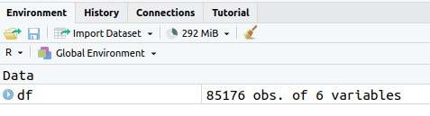

What data have we got here?
This is from the latest ONS “Regional gross value added (balanced) by industry: all International Territorial Level (ITL) regions” (The Excel file is available here). Released April 2025, it’s got data up to 2023. It’s got:
- GVA values from 1998 to 2023, broken down by:
- ITL3 zones i.e. local authorities rather than MCAs
- SIC sections: 18 broad sector categories (max in this data is 45 categories)
Plus…

- This is current price data: what the pound value of GVA was in each separate year, unadjusted for inflation
- This data can be summed, unlike the inflation-adjusted (chained volume) data (where each sector in each place is inflation-adjusted separately, so can’t be summed)
- Because it can be summed, this current price data is great for digging into structural change (e.g. “How have sector proportions changed over time?”) But not so good for real growth analysis.
Let’s start looking at the data in R…

Task: look at what SIC sector categories are in the data
We can do this by pulling out the unique values from a column.
In R, there are different ways to refer to columns. Here’s a key one: use the object’s name, then a dollar sign. R will then let you autocomplete the column name.
unique(df$SIC07_description)
[1] "Agriculture, forestry and fishing; mining and quarrying"
[2] "Manufacturing"
[3] "Electricity, gas, water; sewerage and waste management"
[4] "Construction"
[5] "Wholesale and retail trade; repair of motor vehicles"
[6] "Transportation and storage"
[7] "Accommodation and food service activities"
[8] "Information and communication"
[9] "Financial and insurance activities"
[10] "Real estate activities, excluding imputed rental"
[11] "Professional, scientific and technical activities"
[12] "Administrative and support service activities"
[13] "Public administration and defence"
[14] "Education"
[15] "Human health and social work activities"
[16] "Arts, entertainment and recreation"
[17] "Other service activities"
[18] "Activities of households"

Task: do the same for place names
We can use the same method to get the full list of ITL3 place names too (though we’ll use an easier method to pick them out later). Here, we also stick them into alphabetical order.
unique(df$Region_name)[order(unique(df$Region_name))]

“R is brilliant” exhibit A: we can use it to automate/repeat tedious things.
Here’s a sample of what the data looks like in the original Excel file. Different SIC sector levels are nested, there’s one column per year (in R, we’ve made year a single ‘tidy’ column)
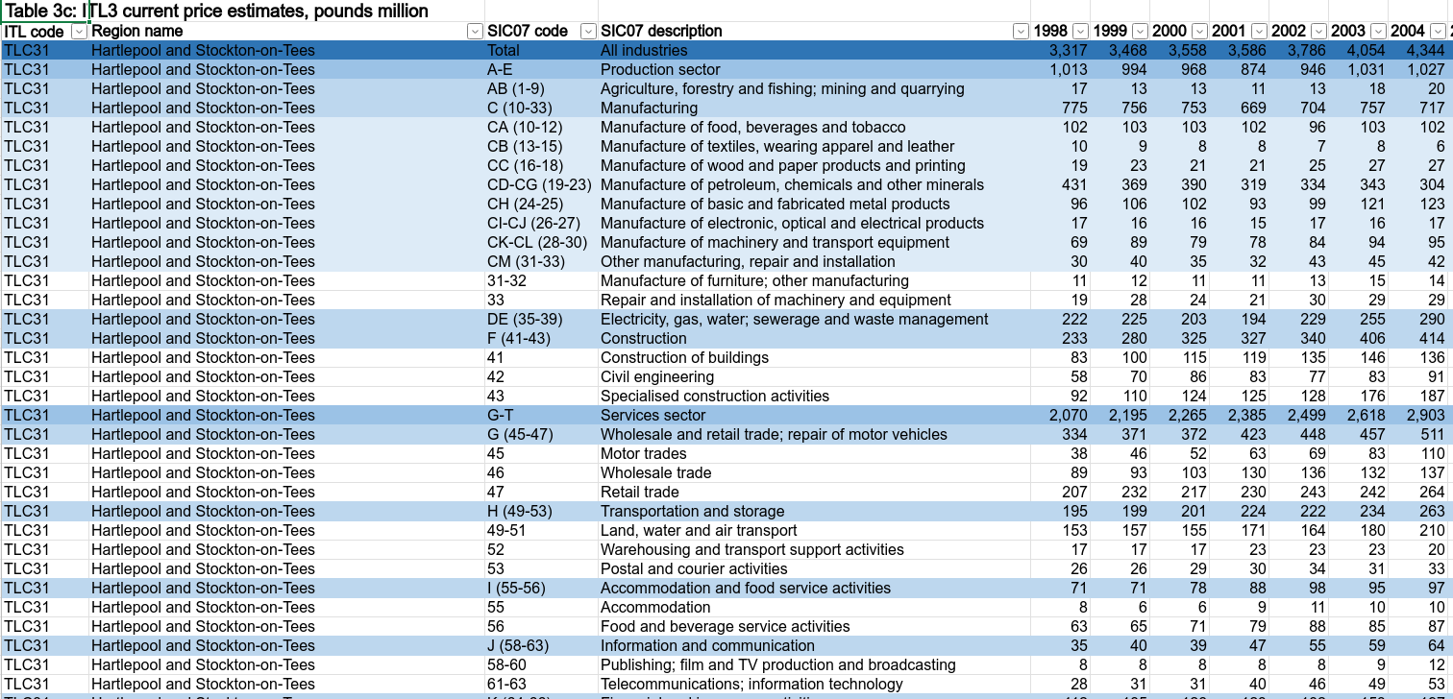

- The data we’ve attached to the df object comes from that ONS Excel sheet
- I’ve used R to get it directly from the web and then extract each CSV separately that might be needed
- Each of those nested sector groups gets separated out: goods/services, sections, the full SIC list (45 sectors in this data)
- The code for that is here.
- (Is this an example of R code that could be useful to run in powerBI to wrangle data for use?)

Wrangling the data
- We have our sector/region GVA data in R now - but how to wrangle it by place and sector, to start getting useful info out of it?
- Here’s an example of using the tidyverse to do this - we’ll group by sector for the latest year to see its median and range

Task: Wrangle the data to get some summary numbers
We’ll talk about what’s going on here a bit more in the next slide. For now - copy and run the code.
Note: RStudio will run the whole block if press CTRL + ENTER with cursor anywhere in it.
df %>%
filter(year == max(year)) %>%
group_by(SIC07_description) %>%
summarise(
median_gva = median(value),
min_gva = min(value),
max_gva = max(value)
) %>%
arrange(-median_gva)
# A tibble: 18 × 4
SIC07_description median_gva min_gva max_gva
<chr> <dbl> <dbl> <dbl>
1 Wholesale and retail trade; repair of motor vehic… 998. 113 11342
2 Manufacturing 968 112 4833
3 Human health and social work activities 944 87 4412
4 Construction 705 100 3712
5 Education 612. 75 4336
6 Professional, scientific and technical activities 516. 24 34316
7 Public administration and defence 494. 93 7834
8 Administrative and support service activities 446. 27 12461
9 Transportation and storage 350. 38 2283
10 Real estate activities, excluding imputed rental 320. 8 7529
11 Information and communication 265 13 25073
12 Accommodation and food service activities 264 61 5393
13 Financial and insurance activities 246 5 74615
14 Electricity, gas, water; sewerage and waste manag… 226 10 2547
15 Other service activities 157 19 2500
16 Arts, entertainment and recreation 104. 11 3201
17 Agriculture, forestry and fishing; mining and qua… 43.5 0 1862
18 Activities of households 8 2 65

Piping interlude!
- That last block of code was piping output of one function into the input of the next, chaining them together. This is super-powerful and useful.
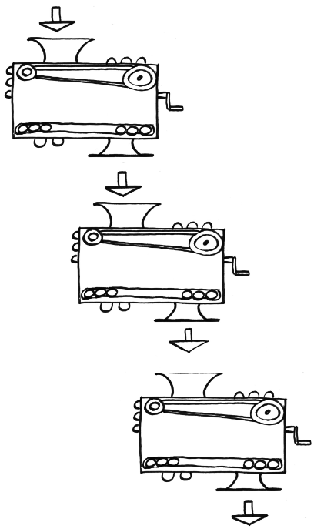

Here’s the principle with a silly toy example using two functions. Dead simple here, but with larger processing chains it quickly becomes indispensible. It’ll crop up a lot as we go.
Task: compare standard R function to ‘piping in’ the argument
If typing these out, the keyboard shortcut in RStudio for the pipe operator is CTRL + SHIFT + M.
#Boooo, nested brackets...
sqrt(log10(10000))
[1] 2
#Wooo! Lovely piped functions!
10000 %>% sqrt %>% log10
[1] 2

Getting sector proportions and location quotients
- Now we’ll wrangle the data using a function we loaded earlier Blue Peter style (may be showing age there!)
- This function adds in columns for what proportion of each place’s economy each sector makes up and, using that, what the location quotient (LQ) is for each sector in each place.


 Location quotient (LQ)
- In case the LQ is new to anyone: it’s just the proportion of a sector in a place, over its proportion nationally.
- So it’s less than one if a sector is less concentrated in a place than the UK average / more than 1 if higher (and 0.5 and 2 if it’s half or double the UK concentration).
- This ONS LQ excel sheet has a really clear explanation in the notes.
- I’ve made a page on other ways to use the LQ in R here, if of interest.

Task: run this function and glimpse the result in the console.
We stick four arguments into the function - including the data itself, which here we filter to the latest year.
It’s then piped to glimpse, which lets us look at all columns at once by sticking them on their side (a nice way to check our results look sane).
# LOCATION QUOTIENTS/PROPORTIONS----
add_location_quotient_and_proportions(
df %>% filter(year == max(year)),
regionvar = Region_name,
lq_var = SIC07_description,
valuevar = value
) %>% glimpse
Rows: 3,276
Columns: 13
$ ITL_code <chr> "TLC31", "TLC31", "TLC31", "TLC31", "TLC31"…
$ Region_name <chr> "Hartlepool and Stockton-on-Tees", "Hartlep…
$ SIC07_code <chr> "AB (1-9)", "C (10-33)", "DE (35-39)", "F (…
$ SIC07_description <chr> "Agriculture, forestry and fishing; mining …
$ year <dbl> 2023, 2023, 2023, 2023, 2023, 2023, 2023, 2…
$ value <dbl> 19, 933, 266, 716, 891, 234, 178, 195, 558,…
$ region_totalsize <dbl> 7091, 7091, 7091, 7091, 7091, 7091, 7091, 7…
$ sector_regional_proportion <dbl> 0.002679453, 0.131575236, 0.037512340, 0.10…
$ total_sectorsize <dbl> 20156, 225096, 63700, 154147, 243916, 83906…
$ totalsize <dbl> 2200006, 2200006, 2200006, 2200006, 2200006…
$ sector_total_proportion <dbl> 0.0091617932, 0.1023160846, 0.0289544665, 0…
$ LQ <dbl> 0.2924594, 1.2859682, 1.2955631, 1.4411007,…
$ LQ_log <dbl> -1.22942932, 0.25151194, 0.25894546, 0.3654…

 Tip
Once the code from the next slide is in RStudio, if you CTRL + mouse click on the function name, it’ll take you to the code (if you loaded them above). You’ll see it’s a not-too-elaborate piping operation of the type we were just looking at.
The power of functions is in packaging this kind of ‘need often’ task into flexible, reusable form.

In the next code block we’re running the same code but doing four extra things that we chain together:
- We group_split the data into years (one separate dataframe per year)
- map each year bundle into the add_location_quotient_and_proportions function
- bind_rows it all back together
- We also overwrite df with the result (first line) so we’ve kept it (rather than, in the last example, just outputting to the console).

Task: find LQs and proportions for each year and keep the result
Once run, we can also look at the result again via the environment panel.
(Note: you’ll probably get a warning - this is due to a single negative GVA value, it won’t affect anything here.)
While we’re here: highlight just this bit of code: df %>% group_split(year) and then run. We can see what just that chunk is doing exactly what the function name suggests.
#Finding location quotients for each year in the data
#And then overwriting the df variable with the result
df = df %>%
group_split(year) %>%
map(add_location_quotient_and_proportions,
regionvar = Region_name,
lq_var = SIC07_description,
valuevar = value) %>%
bind_rows()

Now let’s do something with result:
- Pick out one place or local authority: you’ll only need some of the place name you want - here I’m using rotherh to find Rotherham, but do change it to other places.
- For the latest year in the data, pull out the location quotient and sector proportion for that place
- And then order, highest to lowest.
Task:
#View a single place...
df %>% filter(
qg('rotherh',Region_name),
year == max(year)#get latest year in data
) %>%
mutate(regional_percent = sector_regional_proportion *100) %>%
select(SIC07_description,regional_percent, LQ) %>%
arrange(-LQ)

Output from that code…
- Rotherham’s largest sector specialism (highest LQ) is manufacturing for the latest year (and nearly 19% of its economy).
# A tibble: 18 × 3
SIC07_description regional_percent LQ
<chr> <dbl> <dbl>
1 Manufacturing 18.8 1.84
2 Construction 12.7 1.81
3 Activities of households 0.139 1.40
4 Transportation and storage 5.28 1.38
5 Human health and social work activities 12.8 1.38
6 Electricity, gas, water; sewerage and waste manageme… 3.89 1.34
7 Public administration and defence 6.74 1.21
8 Wholesale and retail trade; repair of motor vehicles 13.2 1.19
9 Administrative and support service activities 6.47 1.10
10 Education 7.24 1.05
11 Accommodation and food service activities 3.25 1.03
12 Agriculture, forestry and fishing; mining and quarry… 0.694 0.758
13 Other service activities 1.33 0.733
14 Arts, entertainment and recreation 0.774 0.502
15 Professional, scientific and technical activities 3.09 0.333
16 Information and communication 2.20 0.333
17 Financial and insurance activities 1.21 0.123
18 Real estate activities, excluding imputed rental 0.159 0.0398

 Cheatsheets!
There are a bunch of excellent cheat sheet documents available for many of R’s features. You can easily access them via RStudio’s help menu.
The data tranformation with dplyr sheet covers a lot of the functions we’re using in piping operations.
There’s also an excellent ggplot cheatsheet, among many others. We’ll come back to this one…

Visualising: how has the structure of places’ economies changed over time?
Let’s plot some of the data. We’ll look at how an ITL3 zone’s broad sectors have changed their proportion over time, to see how those economies have changed structurally.
We’ll do this in 3 stages:
- Add in a moving average to smooth the data a little
- Pick out the top 12 broad sectors in the latest year
- Plot!

Task: apply the moving average to our df data object and pick out the placename we want
You can look at the available ITL3 zones at geoportal.statistics.gov.uk here, if useful for checking names. (Opens in new tab.)
# PLOT STRUCTURAL CHANGE OVER TIME IN ITL3 ZONE----
#Processing before plot
#1. Set window for rolling average: 3 years
smoothband = 3
#2. Make new column with rolling average in (applying to all places and sectors)
#Years are already in the right order, so will roll apply across those correctly
df = df %>%
group_by(Region_name,SIC07_description) %>%
mutate(
sector_regional_prop_movingav = rollapply(
sector_regional_proportion,smoothband,mean,align='center',fill=NA
)
) %>%
ungroup()
#3. Pick out the name of the place / ITl3 zone to look at
#We only need a bit of the name...
place = getdistinct('doncas',df$Region_name)
#Check we found the single place we wanted (some search terms will pick up none or more than one)
place
[1] "Doncaster"

Task: for our chosen place, pick out the largest proportion sectors in the most recent year
Here, we filter to get our place and year, arrange in reverse order of moving average, slice off the top 12 and pull out the sector names.
# top 12 sectors in latest year
top12sectors = df %>%
filter(
Region_name == place,
year == max(year) - 1#to get 3 year moving average value
) %>%
arrange(-sector_regional_prop_movingav) %>%
slice_head(n= 12) %>%
select(SIC07_description) %>%
pull()

GGPLOT interlude!
- In the next slide, we finally make an actual chart. Phew.
- There’s a lot going on in ggplot, the package we’ll be using to visualise data - but it’s worth mentioning that its principles are actually clear and consistent.
- You’ll see it has an aes argument - that’s short for aesthetics. An aesthetic is any single distinct plot element - like the x or y axis, colour, shape, size etc.

- The rule is simple: you map one column to one aesthetic. This is another tidy data principle, and its the reason - for example - why we have years all their own column, so year can be mapped to one axis.
- We’ll see later with geographical zones - categorical variables also get mapped to single aesthetics.
- The ggplot cheatsheet shows, for all plot types, what aesthetics are available.

Task: plot smoothed sector proportion over time using ggplot
#Plot!
ggplot(df %>%
filter(
Region_name == place,
SIC07_description %in% top12sectors,
!is.na(sector_regional_prop_movingav)#Remove NAs created by 3 year moving average
),
aes(x = year, y = sector_regional_prop_movingav * 100, colour =
fct_reorder(SIC07_description,-sector_regional_prop_movingav) )) +
geom_point() +
geom_line() +
scale_color_brewer(palette = 'Paired', direction = 1) +
ylab('Sector: percent of regional economy') +
labs(colour = paste0('Largest 12 sectors in ',max(df$year))) +
ggtitle(paste0(place, ' GVA % of economy over time (', smoothband,' year moving average)'))
Resulting plot is on on next slide –>

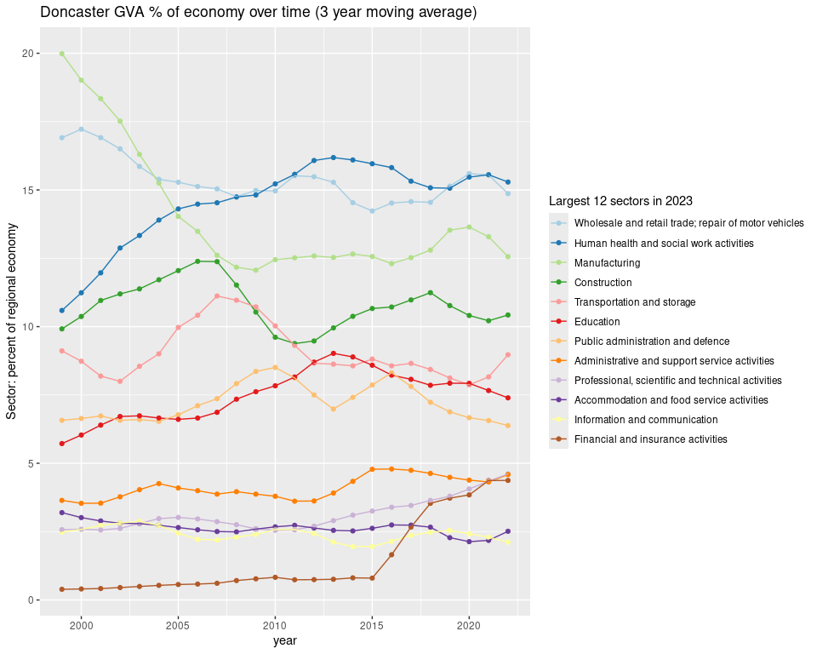

Real GVA growth over time
Current prices are great and everything - loads of value being able to examine relative change, and things actually adding up. But they’re not real prices, so can’t be used to understand real growth over time.
For this, we have to use chained volume data that adjusts for inflation…

So next we load data for the same sectors and ITL3 zones, but it’s chained volume GVA figures, inflation-adjusted to 2022 money value.
We’ll then pick out a single place to examine. I’ve chosen Barnsley - but note: you can use a small part of a local authority / place name to return the full name that we’ll use to filter the data.
Check it’s returned what you want though. For example, glouc will return a couple of different places with ‘Gloucester’ in.

Tasks: Load in the chained volume data for ITL3 zones and SIC sections, then pick a place name to examine
# CHAINED VOLUME ITL3 DATA----
df.cv = read_csv('https://bit.ly/rtasteritl3cvnoir')
#Get the text for an ITL3 zone by searching for a bit of the name
place = getdistinct('barns',df$Region_name)
#Check we got just one place!
place
[1] "Barnsley"

Now we’ll examine sector growth trends, looking at average growth over time. To start with, let’s pick out a couple of sectors for our chosen place.
Task: Plot trends over time for a couple of sectors using ggplot.
Set a start/end year (here, the most recent decade). Note: two sector names are searched for here, separating with a | vertical bar meaning or. Reminder: you can look at the full list of available sectors with unique(df.cv$SIC07_description)
startyear = 2014
endyear = 2023
#Pick out single slopes to illustrate
ggplot(
df.cv %>% filter(
year %in% startyear:endyear,
Region_name == place,
qg('information|professional', SIC07_description)
),
aes(x = year, y = value, colour = SIC07_description)
) +
geom_point() +
geom_line() +
geom_smooth(method = 'lm') +
ggtitle(paste0(place, ' selected sectors\nGVA change over time (chained volume)'))

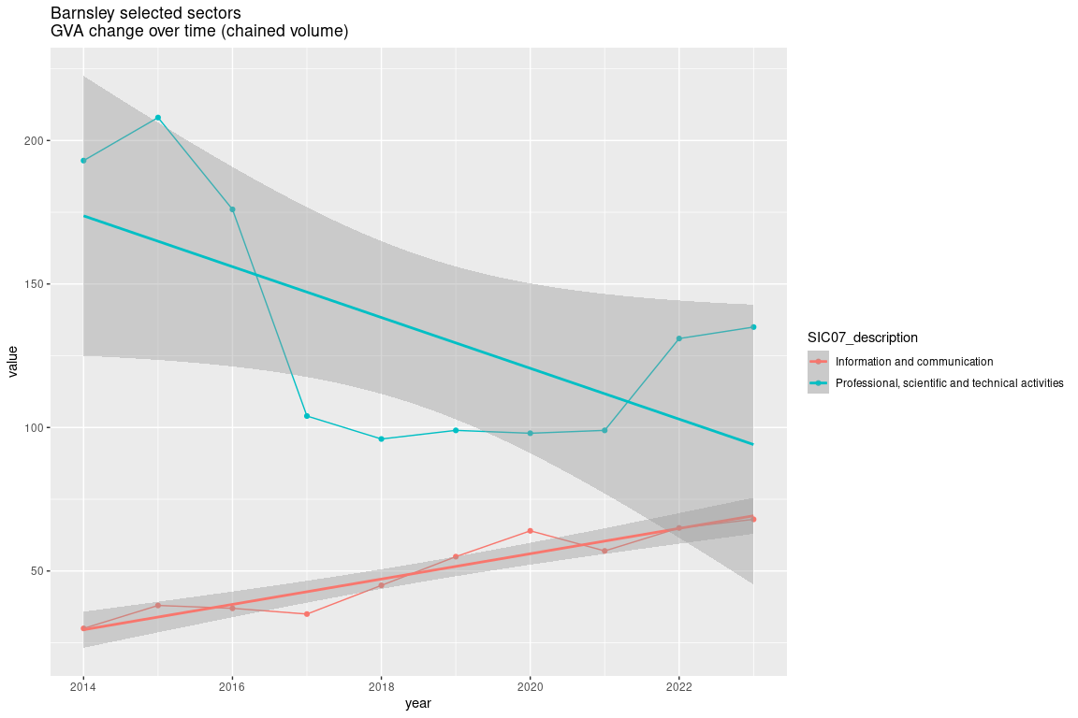

Next, we’re going to find linear trends for every sector in our chosen place and compare them, including some confidence intervals. To do this we’ll:
- Use another pre-made function loaded earlier that finds linear slopes and standard errors for each group (each sector in this case), using log values so change is comparable.
- Do a bit of wrangling and then plot average % change per year for each sector.

Task: Get slopes and confidence intervals for each sector in our chosen place
The function has a ‘use Newey West estimators’ option - better standard errors for sticking lines through time series data (open contibutions to improve trend analysis here would be very welcome!)
#Get all slopes for sectors in that place
slopes = get_slope_and_se_safely(
df.cv %>% filter(
year %in% startyear:endyear,
Region_name == place,
!qg('households', SIC07_description)
),
SIC07_description,
y = log(value),
x = year,
neweywest = T)
#Add 95% confidence intervals around the slope
slopes = slopes %>%
mutate(
ci95min = slope - (se * 1.96),
ci95max = slope + (se * 1.96)
)

Task:
#Adjust to get percentage change per year
slopes = slopes %>%
mutate(across(c(slope,ci95min,ci95max), ~(exp(.) - 1) * 100, .names = '{.col}_percentperyear'))
#Plot the slope with those confidence intervals
ggplot(slopes, aes(x = slope_percentperyear, y = fct_reorder(SIC07_description,slope))) +
geom_point() +
geom_errorbar(aes(xmin = ci95min_percentperyear, xmax = ci95max_percentperyear), width = 0.1) +
geom_vline(xintercept = 0, colour = 'black', alpha = 0.5) +
coord_cartesian(xlim = c(-25,25)) +
xlab('Av. % change per year') +
ylab("") +
ggtitle(paste0(place, ' broad sectors av. chained volume GVA % change per year\n',startyear,'-',endyear,', 95% conf intervals'))
Plot in next slide –>

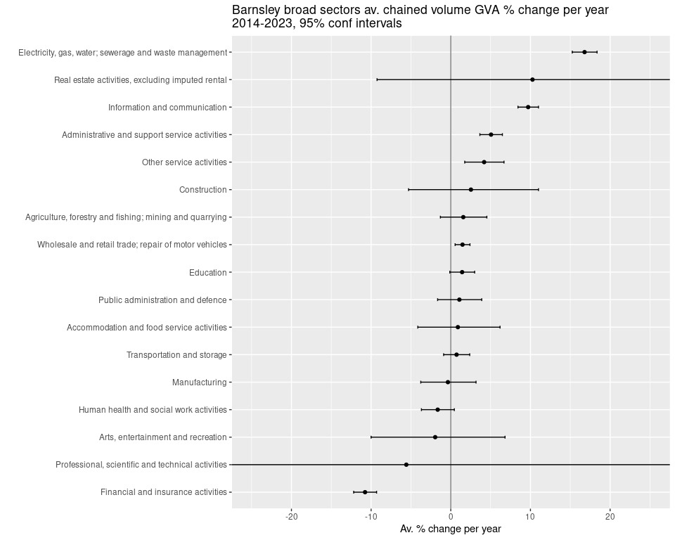

More growth analysis: ITL2 zones
Let’s actually run through extracting data from an online Excel sheet. It’s not too much work. We’ll use it to look at growth rates for the entire economies of mayoral authorities and other ITL2 zones.
We use the readxl package - this is already installed in posit.cloud RStudio. If you’re working in RStudio on your own machine, here’s some code to check if you have it installed and install it if not.
Task: Check if readxl is installed and install if not
# EXAMPLE OF GETTING DATA DIRECTLY (GET NATIONAL SIC SECTION DATA)----
#Check readxl is already installed, install if not.
if(!require(readxl)){
install.packages("readxl")
library(readxl)
}

Then onto getting the data directly and processing it…
Task: Copy and run this code to get data directly from the ONS regional/industry GVA Excel file
We download a temporary local copy and then extract from a sheet and cell range we define using the readxl package.
#2025:
url1 <- 'https://www.ons.gov.uk/file?uri=/economy/grossvalueaddedgva/datasets/nominalandrealregionalgrossvalueaddedbalancedbyindustry/current/regionalgrossvalueaddedbalancedbyindustryandallinternationalterritoriallevelsitlregions.xlsx'
p1f <- tempfile(fileext=".xlsx")
download.file(url1, p1f, mode="wb")
itl2.all <- read_excel(path = p1f,range = "Table 2a!A2:AD4556")
names(itl2.all) <- gsub(x = names(itl2.all), pattern = ' ', replacement = '_')
itl2.all = itl2.all %>%
filter(SIC07_description == 'All industries') %>%
pivot_longer(`1998`:names(itl2.all)[length(names(itl2.all))], names_to = 'year', values_to = 'value') %>% #get most recent year
mutate(year = as.numeric(year))

Now we have the data in the itl.all object in the form we want, we’ll do as we did above for sectors in one place - find linear slopes for each ITL2 zone and some confidence intervals.
Task: choose a time window and find OLS slopes for each ITL2 zone
startyear = 2011
endyear = 2023
#Get all slopes for sectors in that place
slopes = get_slope_and_se_safely(
itl2.all %>% filter(year %in% c(startyear:endyear)),
Region_name,
y = log(value),
x = year,
neweywest = T)
#Add 95% confidence intervals around the slope
slopes = slopes %>%
mutate(
ci95min = slope - (se * 1.96),
ci95max = slope + (se * 1.96)
)

Finally, we plot the slopes to show average percent change over time…
Task: plot each ITL2’s linear slopes with confidence intervals
#Adjust to get percentage change per year from log slopes
slopes = slopes %>%
mutate(across(c(slope,ci95min,ci95max), ~(exp(.) - 1) * 100, .names = '{.col}_percentperyear'))
#Plot the slope with those confidence intervals
ggplot(slopes, aes(x = slope_percentperyear, y = fct_reorder(Region_name,slope))) +
geom_point() +
geom_errorbar(aes(xmin = ci95min_percentperyear, xmax = ci95max_percentperyear), width = 0.1) +
geom_vline(xintercept = 0, colour = 'black', alpha = 0.5) +
xlab('Av. % change per year') +
ylab("") +
ggtitle('All industries in ITL2 zones, chained volume GVA\nAv. % change per year\n2014-2023, 95% conf intervals')

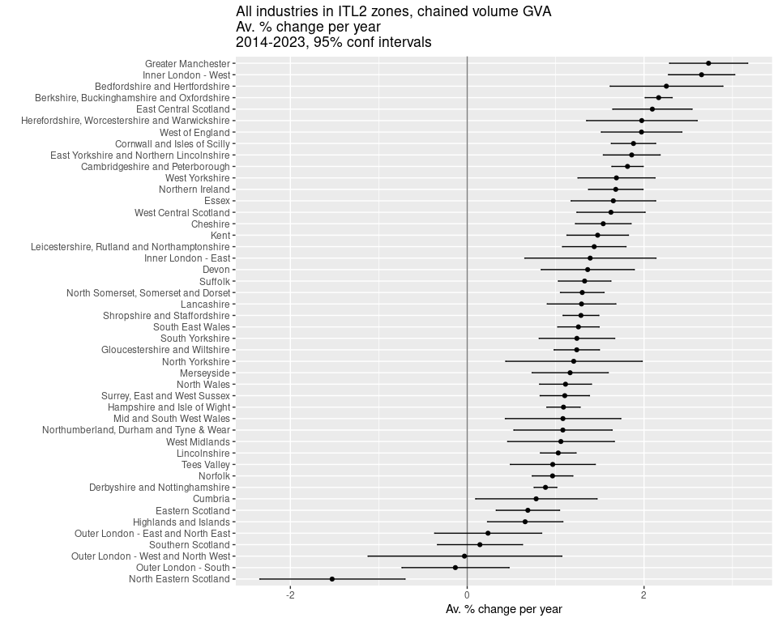

BONUS MATERIAL

Multiple proportion plots with consistent sector colours
Task:
n <- length(unique(df$SIC07_description))
set.seed(12)
qual_col_pals = RColorBrewer::brewer.pal.info[RColorBrewer::brewer.pal.info$category == 'qual',]
col_vector = unlist(mapply(RColorBrewer::brewer.pal, qual_col_pals$maxcolors, rownames(qual_col_pals)))
randomcols <- col_vector[10:(10+(n-1))]
#Do once!
getplot <- function(place){
df = df %>%
filter(!qg("Activities of households|agri",SIC07_description)) %>%
mutate(
SIC07_description = case_when(
grepl('defence',SIC07_description,ignore.case = T) ~ 'public/defence',
grepl('support',SIC07_description,ignore.case = T) ~ 'admin/support',
grepl('financ',SIC07_description,ignore.case = T) ~ 'finance/insu',
grepl('agri',SIC07_description,ignore.case = T) ~ 'Agri/mining',
grepl('electr',SIC07_description,ignore.case = T) ~ 'power/water',
grepl('information',SIC07_description,ignore.case = T) ~ 'ICT',
grepl('manuf',SIC07_description,ignore.case = T) ~ 'Manuf',
grepl('other',SIC07_description,ignore.case = T) ~ 'other',
grepl('scientific',SIC07_description,ignore.case = T) ~ 'Scientific',
grepl('real estate',SIC07_description,ignore.case = T) ~ 'Real est',
grepl('transport',SIC07_description,ignore.case = T) ~ 'Transport',
grepl('entertainment',SIC07_description,ignore.case = T) ~ 'Entertainment',
grepl('human health',SIC07_description,ignore.case = T) ~ 'Health/soc',
grepl('food service activities',SIC07_description,ignore.case = T) ~ 'Food/service',
grepl('wholesale',SIC07_description,ignore.case = T) ~ 'Retail',
.default = SIC07_description
)
)
top12sectors = df %>%
filter(
Region_name == place,
year == max(year) - 1#to get 3 year moving average value
) %>%
arrange(-sector_regional_prop_movingav) %>%
slice_head(n= 12) %>%
select(SIC07_description) %>%
pull()
ggplot(df %>%
filter(
Region_name == place,
SIC07_description %in% top12sectors,
!is.na(sector_regional_prop_movingav)#Remove NAs created by 3 year moving average
),
aes(x = year, y = sector_regional_prop_movingav * 100, colour = fct_reorder(SIC07_description,-sector_regional_prop_movingav) )) +
geom_point() +
geom_line() +
scale_color_manual(values = setNames(randomcols,unique(df$SIC07_description))) +#set manual pastel colours matching sector name
ylab('Sector: percent of regional economy') +
theme(plot.title = element_text(face = 'bold')) +
labs(colour = 'SIC section') +
# scale_y_log10() +
ggtitle(paste0(place, ' GVA % of economy over time\nTop 12 sectors in ',max(df$year),'\n (', smoothband,' year moving average)'))
}
places = getdistinct('doncas|roth|barns|sheff',df$Region_name)
plots <- map(places, getplot)
patchwork::wrap_plots(plots)

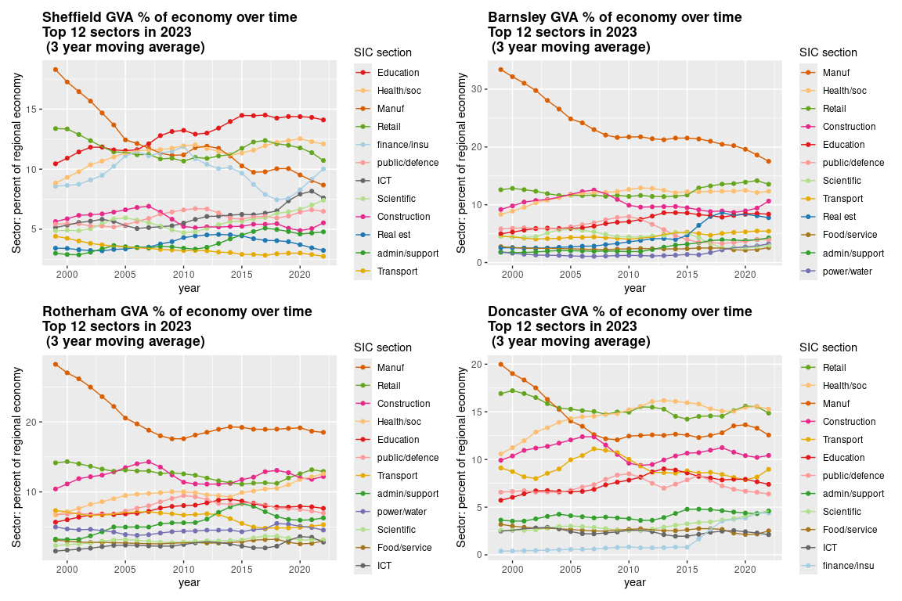

R geek footnote: magrittr pipe not native pipe because only one shortcut in RStudio + magrittr pipe more versatile.
Though Diane Coyle quotes Schelling 1958: “What we call ‘real’ magnitudes are not completely real; only the money magnitudes are real. The ‘real’ ones are hypothetical.” Coyle 2025 p.178

