Pipeline

Introduction
We’ll look at 3 examples of piping data through from web to this output. Starting with…

1. Extracting from an Excel file on a website: productivity data example
We can copy the URL for the Excel sheet from the web page…
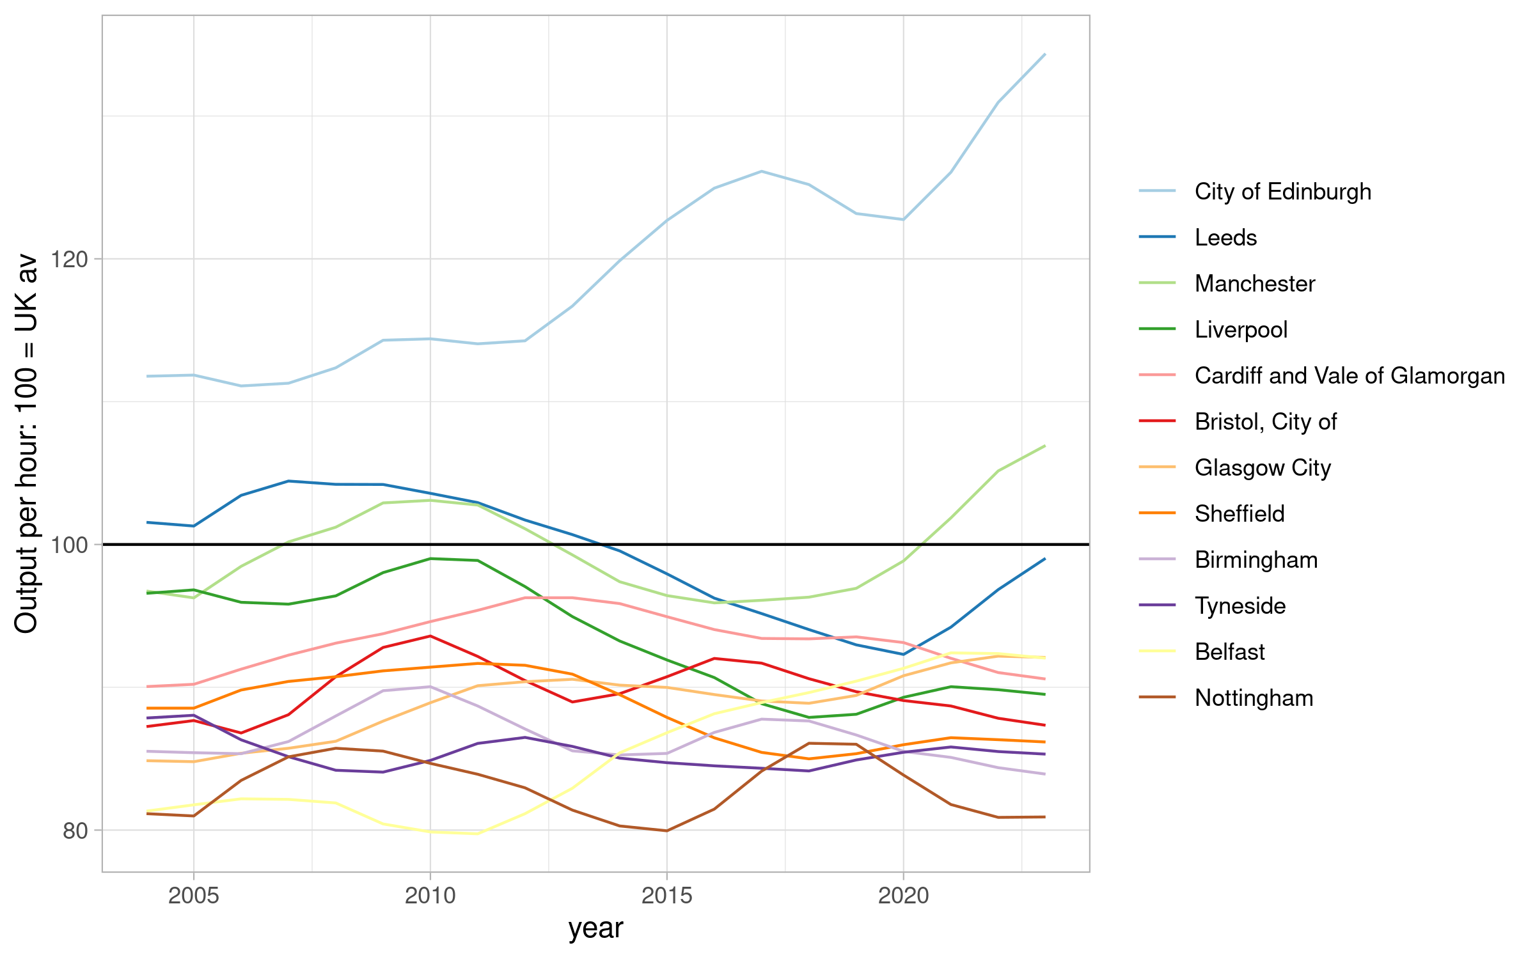

2. Using the NOMISR package to extract data through the NOMIS API
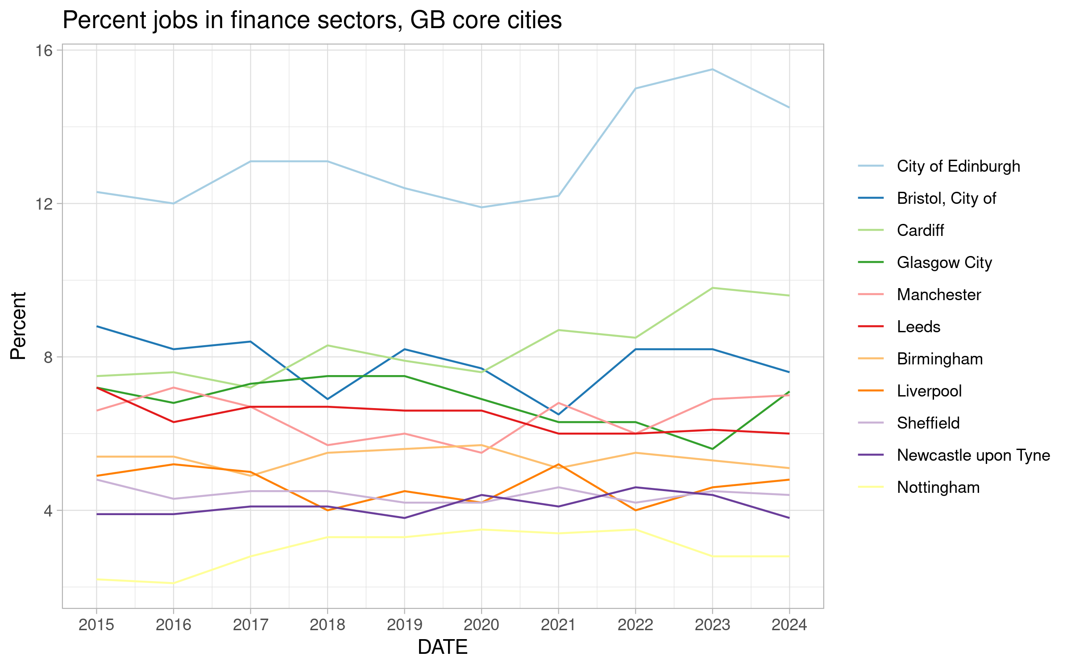
You can run code in the text too, to include dynamic values from the data, rather than handwriting those in. For instance, we can say that the percent of Edinburgh’s finance jobs in 2024 was 14.5%.
We can also add tables in from the data:
Table: core cities’ percent of finance jobs in 2024 (SICs 64-66)
City | percent
City of Edinburgh | 14.5
Cardiff | 9.6
Bristol, City of | 7.6
Glasgow City | 7.1
Manchester | 7.0
Leeds | 6.0
Birmingham | 5.1
Liverpool | 4.8
Sheffield | 4.4
Newcastle upon Tyne | 3.8
Nottingham | 2.8

3. Scraping websites for links, downloading one and extracting from a zip
First we look at occupation percents in England/Wales core cities.
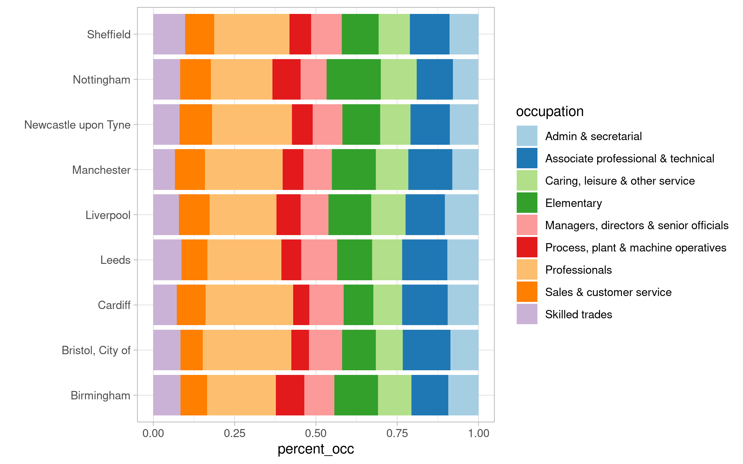
But how do those compare to average?
