Pipeline
Checking on missing packages, installing if we need to. Starting timer...
Packages installed. Time taken:
Time difference of 1.476925 secs

Introduction
We’ll look at 3 examples of piping data through from web to this output. Starting with…

1. Extracting from an Excel file on a website: productivity data example
We can copy the URL for the Excel sheet from the web page…
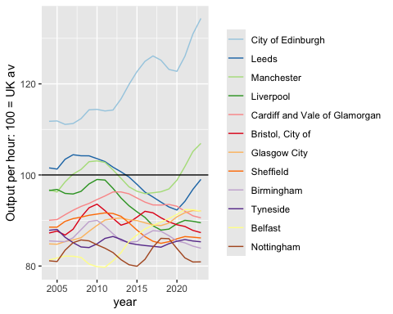

2. Using the NOMISR package to extract data through the NOMIS API


