South Yorkshire sectors: the economic impact of new jobs, including in low carbon jobs. July/Aug 2024
Dan Olner

Summary of report
- In the UK, direct low carbon and renewable energy jobs are around 1.3% of the total, according to ONS’ LCREE survey. LCREE job growth has accelerated to 6% a year during and since COVID. The largest green sectors by proportion are power/energy, construction, manufacturing, water, and scientific/technical, though in South Yorkshire, construction, manufacturing and scientific make up the bulk of green jobs. The power sector appears highly productive but has relatively very small job numbers.
- The context of South Yorkshire’s economy is that, for sectors where green jobs growth is concentrated, manufacturing is on average at bottom end of UK productivity, with construction much higher. Scientific/technical is also at the lower end, though recently is improving.
  - SY’s more productive sectors like ICT and education are not LCREE-strong. But if thinking about sector connectivity/linkages, they can both play key roles in green jobs growth (including education’s role in SY’s training/upskilling needs, which would boost that sector’s output).
- Scenarios for ‘adding a new job to South Yorkshire’ are modelled to show their average GVA addition, explore the impact on sectors, geographical push/pull and other measures, and what macro factors will shape outcomes, including compositional changes and over/under supply of skills.
  - Average GVA numbers are given for broad sectors, with percent gains if job exchanges occur within South Yorkshire. More productive sectors of course have higher additions from job investment.
  - This section makes the point that productivity accounting favours filling new jobs with commuters, migrants (internal or external to UK) and newly qualified workers because those are not net of any other SY workers moving position. A later section expands on this: being clear on how to measure GVA ‘success’ is vital, and for regional policy may not overlap with national level measures.
- Investment choices, including capital investment, may not boost jobs. Data is presented to show the range of historical GVA vs job outcomes for an example sector (manufacturing). This highlights a need to be explicit about what kind of ‘good growth’ policy to aim for.
- Five policy ‘dials’ are described (some more in direct control than others) for job investment:
  - 1: Investment cost per job, averaging between £345-680 thousand from the literature, implies four to eight years for positive returns for an average SY job.
  - 2: Public/private ratio and ‘crowding in’ value. Several sources suggest a 1:3 ratio is achievable, meaning on average a SY job would on average be a public investment of between £115,000 and £225,000.
  - 3: Sector investment choices, including mix of job vs capital investment, and what difference that could make e.g. for SY’s manufacturing with low average productivity.
  - 4: Balance of investment focus: including supporting entirely new firms, existing SMEs to increase productivity, defining ‘good growth’ investment (see above), balance of investment in new jobs vs skills improvements. In this dial, sector linkages could be included: understanding how cross-sector knowledge can boost ROI.
  - 5: Spatial outcomes: the least in control of policy, but vital - what balance of jobs and skills improvements within SY (with all the GVA accounting implications) versus outward focus on higher productivity jobs more likely to be tradeable and attract more distant workers?

Introduction
This report investigates the following questions:
- What factors are important to using investment to grow South Yorkshire’s (hereafter SY) different economic sectors?
- How might GVA outcomes differ depending on those investment choices?
- What role could green jobs play in this picture?
A more positive investment landscape is emerging post-election in the UK. The Labour manifesto committed to a £2.5 billion National Wealth Fund including support for the steel industry, green hydrogen and supply chain development, with an aim for 650,000 new jobs by 2030 - a good chunk of which would be green jobs.
There is a renewed focus on industrial strategy, using public funds to ‘crowd in’ private investment in the pursuit of strategic goals. Several sources cite an achievable ratio of around £1 of public investment to £3 of private ‘crowding in’.
This report considers what investment outcomes could be - and what the main ‘dials’ policymakers might consider - given this strategic context.
The sections below examine:
- The ‘Low Carbon and Renewable Energy’ economy in the UK and its implications for SY.
- The current picture of SY’s sectoral productivity and what that implies for investment choices.
- A look at how GVA growth and job number change can vary, to consider what kind of job and sector growth to aim for.
- Modelling ‘adding a new job to SY’: a first approximation to explore how the location, activity status and skill levels of workers interacts with new jobs and where GVA gets counted.
- Bringing all that together: identifying the dials to turn
- How to measure outcomes from those dials, how to measure ‘success’, and what difference the choices in the previous sections make to that

Low Carbon and Renewable Energy Economy
The Office of National Statistics survey, ‘Low Carbon and Renewable Energy Economy’ or LCREE, asks businesses what proportion of turnover and jobs are in a range of green activities, and has data going back to 2015.
Linking the LCREE survey to GVA data shows that in the most recent year 1.27% (1 to 1.54% 95% CI) of the economy currently comes from LCREE jobs. The 2024 CBI net zero report finds around the same using Data City data - direct economic impacts of green jobs is 1.27% (1 to 1.54% 95% CI) of the economy - but it also finds economic spillovers triple the GVA impact nationally. The same is true for job count. LCREE finds direct green jobs are at around 270,000 (210-330K 95% CI), with the CBI report roughly tripled that with spillovers included (765,000).
Figure 1 shows what percentage of jobs in that sector are ‘LCREE’ (showing sectors with the biggest percent). For the majority it is very low, but the key five sectors with substantial LCREE jobs are (in order of percent) power, construction, manufacturing, water, and scientific/technical.
These top five LCREE sectors vary in size: while the power sector has the largest percent of LCREE jobs, it is only 0.5% of total jobs, whereas manufacturing and construction account for 6% and 10% of total jobs respectively.
LCREE job numbers have accelerated since COVID - an average rate of 6.25% in the last three years of data, compared to 1.45% in the first three. While this only takes its direct GVA up to 1.27% of the UK’s economy, if that growth rate holds, it represents an important step change. The final section reflects more on what this means for investing for productivity in SY.
The 2024 CBI net zero report suggest LCREE type jobs are 1.6 times more productive than average. While this is likely mostly due to which sectors dominate LCREE jobs, rather than green jobs themselves being higher productivity, it is nevertheless true that investment in the most prominent LCREE jobs would be on average more productive. In SY, however, two of the region’s highly productive sectors have very few LCREE jobs: ICT and education. The analysis below considers how understanding sector linkages may help in thinking through how productive sectors in SY can reinforce each other’s strengths.
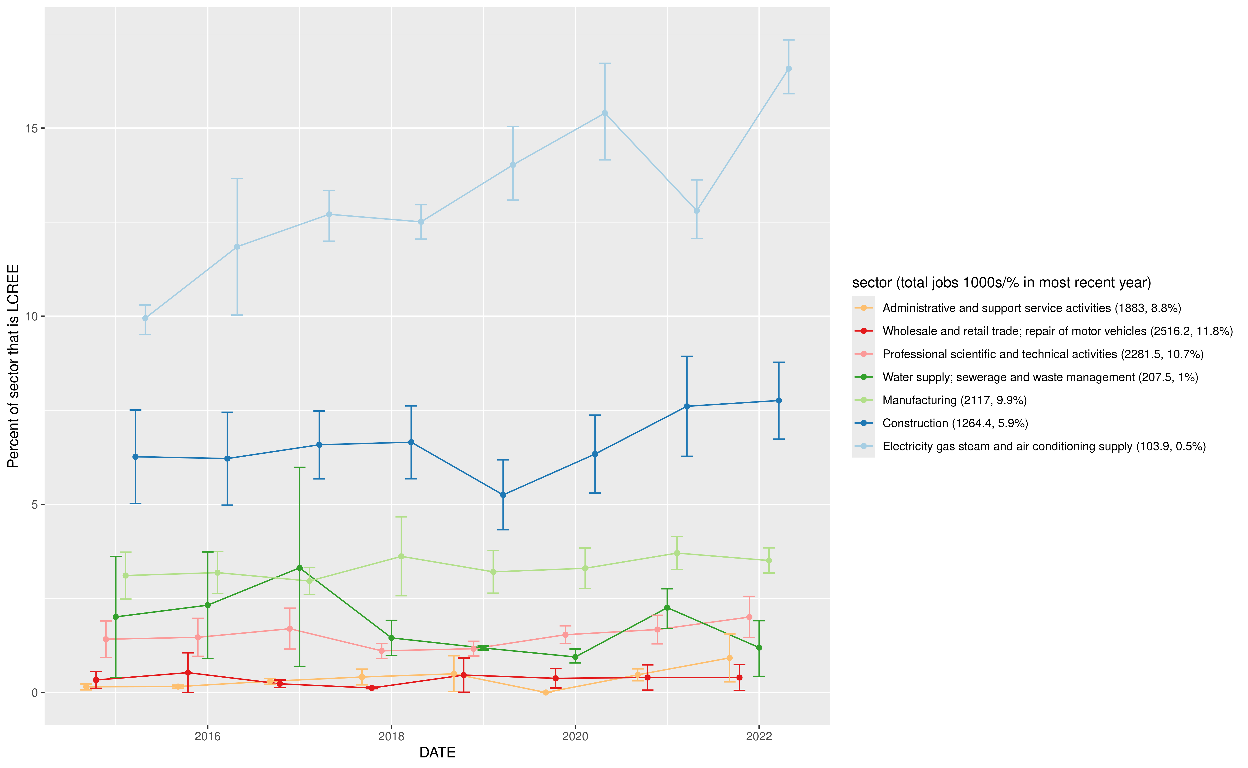
Figure 1: Percent of sector jobs identified as LCREE. 95% error bars. Total jobs in that sector / percent of total jobs in brackets.
Figure 2 links LCREE to GVA data at regional level, and presents an ‘if / then’ scenario: if LCREE GVA and jobs existed in proportion to sector size in each location, what would the likely spread of GVA be? (Note, this is not showing what SY’s actual LCREE job count is.) It includes 95% likelihood range for SY for this if/then scenario. The true concentration of LCREE jobs will not be so even (see the recent Northern Powerhouse report for analysis of this ) but it gives an indication of which sectors and what economic scale LCREE jobs could take.
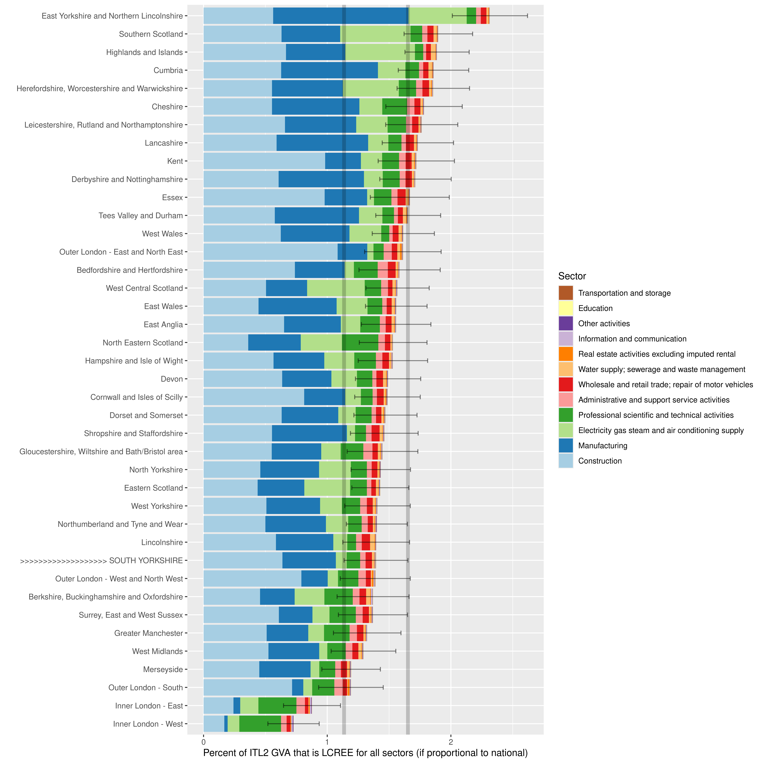
Figure 2: If/then estimate of ITL2 region % green (LCREE) GVA by sector, South Yorkshire in caps/arrows (bottom quarter), Grey lines are South Yorkshire 95% CIs

The productivity of South Yorkshire’s sectors relative to the rest of the UK
A starting point for thinking about how job investment could change SY’s productivity is being clear on where the region sits relative to the rest of the UK. Figure 3 shows this, for broad sectors, combined to match the LCREE survey’s sector categories (though note some sectors are excluded and put in Figure 4 instead, see below). Sectors are in each pane, most productive on average left to right. All ITL2 zones are shown in dots, for five years of moving average output per job (expressed as a percent of total GB output so comparisons across time are valid). SY is overlaid in large red dots.
Some of the key facts Figure 3 shows:
- The top two green job sectors in LCREE, manufacturing and construction, have very different productivity per job in SY. Manufacturing has remained at or near the lowest end of all places in the UK. There will of course be firms with much higher productivity, but on average it has been stuck for some time. Construction has been much more typical of the UK as a whole, with some ups and downs. Another important green sector, scientific and technical jobs, while relatively low, has seen recent productivity increases when compared with the rest of the UK.
- ICT, as well as being a highly productive sector, has seen SY’s output per job rapidly climb into the highest places in the UK.
- Education has been consistently productive in SY, and continues to increase relative to other places in the UK.
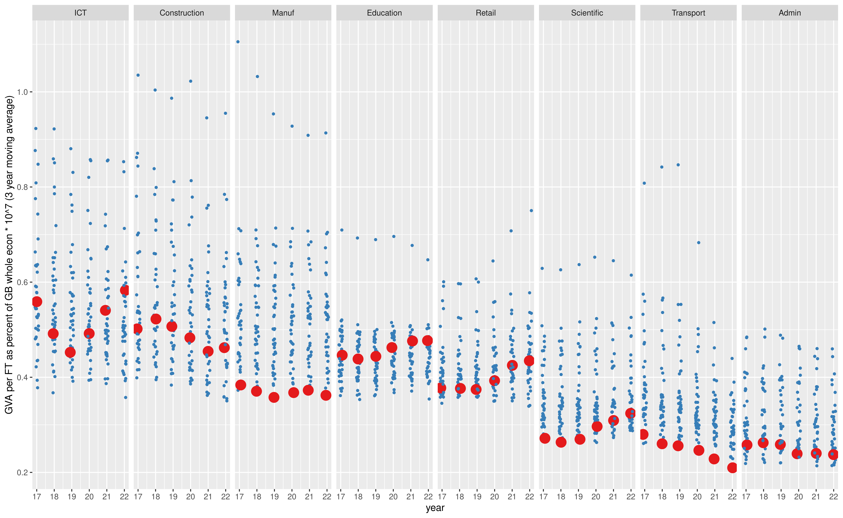
Figure 3: Productivity per job, as % of GB total output. Broken down by SIC section, each point is an ITL2 zone. 3 yr moving average shows change over time. SY overlaid in larger dots.
Figure 4 adds back in the power, real estate and mining sectors and includes other key LCREE SY sectors for comparison. These appear highly productive, but this is likely a combination of very low job counts (see table below, but in SY, power has around 800 jobs, real estate a thousand and mining around 200) and how that denominator raises apparent output per job.
Power in particular is a thorny sector here - the sector with the largest percent of LCREE jobs, but very small in SY in terms of direct jobs. Real estate productivity is largely due to the rental sector (imputed rent has been removed from this analysis).
These differences are discussed below to think about how they affect economic outcomes from new jobs and capital investment.
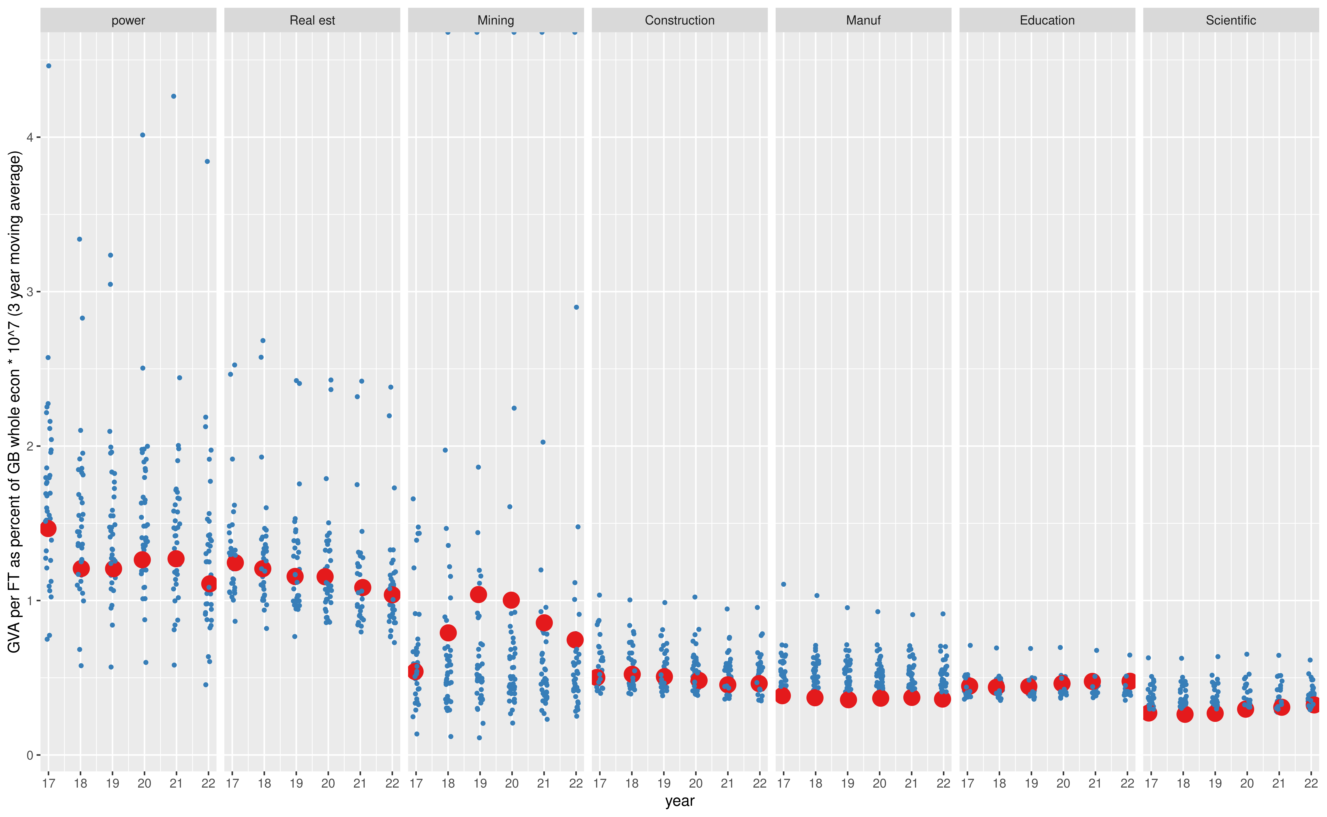
Figure 4: Productivity per job, as % of GB total output, comparing power, real estate and mining. SY overlaid in larger dots.

Keeping a focus on ‘good growth’ that grows both GVA and jobs
Figure 5 makes the point that investment can lead to very different outcomes for GVA versus jobs - a key point to consider if policy is aiming for ‘good growth’ that, as much as possible, supports jobs as well as productivity growth.
In Figure 5:
- Percent change of total manufacturing GVA over time is plotted against percent change in job count, for all ITL2 zones including South Yorkshire (in blue).
- Labels are coloured by ‘compass direction’ - for example, green ‘North East’ arrows saw both GVA and jobs growth, whereas purple ‘South East’ arrows saw GVA grow while job count shrank.
- Arrows in the dark diagonal section of the plot show places where productivity (GVA per job, shown in the labels) increased. A portion of places increased productivity while increasing both GVA and job count (including SY). Another chunk (all those pointing ‘south east’) grew both productivity and GVA while job counts dropped. Two pointing ‘south west’ grew productivity because job count dropped proportionall slower than GVA.
The data here is underscoring a basic point: total factor productivity for a sector can come from several sources, and investment is not guaranteed to boost jobs. Indeed, if discussing green investment, some sectors may well be very vulnerable to job losses while productivity and carbon output improves.
Capital deepening is likely essential for overall productivity improvements, especially given SY’s manufacturing productivity for example, but how to achieve this in a ‘good growth’ way? Wilkes quotes Lord Turner pointing out that “rapid productivity growth in one sector of the economy, reflecting rapid technological progress, can be combined with low overall productivity growth, if freed up labour moves into low productivity growth sectors”. This is the opposite of under-utilised labour moving into better work.
For sectors where it makes sense, is it possible to keep job, skills and investment strategy pointing ‘north east’ in this plot? For those where it doesn’t make sense, how to support changes in job composition that support workers and help to avoid scenarios like that described by Lord Turner?
Figure 5: MANUFACTURING Percent change GVA and jobs in ITL2 zones, moving average between 2015/17 and 2018/20. South Yorkshire in Blue. See text for full breakdown.

Adding a new job in South Yorkshire: what factors determine its economic impact and how we measure it?
This section uses existing output per job in SY to estimate how a new job could change the economy on average, given its likely spread of productivity values. As well as the value of the job, the following other factors can be considered: the value of any replaced job, if someone within SY moves to the new post; where in the job landscape the employee came from - from inactive workers, from outside the area, whether commuting.
The numbers are a first approximation using reasonable assumptions based on the data about job value spreads, in order to explore how the location, activity status and skill levels of workers interacts with new jobs and where GVA gets counted.
It is possible to identify two bounds on how much extra GVA a new job will bring to SY, with the reality being somewhere between them. At one extreme, someone already economically active in South Yorkshire gets the job, most likely moving from a lower to higher GVA position - so the net GVA gain for South Yorkshire is smallest. At the other, the new job attracts a new worker to the region, either through inducing a commute, attracting a migrating worker (internal to the UK or not, broadly the same outcome on SY GVA) or drawing in someone from South Yorkshire’s existing pool of inactivity (which could include, for example, a graduate based in the region starting a new job). Each of those has different implications for what the ultimate GVA gains look like, on top of which sector the job is in.
Where on average those numbers fall given any investment depends on the larger pull and push factors at play in the region. For example, there is evidence that SY has an oversupply of workers with L4 skills, often in jobs that do not fully exploit their productivity potential. This would lead to more candidates from SY for the newly created jobs - increasing productivity but lowering the net gain relative to growing the workforce. There are knock-on effects as job composition shifts (moving jobs creates vacancies; job creation spillovers occur etc) but SY’s low skill equilibrium will tend to mean there is more unexploited productivity locally to soak up, compared to some other places where skills more closely match jobs.
Other economic geography push/pull factors will be considered below.
Starting with the scenario where a new job is taken by a worker already in SY, take as an example a new job in manufacturing. Assume that additional output per job roughly matches its pay. The likely spread of GVA output per job across all SY jobs ranges currently (latest data is 2022) from around £40,000 to £105,000 a year (5% to 95% quantiles from a spread of SY jobs in the main selected sectors) with an average of around £73,000. A credible spread of GVA per job for SY manufacturing around its average output of £65,000 is around £50,000 to £83,000.
If a new manufacturing job is filled from another SY position, assume that the net GVA output (the difference between the old and new job) will always be positive (on the basis that output reflects earnings and the candidate would not move to a less well paying job). Also assume that job is being filled from someone moving from within the range of existing SY jobs (though again, only those with a GVA value below the randomly selected manufacturing job).
Simulating using these assumptions to get a full spread of possible outcomes finds that, on average, the net GVA gain would be around £14,300 a year per job, stretching to £35,000 at the 95% percentile. That’s an average of around 28% extra GVA compared to the internally displaced jobs.
The table below repeats these simulations for all broad SIC sections (matching the LCREE sector categories), ordering by average percent GVA gained per new job if the worker moved from elsewhere in the SY economy. These simulations contain several assumptions, and are approximate. Some bullet points on what might be learned from them:
- The first value column - av new job GVA - would be the additional GVA from a new job filled by a commuter, a SY graduate, or new migrant (from within or outside the UK) i.e. it wouldn’t be net of GVA from other work within South Yorkshire. av net GVA is the estimate if job composition changes within South Yorkshire, with percent GVA gained showing how much extra GVA proportionally would be gained per job (on average) if internal job composition changed.
- Unsurprisingly, new jobs in higher productivity sectors tend to have higher average proportional GVA gains, if workers with SY move to those jobs.
- As already mentioned, GVA in the top three sectors of power, real estate and mining are perhaps misleading due to the their oversized apparent productivity per worker (based e.g. for power on very high profit rates), and they have very small job numbers overall (see job count and % in table). It would be necessary to more fully understand productivity in power firms to better estimate what role they could play in SY growth and green growth, but in terms of jobs numbers, there isn’t a large base to grow from currently.
- For all other sectors with more straightforward GVA per worker (from ICT to transport) the absolute and percent net gains are higher the more productive the sector is. Built into the assumptions is that a higher productivity job would more likely release a larger chain of spillovers to other jobs within SY, so internal gains should be higher. Compare ICT to transport directly: a new ICT job could add £105,000, netting £35,000 on average if from internal job shifts. Compare to transport: as Figure 3 shows, productivity per worker has been dropping, most likely due to the sector’s large recent job expansion into warehousing activities. An average new transport job adds around £37,000, netting only around £3,000 on average if employing from within SY - though note, lower pay jobs like this have a higher probability of attracting workers from SY’s pool of inactivity, so the full £37,000 could well be added.
- This data implies that there is an inverse relationship between sector productivity and the ratio of purely new job to net new job value. For example, a new job in transport attracting someone from outside SY could bring in ten times more GVA than if displacing another SY job. That ratio drops rapidly for higher productivity jobs, with new ICT jobs filled external to SY bringing in three times more GVA than if net. But note from the table, the absolute amounts are so much larger for more productive posts.
The next section looks more closely at what different scenarios these numbers might imply, looking at the scale and productivity of sectors (see job counts / percents in the table) and how geographical economic forces shape which of these outcomes are more likely from job investment, and considers what role green jobs play in it.
sector (jobs 1000s/%) | av new job GVA | av old job GVA | av net GVA | percent GVA gained
power (0.8, 0.2%) | 199,911 | 73,531 | 126,381 | 171.87
Real est (4.4, 1.1%) | 187,501 | 73,556 | 113,945 | 154.91
Mining (0.2, 0%) | 135,881 | 73,235 | 62,646 | 85.54
ICT (14, 3.7%) | 105,590 | 70,003 | 35,587 | 50.84
Agri (0.7, 0.2%) | 105,031 | 70,039 | 34,991 | 49.96
Water (4.1, 1.1%) | 89,558 | 64,812 | 24,746 | 38.18
Education (35.3, 9.3%) | 86,255 | 63,496 | 22,759 | 35.84
Construction (25.1, 6.6%) | 83,889 | 62,253 | 21,636 | 34.76
Retail (46.6, 12.2%) | 78,558 | 59,378 | 19,180 | 32.30
other (109.4, 28.7%) | 74,486 | 57,176 | 17,310 | 30.27
Manuf (54.5, 14.3%) | 65,544 | 51,222 | 14,322 | 27.96
Scientific (23.9, 6.3%) | 58,906 | 46,921 | 11,984 | 25.54
Admin (30.2, 7.9%) | 43,460 | 37,620 | 5,840 | 15.52
Transport (31.4, 8.2%) | 37,912 | 34,079 | 3,834 | 11.25

Bringing all that together: identifying the dials to turn
This section synthesises the above to consider the following:
- The gains from different types of investment, given some key assumptions
- How the balance of geographical forces can impact on productivity outcomes (both in GVA accounting terms and otherwise)
- Implications from this analysis for green job investment
Consider a series of ‘dials’ that policy could turn, and also a series of variables that policy has less direct control over but can be treated as dials for now. The outcome of those can then be measured (though some discussion of the vital importance of measure choice is below).
- Dial 1: Cost of investment per new job. The 2024 CBI net zero report finds investment per new green job has been around £680,000. A 2019 Department for International Trade report finds FDI investment per new job is around £345,000. If those figures are in the right order of magnitude, and using the average SY GVA per job of around £88,700, time to positive returns in SY jobs would on average be four to eight years, all else equal.
- Dial 2: Public investment cost and the ratio to private ‘crowding in’. The sources cited above average around a 1 to 3 ratio as achievable[^Empirical evidence for this?]. If true, and tying to the last point, on average public investment of between £115,000 and £225,000 could crowd in one job’s worth of public/private investment.
- Dial 3: sector investment choices, and how much can that investment focus on higher productivity jobs within that sector? The table above indicates average GVA per job for different broad sectors, and net GVA if the new job pulls from SY’s existing workforce. Increasing average SY productivity per worker will happen if the job is above average productivity by any amount (whether net or fully new, because the former keeps the denominator the same). Total output will increase more if attracting new workers to the region (or e.g. employing a new graduate).
- Dial 4: the balance of investment focus. This ranges between supporting entirely new firms in the region through to supporting SMEs to analyse factors holding productivity back - which includes but isn’t limited to skills investment, and also includes investment in other productivity factors. This dial also connects strongly to the ‘good growth’ points above: investment across all production factors is necessary, but will affect the balance of GVA versus affect on worker numbers.
  - This dial also covers investment in supporting SY people out of inactivity into employment, education or training. It needs special consideration in how it leads to measured outcomes, because it could potentially lower apparent average productivity. This is true for dial 4 generally: there are times when certain measures might appear to worsen while achieving desirable policy outcomes. (More on this below.)
- Dial 5: the balance of pulling from SY’s existing workforce versus attracting external workers. This is not in policymakers’ direct power to control, of course - but certain jobs including tradeable jobs in higher-productivity sectors will be more likely to pull in new workers from outside SY. That interacts with job values in neighbouring regions - a particular issue for the average SY manufacturing job who may struggle to attract workers from further afield. Though if higher-value jobs can be prioritised, that will both improve average productivity and act as a more effective external ‘pull’. It is still worth considering where policy would ideally want this dial to be set - what balance of growing the workforce versus supporting the existing SY workforce is optimal?
There are a range of other factors to consider that affect those dials:
- Different capital intensity for different jobs to be productive changes the investment picture. (Contrast ICT with manufacturing.)
- “A mix of demand-side and supply-side policies, which are sectorally and geographically sensitive, underpinned by collaboration and networking across firms, and broader partnership working, are needed to help escape low skill traps”.
The geographical factors are partly a matter of accounting - where GVA gets counted and whether it is net of other lost GVA as job composition changes. They are also partly a matter of policy - whether to invest in skill and capital improvements in the region, or whether to attempt to grow by attracting new workers. The latter is, however, also a function of economic forces - whether SY can generate enough overall momentum to produce larger flows of commuters and migrants (internal to the UK or otherwise).
The accounting factor - that bringing in external workers produces such a large GVA gain compared to the net effects of improving job composition within South Yorkshire - needs consideration. Should different measurement methods be used that can better support ‘good growth’ goals? The final section briefly considers this.
SY’s manufacturing sector needs perhaps unique consideration when it comes to combining all the above factors. The balance of where jobs are filled from will be a function of how attractive it is in comparison to similar roles elsewhere. While some higher productivity manufacturing jobs may attract workers from outside SY, given the region’s manufacturing productivity is currently so low, it may struggle to do so.
As well as suggesting investment in across-the-board productivity improvements, this points to a need to dig deeper into the nature of SY’s own manufacturing ‘productivity puzzle’. Overall productivity can be increased through above-average GVA output from new jobs, successful capital deepening (though with the possibility of job losses), skills support and direct research to understand factors holding especially SMEs back. If done successfully, it will be economically self-reinforcing.
That does still leave this question: investment-wise, what are the marginal gains of improving SY’s low manufacturing productivity compared to investing in already high productivity sectors? Both are needed, so the choice is not binary, but thinking about this way could help focus further research.
The LCREE element of investing in jobs and sectors is double edged. As mentioned above, LCREE jobs and GVA growth has accelerated since COVID - an average rate of 6.25% in the last three years of data, compared to 1.45% in the first three. But this only takes its GVA up to 1.27% of the UK’s economy (1 to 1.54% 95% CI). LCREE jobs are mostly in already higher-productivity sectors, so investing in them aids the goal of increasing SY’s average productivity, while also supporting green goals. But improving SY’s overall productivity will require looking beyond direct LCREE jobs to ask how it can be improved across the board, especially in sectors like manufacturing where SY continues to struggle.
A perennial issue also is our lack of detailed understanding of how sectors inter-relate. This is especially important if attempting to promote LCREE jobs and sectors generally - what is the ecosystem? It is also a vital question more generally. For instance, the Sheffield based company Fourjaw makes manufacturing analytics software; in a recent case study, they optimised a company’s machines enough to increase productivity by 10% - an example where ICT and manufacturing reinforce each other. Equally, as Diane Coyle argues, manufacturing and services are in the same way not cleanly separable, and increasingly so.
Some of that is captured in models of spillover used, for example, by the 2024 CBI net zero report and DIT’s FDI report, generally finding a 1 to 3 ratio of direct versus spillover gains - but these are top down using input-output data, not based on any detailed ground-level understanding of how sectors interact. Combining both data analysis with on the ground work would be a good way forward.

How we measure success
It is desirable both to add more higher productivity jobs in SY; it is also desirable to address SY’s inactivity rates and support more people into employment, education or training. But care is needed when measuring top level success for the various different productivity goals. For example:
- For every person moved from inactivity to a new job with below average productivity (which is likely in this case), South Yorkshire average output per worker will drop, apparently increasing the productivity gap to other regions. (GDP per capita will still increase, but this is a tricky measure to use for productivity.)
This is partly a consequence of the choice of measures that tend to be used to compare regions. Those comparisons are important, but they are less well suited to actually helping to guide regional policy.
Further careful thinking is required to decide how to measure success in SY’s productivity goals, to avoid perverse data outcomes and disincentivise desirable policies.

LSE, Grantham Institute, “Boosting growth and productivity in the United Kingdom through investments in the sustainable economy”, January 2024: This cites a 1 to 3 crowding in ratio. Northern Powerhouse, “Net Zero by 2050: One Plan, Two Objectives - How Green Growth Can Build the Northern Powerhouse”, July 2024, suggests an average crowding in ratio of £1 to £2.65. The Labour Manifesto aims, through its new National Wealth Fund, “three pounds of private investment for every one pound of public investment”.
Northern Powerhouse, “Net Zero by 2050: One Plan, Two Objectives - How Green Growth Can Build the Northern Powerhouse”, July 2024
Wilkes, G., “Productivity: firing on all cylinders Why restoring growth is a matter for every UK sector”. 2021 p.27
This could be empircally estimated by digging deeper into individual firm productivity using e.g. Beauhurst data.
CBI, “The UK’s net zero economy: The scale and geography of the net zero economy in the UK”. 2024
DIT, “Understanding FDI and its impact in the United Kingdom for DIT’s investment promotion activities and services”. 2021
Green, A., “Low skill traps in sectors and geographies: underlying factors and means of escape”. 2016
See lnkd.in/d8NfN_WY

