# SECTOR INVESTMENT & GREEN JOBS

## DOCUMENT OUTLINE

* The first section looks at investment in new jobs, return on investment in GVA and where the gaps in knowledge are for South Yorkshire. It does this using broad sectors, processed to match those in the ONS ‘Low Carbon and Renewable Energy Economy’ (LCREE) survey, so that implications for green jobs can be discussed.
* The second section discusses the LCREE survey and its implications for South Yorkshire.

# Investment in new jobs and their GVA

## We have a reasonable idea of investment/GVA per job at the UK level...

**Cost of investment and GVA return per new job.** At the UK level, the 2024 CBI ‘Net Zero’ report finds investment per new green job costs around £680,000[1]. A 2019 Department for International Trade report finds FDI investment per new job (of any type) is around £345,000[2]. The same CBI report finds each new Net Zero job generates £114,300 GVA per year, including ‘spillovers’ from each new job into other sectors. The DIT report finds this figure (for FDI, and again including spillovers) to be £212,000. GVA for the single new job itself is likely around a third of that, on average.

**Public investment cost and the ratio to private ‘crowding in’**. Several sources suggest a 1 to 3 ratio of public investment ‘crowding in’ private investment as achievable[3]. Using the CBI and DIT cost-per-job estimates above, a*n average* public investment of between £115,000 and £225,000 could crowd in enough private investment to fund one average UK job.

## But no robust analysis of how GVA returns on investment *differ for separate sectors (*including in South Yorkshire). We can take some educated guesses, but there’s more to learn

Ideally, we want to be able to answer the following statement to compare return on investment in different sectors: “Public investment of X amount to create Y number of green jobs in this sector will unlock Z GVA.” The findings from the literature above provide only an **average** answer to this question, at the UK level.

We do have figures for GVA per job in South Yorkshire – see the table below (with job count and percent of South Yorkshire job total in brackets). The **top sector by GVA per job is power,** with a very high productivity value, but only around 800 jobs in SY, which is 0.2% of SY total jobs. Compare to ICT (at close to half the productivity of the power sector but very high for South Yorkshire and compared to GB) with around 14,000 jobs – 3.7% of SY’s total jobs.

|  |  |
| --- | --- |
| **sector (jobs 1000s / %)** | **av GVA per job** |
| power (0.8, 0.2%) | 199,911 |
| Real est (4.4, 1.1%) | 187,501 |
| Mining (0.2, 0%) | 135,881 |
| ICT (14, 3.7%) | 105,590 |
| Agri (0.7, 0.2%) | 105,031 |
| Water (4.1, 1.1%) | 89,558 |
| Education (35.3, 9.3%) | 86,255 |
| Construction (25.1, 6.6%) | 83,889 |
| Retail (46.6, 12.2%) | 78,558 |
| other (109.4, 28.7%) | 74,486 |
| Manuf (54.5, 14.3%) | 65,544 |
| Scientific technical (23.9, 6.3%) | 58,906 |
| Admin (30.2, 7.9%) | 43,460 |
| Transport (31.4, 8.2%) | 37,912 |

All else equal, maximising the highest output jobs would provide the highest per-job return. However, consider the following factors.

* **Each sector has very different capital/investment intensities, and different capacity for jobs growth overall.**
  + For example, the power sector (SIC section ‘electricity, gas, steam, air supply’) is highly capital and infrastructure-intensive, leading to very high output per worker. At the same time, the power sector historically never moves far from 0.5% of the UK’s total workforce. In South Yorkshire, that number is lower (0.2% of SY jobs) – hitting the national average would add another 2000 power jobs, increasing the size of SY’s economy by around £400 million or 1 to 1.5% - a large chunk, but perhaps unable to go much beyond that.
  + Sectors like ICT can have a mix of low and high capital intensity. One of SY’s largest ICT sectors, **telecommunications**, can be very capital-intensive[4].
* **In South Yorkshire, each sector’s average job output differs from (and is often lower than) elsewhere in Great Britain. What opportunities are there to move SY closer to other places?** Figure 1 illustrates these output differences for key sectors (excluding power, real estate and mining to make comparisons easier), showing relative productivity per job over time.
  + Sectors like ICT and education are strong in SY, high output per worker and increasing their productivity rank, relative to GB. They seem a safe investment bet for GVA and job returns.
  + Construction, manufacturing and scientific/technical vary in their relative productivity, but they are all also where green jobs tend to be found (see below). Two of these – manufacturing and scientific – are relatively low productivity, with SY manufacturing in particular struggling historically. More work is needed to understand why, what the spread of productivity within those sectors is, and what difference public investment can make.

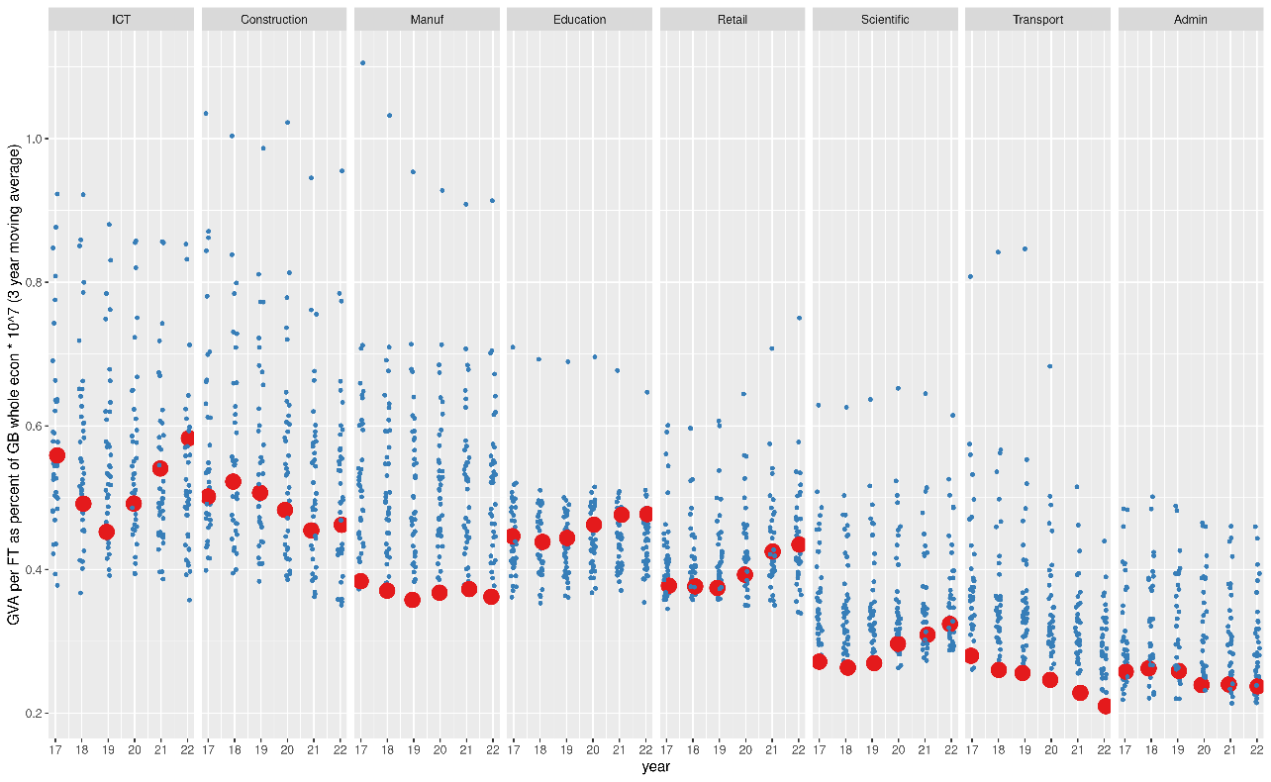

Figure 1: Productivity per job, as % of GB total output. Broken down by SIC section, each point is an ITL2 zone. 3 yr moving average shows change over time. SY overlaid in larger dots.

## What could be done to understand the investment to GVA relationship better in South Yorkshire?

This can be broken down into two approaches (both of which could of course be combined):

* “Top down” data analysis and modelling approaches. These would be larger projects. including:
  + Continuing with relatively simple descriptive data analysis to shine a light on South Yorkshire’s existing sector picture (relatively easy).
  + Decomposing productive factors in different regions to try to understand relative investment needs. This would be statistically trying to extract how sectors differ given data on inputs, including jobs. There is a literature around doing this; more research is needed to check if it can be applied to the specifics of South Yorkshire.
* “Bottom up” qualitative and networking to dig deeper into South Yorkshire’s specific industrial makeup, connections and investment needs.

# What does the ‘Low Carbon and Renewable Energy Economy’ survey tell us about the Green Economy?

The Office of National Statistics ‘Low Carbon and Renewable Energy Economy’ (LCREE) survey asks businesses what proportion of turnover and jobs are in a range of green activities, and has data going back to 2015.

Linking the LCREE survey to GVA data shows that in the most recent year 1.27% (1 to 1.54%, 95% CI) of the UK economy currently comes from ‘LCREE jobs’. The 2024 CBI net zero report finds around the same using Data City data - direct economic impacts of green jobs is 1.27% (1 to 1.54%, 95% CI) of the economy - but it also finds economic spillovers triple the GVA impact nationally. The same is true for job count. The LCREE survey finds direct green job count is around 270,000 (210-330K 95% CI), with the CBI report roughly triple that (765,000 – with spillovers included).

Figure 2 shows what percentage of jobs in that sector have been ‘LCREE’ over time (showing sectors with the biggest percent). For the majority it is very low, but the key five sectors with substantial LCREE jobs are (in order of percent jobs) power, construction, manufacturing, water, and scientific/technical.

These top five LCREE sectors vary in size: while the power sector has the largest percent of LCREE jobs, it is only 0.5% of total jobs in Great Britain, whereas manufacturing and construction account for 6% and 10% of total GB jobs respectively.

LCREE job numbers have accelerated since COVID - an average growth rate of 6.25% in the last three years of data, compared to 1.45% in the first three. While this only takes its direct GVA up to 1.27% of the UK’s economy, if that growth rate holds, it represents an important step change.

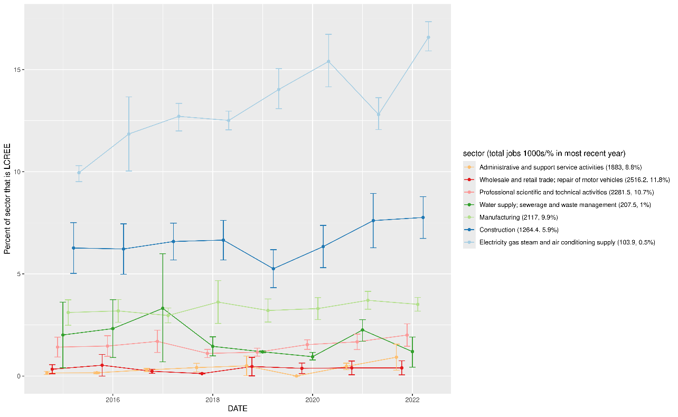

Figure 2: Percent of sector jobs identified as LCREE. 95% error bars. Total jobs in that sector / percent of total jobs in brackets.

## What are the implications for South Yorkshire?

The vast majority of LCREE jobs are in only these four broad sectors: construction, manufacturing, power (‘electricity, gas, steam and air supply’) and ‘scientific / technical’ (listed in order of the total GVA contribution coming from LCREE jobs in those sectors).

The 2024 CBI net zero report suggests ‘LCREE jobs’ are 1.6 times more productive than average. While this is likely mostly due to which sectors dominate LCREE jobs, rather than green jobs themselves being higher productivity, it is nevertheless true that investment in the most prominent LCREE jobs would be on average more productive.

However, for South Yorkshire – as shown above – there are productivity challenges for three out of those four sectors, with only construction being a strong LCREE sector in terms of both output *and*job numbers. The power sector’s potential output contribution is high (adding 1 to 1.5% to SY’s economy if job numbers matched the GB average) but may be capped at a relatively low number of jobs, relative to the required capital investment. Both manufacturing and scientific sectors in SY are, on average, relatively very low productivity jobs, despite together making up a fifth of SY jobs.

More research is needed to find out whether LCREE jobs are indeed more productive on average than others in those two sectors (e.g. by examining the output of specific firms using Beauhurst data). If so, LCREE investment could help improve those sector’s productivity overall.

1. CBI, “The UK’s net zero economy: The scale and geography of the net zero economy in the UK”. 2024
2. DIT, “Understanding FDI and its impact in the United Kingdom for DIT’s investment promotion activities and services”. 2021
3. LSE, Grantham Institute, “Boosting growth and productivity in the United Kingdom through investments in the sustainable economy”, January 2024: This cites a 1 to 3 crowding in ratio. Northern Powerhouse, “Net Zero by 2050: One Plan, Two Objectives - How Green Growth Can Build the Northern Powerhouse”, July 2024, suggests an average crowding in ratio of £1 to £2.65. The Labour Manifesto aims, through its new National Wealth Fund, “three pounds of private investment for every one pound of public investment”.
4. See Elmasr H., Morgan Stanley Investment Management, “Capital intensity and stockreturns”, Journal of Investment Strategy Vol 2 No.1, 2007.