# Scottish Employment 1971 to 2011: looking for shocks

## Overview of data

From 1971 to 2011 "economically active" % of zone population.

### Raw employment percent per zone

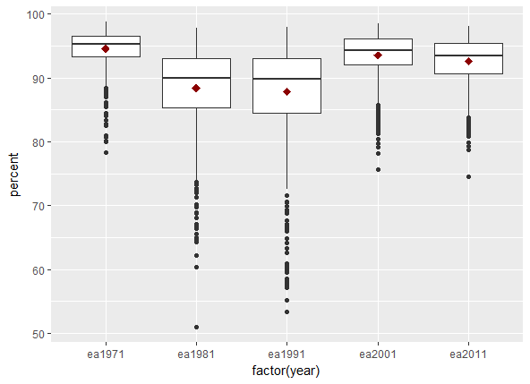

### Change in employment between decades

Last one: change between 71 and 91. Many / most places saw two consecutive decades of increased unemployment.

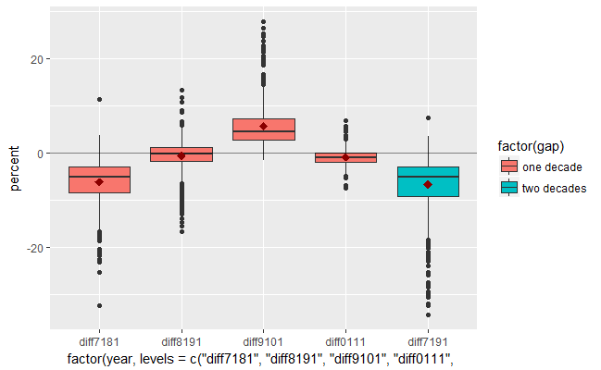

### Geography...

Decrease in employment between 71 and 91 (blue boxplot above) looks like the most effective way to identify shock points. Almost all of Scotland saw something like a ~5% increase in unemployment over those 20 years - 54% of zones sustained the increase over that period, with most of those in urban areas.

This Glasgow map: three red clusters show 30-34% decreases in economic activity of the people in those zones between 71 and 91. The blue area in the north actually increased. Zones with a thicker black outline had decreases between both of those Censuses - so those are more urban.

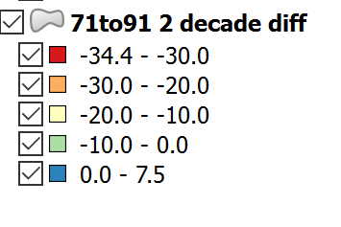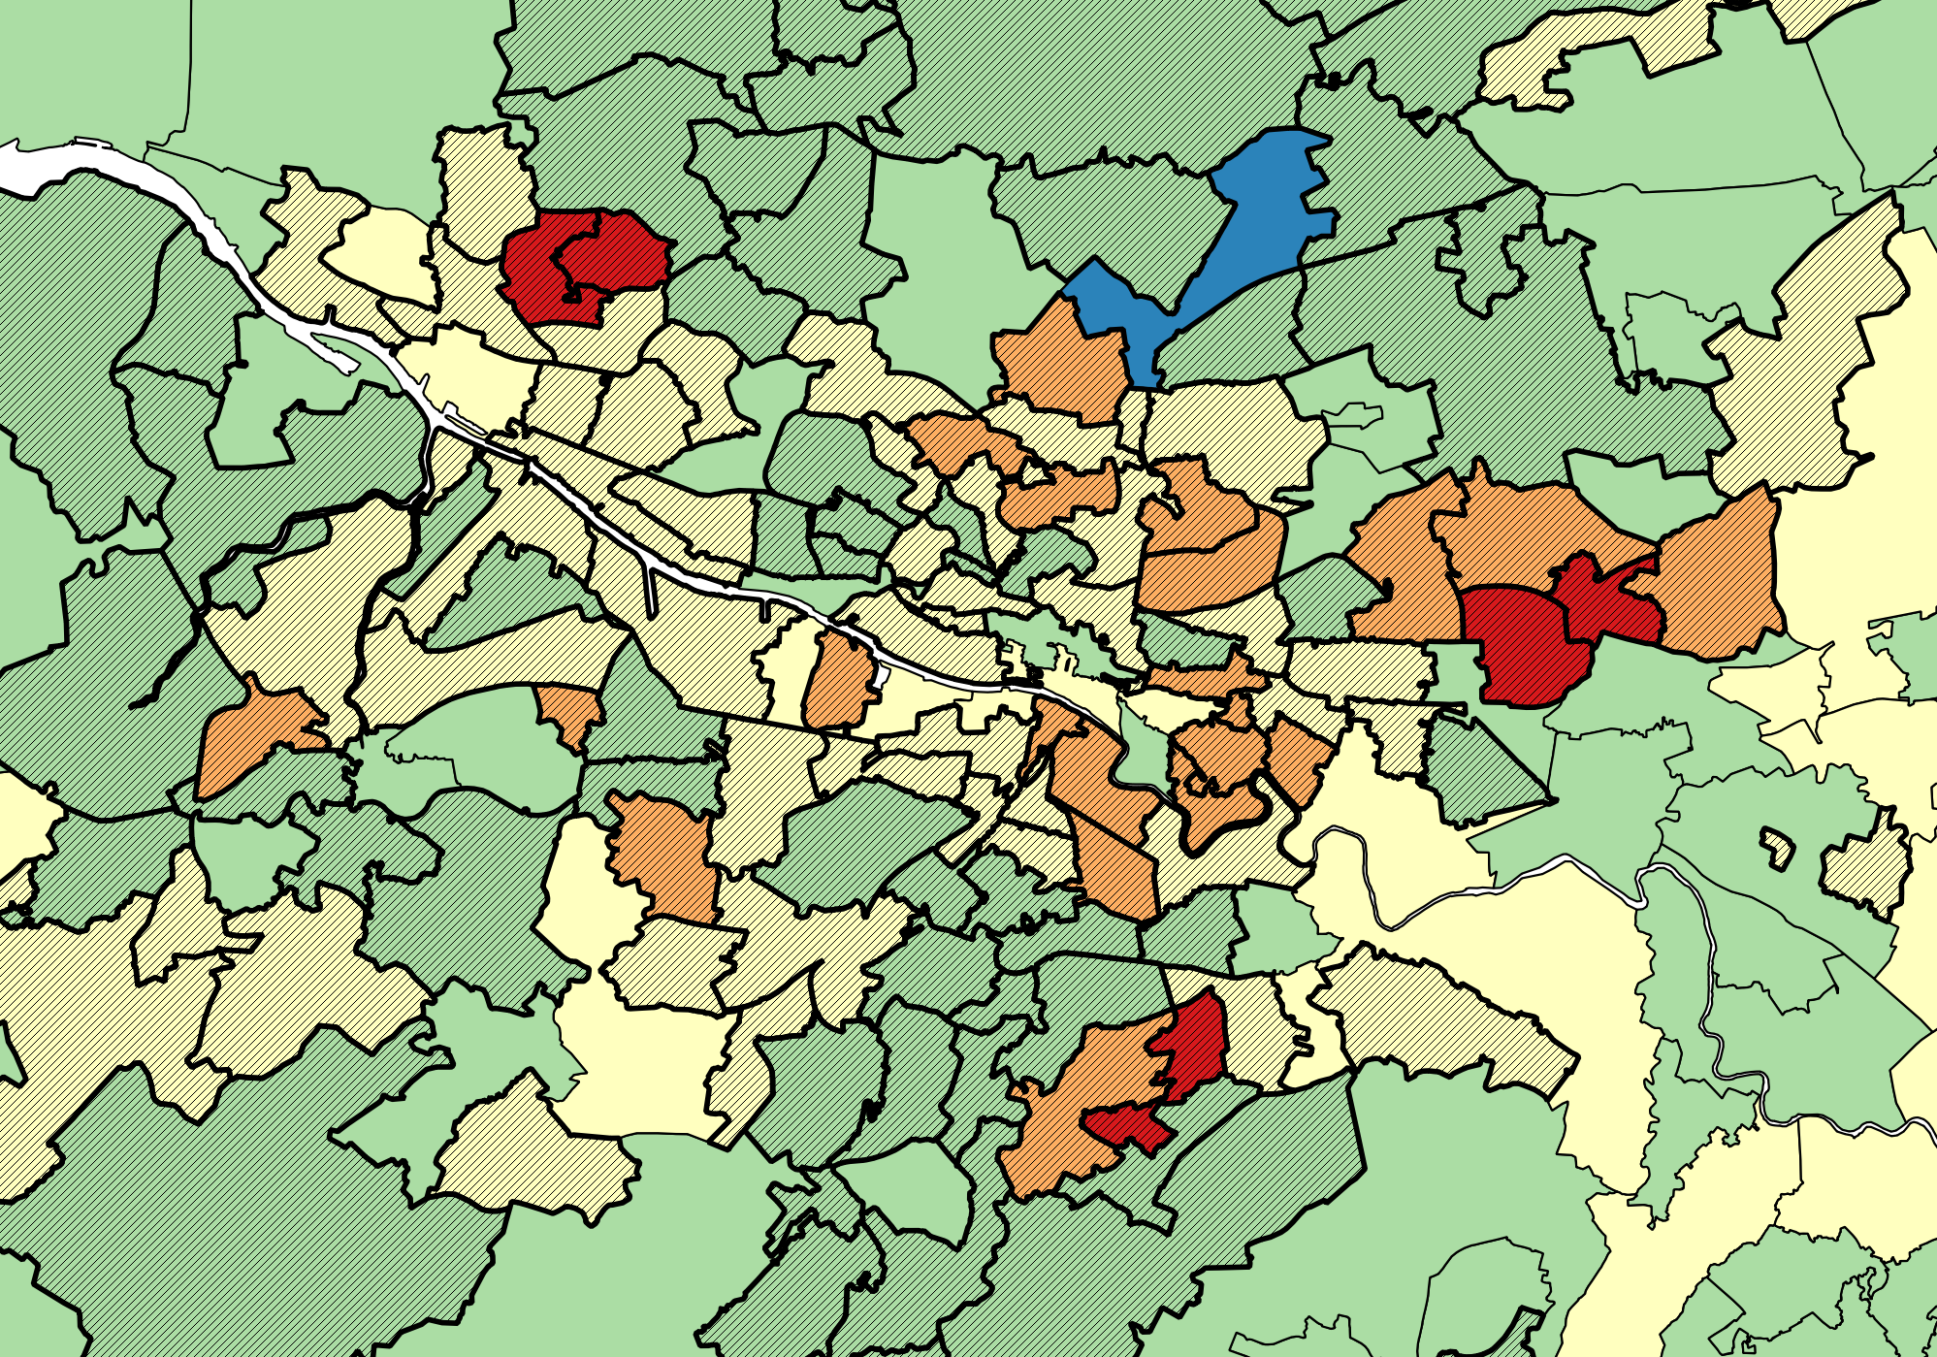

A few other features from looking at those decades, though most of these are not going have very interesting country-of-birth numbers:

* Change around Edinburgh is much more even, though two zones next to each other in the South see an employment drop and increase.
* A large region East of Ayr (south of Glasgow) got hit over both 71 and 81 to 91.
* Areas north of Inverness saw a large unemployment increase but only 81 to 91.
* Aberdeen has increases over both of those decades in the centre but it's also sandwiched in the North and South by places that decreased. New incomers?