# Regressions

## ALL

Call:

lm(formula = xij2011 ~ xij1991 + lph91 + lpophs91 + migsh91,

data = eViewsFile)

Residuals:

Min 1Q Median 3Q Max

-4.7537 -0.0638 -0.0203 0.0256 5.1072

Coefficients:

Estimate Std. Error t value Pr(>|t|)

(Intercept) 0.0063484 0.0403960 0.157 0.875

xij1991 0.4333795 0.0063900 67.822 < 2e-16 ***

lph91 0.0246481 0.0041584 5.927 3.13e-09 ***

lpophs91 -0.2854673 0.0113848 -25.074 < 2e-16 ***

migsh91 0.0138218 0.0007167 19.286 < 2e-16 ***

---

Signif. codes: 0 ‘***’ 0.001 ‘**’ 0.01 ‘*’ 0.05 ‘.’ 0.1 ‘ ’ 1

Residual standard error: 0.1934 on 18079 degrees of freedom

Multiple R-squared: 0.342, Adjusted R-squared: 0.3419

F-statistic: 2349 on 4 and 18079 DF, p-value: < 2.2e-16

## EUROPE INC. IRELAND

Call:

lm(formula = xij2011 ~ xij1991 + lph91 + lpophs91 + migsh91,

data = europe)

Residuals:

Min 1Q Median 3Q Max

-2.41006 -0.05723 -0.01170 0.03159 2.22117

Coefficients:

Estimate Std. Error t value Pr(>|t|)

(Intercept) -0.1496924 0.0559397 -2.676 0.00747 **

xij1991 0.4699389 0.0102976 45.636 < 2e-16 ***

lph91 0.0397885 0.0057607 6.907 5.49e-12 ***

lpophs91 -0.2955279 0.0157222 -18.797 < 2e-16 ***

migsh91 0.0141535 0.0009701 14.589 < 2e-16 ***

---

Signif. codes: 0 ‘***’ 0.001 ‘**’ 0.01 ‘*’ 0.05 ‘.’ 0.1 ‘ ’ 1

Residual standard error: 0.1507 on 5749 degrees of freedom

Multiple R-squared: 0.4363, Adjusted R-squared: 0.4359

F-statistic: 1112 on 4 and 5749 DF, p-value: < 2.2e-16

## RICH

Call:

lm(formula = xij2011 ~ xij1991 + lph91 + lpophs91 + migsh91,

data = rich)

Residuals:

Min 1Q Median 3Q Max

-3.2528 -0.0601 -0.0163 0.0296 5.1349

Coefficients:

Estimate Std. Error t value Pr(>|t|)

(Intercept) -0.3591212 0.0516604 -6.952 3.89e-12 ***

xij1991 0.2949311 0.0081994 35.970 < 2e-16 ***

lph91 0.0607768 0.0053193 11.426 < 2e-16 ***

lpophs91 -0.2885435 0.0145745 -19.798 < 2e-16 ***

migsh91 0.0156100 0.0008963 17.417 < 2e-16 ***

---

Signif. codes: 0 ‘***’ 0.001 ‘**’ 0.01 ‘*’ 0.05 ‘.’ 0.1 ‘ ’ 1

Residual standard error: 0.1668 on 8215 degrees of freedom

Multiple R-squared: 0.3129, Adjusted R-squared: 0.3125

F-statistic: 935.1 on 4 and 8215 DF, p-value: < 2.2e-16

## POOR

Call:

lm(formula = xij2011 ~ xij1991 + lph91 + lpophs91 + migsh91,

data = poor)

Residuals:

Min 1Q Median 3Q Max

-2.4675 -0.0666 -0.0217 0.0235 4.1471

Coefficients:

Estimate Std. Error t value Pr(>|t|)

(Intercept) 0.332131 0.059156 5.615 2.02e-08 ***

xij1991 0.550934 0.009416 58.508 < 2e-16 ***

lph91 -0.007177 0.006088 -1.179 0.238

lpophs91 -0.279772 0.016655 -16.798 < 2e-16 ***

migsh91 0.010359 0.001074 9.642 < 2e-16 ***

---

Signif. codes: 0 ‘***’ 0.001 ‘**’ 0.01 ‘*’ 0.05 ‘.’ 0.1 ‘ ’ 1

Residual standard error: 0.2089 on 9859 degrees of freedom

Multiple R-squared: 0.3802, Adjusted R-squared: 0.3799

F-statistic: 1512 on 4 and 9859 DF, p-value: < 2.2e-16

## ALL PLUS MIGSHARE-MINUS-OWN AND QUEEN CONTIG

Call:

lm(formula = xij2011 ~ xij1991 + lph91 + lpophs91 + migsh91minusown +

w91q, data = eViewsFile)

Residuals:

Min 1Q Median 3Q Max

-4.3413 -0.0589 -0.0175 0.0252 5.1904

Coefficients:

Estimate Std. Error t value Pr(>|t|)

(Intercept) 0.0593134 0.0395150 1.501 0.133364

xij1991 0.3541068 0.0068351 51.807 < 2e-16 ***

lph91 0.0146054 0.0040717 3.587 0.000335 ***

lpophs91 -0.2457907 0.0111484 -22.047 < 2e-16 ***

migsh91minusown 0.0132139 0.0007076 18.674 < 2e-16 ***

w91q 0.2614349 0.0093439 27.979 < 2e-16 ***

---

Signif. codes: 0 ‘***’ 0.001 ‘**’ 0.01 ‘*’ 0.05 ‘.’ 0.1 ‘ ’ 1

Residual standard error: 0.1888 on 18078 degrees of freedom

Multiple R-squared: 0.3725, Adjusted R-squared: 0.3723

F-statistic: 2146 on 5 and 18078 DF, p-value: < 2.2e-16

## EUROPE PLUS MIGSHARE-MINUS-OWN AND QUEEN CONTIG

Call:

lm(formula = xij2011 ~ xij1991 + lph91 + lpophs91 + migsh91minusown +

w91q, data = europe)

Residuals:

Min 1Q Median 3Q Max

-2.02895 -0.05376 -0.01017 0.03203 2.17676

Coefficients:

Estimate Std. Error t value Pr(>|t|)

(Intercept) -0.0489001 0.0538676 -0.908 0.364

xij1991 0.3510208 0.0113838 30.835 < 2e-16 ***

lph91 0.0244024 0.0055594 4.389 1.16e-05 ***

lpophs91 -0.2558450 0.0151092 -16.933 < 2e-16 ***

migsh91minusown 0.0131895 0.0009428 13.989 < 2e-16 ***

w91q 0.3860286 0.0181669 21.249 < 2e-16 ***

---

Signif. codes: 0 ‘***’ 0.001 ‘**’ 0.01 ‘*’ 0.05 ‘.’ 0.1 ‘ ’ 1

Residual standard error: 0.1446 on 5748 degrees of freedom

Multiple R-squared: 0.4811, Adjusted R-squared: 0.4806

F-statistic: 1066 on 5 and 5748 DF, p-value: < 2.2e-16

## RICH PLUS MIGSHARE-MINUS-OWN AND QUEEN CONTIG

Call:

lm(formula = xij2011 ~ xij1991 + lph91 + lpophs91 + migsh91minusown +

w91q, data = rich)

Residuals:

Min 1Q Median 3Q Max

-2.8681 -0.0585 -0.0155 0.0301 5.1746

Coefficients:

Estimate Std. Error t value Pr(>|t|)

(Intercept) -0.3010463 0.0512739 -5.871 4.49e-09 ***

xij1991 0.2730483 0.0088860 30.728 < 2e-16 ***

lph91 0.0524378 0.0052826 9.927 < 2e-16 ***

lpophs91 -0.2673738 0.0144206 -18.541 < 2e-16 ***

migsh91minusown 0.0172221 0.0008895 19.362 < 2e-16 ***

w91q 0.0990053 0.0112108 8.831 < 2e-16 ***

---

Signif. codes: 0 ‘***’ 0.001 ‘**’ 0.01 ‘*’ 0.05 ‘.’ 0.1 ‘ ’ 1

Residual standard error: 0.1652 on 8214 degrees of freedom

Multiple R-squared: 0.3263, Adjusted R-squared: 0.3259

F-statistic: 795.7 on 5 and 8214 DF, p-value: < 2.2e-16

## POOR PLUS MIGSHARE-MINUS-OWN AND QUEEN CONTIG

Call:

lm(formula = xij2011 ~ xij1991 + lph91 + lpophs91 + migsh91minusown +

w91q, data = poor)

Residuals:

Min 1Q Median 3Q Max

-1.6477 -0.0579 -0.0167 0.0250 4.0366

Coefficients:

Estimate Std. Error t value Pr(>|t|)

(Intercept) 0.365397 0.056280 6.492 8.85e-11 ***

xij1991 0.411278 0.009784 42.037 < 2e-16 ***

lph91 -0.018060 0.005800 -3.114 0.00185 **

lpophs91 -0.212605 0.015934 -13.343 < 2e-16 ***

migsh91minusown 0.005122 0.001048 4.885 1.05e-06 ***

w91q 0.466581 0.014451 32.287 < 2e-16 ***

---

Signif. codes: 0 ‘***’ 0.001 ‘**’ 0.01 ‘*’ 0.05 ‘.’ 0.1 ‘ ’ 1

Residual standard error: 0.1986 on 9858 degrees of freedom

Multiple R-squared: 0.4403, Adjusted R-squared: 0.44

F-statistic: 1551 on 5 and 9858 DF, p-value: < 2.2e-16

## ALL PLUS MIGSHARE-MINUS-OWN, CONTIG & TTWA-LEVEL ECON ACTIVE

Call:

lm(formula = xij2011 ~ xij1991 + lph91 + lpophs91 + migsh91minusown +

w91q + ea_ttwa91, data = eViewsFile)

Residuals:

Min 1Q Median 3Q Max

-4.3275 -0.0598 -0.0175 0.0263 5.1855

Coefficients:

Estimate Std. Error t value Pr(>|t|)

(Intercept) -0.0511964 0.0484897 -1.056 0.29106

xij1991 0.3538984 0.0068325 51.796 < 2e-16 ***

lph91 0.0118916 0.0041283 2.881 0.00397 **

lpophs91 -0.2422873 0.0111795 -21.672 < 2e-16 ***

migsh91minusown 0.0132430 0.0007074 18.721 < 2e-16 ***

w91q 0.2603096 0.0093445 27.857 < 2e-16 ***

ea_ttwa91 0.0015478 0.0003939 3.929 8.56e-05 ***

---

Signif. codes: 0 ‘***’ 0.001 ‘**’ 0.01 ‘*’ 0.05 ‘.’ 0.1 ‘ ’ 1

Residual standard error: 0.1887 on 18077 degrees of freedom

Multiple R-squared: 0.373, Adjusted R-squared: 0.3728

F-statistic: 1793 on 6 and 18077 DF, p-value: < 2.2e-16

## EUROPE PLUS PLUS MIGSHARE-MINUS-OWN, CONTIG & TTWA-LEVEL ECON ACTIVE

Call:

lm(formula = xij2011 ~ xij1991 + lph91 + lpophs91 + migsh91minusown +

w91q + ea_ttwa91, data = europe)

Residuals:

Min 1Q Median 3Q Max

-2.03851 -0.05449 -0.01022 0.03393 2.17514

Coefficients:

Estimate Std. Error t value Pr(>|t|)

(Intercept) -0.2559169 0.0664603 -3.851 0.000119 ***

xij1991 0.3496893 0.0113599 30.783 < 2e-16 ***

lph91 0.0198616 0.0056123 3.539 0.000405 ***

lpophs91 -0.2500139 0.0151140 -16.542 < 2e-16 ***

migsh91minusown 0.0133610 0.0009412 14.196 < 2e-16 ***

w91q 0.3760179 0.0182227 20.635 < 2e-16 ***

ea_ttwa91 0.0028500 0.0005383 5.295 1.24e-07 ***

---

Signif. codes: 0 ‘***’ 0.001 ‘**’ 0.01 ‘*’ 0.05 ‘.’ 0.1 ‘ ’ 1

Residual standard error: 0.1442 on 5747 degrees of freedom

Multiple R-squared: 0.4836, Adjusted R-squared: 0.483

F-statistic: 896.9 on 6 and 5747 DF, p-value: < 2.2e-16

## RICH PLUS PLUS MIGSHARE-MINUS-OWN, CONTIG & TTWA-LEVEL ECON ACTIVE

Call:

lm(formula = xij2011 ~ xij1991 + lph91 + lpophs91 + migsh91minusown +

w91q + ea_ttwa91, data = rich)

Residuals:

Min 1Q Median 3Q Max

-2.8261 -0.0599 -0.0144 0.0337 5.1614

Coefficients:

Estimate Std. Error t value Pr(>|t|)

(Intercept) -0.6171948 0.0628489 -9.820 <2e-16 ***

xij1991 0.2700613 0.0088534 30.504 <2e-16 ***

lph91 0.0448618 0.0053320 8.414 <2e-16 ***

lpophs91 -0.2573162 0.0144039 -17.864 <2e-16 ***

migsh91minusown 0.0173964 0.0008858 19.640 <2e-16 ***

w91q 0.0925302 0.0111863 8.272 <2e-16 ***

ea_ttwa91 0.0044101 0.0005114 8.623 <2e-16 ***

---

Signif. codes: 0 ‘***’ 0.001 ‘**’ 0.01 ‘*’ 0.05 ‘.’ 0.1 ‘ ’ 1

Residual standard error: 0.1645 on 8213 degrees of freedom

Multiple R-squared: 0.3323, Adjusted R-squared: 0.3319

F-statistic: 681.4 on 6 and 8213 DF, p-value: < 2.2e-16

## POOR PLUS PLUS MIGSHARE-MINUS-OWN, CONTIG & TTWA-LEVEL ECON ACTIVE

Call:

lm(formula = xij2011 ~ xij1991 + lph91 + lpophs91 + migsh91minusown +

w91q + ea_ttwa91, data = poor)

Residuals:

Min 1Q Median 3Q Max

-1.6463 -0.0584 -0.0167 0.0252 4.0336

Coefficients:

Estimate Std. Error t value Pr(>|t|)

(Intercept) 0.3359987 0.0689855 4.871 1.13e-06 ***

xij1991 0.4113795 0.0097848 42.043 < 2e-16 ***

lph91 -0.0187984 0.0058857 -3.194 0.00141 **

lpophs91 -0.2116460 0.0159874 -13.238 < 2e-16 ***

migsh91minusown 0.0051130 0.0010486 4.876 1.10e-06 ***

w91q 0.4666674 0.0144518 32.291 < 2e-16 ***

ea_ttwa91 0.0004133 0.0005609 0.737 0.46116

---

Signif. codes: 0 ‘***’ 0.001 ‘**’ 0.01 ‘*’ 0.05 ‘.’ 0.1 ‘ ’ 1

Residual standard error: 0.1986 on 9857 degrees of freedom

Multiple R-squared: 0.4403, Adjusted R-squared: 0.44

F-statistic: 1292 on 6 and 9857 DF, p-value: < 2.2e-16

# Other bits

## R-squareds for rich/poor shares per zone against all variables

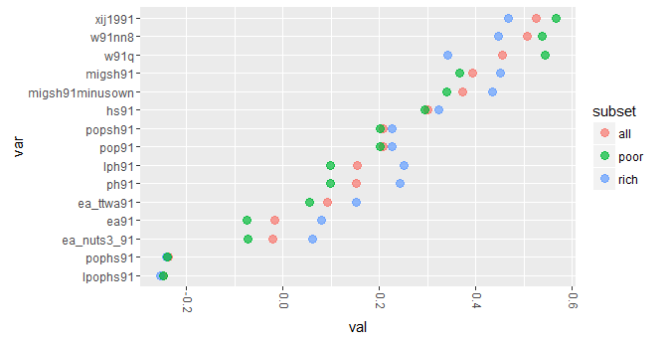

Things of note:

* Geographic correlations: higher for poorer, as we'd expect to see (but not huge difference).
* Next two highest are contiguity measures: **nn8** is 'eight nearest neighbours' vs the next, **w91q** is queen contiguity.
  + So a bit of evidence that, for richer CoBs, larger areas better predict their clustering.
* **migsh91** vs **migsh91minusown**: Removing "my CoB" from migrant share measure makes a small difference in the right direction.
* TTWA-aggregated employment measure (ea_ttwa91) does better than either direct zone-level or NUTS3 aggregation. Which makes sense: TTWAs are designed to capture distinct work catchments. See below for more on this.
* Lack of difference in overcrowding measure for rich/poor suggests it's maybe a bit weak currently. Will try a dasymetric approach to strengthen this (housing density accounting for where urban areas are.)

See next page.

## Closer look at 'economically active' / employment measure

* Again: R-squared of CoB share against three employment measures:
  + **ea91**: is the original % economically active per zone
  + **ea_nuts91 and ea_ttwa91** are % economically active in those larger zones, with the values repeated for each postcode sector in them.

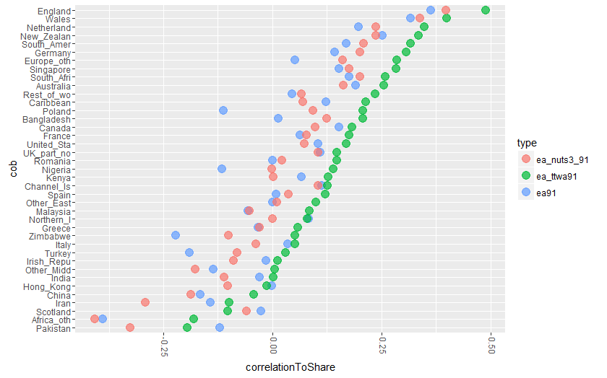

* So TTWA does OK.