Models of Marine Protected Areas Must Explicitly Address Spatial Dynamics

Daniel Ovando

Owen Liu

Renato Molina

Cody Szuwalski

We agree with three broad points raised by Cabral *et al.* 2020 (1): 1) Marine Protected Areas (MPAs) can play an important role in conservation and food security, 2) much of the high-seas could be closed to fishing without substantially reducing global catch and 3) much of the potential food-security benefits of MPAs could be achieved by targeted protection in key places. We noted an error in the business-as-usual (BAU) policy in their original manuscript which overestimated the food gains of MPAs and distorted the prioritization map, but which is being corrected by Cabral *et al.*. However, beyond this issue their model makes a series of assumptions that produce results inconsistent with best available knowledge of the state of global fisheries and marine ecology.

Cabral *et al.* do not explicitly account for spatial structure of fish populations in their model, instead assuming that all unassessed (i.e. not in the RAM Legacy Stock Assessment Database (2)) stocks of the same species comprise a single perfectly interconnected population, based on probability of occurrence estimates from Aquamaps (3). This results in the median modeled geographic range of an unassessed stock being 17 times that of an assessed stock, which is not credible and distorts the optimal size of MPA networks. This lack of explicit spatial structure produces results such as MPAs placed in Australia providing equal benefits to areas as far apart as Indonesia and Mexico (Fig.1a), and closures by the Americas benefiting species only caught near China (Fig.1b). Based on the results in the paper, users cannot know if the purported food benefits of MPAs in an area highlighted by Cabral *et al.* stem from these sorts of trans-oceanic connections.

The global MPA network for food production resulting from this distance-free model should give pause to MPA stakeholders of all kinds. Using the corrected BAU policy, Cabral *et al.*’s food maximizing MPA network would close 22% of the USA’s EEZ to fishing, yet places only 2.5% of India’s, 10% of Indonesia’s, and 12% of China’s EEZ in MPAs (Fig.1b). Costello *et al.*. 2016 (4) estimated that the median $F/F_{MSY}$ (fishing mortality rate *F* relative to the fishing mortality rate producing maximum sustainable yield *FMSY*) of fisheries in India, Indonesia, and China is nearly twice that of the USA, creating almost five times as much potential food upside from fishery reforms in those regions relative to the USA.

Any global model must make simplifying assumptions, but the assumptions made in Cabral *et al.* 2020 are not necessary and produce misleading results. A global model of MPAs must consider biological constraints of movement and spatial heterogeneity of fishery institutions. Reducing the effective range of populations by following the same stock structure as Costello *et al.* (2016) would be a start in this direction, but explicitly modeling the role that distance plays in ecological and economic responses to MPAs would be preferred. Either of these approaches would be computationally intensive but feasible, and we suspect would produce markedly different results from the findings they currently report.

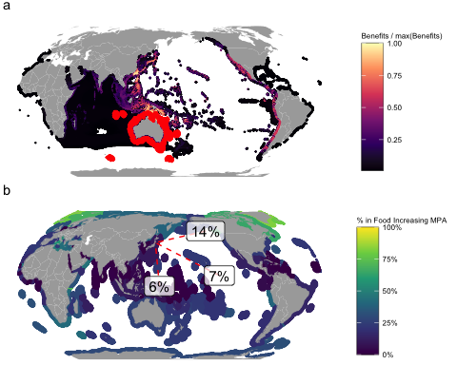

Figure 1: Omitting distance from MPA models produces results that are not credible. Panel *a* shows the distribution of food increases, omitting tunas, generated by a network of MPAs covering Australia’s EEZ according to the Cabral *et al.* 2020 model, with MPAs shown in red, and color of individual non-MPA cells showing the predicted food benefits generated by the Australian MPAs in that cell, scaled by the maximum food benefits generated by these MPAs in any cell. White areas show cells with benefits divided by maximum benefits less than 0.01. Panel *b* shows percent of each country’s exclusive economic zone (EEZ) protected under Cabral *et al.* 2020’s food maximizing MPA network under their business as usual (BAU) policy, applying the BAU correction for RAM stocks. Text percentages show percent of MPA-generated food benefits for overfished unassessed species caught nearly exclusively by China in the Pacific Northwest FAO region originating from FAO regions outside the Pacific Northwest according to Cabral *et al.* 2020. White areas are outside of EEZs.

# Data Availablity

All materials needed to fully reproduce this letter are publicly available at <https://github.com/DanOvando/FoodProvision2019-reply>.

# Acknowledgements

We thank the authors of Cabral *et al.* 2020 for freely sharing the code and data needed to replicate their results, and for helpful discussions during the writing of this letter.

# References

1. Cabral RB, et al. (2020) A global network of marine protected areas for food. *Proceedings of the National Academy of Sciences*. doi:[10.1073/pnas.2000174117](https://doi.org/10.1073/pnas.2000174117).

2. Ricard D, Minto C, Jensen OP, Baum JK (2012) Examining the knowledge base and status of commercially exploited marine species with the RAM Legacy Stock Assessment Database. *Fish and Fisheries* 13(4):380–398.

3. Kaschner K, et al. (2019) *AquaMaps: Predicted range maps for aquatic species* (World wide web electronic publication) Available at: [www.aquamaps.org](https://www.aquamaps.org).

4. Costello C, et al. (2016) Global fishery prospects under contrasting management regimes. *Proceedings of the National Academy of Sciences* 113(18):5125–5129.