GFR SOM Sensitivities

Dan Ovando

February 26, 2015

# Model Validation

We performed a series of jackknifing and Monte Carlo routines to evaluate the performance of our models across a variety of metrics including

* The effects of Illegal, unreported, unregulated fishing (IUU)
* Out of sample prediction of B/Bmsy, F/Fmsy, and MSY
* Sensitivity of our predicted future values to uncertainty in
* MSY
* Profits
* Catch
* B/Bmsy
* F/Fmsy

## Key Results

* IUU has little effect on estimated B/BMSY and F/FMSY, but has an almost perfectly linear effect on MSY; if catch is in fact 25% higher than reported, MSY rises by 25%
* Out estimates of MSY are likely to be conservative if chronic under-reporting of catch is occurring
* Our estimates of B/BMSY are likely on negatively biased on average
* The magnitude of catch in any given year has no systemic effect on estimated B/BMSY
* We overestimate B/B~MSY when the stock is very depleted. and under-estimate B/BMSY when the stock is relatively unexploited
* We systemically overestimate F/FMSY, and our estimates themselves are highly uncertain
* The jackknifing routines strongly suggest that we are underestimating MSY both at the individual fishery and regional level
* Our estimates of total MSY and catch are relatively insensitive to uncertainty in price, costs, growth rates, and carrying capacity
* Our estimates of total profits are much more sensitive to uncertainty in price, costs, growth rates, and carrying capacity.

## IUU

Stock assessed fisheries make up a substantial portion of the catch and global MSY in our analysis. However, XX% of fisheries, XX% of catch, and XX% of MSY in our analysis are derived from unassessed fisheries, through our paired PRM-Catch MSY process. Both the PRM and Catch MSY depend on the reported catch history in order to reach results; while life history variables are included the catch is the basis of the method. The quality of catch records for these unassessed fisheries is highly variable, and in many instances misreporting occurs. This may take the form of IUU fishing, which would mean that more catch is occurring than is being reported, over-reporting of catches (as occurred with Chinese catches), or random misreporting. Given the recent focus on the problem of IUU, we tested the robustness of our estimates of B/BMSY F/FMSY, and MSY to the presence of IUU.

We increased the catches of each unassessed stock by 25%. We then re-estimated B/BMSY using the PRM with the new IUU adjusted catch. Note that raw catch only enters the PRM through the max catch variables; if we assume a constant rate of IUU then all other catch statistics in the PRM remain the same, as they are all scaled relative to max catch. The IUU based estimates of B/BMSY were then fed to Catch MSY as the priors on final depletion, and MSY, F/FMSY,B/BMSY, and *g* were estimated. These metrics resulting from the IUU adjusted catch were then compared to the original values estimated with the raw reported catch data.

Our results indicate that on average an IUU level of 25% has on average no effect on our estimates B/BMSY and F/FFMSY (Fig.XX). Our estimate of total MSY is on average highly linearly related with IUU; when catches were increased by 25%, most fishery's MSY also increased by 25%, though some fisheries saw a greater increase in MSY. Our results indicate that if IUU, in the form of systemic under-reporting of catch, is present, our methods are likely to underestimate MSY. This suggests that if under-reporting of global catch is occurring, our estimates of MSY are conservative.



Effects of IUU. Proportional error represents the % change from the current estimate of B/B~MSY (bPE)~, F/F~MSY(fPE), and MSY (MSYPE). The black vertical line marks a proportional error of zero. The red line is the percentage of IUU used

## Individual Jackknife

We performed two jackknife routines to evaluate the ability of our model to predict out of sample. For both routines, we consider only RAM stocks, as these are the only instances we have "true" values for the parameters of interest (MSY, BvBmsy, FvFmsy).

We first performed an individual jackknife. We sequentially removed each RAM stock (n=398XX) from the regression block and re-estimated the PRM. We then predicted the status of the omitted stock using the re-estimated regression. This predicted status was passed to CatchMSY as the prior on final depletion, and the resulting predictions for BvBmsy, FvFmsy, and MSY for the omitted RAM stock were stored.

Our median proportional error in BvBmsy in 2012 (the primary year of interest) was ~20%, suggesting that for the median fishery we are underestimating B/Bmsy somewhat. However, there is substantial variation in our estimates (Fig.XX). The individual jackknifing suggest that our estimates are on average negatively biased, but that there is substantial variation in the direction and magnitude of this bias for any individual fishery.

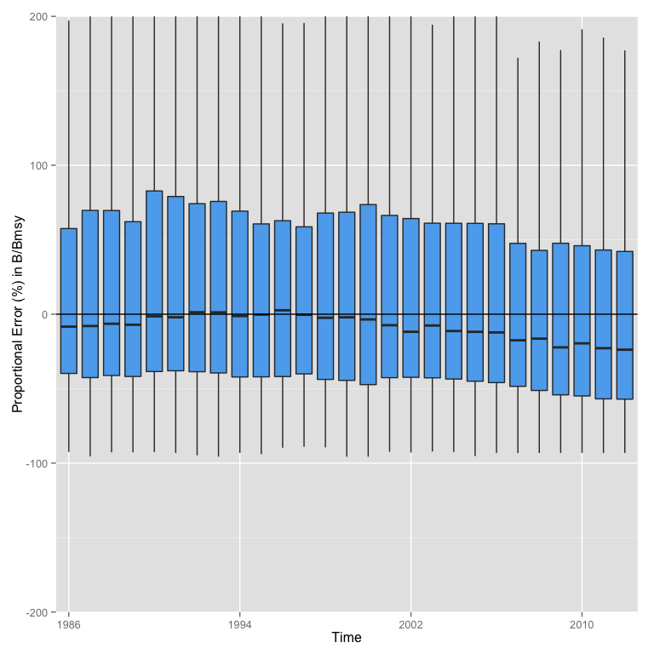

Proportional error in B/Bmsy over time

The proportional error in our estimates of B/Bmsy appear uncorrelated with catch in any given year (Fig.XX), but highly influenced by the true B/Bmsy (Fig.XX). Specifically, we severely over-predict the B/BMSY for highly overfished RAM stocks (i.e. when "true" B/Bmsy is less than 0.5, Fig.XX), and under-predict B/BMSY when true B/BMSY is high.

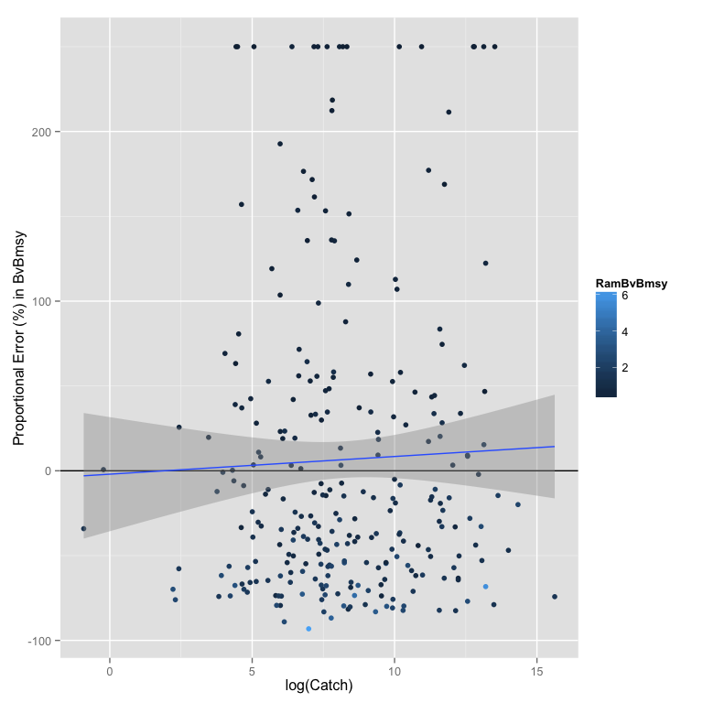

Proportional error in B/Bmsy by catch

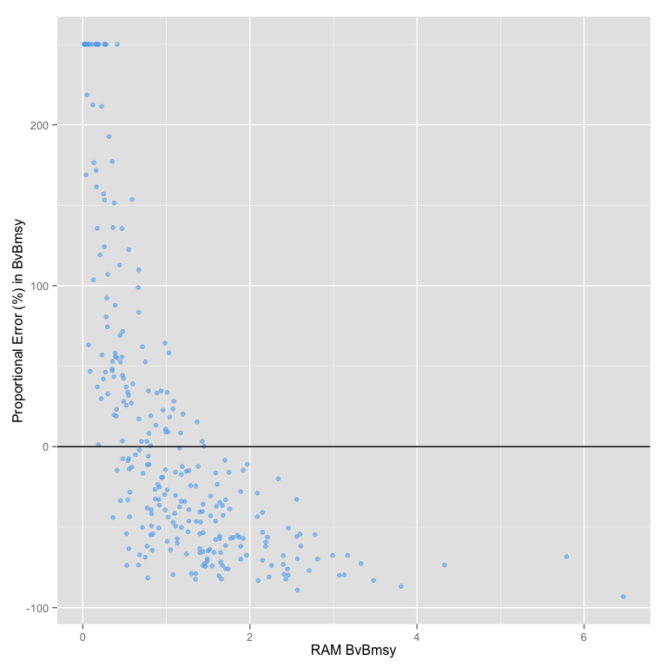

Proportional error in B/Bmsy by RAM B/Bmsy

The F/Fmsy values from our individual jackknifing are highly positively biased, and have substantial amounts of error (Fig.XX)

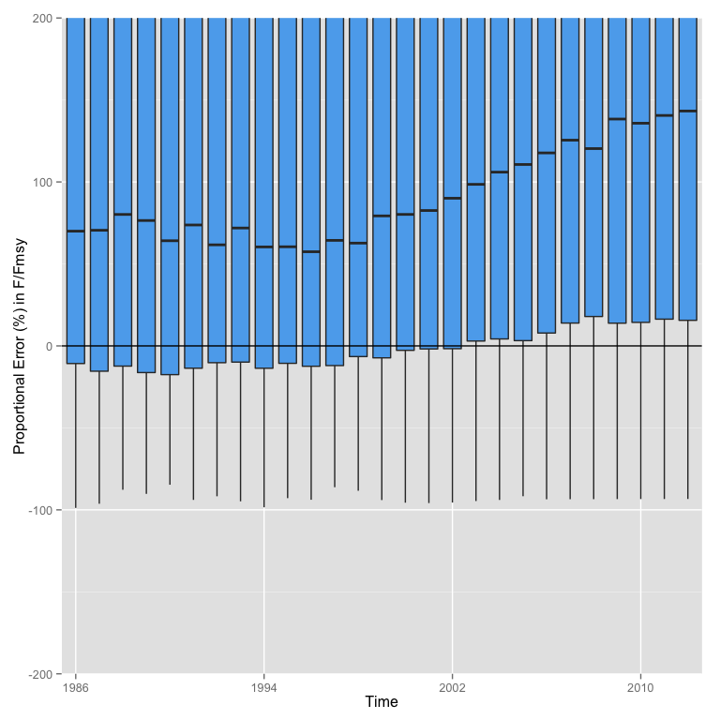

Proportional error in F/Fmsy over time

The MSYs estimated through our individual jackknifing routine indicate that we are underestimating MSY out of sample, with a mean underestimate of 50% (Fig.XX).

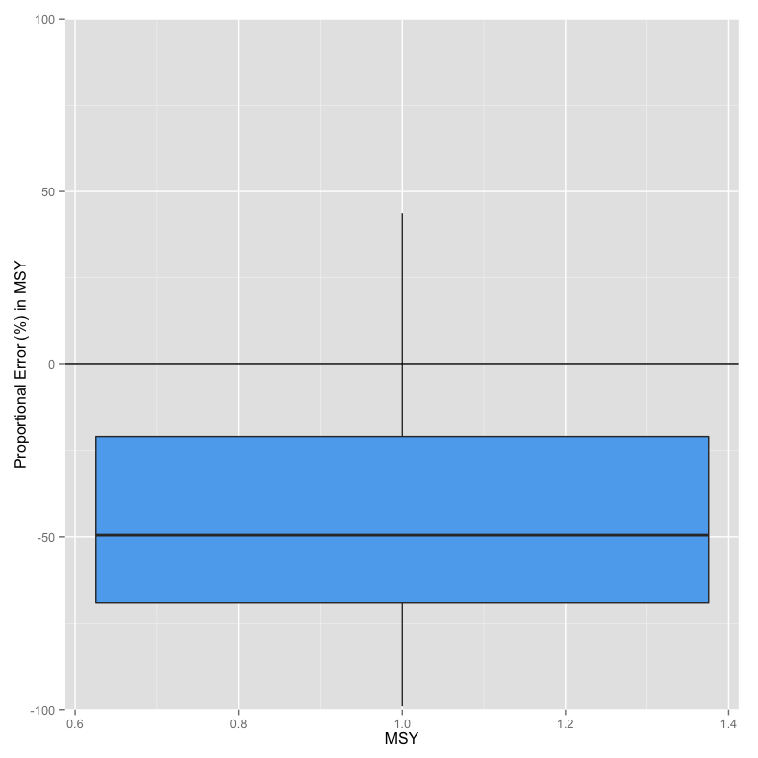

Proportional error in MSY

However, there appears to be little correlation between our error in MSY and the size of the fishery (as defined by lifetime catch), indicating that out of sample we underestimate MSY our of sample for most of the RAM stocks regardless of size (Fig.XX)

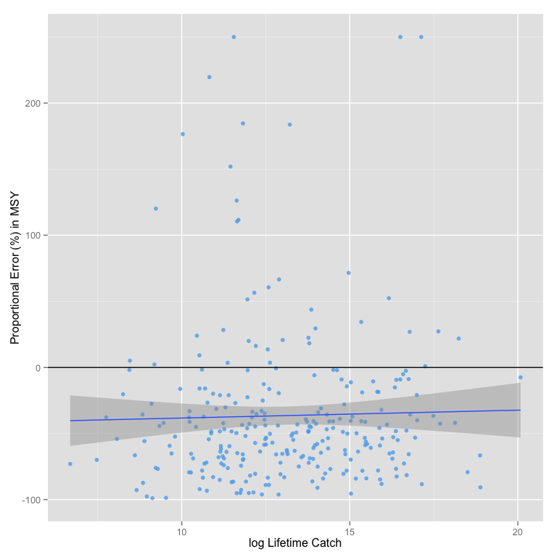

Proportional error in MSY by lifetime catch

## Regional Jackknife

We might expect the out-of-sample predictive ability of our model to be fairly good when simply omitting and predicting one single fishery. This paper's results depend though on the ability of our model to predict fisheries that are very much out of sample; we are trying to predict Indonesia using Alaska. As such, we also performed a regional jackknifing routine. In this procedure, we sequentially removed all the RAM stocks in each unique region (roughly country) in RAM. We then re-estimated the PRM omitting all the RAM stocks from that region, and then predicted the omitted region. The predictions were then passed to CatchMSY, and the individual predictions for MSY, BvBmsy, and FvFmsy for each omitted fishery are stored. Our broad results on the out-of-sample error in B/BMSY F/FMSY and MSY did not substantially change from the individual jackknifing, as such we will focus on the out of sample regional predictive power demonstrated by this analysis.

Looking at B/Bmsy, our out-of-sample prediction of B/Bmsy varies substantially by region. This was especially true for South African stocks, which we might consider to be the most representative of the RAM countries of many of the developing world countries for which we are attempting to estimate status (though the sample size for South Africa is also very small). Australian B/BMSYs are severely over-predicted when omitted from the regression, and we systemically underestimate the status of New Zealand stocks under the regional jackknifing.

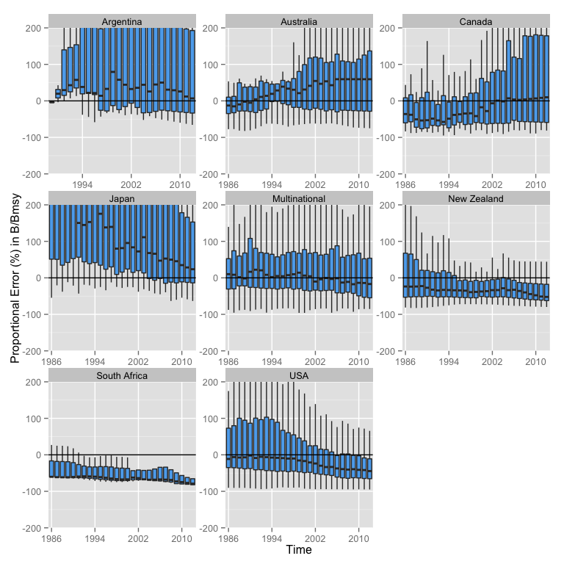

Proportional error in B/Bmsy by time and region

The regional out of sample predictive power of MSY shows a negative bias across all regions, providing further evidence that we are likely to be underestimating MSY for most countries.

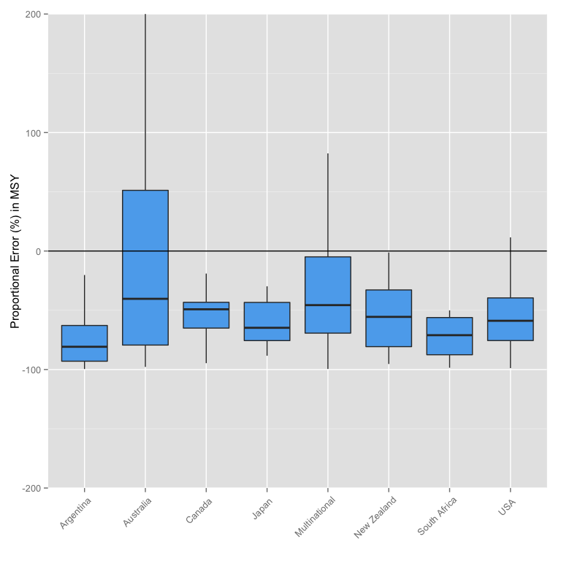

Proportional error in MSY by region

## Monte Carlo Analysis

We performed a Monte Carlo routine to evaluate the sensitivity of components of our final results (e.g. total MSY, change in profits, change in BvBmsy, etc.). We do not consider potential errors in the underlying catch data, or a complete range of potential starting biomass levels. We do consider the sensitivity of our results in response to limited ranges of starting BvBmsy,as well as estimated intrinsic growth rates *r*, MSY, prices, costs, and catch-share economic benefits.

The Monte Carlo currently only evaluates stocks that were run through Catch MSY. It does not include RAM stocks for which we have "true" estimates of MSY, since at this time we do not have any method for estimating uncertainty around RAM values. The Monte Carlo also omits NEI stocks at this time. As a result this process provides an assessment of the degree of variability in our metrics of interest resulting from reasonably uncertainty in our parameter values. It is not a true assessment of the actual variability in our final results.

Catch MSY provides a range of plausible values for *g* and MSY (often thousands of individual estimates for each fishery). For each iteration of the Monte Carlo, we drew random *g* and MSY pairs from Catch MSY for each fishery. For each fishery in each iteration we also apply a multiplicative log-normal error term (~ln(0,0.5)) to price, BvBmsy at open access (which implicitly affects costs), and the "catch share effect" (the price and cost changes resulting from moving to a catch share policy). We ran 500 iterations of each fishery and stored results.

Our results show that the total MSY estimated by CatchMSY has relatively little variability, with most estimates of total MSY falling between 27 and 39 million MT ( Fig.XX ).

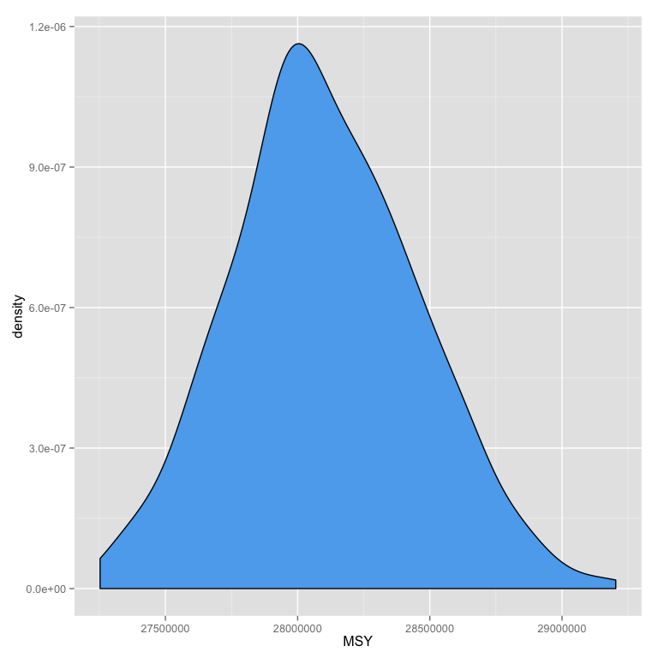

Distribution of MSY

Our estimates of total catch in 2050 vary greatly among policies (as they are intended to do), but show relatively little variation within policy (Fig.XX), with the exception of our Status Quo Open Access policy, which while having consistently lower catch than the other policies in all simulations showed much grater variation around this lower value. This is due to the fact that many stocks have different open access biomass levels, and not all stocks have converged to this open access level by 2050.

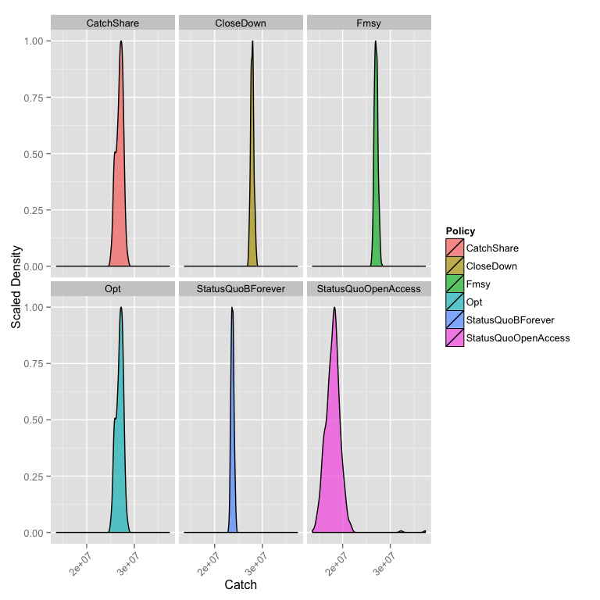

Distribution of Catch

Our 2050 distributions of profits by policy do exhibit substantial variability. Our "status quo" policies especially vary drastically as a function of the uncertainty introduced by the Monte Carlo. Our non-Status Quo policies also show substantial variation, though all remain positive and greater than the open access status quo scenario. However, while the Catch Share policy remained the most profitable, it is very difficult to differentiate the profitability of fisheries in 2050 among the other non-open access policies. This suggests that our estimates of future profits, and the relative rankings of our policies with respect to future profits, are substantially uncertain, especially as compared to our estimates of future catch. This comes as no surprise, since our estimates of profits are dependent on more uncertain variables than catches alone. It should also be noted that our estimates of total profits vary much more in magnitude than our estimates of total catch.

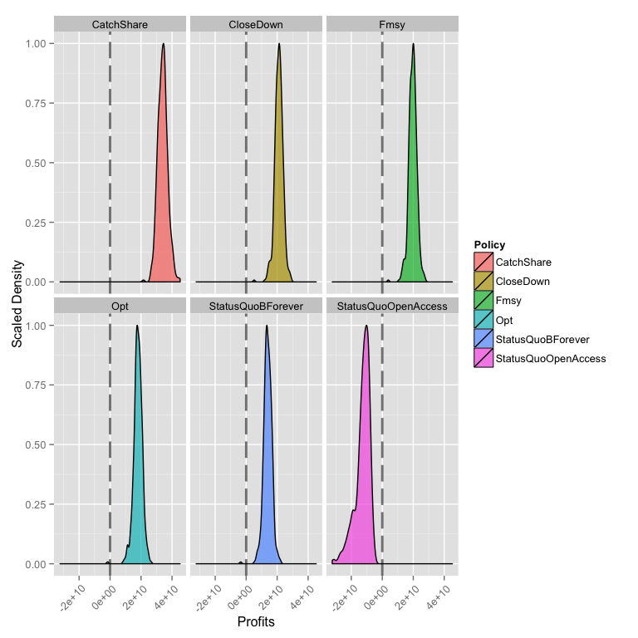

Distribution of Profits

Our estimates of future B/Bmsy (Fig.xx) and F/Fmsy (Fig.XX) show very little variation within policies, and the relative differences among policies remain constant. However, this is of little surprise since most of our policies dictate F/Fmsy in order to achieve a particular B/Bmsy. We do not re-optimize our policy functions for each Monte-Carlo run, so we do observe some variation in final B/Bmsy stemming from variation in *g*. The net result though is that our estimates of future B/Bmsy are largely unaffected by the values of the variables tested in the Monte Carlo. However, it is important to note that we do not consider any stochasticity in the growth function, or any errors in the application of management.

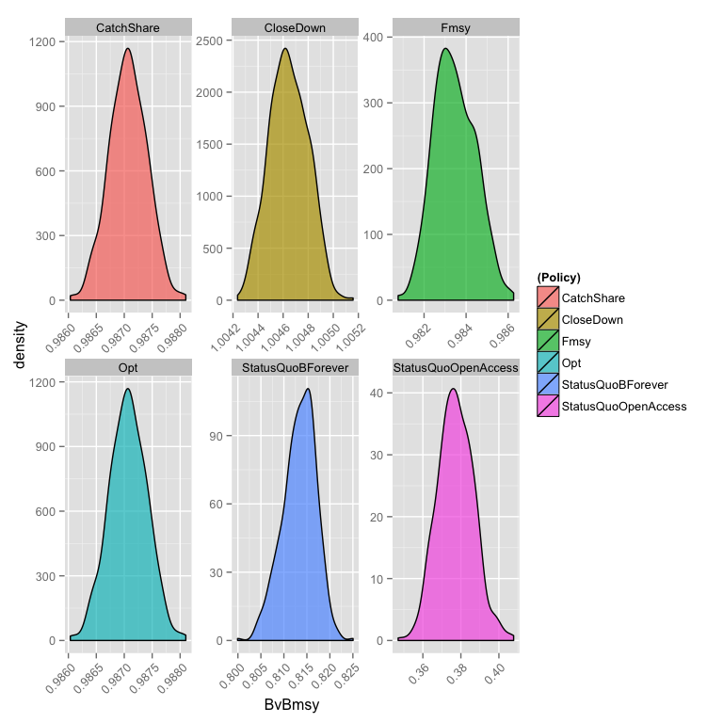

Distribution of BvBmsy

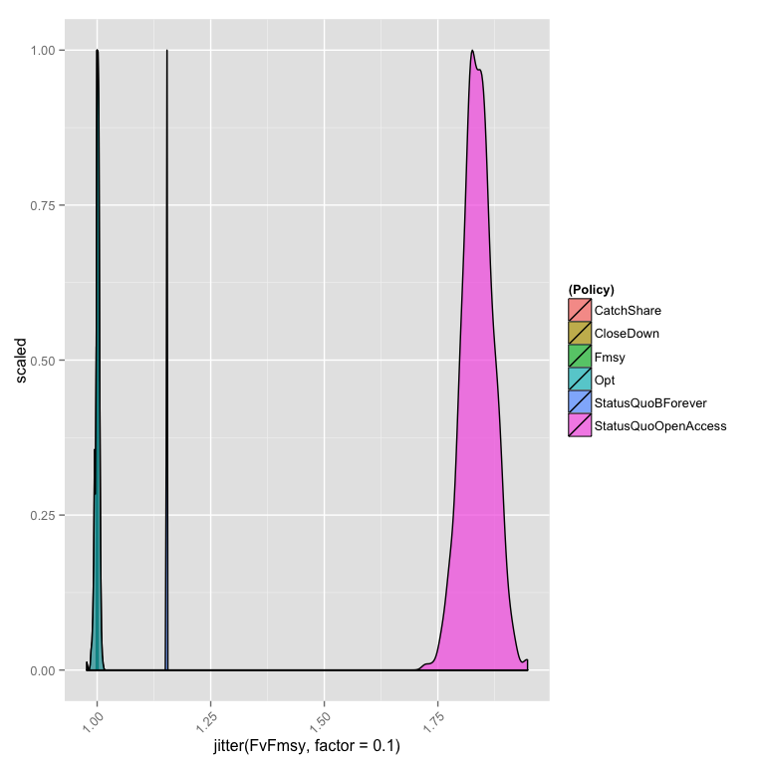

Distribution of FvFmsy