Regional Effects of Marine Protected Area Networks Are Unclear

Daniel Ovando

Jennifer E. Caselle

Christopher Costello

Olivier Deschenes

Steven D. Gaines

Ray Hilborn

Owen Liu

Marine Protected Areas (MPAs) cover 3-7% of the world’s oceans, up from less than 1% in the year 2000. The Convention on Biological Diversity called for 10% of coastal waters to be protected inside MPAs by 2020, while the International Union for Conservation of Nature is now calling for 30% protection by 2030. It is often clear that MPAs produce conservation benefits inside their borders, but many MPAs are also justified on the grounds that they may benefit the broader region outside their borders. The conservation effects of MPAs are most commonly evaluated using response ratios—measures of numerical or biomass densities inside their borders, relative to these metrics in reference sites outside their borders. Studies of this nature have provided broad evidence that MPAs produce conservation benefits within their borders. While these gains can be vitally important, marine populations are rarely contained entirely within the borders of MPAs; therefore a critical question is not only do MPAs produce conservation gains inside their borders, but how do they affect the broader region in which they are located? The Channel Islands National Marine Sanctuary provides a clear example of this challenge. A network of MPAs covering 20% of the Islands’ waters was put in place in 2003, with a goal of providing regional conservation and fishery benefits. Response ratios from the region indicate that the Channel Island MPAs have increased biomass densities inside the MPAs. We are unable to find a clear effect of these same MPAs on biomass densities throughout the Channel Islands region. We use a bio-economic simulation model to explain this discrepancy, and demonstrate under what conditions we likely can and cannot clearly estimate the regional conservation effects of MPAs. MPA networks covering 25% or less of a region are likely to produce regional increases in fish biomass densities on the order of 25% or less, a meaningful effect but also one that can easily be overwhelmed by environmental shocks. Our results provide a novel assessment of the regional effects of a large and iconic Marine Protected Area network, and provide guidance for managers charged with monitoring and adapting MPAs.

# Front Matter

## author_contributions:

D.O., S.G., and R.H. developed structure of simulation model. D.O., O.D., C.C., and J.C. developed estimation strategy. J.C. provided support on collecting and interpreting data. All simulations, statistics, and sensitivity analyses performed by D.O. and O.L. . All authors contributed to the manuscript.

## conflict_of_interest:

R.H’s research program receives funding from environmental NGOs, foundations, fishing industry, governments and international agencies. All of these can be interpreted as a conflict of interest when evaluating fisheries policy. C.C., S.G., and O.D’s research program includes funding from environmental NGOs and foundations with an interest in ocean conservation and food security. Funding for D.O. was partly provided by the NMFS-Sea Grant Population and Ecosystem Dynamics Fellowship.

## significance

Healthy marine ecosystems are critical to the well-being of the planet. Marine protected areas, parts of the oceans protected from human activities such as fishing, are increasingly being used to conserve and manage these ecosystems. Our study pairs theory with empirical methods to examine the regional effects of MPAs on conservation outcomes. We show that the regional effects of marine protected areas can be highly variable and dependent on human drivers. We find no statistically clear effect of a network of MPAs after 14 years of protection, which our simulation analysis suggests is actually to be expected. Our results lay a foundation for future research on the design and monitoring of marine protected areas.

## acknowledgements

Funding for the simulation model was provided by the NMFS-Sea Grant Population and Ecosystem Dynamics Fellowship. Empirical data collection was funded primarily by the David and Lucille Packard Foundation in support of the Partnership for Interdisciplinary Studies of Coastal Oceans (PISCO) with additional funding from the California Ocean Protection Council and California SeaGrant. This study would not be possible without the work provided by PISCO divers over the years. DO thanks Cody Szuwalski, Julia Lawson, and André Punt for helpful comments and technical support and special thanks to Kathyrn Davis Koehn and Avrey Parsons-Field.

## keywords:

* Marine Protected Areas
* Conservation
* Bio-economic modeling
* Program Evaluation

# Body

No-take Marine Protected Areas (MPAs), spatial regions of the ocean in which fishing is prohibited, have a long history in the management of marine resources. Traditional cultures in Oceania utilized - often temporary - MPAs as “fish banks” for times of need (1). Modern MPAs were first established primarily as marine analogs to the terrestrial protection of iconic landscapes like Yellowstone or Kruger National Parks (2, 3). Over time our goals and expectations for MPAs have evolved; while all MPAs are expected to deliver conservation benefits within their borders, many modern MPAs are also established to bolster fish populations throughout the region in which they are located (4).

Many recent agreements to expand MPAs (most proximately, the Convention on Biological Diversity’s Strategic Plan for Biodiversity, which calls for 10% of coastal waters to be protected inside MPAs by 2020 and the International Union for Conservation of Nature call for 30% by 2030) are based on the expectation that well-designed MPAs will achieve benefits both within, and outside, their borders. Despite these assumptions, our collective scientific understanding of the regional-scale conservation and fishery impacts of current and future MPAs is surprisingly limited.

Numerous studies provide evidence that well-enforced and appropriately sized MPAs can produce conservation benefits within their borders (5–8). As these conservation benefits accrue inside MPAs, theory holds that MPAs can affect the waters beyond their borders through the spillover of adult and larval fish from the protected to the fished areas, as well as through displacement of fishing effort. Several studies have documented empirical evidence for the existence of adult or larval spillover affecting both abundance and fisheries (9–17), as well as alteration of fishing effort in reaction to (18–20) and in anticipation of (21) MPA placement. The potentially more important question, however, is not whether spillover occurs (it must to some degree in any realistic scenario), but what the net effects of spillover are and whether those effects are empirically detectable. From a fishery perspective, are spillover benefits sufficient to offset losses in fishing grounds and changes in responses of displaced fishers caused by an MPA? From a conservation perspective, how much does the buildup of fish inside an MPA increase biomass outside the protected area? Overall, what are the regional effects of MPAs?

As stakeholders around the world increasingly seek to use MPAs in marine resource management portfolios, it is critical that we develop a better understanding of the magnitude and drivers of regional-scale MPA effects. This is particularly true in the context of a changing climate, in which “set it and forget it” management strategies are increasingly untenable; we need to be able to monitor the performance of MPAs in order to adapt them as dictated by a shifting environment. The MPAs within the Channel Islands National Marine Sanctuary, California, USA (which we will refer to as the Channel Islands from now on) provides an ideal case study to address this need. A network of protected areas covering approximately 20% of the Islands’ waters was put in place in 2003 (22). This MPA network has subsequently been used as a model case study in protected area design around the world (24).

We use data from the first 14 years of protection to provide what is to our knowledge the first empirical assessment of the regional effect (defined here as the effect of MPAs on the mean biomass density of targeted finfish both inside and outside of MPAs) of a large MPA network on a wide array of finfish species. In contrast to clear differences in biomass densities observed inside and outside of well protected MPAs both globally (5) and in the Channel Islands (26) we are unable to detect a clear regional effect from the Channel Islands MPAs. We build off of existing MPA theory to consider why this might be, and provide guidance for scientists and managers as to when and how we might expect to estimate the regional conservation effects of MPAs.

## Results & Discussion

### What Are the Regional Effects of MPAs?

The empirical MPA literature has generally focused on assessing conservation effects within the borders of protected areas (7). While these within-MPA effects are vitally important for protecting rare species, biodiversity, critical habitats, and often tourism, they paint an incomplete picture of the overall population effects of MPAs. The organisms within the borders of protected areas are generally part of a broader biological stock, connected through adult movement and larval dispersal. If the goal of conservationists or natural resource managers is to increase the total abundance or productivity of a resource, a broader question we should ask of MPAs is not just are there more fish inside their borders, but also how have reserves affected populations throughout the region in which they are located? This logic, that MPAs will have conservation benefits for most species beyond their borders, is implicit in all multilateral calls for MPA expansion.

We define the regional conservation effects of MPAs as the change in mean total biomass densities of targeted finfish both inside and outside of MPAs, relative to the mean total biomass densities of targeted finfish inside and outside of MPAs that would have occurred without the MPAs (acknowledging that other outcomes such as increased biodiversity or resiliency are also important to conservation but are beyond the scope of this analysis). Consider a evenly distributed population that has 50% of its range protected by an MPA. Suppose that the MPA increase biomass densities inside the reserves by 20%, and by 0% outside the reserve. The regional effect of the MPA would be 10%.

Numerous factors can affect the regional effects of MPAs. These include the scale of adult and larval dispersal relative to the size of the MPAs (8, 27–30), larval dispersal patterns and the strength and timing of density dependence in the population (e.g. pre- or post-settlement, (31)), how overfished the population would be without the MPA, and how fishing and management responds to the implementation of the MPAs (4, 32–42). In addition, even for the same total area of MPAs, the location and spacing of the MPAs can have a profound influence on their cumulative impact through habitat and network effects (4, 43).

Given this existing body of theory, what should we expect *a priori* the effect size of the Channel Islands MPAs to be? While we know many parameters will affect the expected effects of the MPAs, theory suggests that life history, adult and larval dispersal relative to MPA size, and fishing pressure will be key drivers. The targeted species in our database span a range of life histories, but are largely made up of fishes in the perch and rockfish complexes, with a mean Von Bertalanffy growth coefficient of 0.32, and a mean age at maturity of 4 years (44).

The MPAs in this study cover 21% of the the surface waters of the Northern Channel Islands, a region spanning roughly 90km east to west. While detailed dispersal studies are not available for all of the species covered by our study, what information we have suggest that while adults of some of these species are likely to exhibit site fidelity (45), larvae are likely distributed beyond the Channel Islands (46). Therefore, if we assume that the population of the targeted species is at least equal to the extent of the Channel Islands, we can assume that at most the MPAs cover roughly 20% of the targeted populations’ ranges.

Turning to the critical question of fishing pressure, formal stock assessments are largely lacking for these species. However, what evidence we have suggests mostly moderate fishing pressure, with some species such as California sheephead (*Semicossyphus pulcher*) and blue rockfish (*Sebastes mystinus*) experiencing high levels of fishing mortality / biomass levels below target levels during the early 2000s (47, 48).

We integrated these network design features, life history traits, and exploitation histories into a spatially explicit bio-economic simulation model, and used this model to generate expected outcomes for the Channel Islands MPAs. Our results suggest that while a wide range of outcomes are plausible, from 0% to upwards of 200%, across the majority of our simulations the effect size was 25% or less, with a median simulated effect size of roughly 20%; a potentially small value given the natural variability and sampling challenges of marine environments.

### Effects of the Channel Islands MPA Network

Having established a theoretical grounding for the likely biomass density outcomes of the Channel Island MPAs, what empirical evidence do we have of the effects? (26) examined changes in biomass densities of species targeted by fishing activity inside and outside of the MPAs over time (a metric generally termed a “response ratio”), and compared these changes to the trends in non-targeted species. They found a statistically significant increase in the response ratios of targeted species over time, and evidence that this increase is smaller in the non-targeted species. Updating the results of (26) through 2017 with a Bayesian response-ratio regression shows a continuation of the increasing trend in the response ratios of targeted species (Fig.1).

Why do these response ratio results not serve as sufficient evidence for the regional effects of the Channel Island MPAs? Control sites used in calculating response ratios are often selected based on abiotic or ecological traits such as habitat characteristics (49). However, selection of control sites is further complicated by the very spillover that MPAs are often intended to create. Export of adults or larvae from the MPA to the “control” site affects their status as controls, as does displacement of fishing effort from MPAs to control sites. In theory, control sites far enough away to negate both biological spillover and concentration by the fishing fleet could be selected, but finding suitably far sites that are also appropriate proxies for the ecological and economic context of the MPAs may be challenging. While these concerns have been stated previously (42, 50), the MPA evaluation literature has by and large been unable to adequately address them, often due to the very real logistical challenges of identifying and sampling adequate control sites that are truly independent of the MPAs in question. As a result of these challenges, response ratios can be a highly imprecise and biased measure of the regional conservation effect of an MPA network (49).

In the case of the Channel Islands MPAs, control sites are often located within a few kilometers of an MPA, suggesting that they are susceptible to biological spillover and concentration of fishing effort resulting from the MPAs. Given these complications, we can certainly interpret the response ratios reported in (26), and updated here, as evidence that the MPAs are providing effective protection of targeted fish biomass inside their borders, particularly in light of the general increase in response ratios over time. However, it is unclear how well these response ratio results serve as in indicator of overall regional effects of the MPAs.

To illustrate this problem, we used our bio-economic model to simulate response ratio trajectories for species and MPA coverage representative of the Channel Islands (see methods and SI for details of model structure). These simulations cover the life-histories and MPA sizes seen in the Channel Islands, but vary in key unknowns such as the actual degree of fishing pressure, the timing of density dependence, and the fishing fleets response to the MPAs. For each year of protection, we paired our simulated response ratios to the estimated posterior probability distributions of the Channel Island response ratios. For example, if the mean estimated response ratio in the year 2006 is one, we found all simulations with three years of protection that had simulated response ratios near one, and then pulled out the “true” simulated regional MPA effect from each of those simulations. This provides us with a distribution of simulated regional MPA effects that could plausibly generate the types of response ratios actually observed in the Channel Islands.

As reported in (26), we see an increasing trend in response ratios of targeted species over time (Fig.1). This provides strong evidence that the MPAs are providing protection for targeted species within their borders. However, our simulation results show that the response ratio trends we observe in the data could plausibly be produced by a wide range of regional MPA effects (Fig.1). Response ratios well over one were associated with regional MPA effects generally less than 25%, and many simulations produced large response ratios but regional MPA effects close to 0% This can occur if for example fishing pressure is only moderate, adult movement is low, larval dispersal is high, and displaced fishing effort concentrates around the border of the MPAs.

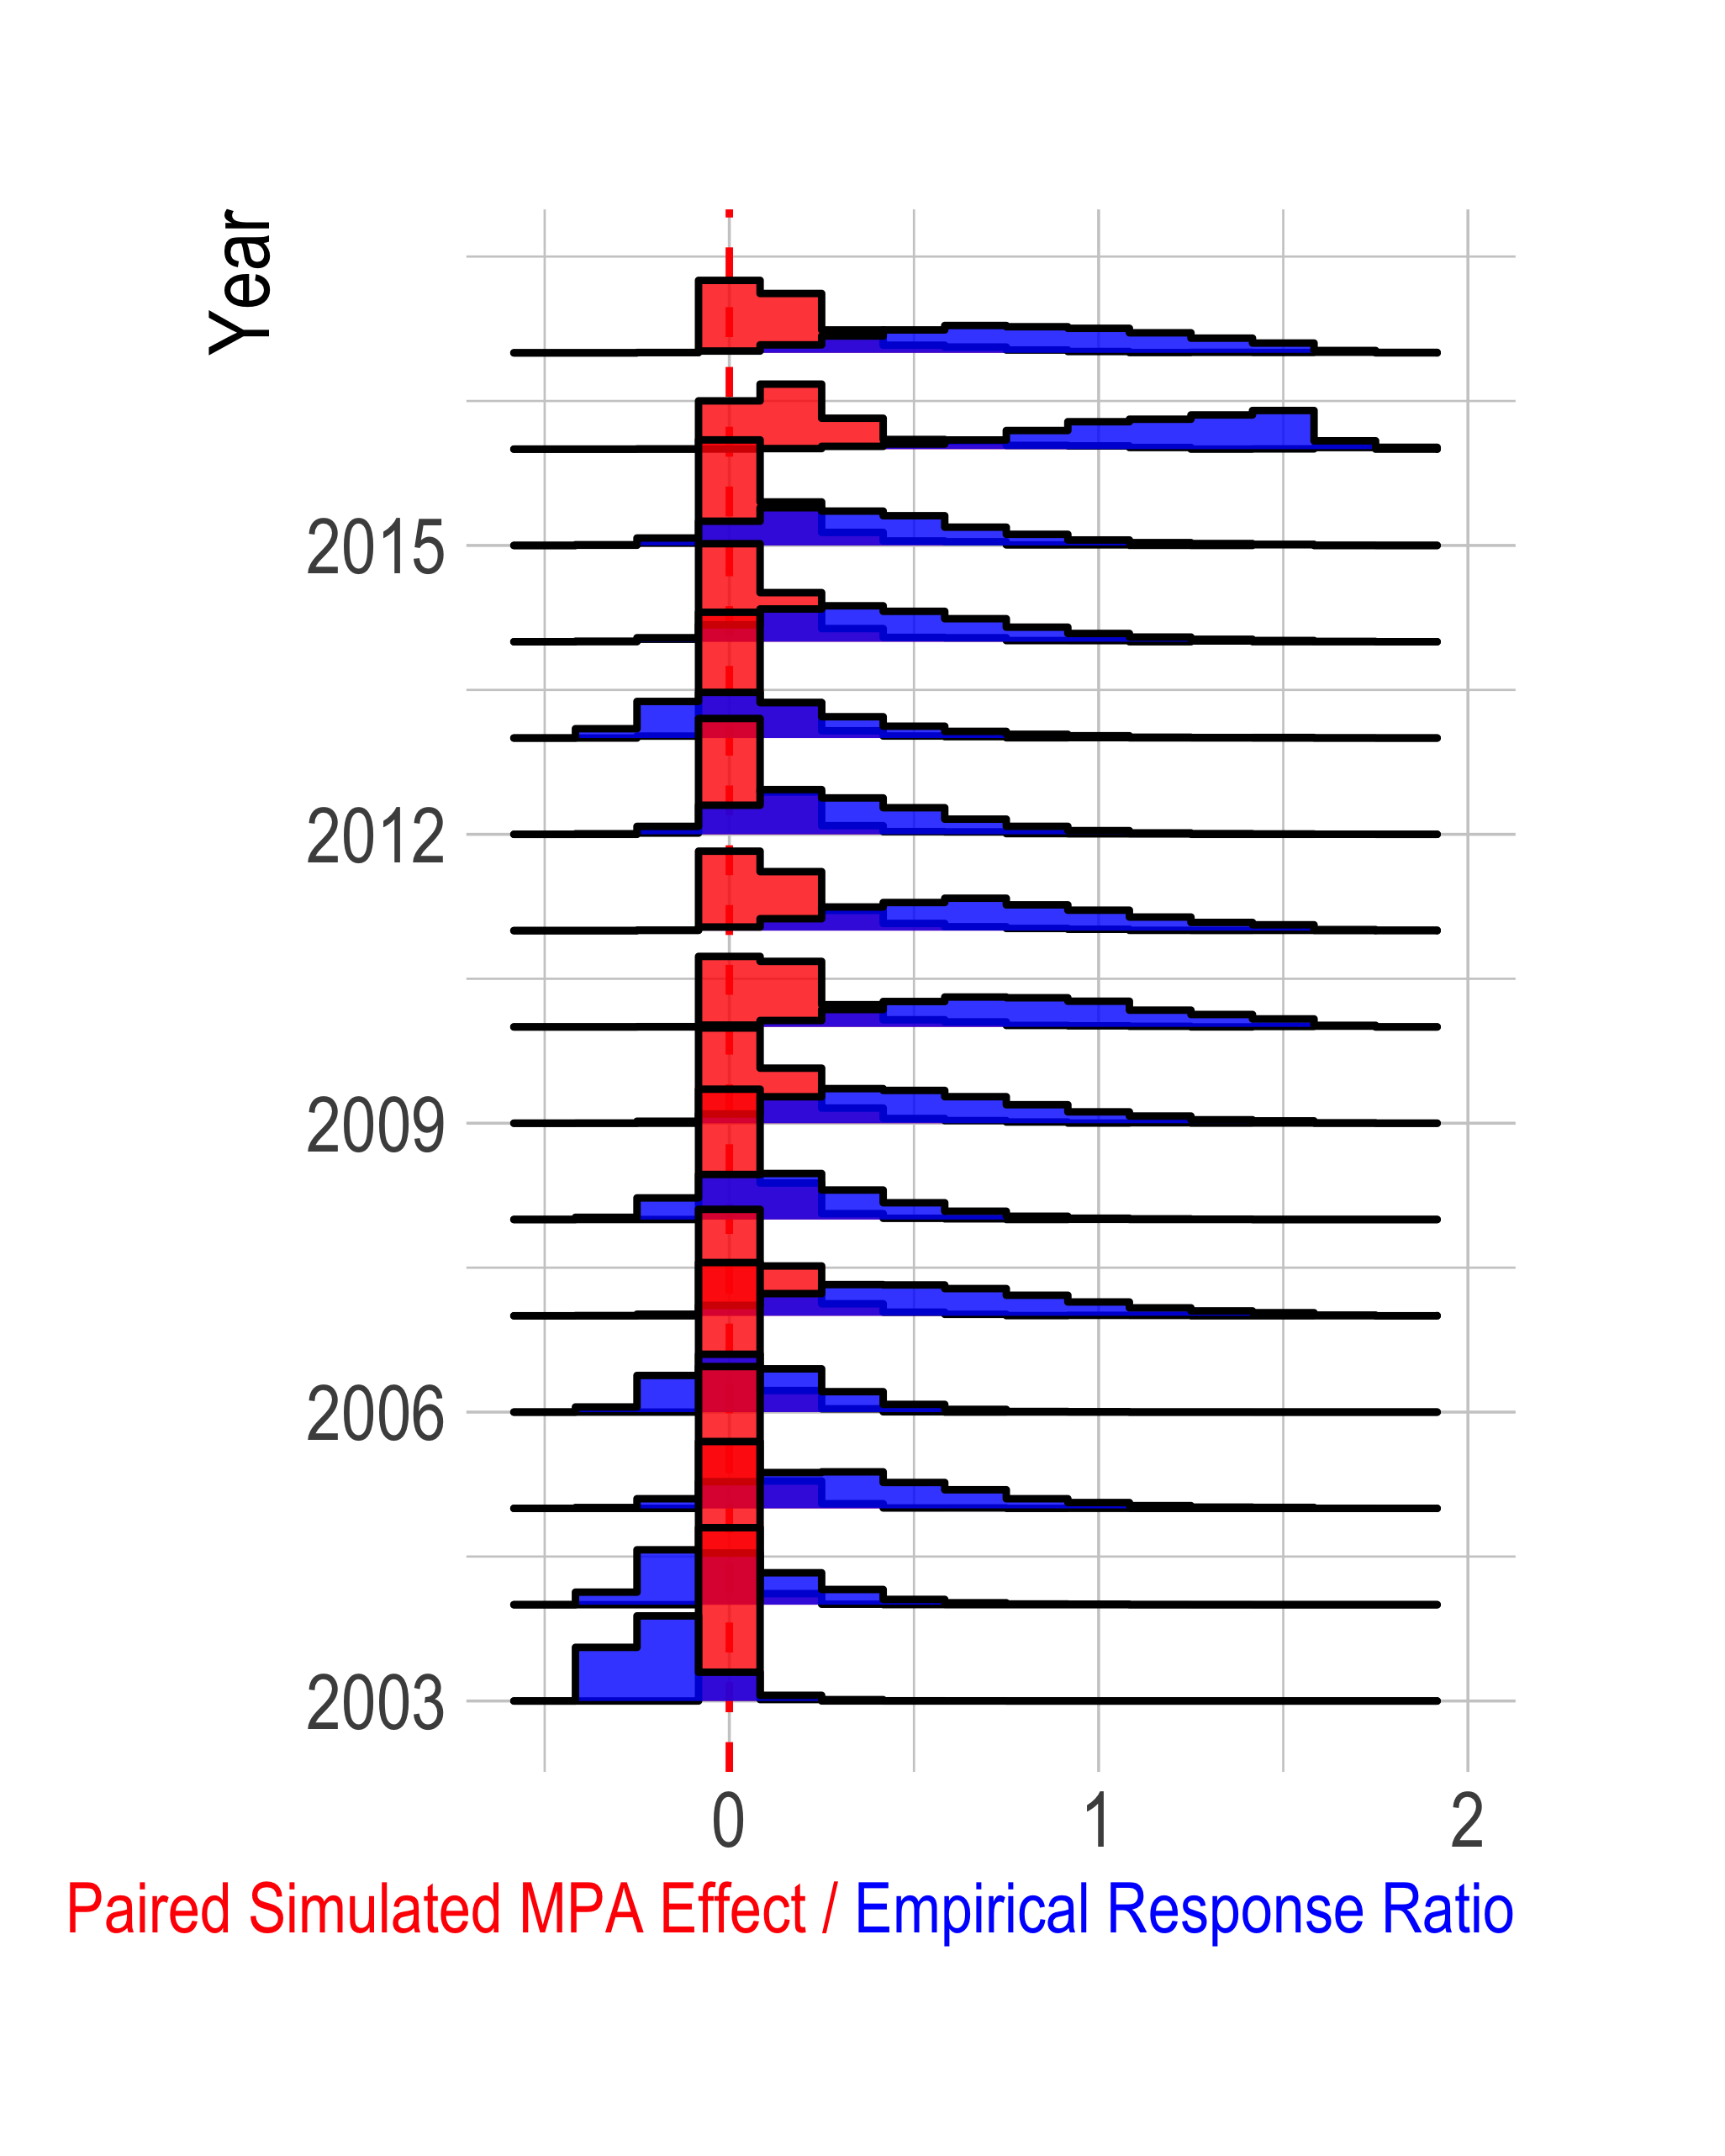

Figure 1: 90% Posterior probability distributions of response ratios for targeted species (x-axis) over time (y-axis) in blue. Simulated MPA effects associated with simulated response ratios matched to empirical response ratios in red. For response ratios, a value of zero indicates that biomass densities of targeted and non-targeted species are identical inside and outside MPAs, a value of 1 indicates that biomass densities of targeted species are 100% greater inside MPAs than outside. For MPA effect, a value of zero indicates that mean biomass densities are identical in the with- and without- MPA scenarios. A value of 1 indicates that mean biomass densities are 100% greater in the scenario with MPAs than the scenario without MPAs.

Given the potential unreliability of response ratios for the task, in an ideal world how would we empirically measure the regional effects of MPAs? The perfect experiment would involve two parallel worlds that were identical, except for the implementation of an MPA. In world “A”, no MPA would be implemented, and in the facsimile world “B”, the MPA would be implemented. Both worlds would be tracked before and after MPA implementation, and the biomass densities would be compared after treatment. Instead of two parallel worlds, a similar experimental design would involve random placement of MPAs. Unfortunately, neither of these experimental designs has been implemented, because parallel worlds do not exist and MPAs are to our knowledge never placed at random. Careful causal inference requires some other means of controlling for biases introduced by factors such as the unobserved environmental shocks, the MPA siting process, biological spillover, and concentration of fishing effort (49, 51).

Building off of the concepts explored in (26), we used an identification strategy utilizing biomass densities of 11 species that are not directly targeted by fishing as our control group (non-targeted), and biomass densities of 12 species targeted by fishing as our treatment group. Targeted species in the Channel Islands, include commercially important fin-fish such as California sheephead (*Semicossyphus pulcher*), and copper (*Sebastes caurinus*) and blue (*Sebastes mystinus*) rockfish. Each of these targeted species was the subject of prior bio-economic modeling related to the effects of MPAs in southern California (43, 52). It should be noted though that our analysis omits species from important invertebrate fisheries including red urchin (*Mesocentrotus franciscanus*) and spiny lobster (*Panulirus interruptus*). Included non-targeted species include garibaldi (*Hypsypops rubicundus*), halfmoons (*Medialuna californiensis*), and blacksmith (*Chromis punctipinnis*) (See Table.S2 for a complete list of species). We used a Bayesian difference-in-difference regression to estimate any difference in mean total biomass densities of fin-fish species targeted by fishing effort (i.e., those potentially affected by an MPA) and those species not targeted by fishing before and after MPA implementation (51). The result of this regression is, conditional on the assumptions of the model, an estimate of the effect of the MPAs on the mean total biomass densities of targeted species throughout the Channel Islands.

As conventional wisdom and theory would suggest, over the first three years of implementation (2003-2006), the effects of the MPAs are unclear, with support for a small negative effect to a substantially positive effect, with much higher probability of a small positive effect (median estimated effect 27%, 90% credible interval -1% - 65%). Over the next six years the model estimates greater probabilities of an increasingly positive MPA effect, peaking in 2009-2011 with a median estimate of MPA effect of a 77% increase in mean total biomass density of targeted species (90% credible interval 37% - 128%. These empirical estimates are in line with (though in the upper range of) the outcomes that our simulation model suggests are plausible given the rough characteristics of the northern Channel Island MPAs. While this concordance between theory and empirics is by no means proof of the robustness of our results, it is an important line of evidence. However, in the subsequent years the trend reverses itself, and for the years 2015-2017 we once again see no clear effect of the MPAs (median estimated effect -11%, 90% credible interval -33% - 20%.) Fig.2

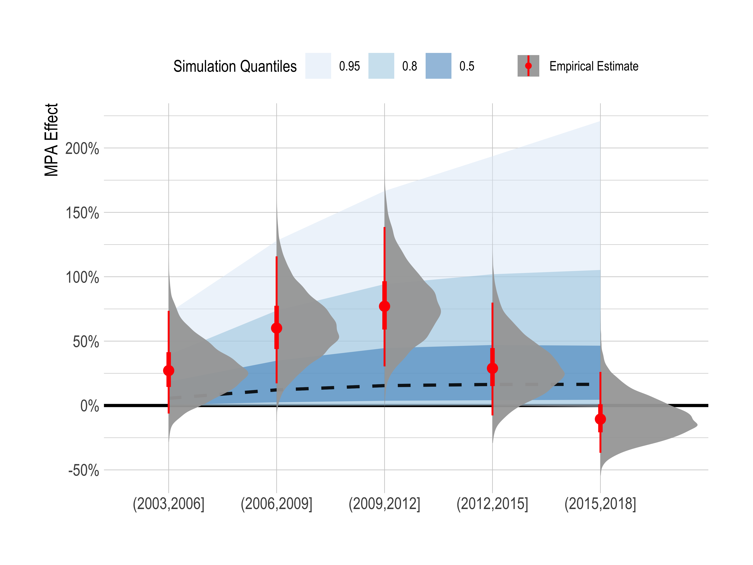

Figure 2: Results of difference-in-difference regression estimating the regional effect of the northern Channel Island MPAs on mean total biomass densities of targeted species (difference in mean total biomass density of targeted species over time relative to expected levels using non-targeted species as a control). Grey distributions show posterior probability distribution of estimated MPA effect; red point is median estimated effect, thicker red section 50% credible interval, thinner red line 90% credible interval). Blue distributions in background show range of MPA effects produced by simulation model tuned to reflect the dynamics of the Northern Channel Island MPAs (black dashed line is median simulated value). Results are estimated in blocks of three years, including years greater than or equal to left-hand value and less than right-hand value.

The network of MPAs implemented in the Northern Channel Islands in 2003 provides an ideal opportunity to examine the regional effects of protected area networks. This analysis is to our knowledge the first empirical estimate of the regional effects of a large and iconic MPA network on a broad assemblage of targeted fin-fish. Despite the well enforced nature of these MPAs [XX is there any citation for this XX], and the presence of a rigorous scientific monitoring program, we are unable to estimate a clear effect of protection. While response ratios of targeted species have increased over time, providing evidence of effective *within MPA* protection, these response ratios are on their own an unreliable indicator of the regional conservation effects of the MPAs. Our difference-in-difference regression estimates a high probability of increasingly positive MPA effects over the first nine years of protection, only to see these estimated gains reversed from 2012 to 2017. For the most recent time period, we can detect no clear positive or negative regional effect of the Channel Island MPAs on biomass densities of targeted fin-fish (Fig.2).

How can we explain these results? One explanation may lie in fleet dynamics. Much of the theoretical literature on MPAs assumes that all else being equal bigger reserves produce bigger conservation gains (42). However, these models generally simulate fleet dynamics through fishing mortality rates (e.g. concentration of fishing mortality (50)). The assumption of these models is that fishers determine an amount off effort to exert, and distribute that effort outside the MPA in response to some function.

An alternative and to our knowledge unexplored (in the context of MPA simulation) fleet model though is a “constant-catch” strategy. Under this model, fishers have a catch objective, and exert as much (or little) effort as needed to achieve that objective. While a constant-catch greater than MSY is not possible over the long-term under the assumptions of our model, over the short-term a constant-catch scenario is not implausible. Subsistence fisheries may use a constant-catch style policy over the short-term, as they seek to ensure that their food needs are met. More industrial fisheries may have pre-arranged agreements with buyers to deliver set amounts of fish. Constant-catch dynamics might also occur in fisheries with constraining quotas that are not updated after the implementation of MPAs. While open-access fishing strategies can result in “scorched earth” scenarios where the only fish left are found inside the reserve, across 94% simulations the net effect of the reserves was still positive. Under a constant-catch scenario though, fishers have to fish much harder than before to get the same catch from a smaller part of the population, reducing the size structure of the population and subsequently causing net conservation loss under 70% of our constant-catch simulations. This is an important and often overlooked possibility, especially as MPAs are increasingly implemented in quota-managed fisheries.

While we do not have access to fine scale fishing data from the Northern Channel Islands alone, reported catches for the species of interest in the Santa Barbara region in fact exhibit an overall downward trend in the years post reserve (see Fig.SXX). We can most likely rule out a negative MPA effect caused by a constant-catch fishing strategy then. What is another possible explanation for the recent downward trend in the estimated MPA effects? The Channel Islands region (and the entire West coast of the USA) experienced a dramatic ‘marine heatwave’ beginning in 2014 and persisting through 2016, resulting in part in extremely elevated water temperatures throughout the region (53). Biogeographic differences in the distributions of targeted and non-targeted species may confound the observed effects of MPAs. Many of the non-targeted species in the Channel Islands have warm thermal affinities and have increased in numbers since the heatwave (54). The targeted group is made up mostly of fishes with cold-water affinities, such as members of the genus *Sebastes*. As such, we hypothesize that the recent evidence for a decline in densities of targeted species is due to environmental conditions that disproportionately affect the targeted group (and not for example due to concentrated fishing pressure outside the reserves). This hypothesis is supported by the declining trend in mean biomass densities of targeted species seen inside the MPAs themselves. If the cause of recent declines was due to increases in fishing pressure we would expect to see substantial declines only in the fished areas (Fig.3).

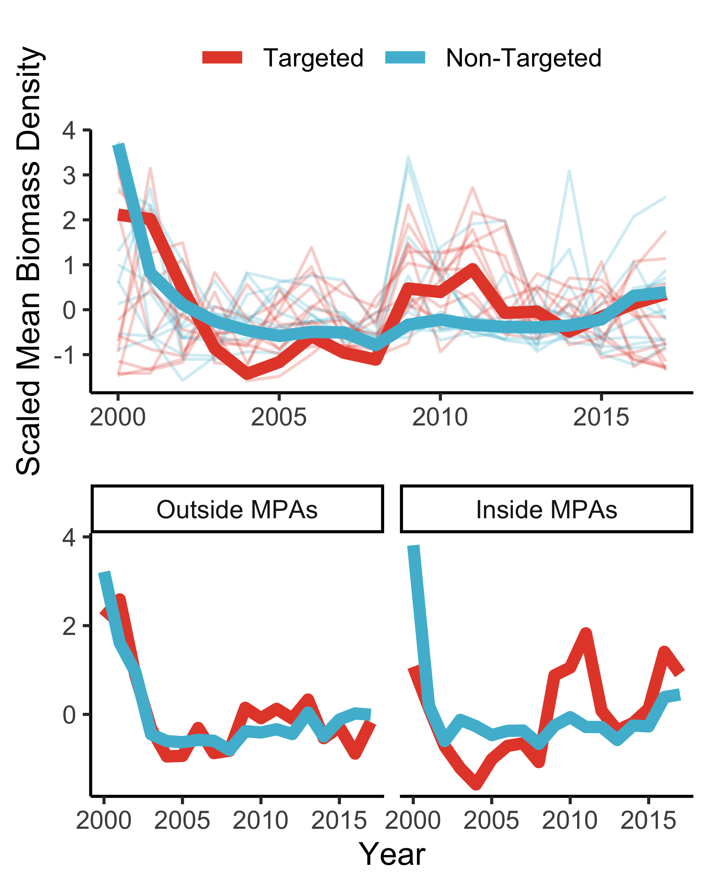

Figure 3: Centered and scaled trends in biomass densities of targeted and non-targeted finfish included in our stury. Top panel shows trends across all sites, with smaller background lines showing trends for each indivdual species. Bottom two panels show aggregate biomass density trends outside and inside MPAs

### When Can We Detect the Effects of MPAs?

Containing a carefully designed, well-enforced, and well-studied MPA network, The Channel Islands would seem at face value to be an ideal location to study the regional conservation effects of protected areas. The persistently high response ratios suggest that despite overall decreases in targeted biomass densities inside and outside MPAs, the MPAs may still be providing protection within their borders. But, as we have shown here these response ratios are not necessarily an indicator of regional effects. The difference-in-difference strategy utilized here presents an alternative identification strategy, that while not without its own strict caveats presents some potential improvements over response-ratios as a means of estimating regional conservation effects. While we estimate a highly uncertain but overall positive effect at first, we are unable to detect a robust signal from 2012-2017. We believe that the dissapearance of increasing probabilities of positive MPA effects estimated by our model are likely driven by the marine heatwave experienced by the region beginning in 2014. After 14 years of MPA protection and following a large environmental perturbation we are left without a clear picture of the effect of the Channel Island MPA network on biomass densities of targeted fin-fish species.

Our simulation results suggest that we should not be surprised by this result. The Channel Islands MPAs cover 20% of the surface waters in the Channel Islands, and while formal stock assessments are not available for many of the targeted species in our analysis, what evidence we have suggests that, as a group, these fish are on average not heavily overfished. Some species, such as California sheephead and blue rockfish were likely below target levels during the period (47, 48), but projections based upon the overall average response across all species will likely suggest modest benefits even if a subset of species could experience much larger population gains. Our simulations suggest that the average percentage difference in densities of targeted species with and without MPAs to be modest (Fig.). Effects of this size are likely to be challenging to detect empirically given the large natural variation of marine ecosystems (especially temperate reefs) and the observation error inherent in infrequent (e.g. annual) common in marine systems.

As an additional complication, our simulations and difference-in-difference model examine percentage changes in biomass densities (as oppose to changes in total population size). As an extreme example, an increase in biomass densities from 0.2kg/m2 to 0.4kg/m2 would be produce as a 100% increase. While a large percentage increase, this is a small change in biomass densities relative to the variance in the observation process itself (see Fig.S1 for a companion to Fig. scaled by absolute population size). In addition, the median estimated age at sexual maturity for the targeted species included in this study is 6 years, meaning that the span of this analysis represents less than three generations of MPA protection for half of the the measured species. Ongoing monitoring may yet reveal clearer effects. Analysis of more rapidly growing and maturing species, e.g. spiny lobster, may also reveal clearer signals.

Given the natural variability of marine ecosystems, and the large challenges of obtaining accurate samples from oceanic environments, how large of an effect would an MPA network have to have in order to allow a difference-in-difference strategy such as this to be a reliable measure of MPA effects? To provide guidance on this important question, we used our bio-economic model to simulate data from a range of scenarios with increasing MPA effect size, along with increasing degrees of observation error and natural recruitment variation. As an added measure, we include scenarios in which the sampled species go through recruitment regimes, which may be positive for both targeted and non-targeted species, or positive for non-targeted species and negative for targeted species. We then used a simple Bayesian difference-in-difference regression styled after the full model used here on these simulated data, and estimated the percent error between the posterior probability distribution of the estimated MPA effect and true simulated MPA effect.

While unbiased across simulations, the difference-in-difference model struggled severely when MPA effect sizes were less than 25% and the model was faced with observation and process errors (Fig.4). Even larger effect sizes commonly misestimated the true MPA effect by 50% or more. Obtaining a mean absolute percent error (MAPE) of 25% or less across our simulated datasets required an MPA effect of at least 30%. This is merely an illustrative exercise, omitting clearly critical factors such as detection probability and sampling strategy. However, since nearly any omission which one can think of would make an MPA effect harder to detect, not easier, these results serve as a useful floor for the likely difficulty in estimating MPA effects. In the context of the Channel Islands, given the potential effect size produced by our simulation model these results suggest that we might expect to be unable to detect a clear effect.

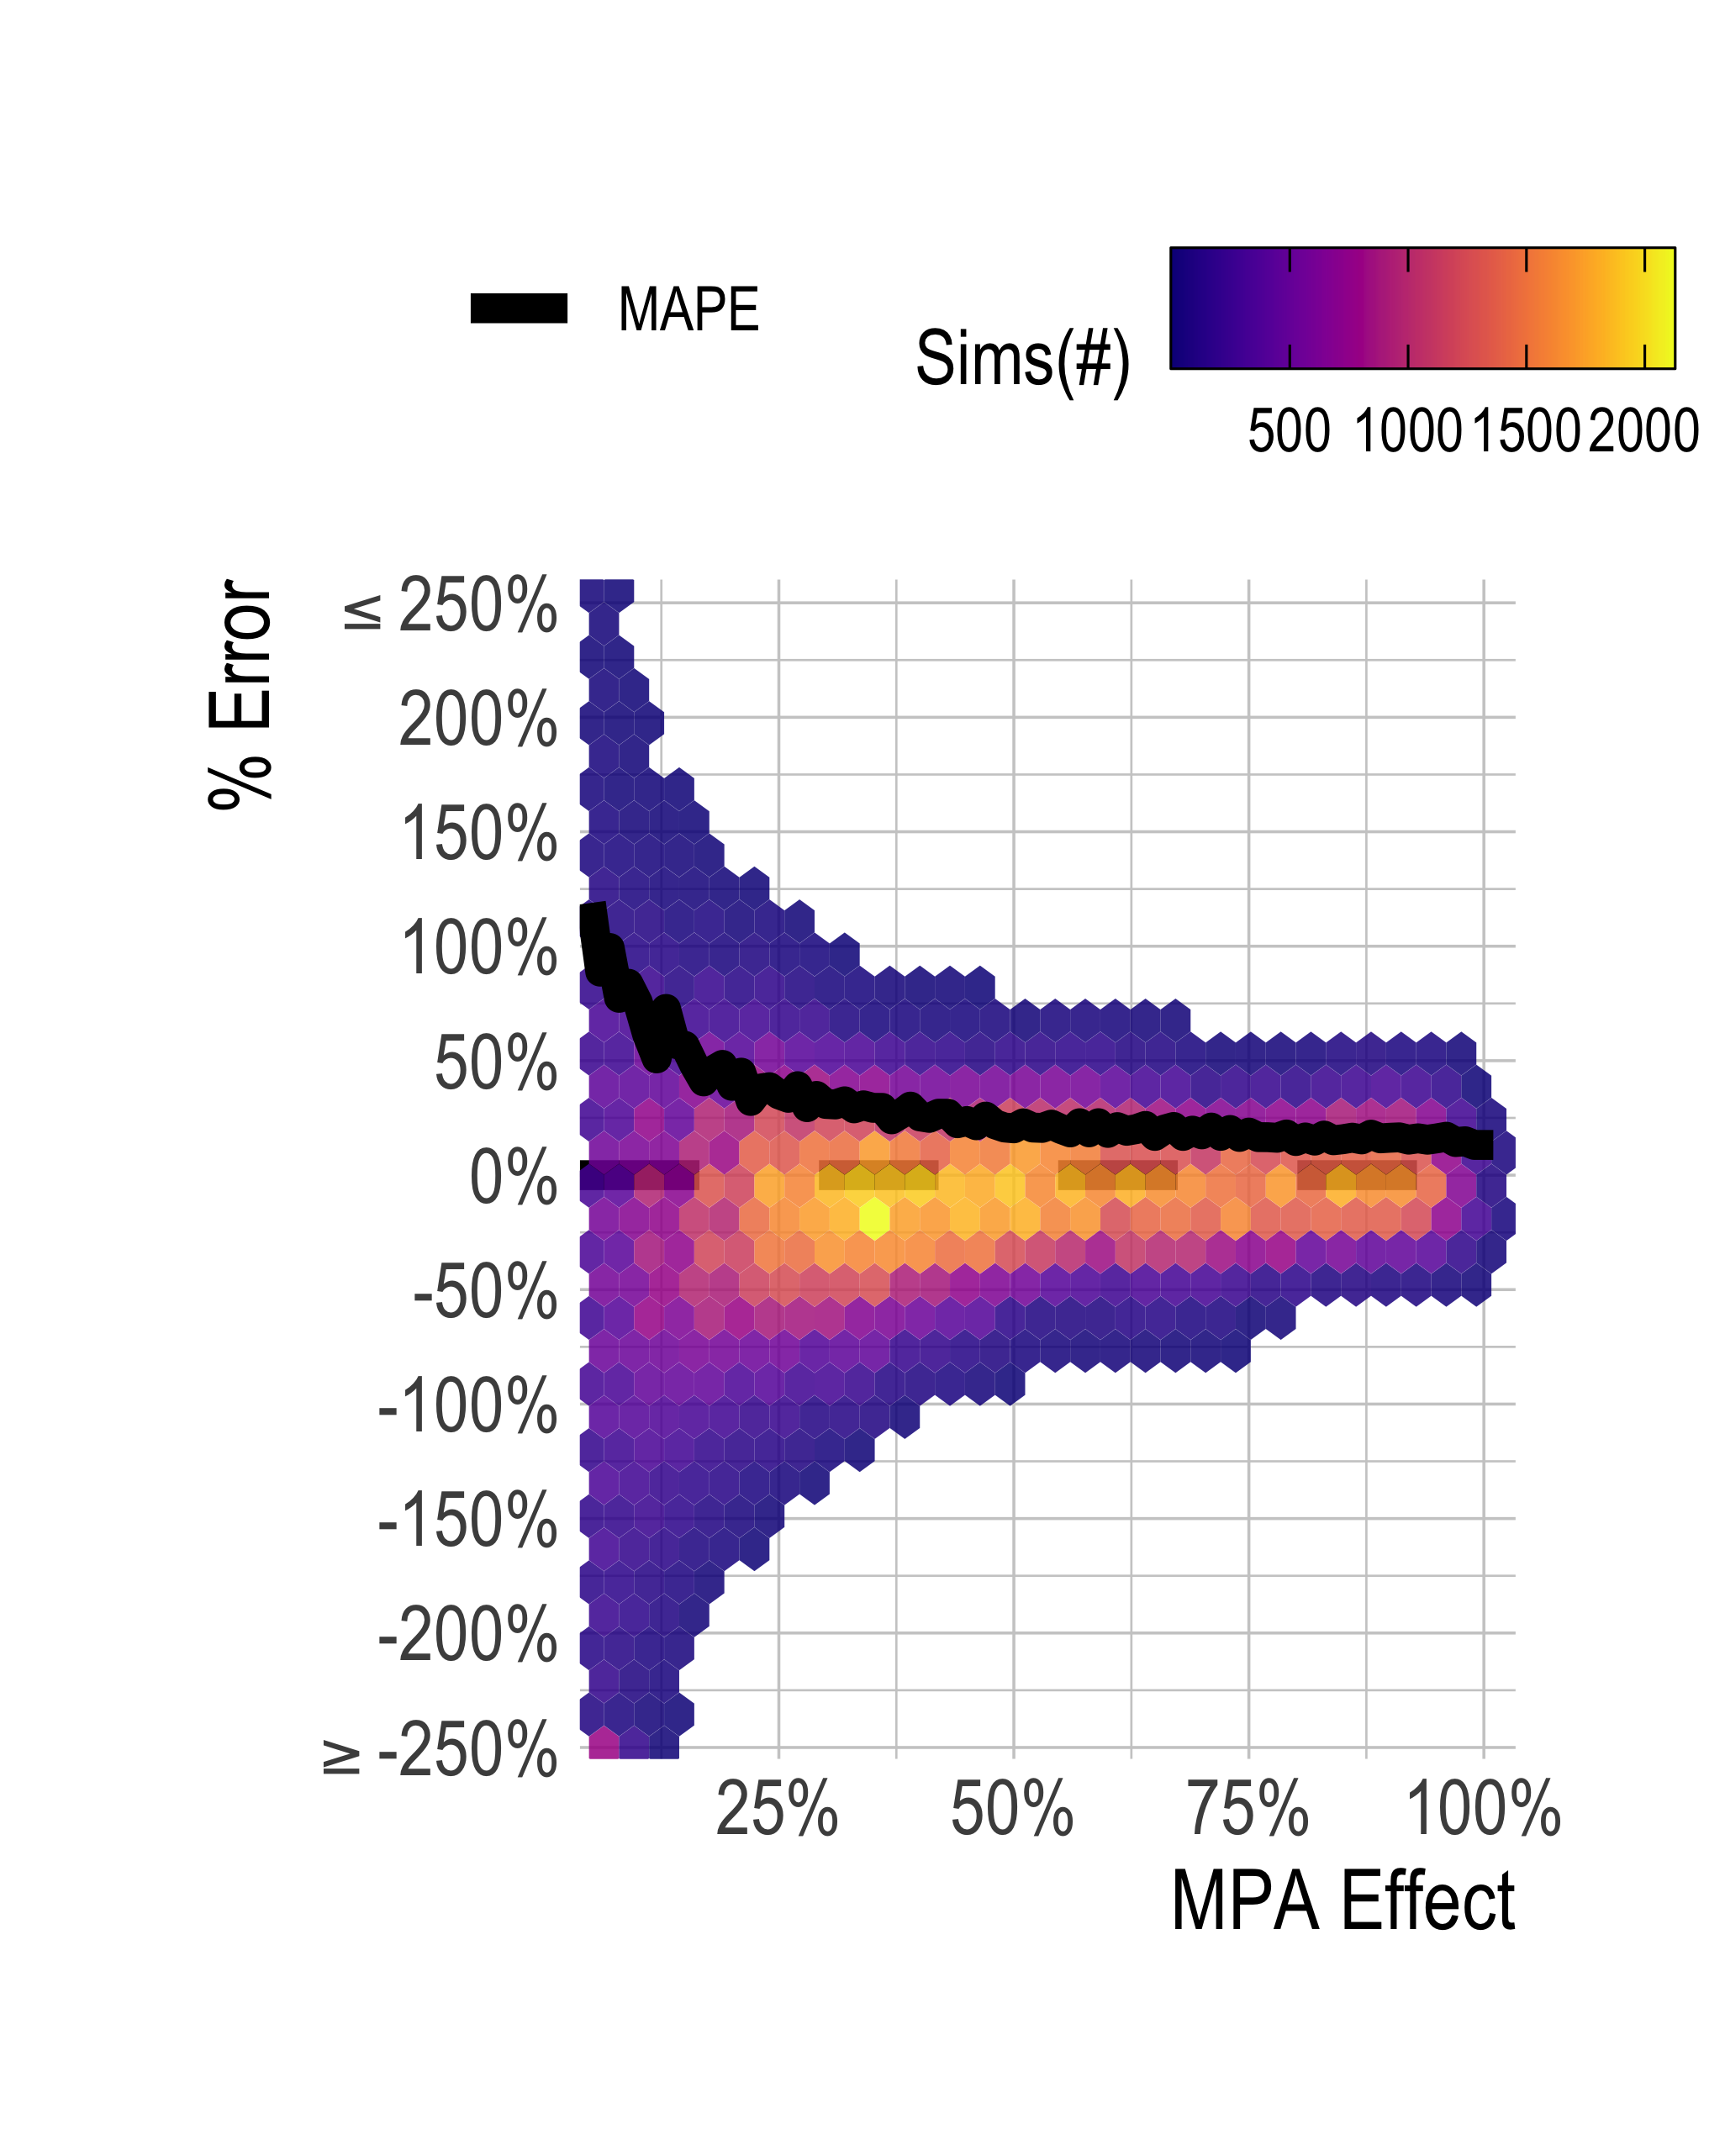

Figure 4: Distribution of percent error in posterior estimate of MPA effect (y-axis) plotted against true simulated MPA effect (x-axis). Color shows concentration of simulations. Black line shows mean absolute percent error (MAPE) as a function of true simulated MPA effect.

This finding begs an important question: when should we expect to see MPA effects big enough to stand a reasonable chance of detection? We simulated 9252 MPA scenarios across a wide range of life histories, network designs, and fishing dynamics (see SI for a full description of scenarios). Using these simulations, we can consider what we might expect the regional effects of an MPA network to be under a range of plausible circumstances.

Suppose that we are willing to tolerate a MAPE of 25%. Our analysis suggests that we would need an MPA effect size of at least 30% to achieve this. Two of the most critical drivers of MPA performance are the size of the MPA and the degree of fishing pressure. Looking across these two variables, our simulations suggest if the MPA network covers 25% or more of a species range and pre-MPA depletion is greater than 60% we might expect an effect size with our target MAPE. While recently some extremely large MPAs have been enacted that may indeed reach into the higher levels of MPA coverage, for near-shore commercial fin-fish many MPA networks are likely to cover areas more in line with the Channel Islands (20%), and as such have effect sizes that may be difficult to detect (Fig.5-A).

These initial simulation results suggest some rather simple rules of thumb: put an MPA of sufficient size on an at least somewhat overexploited population and one can expect large and potentially detectable results. The MPA literature highlights a large number of variables beyond simply size and fishing pressure that can affect performance. To address this, we examined the variability in expected MPA effects across each of the two major axes (pre-MPA depletion and MPA size). As both MPA size and pre-MPA depletion increase, the potential for a large MPA effect increases. However, for both variables even at extremely large or extremely small values a wide range of MPA effects were possible (though as we might expect the effect of pre-MPA depletion, in other words fishing pressure, was much clearer than MPA size alone) (Fig.5-B).

To put these results into context, the FAO estimates that 7% of the worlds fisheries with status estimates fall into the relatively unexploited category (roughly depletion less than 50%), 60% fall into the fully fished category (roughly depletion 50%-70%), and 33% fall into the heavily fished category (roughly depletion greater than 70%) (55), though works that include a broader range of fisheries estimate that 50% or more of stocks to fall into the heavily fished category (57, 58). The regional effects of MPA networks covering 25% or less of a species range may be difficult to detect in many places with already well-managed fisheries, while for that size we might expect clearer effects in less-managed locations (though that of course ignores the complication of compliance with MPA regulations). Within these broad guidelines a wide range of outcomes are possible based on local fleet and fish dynamics: as a starting place users can use the bio-economic MPA simulation model developed for this paper to explore potential outcomes for specific MPAs using an interactive web application available at [danovando.shinyapps.io/simmpa](https://danovando.shinyapps.io/simmpa/).

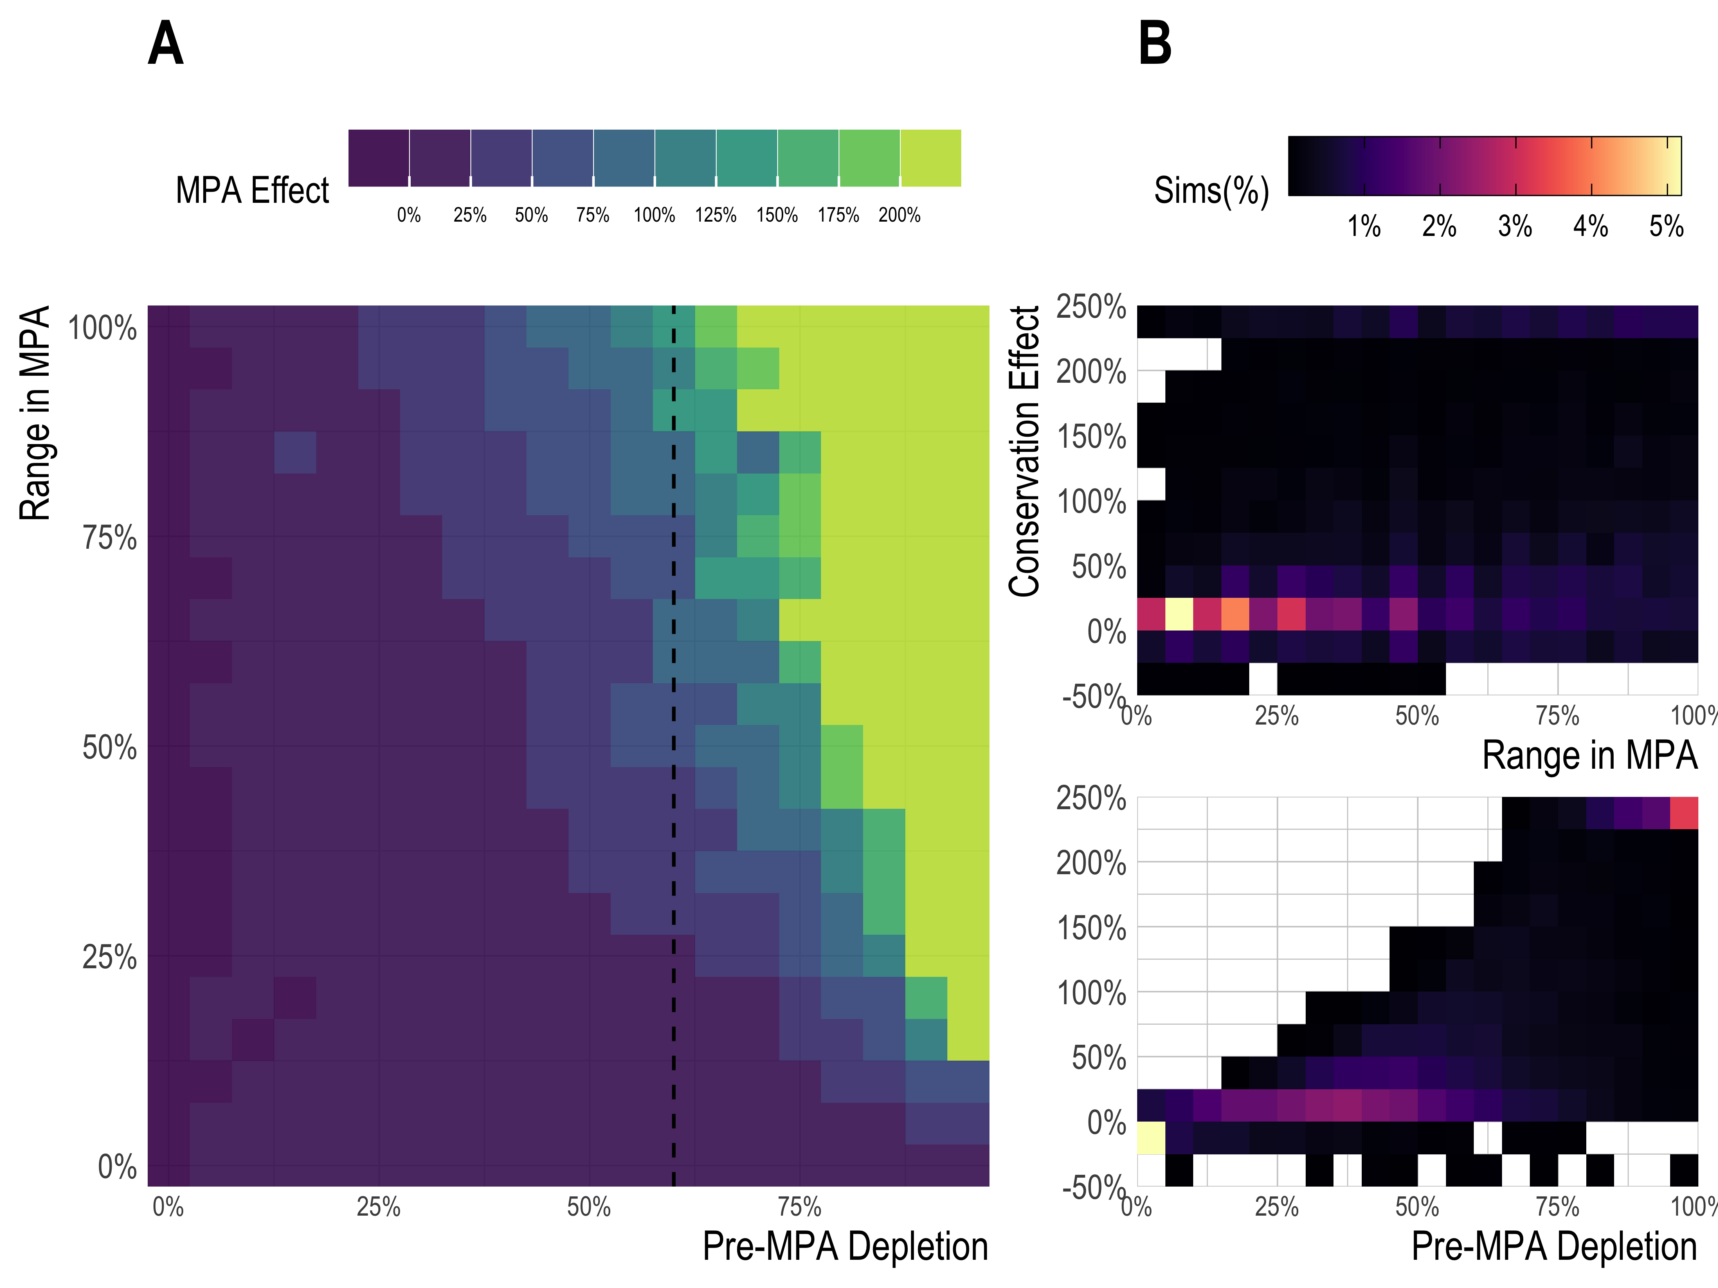

Figure 5: Simulated MPA effect sizes as a function of percent of species’ range inside MPA, and pre-MPA depletion. Pre-MPA depletion is a measure of fishing pressure, where 0 means that the population is unfished, and 1 means that the population is extinct in the time period immediately prior to MPA implementation. A) shows median MPA effects across range in MPA and pre-mpa depletin. Panel B shows distribution of simulations across range in MPA and pre-mpa depletion separately.

## Conclusions

MPAs are an important part of the marine resource management toolbox. Under ideal circumstances they can protect individual species and ecosystem linkages, while supporting local economies through tourism and fishing opportunities. One rationale for the expansion of MPAs is that they will deliver net conservation benefits both inside *and outside* their borders. To date, this assumption is insufficiently tested, and this is the focus of our paper. Our results show that regional conservation benefits of MPAs are highly context dependent and in many circumstances, are likely to be small enough that they are nearly impossible to detect empirically. Indeed, this is exactly what we found in our empirical case study from the relatively large and well-studied network of MPAs in the Channel Islands, California, USA.

What do our results imply about the future of MPA science? Our simulation model is by no means exhaustive (for example it ignores features such as species interactions, habitat effects, and climate feedback), but captures many of the core factors theorized to affect MPA performance. While attributes such as MPA size and fishing pressure are important factors in determining the effects of protection, local fleet dynamics and the movement rates of adult fish can dramatically affect the outcomes of protected areas as well (Fig.). The effects of MPAs can be highly context dependent, requiring - we would argue - a bio-economic model of at minimum the complexity presented here to help communities design and set expectations of MPAs at the tactical level. While users may not be able to parameterize every aspect of a model such as that presented here, working with stakeholders to visualize the implications of, for example, different fleet responses to MPA implementation is a critical step in MPA design.

Once simulation models have been used to help design an MPA, how can users evaluate whether it is achieving their objectives? Response ratios are commonly used as evidence for conservation outcomes of MPAs; (5) and (59) present meta-analyses of hundreds of such studies. These results often find massively higher densities and biomass inside MPAs than outside (5). But as suggested in (42), (49), (51) and further demonstrated here, without careful attention to the design of control sites (e.g. accounting for the displacement of fishing effort by MPAs), response ratios may be highly unreliable estimators of regional MPA effects. When MPAs affect nearby control sites used in response ratios through biological spillover or concentration of fishing effort, it is entirely possible to for MPA to produce massive response ratios while simultaneously having minimal effects on the entire population partially protected by the MPAs. As (51) suggests, there are many potential alternatives for estimating the effects of MPAs that better account for the challenges of causal inference (though that may be more data-intensive). We applied one such approach here (a difference-in-difference estimator), and yet were still unable to reach robust conclusions as to the effect of MPAs on the biomass density of targeted finfish in the Channel Islands, due to the likely small size of the true effect relative to the strength and variability of environmental drivers.

While this does not mean that all MPAs will face similar challenges in estimating their effects, our results in the rigorously studied and iconic Channel Islands Marine Protected Area network make clear that in many instances empirically detecting a clear regional effect of MPAs may not be possible. How then should stakeholders go about adaptively monitoring and managing MPAs? Simulation modeling can help inform the range of effect sizes that may be expected, and monitoring programs can perhaps be tuned to focus on the species groups that have the highest chance of a detectable effect size over the early years of the reserve (60). Expanding data collection to include robust monitoring of spatio-temporal fleet dynamics may help assess the validity of control sites used in response ratios, support the direct inclusion of these fleet dynamics into statistical models, and allow managers to take into account potential negative interactions between MPAs and fleet dynamics such as those that may occur under constant-catch dynamics. Whenever possible monitoring programs should be implemented prior to MPA implementation to provide a pre-treatment benchmark.

Non-equilibrium analyses also help set expectations for effect sizes over time (60). Educating communities about the challenges of estimating the effects of MPAs can help set expectations, so that a lack of a clear effect is not necessarily viewed as a failure of the program, or large positive result based solely on response ratios as a clear sign of success and subsequent increased fishing opportunity. Rather, results and subsequent management actions (such as adaptation of MPA networks) must be considered in the context of reasonable expectations given the size, age, and degree of enforcement of the MPAs in question, together with the ecological and economic dynamics of a given system. While this paper has focused on the conservation outcomes of MPAs, future work must also address the challenge of predicting and estimating the fishery impacts of protected areas.

As the number and size of global MPA networks increase, it is critical that we both set appropriate expectations for their outcomes, and plan how we will monitor the performance of these protected areas over time. While the history of MPA science has made important strides in helping us understand the dynamics of protected areas, the future of MPA science must directly tackle the challenge of evaluating the performance of these MPAs at the regional scale, and adapting their design as needed to best achieve objectives. This is particularly true if communities are depending on MPAs as their primary marine resource management tool. Commonly employed metrics such as response ratios may be applicable in some circumstances, but can have severe shortcomings as metrics of regional conservation effects. Dependence on unreliable estimators of MPA effects may lead to stakeholders incorrectly attributing negative environmental shocks as MPA failures, or interpreting data arising from scorched-earth fishing outside MPAs as a conservation success. Both of these scenarios would hinder the ability of MPAs to serve as effective marine resource management tools. Bio-economic modeling can help frame community expectations, reducing the potential for a reduction in support if unrealistic conservation or fishery expectations are not realized. Statistical approaches that explicitly address complications such as the spatial spillover effects of MPAs (such as the difference-in-difference approach used here) may give users an improved understanding of the performance of their MPAs, but even they may struggle when expected effect sizes are small. Clearly communicating what we should expect, and what we can detect, from MPAs is critical in ensuring that MPAs play effective roles in fisheries management and marine conservation.

## Materials and Methods

We present here critical characteristics of our simulation model and regression approach. Further details can be found in the Supplementary Information. All analysis were conducted in R (61). Our main difference-in-difference model was fit using Stan (62) using the rstanarm package (63). All materials needed to replicate results can be found [here](https://github.com/DanOvando/regional-effects-of-mpas).

### Simulation Model

Our bio-economic model simulates the effect of MPAs on a spatially explicit age-structured representation of a single species. Readers can explore the functionality of the model using an online tool available [here](https://danovando.shinyapps.io/simmpa/). See Table.S1 for a complete description of simulation states. The model consists of 50 patches with wrapped edges (picture the waters around a circular island). For any one simulation we randomly pull a species and its associated life history from the FishLife (44) package in R. We pair these data with randomly selected values between 0.6 and 0.95 for Beverton-Holt steepness (64), as well as larval and adult dispersal rates. We randomly assign whether adult fish preferentally move towards patches with lower relative densities, as well as one of three potential types of recruitment density dependence (65):

1. Local density dependence: Density dependence occurs independently in each patch, and recruits then disperse to nearby patches
2. Global density dependence: Density dependence is a function of the sum of spawning biomass across all patches, and recruits are then distributed according to habitat quality
3. Post-dispersal density dependence: Larvae are distributed throughout the system, and then density dependence occurs based on the density of adult biomass at the destination patch

We allow for three potential siting strategies for MPAs. In the first, MPAs are randomly placed. In the second, we assume that MPAs are placed in preferentially better habit (unfished recruitment is four times greater inside MPA locations). In the third, we allow for scenarios in which MPAs are placed in hotspots of larval dispersal. In this scenario, patches in which MPAs will be placed have larval dispersal rates four times greater than patches that do not become MPAs.

Each simulation is randomly assigned a fleet model of the form

1. Open access: fishing effort changes in response to profit-per-unit-effort
2. Constant effort: total fishing effort is constant over time (unless altered by MPA displacement model)
3. Constant catch: the fleet exerts as much effort as need to achieve a target catch

This fleet model is paired with a gear selectivity ranging from .1 to 1.5 of the length at 50% maturity for the species in question, and the fleet model is tuned to achieve a target fishing mortality relative to natural mortality ratio at equilibrium.

Along with the fleet dynamics model, each simulation is assigned a random fleet dispersal scenario: uniform dispersal (where the total effort of the fleet is divided evenly among all open patches), catch dispersal (where the total effort of the fleet is divided according to the catchable biomass in each available patch), and profit dispersal (where the total effort of the fleet is divided according to the profit per unit effort in each available patch).

Lastly each simulation is assigned an MPA scenario, defined by the number and size of MPAs, the placement of those MPAs, and the year that the MPAs are put in place. Each simulation starts the population off at unfished equilibrium and then beings to apply the fleet model. The MPAs are then placed during the randomly selected start year, allowing some runs to explore how the early dynamics of the MPA play out when the fishery and population they are placed on is not already at equilibrium. Fishing effort in displaced by MPAs can either concentrate outside or leave the fishery. Each simulation is run to equilibrium with and without the selected MPA strategy (holding all else constant). We then measure the difference in biomass densities each time step in the scenario with and without the MPAs to calculate the conservation and fishery effects of the MPAs over time.

### Difference in Difference Regression

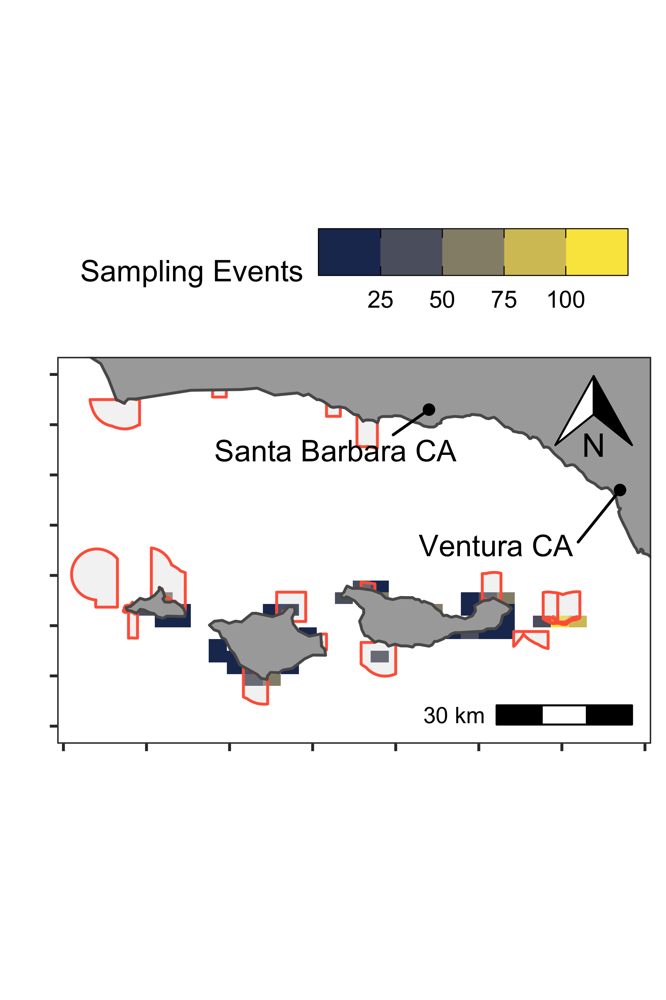

Figure 6: Map of study region; the Northern Channel Islands, California, USA. Colors show binned number of PISCO sampling events across the time period of our study.

The difference-in-difference model used empirical kelp forest survey data from the Partnership for Interdisciplinary Studies of Coastal Oceans (PISCO) monitoring in the Northern Channel Islands. A network of MPAs covering approximately 20% of the islands’ waters was put in place in 2003 as part of the California Marine Life Protection Act (MLPA) (see (22), (23), (24), and (25) for information on the creation of the MLPA). PISCO conducts visual SCUBA surveys at a large number of rocky-reef and kelp forest sites inside and outside of MPAs throughout the Channel Islands, producing estimates of densities of fishes that are both targeted and non-targeted by fishing (Fig.). The details of the monitoring program are described in (26).

The key assumptions of the difference-in-difference model are that a) within the time-frame of the model there are no significant interaction effects between the targeted and non-targeted species (which in fact we do not detect, see SI), and b) that in the absence of the MPAs both the targeted and non-targeted groups of species would have exhibited similar trends in densities. The advantage to this approach is that given the time-frame of the model (14 years with MPAs), we believe that spillover effects of MPA placement on the non-targeted species are likely to be much less severe than the effects of biological spillover and fishing concentration that may bias the performance of estimators such as a response ratios.

The regression amounts to estimating the pre-post MPA difference in the biomass densities of targeted species minus the same difference for non-targeted species in the Channel Islands.

The simplified form of this model is

where is the biomass density at observation *i*, *T* indicates whether the observation *i* is for a targeted () or non-targeted () species, and *MPA* marks whether observation *i* is in a pre MPA () or post MPA () state. **Bc** is a vector of coefficients for additional control variables in matrix *X* such as water visibility and observer experience. **Bs** is a vector of hierarchical coefficients for each sampling location **S** , clustered by island. Under the assumptions of this model, is the causal effect of the treatment (*MPA*) on the treated (targeted species). The shape and scale parameters of the Gamma distribution are estimated as well. See SI for further details of the estimation model. xx% of the samples in the raw data come from within MPAs, while the MPAs themselves cover roughly 20% of the surface waters of the channel islands. As such, we weight each observation such that within MPA data are assigned a total weight of 0.2 and outside-MPA data a total weight of 0.8.

We briefly assess two of the most critical assumptions of this model here: that the treated and non-treated groups have parallel trends, and that the effect of the treatment on the treated does not tangentially affect the untreated. While the parallel trends assumption cannot be formally proven, we can examine its validity using the data from the years before the MPAs were put in place in 2003. We do not detect any significant differences in the trends of the biomass densities of the targeted and non-targeted species in the years before the MPAs. With regards to the second assumption, all of the species in this empirical analysis exist within an ecosystem, and as such affect each other through mechanisms such as predation, competition, and habitat modification. We find it unlikely that these effects have had enough time to manifest in a meaningful way in the 14 years of post-MPA data used in our analysis (66, 67).

We used convergent cross mapping (CCM), in the manner of (68), to test for the possibility of the trophic cascades biasing our results. Generalizations of Takens’ theorem indicate that if two variables are part of the same dynamic system, their individual dynamics should reflect their relative causal influence. Convergent cross mapping (CCM) tests for causation by using the attractor/manifold built from the time series of one variable to predict another (hence the “cross-mapping”). CCM then allows us to test for causal relationships in the timeseries of densities of targeted and non-targeted species. Our results found no significant cross-mappings between targeted and non-targeted species, indicating that while clearly there are interactions between these groups on some level, the effects within the timespan of the data are not pronounced enough to be of concern to our results (see SI for additional information in CCM testing). However, the longer MPAs are in place, the greater the possibility that substantial species interactions that can affect use of non-targeted species as a control may arise.

1. Johannes RE (1978) Traditional Marine Conservation Methods in Oceania and Their Demise. *Annual Review of Ecology and Systematics* 9(1):349–364.

2. IUCN (1976) *IUCN yearbook, 1975-76 : Annual report of the International Union for Conservation of Nature and Natural Resources for 1975 and for January-May 1976*.

3. Watson JEM, Dudley N, Segan DB, Hockings M (2014) The performance and potential of protected areas. *Nature* 515(7525):67–73.

4. Gaines SD, White C, Carr MH, Palumbi SR (2010) Designing Marine Reserve Networks for Both Conservation and Fisheries Management. *Proceedings of the National Academy of Sciences* 107(43):18286–18293.

5. Lester SE, et al. (2009) Biological effects within no-take marine reserves: A global synthesis. *Marine Ecology Progress Series* 384:33–46.

6. Halpern BS, Warner RR (2003) Review Paper. Matching marine reserve design to reserve objectives. *Proceedings of the Royal Society of London Series B: Biological Sciences* 270(1527):1871–1878.

7. Edgar GJ, et al. (2014) Global conservation outcomes depend on marine protected areas with five key features. *Nature* 506(7487):216.

8. Gerber LR, Heppell SS, Ballantyne F, Sala E (2005) The role of dispersal and demography in determining the efficacy of marine reserves. *Canadian Journal of Fisheries and Aquatic Sciences* 62(4):863–871.

9. Goni R, Hilborn R, D\’ıaz D, Mallol S, Adlerstein S (2010) Net contribution of spillover from a marine reserve to fishery catches. *Mar Ecol Prog Ser* 400:233–243.

10. Halpern BS, Lester SE, Kellner JB (2009) Spillover from marine reserves and the replenishment of fished stocks. *Environmental Conservation* 36(04):268–276.

11. Kay MC, Lenihan HS, Kotchen MJ, Miller CJ (2012) Effects of marine reserves on California spiny lobster are robust and modified by fine-scale habitat features and distance from reserve borders. *Marine Ecology Progress Series* 451:137–150.

12. Stobart B, et al. (2009) Long-term and spillover effects of a marine protected area on an exploited fish community. *Marine Ecology Progress Series* 384:47–60.

13. McClanahan TR, Mangi S (2000) Spillover Of Exploitable Fishes From A Marine Park And Its Effect On The Adjacent Fishery. *Ecological Applications* 10(6):1792–1805.

14. Russ G, Alcala A (1996) Do marine reserves export adult fish biomass? Evidence from Apo Island, central Philippines. *Marine Ecology Progress Series* 132:1–9.

15. Thompson AR, Chen DC, Guo LW, Hyde JR, Watson W (2017) Larval abundances of rockfishes that were historically targeted by fishing increased over 16 years in association with a large marine protected area. *Royal Society Open Science* 4(9):170639.

16. Baetscher DS, et al. (2019) Dispersal of a nearshore marine fish connects marine reserves and adjacent fished areas along an open coast. *Molecular Ecology* 28(7):1611–1623.

17. Pelc R, Baskett M, Tanci T, Gaines S, Warner R (2009) Quantifying larval export from South African marine reserves. *Marine Ecology Progress Series* 394:65–78.

18. Costa BH e, et al. (2013) Fishers’ Behaviour in Response to the Implementation of a Marine Protected Area. *PLOS ONE* 8(6):e65057.

19. Mason J, Kosaka R, Mamula A, Speir C (2012) Effort changes around a marine reserve: The case of the California Rockfish Conservation Area. *Marine Policy* 36(5):1054–1063.

20. Murawski SA, Wigley SE, Fogarty MJ, Rago PJ, Mountain DG (2005) Effort distribution and catch patterns adjacent to temperate MPAs. *ICES Journal of Marine Science* 62(6):1150–1167.

21. McDermott GR, Meng KC, McDonald GG, Costello CJ (2019) The blue paradox: Preemptive overfishing in marine reserves. *Proceedings of the National Academy of Sciences* 116(12):5319–5325.

22. Osmond M, Airame S, Caldwell M, Day J (2010) “Lessons for marine conservation planning: A comparison of three marine protected area planning processes”. *Ocean & Coastal Management* 53(2):41–51.

23. Kirlin J, et al. (2013) California’s Marine Life Protection Act Initiative: Supporting implementation of legislation establishing a statewide network of marine protected areas. *Ocean & Coastal Management* 74:3–13.

24. Botsford LW, White JW, Carr MH, Caselle JE (2014) Chapter Six - Marine Protected Area Networks in California, USA. *Advances in Marine Biology*, Marine Managed Areas and Fisheries., eds Johnson ML, Sandell J (Academic Press), pp 205–251.

25. Hilborn R, Stewart IJ, Branch TA, Jensen OP (2012) Defining Trade-Offs among Conservation, Profitability, and Food Security in the California Current Bottom-Trawl Fishery. *Conservation Biology* 26(2):257–268.

26. Caselle JE, Rassweiler A, Hamilton SL, Warner RR (2015) Recovery trajectories of kelp forest animals are rapid yet spatially variable across a network of temperate marine protected areas. *Scientific reports* 5:14102.

27. Gaines SD, Gaylord B, Largier JL (2003) Avoiding Current Oversights in Marine Reserve Design. *Ecological Applications* 13(sp1):32–46.

28. Botsford LW, et al. (2008) Connectivity, sustainability, and yield: Bridging the gap between conventional fisheries management and marine protected areas. *Reviews in Fish Biology and Fisheries* 19(1):69–95.

29. Di Franco A, et al. (2018) Linking home ranges to protected area size: The case study of the Mediterranean Sea. *Biological Conservation* 221:175–181.

30. McGilliard CR, Hilborn R (2008) Modeling no-take marine reserves in regulated fisheries: Assessing the role of larval dispersal. *Canadian Journal of Fisheries and Aquatic Sciences* 65(11):2509–2523.

31. Burgess SC, et al. (2014) Beyond connectivity: How empirical methods can quantify population persistence to improve marine protected-area design. *Ecological Applications* 24(2):257–270.

32. Hilborn R, Punt AE, Orensanz J (2004) Beyond band-aids in fisheries management: Fixing world fisheries. *Bulletin of Marine Science* 74(3):493–507.

33. Hilborn R (1992) Can fisheries agencies learn from experience? *Fisheries* 17(4):6–14.

34. Walters CJ, Martell SJ (2004) *Fisheries ecology and management* (Princeton University Press).

35. Hastings A, Botsford LW (2003) Comparing Designs Of Marine Reserves For Fisheries And For Biodiversity. *Ecological Applications* 13(sp1):65–70.

36. Gerber LR, et al. (2003) Population Models For Marine Reserve Design: A Retrospective And Prospective Synthesis. *Ecological Applications* 13(sp1):47–64.

37. Hilborn R, et al. (2004) When can marine reserves improve fisheries management? *Ocean & Coastal Management* 47(34):197–205.

38. Botsford LW, Micheli F, Hastings A (2003) Principles for the Design of Marine Reserves. *Ecological Applications* 13(sp1):25–31.

39. Smith MD, Wilen JE (2003) Economic impacts of marine reserves: The importance of spatial behavior. *Journal of Environmental Economics and Management* 46(2):183–206.

40. Smith K (2006) Distributions, relative abundances and reproductive biology of the deep-water crabs Hypothalassia acerba and Chaceon bicolor in southwestern Australia.

41. Walters C (2000) Impacts of dispersal, ecological interactions, and fishing effort dynamics on efficacy of marine protected areas: How large should protected areas be? *Bulletin of Marine Science* 66(3):745–757.

42. White JW, et al. (2011) Linking models with monitoring data for assessing performance of no-take marine reserves. *Frontiers in Ecology and the Environment* 9(7):390–399.

43. Costello C, et al. (2010) The Value of Spatial Information in MPA Network Design. *Proceedings of the National Academy of Sciences* 107(43):18294–18299.

44. Thorson JT, Munch SB, Cope JM, Gao J (2017) Predicting life history parameters for all fishes worldwide. *Ecological Applications*:n/a–n/a.

45. Love MS (2011) *Certainly more than you want to know about the fishes of the Pacific Coast: A postmodern experience* (Really Big Press, Santa Barbara, Calif.).

46. Rassweiler A, Costello C, Siegel DA (2012) Marine protected areas and the value of spatially optimized fishery management. *Proceedings of the National Academy of Sciences* 109(29):11884–11889.

47. Alonzo S, Key M, Ish T, MacCall AD (2004) *Status of the California Sheephead Stock for 2004*.

48. Dick EJ, et al. (2017) *The Combined Status of Blue and Deacon Rockfishes in U.S. Waters off California and Oregon in 2017* (Pacific Fishery Management Council, Portland, OR).

49. Ferraro PJ, Sanchirico JN, Smith MD (2018) Causal inference in coupled human and natural systems. *Proceedings of the National Academy of Sciences*:201805563.

50. Halpern BS, Gaines SD, Warner RR (2004) Confounding effects of the export of production and the displacement of fishing effort from marine reserves. *Ecological Applications* 14(4):1248–1256.

51. Larsen AE, Meng K, Kendall BE (2019) Causal analysis in controlImpact ecological studies with observational data. *Methods in Ecology and Evolution* 0(0). doi:[10.1111/2041-210X.13190](https://doi.org/10.1111/2041-210X.13190).

52. Rassweiler A, Costello C, Hilborn R, Siegel DA (2014) Integrating scientific guidance into marine spatial planning. *Proceedings of the Royal Society B: Biological Sciences* 281(1781):20132252.

53. Gentemann CL, Fewings MR, García-Reyes M (2017) Satellite sea surface temperatures along the West Coast of the United States during the 20142016 northeast Pacific marine heat wave. *Geophysical Research Letters* 44(1):312–319.

54. Freedman R (2019) Understanding the Efficacy of Spatial Management on Emerging Threats. PhD thesis (University of California, Santa Barbara).

55. FAO ed. (2018) *The state of world fisheries and aquaculture* (Rome).

56. Thorson JT, Cope JM, Branch TA, Jensen OP (2012) Spawning biomass reference points for exploited marine fishes, incorporating taxonomic and body size information. *Canadian Journal of Fisheries and Aquatic Sciences* 69(9):1556–1568.

57. Costello C, Gaines S, Gerber LR (2012) Conservation science: A market approach to saving the whales. *Nature* 481(7380):139–140.

58. Rosenberg AA, et al. (2018) Applying a New Ensemble Approach to Estimating Stock Status of Marine Fisheries around the World. *Conservation Letters* 11(1):e12363.

59. Halpern BS, Warner RR (2002) Marine reserves have rapid and lasting effects. *Ecology Letters* 5(3):361–366.

60. Nickols KJ, et al. (2019) Setting ecological expectations for adaptive management of marine protected areas. *Journal of Applied Ecology* 0(0). doi:[10.1111/1365-2664.13463](https://doi.org/10.1111/1365-2664.13463).

61. R Core Team (2019) R: A Language and Environment for Statistical Computing.

62. Carpenter B, et al. (2017) *Stan* : A Probabilistic Programming Language. *Journal of Statistical Software* 76(1). doi:[10.18637/jss.v076.i01](https://doi.org/10.18637/jss.v076.i01).

63. Goodrich B, Ali I, Brilleman S (2020) Rstanarm: Bayesian applied regression modeling via Stan.

64. Mace PM (1994) Relationships between Common Biological Reference Points Used as Thresholds and Targets of Fisheries Management Strategies. *Canadian Journal of Fisheries and Aquatic Sciences* 51(1):110–122.

65. Babcock EA, MacCall AD (2011) How useful is the ratio of fish density outside versus inside no-take marine reserves as a metric for fishery management control rules? *Canadian Journal of Fisheries and Aquatic Sciences* 68(2):343–359.

66. Babcock RC, et al. (2010) Decadal trends in marine reserves reveal differential rates of change in direct and indirect effects. *Proceedings of the National Academy of Sciences* 107(43):18256–18261.

67. Pershing AJ, et al. (2015) Slow adaptation in the face of rapid warming leads to collapse of the Gulf of Maine cod fishery. *Science* 350(6262):809–812.

68. Clark AT, et al. (2015) Spatial convergent cross mapping to detect causal relationships from short time series. *Ecology* 96(5):1174–1181.