My Excellent Research

Dan Ovando

Daniel Ovando

2020-11-16

# Introduction

We found some cool stuff (Fig.1)

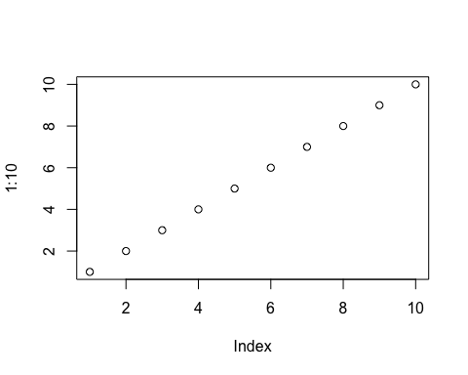

Figure 1: Our Main Results

Here are some penguins (Table.1)

Table 1: Here are some penguins

|  |  |  |  |  |  |  |  |
| --- | --- | --- | --- | --- | --- | --- | --- |
| species | island | bill_length_mm | bill_depth_mm | flipper_length_mm | body_mass_g | sex | year |
| Adelie | Torgersen | 39.1 | 18.7 | 181 | 3750 | male | 2007 |
| Adelie | Torgersen | 39.5 | 17.4 | 186 | 3800 | female | 2007 |
| Adelie | Torgersen | 40.3 | 18.0 | 195 | 3250 | female | 2007 |
| Adelie | Torgersen | NA | NA | NA | NA | NA | 2007 |
| Adelie | Torgersen | 36.7 | 19.3 | 193 | 3450 | female | 2007 |
| Adelie | Torgersen | 39.3 | 20.6 | 190 | 3650 | male | 2007 |

Here is a manual table, Tab.2.

This is a manual table (Table.2)

Table 2: Caption for a Manual Table

|  |  |  |
| --- | --- | --- |
| Thing 1 | Thing 2 | Col3 |
| A | B | C |
| D | E | F |
| G | H | I |

Here is a flipper model (Table.??)

My flipper model

|  | Flipper Model |
| --- | --- |
| (Intercept) | 209.707*** |
|  | (0.862) |
| islandDream | -16.634*** |
|  | (1.321) |
| islandTorgersen | -18.511*** |
|  | (1.782) |
| Num.Obs. | 342 |
| R2 | 0.376 |
| R2 Adj. | 0.372 |
| AIC | 2624.4 |
| BIC | 2639.7 |
| Log.Lik. | -1308.197 |
| F | 102.129 |
| * p < 0.1, ** p < 0.05, *** p < 0.01 | |

As you can see in Equation.(1)

# Supplementary Materials

Here are our Supplementary materials…

Here is another flipper model (Table.??)

My SI flipper model

|  | SI Flipper Model |
| --- | --- |
| (Intercept) | 188.795*** |
|  | (0.999) |
| islandDream | 0.937 |
|  | (1.336) |
| islandTorgersen | 2.401* |
|  | (1.364) |
| speciesChinstrap | 6.091*** |
|  | (1.196) |
| speciesGentoo | 28.392*** |
|  | (1.165) |
| Num.Obs. | 342 |
| R2 | 0.780 |
| R2 Adj. | 0.778 |
| AIC | 2271.4 |
| BIC | 2294.4 |
| Log.Lik. | -1129.679 |
| F | 299.249 |
| * p < 0.1, ** p < 0.05, *** p < 0.01 | |

As you can see in Equation.(2)

# Appendix

This is an appendix

As you can see in Equation.(3)