Welcome to the first edition of our monthly members’ bulletin, the Entrepreneurial Underwriter. In addition to news from our members, this issue includes a deep dive into Lloyd’s coverholder business in Europe, an article on the advantages for MGAs of incorporating reinsurance captives in their capacity stacks, and an update on FASE’s annual conference, the MGA Rendezvous.

Lloyd’s in Europe: Coverholder Business Growing Fast After 123 Years

Ever since the pioneering Lloyd’s underwriter, Cuthbert Heath, first granted a binding authority to his agent in Amsterdam, Alfred Schroder, in 1903, Lloyd’s has played a key role in the development of Europe’s delegated authority market.
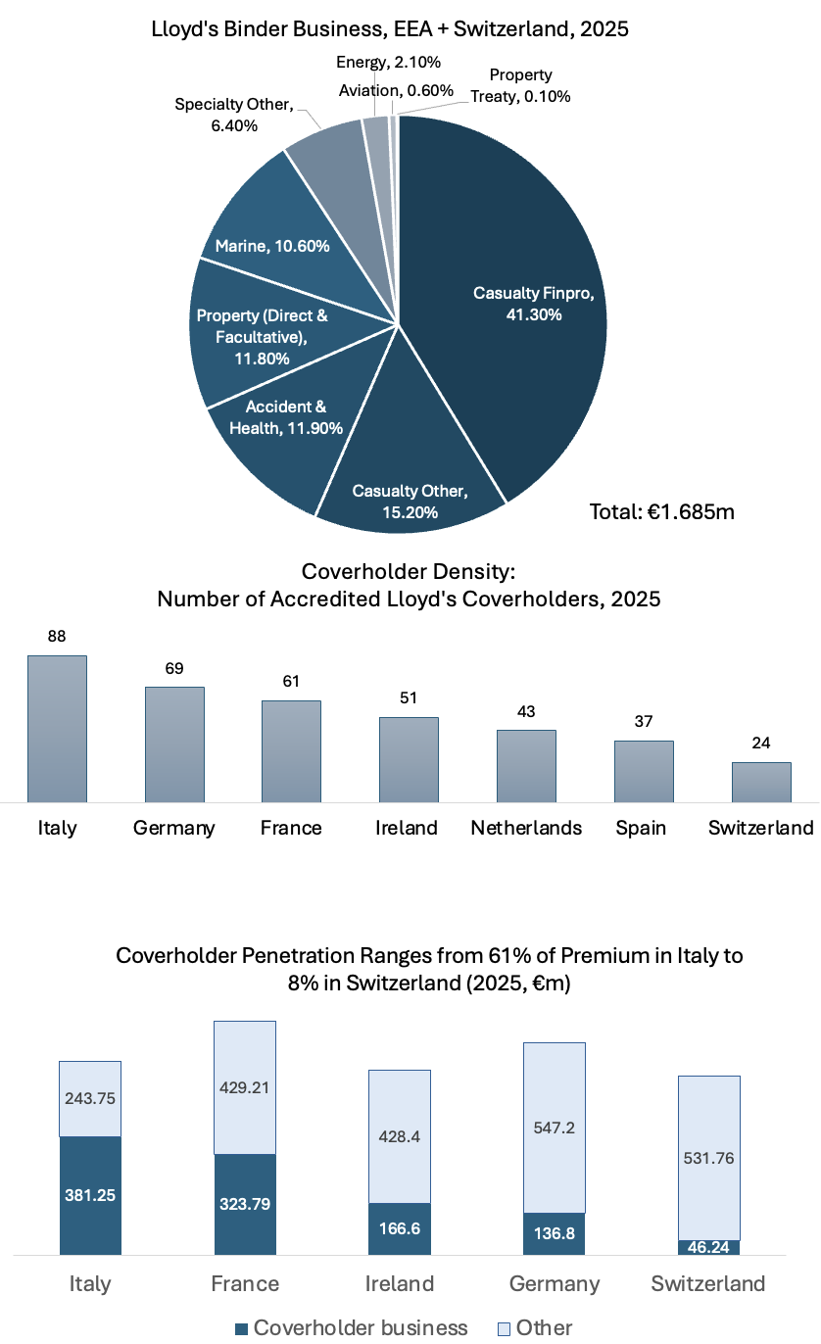
Today, Lloyd’s writes approximately 28% of its total premiums (€1,685m out of €5,939m) from the European Economic Area plus Switzerland on a delegated authority business. Five hundred and thirty-two Lloyd’s coverholders, including many of the region’s leading MGAs, underwrite a wide array of business backed by Lloyd’s binding authorities.

In recent years, Lloyd’s managing agents’ delegated authority business in Europe has surged, growing by 15% annually between 2023 and 2025.

The share of coverholder business in national markets varies widely. In Italy, Lloyd’s 88 coverholders generated 61% of the market’s total premium in 2025; in France the coverholder proportion was 43%; in Ireland, 28%; in Germany, 20%; and in Switzerland just 8%.

The overall figures are boosted by Lloyd’s broad definition of what constitutes a coverholder, which includes 61 service companies owned and operated by Lloyd’s managing agents. Coverholder business also includes business underwritten by consortia of Lloyd’s syndicates, under which the lead syndicate operates with delegated authority from following syndicates.

Many Lloyd’s coverholders are brokers with tightly worded binding authorities for particular classes of business. They operate as an efficient distribution channel for Lloyd’s products but have little or no underwriting autonomy. But in common with insurance and reinsurance companies around the world, Lloyd’s syndicates have also been increasing their capacity allocations to MGAs. And in the process some old preconceptions about the approach of the Lloyd’s market to business sourced through MGAs may need revision.

No longer short-termist
Lloyd’s capacity was historically tendered on a short-term – and often opportunistic - basis. But since 2016 Lloyd’s managing agencies have been permitted to enter into multi-year binding authority agreements that can run for up to three years. And this year, Lloyd’s plans to offer the option for continuous contracts that run indefinitely until termination.

This aligns with the broader market for capacity, in which larger MGAs in particular have been able to negotiate longer term capacity arrangements with carriers.

Streamlined accreditation
Another widely held preconception is that Lloyd’s coverholder accreditation is a lengthy and complex process. It need not be so. The delegated authorities team at Lloyd’s can process coverholder applications within a few days. The due diligence performed by the Lloyd’s managing agent may take much longer, but this is not fundamentally different from the process an insurance company would require.

For FASE members, Lloyd’s has provided two valuable guides:

- The first charts the scale, composition and growth rate of Lloyd’s coverholder business across nine European markets: Belgium, France, Germany, Ireland, Italy, the Netherlands, Spain, Sweden and Switzerland.
- The second explains the benefits of becoming a Lloyd’s coverholder and how they are remunerated and regulated. It also explains the audit process for coverholders.

One hundred and twenty-three years after Cuthbert Heath first lent his pen to his trusted agent in Amsterdam, Lloyd’s delegated authority business is still driven by the same motivation. In the words of Lloyd’s guide, it permits access to “business that otherwise would not be seen or could not be written economically at the box.” But the relationship between Lloyd’s managing agencies and modern MGAs is today more balanced and the delegation of authority is, often, much broader.

***
The approach of Lloyd’s managing agencies towards delegated authority business varies widely. Future issues of the Entrepreneurial Underwriter will include interviews with chief underwriting officers at Lloyd’s on the strategies their organizations have adopted.

Callum Alexander, the director of delegated authority at Lloyd’s, will be attending the MGA Rendezvous in May and addressing the role that Lloyd’s plays in the evolving market for underwriting capacity.

Seven reasons to consider a captive
By Mark Elliott, Polo Insurance Managers

The role of reinsurance captives has been growing in the capacity stack of MGAs in the United States and United Kingdom. In the first of a series of monthly articles that Entrepreneurial Underwriter will be publishing on captive management issues, Mark Elliott, CEO of Guernsey-based Polo Insurance Managers, highlights the top seven reasons why profitable MGAs of all sizes across Europe should consider establishing a captive.

It is estimated that there are over 300 MGAs in the UK retaining some of their own risk. But in continental Europe, MGAs have generally been slower to retain risk through captives. For MGAs that can demonstrate a profitable track record, there are seven good reasons to consider retaining risk through a captive.

- Enhanced margin capture
Retaining a portion of the risk allows the MGA to participate directly in underwriting profits rather than ceding all value to capacity providers.
- Greater control over capacity
A captive reduces dependence on third-party insurers and reinsurers, improving resilience during hard markets or sudden capacity withdrawals.
- Alignment of underwriting incentives
Retention enforces stronger underwriting discipline by directly linking portfolio performance to the MGA’s own capital at risk.
- Improved negotiating power with carriers
Demonstrated “skin in the game” strengthens credibility and can lead to better commission terms, profit shares, and long-term capacity agreements. Indeed we have seen some clients who managed to increase commission just by having the captive in place – they didn’t even take a retention initially.
- Access to reinsurance markets on better terms
A captive can access quota share or excess-of-loss reinsurance directly, often at more efficient pricing than through fronted arrangements alone. There is still an insurance / reinsurance pricing arbitrage which we often see – especially when the incumbent insurer has been on the programme for many years.
- Portfolio diversification and capital efficiency
Well-structured captives (often domiciled in EU-friendly jurisdictions) allow optimized capital usage across lines, geographies, and cycles. Traditionally Malta is an excellent location for direct EU access, but requires scale. Guernsey can operate using a fronting insurer and can sometimes be more cost-effective from a cost and capital perspective for smaller programmes.
- Strategic optionality and scalability
Captives enable controlled experimentation with new products, niches, or geographies without full reliance on external carriers. We need many new start-ups and the incubation of new products in their own captive helps collect data and demonstrates to insurers a positive alignment of interest.

In the March issue, we will dig further into the practicalities of captive establishment – and the merits of different domiciles – for European MGAs.

MGA Rendezvous registrations set rapid pace

More than 170 delegates have so far registered to attend the 2026 MGA Rendezvous, FASE’s annual conference, representing 35 MGAs, 20 carriers and seven service providers. Total attendance at the conference, which is due to take place at the Hotel Arts in Barcelona on May 11 and 12, is now expected to exceed 500.
The conference will be cohosted this year by FASE and the Spanish MGA association, ASASE and sponsored by Howden. It will feature presentations and panel discussions with business leaders from Europe and the United States, but a significant portion of the day and a half event will be given over to networking. Prior to the Rendezvous, carriers will be invited to share information about their risk appetite and MGAs about their areas of risk focus so that productive and efficient meetings can be scheduled for Barcelona.
FASE members are entitled to a 50% discount on passes to the event. For an MGA, a single conference pass would therefore cost €400; for a carrier or broker, €550; and for a service provider €700.
If you have yet to register for the 2026 MGA Rendezvous, you can do so at mgarendezvous.com/register.
We look forward to seeing you in Barcelona.

