2) What command can be used to determine the type of file (for example, text or binary)? Give an example

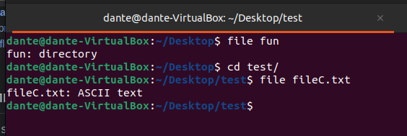

3) Master the skills of navigating the file system using relative and absolute paths. How can you go back to your home directory from anywhere in the filesystem

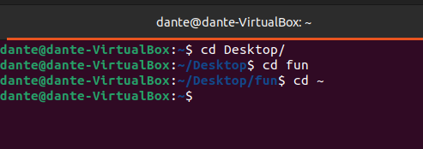

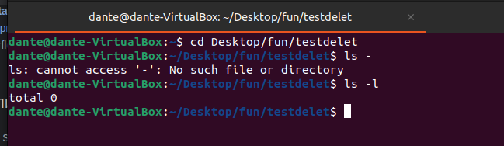

4) Become familiar with the various options for the ls command. Give examples of listing directories using different keys. Explain the information displayed on the terminal using the -l and -a switches.

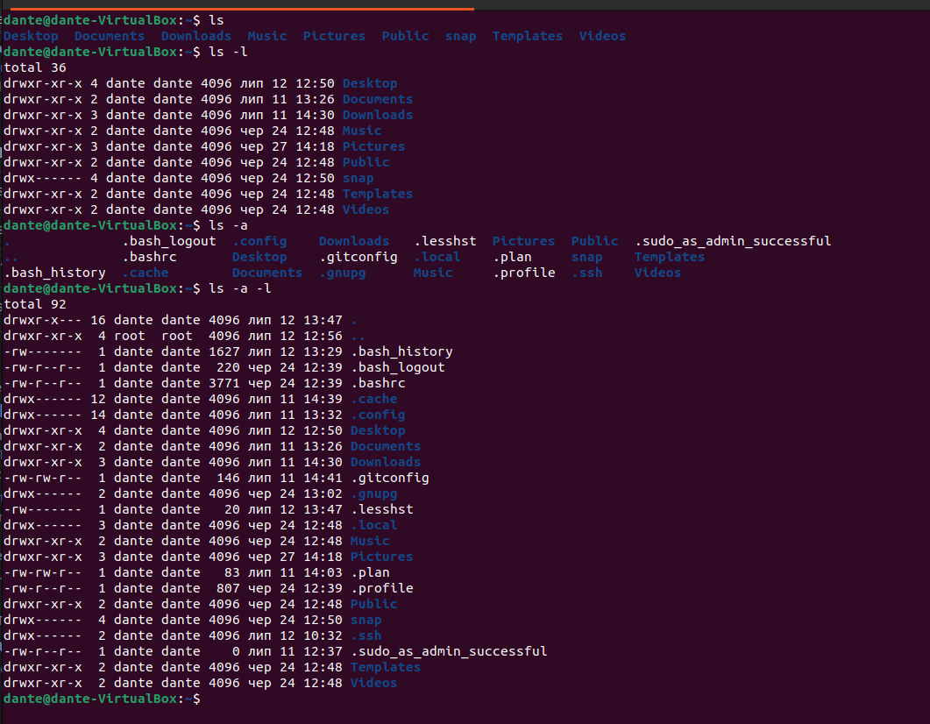

ls -l is used for displaying files’ permissions, date of creation

ls –a is used for displaying all files in the directory, even the hidden ones, does not ignore files starting with a “.”

5) Perform the following sequence of operations:

- create a subdirectory in the home directory;

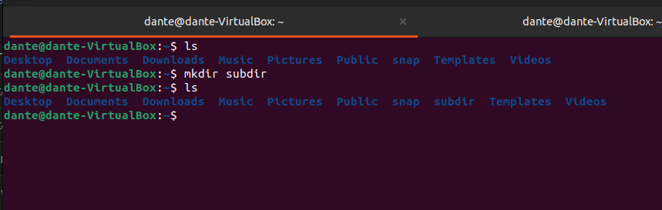

- in this subdirectory create a file containing information about directories located in the root directory (using I/O redirection operations);

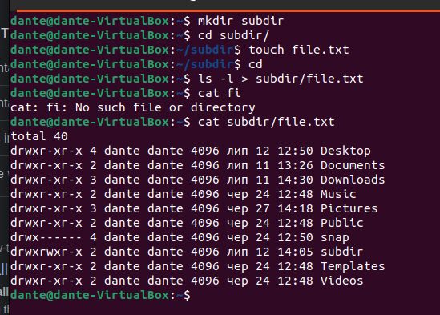

- view the created file;



- copy the created file to your home directory using relative and absolute addressing.

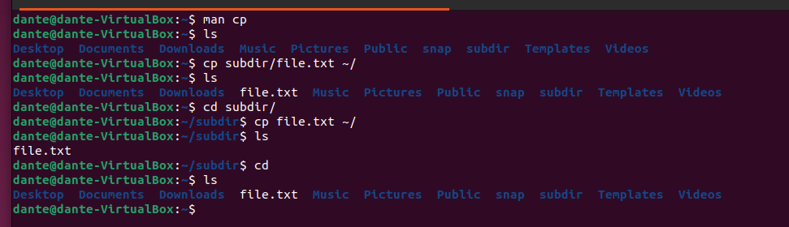

- delete the previously created subdirectory with the file requesting removal;

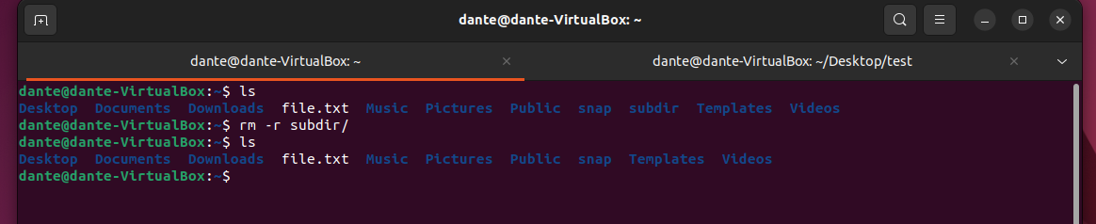

- delete the file copied to the home directory

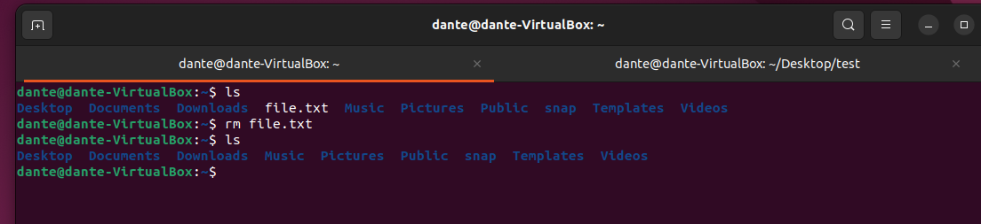

(6) Perform the following sequence of operations:

- create a subdirectory test in the home directory;

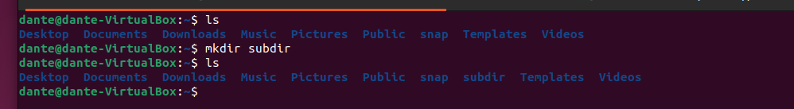

- copy the .bash_history file to this directory while changing its name to labwork2;

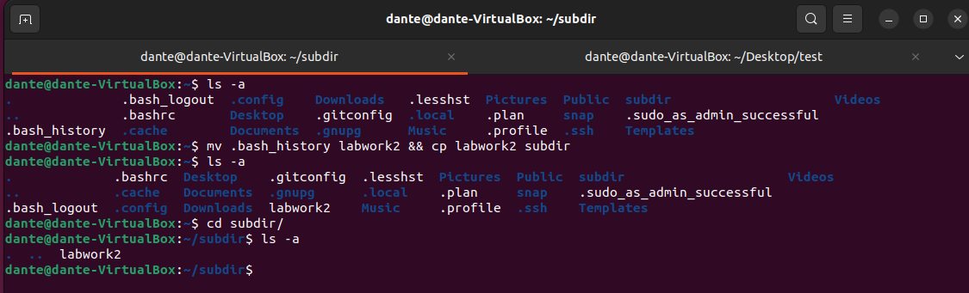

- create a hard and soft link to the labwork2 file in the test subdirectory;

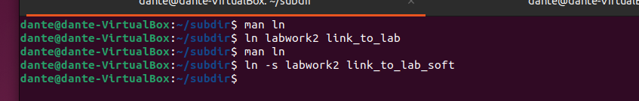

- how to define soft and hard link, what do these concepts;

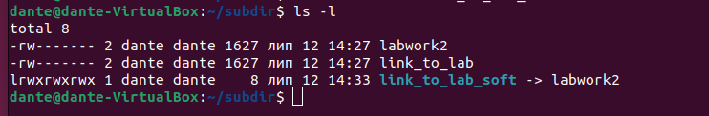

Hard links refer to the data itself, soft links point to the path to the data.

- change the data by opening a symbolic link. What changes will happen and why



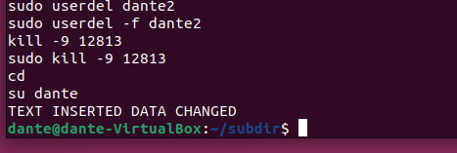

Content and editing date has changed.

- rename the hard link file to hard_lnk_labwork2;

- rename the soft link file to symb_lnk_labwork2 file;

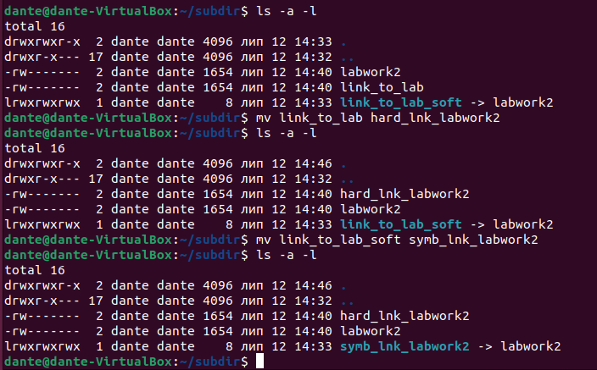

- then delete the labwork2. What changes have occurred and why?

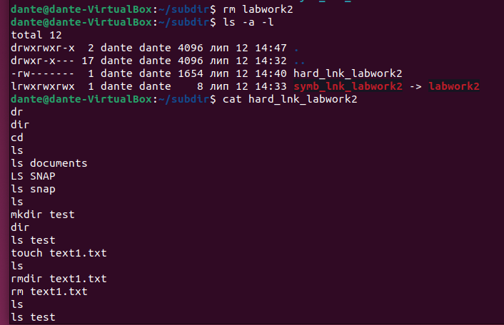

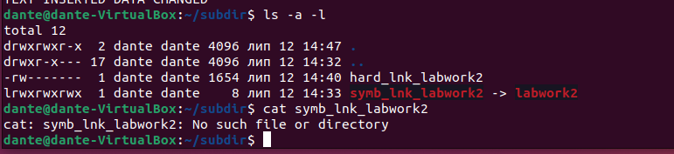

If we try to access the file via hard link -we can see the content as the file is still save on the disc. File will be saved until at least one hard link exists

If we try to access the file via soft link – here’s no such file as soft link only indicates on the file.

7) Using the locate utility, find all files that contain the squid and traceroute sequence.

Having difficulties with this one.

8) Determine which partitions are mounted in the system, as well as the types of these partitions.

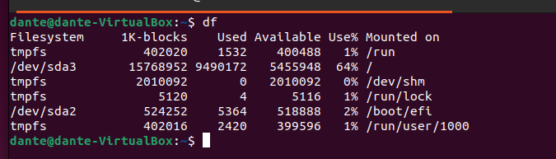

10) Using the find command, find all files in the /etc directory containing the host character sequence.

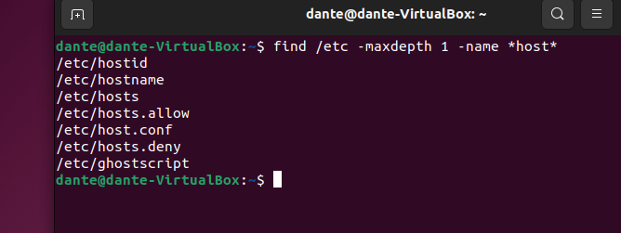

11) List all objects in /etc that contain the ss character sequence. How can I duplicate a similar command using a bunch of grep?

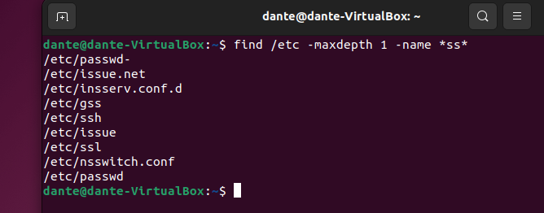

12) Organize a screen-by-screen print of the contents of the /etc directory. Hint: You must use stream redirection operations.

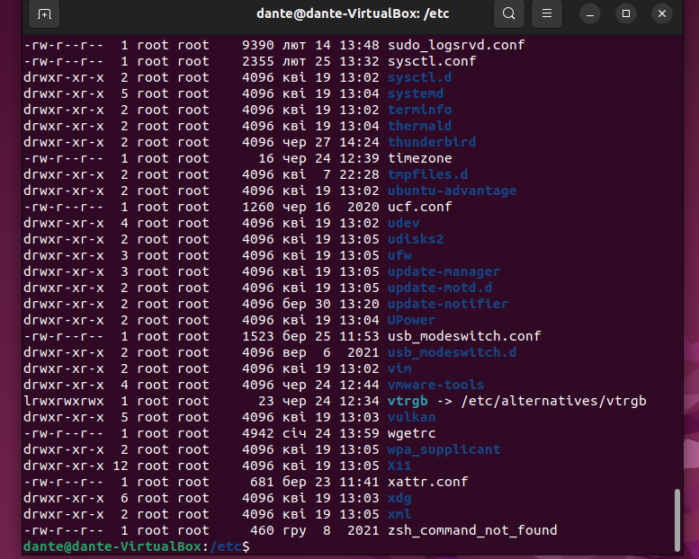

13) What are the types of devices and how to determine the type of device? Give examples.

b - block device; c - character device;

We can determine it by typing ls –l command and see the first letter of a row.

14) How to determine the type of file in the system, what types of files are there?

Command “file <file_name>”.

Ordinary Files.

Directories.

Special Files.

Pipes.

Sockets.

Symbolic Links.

15) * List the first 5 directory files that were recently accessed in the /etc directory.

