Task Outputs. Also found in Task folders.

Task 1 Output:
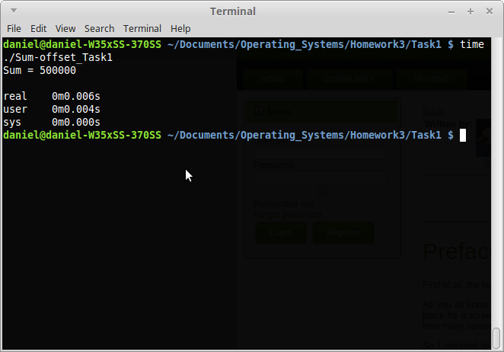

Task 2 Output:
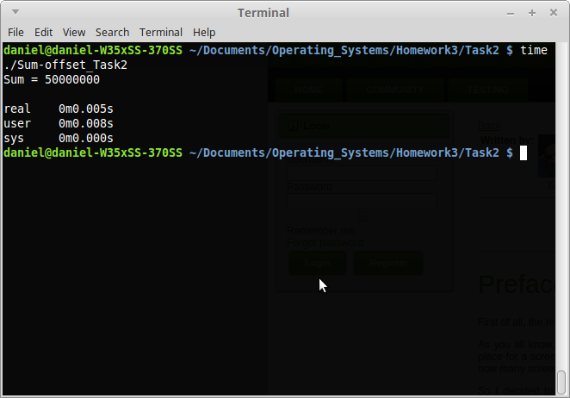

Task 3 Output:
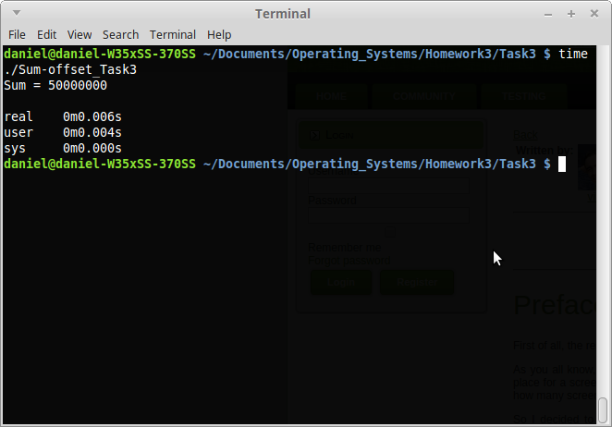
Task 4 Output:
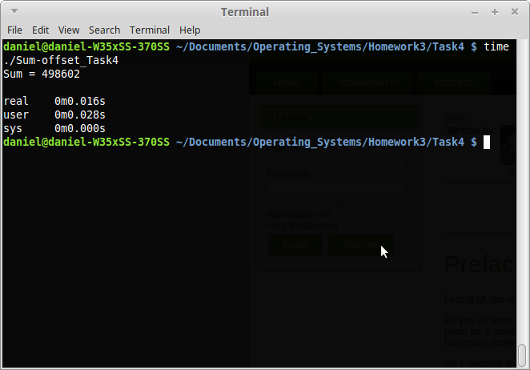

Task 5 Output:
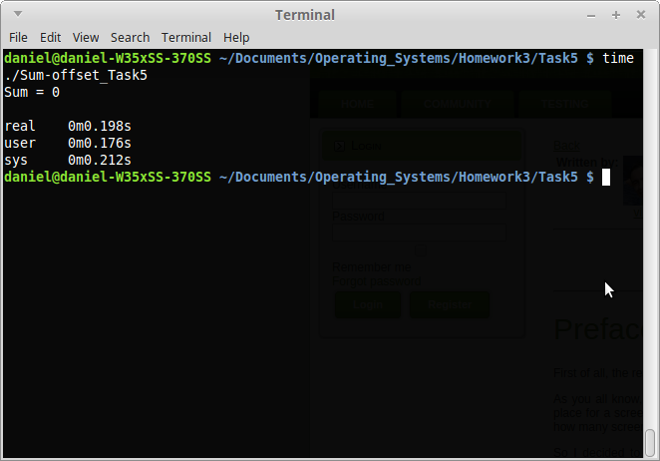

For Task 6, the critical section was the variable “count”.

Task 6-7 Output Part 1:
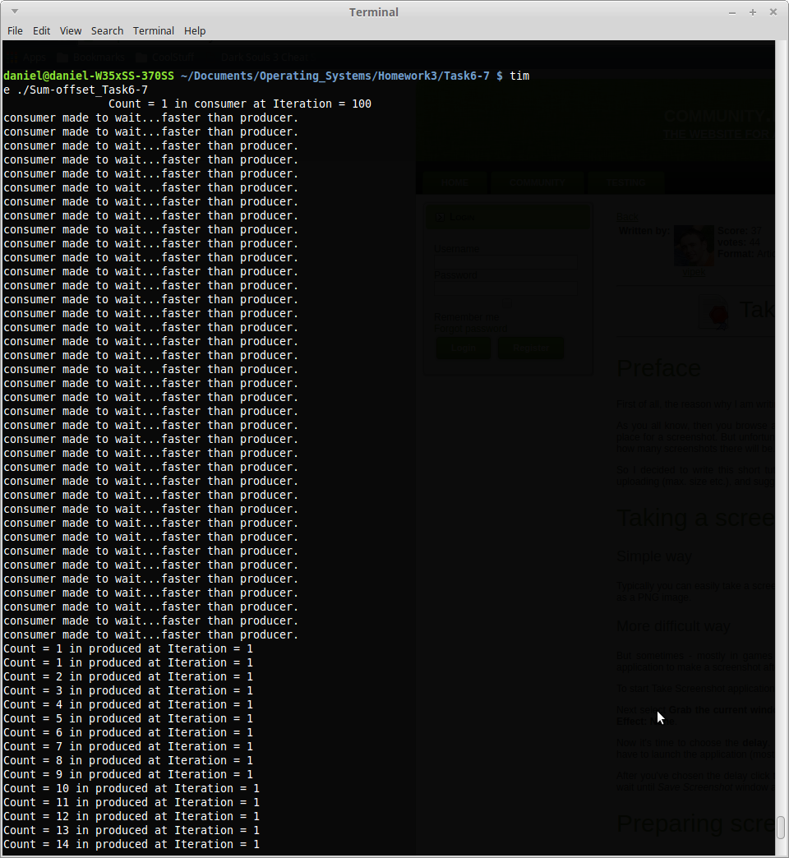

Task 6-7 Output Part 2:
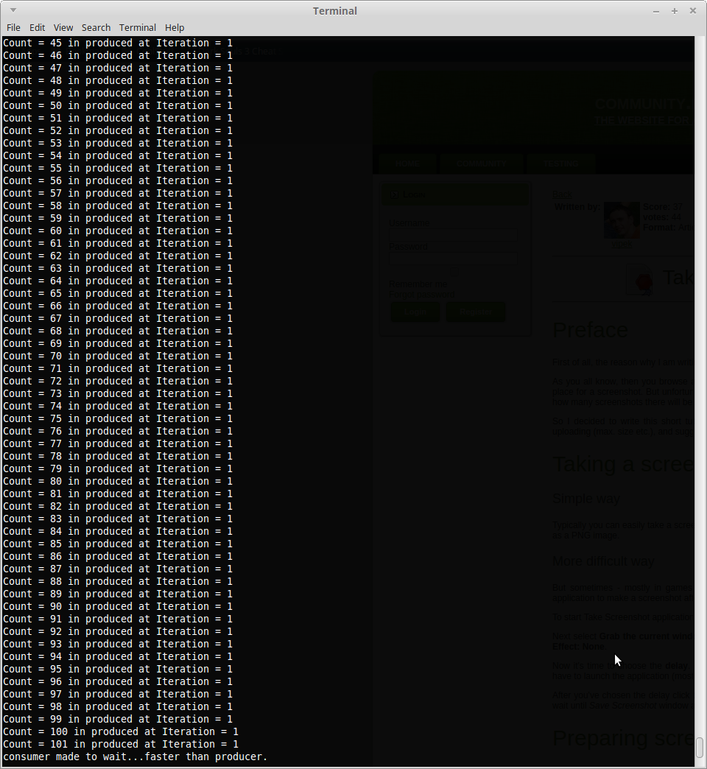

Task 6-7 Output Part 3:
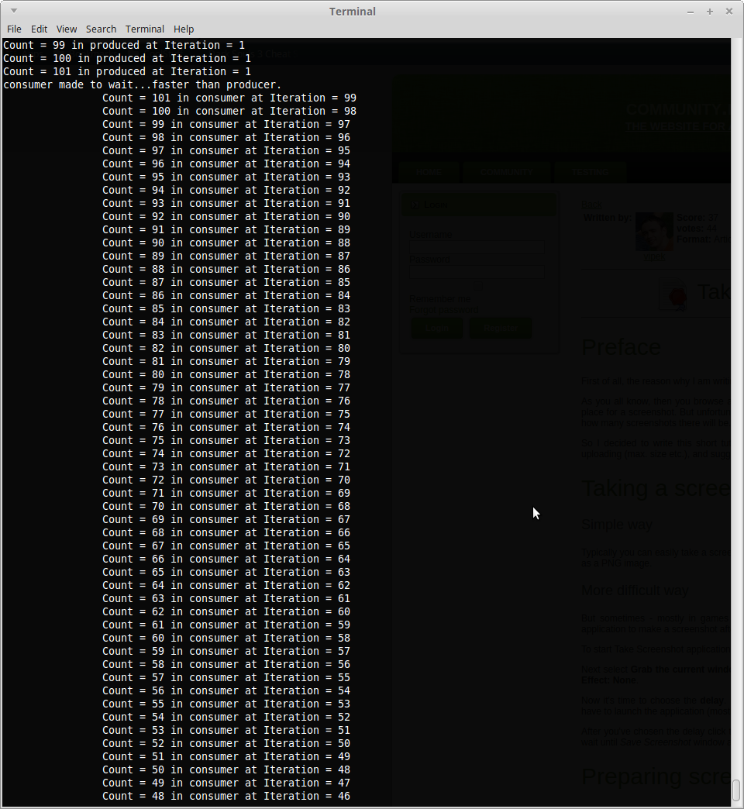

Task 6-7 Output Part 4:
